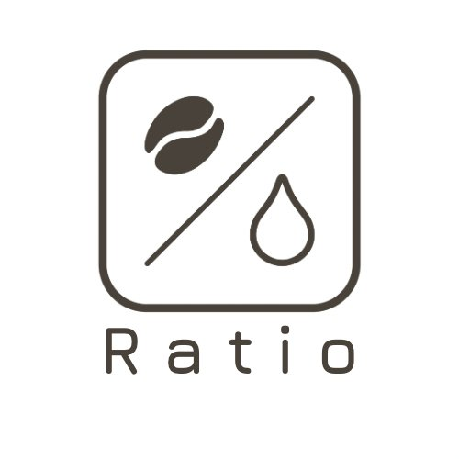 | Ratio Coffee  Ratio Coffee Pty Ltd | ABN 57 658 829 899  Shop 2, 473 Pacific Hwy, Crows Nest NSW 2065  ratiocoffee2473@gmail.com | 0403 037 369

WHOLESALE ACCOUNT APPLICATION FORM

1. Parties
This Wholesale Agreement is entered into between:

Supplier: | Ratio Coffee Pty Ltd (ABN 57 658 829 899)
Trading as: | Ratio Retail
Address: | Shop 2, 473 Pacific Hwy, Crows Nest NSW 2065
Email: | ratiocoffee2473@gmail.com
Phone: | 0403 037 369

Buyer (Business Name): | ___________________________________
ABN: | ___________________________________
Address: | ___________________________________
Contact Name: | ___________________________________
Email: | ___________________________________
Phone: | ___________________________________

2. Ordering Process
- Orders open every Sunday and must be submitted by Monday 5:00 PM.
- Roasting takes place every Tuesday. Orders are dispatched or available for pick-up on Wednesday.
- Please allow one (1) business day for packaging after roasting.
- Orders placed after the Monday 5:00 PM cut-off will be fulfilled from available stock only. Ratio Retail cannot guarantee availability for late orders.
- To place an order, contact us via email at ratiocoffee2473@gmail.com or SMS 0403 037 369 (please include your business name and product requirements).
3. Pricing & Minimum Order
- Wholesale pricing will be provided separately and may be updated by Ratio Retail with reasonable notice.
- A minimum order value of AUD $150 (excluding GST) applies per order.
- Orders meeting the minimum order value qualify for free delivery.
- Orders below AUD $150 are subject to a delivery fee of AUD $20.
4. Payment Terms
- Full payment is required prior to order fulfilment (prepayment).
- Bank Transfer: Commonwealth Bank — Account Name: Ratio Coffee Pty Ltd — BSB: 062-151 — Account Number: 1049 7845. Please reference your business name and order date.
- In-store pick-up: Card payment accepted on collection.
- Orders will not be processed until payment is confirmed.
5. Delivery & Pick-Up
- Delivery is available for qualifying orders (see Section 3).
- Pick-up is available at Shop 2, 473 Pacific Hwy, Crows Nest NSW 2065. Please contact us to arrange a suitable pick-up time.
- Ratio Retail is not responsible for delays caused by third-party delivery providers.
6. Product & Quality
- All coffee is freshly roasted to order. Ratio Retail takes pride in consistent quality and will notify the Buyer of any changes to products or availability.
- If there is a quality issue with any product received, the Buyer must notify Ratio Retail within 48 hours of receipt with details and supporting evidence.
7. Term & Termination
- This Agreement commences on the date signed below and continues until terminated by either party.
- Either party may terminate this Agreement with 14 days' written notice.
- Ratio Retail reserves the right to suspend or cancel wholesale arrangements for non-payment or breach of this Agreement.
8. General
- This Agreement is governed by the laws of New South Wales, Australia.
- Ratio Retail reserves the right to update wholesale pricing, product range, or order conditions with reasonable prior notice.
- This Agreement does not create an exclusive supply arrangement.
9. Signatures
By signing below, both parties agree to the terms of this Wholesale Agreement.

Supplier — Ratio Coffee Pty Ltd  Signature: ___________________________  Name: ___________________________  Date: ___________________________ | Buyer  Signature: ___________________________  Name: ___________________________  Date: ___________________________

Ratio Coffee Pty Ltd · ABN 57 658 829 899 · ratiocoffee2473@gmail.com

