3. The difference between bottom-up evaluation and top-down evaluation is that bottom-up evaluation requires a recursive call to be made first whereas top-down evaluation requires the recursive call to be made last. See the example below.

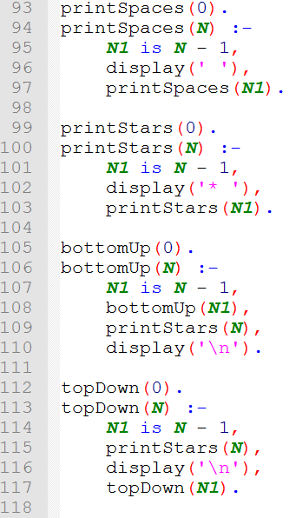

In the bottom up rule, the recursive call is made after the problem set is reduced by line 107. This forces computation to reach the base case first (line 105) before reaching any successive method calls, such as line 109. When the base case is reached, recursion ceases and the calls are resolved. So 109 will first be called with N = 1, then N = 2, and so on until the top most call is resolved (where N = 5).

In the case of top down evaluation, the recursive call is made last (line 117). This forces execution to resolve the previous method calls first, namely lines 114 (to reduce the problem set), 115 and 116. This style of execution results in line 115 being called with N = 5, then N = 4, and so on until the base case is reached.

The figure below represents the output of the program above.

