install.packages('plotly', repos = 'http://cran.us.r-project.org')

## Installing package into 'C:/Users/Rahul/Documents/R/win-library/3.3'  
## (as 'lib' is unspecified)

## package 'plotly' successfully unpacked and MD5 sums checked  
##   
## The downloaded binary packages are in  
## C:\Users\Rahul\AppData\Local\Temp\RtmpU7Ki8b\downloaded_packages

library(ggplot2)  
library(GGally)

checkNaFunction <- function(houseData){  
naColumns <- c()  
#checking NA for each columns  
for(i in 1:ncol(houseData)) {  
 #cat(sprintf("Checking NA: %s \n", colnames(houseData)[i]))  
 if(length(which(is.na(houseData[,i]))) > 0){  
 #cat(sprintf("There is NA: %s \n" , colnames(houseData)[i]))  
 naColumns <- c(naColumns, colnames(houseData)[i])  
 }  
}  
return(naColumns)  
}

bucketByColumn <- function(houseData,i){  
minP <- min(as.numeric(houseData[,i]))  
maxP <- max(as.numeric(houseData[,i]))  
rangeP <- range(as.numeric(houseData[,i]))  
rangeP  
cat(sprintf("Min-Max value for: %s , MAX: %d, MIN: %d \n", colnames(houseData)[i], maxP, minP))  
}

findSSEByColName <- function(colName, SSEVals){  
 modlm<-lm(as.formula(paste("log(price)~", paste(c(colName), collapse="+"))),data=train)  
 ## Predicting prices using each Model. we need to take exponent of predict function since it returns log of price.  
 predt<-exp(predict(modlm,newdata=test))  
 SSE<-sum((test$price-predt)^2)  
 SSEVals[[1]]<-c(SSEVals[[1]],colName)  
 SSEVals[[2]]<-c(SSEVals[[2]],SSE)  
 return(SSEVals)  
}

analysis <- function(houseData, i, labels, plotLog, boxLog){  
 #Simple Plot with Price  
 plot(houseData[,i], houseData$price, main = labels[1], xlab = labels[2],ylab = labels[3], col=(c("gold","darkgreen")))  
 #Plot with Log(Price )  
 plot(houseData[,i],log(houseData$price), main = labels[1], xlab =labels[2], ylab = paste('Log of ', labels[3]), col=(c("gold","darkgreen")))  
   
 if(plotLog=='Y'){  
 #Plot with Log(Price ) & Log(independent-variable)  
 plot(log(houseData[,i]+0.5),log(houseData$price), main = labels[1], xlab = paste('Log of ',labels[2]), ylab = paste('Log of ', labels[3]), col=(c("gold","darkgreen")))  
 }  
 #Histogram of independent-variable  
 hist(houseData[,i], main = labels[2], xlab = labels[2], ylab = "Frequency", col=(c("gold","darkgreen")))  
 #BoxPlot of independent-variable  
 boxplot(houseData[,i], main = labels[2], xlab = labels[2], ylab= "Frequency", col=(c("gold","darkgreen")))  
 if(boxLog=='Y'){  
 #BoxPlot of independent-variable & dependent variable  
 boxplot(houseData$price~houseData[,i], main = labels[1], xlab = labels[2], ylab= labels[3], col=(c("gold","darkgreen")))  
 #BoxPlot of independent-variable & dependent variable  
 boxplot(log(houseData$price)~houseData[,i], main = labels[1], xlab = labels[2], ylab= paste('Log of ', labels[3]), col=(c("gold","darkgreen")))  
   
 #BoxPlot of independent-variable & dependent variable  
 boxplot(log(houseData$price)~log(houseData[,i]+0.5), main = labels[1], xlab = paste('Log of ',labels[2]), ylab= paste('Log of ', labels[3]), col=(c("gold","darkgreen")))  
 }  
 #Corelation of independent-variable with Price  
 cor(houseData[,i],houseData$price)  
}

# Data Importing And Cleaning

houseData <- read.csv("file:///G:/Ryerson-BigData/capstone-R/CKME-136/data/kc_house_data.csv")  
head(houseData)

## id date price bedrooms bathrooms sqft_living  
## 1 7129300520 20141013T000000 221900 3 1.00 1180  
## 2 6414100192 20141209T000000 538000 3 2.25 2570  
## 3 5631500400 20150225T000000 180000 2 1.00 770  
## 4 2487200875 20141209T000000 604000 4 3.00 1960  
## 5 1954400510 20150218T000000 510000 3 2.00 1680  
## 6 7237550310 20140512T000000 1225000 4 4.50 5420  
## sqft_lot floors waterfront view condition grade sqft_above sqft_basement  
## 1 5650 1 0 0 3 7 1180 0  
## 2 7242 2 0 0 3 7 2170 400  
## 3 10000 1 0 0 3 6 770 0  
## 4 5000 1 0 0 5 7 1050 910  
## 5 8080 1 0 0 3 8 1680 0  
## 6 101930 1 0 0 3 11 3890 1530  
## yr_built yr_renovated zipcode lat long sqft_living15 sqft_lot15  
## 1 1955 0 98178 47.5112 -122.257 1340 5650  
## 2 1951 1991 98125 47.7210 -122.319 1690 7639  
## 3 1933 0 98028 47.7379 -122.233 2720 8062  
## 4 1965 0 98136 47.5208 -122.393 1360 5000  
## 5 1987 0 98074 47.6168 -122.045 1800 7503  
## 6 2001 0 98053 47.6561 -122.005 4760 101930

colnames(houseData)

## [1] "id" "date" "price" "bedrooms"   
## [5] "bathrooms" "sqft_living" "sqft_lot" "floors"   
## [9] "waterfront" "view" "condition" "grade"   
## [13] "sqft_above" "sqft_basement" "yr_built" "yr_renovated"   
## [17] "zipcode" "lat" "long" "sqft_living15"  
## [21] "sqft_lot15"

naColumns <- checkNaFunction(houseData)  
if(length(naColumns)>0){  
 cat("Found NA Colums:")  
 for(i in 1:length(naColumns)) {  
 cat(sprintf("%s,", colnames(houseData)[i]))  
 }  
}  
  
cat ("Conclusion: Here we conclude that this data does not hold any column with NA.")

## Conclusion: Here we conclude that this data does not hold any column with NA.

##bucketByColumn(houseData,3)

# Price with other attributes

## verify the relationship between price, bedrooms, bathrooms, sqft_living and sqft lot  
plot1 <- ggpairs(data=houseData, columns=3:7, mapping = aes(color = "dark green"), axisLabels="show")  
plot1

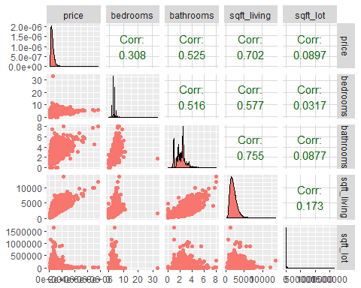

## verify the relationship between price, floors, waterfront, view, condition and grade  
plot2 <- ggpairs(data=houseData, columns=c(3,8:12), mapping = aes(color = "dark green"), axisLabels="show")  
plot2

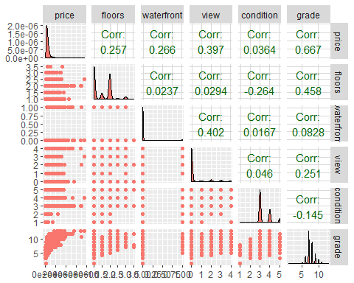

## verify the relationship between price, yr built, lat and long  
plot3 <- ggpairs(data=houseData, columns=c(3,15,18,19), mapping = aes(color = "dark green"), axisLabels="show")  
plot3

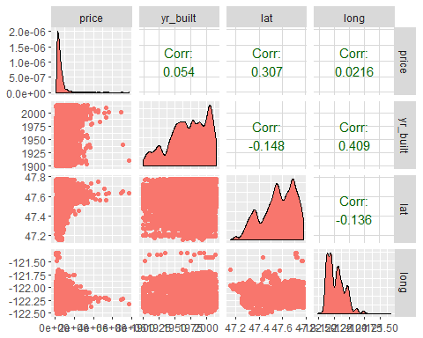

## Correlation among all the variables

#Remove the columns which does not hold any significance in predicing house price  
houseData$date <- NULL  
houseData$id <- NULL  
cor(houseData)

## price bedrooms bathrooms sqft_living  
## price 1.00000000 0.308349598 0.52513751 0.70203505  
## bedrooms 0.30834960 1.000000000 0.51588364 0.57667069  
## bathrooms 0.52513751 0.515883638 1.00000000 0.75466528  
## sqft_living 0.70203505 0.576670693 0.75466528 1.00000000  
## sqft_lot 0.08966086 0.031703243 0.08773966 0.17282566  
## floors 0.25679389 0.175428935 0.50065317 0.35394929  
## waterfront 0.26636943 -0.006582479 0.06374363 0.10381782  
## view 0.39729349 0.079531852 0.18773702 0.28461119  
## condition 0.03636179 0.028472104 -0.12498193 -0.05875259  
## grade 0.66743426 0.356966725 0.66498253 0.76270448  
## sqft_above 0.60556730 0.477600161 0.68534248 0.87659660  
## sqft_basement 0.32381602 0.303093375 0.28377003 0.43504297  
## yr_built 0.05401153 0.154178069 0.50601944 0.31804877  
## yr_renovated 0.12643379 0.018840823 0.05073898 0.05536293  
## zipcode -0.05320285 -0.152668487 -0.20386627 -0.19943004  
## lat 0.30700348 -0.008931010 0.02457295 0.05252946  
## long 0.02162624 0.129472975 0.22304184 0.24022330  
## sqft_living15 0.58537890 0.391637524 0.56863429 0.75642026  
## sqft_lot15 0.08244715 0.029244224 0.08717536 0.18328555  
## sqft_lot floors waterfront view  
## price 0.089660861 0.256793888 0.266369434 0.397293488  
## bedrooms 0.031703243 0.175428935 -0.006582479 0.079531852  
## bathrooms 0.087739662 0.500653173 0.063743629 0.187737024  
## sqft_living 0.172825661 0.353949290 0.103817818 0.284611186  
## sqft_lot 1.000000000 -0.005200991 0.021603683 0.074710106  
## floors -0.005200991 1.000000000 0.023698320 0.029443820  
## waterfront 0.021603683 0.023698320 1.000000000 0.401857351  
## view 0.074710106 0.029443820 0.401857351 1.000000000  
## condition -0.008958250 -0.263767946 0.016653157 0.045989737  
## grade 0.113621124 0.458182514 0.082774914 0.251320585  
## sqft_above 0.183512281 0.523884710 0.072074592 0.167649344  
## sqft_basement 0.015286202 -0.245704542 0.080587939 0.276946579  
## yr_built 0.053080367 0.489319425 -0.026161086 -0.053439851  
## yr_renovated 0.007643505 0.006338401 0.092884837 0.103917288  
## zipcode -0.129574486 -0.059120642 0.030284728 0.084826917  
## lat -0.085682788 0.049614131 -0.014273776 0.006156732  
## long 0.229520859 0.125419028 -0.041910200 -0.078399712  
## sqft_living15 0.144608174 0.279885265 0.086463136 0.280439082  
## sqft_lot15 0.718556752 -0.011269187 0.030703283 0.072574568  
## condition grade sqft_above sqft_basement  
## price 0.036361789 0.66743426 0.6055672984 0.32381602  
## bedrooms 0.028472104 0.35696673 0.4776001614 0.30309338  
## bathrooms -0.124981933 0.66498253 0.6853424759 0.28377003  
## sqft_living -0.058752587 0.76270448 0.8765965987 0.43504297  
## sqft_lot -0.008958250 0.11362112 0.1835122809 0.01528620  
## floors -0.263767946 0.45818251 0.5238847103 -0.24570454  
## waterfront 0.016653157 0.08277491 0.0720745917 0.08058794  
## view 0.045989737 0.25132058 0.1676493441 0.27694658  
## condition 1.000000000 -0.14467367 -0.1582136164 0.17410491  
## grade -0.144673671 1.00000000 0.7559229376 0.16839182  
## sqft_above -0.158213616 0.75592294 1.0000000000 -0.05194331  
## sqft_basement 0.174104914 0.16839182 -0.0519433068 1.00000000  
## yr_built -0.361416562 0.44696320 0.4238983517 -0.13312410  
## yr_renovated -0.060617787 0.01441428 0.0232846879 0.07132290  
## zipcode 0.003025524 -0.18486209 -0.2611899765 0.07484461  
## lat -0.014941006 0.11408406 -0.0008164986 0.11053796  
## long -0.106500448 0.19837215 0.3438030175 -0.14476477  
## sqft_living15 -0.092824268 0.71320209 0.7318702924 0.20035498  
## sqft_lot15 -0.003405523 0.11924790 0.1940498619 0.01727618  
## yr_built yr_renovated zipcode lat  
## price 0.05401153 0.126433793 -0.053202854 0.3070034800  
## bedrooms 0.15417807 0.018840823 -0.152668487 -0.0089310097  
## bathrooms 0.50601944 0.050738978 -0.203866274 0.0245729528  
## sqft_living 0.31804877 0.055362927 -0.199430043 0.0525294622  
## sqft_lot 0.05308037 0.007643505 -0.129574486 -0.0856827882  
## floors 0.48931942 0.006338401 -0.059120642 0.0496141310  
## waterfront -0.02616109 0.092884837 0.030284728 -0.0142737756  
## view -0.05343985 0.103917288 0.084826917 0.0061567321  
## condition -0.36141656 -0.060617787 0.003025524 -0.0149410064  
## grade 0.44696320 0.014414281 -0.184862093 0.1140840571  
## sqft_above 0.42389835 0.023284688 -0.261189977 -0.0008164986  
## sqft_basement -0.13312410 0.071322902 0.074844608 0.1105379580  
## yr_built 1.00000000 -0.224873518 -0.346869178 -0.1481224021  
## yr_renovated -0.22487352 1.000000000 0.064357057 0.0293976092  
## zipcode -0.34686918 0.064357057 1.000000000 0.2670479500  
## lat -0.14812240 0.029397609 0.267047950 1.0000000000  
## long 0.40935620 -0.068372369 -0.564071606 -0.1355117836  
## sqft_living15 0.32622890 -0.002672555 -0.279032997 0.0488579321  
## sqft_lot15 0.07095793 0.007853765 -0.147221069 -0.0864188072  
## long sqft_living15 sqft_lot15  
## price 0.02162624 0.585378904 0.082447153  
## bedrooms 0.12947298 0.391637524 0.029244224  
## bathrooms 0.22304184 0.568634290 0.087175361  
## sqft_living 0.24022330 0.756420259 0.183285551  
## sqft_lot 0.22952086 0.144608174 0.718556752  
## floors 0.12541903 0.279885265 -0.011269187  
## waterfront -0.04191020 0.086463136 0.030703283  
## view -0.07839971 0.280439082 0.072574568  
## condition -0.10650045 -0.092824268 -0.003405523  
## grade 0.19837215 0.713202093 0.119247897  
## sqft_above 0.34380302 0.731870292 0.194049862  
## sqft_basement -0.14476477 0.200354983 0.017276181  
## yr_built 0.40935620 0.326228900 0.070957926  
## yr_renovated -0.06837237 -0.002672555 0.007853765  
## zipcode -0.56407161 -0.279032997 -0.147221069  
## lat -0.13551178 0.048857932 -0.086418807  
## long 1.00000000 0.334604984 0.254451288  
## sqft_living15 0.33460498 1.000000000 0.183191749  
## sqft_lot15 0.25445129 0.183191749 1.000000000

cat ("\nConclusion: sqft_living , sqft_above, grade, sqft_living15, bathrooms have moderate to strong correlation with Price")

##   
## Conclusion: sqft_living , sqft_above, grade, sqft_living15, bathrooms have moderate to strong correlation with Price

cat ("\nConclusion: bathrooms has moderate to strong correlation sqft_living, sqft_above, grade, sqft_living15")

##   
## Conclusion: bathrooms has moderate to strong correlation sqft_living, sqft_above, grade, sqft_living15

cat ("\nConclusion: sqft_living has moderate to strong correlation sqft_above, grade, sqft_living15 and all the above variables studied.")

##   
## Conclusion: sqft_living has moderate to strong correlation sqft_above, grade, sqft_living15 and all the above variables studied.

cat ("\nConclusion: grade has moderate to strong correlation sqft_above, sqft_living15 and all the above variables studied.")

##   
## Conclusion: grade has moderate to strong correlation sqft_above, sqft_living15 and all the above variables studied.

cat ("\nConclusion: sqft_above has moderate to strong correlation sqft_living15 and all the above variables studied.")

##   
## Conclusion: sqft_above has moderate to strong correlation sqft_living15 and all the above variables studied.

cat ("\nConclusion: sqft_basement has moderate correlation with sqft_living only.")

##   
## Conclusion: sqft_basement has moderate correlation with sqft_living only.

cat ("\nConclusion: yr_built has moderate correlation with bathrooms, floors, grade, sqft_above only.")

##   
## Conclusion: yr_built has moderate correlation with bathrooms, floors, grade, sqft_above only.

cat ("\nConclusion: sqft_lot15 has strong correlation with sqft_lot only.")

##   
## Conclusion: sqft_lot15 has strong correlation with sqft_lot only.

cat ("\nConclusion: waterfront, view, condition, zipcode, latitude, longitude, yr_renovated has very weak with other attributes as well as with price.")

##   
## Conclusion: waterfront, view, condition, zipcode, latitude, longitude, yr_renovated has very weak with other attributes as well as with price.

cat ("\nConclusion: we can see that zip-code has very weak co-orelation -0.053202854, so let us remove it")

##   
## Conclusion: we can see that zip-code has very weak co-orelation -0.053202854, so let us remove it

houseData$zipcode <- NULL  
 houseData <- read.csv("file:///G:/Ryerson-BigData/capstone-R/CKME-136/data/kc_house_data.csv")

# Now Let us do analysis of price with all other variables one by one

# Bedroom Vs Price analysis

#bucketByColumn(houseData,4)  
analysis(houseData,4,c('Bedrooms vs. price','Bedrooms', 'Price of House'), 'Y', 'Y')

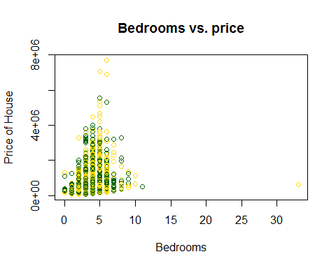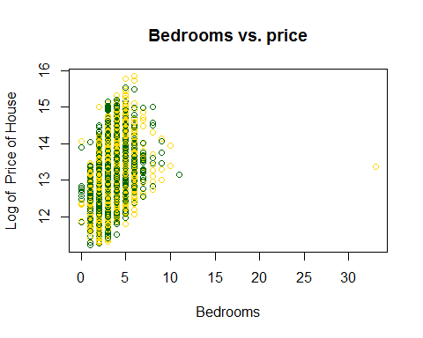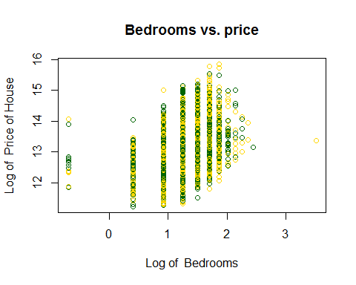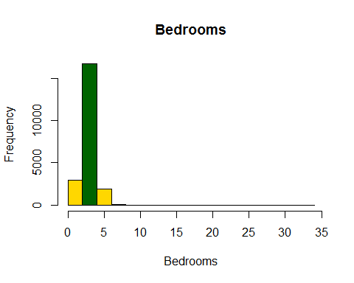sd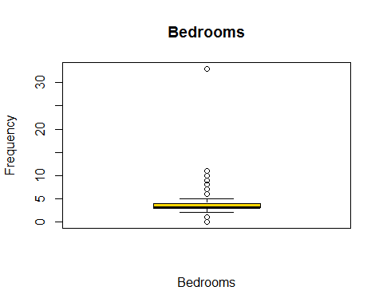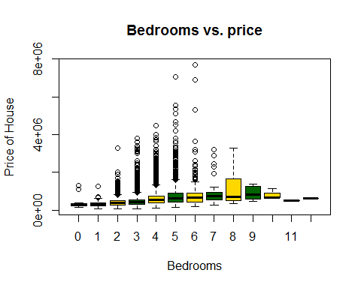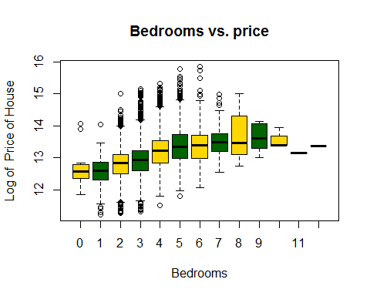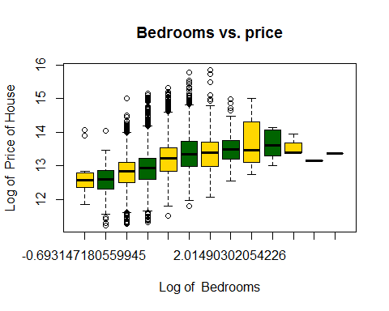

## [1] 0.3083496

#*******Removing the outliers  
#Since more than 7 bedrooms are very rare.Also it's the outlier for my model.  
#I have removed the outlier data.  
houseData<-subset(houseData,bedrooms>=1 & bedrooms<=7)  
#*******Once we removed the outliers, again get the analysis  
analysis(houseData,4,c('Bedrooms vs. price','Bedrooms', 'Price of House'), 'Y', 'Y')

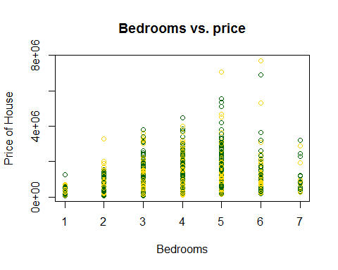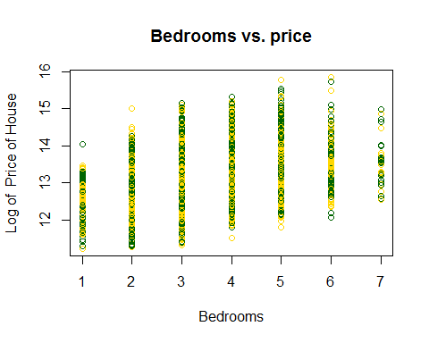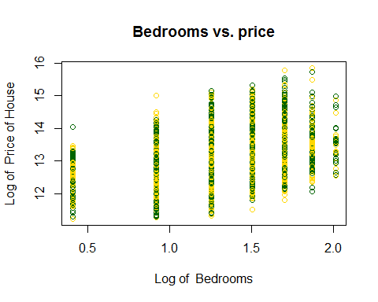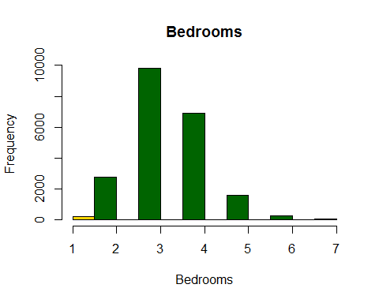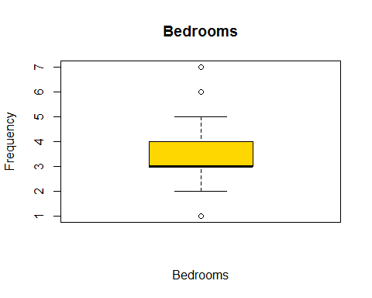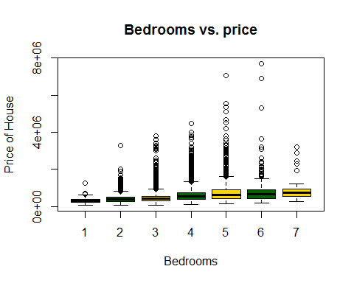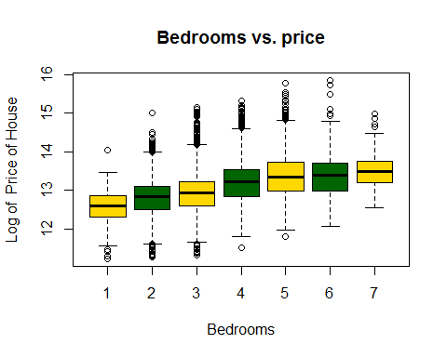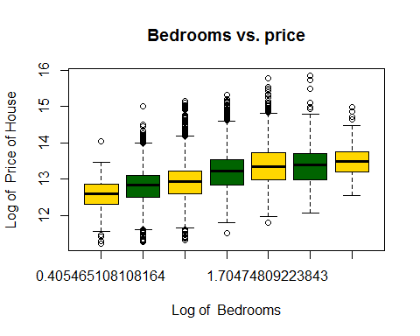

## [1] 0.3156734

#bucketByColumn(houseData,4)  
cat ("Conclusion: here we can found that log of bedroom give better performance than bedroom.")

## Conclusion: here we can found that log of bedroom give better performance than bedroom.

# Bathroom Vs Price analysis

#bucketByColumn(houseData,5)  
analysis(houseData,5,c('Bathrooms vs. price','Bathrooms', 'Price of House'), 'Y', 'Y')

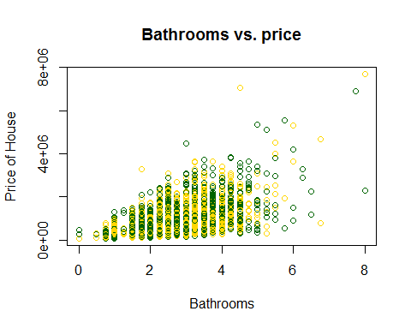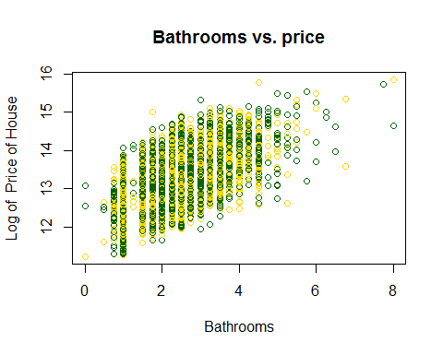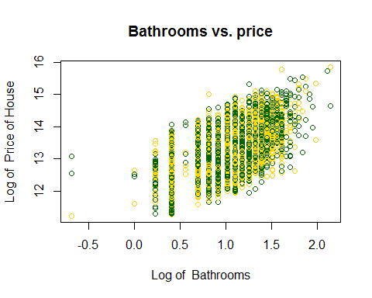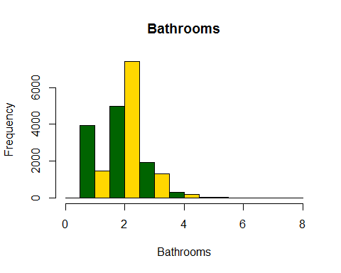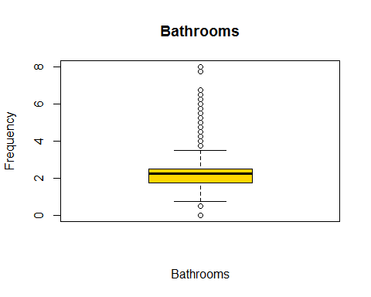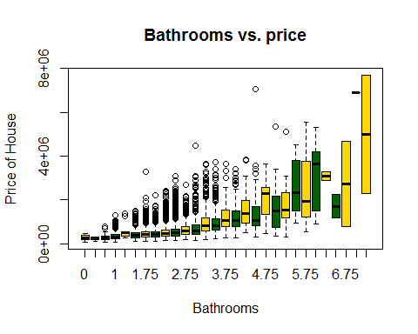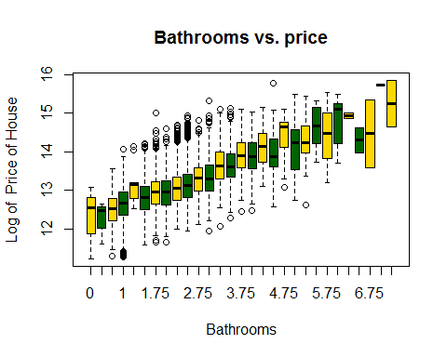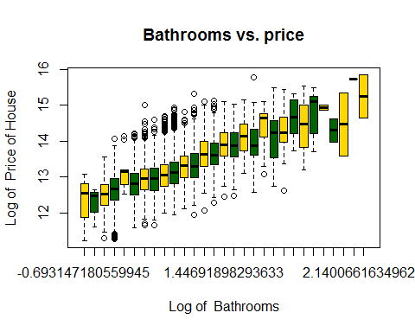

## [1] 0.5259342

cat ("Conclusion: here we can found that log of bathrooms give better performance than bathrooms with one expection in when bathroom=7.")

## Conclusion: here we can found that log of bathrooms give better performance than bathrooms with one expection in when bathroom=7.

#*******Removing the outliers  
#More than 4 bathrooms are very rare in this data.So I am removing it.  
houseData<-subset(houseData,bathrooms>=1 & bathrooms<=4)  
analysis(houseData,5,c('Bathrooms vs. price','Bathrooms', 'Price of House'), 'Y', 'Y')

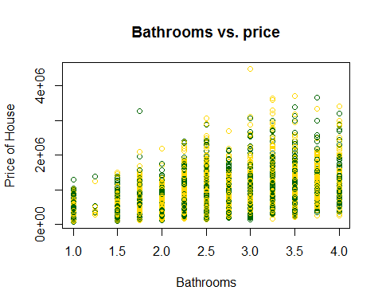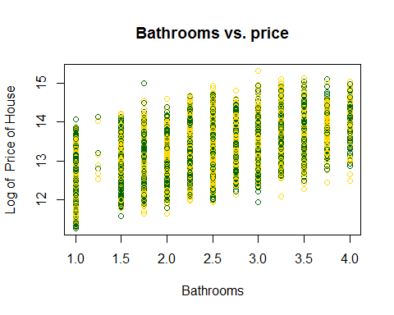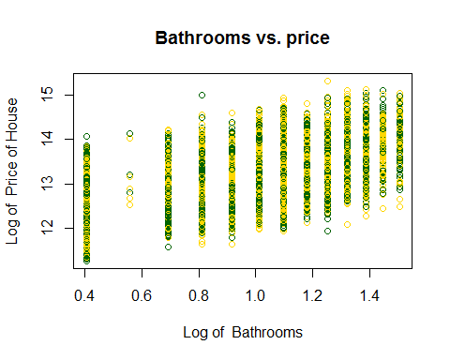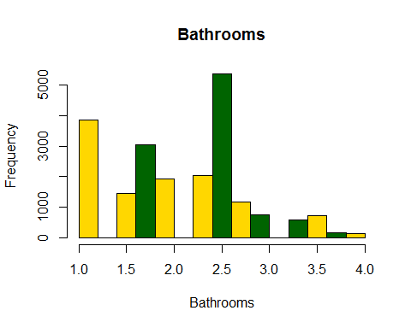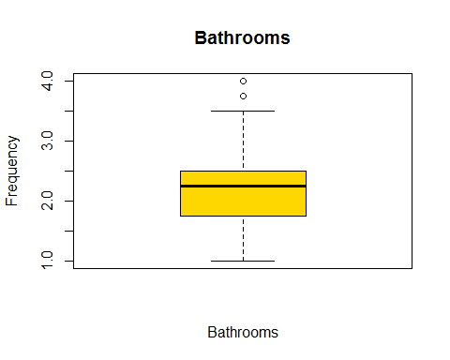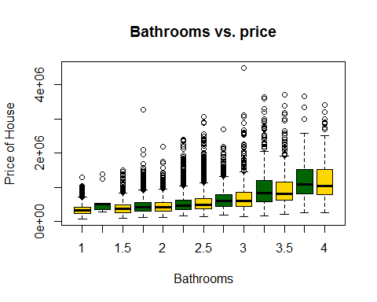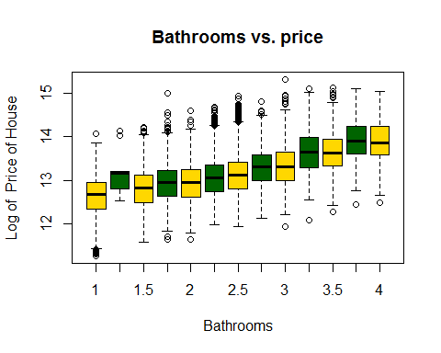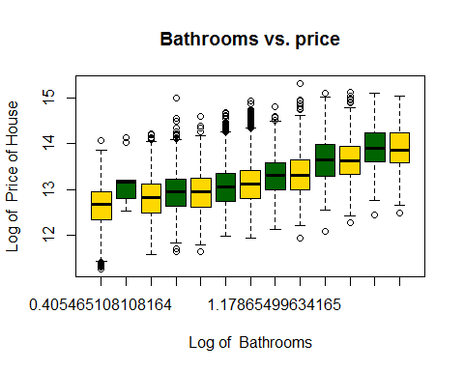

## [1] 0.475159

#bucketByColumn(houseData,5)

# SQFT Living Vs Price analysis

#bucketByColumn(houseData,6)  
analysis(houseData,6,c('Living-Sqft vs. price','Living-Sqft', 'Price of House'), 'Y', 'N')

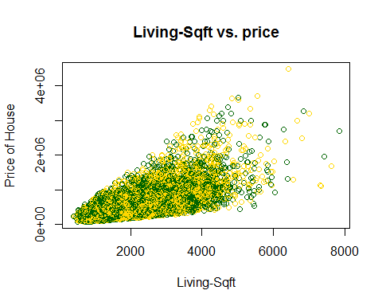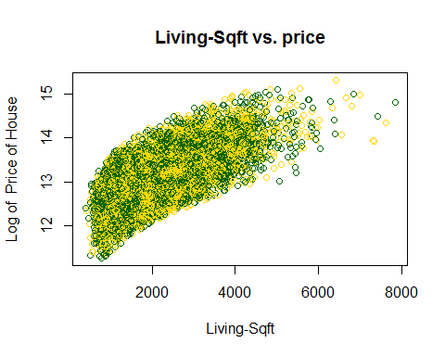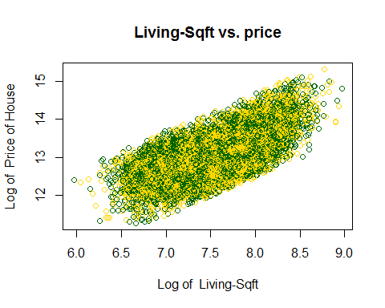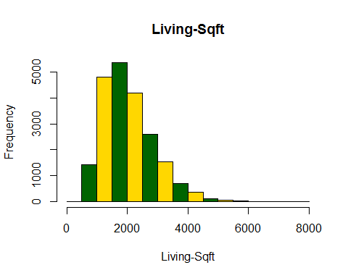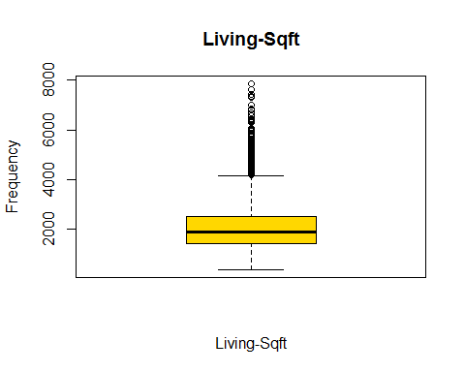

## [1] 0.6701029

cat ("Conclusion: Strong correlation, as Lining sqft increases, price increases as well.")

## Conclusion: Strong correlation, as Lining sqft increases, price increases as well.

#*******Removing the outliers  
houseData<-subset(houseData,sqft_living >1000 & sqft_living<=4000)  
analysis(houseData,6,c('Living-Sqft vs. price','Living-Sqft', 'Price of House'), 'Y', 'N')

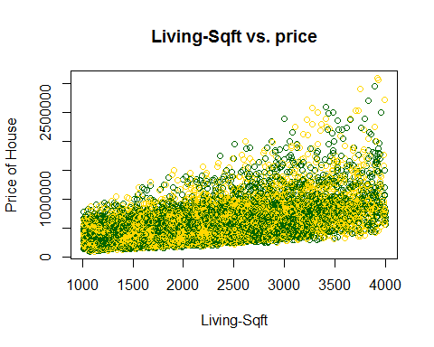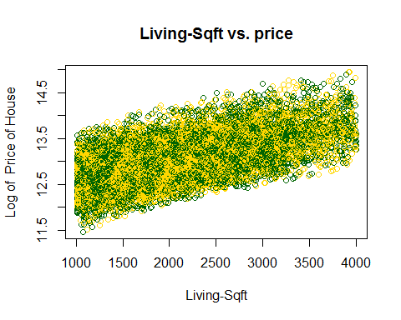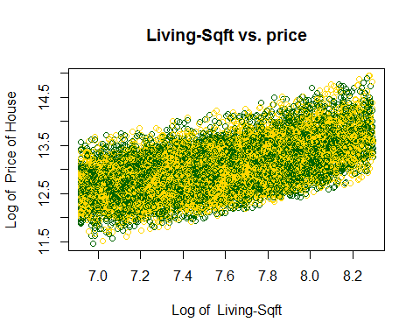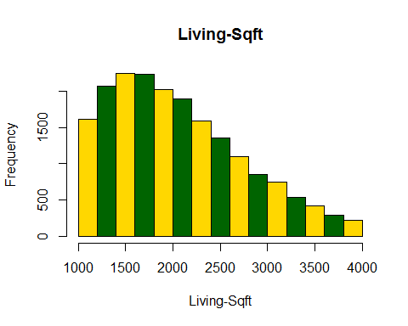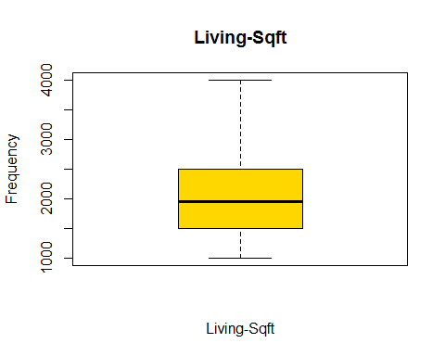

## [1] 0.5938015

#bucketByColumn(houseData,6)

## SQFT_LOT Vs Price analysis

#bucketByColumn(houseData,7)  
analysis(houseData,7,c('LotSize vs. price','LotSize', 'Price of House'), 'Y', 'N')

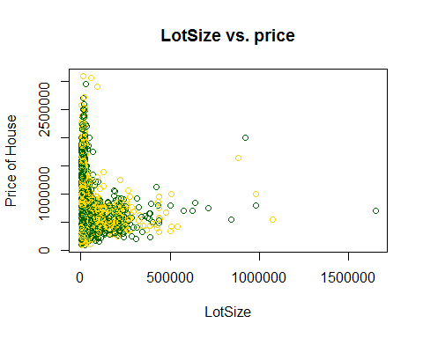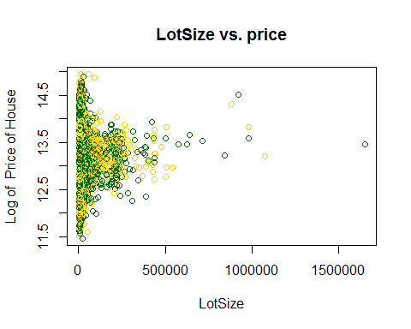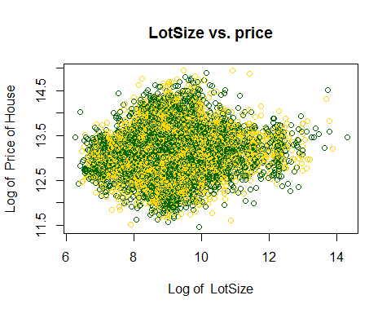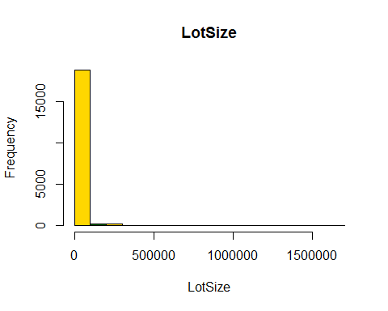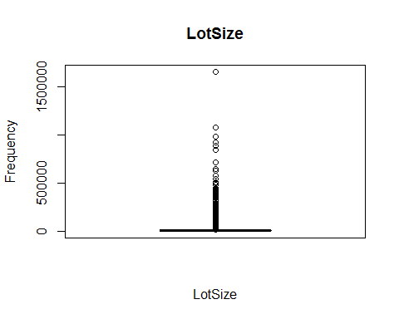

## [1] 0.06105332

#*******Removing the outliers  
houseData<-subset(houseData,sqft_lot>=0 & sqft_lot<=25000)  
analysis(houseData,7,c('LotSize vs. price','LotSize', 'Price of House'), 'Y', 'N')

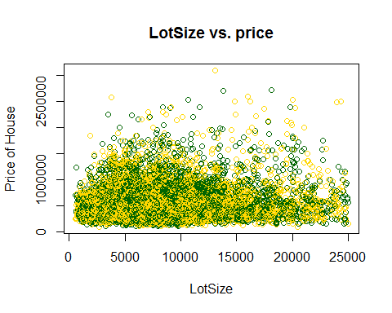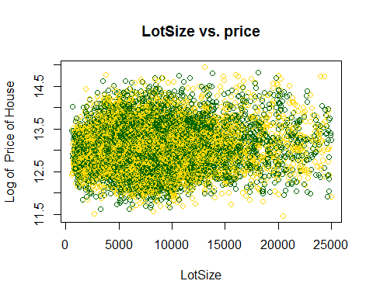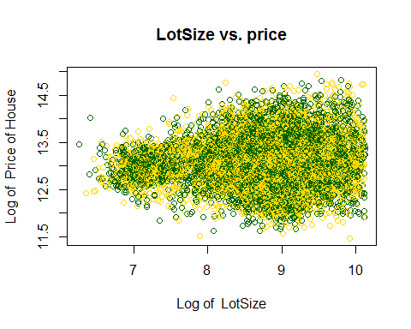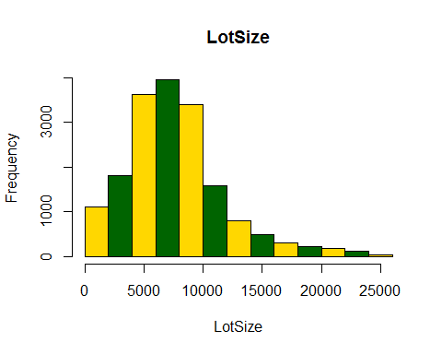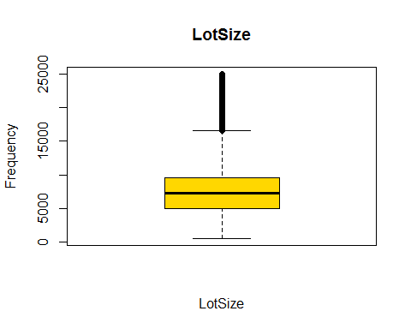

## [1] 0.06714415

#bucketByColumn(houseData,7)

## FLOOR Vs Price analysis

analysis(houseData,8,c('Floors vs. price','Floor', 'Price of House'), 'Y', 'Y')

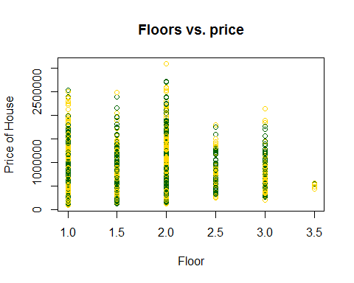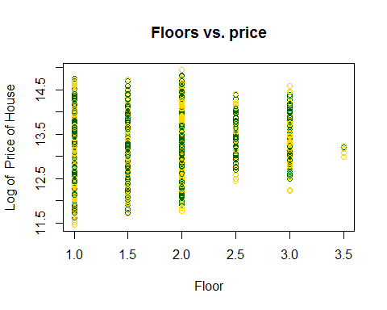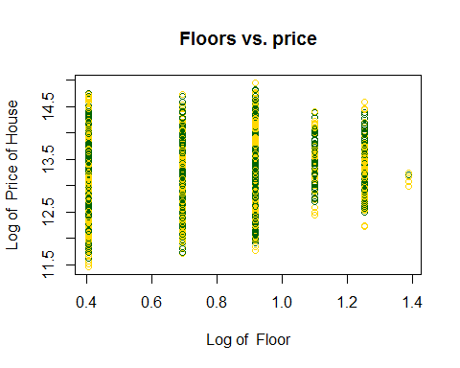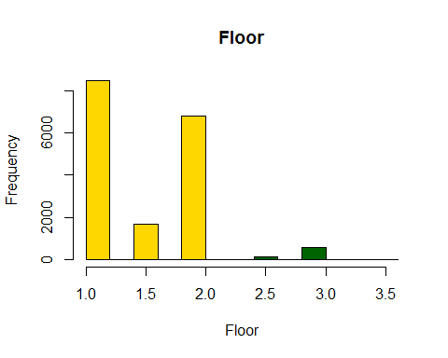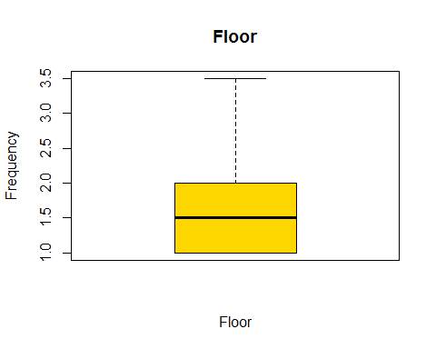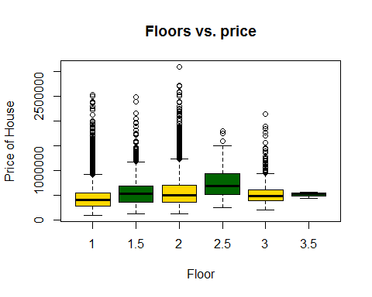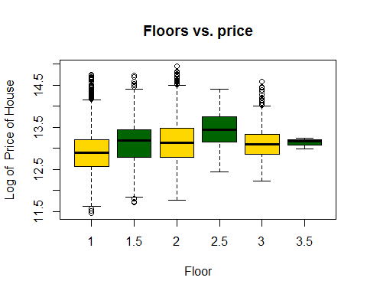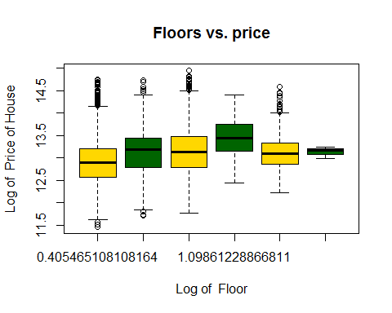

## [1] 0.2072373

##bucketByColumn(houseData,8)

## SQFT_LOT Vs Price analysis

#bucketByColumn(houseData,9)  
analysis(houseData,9,c('WaterFront vs. price','WaterFront', 'Price of House'), 'Y', 'N')

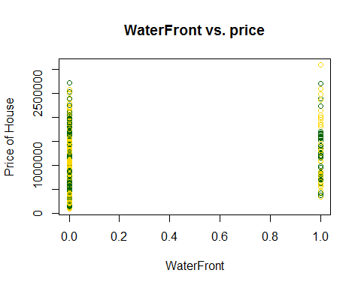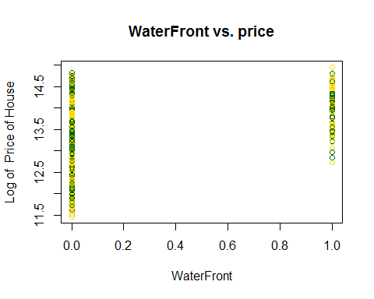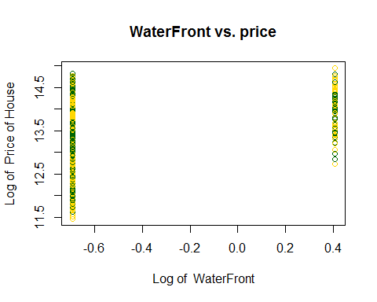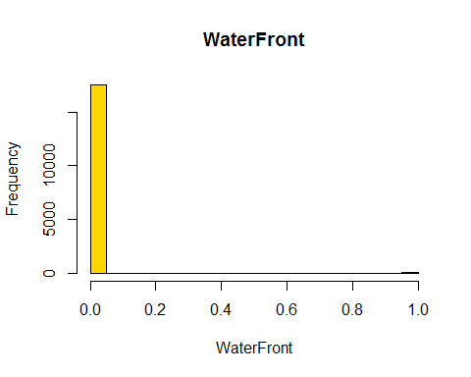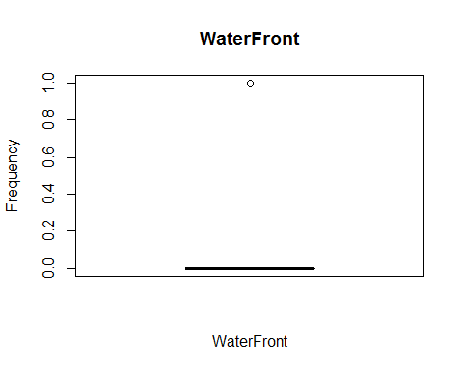

## [1] 0.209102

#*******Removing the outliers  
houseData<-subset(houseData,sqft_lot>=0 & sqft_lot<=25000)  
analysis(houseData,9,c('WaterFront vs. price','WaterFront', 'Price of House'), 'Y', 'N')



## [1] 0.209102

#bucketByColumn(houseData,9)

## View Vs Price analysis

#bucketByColumn(houseData,10)  
analysis(houseData,10,c('View vs. price','View', 'Price of House'), 'Y', 'Y')

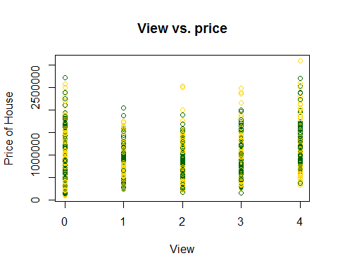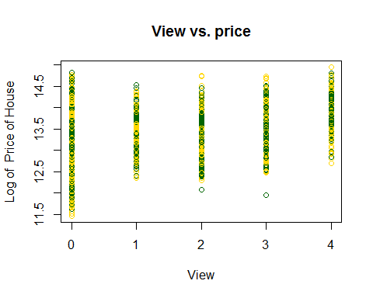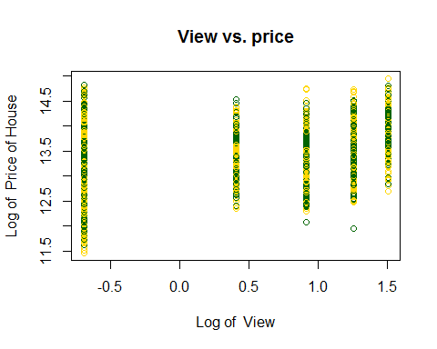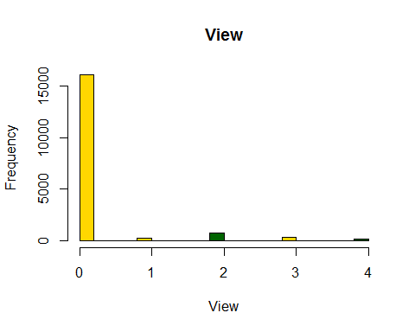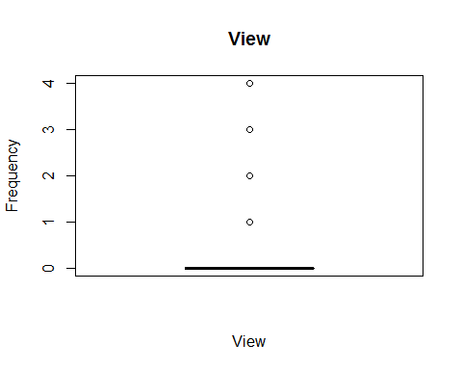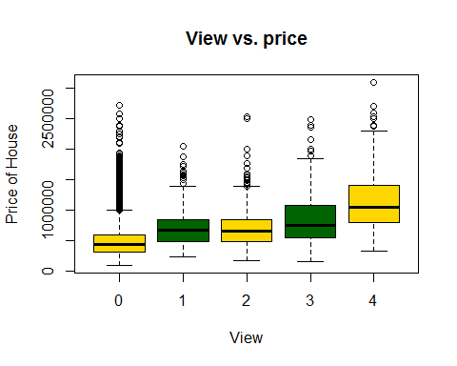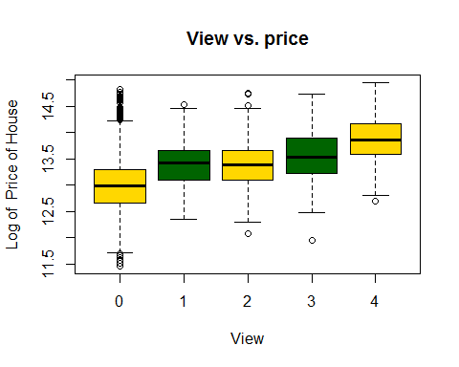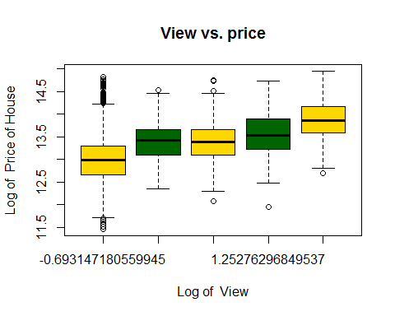

## [1] 0.3578146

cat ("Conclusion: Moderate correlation, view increases, price increases as well")

## Conclusion: Moderate correlation, view increases, price increases as well

#*******Removing the outliers  
analysis(houseData,10,c('View vs. price','View', 'Price of House'), 'Y', 'Y')



## [1] 0.3578146

#bucketByColumn(houseData,10)

## CONDITION Vs Price analysis

#bucketByColumn(houseData,11)  
analysis(houseData,11,c('Condition vs. price','condition', 'Price of House'), 'Y', 'Y')

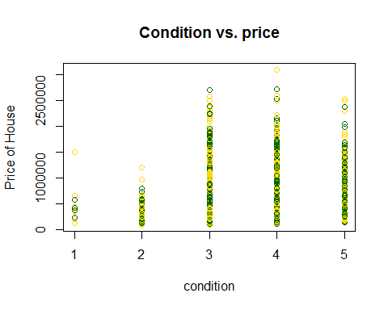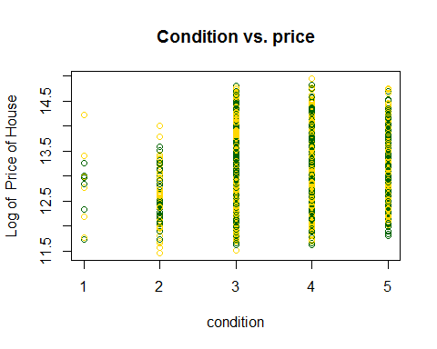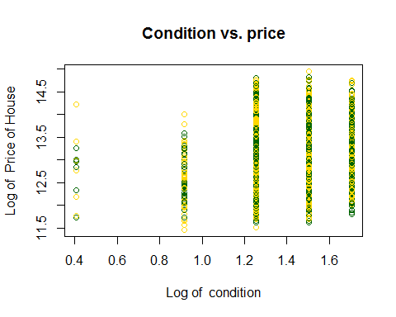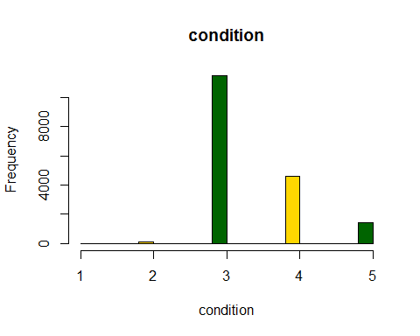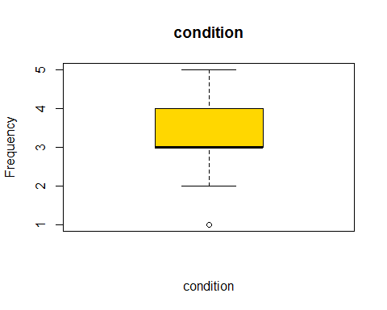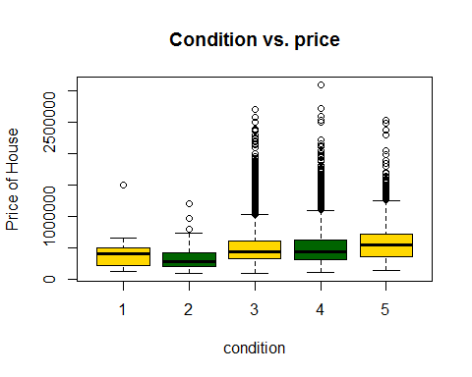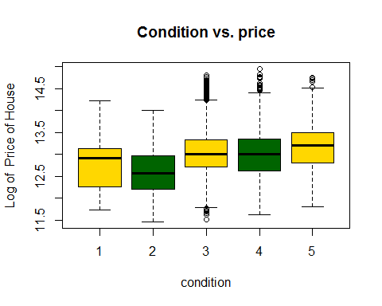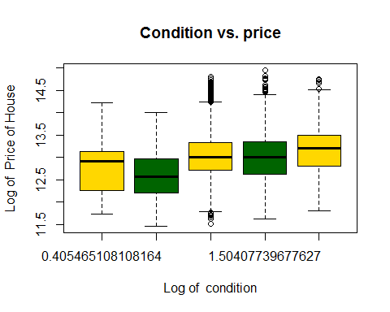

## [1] 0.07301379

#*******Removing the outliers  
houseData<-subset(houseData,condition>=3& condition<=5)  
analysis(houseData,11,c('Condition vs. price','condition', 'Price of House'), 'Y', 'Y')

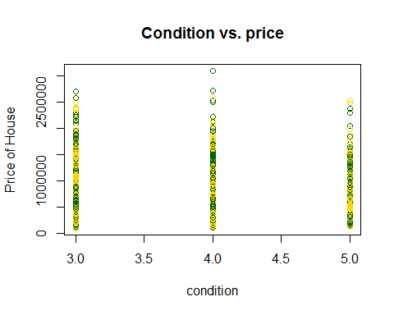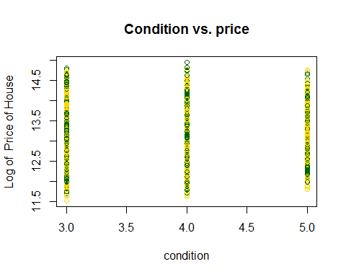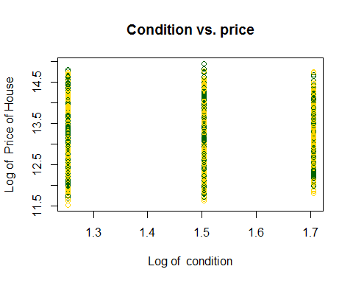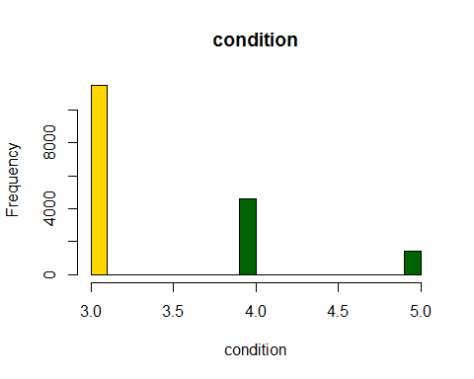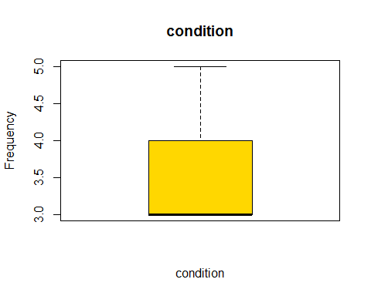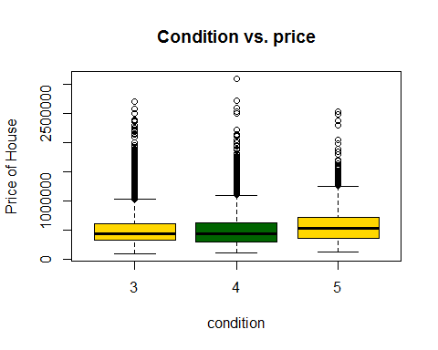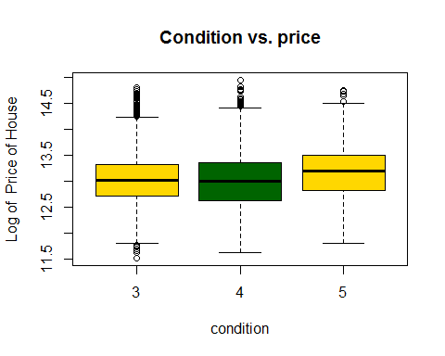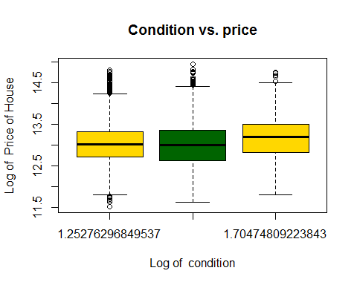

## [1] 0.06582398

#bucketByColumn(houseData,11)

## Grade Vs Price analysis

#bucketByColumn(houseData,12)  
analysis(houseData,12,c('Grade vs. price','Grade', 'Price of House'), 'Y', 'Y')

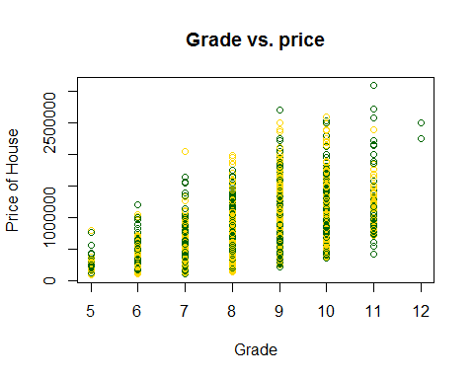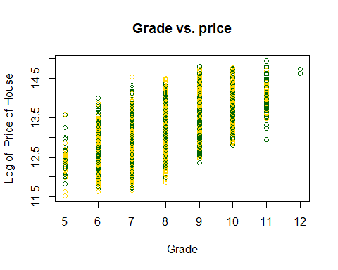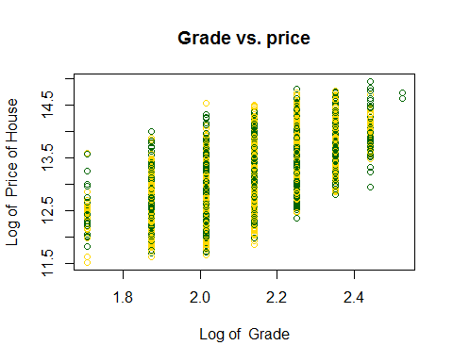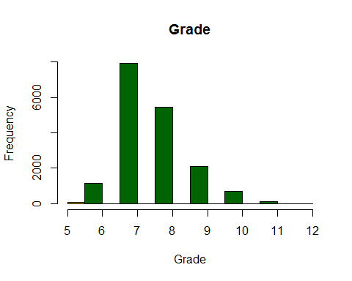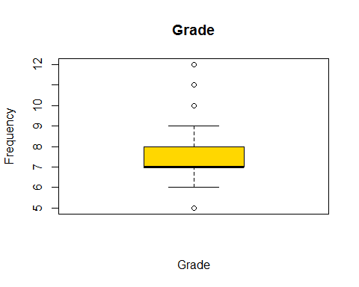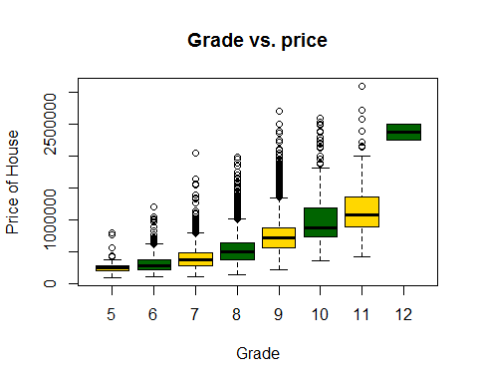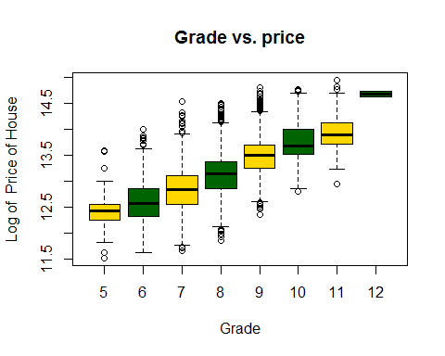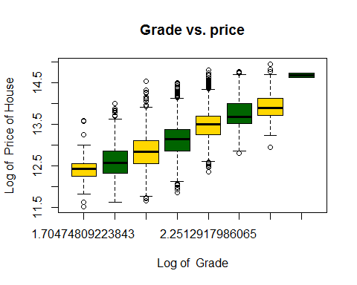

## [1] 0.6086724

cat ("Conclusion: Moderate correlation, grade increases, price increases as well")

## Conclusion: Moderate correlation, grade increases, price increases as well

#*******Removing the outliers  
#Most of the houses grades are between 6-10   
houseData<-subset(houseData,grade >= 6 & grade<=10)  
analysis(houseData,12,c('Grade vs. price','Grade', 'Price of House'), 'Y', 'Y')

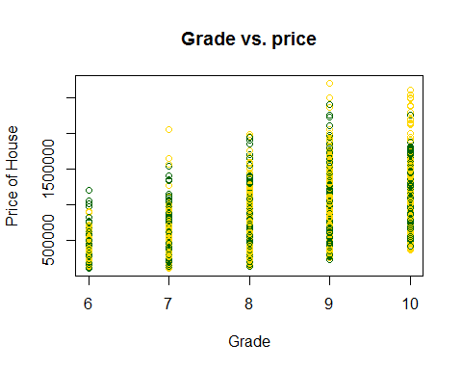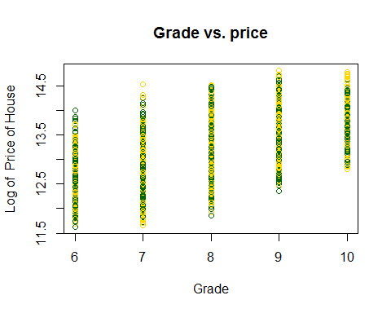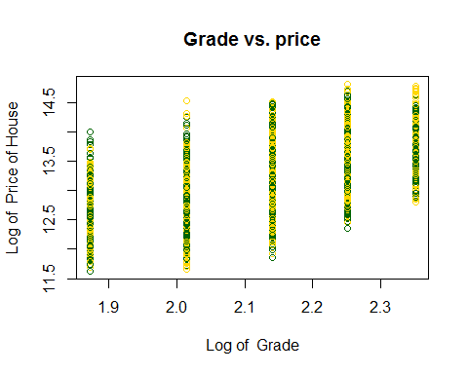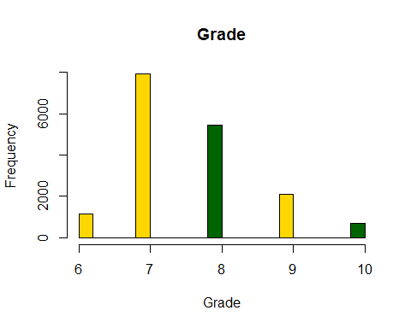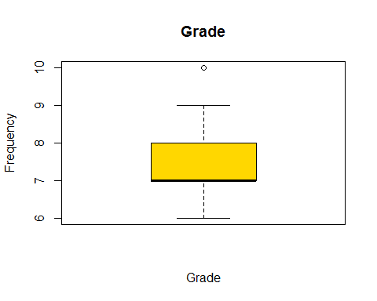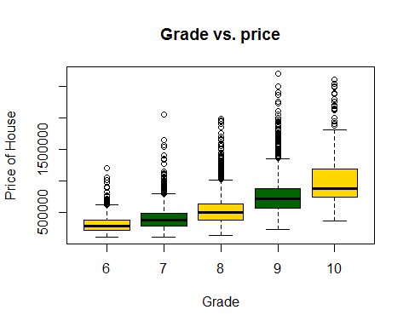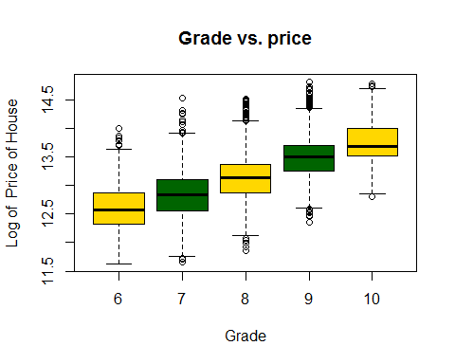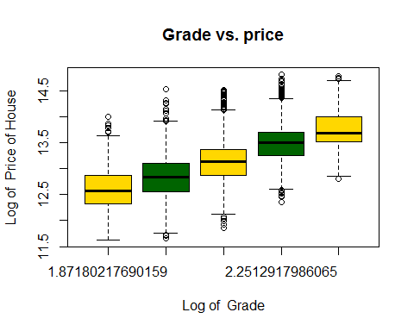

## [1] 0.5926375

#bucketByColumn(houseData,12)  
#grade is good without log

# SQFT_ABOVE Vs Price analysis

#bucketByColumn(houseData,13)  
analysis(houseData,13,c('MainHouseSize vs. price','MainHouseSize', 'Price of House'), 'Y', 'N')

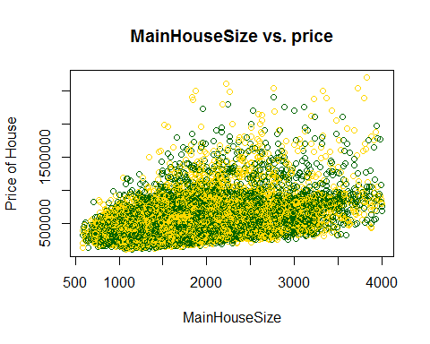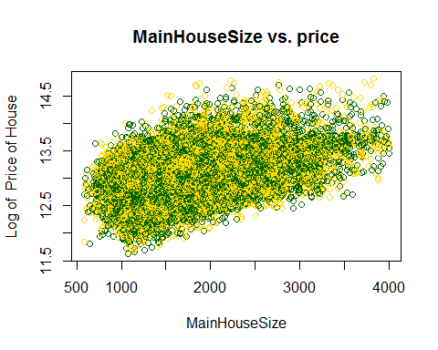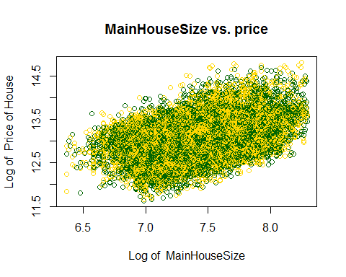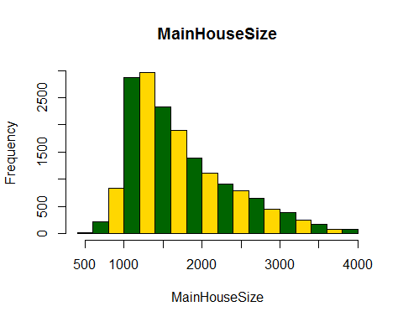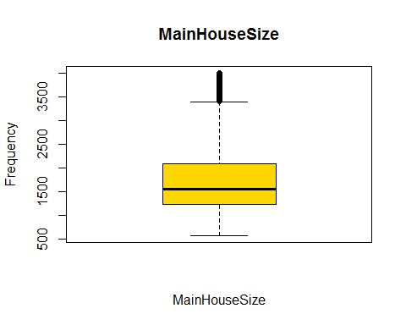

## [1] 0.4454655

#*******Removing the outliers  
houseData<-subset(houseData,sqft_above >=500 & sqft_above<=3500)  
analysis(houseData,13,c('MainHouseSize vs. price','MainHouseSize', 'Price of House'), 'Y', 'N')

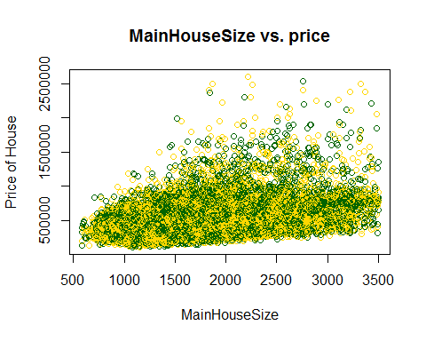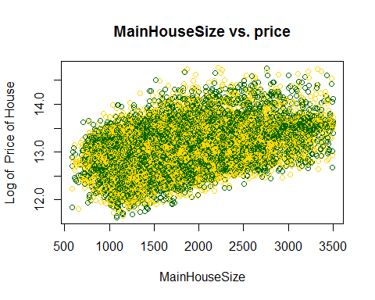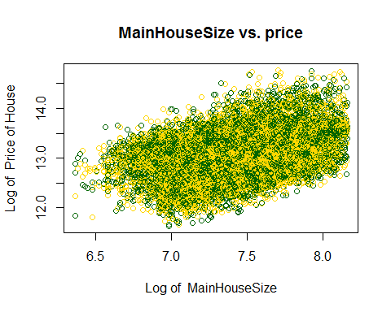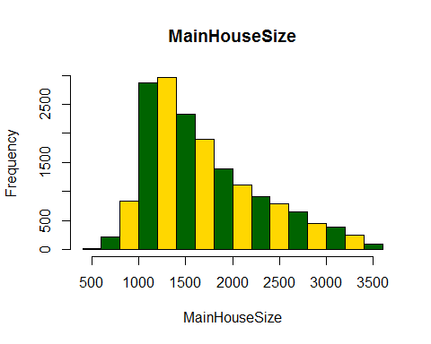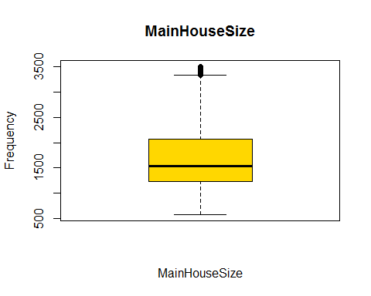

## [1] 0.4176138

#bucketByColumn(houseData,13)

## SQFT_BASEMENT Vs Price analysis

#bucketByColumn(houseData,14)  
analysis(houseData,14,c('BasementSize vs. price','BasementSize', 'Price of House'), 'Y', 'N')

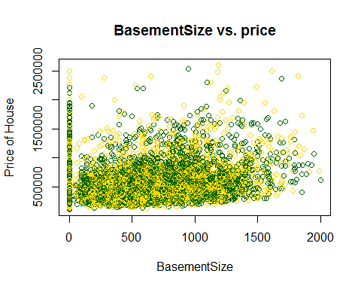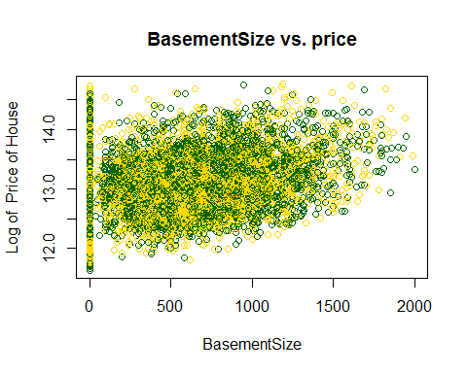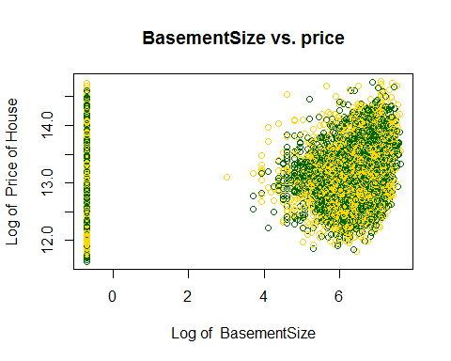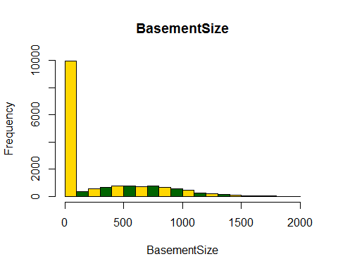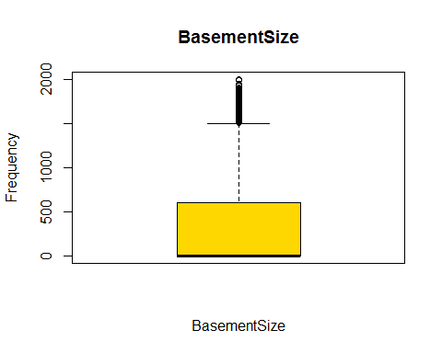

## [1] 0.2686956

#*******Removing the outliers  
houseData<-subset(houseData,sqft_basement >=0 & sqft_basement<=1500)  
analysis(houseData,14,c('BasementSize vs. price','BasementSize', 'Price of House'), 'Y', 'N')

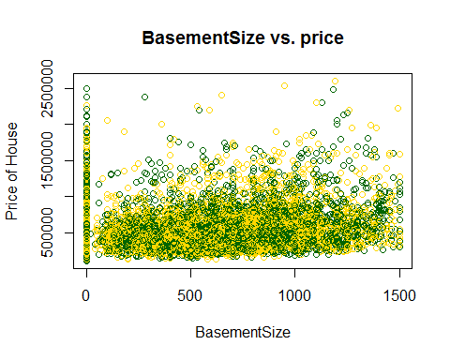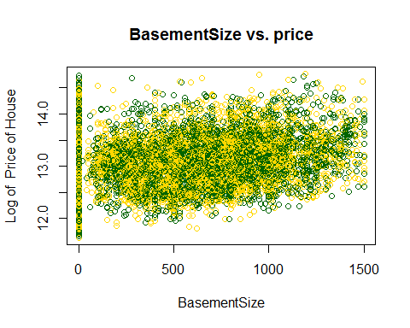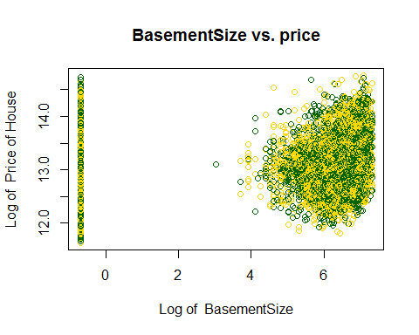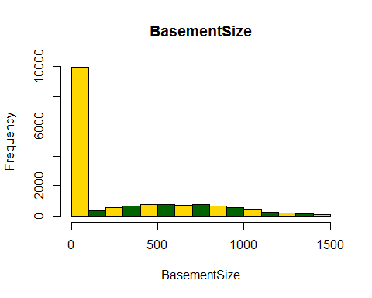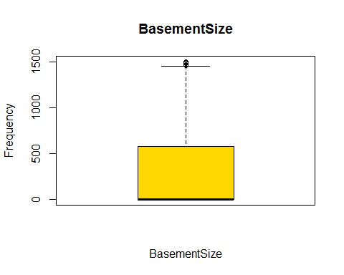

## [1] 0.2404668

#bucketByColumn(houseData,14)

# YR_BUILT Vs Price analysis

#bucketByColumn(houseData,15)  
analysis(houseData,15,c('YearBuilt vs. price','YearBuilt', 'Price of House'), 'Y', 'N')

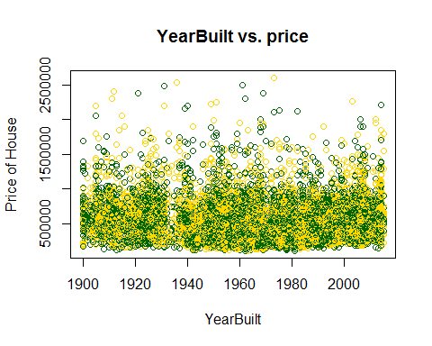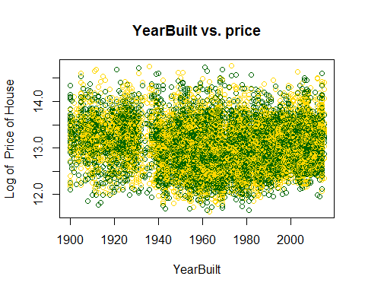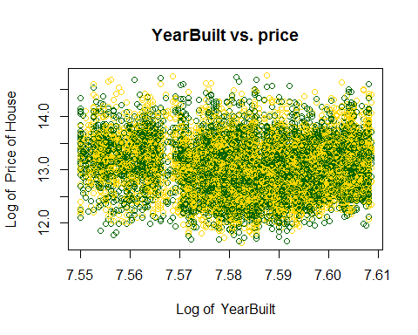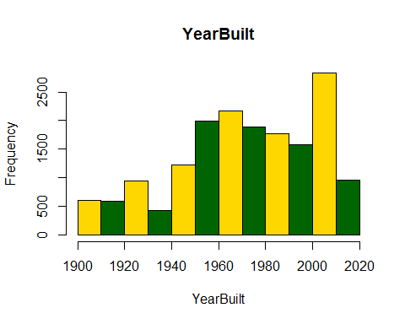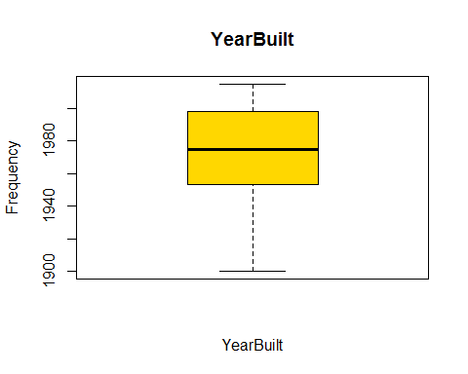

## [1] -0.09523834

#*******Removing the outliers  
#In our data some records are too old..I just removed that data from my model.  
#Because It doesn't make any sense to keep more than 100 years house in our model  
#houseData<-subset(houseData,yr_built>=1950& yr_built<=2015)  
#analysis(houseData,15,c('YearBuilt vs. price','YearBuilt', 'Price of House'), 'Y', 'N')  
#bucketByColumn(houseData,15)

# YR_RENOVATED Vs Price analysis

#bucketByColumn(houseData,16)  
analysis(houseData,16,c('YearRenovated vs. price','YearRenovated', 'Price of House'), 'N', 'N')

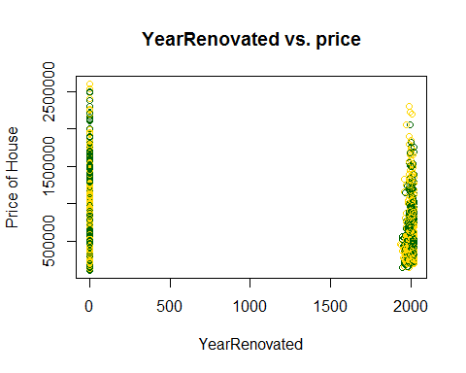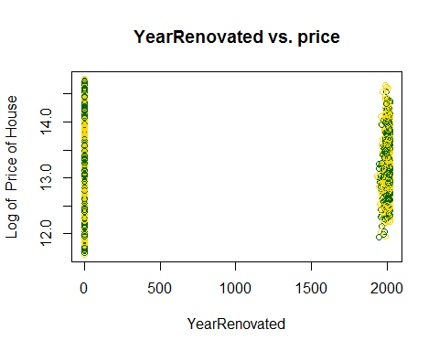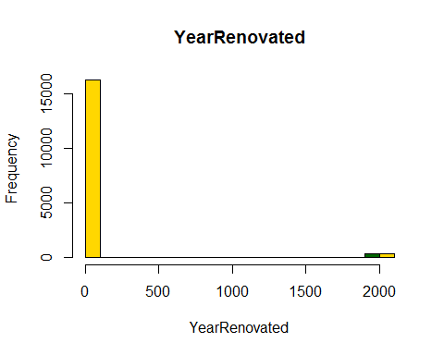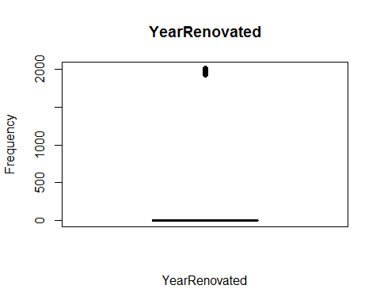

## [1] 0.1497455

#*******Removing the outliers  
#In our data some records are too old..I just removed that data from my model.  
#houseData<-subset(houseData,yr_renovated>=1950& yr_renovated<=2015)  
#analysis(houseData,16,c('YearRenovated vs. price','YearRenovated', 'Price of House'), 'N')  
#bucketByColumn(houseData,16)

# ZIPCODE Vs Price analysis

analysis(houseData,17,c('ZipCode vs. price','ZipCode', 'Price of House'), 'Y', 'N')

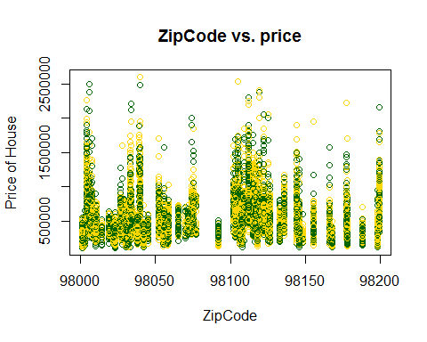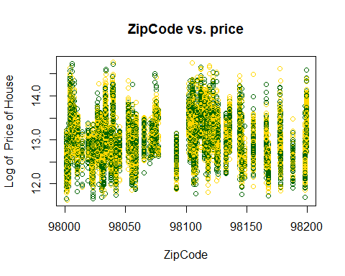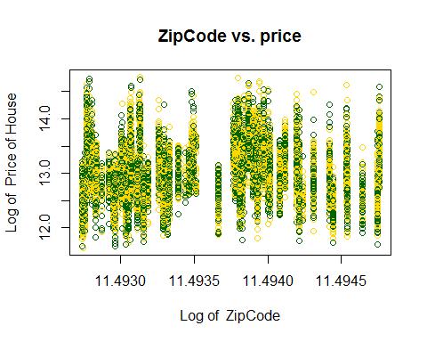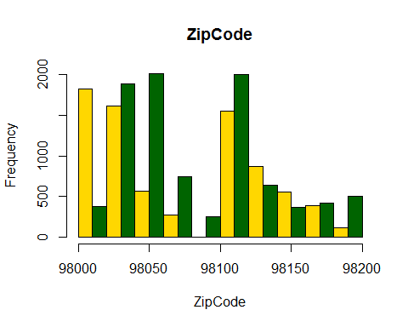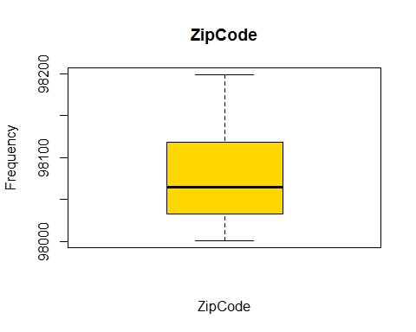

## [1] 0.04577519

## LAT Vs Price analysis

analysis(houseData,18,c('Latitude vs. price','latitude', 'Price of House'), 'N', 'N')

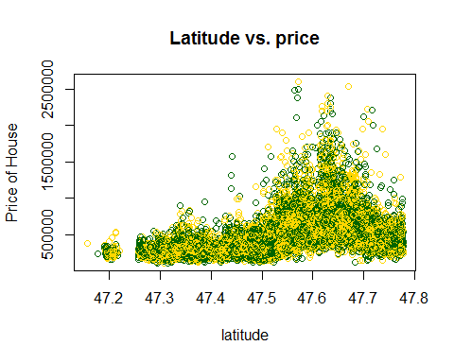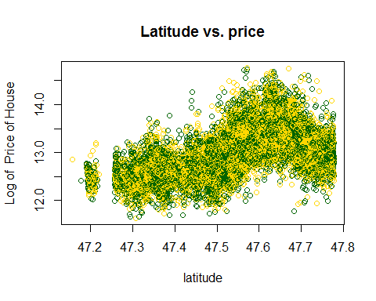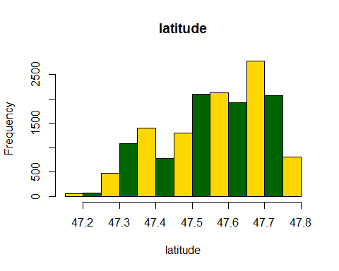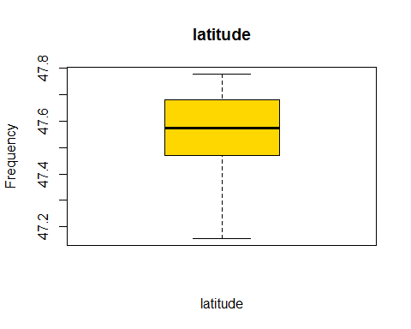

## [1] 0.4107748

cat ("Conclusion: This is more like a normal dist relationship, but this can be modeled easily. So we should include LAT for price predication")

## Conclusion: This is more like a normal dist relationship, but this can be modeled easily. So we should include LAT for price predication

#*******Removing the outliers  
houseData<-subset(houseData,lat>=47.3)  
analysis(houseData,18,c('Latitude vs. price','latitude', 'Price of House'), 'N', 'N')

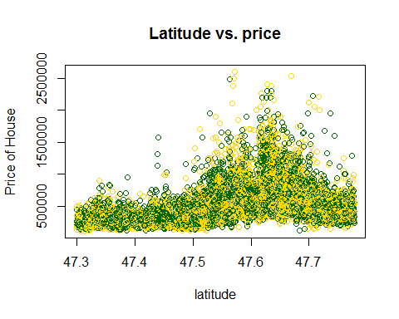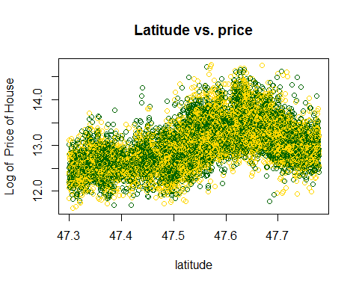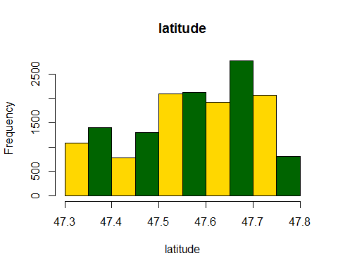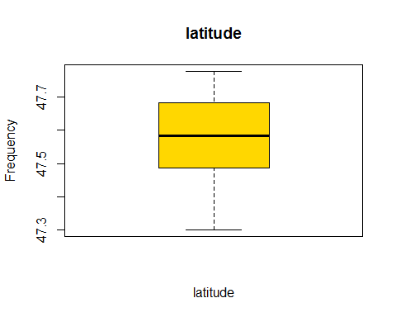

## [1] 0.3788783

## LONG Vs Price analysis

analysis(houseData,19,c('Longitude vs. price','Longitude', 'Price of House'), 'N', 'N')

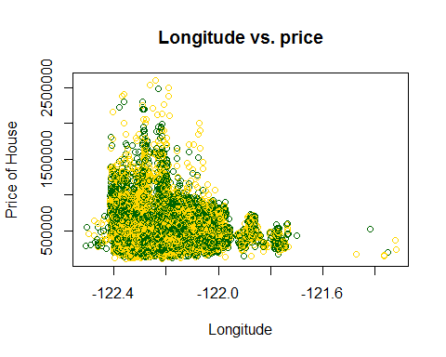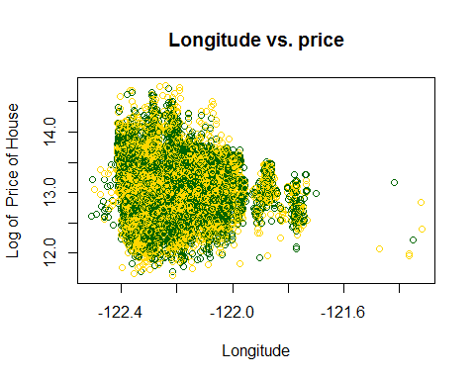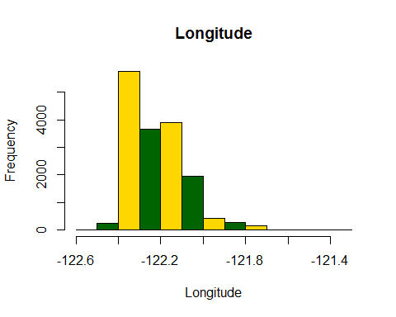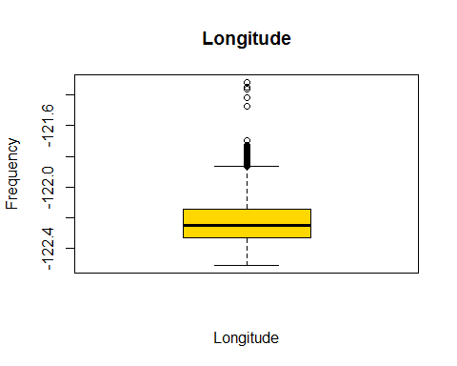

## [1] -0.05515808

#*******Removing the outliers  
#houseData<-subset(houseData,long>=-122.4 & long < -121.8)  
#analysis(houseData,19,c('Longitude vs. price','Longitude', 'Price of House'), 'N', 'N')

## SQFT_LIVING15 Vs Price analysis

#bucketByColumn(houseData,20)  
analysis(houseData,20,c('sqft_living15 vs. price','sqft_living15', 'Price of House'), 'Y', 'N')

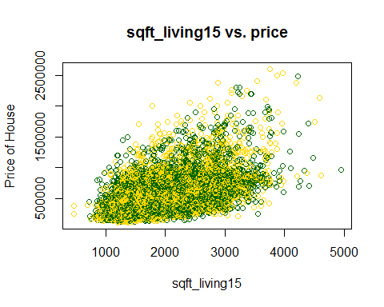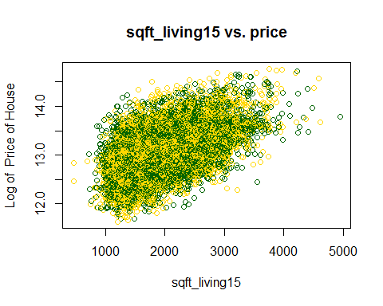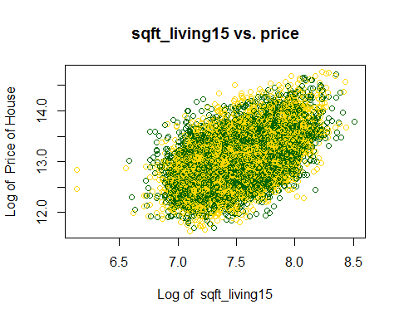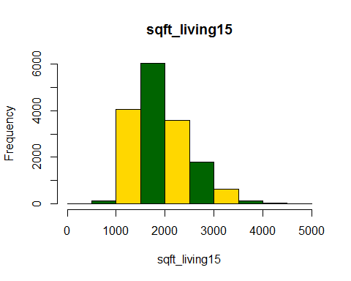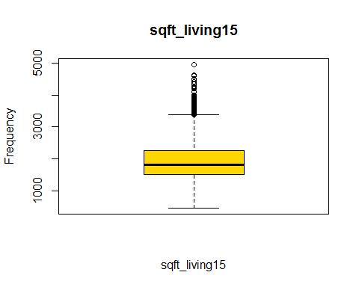

## [1] 0.5059352

## SQFT_LOT15 Vs Price analysis

#bucketByColumn(houseData,21)  
analysis(houseData,21,c('sqft_lot15 vs. price','sqft_lot15', 'Price of House'), 'Y', 'N')

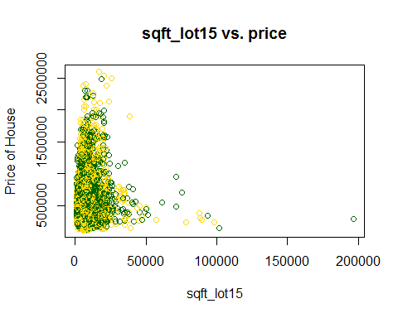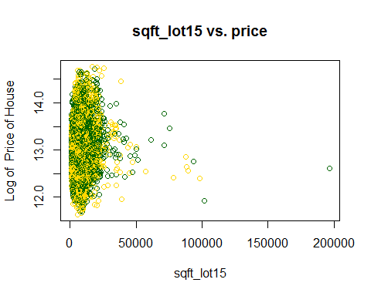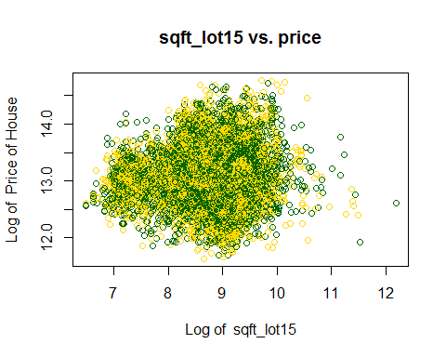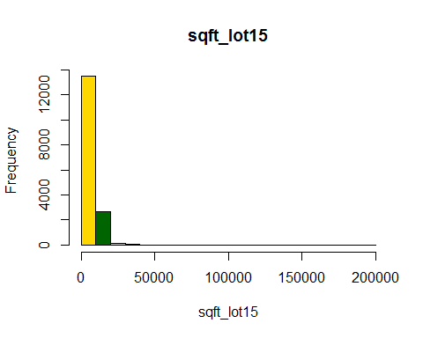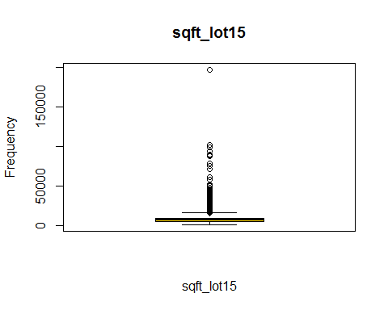

## [1] 0.03039019

#*******Removing the outliers  
houseData<-subset(houseData,sqft_lot15>=0 & sqft_lot<=20000)  
analysis(houseData,21,c('sqft_lot15 vs. price','sqft_lot15', 'Price of House'), 'Y', 'N')

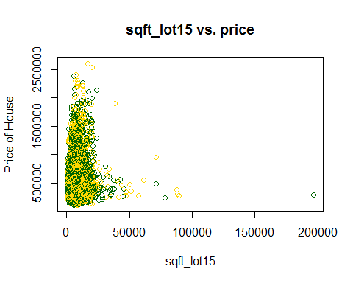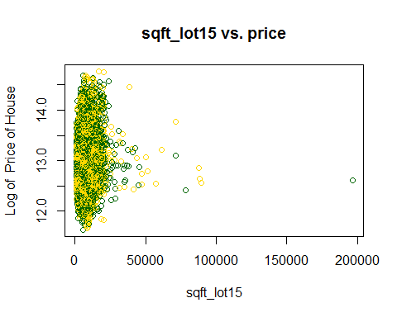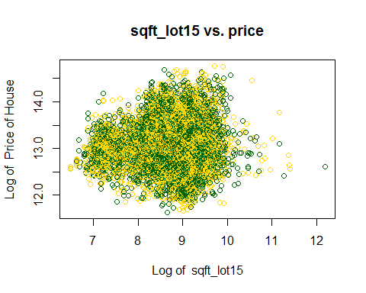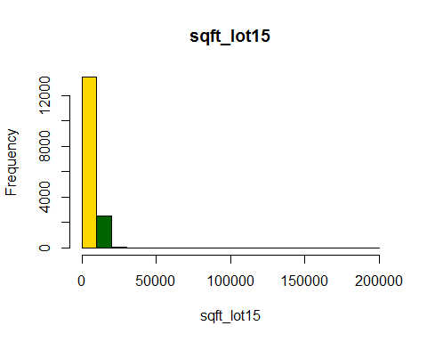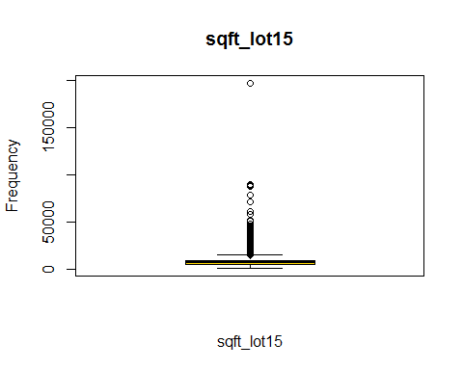

## [1] 0.01443069

#bucketByColumn(houseData,21)

## Correlation among all the variables

#houseData <- read.csv("file:///G:/Ryerson-BigData/capstone-R/CKME-136/data/kc_house_data.csv")  
#Remove the columns which does not hold any significance in predicing house price  
houseData$date <- NULL  
#houseData$id <- NULL  
#houseData$zipcode <- NULL  
cor(houseData)

## id price bedrooms bathrooms  
## id 1.0000000000 0.01143388 0.0002361529 0.03163163  
## price 0.0114338820 1.00000000 0.2091756651 0.36194911  
## bedrooms 0.0002361529 0.20917567 1.0000000000 0.39209060  
## bathrooms 0.0316316316 0.36194911 0.3920905987 1.00000000  
## sqft_living 0.0367653294 0.56442385 0.5410387776 0.63702522  
## sqft_lot -0.0455318043 0.01876577 0.1755961728 -0.06871884  
## floors 0.0212661816 0.20662923 0.0705733203 0.47816328  
## waterfront 0.0010194371 0.17456979 -0.0230699708 0.01753134  
## view 0.0240787568 0.34162165 0.0286568565 0.10107146  
## condition -0.0333233342 0.08514221 0.0328961173 -0.15089396  
## grade 0.0413583802 0.57797736 0.2098180353 0.54371647  
## sqft_above 0.0432018940 0.43136334 0.4022870729 0.55180951  
## sqft_basement -0.0081506170 0.23306924 0.2407207865 0.16269885  
## yr_built 0.0361973063 -0.08917519 0.0557194457 0.49211680  
## yr_renovated -0.0108237646 0.15279679 0.0158536971 0.04969098  
## zipcode -0.0358085658 0.01755183 -0.1129306298 -0.17401206  
## lat -0.0050349775 0.38499386 -0.0482258043 -0.02030436  
## long 0.0888037626 -0.05591129 0.0974013544 0.20522730  
## sqft_living15 0.0441244099 0.49988474 0.3177246672 0.45383622  
## sqft_lot15 -0.0499662192 0.01443069 0.1165777081 -0.05988074  
## sqft_living sqft_lot floors waterfront  
## id 0.036765329 -0.04553180 0.021266182 0.001019437  
## price 0.564423846 0.01876577 0.206629229 0.174569789  
## bedrooms 0.541038778 0.17559617 0.070573320 -0.023069971  
## bathrooms 0.637025219 -0.06871884 0.478163277 0.017531339  
## sqft_living 1.000000000 0.19820432 0.270528403 0.041698559  
## sqft_lot 0.198204325 1.00000000 -0.384503667 0.086919843  
## floors 0.270528403 -0.38450367 1.000000000 0.018659573  
## waterfront 0.041698559 0.08691984 0.018659573 1.000000000  
## view 0.200062577 0.08958453 -0.001229866 0.348892523  
## condition -0.053750363 0.14328773 -0.299656424 0.013488466  
## grade 0.629058762 0.03289696 0.428657101 0.039285103  
## sqft_above 0.797370328 0.14354720 0.508622920 0.022631059  
## sqft_basement 0.361775709 0.09409729 -0.354615993 0.031488303  
## yr_built 0.229793174 -0.08248549 0.476688809 -0.026690358  
## yr_renovated 0.057608432 0.00116957 0.006124387 0.081780181  
## zipcode -0.150371421 -0.24121431 -0.037895715 0.035364321  
## lat 0.008105012 -0.11580698 0.020066957 -0.015266662  
## long 0.194253942 0.23066503 0.105899291 -0.016162230  
## sqft_living15 0.697868872 0.26243643 0.201674073 0.060720453  
## sqft_lot15 0.142721794 0.73952278 -0.304480288 0.118857410  
## view condition grade sqft_above  
## id 0.024078757 -0.03332333 0.04135838 0.04320189  
## price 0.341621655 0.08514221 0.57797736 0.43136334  
## bedrooms 0.028656857 0.03289612 0.20981804 0.40228707  
## bathrooms 0.101071460 -0.15089396 0.54371647 0.55180951  
## sqft_living 0.200062577 -0.05375036 0.62905876 0.79737033  
## sqft_lot 0.089584526 0.14328773 0.03289696 0.14354720  
## floors -0.001229866 -0.29965642 0.42865710 0.50862292  
## waterfront 0.348892523 0.01348847 0.03928510 0.02263106  
## view 1.000000000 0.04327161 0.18019550 0.07332838  
## condition 0.043271615 1.00000000 -0.17938320 -0.19041926  
## grade 0.180195500 -0.17938320 1.00000000 0.63891059  
## sqft_above 0.073328382 -0.19041926 0.63891059 1.00000000  
## sqft_basement 0.205531760 0.20850396 0.01545116 -0.27414378  
## yr_built -0.100581799 -0.41152029 0.40106956 0.39365870  
## yr_renovated 0.105176180 -0.06957926 0.01684730 0.01397774  
## zipcode 0.131494314 0.01435710 -0.15528743 -0.25245663  
## lat 0.018501159 0.01591340 0.07914349 -0.06721526  
## long -0.117206963 -0.12818534 0.15800734 0.34991253  
## sqft_living15 0.236522082 -0.09507790 0.61776203 0.66135046  
## sqft_lot15 0.094655883 0.12145254 0.03362976 0.10627697  
## sqft_basement yr_built yr_renovated zipcode  
## id -0.008150617 0.03619731 -0.010823765 -0.03580857  
## price 0.233069237 -0.08917519 0.152796792 0.01755183  
## bedrooms 0.240720787 0.05571945 0.015853697 -0.11293063  
## bathrooms 0.162698848 0.49211680 0.049690975 -0.17401206  
## sqft_living 0.361775709 0.22979317 0.057608432 -0.15037142  
## sqft_lot 0.094097293 -0.08248549 0.001169570 -0.24121431  
## floors -0.354615993 0.47668881 0.006124387 -0.03789572  
## waterfront 0.031488303 -0.02669036 0.081780181 0.03536432  
## view 0.205531760 -0.10058180 0.105176180 0.13149431  
## condition 0.208503962 -0.41152029 -0.069579262 0.01435710  
## grade 0.015451165 0.40106956 0.016847300 -0.15528743  
## sqft_above -0.274143782 0.39365870 0.013977744 -0.25245663  
## sqft_basement 1.000000000 -0.24193394 0.070208939 0.15036865  
## yr_built -0.241933942 1.00000000 -0.240636085 -0.33674162  
## yr_renovated 0.070208939 -0.24063609 1.000000000 0.09140698  
## zipcode 0.150368655 -0.33674162 0.091406981 1.00000000  
## lat 0.116749091 -0.17857092 0.044945620 0.23426120  
## long -0.230988693 0.42995516 -0.096319359 -0.59345812  
## sqft_living15 0.090438280 0.26659778 -0.019204514 -0.27296139  
## sqft_lot15 0.063258054 -0.04944481 0.010334036 -0.19762198  
## lat long sqft_living15 sqft_lot15  
## id -0.005034977 0.08880376 0.04412441 -0.04996622  
## price 0.384993861 -0.05591129 0.49988474 0.01443069  
## bedrooms -0.048225804 0.09740135 0.31772467 0.11657771  
## bathrooms -0.020304356 0.20522730 0.45383622 -0.05988074  
## sqft_living 0.008105012 0.19425394 0.69786887 0.14272179  
## sqft_lot -0.115806977 0.23066503 0.26243643 0.73952278  
## floors 0.020066957 0.10589929 0.20167407 -0.30448029  
## waterfront -0.015266662 -0.01616223 0.06072045 0.11885741  
## view 0.018501159 -0.11720696 0.23652208 0.09465588  
## condition 0.015913405 -0.12818534 -0.09507790 0.12145254  
## grade 0.079143489 0.15800734 0.61776203 0.03362976  
## sqft_above -0.067215262 0.34991253 0.66135046 0.10627697  
## sqft_basement 0.116749091 -0.23098869 0.09043828 0.06325805  
## yr_built -0.178570922 0.42995516 0.26659778 -0.04944481  
## yr_renovated 0.044945620 -0.09631936 -0.01920451 0.01033404  
## zipcode 0.234261199 -0.59345812 -0.27296139 -0.19762198  
## lat 1.000000000 -0.16689129 -0.01114907 -0.10021621  
## long -0.166891288 1.00000000 0.32118284 0.19377056  
## sqft_living15 -0.011149068 0.32118284 1.00000000 0.22930004  
## sqft_lot15 -0.100216215 0.19377056 0.22930004 1.00000000

cat ("\nConclusion: sqft_living , sqft_above, grade, sqft_living15, bathrooms have moderate to strong correlation with Price")

##   
## Conclusion: sqft_living , sqft_above, grade, sqft_living15, bathrooms have moderate to strong correlation with Price

cat ("\nConclusion: bathrooms has moderate to strong correlation sqft_living, floors, sqft_above, grade, sqft_living15, bedrooms")

##   
## Conclusion: bathrooms has moderate to strong correlation sqft_living, floors, sqft_above, grade, sqft_living15, bedrooms

cat ("\nConclusion: sqft_living has moderate to strong correlation sqft_above, grade, sqft_living15, bedrooms and all the above variables studied.")

##   
## Conclusion: sqft_living has moderate to strong correlation sqft_above, grade, sqft_living15, bedrooms and all the above variables studied.

cat ("\nConclusion: grade has moderate to strong correlation sqft_above, sqft_living15 and all the above variables studied.")

##   
## Conclusion: grade has moderate to strong correlation sqft_above, sqft_living15 and all the above variables studied.

cat ("\nConclusion: sqft_above has moderate to strong correlation sqft_living15 and all the above variables studied.")

##   
## Conclusion: sqft_above has moderate to strong correlation sqft_living15 and all the above variables studied.

cat ("\nConclusion: sqft_basement has moderate correlation with sqft_living only.")

##   
## Conclusion: sqft_basement has moderate correlation with sqft_living only.

cat ("\nConclusion: yr_built has moderate correlation with bathrooms, floors, grade, sqft_above only.")

##   
## Conclusion: yr_built has moderate correlation with bathrooms, floors, grade, sqft_above only.

cat ("\nConclusion: sqft_lot15 has strong correlation with sqft_lot only.")

##   
## Conclusion: sqft_lot15 has strong correlation with sqft_lot only.

cat ("\nConclusion: waterfront, view, condition, zipcode, latitude, longitude, yr_renovated has very weak with other attributes as well as with price.")

##   
## Conclusion: waterfront, view, condition, zipcode, latitude, longitude, yr_renovated has very weak with other attributes as well as with price.

## Start with price & sqft_living for Relationship

analysis(houseData,6,c('Living-Sqft vs. price','Living-Sqft', 'Price of House'), 'Y', 'N')

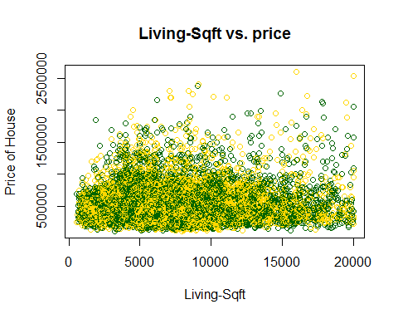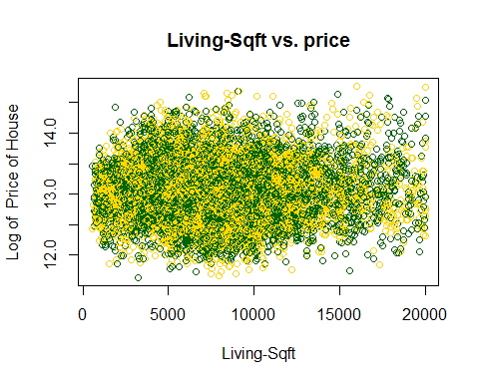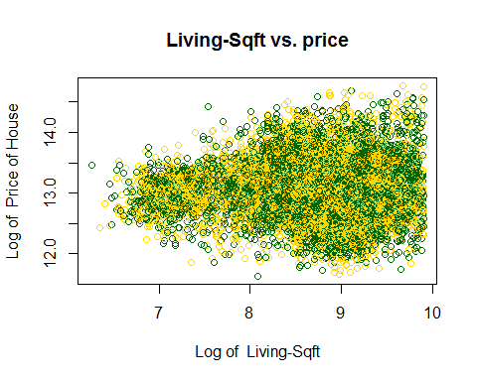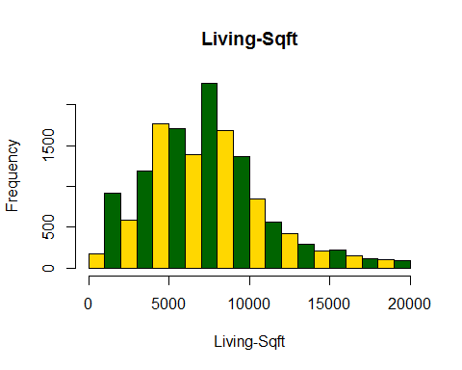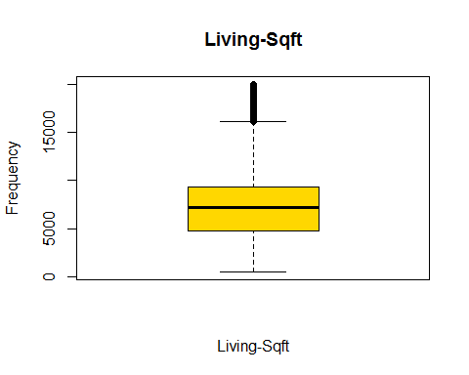

## [1] 0.01876577

## Since above scatterplot is too crowded,   
## I will plot aggregated vectors to verify the relationship between 2 variables.   
vec_price_sqftliving <-aggregate(price~sqft_living, FUN=mean, data=houseData)  
plot(vec_price_sqftliving, col=(c("gold","darkgreen")))

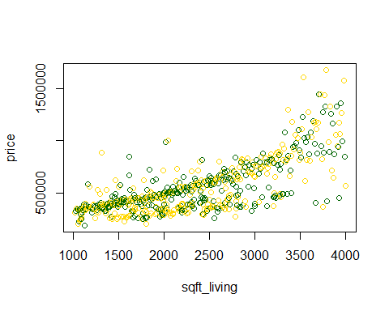

scatterplot1<-recordPlot()  
  
cat ("\nConclusion: Plot does not show that price and sqft_living are linearly related. It looks like an exponential relationship.")

##   
## Conclusion: Plot does not show that price and sqft_living are linearly related. It looks like an exponential relationship.

## I am using aggregated data as opposed to using the raw data. By "aggragated" data, I mean I take the mean for all the same sqft_living.  
  
plot(log(vec_price_sqftliving$sqft_living),log(vec_price_sqftliving$price), main="Log of Sqft_Living vs. Log of Price of House", xlab="Log Sqft_Living", ylab="Log Price of House", col=(c("gold","darkgreen")))

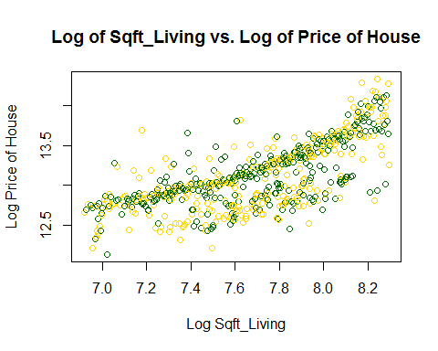

scatterplot2<-recordPlot()  
  
cat ("\nConclusion: Relationship between variables in plot 1 seems to be exponential and in plot 2 it seems to be linear.")

##   
## Conclusion: Relationship between variables in plot 1 seems to be exponential and in plot 2 it seems to be linear.

cat ("\nConclusion: Plot 2 clustered the data points in mid range of both axis and plot 1's data points are clustered around lower range of both axis")

##   
## Conclusion: Plot 2 clustered the data points in mid range of both axis and plot 1's data points are clustered around lower range of both axis

## My fisrt 5 variables are: sqft_living, bathrooms, grade, view, sqft_living15, sqft_above.

## Each of box plots shows that above variables might be directly related in predicting house prices.

## To support my finding, I also computed correlation between prices and variables, and my top 5 picks are supported with correlation coefficients as well [see below]

# corr between price vs sqft_living: 0.70203505

# corr between price vs bathrooms: 0.52513751

# corr between price vs bedrooms: 0.308349598

# corr between price vs floors: 0.256793888

# corr between price vs waterfront: 0.266369434

# corr between price vs view: 0.397293488

# corr between price vs grade: 0.66743426

# corr between price vs sqft_above: 0.6055672984

# corr between price vs lat: 0.3070034800

# corr between price vs sqft_living15: 0.58537890

## Prepare the data for the Model

## 1: seed is being set, so that distribution is same at each run

## 2: put 70% to train-set

## 3: put 30% to test-set

set.seed(1)  
rn_train <- sample(nrow(houseData),floor(nrow(houseData)*0.70))  
train <- houseData[rn_train,colnames(houseData)]  
test <- houseData[-rn_train,colnames(houseData)]

## Selection Method: START

## We have suggested 12 variables. I will calculate SSE and see which one gives me a smaller SSE and I pick that variable.

## From above correlation, variables selected are: bedrooms, bathrooms, log(sqft living), log(sqft lot), floors, waterfront, view, grade, yr built, lat

## STEP -01 : One variable predication - START

## Creating Models using 1 variables fpr each of the variables with price, so total we have 12 Models.   
SSEVals <- list(c(), c())  
SSEVals = findSSEByColName('bedrooms', SSEVals)  
SSEVals = findSSEByColName('bathrooms', SSEVals)  
SSEVals = findSSEByColName('log(sqft_living)', SSEVals)  
SSEVals = findSSEByColName('log(sqft_lot)', SSEVals)  
SSEVals = findSSEByColName('floors', SSEVals)  
SSEVals = findSSEByColName('waterfront', SSEVals)  
SSEVals = findSSEByColName('view', SSEVals)  
SSEVals = findSSEByColName('grade', SSEVals)  
SSEVals = findSSEByColName('yr_built', SSEVals)  
SSEVals = findSSEByColName('lat', SSEVals)  
SSEArr = SSEVals[[2]];  
which(SSEArr==min(SSEArr))

## [1] 8

SSEVals[[1]][which(SSEArr==min(SSEArr))]

## [1] "grade"

cat("\nSTEP -01 : Conculsion: SSE is minimum for variable 'grade' so it is the best predictor, when we use single variable")

##   
## STEP -01 : Conculsion: SSE is minimum for variable 'grade' so it is the best predictor, when we use single variable

## STEP -01 : one variable predication - END

## STEP -02 : Add more attributes to model - START

# we will also use R-squared to measure accuracy of model with addition of more variable

# R-squared is a statistical measure of how close the data are to the fitted regression line. It is also known as the coefficient of determination, or the coefficient of multiple determination for multiple regression. 0% indicates that the model explains none of the variability of the response data around its mean

# As in last phase, grade is bet to predict the price with single variable  
# let us name is model01 & compute r_square for the model  
# Linear Model  
model01 <- lm(data=train,log(price)~grade)  
summary(model01)

##   
## Call:  
## lm(formula = log(price) ~ grade, data = train)  
##   
## Residuals:  
## Min 1Q Median 3Q Max   
## -1.30048 -0.25702 0.00205 0.24136 1.67255   
##   
## Coefficients:  
## Estimate Std. Error t value Pr(>|t|)   
## (Intercept) 10.837314 0.028973 374.05 <2e-16 ***  
## grade 0.289070 0.003795 76.16 <2e-16 ***  
## ---  
## Signif. codes: 0 '***' 0.001 '**' 0.01 '*' 0.05 '.' 0.1 ' ' 1  
##   
## Residual standard error: 0.3612 on 11256 degrees of freedom  
## Multiple R-squared: 0.3401, Adjusted R-squared: 0.34   
## F-statistic: 5801 on 1 and 11256 DF, p-value: < 2.2e-16

# R-Square of Model  
r_squared_model01<-summary(model01)$r.squared  
# RMSE of Model  
predic_model01<-exp(predict(model01,interval='prediction',newdata=test))   
RMSE_model01=sqrt(sum((predic_model01 - test$price)^2)/nrow(test))

# Now let us add more variable which has greater impact on the price prediction.

# Let us call it model02.

# Approach of attribute selection:

# I have selecetd log(sqft_living), bedrooms, bathrooms, grade, waterfront

# here I have tried to make mix-match of the variables which have strong/moderate correlation with price, but variable do not strong co-orelation between then

# Linear Model  
model02<-lm(log(price)~log(sqft_living)+bedrooms+bathrooms+grade+waterfront,data=train)  
summary(model02)

##   
## Call:  
## lm(formula = log(price) ~ log(sqft_living) + bedrooms + bathrooms +   
## grade + waterfront, data = train)  
##   
## Residuals:  
## Min 1Q Median 3Q Max   
## -1.2946 -0.2457 0.0055 0.2330 1.3062   
##   
## Coefficients:  
## Estimate Std. Error t value Pr(>|t|)   
## (Intercept) 7.599956 0.098861 76.875 < 2e-16 ***  
## log(sqft_living) 0.555118 0.016358 33.936 < 2e-16 ***  
## bedrooms -0.033813 0.004836 -6.992 2.86e-12 ***  
## bathrooms -0.043236 0.006751 -6.404 1.57e-10 ***  
## grade 0.190612 0.004743 40.185 < 2e-16 ***  
## waterfront 0.632131 0.048576 13.013 < 2e-16 ***  
## ---  
## Signif. codes: 0 '***' 0.001 '**' 0.01 '*' 0.05 '.' 0.1 ' ' 1  
##   
## Residual standard error: 0.3385 on 11252 degrees of freedom  
## Multiple R-squared: 0.4206, Adjusted R-squared: 0.4203   
## F-statistic: 1633 on 5 and 11252 DF, p-value: < 2.2e-16

# R-Square of Model  
r_squared_model02<-summary(model02)$r.squared  
##compute RMSE for Model-02  
predic_model02<-exp(predict(model02,interval='prediction',newdata=test))   
RMSE_model02=sqrt(sum((predic_model02 - test$price)^2)/nrow(test))   
  
cat("\nR-Squared for Model-02 is ",100*(r_squared_model02/r_squared_model01-1),"% better than Model-01.")

##   
## R-Squared for Model-02 is 23.66765 % better than Model-01.

cat("\nSTEP -02 : Conculsion: \n Model-02 will predict the price better tha Model-01")

##   
## STEP -02 : Conculsion:   
## Model-02 will predict the price better tha Model-01

predic_model02<-exp(predict(model02,newdata=test))

## STEP -02 : Add more attributes to model - END

## STEP -03 : Sometime we should, Use Residual to add more eligible attributes for model - START

## If we plot residual vs. a variable (that is not used in the prediction) and if we see any recognizable patterns,

## then it indicates that some of the variation in residual is due to non-used variable

## therefore we should include it in our model to reduce the residual errors.

## To calculate residuals,

## we simply need to substract predic_model02 from the actual price.

##calculate residual for Model-02  
residual_model02=test$price - predic_model02  
## Residual vs. sqft_lot  
plot(test$sqft_lot,residual_model02, col=(c("gold","darkgreen")))

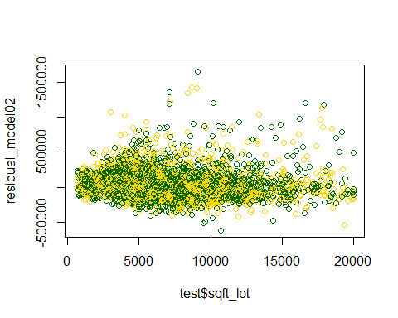

## Residual vs. floors  
plot(test$floors,residual_model02, col=(c("gold","darkgreen")))

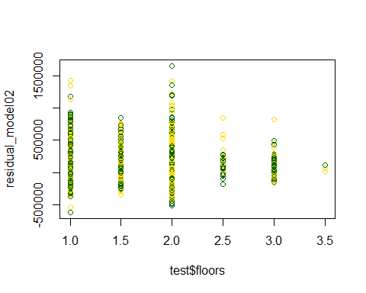

## Residual vs. view  
plot(test$view,residual_model02, col=(c("gold","darkgreen")))

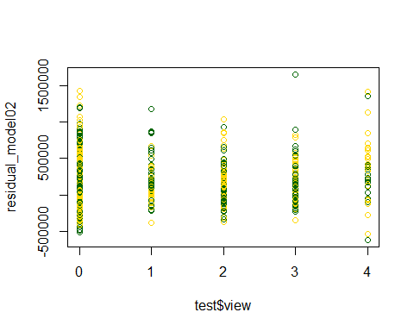

## Residual vs. condition  
plot(test$condition,residual_model02, col=(c("gold","darkgreen")))

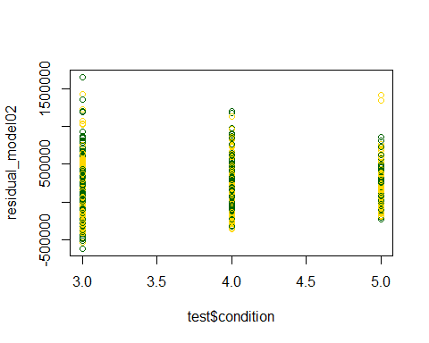

## Residual vs. sqft_above  
plot(test$sqft_above,residual_model02, col=(c("gold","darkgreen")))

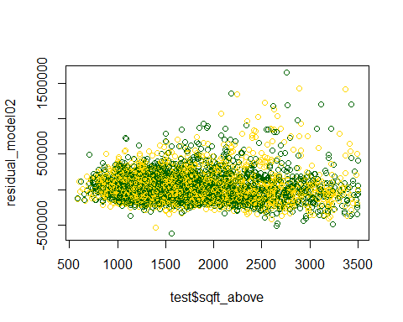

## Residual vs. sqft_basement  
plot(test$sqft_basement,residual_model02, col=(c("gold","darkgreen")))

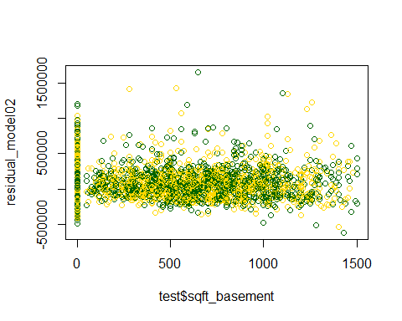

## Residual vs. yr_built  
plot(test$yr_built,residual_model02, col=(c("gold","darkgreen")))

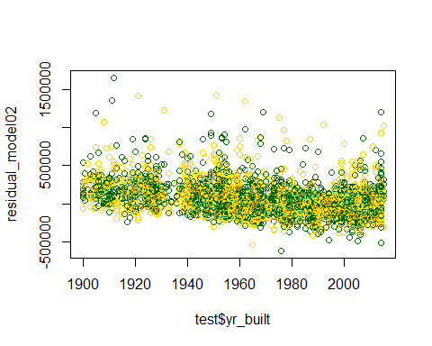

## Residual vs. yr_renovated  
plot(test$yr_renovated,residual_model02, col=(c("gold","darkgreen")))

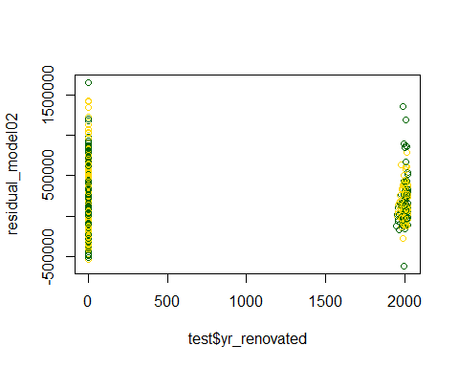

## Residual vs. zipcode  
#plot(test$zipcode,residual_model02, col=(c("gold","darkgreen")))   
  
## Residual vs. lat  
plot(test$lat,residual_model02, col=(c("gold","darkgreen")))

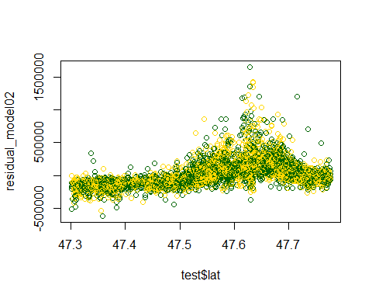

## Residual vs. long  
plot(test$long,residual_model02, col=(c("gold","darkgreen")))

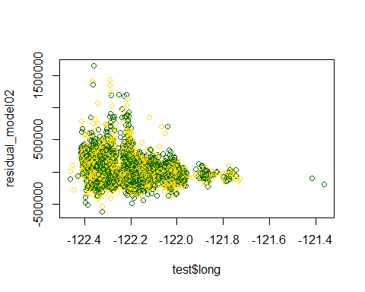

## Residual vs. sqft_living15  
plot(test$sqft_living15,residual_model02, col=(c("gold","darkgreen")))

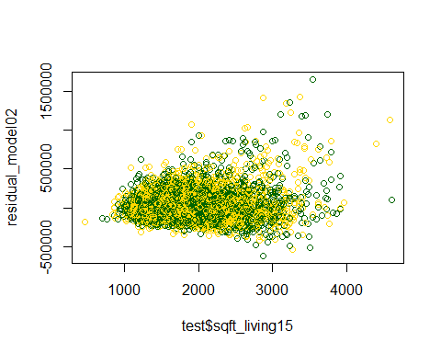

## Residual vs. sqft_lot15  
plot(test$sqft_lot15,residual_model02, col=(c("gold","darkgreen")))

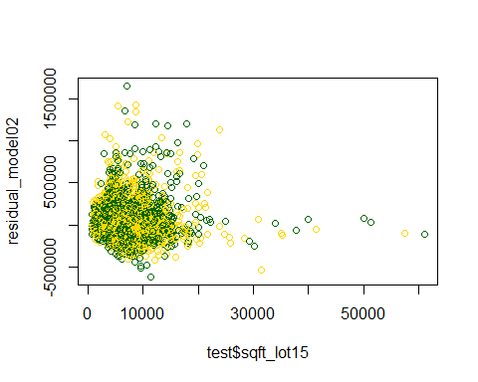

cat("\nSTEP -03 : Conculsion: After analzing scattered plot, we found that yr_built & lat are good candidate to predict the price of house")

##   
## STEP -03 : Conculsion: After analzing scattered plot, we found that yr_built & lat are good candidate to predict the price of house

## STEP -03 : Use Residual to more eligible attributes for model - END

## STEP -04 : Add Attributes found using Residual - START

## Below two columns is being added

## 1: yr_built

## 2:lat

#Now create model03, which will include yr_built & lat and we will try to find model03 vs model02  
model03<-lm(log(price)~log(sqft_living)+bedrooms+bathrooms+grade+waterfront+yr_built+lat,data=train)  
summary(model03)

##   
## Call:  
## lm(formula = log(price) ~ log(sqft_living) + bedrooms + bathrooms +   
## grade + waterfront + yr_built + lat, data = train)  
##   
## Residuals:  
## Min 1Q Median 3Q Max   
## -1.19597 -0.15767 0.00181 0.15816 1.27443   
##   
## Coefficients:  
## Estimate Std. Error t value Pr(>|t|)   
## (Intercept) -5.016e+01 9.654e-01 -51.959 <2e-16 ***  
## log(sqft_living) 4.568e-01 1.226e-02 37.270 <2e-16 ***  
## bedrooms -3.299e-02 3.576e-03 -9.225 <2e-16 ***  
## bathrooms 8.168e-02 5.503e-03 14.843 <2e-16 ***  
## grade 2.042e-01 3.641e-03 56.077 <2e-16 ***  
## waterfront 5.875e-01 3.587e-02 16.381 <2e-16 ***  
## yr_built -4.331e-03 9.848e-05 -43.981 <2e-16 ***  
## lat 1.402e+00 1.887e-02 74.267 <2e-16 ***  
## ---  
## Signif. codes: 0 '***' 0.001 '**' 0.01 '*' 0.05 '.' 0.1 ' ' 1  
##   
## Residual standard error: 0.2494 on 11250 degrees of freedom  
## Multiple R-squared: 0.6856, Adjusted R-squared: 0.6854   
## F-statistic: 3505 on 7 and 11250 DF, p-value: < 2.2e-16

r_squared_model03<-summary(model03)$r.squared  
  
cat("\nR-Squared for Model-03 is ",100*(r_squared_model03/r_squared_model02-1),"% better than Model-02.\nR-squared for Model-03 and Model-02 are:", r_squared_model03,"and", r_squared_model02, "respectively.So here Model-03 wins over other previous model.")

##   
## R-Squared for Model-03 is 63.02309 % better than Model-02.  
## R-squared for Model-03 and Model-02 are: 0.6856254 and 0.4205695 respectively.So here Model-03 wins over other previous model.

## RMSE for Model-03:  
predic_model03<-exp(predict(model03,interval='prediction',newdata=test))  
RMSE_model03=sqrt(sum((predic_model03 - test$price)^2)/nrow(test))  
  
cat("\nRMSE for model02:",RMSE_model02,"\nRMSE for model03:",RMSE_model03)

##   
## RMSE for model02: 614498.8   
## RMSE for model03: 465951.2

cat("\nConclusion: RMSE for Model-02 is ",round(100*(RMSE_model02/RMSE_model03-1),2),"% more than Model-03. So Model-03 predicts the prices better.")

##   
## Conclusion: RMSE for Model-02 is 31.88 % more than Model-03. So Model-03 predicts the prices better.

## STEP -04 : Add Attributes found using Residual - END

## STEP -05 : Come Up with the Model, using bit of common sense - START

# log(price) seems to have good correlation with exp(bathrooms).

# log(price) seems to have good correlation with log(bedrooms), add 0.05 as it has 0 values.

# log(price) seems to have good correlation with log(lat). to reduce the noice and we will use lat-min(lat)+0.5, so that relative relation can be found. Similar approach has been taken for long

# log(price) seems to have good correlation with log(yr_renovated). to get more relevent data we wil try to compute the age of the building

# bedroom & bathroom can also play a big role when price of an house is being calculate, so i have use bedrooms*bathrooms as one of the variable to compute linear model #grade & condition can also play a big role when price of an house is being calculate, so i have use log(grade)*exp(condition) as one of the variable to compute linear model

model05<-lm(log(price)~grade+log(sqft_living)+log(bedrooms+0.5)+exp(bathrooms)+waterfront+log(abs(lat-min(lat))+0.5)+log(abs(long-min(long))+0.05)+(zipcode*lat)+log(view+0.5)+condition+log(sqft_above+0.05)+log(sqft_basement+0.05)+log(sqft_lot15)+log(2015-yr_renovated+1)+(bedrooms*bathrooms)+(log(grade)*exp(condition))+(bedrooms*log(sqft_living))+(view*bedrooms),data=train)  
summary(model05)

##   
## Call:  
## lm(formula = log(price) ~ grade + log(sqft_living) + log(bedrooms +   
## 0.5) + exp(bathrooms) + waterfront + log(abs(lat - min(lat)) +   
## 0.5) + log(abs(long - min(long)) + 0.05) + (zipcode * lat) +   
## log(view + 0.5) + condition + log(sqft_above + 0.05) + log(sqft_basement +   
## 0.05) + log(sqft_lot15) + log(2015 - yr_renovated + 1) +   
## (bedrooms * bathrooms) + (log(grade) * exp(condition)) +   
## (bedrooms * log(sqft_living)) + (view * bedrooms), data = train)  
##   
## Residuals:  
## Min 1Q Median 3Q Max   
## -1.06268 -0.14128 -0.00107 0.13625 1.09027   
##   
## Coefficients:  
## Estimate Std. Error t value Pr(>|t|)  
## (Intercept) 1.898e+04 1.613e+03 11.770 < 2e-16  
## grade 2.277e-01 3.257e-02 6.992 2.86e-12  
## log(sqft_living) 3.127e-01 4.813e-02 6.497 8.54e-11  
## log(bedrooms + 0.5) 1.500e-01 8.016e-02 1.871 0.06138  
## exp(bathrooms) -1.897e-04 8.358e-04 -0.227 0.82047  
## waterfront 3.911e-01 3.811e-02 10.264 < 2e-16  
## log(abs(lat - min(lat)) + 0.5) 7.909e+00 1.631e-01 48.484 < 2e-16  
## log(abs(long - min(long)) + 0.05) -1.754e-01 8.090e-03 -21.684 < 2e-16  
## zipcode -1.890e-01 1.640e-02 -11.522 < 2e-16  
## lat -3.961e+02 3.392e+01 -11.679 < 2e-16  
## log(view + 0.5) 4.432e-02 2.637e-02 1.680 0.09290  
## condition 9.546e-02 1.117e-02 8.547 < 2e-16  
## log(sqft_above + 0.05) 2.642e-01 2.323e-02 11.373 < 2e-16  
## log(sqft_basement + 0.05) 8.928e-03 1.108e-03 8.060 8.38e-16  
## log(sqft_lot15) -2.896e-02 4.605e-03 -6.289 3.31e-10  
## log(2015 - yr_renovated + 1) -3.066e-02 2.106e-03 -14.556 < 2e-16  
## bedrooms -9.791e-02 1.053e-01 -0.930 0.35250  
## bathrooms -1.110e-01 1.809e-02 -6.137 8.69e-10  
## log(grade) -8.249e-01 2.561e-01 -3.221 0.00128  
## exp(condition) -7.185e-03 1.094e-03 -6.570 5.24e-11  
## view 6.997e-02 2.272e-02 3.080 0.00207  
## zipcode:lat 3.945e-03 3.449e-04 11.437 < 2e-16  
## bedrooms:bathrooms 2.941e-02 5.552e-03 5.297 1.20e-07  
## log(grade):exp(condition) 3.544e-03 5.437e-04 6.520 7.34e-11  
## log(sqft_living):bedrooms -2.526e-03 1.303e-02 -0.194 0.84627  
## bedrooms:view -6.568e-03 3.641e-03 -1.804 0.07127  
##   
## (Intercept) ***  
## grade ***  
## log(sqft_living) ***  
## log(bedrooms + 0.5) .   
## exp(bathrooms)   
## waterfront ***  
## log(abs(lat - min(lat)) + 0.5) ***  
## log(abs(long - min(long)) + 0.05) ***  
## zipcode ***  
## lat ***  
## log(view + 0.5) .   
## condition ***  
## log(sqft_above + 0.05) ***  
## log(sqft_basement + 0.05) ***  
## log(sqft_lot15) ***  
## log(2015 - yr_renovated + 1) ***  
## bedrooms   
## bathrooms ***  
## log(grade) **   
## exp(condition) ***  
## view **   
## zipcode:lat ***  
## bedrooms:bathrooms ***  
## log(grade):exp(condition) ***  
## log(sqft_living):bedrooms   
## bedrooms:view .   
## ---  
## Signif. codes: 0 '***' 0.001 '**' 0.01 '*' 0.05 '.' 0.1 ' ' 1  
##   
## Residual standard error: 0.223 on 11232 degrees of freedom  
## Multiple R-squared: 0.7489, Adjusted R-squared: 0.7484   
## F-statistic: 1340 on 25 and 11232 DF, p-value: < 2.2e-16

## Let's compute the root mean square error

## computing RMSE for Model-05  
prediction05<-exp(predict(model05,interval='prediction',newdata=test))   
RMSE_05=sqrt(sum((prediction05 - test$price)^2)/nrow(test))  
  
cat("RMSE for model03:",RMSE_model03,"\nRMSE for model05:",RMSE_05)

## RMSE for model03: 465951.2   
## RMSE for model05: 427364

cat("Conclusion: RMSE for Model-03 is ",round(100*(RMSE_model03/RMSE_05-1),2),"% more than Model-05, so here Model-05 is the clear winner.")

## Conclusion: RMSE for Model-03 is 9.03 % more than Model-05, so here Model-05 is the clear winner.

## Let's find the percentage of cases with less than 25% error.

## this process will give the confidence in the Model

errors <- prediction05[,'fit'] - test$price  
hist(errors,col=(c("gold","darkgreen")))

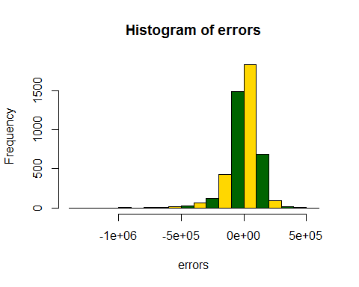

cat("Conclusion: we can see that Histogram of error shows that possibility of error are less, which gives confidence in the variable selection for the model with current set of data")

## Conclusion: we can see that Histogram of error shows that possibility of error are less, which gives confidence in the variable selection for the model with current set of data

rel_change = 1 - ((test$price - abs(errors)) / test$price)  
##Now the percentage of cases with less than 25% error.  
pred25 = table(rel_change<0.25)["TRUE"] / nrow(test)  
pred25

## TRUE   
## 0.7409863

cat("Conclusion: we can see 70%+ have 25% or less error.")

## Conclusion: we can see 70%+ have 25% or less error.

## STEP -05 : Come Up with the Model, using bit of common sense - END

## Selection Method: End

## STEP -06 : Get correct Intercept & coefficient for derived Model - START

## As above model is winner,

## let us run the model on different set of test and training data and find the best RMSE

## I Start with

## Training-dataset = 60%

## Testing-dataset = 40 % ,

## and increment Training-dataset by 1% data

## and continue till Training-dataset reach to 95%.

set.seed(1)  
newhouseData <- subset(houseData, select = c(price,bathrooms,sqft_living,grade,sqft_above, bedrooms, waterfront, lat, long, view, condition, sqft_basement, yr_renovated, sqft_lot15, zipcode))  
i=0.6  
storage <- list(c(), c(), c(),c())  
for(i in seq(from=0.60, to=0.95, by=0.01)){  
 rn_train <- sample(nrow(newhouseData),floor(nrow(newhouseData)*i))  
 train <- newhouseData[rn_train,colnames(newhouseData)]  
 test <- newhouseData[-rn_train,colnames(newhouseData)]  
 model <- lm(log(price)~grade+log(sqft_living)+log(bedrooms+0.5)+exp(bathrooms)+waterfront+log(abs(lat-min(lat))+0.5)+log(abs(long-min(long))+0.05)+(zipcode*lat)+log(view+0.5)+condition+log(sqft_above+0.05)+log(sqft_basement+0.05)+log(sqft_lot15)+log(2015-yr_renovated+1)+(bedrooms*bathrooms)+(log(grade)*exp(condition))+(bedrooms*log(sqft_living))+(view*bedrooms),data=train)  
#summary(model)  
   
 prediction <- round(exp(predict(model,interval='prediction',newdata = test)),0)  
 train_prediction = fitted(model)  
 train_rmse = sqrt(sum((train_prediction-train$price)^2)/nrow(train))  
 test_rmse = sqrt(sum((prediction - test$price)^2)/nrow(test))  
   
 storage[[1]]<-c(storage[[1]],i)  
 storage[[2]]<-c(storage[[2]],test_rmse)  
 storage[[3]]<-c(storage[[3]],train_rmse)  
}  
  
##find the LM with minimun training error  
RMSE = storage[[3]]  
minimumVal = min(RMSE)  
minimumVal

## [1] 561425.3

indx = which(RMSE==min(RMSE))  
indx

## [1] 16

storage[[1]][indx]

## [1] 0.75

cat("\nConclusion: Minimum Training RMSE of Regression:",storage[[3]][indx],"\nRMSE of testing :",storage[[2]][indx], "\nTraining data Percentage:",storage[[1]][indx])

##   
## Conclusion: Minimum Training RMSE of Regression: 561425.3   
## RMSE of testing : 429032.6   
## Training data Percentage: 0.75

## Now we come to a conclusion that 77% Training data provides the Minimum RMSE

## 1: SET training Data = 77% &

## 2: Get model with coeeficient & Intercept

## 3: Draw the error of Histogram to get confidence with model

## 4: Find out how many data have less than 25% of error

rn_train <- sample(nrow(newhouseData),floor(nrow(newhouseData)*storage[[1]][indx]))  
train <- newhouseData[rn_train,colnames(newhouseData)]  
test <- newhouseData[-rn_train,colnames(newhouseData)]  
modelXGen <- lm(log(price)~grade+log(sqft_living)+log(bedrooms+0.5)+exp(bathrooms)+waterfront+log(abs(lat-min(lat))+0.5)+log(abs(long-min(long))+0.05)+(zipcode*lat)+log(view+0.5)+condition+log(sqft_above+0.05)+log(sqft_basement+0.05)+log(sqft_lot15)+log(2015-yr_renovated+1)+(bedrooms*bathrooms)+(log(grade)*exp(condition))+(bedrooms*log(sqft_living))+(view*bedrooms),data=train)  
summary(modelXGen)

##   
## Call:  
## lm(formula = log(price) ~ grade + log(sqft_living) + log(bedrooms +   
## 0.5) + exp(bathrooms) + waterfront + log(abs(lat - min(lat)) +   
## 0.5) + log(abs(long - min(long)) + 0.05) + (zipcode * lat) +   
## log(view + 0.5) + condition + log(sqft_above + 0.05) + log(sqft_basement +   
## 0.05) + log(sqft_lot15) + log(2015 - yr_renovated + 1) +   
## (bedrooms * bathrooms) + (log(grade) * exp(condition)) +   
## (bedrooms * log(sqft_living)) + (view * bedrooms), data = train)  
##   
## Residuals:  
## Min 1Q Median 3Q Max   
## -1.04399 -0.14424 -0.00191 0.13870 1.19315   
##   
## Coefficients:  
## Estimate Std. Error t value Pr(>|t|)  
## (Intercept) 1.874e+04 1.555e+03 12.048 < 2e-16  
## grade 2.392e-01 3.177e-02 7.529 5.48e-14  
## log(sqft_living) 3.515e-01 4.752e-02 7.397 1.48e-13  
## log(bedrooms + 0.5) 6.846e-02 7.950e-02 0.861 0.389226  
## exp(bathrooms) 1.668e-04 8.126e-04 0.205 0.837329  
## waterfront 4.662e-01 3.858e-02 12.084 < 2e-16  
## log(abs(lat - min(lat)) + 0.5) 7.966e+00 1.589e-01 50.147 < 2e-16  
## log(abs(long - min(long)) + 0.05) -1.799e-01 7.883e-03 -22.825 < 2e-16  
## zipcode -1.864e-01 1.582e-02 -11.788 < 2e-16  
## lat -3.908e+02 3.270e+01 -11.950 < 2e-16  
## log(view + 0.5) 8.606e-02 2.473e-02 3.480 0.000504  
## condition 8.973e-02 1.089e-02 8.241 < 2e-16  
## log(sqft_above + 0.05) 2.681e-01 2.243e-02 11.954 < 2e-16  
## log(sqft_basement + 0.05) 9.197e-03 1.070e-03 8.594 < 2e-16  
## log(sqft_lot15) -3.094e-02 4.498e-03 -6.878 6.36e-12  
## log(2015 - yr_renovated + 1) -2.787e-02 2.054e-03 -13.571 < 2e-16  
## bedrooms 6.028e-02 1.058e-01 0.570 0.568715  
## bathrooms -1.092e-01 1.767e-02 -6.181 6.58e-10  
## log(grade) -8.508e-01 2.500e-01 -3.403 0.000670  
## exp(condition) -5.351e-03 1.066e-03 -5.018 5.29e-07  
## view 2.647e-02 2.169e-02 1.220 0.222319  
## zipcode:lat 3.890e-03 3.326e-04 11.696 < 2e-16  
## bedrooms:bathrooms 2.820e-02 5.416e-03 5.206 1.97e-07  
## log(grade):exp(condition) 2.693e-03 5.317e-04 5.064 4.16e-07  
## log(sqft_living):bedrooms -1.989e-02 1.300e-02 -1.530 0.126131  
## bedrooms:view -2.901e-03 3.646e-03 -0.796 0.426237  
##   
## (Intercept) ***  
## grade ***  
## log(sqft_living) ***  
## log(bedrooms + 0.5)   
## exp(bathrooms)   
## waterfront ***  
## log(abs(lat - min(lat)) + 0.5) ***  
## log(abs(long - min(long)) + 0.05) ***  
## zipcode ***  
## lat ***  
## log(view + 0.5) ***  
## condition ***  
## log(sqft_above + 0.05) ***  
## log(sqft_basement + 0.05) ***  
## log(sqft_lot15) ***  
## log(2015 - yr_renovated + 1) ***  
## bedrooms   
## bathrooms ***  
## log(grade) ***  
## exp(condition) ***  
## view   
## zipcode:lat ***  
## bedrooms:bathrooms ***  
## log(grade):exp(condition) ***  
## log(sqft_living):bedrooms   
## bedrooms:view   
## ---  
## Signif. codes: 0 '***' 0.001 '**' 0.01 '*' 0.05 '.' 0.1 ' ' 1  
##   
## Residual standard error: 0.2245 on 12037 degrees of freedom  
## Multiple R-squared: 0.7479, Adjusted R-squared: 0.7474   
## F-statistic: 1429 on 25 and 12037 DF, p-value: < 2.2e-16

predictionXGen <- round(exp(predict(modelXGen,interval='prediction',newdata = test)),0)  
test_rmseXGen = sqrt(sum((predictionXGen - test$price)^2)/nrow(test))  
errors <- predictionXGen[,'fit'] - test$price  
hist(errors,col=(c("gold","darkgreen")))

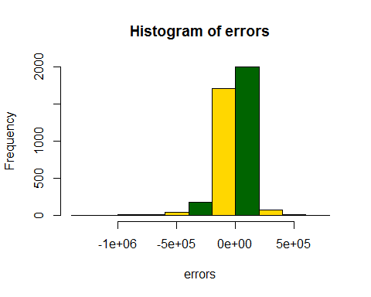

rel_change = 1 - ((test$price - abs(errors)) / test$price)  
##Now the percentage of cases with less than 25% error.  
pred25 = table(rel_change<0.25)["TRUE"] / nrow(test)  
pred25

## TRUE   
## 0.74857

cat("\nConclusion:percent of data having less than 25% error:",pred25)

##   
## Conclusion:percent of data having less than 25% error: 0.74857

## Now Write the file

#Now write the Real & Predicted price file for comparision  
predictionXGen <- round(exp(predict(modelXGen,newdata = test)),0)  
values <- (cbind("ID"=test$id,"Orginal Price"=test$price,"Predicted Price"=predictionXGen))  
write.csv(values, file = "RealPriceVsPredictedAsStaticticalAnalysis.csv", row.names=FALSE)