# Lesson 3: Navigating a CourseSite as a Student

**Note**: Content pictured in topics 1 through step 5 provided courtesy of Prentice Hall/Pearson Education - Introductory Oceanography - Edition 9 (2001)

## 1. Navigate between Course Areas

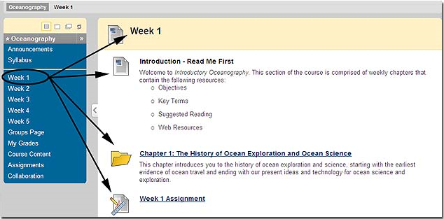

To navigate between course areas, click on the desired link in the Course Menu. As pictured here, to get to the Week 1 area, you would click on the Week 1 link on the Course Menu.

## 2. Navigate Using the Course Map

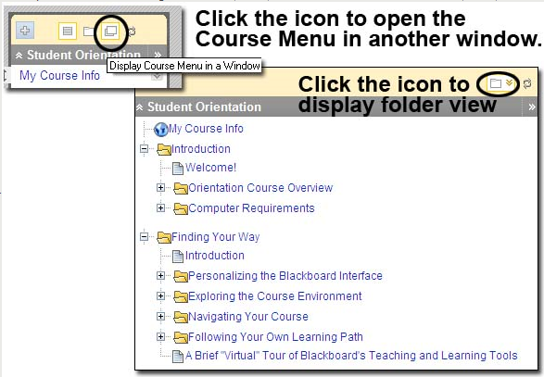

Another way to move between course areas is by using the Course Map. To view a Course Map:

1. Click the double rectangle icon in the tool bar of the Course Menu to open it in a separate window.
2. Click the folder icon to display all the content in a tree.
3. Use the plus and minus icons next to each folder to expand and collapse the tree.

## 3. Navigate within a Content Area -- Bread Crumb Trail

1.png

**Note**: Use the internal navigation to move between documents and folders. This path of links is often referred to as a "breadcrumb trail, or just "breadcrumbs". Due to the dynamic nature of many of the pages within the course, we strongly recommend that you use the breadcrumb links instead of the browser's Back and Forward buttons.

Breadcrumbs, like these shown here, will appear at the top of each content area within a course. Clicking on a link will take you to that area of the course. For example, the course name (Oceanography) will take you to the entry page of the course. Selecting the name of a content area (Chapter 3) will take you to the top level of that content area. Ellipses ( ... ) indicate additional levels and they will fully display when you click them.

## 4. Navigate within a Content Area -- Opening Files

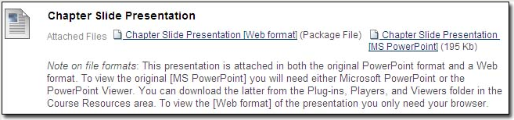

**Note**: Instructors may upload files to CourseSites for students to view or download. These files appear within the content as blue, underlined text. For example, the link to open a chapter presentation may appear as " Chapter Slide Presentation " As pictured above, you would click on the link to open, print or save the file.

After clicking on the link, students may be prompted to either open or save the file. You can choose to open the file if the item is to be reviewed right away. Students can choose to save the file to your computer desktop or another local drive should they need to refer to the item at a later point. If students are unable to view a file, remember that they may need to download the plug-in to your computer first so the file will open and can be viewed in your Internet browser.

## 5. Navigate within a Content Area -- Accessing folders

1.png

course materials and informationcan be organized using folders. Just as you can organize files on your computer in folders or put documents in folders within a file cabinet, instructors can organize content using folders in certain areas. Instructors may even create folders within folders should the course contain quite a lot of material.

To access information contained within folders, users should click on the folder title, such as the one pictured above. Don't forget to use the breadcrumb trail to keep track of where you are in the course!