**Interview Preparation**



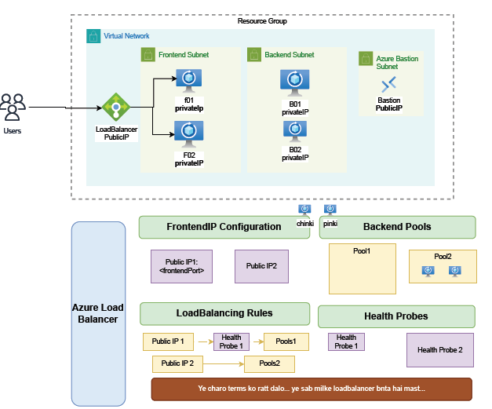

Configuration Steps: -

* **Frontend IP Configuration** – Exposes the load balancer’s public/private IP.
* **Backend Pools** – Collection of backend VMs.
* **Load Balancing Rules** – Define how traffic is distributed.
* **Health Probes** – Monitor backend VM health, check VM availability before forwarding traffic.

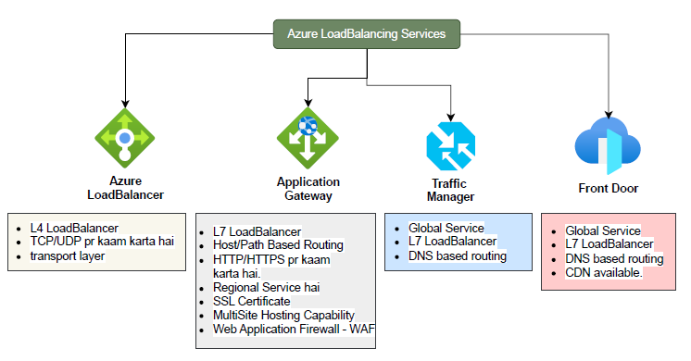

**1. Azure Load Balancer:** LB is working on L4 (TCP/UDP) protocol

* **Type:** Layer 4 (L4) Load Balancer
* **Protocol Support:** Works on **TCP/UDP** traffic.
* **Layer:** Transport Layer
* **Use Case:** Best for distributing non-HTTP(S) workloads (e.g., SQL, gaming, VoIP, custom TCP/UDP apps).
* **Key Features:**
  + Provides high availability by distributing traffic across VMs.
  + Supports inbound and outbound scenarios.
  + Does not support path-based or host-based routing.

**Algorithms:** Round robin, hash-based

### Types of Azure Load Balancer

1. **Internal LB:**
   * Has **private IP**
   * Used for **internal traffic** (within VNet)
2. **External LB:**
   * Has **public IP**
   * Used for **internet-facing** apps or websites
3. **Azure Application Gateway**

* **Type:** Layer 7 (L7) Load Balancer
* **Protocol Support:** Works on **HTTP/HTTPS**.
* **Scope:** **Regional Service** (deployed in a specific region).
* **Key Features:**
  + **Host/Path-Based Routing** – routes traffic based on hostname or URL path.
  + **SSL/TLS Termination** – manages SSL certificates.
  + **Multi-Site Hosting** – multiple web applications can be hosted behind one gateway.
  + **Web Application Firewall (WAF)** – protection against OWASP Top 10 attacks (SQL injection, XSS, etc.).
  + Supports autoscaling and session affinity.

**3. Azure Traffic Manager**

* **Type:** Layer 7 Load Balancer (DNS-based).
* **Scope:** **Global Service** (works across multiple regions).
* **Routing Method:** **DNS-based routing** – directs clients to the best endpoint based on configured routing policies.
* **Key Features:**
  + Improves availability by failing over to healthy endpoints.
  + Supports **geographic routing, performance routing, priority-based routing, and weighted round-robin**.
  + Often used for **global failover** or distributing traffic between multiple regions.

**4. Azure Front Door**

* **Type:** Layer 7 Load Balancer (DNS + Application-level).
* **Scope:** **Global Service**
* **Routing:** DNS-based + advanced request routing.
* **Key Features:**
  + Provides **global HTTP(S) load balancing**.
  + Built-in **CDN (Content Delivery Network)** capability for performance optimization.
  + **Web Application Firewall (WAF)** integration.
  + Supports **SSL offloading, caching, URL-based routing, and session affinity**.
  + Often used for **accelerating global websites and applications**.

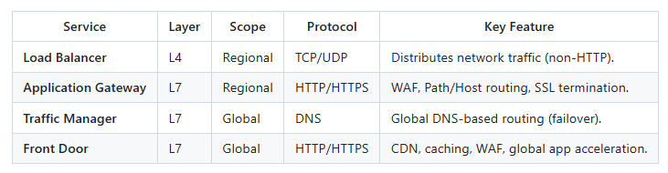

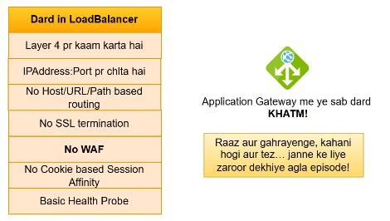

Load Balancer

