Project Requirement
- Suppose we have a client who was basically selling their product (sports-related) on local based but now a days he has grown their business into regional/global level so as of now he wants to sell their product regionally/globally.
- So basically, he has a requirement of website where their customer can reach out to purchase their product, so for that he will reach out to the developer team basically to a IT company.
- To contact with IT team, he will send an email then BD (Business Development team) will consult.
- Requirement from the sports company

- Requirement ----
- Business related questions (which sports item will be selling, global sell or regional sell, page category, payment gateway)
- Technical questions (Frontend-React JS, Backend-Python, which cloud required, mobile app required, which database required)
- DevOps related questions (how many people will be accessing the website in single time, high traffic handling capacity, auto scaling, DR)
- IT company will create a SRS (software requirement specifications)
>>Website page, payment integrations, user roles, admin dashboard, cost

- Client will approve the SRS then Project will be start
- SOP (Standard operation procedure) will signed by the customer---Agreement

- HLD- High level diagram will be designed as per the requirement (Monolithic/Microservices), by the Architect.
- Basically 3 tiers monolithic application/microservices

- Frontend (React JS) – UI (user interface)
- Backend (Python) – Logic will be written
- Database – Datastore (User/Order details, payment details)

- LLD (Low level design will create) as per client budget resources will be plan for the deployment.

- Development phase: -
- Now developer will design the website (Coding part)
- Code will be pushed to SCM tools (GitHub, bitbucket, azure Repo, GitLab)
Parallelly Devops work will also being in progress

Deployment – 1. Compute services (VM) 2. Microservices (container)

Microsoft Entra ID (Azure Active directory)
Tenant ID: Globally ID assign hoti hai
User: इंसान की डिजिटल identity, User खुद से कुछ नहीं कर सकता जब तक उसे permissions (roles) ना दिए जाएँ.
✔ 1. Portal login कर सकता है
✔ 2. Assigned roles के हिसाब से काम कर सकता है
✔ 3. Apps में sign-in कर सकता है
✔ 4. Groups का member हो सकता है
✔ 5. MFA & Security Policies apply होती हैं
Groups: Users या Applications का एक collection
✔️ 1. Bulk Access Control
Roles and Administrator: यह Entra ID (Azure Active Directory) के अंदर Directory-level roles को manage करने का section है।
इसका काम है:

✔️ Azure AD / Entra ID roles को assign करना
जैसे-जैसे subscription में RBAC roles होते हैं, वैसे ही Entra ID में अलग roles होते हैं:
- Global Administrator
- User Administrator
- Groups Administrator
- Helpdesk Administrator
- Application Administrator
- Security Administrator
- Billing Administrator
- आदि
ये directory level roles होते हैं, जो tenant पूरे level पर effect करते हैं।
App registration: Azure Entra ID में किसी application को identity देना।

Password reset: SSPR (Self-Service Password Reset) is service ke through user khud se apna password reset kr sakta hai, isse user ko helpdesk walo ke paas nhi jana padega.

Resources
Azure resource manager:
https://learn.microsoft.com/en-us/azure/azure-resource-manager/management/overview
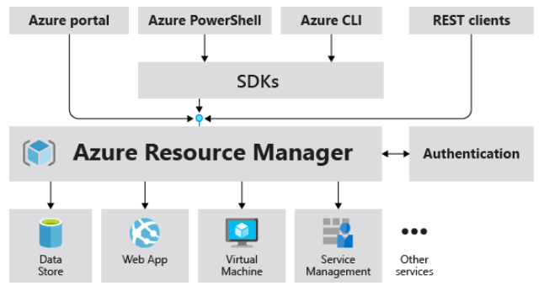

JSON: JavaScript Object Notation

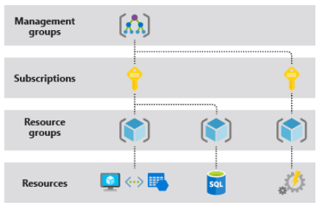

What is a resource group?
A resource group is a container, we can manage all resources inside this.
- Each resource can exist in only one resource group.
- You can add or remove a resource to a resource group at any time.
- You can move a resource from one resource group to another group.
- The resources in a resource group can be located in different regions than the resource group, but we recommend that you use the same location.
- A resource group can be used to scope access control for administrative actions. You can use Azure policies, roles, or resource locks to manage a resource group.

Linux: https://www.w3schools.com/bash/
rwx
Group permissions
---
Others permissions
rwx
Owner permissions

- r: Read permission
- w: Write permission
- x: Execute permission

- 0: No permission
- 1: Execute permission
- 2: Write permission
- 3: Write and execute permissions
- 4: Read permission
- 5: Read and execute permissions
- 6: Read and write permissions
- 7: Read, write, and execute permissions

- chmod: Change file permissions
- chown: Change file ownership
- chgrp: Change group ownership

Q. Agar kisi user ko infra bana hai to cloud kyu use krte hai onprem kyu nhi..?
Q. difference between region and zones ?

Cloud Computing: Hmari demand ke according hme compute service ke resource ko deliver krta hai. (eg:- Database, storage account, vm)
Types of computing:-
- Public Cloud: Azure, AWS, GCP
- Private Cloud: Within organization ke liye
- Hybrid Cloud: Private cloud + Public cloud

Types of cloud services:
- On Premises: We need to manage this
- IAAS (Infrastructure as a service):
- PAAS
- SAAS
