Interview Preparation Monitoring tools

Observability: To check the performance of Infra and Applications with below parameters.
- Monitor
- Logs
- Alerts
Q. When we will use Prometheus and how it works?
- Else we having the time series data or you need to calculate metrics then we will use Prometheus.
- Prometheus collets the metrics and provided to Grafana as a data store.
Q. If you want to collect the logs then what you will use?
- We use Loki, it’s also working as a data store and provides the data to Grafana.
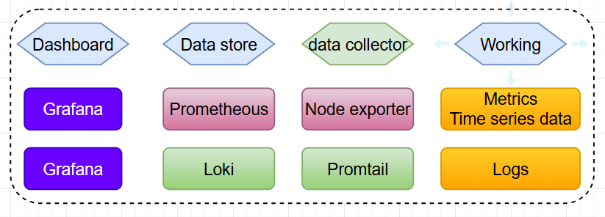
Promtail: Ye alag-alag source se logs capture krta hai aur un logs ko send krta hai loki ke paas.
Prometheus: Metrics ko monitor krta hai ya to timeseries data ko monitor krta hai.
Loki: Logs monitoring ke liye use hota hai.

Practice of Grafana + Loki

- Connect a Linux Virtual machine into Azure.
- Sudo apt update
- Sudo apt install nginx

