Interview Preparation

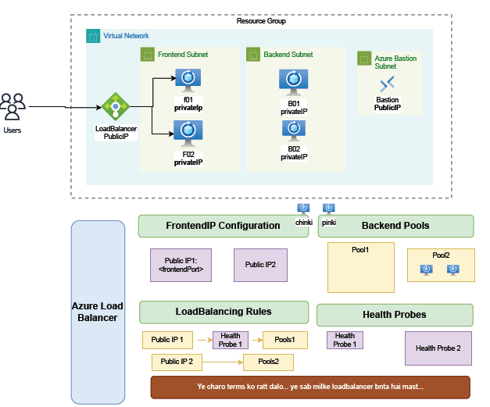

Configuration Steps: -
- Frontend IP Configuration – Exposes the load balancer’s public/private IP.
- Backend Pools – Collection of backend VMs.
- Load Balancing Rules – Define how traffic is distributed.
- Health Probes – Monitor backend VM health, check VM availability before forwarding traffic.

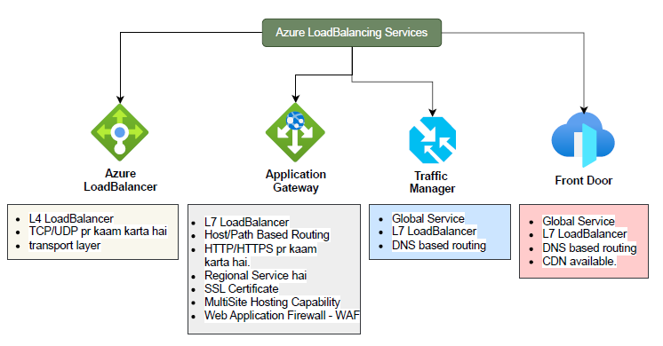
1. Azure Load Balancer: LB is working on L4 (TCP/UDP) protocol
- Type: Layer 4 (L4) Load Balancer
- Protocol Support: Works on TCP/UDP traffic.
- Layer: Transport Layer
- Use Case: Best for distributing non-HTTP(S) workloads (e.g., SQL, gaming, VoIP, custom TCP/UDP apps).
- Key Features:
  - Provides high availability by distributing traffic across VMs.
  - Supports inbound and outbound scenarios.
  - Does not support path-based or host-based routing.
Algorithms: Round robin, hash-based

Types of Azure Load Balancer
- Internal LB:
  - Has private IP
  - Used for internal traffic (within VNet)
- External LB:
  - Has public IP
  - Used for internet-facing apps or websites

- Azure Application Gateway
- Type: Layer 7 (L7) Load Balancer
- Protocol Support: Works on HTTP/HTTPS.
- Scope: Regional Service (deployed in a specific region).
- Key Features:
  - Host/Path-Based Routing – routes traffic based on hostname or URL path.
  - SSL/TLS Termination – manages SSL certificates.
  - Multi-Site Hosting – multiple web applications can be hosted behind one gateway.
  - Web Application Firewall (WAF) – protection against OWASP Top 10 attacks (SQL injection, XSS, etc.).
  - Supports autoscaling and session affinity.

3. Azure Traffic Manager
- Type: Layer 7 Load Balancer (DNS-based).
- Scope: Global Service (works across multiple regions).
- Routing Method: DNS-based routing – directs clients to the best endpoint based on configured routing policies.
- Key Features:
  - Improves availability by failing over to healthy endpoints.
  - Supports geographic routing, performance routing, priority-based routing, and weighted round-robin.
  - Often used for global failover or distributing traffic between multiple regions.

4. Azure Front Door
- Type: Layer 7 Load Balancer (DNS + Application-level).
- Scope: Global Service
- Routing: DNS-based + advanced request routing.
- Key Features:
  - Provides global HTTP(S) load balancing.
  - Built-in CDN (Content Delivery Network) capability for performance optimization.
  - Web Application Firewall (WAF) integration.
  - Supports SSL offloading, caching, URL-based routing, and session affinity.
  - Often used for accelerating global websites and applications.

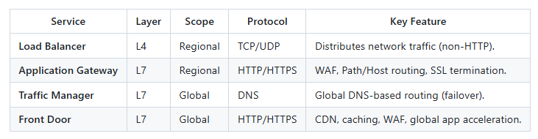

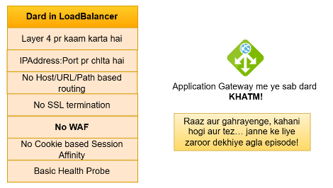

Load Balancer
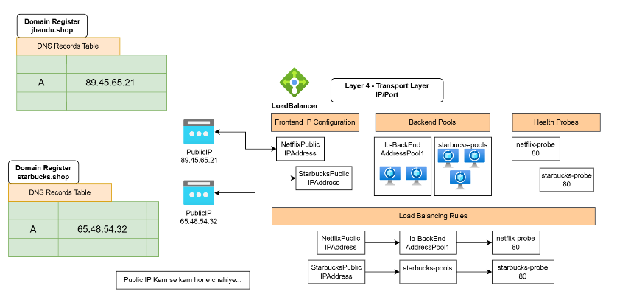

Application gateway
