Linux code
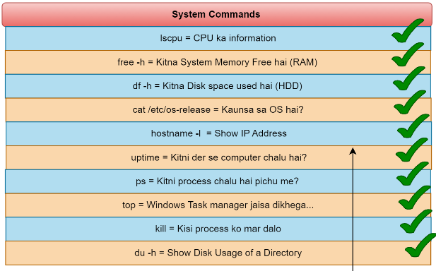

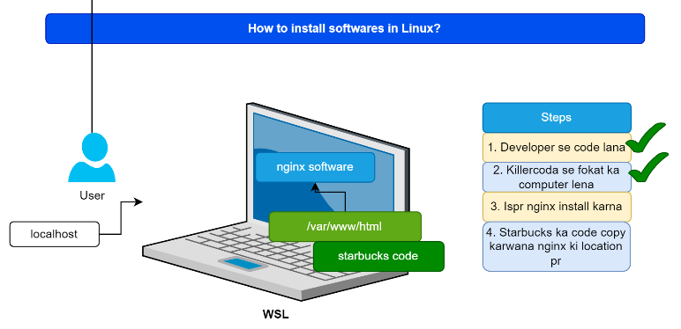

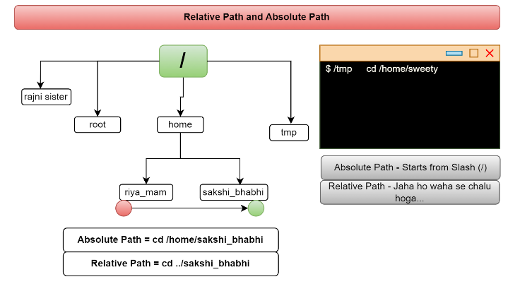

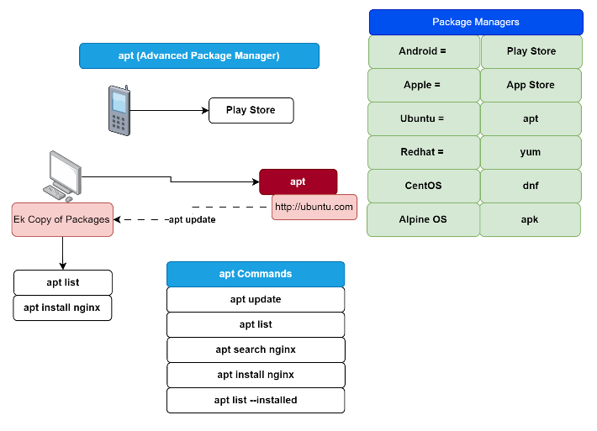

Starbucks Deployment
Steps:- Open killerkoda (UBUNTU) or install WSL on your own computer >> /home >> to switch from current folder to home folder >> apt update (to update its current app list) >> apt list (to check apt list) >> apt install nginx >> systemctl status nginx (to check the current status of middleware nginx) .
We need to copy the code from the git server to our current working directory (home)
- Git clone https://github.com/devopsinsiders/starbucks-clone.git
- Cp - r startbucks-clond /* /var/www/html (To copy statcuks file to html folder)
- Cd /var/www/html (To move from current directory to html)
- Go to three dot option and click on Traffic/Ports >> click host port 80
- Now Starbucks application will be running

Cloud Services-Entra ID

Class Notes: How Token-Based Authentication and Authorization Work (Water Park Analogy)

What is Token-Based Authentication and Authorization?
Token-based authentication and authorization help verify that users are who they say they are and allow them to access only what they are permitted to use. Instead of logging in repeatedly, users get a "ticket" (called a token) that proves their identity and grants access to resources.

Water Park Analogy
Let’s think of a water park to explain how token-based authentication and authorization work:
- Water Park: Represents the system or application you're trying to use.
- Visitor (User): The person trying to enter the park and use its attractions.

Authentication (Proving Who You Are) - The Entry Ticket
- The Entrance Gate: When a visitor arrives at the water park, they must show their ID at the entrance to prove they are who they say they are. This is like logging in with a username and password on a website or app.
- Ticket: Once their identity is checked, the visitor is given an entry ticket. In the world of token-based authentication, this is similar to receiving a token after logging in. This ticket (token) says, "You are allowed to be in the park."

How the Token Works
- Using the Ticket: After getting the ticket, the visitor can move around the park without having to show their ID again. They just show their ticket when asked. This is similar to how, after logging in and getting a token, you can keep using the system without needing to log in every time.
- Ticket Expiry: Just like the ticket expires at the end of the day, the token has an expiry time. After it expires, you need to log in again to get a new token.
- Token Storage: The visitor keeps their ticket in their pocket. Similarly, the token is stored in the app or website so the user can use it to keep accessing the system.

Authorization (What You Can Access) - Access to Attractions
Once inside the park, the visitor might want to go on certain rides or slides. But not everyone can access everything.
- Attractions Have Rules: Some slides may require you to be a certain height, while others might be for VIP members only. This is like authorization—it determines what the visitor (or user) can do based on their ticket (token).

How Authorization Works with Tokens
- Ticket Contains Information: The ticket (token) tells the park staff what attractions the visitor can go to. For example, the ticket might say, “This visitor can go on all slides” or “This visitor can only go on the kiddie pool.”
- Checking the Ticket: When the visitor wants to access a slide, the staff checks the ticket. If the ticket says they can go on the slide, they are allowed in. This is like how the system checks the token to see if the user is allowed to access certain resources.

Key Parts of Token-Based Authentication and Authorization
- Authentication Server (Ticket Issuer): The staff at the entrance who checks the visitor’s ID and gives them a ticket.
- Token (Entry Ticket): The ticket given to the visitor after their identity is confirmed. This is like the token you get after logging in.
- Access Control (Attractions): The rules at each ride or slide, like age or height requirements. These rules decide what the visitor can access based on their ticket.
- Resource Server (Attractions): The rides and slides that require a valid ticket (token) to use.

The Process (Water Park Example)
- Visitor Arrives: They show their ID to get their ticket (token).
- Authentication: The staff checks their ID and gives them a ticket (token).
- Using the Ticket: The visitor shows their ticket to access different attractions (features or resources in the system).
- Token Expiry: The ticket (token) expires at the end of the day, and the visitor must get a new one to come back.

Summary
In simple terms:
- Authentication is like proving your identity at the entrance and getting a ticket (token).
- Authorization is like using that ticket to access certain attractions (resources) in the park, depending on what the ticket allows.
This analogy helps show how tokens make it easier and more secure to access and use systems without constantly logging in.

Comparing Token-Based Authentication and Authorization with Azure Cloud and Entra ID
Let's continue with the water park analogy, but now we will compare it to Azure Cloud and Entra ID.

1. Water Park - The System (Azure Cloud)
- Water Park: Represents the system or platform that the visitor (user) wants to access.
- Azure Cloud: Azure is a cloud platform where companies host applications, services, and data. It’s like the entire water park with many different attractions (services and resources).

2. Authentication (Proving Identity) - Entry Ticket (Azure Active Directory / Entra ID)
- Water Park: The visitor shows their ID at the entrance and gets an entry ticket.
- Azure Active Directory (Entra ID): Entra ID is a cloud-based identity and access management service that helps verify who you are when trying to access Azure or other resources in the cloud.
  - Authentication: Just like the water park checks your ID and gives you a ticket, Entra ID (Azure AD) checks your username and password (or other factors) to verify your identity and gives you a token (an authentication token).
  - Multi-factor Authentication (MFA): Sometimes, you might need extra security to prove who you are, like showing a second form of identification (e.g., a phone number or email). This is similar to requiring both an ID and a membership card to get in.

3. Token (Entry Ticket) - JWT Token (Azure AD Token)
- Water Park: After the visitor proves their identity, they receive a ticket that allows them to access attractions.
- Azure AD Token: After the user logs in and is authenticated, Entra ID gives them a token (often in the form of a JWT token). This token proves that the user has logged in and can now access the services (just like the ticket allows entry to the water park).
  - Token Storage: The visitor keeps their ticket to show at each attraction. Similarly, in a system, the token is stored in the user’s browser or app and is used for subsequent requests (you don’t need to log in again every time).
  - Token Expiry: The ticket has an expiration date at the end of the day, and the user needs to authenticate again. Similarly, the Azure AD token expires after a certain period (e.g., 1 hour), and the user needs to authenticate again to get a new token.

4. Authorization (What You Can Access) - Attractions with Different Permissions (Azure Roles)
- Water Park: Some attractions require certain criteria, such as height or VIP membership. For example, only VIP members can go on the luxury slides.
- Azure Roles (Authorization): After receiving the token, Azure Active Directory (Entra ID) also decides what resources the user can access based on roles (e.g., Admin, User, or Guest).
  - Role-Based Access Control (RBAC): Just like the park checks if you can access certain attractions, Azure uses RBAC (Role-Based Access Control) to check whether the user’s token grants permission to access particular resources (e.g., virtual machines, databases, or cloud applications).
    - Permissions: The visitor with a regular ticket might not be allowed on all rides, and the user with a certain role (e.g., Admin) can access more resources than a regular user.

5. Resource Server (Attractions) - Azure Resources
- Water Park: The attractions (pools, slides, etc.) are the resources in the park, and each one has different access rules based on the ticket (token).
- Azure Resources: These are the cloud services like virtual machines, storage, or databases in Azure. Each resource has specific rules about who can access them based on the user’s role and the permissions tied to their token.
  - For example, if you're an Admin in Azure, your token will let you access all resources, but if you're a User, you might only have access to certain services or limited data.

6. Access Control (Attractions) - Conditional Access Policies
- Water Park: Attractions have rules for who can use them. Some might be for VIPs, some might require a height check, and some might be off-limits based on the visitor’s ticket.
- Azure Conditional Access: In Azure, Conditional Access Policies work like the park’s rules. They control when and how a user can access a resource.
  - For example, if a user tries to access a sensitive resource from an untrusted location or device, Azure can block or limit their access, just like how a visitor might be denied entry to certain rides if they don't meet the criteria.

Summary of the Comparison
Water Park | Azure Cloud / Entra ID
Water Park = The system or platform (Azure Cloud)
Visitor = The user (trying to access Azure resources)
Authentication (ID) = Logging in (Username + Password)
Entry Ticket = Authentication Token (JWT Token)
Attractions = Azure Resources (virtual machines, databases, etc.)
Access Control = Azure RBAC (Role-Based Access Control)
Authorization (Permissions) = Who can access what (roles and policies)
Conditional Access = Extra rules for accessing sensitive resources (e.g., location, device)

Conclusion
In both the water park and Azure Cloud:
- Authentication (identity verification) gives you an entry ticket (token).
- Authorization (access control) checks your ticket (token) to determine which attractions (resources) you can access based on your role and permissions.
- Just like the visitor’s ticket can expire or be restricted, the Azure token can expire, and the access can be limited based on policies.
Azure Active Directory (Entra ID) acts like the entrance gate in a water park, ensuring only authenticated and authorized visitors (users) are allowed to access the park (system).

Azure Hierarchy
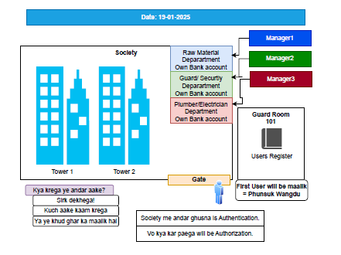
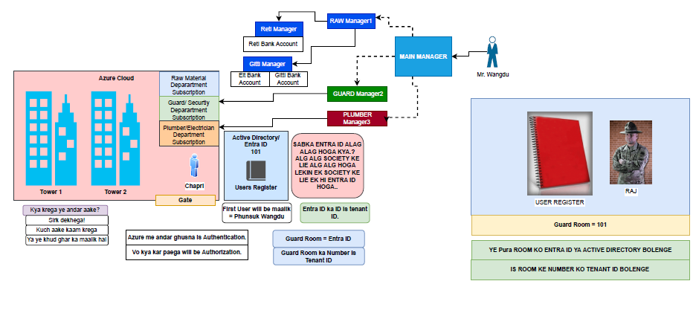

Azure Users and their roles
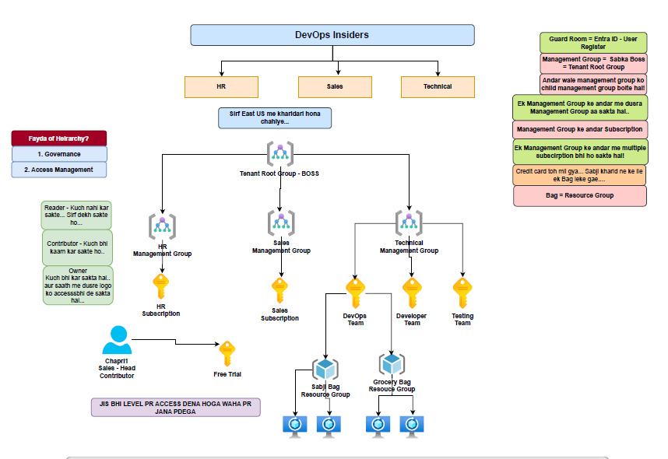

Notes on Owner, Reader, and Contributor Roles in Azure
Azure provides role-based access control (RBAC) to manage access to Azure resources. Three key built-in roles are:

1. Owner
- Permissions: Full control of all resources, including the ability to assign access to others.
- Use Case: Typically assigned to administrators or individuals who need full control over a subscription or resource group.

2. Contributor
- Permissions: Can create and manage all types of Azure resources but cannot grant access to others.
- Use Case: Suitable for developers or DevOps engineers who need to manage resources but don’t need to assign permissions.

3. Reader
- Permissions: Can only view resources and their configurations. No permissions to modify or delete resources.
- Use Case: Best for auditors or team members who need to monitor resources without making changes.

How to Create a User and Assign Access to a Subscription
- Create a User:
  - Go to Azure Active Directory in the Azure portal.
  - Navigate to Users > New User.
  - Fill in the details such as user name, name, and password.
  - Click Create.
- Assign Access to a Subscription:
  - Go to Subscriptions in the Azure portal.
  - Select the desired subscription.
  - Navigate to Access control (IAM).
  - Click Add > Add role assignment.
  - Choose the Role (Owner, Contributor, or Reader).
  - Select the User you just created.
  - Click Save.

What is a Resource Group?
- Definition: A resource group is a container in Azure that holds related resources for an Azure solution. It allows you to manage and organize resources like VMs, storage accounts, and databases.
- Purpose:
  - Simplifies the management of resources.
  - Enables bulk operations like deploying, updating, or deleting all resources in the group.
  - Useful for applying permissions and policies at the group level.

How to Create a Resource Group
- Using the Azure Portal:
  - Go to Resource Groups in the Azure portal.
  - Click Create.
  - Provide:
    - Subscription: Select the subscription to associate the resource group.
    - Resource Group Name: Enter a unique name.
    - Region: Choose the region where the resources in this group will reside.
  - Click Review + Create, then Create.

Azure VS Directory roles

1. Azure AD Roles (Microsoft Entra ID Roles)
- Scope: Manages identity and access at the directory (tenant) level.
- Purpose: Controls access to Azure AD resources like users, groups, applications, and policies.
- Management Tool: Managed in Microsoft Entra ID (formerly Azure AD).
- Common Roles:
  - Global Administrator – Full control over Azure AD and services.
  - User Administrator – Manages users and groups.
  - Application Administrator – Manages app registrations and enterprise apps.
  - Security Administrator – Manages security policies and reports.
  - Privileged Role Administrator – Manages role assignments in Azure AD.
- Use Cases:
  - Managing users, groups, and app registrations.
  - Configuring authentication policies.
  - Assigning enterprise app permissions.

2. Azure Roles (Azure RBAC - Role-Based Access Control)
- Scope: Manages access at the Azure resource level (subscriptions, resource groups, VMs, storage, etc.).
- Purpose: Grants permissions to manage Azure resources.
- Management Tool: Managed in Azure Resource Manager (ARM).
- Common Roles:
  - Owner – Full control, including assigning roles.
  - Contributor – Can manage resources but cannot assign roles.
  - Reader – Read-only access to resources.
  - User Access Administrator – Manages RBAC permissions.
  - Custom Roles – Defined based on specific needs.
- Use Cases:
  - Granting access to virtual machines, databases, storage accounts.
  - Managing Kubernetes clusters (e.g., AKS).
  - Assigning different permissions to teams.

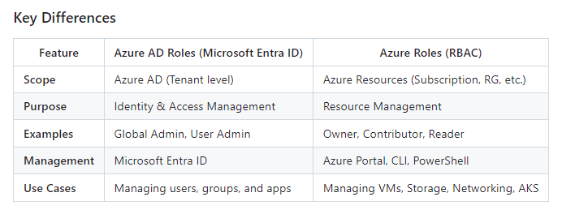

Steps to Create a New HR User (Laila) in Entra ID
- Sign in to Microsoft Entra ID
  - Go to Microsoft Entra ID (Azure AD).
  - Navigate to Users → New User.
- Create the User
  - Select Create user.
  - Fill in the details:
    - User Principal Name (UPN): laila@yourdomain.com
    - Name: Laila
    - First name: Laila
    - Last name: HR
  - Set an initial password (ensure the user changes it upon first login).
- Assign HR Role (Optional, if needed for HR functionalities)
  - Go to Roles and administrators.
  - Assign appropriate HR-related roles if required.

Grant Contributor Access to the Management Group
- Navigate to Management Groups
  - Go to Azure Portal → Management Groups (https://portal.azure.com/#blade/Microsoft_Azure_Resources/ManagementGroupsBlade).
- Select the Target Management Group
  - Choose the Management Group where access is needed.
- Assign IAM Role
  - Click on Access Control (IAM) → Add role assignment.
  - Select Contributor role.
  - Under Members, add laila@yourdomain.com.
  - Click Review + Assign.

Verification
- Ask Laila to log in to Azure Portal (https://portal.azure.com) and verify that she has Contributor permissions on the Management Group.
- Ensure she can manage resources but not assign roles (Contributor role does not allow RBAC assignments).

Managing Groups in Entra ID (Azure AD)
Groups in Microsoft Entra ID (formerly Azure AD) help manage access to resources efficiently by assigning permissions to multiple users at once.

Types of Groups in Entra ID
- Security Groups
  - Used to manage user and device access to resources (e.g., applications, files, subscriptions).
  - Can be assigned to RBAC (Role-Based Access Control) roles.
  - Supports dynamic membership based on user/device attributes.
- Microsoft 365 Groups
  - Used for collaboration (e.g., in Outlook, Teams, SharePoint).
  - Provides shared mailbox, calendar, and OneDrive.
  - Not used for RBAC assignments.

Steps to Create a Group in Entra ID
- Sign in to Entra ID
  - Go to Entra ID Portal.
  - Navigate to Groups → New group.
- Choose Group Type
  - Select Security (for role-based access) or Microsoft 365 (for collaboration).
- Fill in Details
  - Group Name: HR Team
  - Group Description: Group for HR team members with management access.
  - Membership Type:
    - Assigned: Manually add users.
    - Dynamic User: Auto-add users based on attributes (e.g., department = HR).
    - Dynamic Device: Auto-add devices based on attributes.
- Add Members
  - Click Members → Add laila@yourdomain.com and other HR users.
- Create Group

Granting Group Access to Management Group
- Navigate to Management Groups
  - Go to Azure Portal → Management Groups (https://portal.azure.com/#blade/Microsoft_Azure_Resources/ManagementGroupsBlade).
- Select the Target Management Group
  - Choose the Management Group where access is required.
- Assign IAM Role to Group
  - Click Access Control (IAM) → Add role assignment.
  - Select Contributor role.
  - Under Members, select the HR Team group.
  - Click Review + Assign.

Benefits of Using Groups for Access Control
✅ Easier Management – Assign roles to a group instead of individual users.
✅ Improved Security – Ensures only authorized teams have access.
✅ Automation – Dynamic groups reduce manual intervention.
✅ Scalability – As new employees join, they inherit permissions automatically.

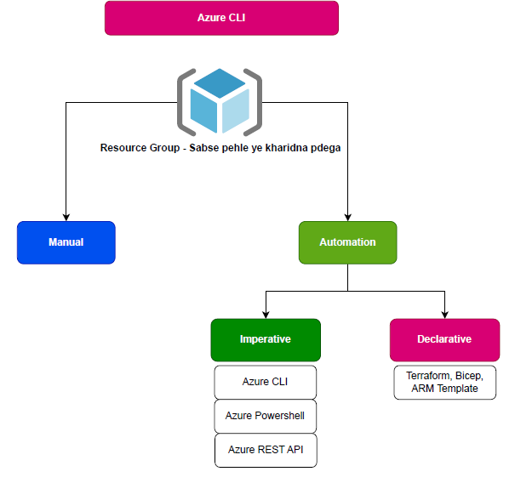
First we needs to know how we can run azure CLI using windows power shell and CMD.
Steps to install >> Google.com >> install azure cli for windows >> https://learn.microsoft.com/en-us/cli/azure/install-azure-cli-windows?pivots=msi >> check on Microsoft installer MSI >> download 64Bit MSI of Azure CLI >> https://aka.ms/installazurecliwindowsx64 >> run the file
Steps to run the azure CLI using PowerShell/CMD >> open power shell/CMD >> type AZ >> or type AZ - -help (-h)
To create Resource Group in Azure CLI command >> az group - - help >> az group create - - help >>
- az group create - l centralindia - n RG-CI
- az group delete - l centralindia - n RG-CI

1. Azure Storage Account
- Azure Storage Account is a cloud storage solution provided by Microsoft Azure.
- It offers several types of storage services:
  - Blob storage: Used for storing large amounts of unstructured data, such as text or binary data.
  - File share: Provides shared access to files with the SMB protocol.
  - Table storage: NoSQL data store for storing structured datasets.
  - Queue storage: Messaging store for reliable messaging between application components.
- Each type serves different purposes and is suitable for different scenarios.

2. Region and Zones
- Azure is divided into geographical regions, each containing one or more datacentres.
- Regions are important for ensuring data residency, compliance, and high availability.
- Within each region, Azure datacentres are further divided into availability zones.
- Availability zones are physically separate locations within an Azure region, each with independent power, cooling, and networking.
- Deploying resources across availability zones increases resilience against datacentre failures.

3. Redundancy - LRS, ZRS, GRS
- Redundancy options in Azure Storage Account ensure data durability and availability.
- Locally Redundant Storage (LRS): Data is replicated within a single datacentre.
- Zone-Redundant Storage (ZRS): Data is replicated across multiple availability zones in the same region.
- Geo-Redundant Storage (GRS): Data is replicated to a secondary region, providing data redundancy across regions for disaster recovery.

