Interview Prep (Linting tools & Security tools)

• SAST = Code ko dekh-kar bug pakadna
• DAST = Running app ko attack karke bug pakadna

INFRA-SAST Tools: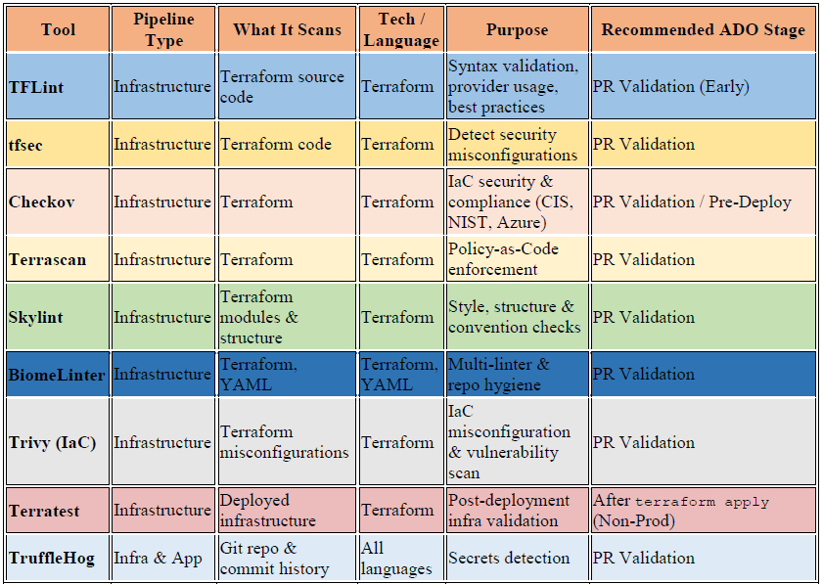

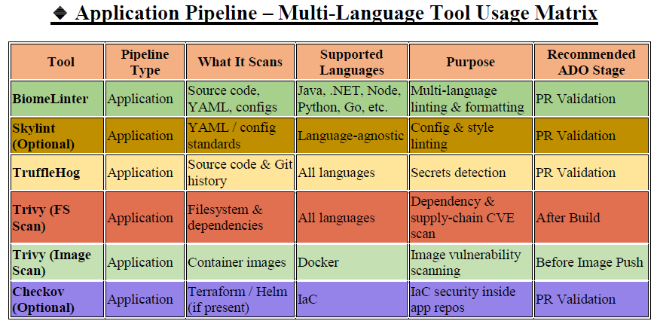

Infra Cost Analysis (FinOps Tools/Cost Management)
Infrastructure cost ko code stage pe hi predict karna

