Instructions:

·         Unzip Archive.zip file somewhere, which contains:

o    The hh-reporter app, OS X build

o    mso-list.csv file with MSO’s data (id, name)

·         Create a folder and a file for AWS credentials:

o    mkdir ~/.aws

o    touch ~/.aws/credentials

·         Add the following to the **~/.aws/credentials** file (enter the access key values provided earlier):

o    *[default]*

o    *aws_access_key_id = <AWS ACCESS KEY>*

o    *aws_secret_access_key = <AWS SECRET ACCESS KEY>*

·         From the folder you have unzipped the Archive, run the following command (replace the date values as needed) – sample output provided:

o    *./hh-reporter -from 20160601 -to 20160701 -v=false*

o    *2016/07/05 13:21:09 Number of objects:  160*

o    *2016/07/05 13:21:10 No failed downloads*

o    *2016/07/05 13:21:10 Starting reading/aggregating the results*

o    *2016/07/05 13:21:10 Aggregated final:*

o    *2016/07/05 13:21:10 Saved the report in file:  hh-report-20160601-20160701.csv*

o    *2016/07/05 13:21:10 Processed 5 MSO's, 31 days, in 1.811335589s*

Important note: the run of this command will create the following folder structure under that working folder:

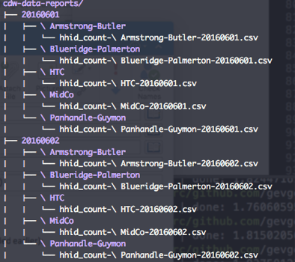

You will need to delete the cdw-data-reports content from previous hh-reporter runs, prior running another command for a different date ranges, otherwise the report will contain all data from all runs.

It intentionally does not clean this data from hh-reporter, as you might want to use the downloaded data after the run, besides the generated aggregated report.

Help:

$>*./hh-reporter -h*

*/hh-reporter, ver. 0.1*

*Command line:*

*prompt$>./hh-reporter -r <aws_region> -b <s3_bucket_name> --from <date> --to <date> -m <mso-list-file-name> -M <max_retry>*

*Usage of ./hh-reporter:*

*-M Max attempts*

*Max attempts to retry download from aws.s3 (default 3)*

*-b Bucket name*

*Bucket name (default "daap-hh-count")*

*-c concurrent*

*The number of files to process concurrently (default 10)*

*-from Date from*

*Date from (default "20160705")*

*-h          Help*

*-m MSO*

*Filename for MSO list (default "mso-list.csv")*

*-r AWS Region*

*AWS Region (default "us-west-2")*

*-to Date to*

*Date to (default "20160705")*

*-v Verbose*

*Verbose: outputs to the screen (default true)*