Room Tracker
Release history & onboarding guide
For new team members joining the housekeeping crew

Welcome — what this is
Room Tracker is the digital checklist we use to coordinate housekeeping across both towers (East and West). It lives at https://gevi14.github.io/Room-Task-Tracker/ and works on phones, tablets, and computers — every check-mark you make appears on everyone else's device within a second or two.
This document is a chronological walk-through of every feature the app has — newest at the bottom, oldest at the top. Read it cover-to-cover on your first day, then keep it around as a reference. The most important section for actually using the app day-to-day is v2 (sign-in) — that's where the rules for logging in live.

Quick start (30 seconds)
- Open https://gevi14.github.io/Room-Task-Tracker/
- Enter your name (it must match the one your admin registered for you — exact spelling)
- Type the property PIN: 27200
- Tap Start. You're in.
- Tap any check-box next to a room and task. That mark is now visible to everyone else.
- To install on iPhone: open the URL in Safari → Share → Add to Home Screen.
If your name isn't on the staff list yet, ask the property admin (Geverson) to add you. It takes under a minute.

v1 — Original features
Released May 12, 2026 — the first public version
The app launched with a five-task checklist per room across both towers. Most of what you see today comes from this initial release. Visual updates and workflow improvements landed alongside the launch.

Five tasks per room
Every room has the same five tasks: Bed Pads, Shower Bottles, Lotion, Beacon, and Closet Hooks. Each task is a check-box. Check it when the task is done; uncheck it if you made a mistake or need to redo. The whole team sees the change instantly.

Color-coded progress
Each task percentage in the summary row is color-coded so you can read progress at a glance:
- Red below 33 percent
- Orange 33 to 65 percent
- Yellow 66 to 99 percent
- Green at 100 percent
The progress bar beneath each percentage uses the same color and is taller than before for visibility. The floor tabs (Floor 2, Floor 3, …) carry the same color tiers next to each floor number.
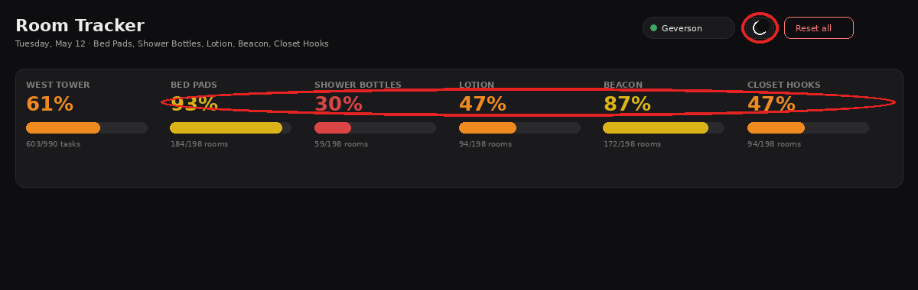
Header with the dark/light theme toggle (left) and color-coded percentages (right).

Dark / light theme
A sun/moon icon in the header switches the entire app between a dark and a light theme. The choice is saved per device, so each housekeeper or supervisor can pick what works best for them.

Floors and rooms
East Tower includes Floor 1 (rooms 114, 117, 118), and Floors 2–8 (with the standard room numbering). West Tower runs from Floor 2 to Floor 9. A few rooms are skipped on each floor by convention; the app already knows which ones.

Select all per task column
Each task column header on the floor table has a small Select all pill button. One tap marks every room on the current floor as done for that task and stamps your name on each. When all rooms on the floor are already done, the pill turns green and reads Clear all — pressing it then clears the column. The pill always reflects the current state of the column.
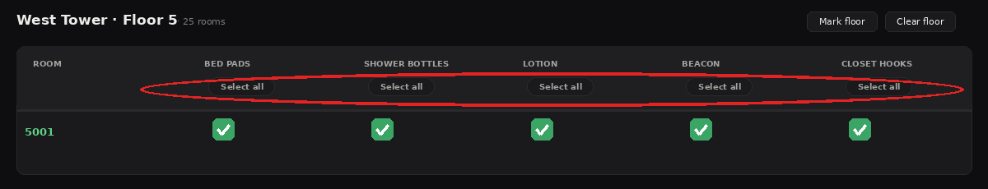
The Select all pill button under each task column header.

Task detail view
Every task percentage card in the summary row is clickable. Tapping one opens a detail view that lists every room across both towers with each room shown as a colored pill: green if done, gray if not. This makes it easy to scan, at a glance, exactly which rooms still need that task — without scrolling through floors one at a time.
At the top of the detail view there are three filter pills: All, Completed, and Incomplete, each showing a live count. The list refreshes instantly when you switch filters, and tapping any room pill toggles that task for that room — useful for cleaning up the stragglers at the end of a shift.
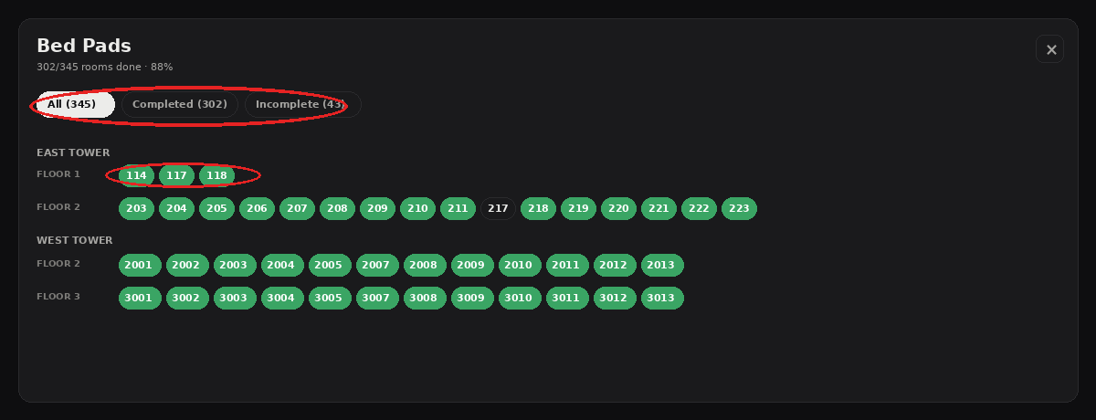
Detail view for one task — filter pills at the top, room pills grouped by tower and floor.

v2 — Security & PIN login
Released May 12, 2026 — same day as v1, evening rollout
The first version let anyone type any name and start using the app. v2 added a name allowlist plus a property PIN, so only registered staff can sign in. It also added an admin-only activity log and admin-only Reset all button to prevent accidents.

How sign-in works now
The login screen has two fields:
- Your name — must match the name your admin has registered for you on the staff list. Use the exact spelling. If your name isn't on the list, you won't get in.
- Property PIN — the same PIN for everyone on the team.
Current property PIN: 27200
Please keep this PIN confidential — don't post it, text it, or share it with vendors or guests. If you suspect it's leaked, tell the admin and it'll be changed immediately.

New for staff (visible to everyone)
- Real names required. No more typing whatever you want. Your check-marks are now tagged to your actual staff name automatically.
- Reset is admin-only. The big Reset all button is hidden for non-admins, so no more accidental wipes of the whole day's work.

New for admins (Geverson and supervisors)
- Activity log. A full history of who did what and when — every check, uncheck, mark-floor, clear-floor, and reset. The log keeps the last 30 days. Day-to-day, you'll never need to think about it; when something looks off, you can pull it up.
- Edit tasks. Admins can rename, add, or remove tasks live from the app — no code change needed. Renaming preserves existing check-marks.
- Reset all. Available only to admins. Clears every check-mark across both towers in one action.

Installing on devices

iPhone
- Open https://gevi14.github.io/Room-Task-Tracker/ in Safari (not Chrome).
- Tap the Share button (square with up-arrow) at the bottom.
- Scroll down and tap Add to Home Screen.
- Tap Add. The app icon now lives on your home screen.

Windows or Mac desktop
- Open the URL in Chrome or Edge.
- Click the three-dot menu in the top right of the browser.
- Chrome: Save and share → Create shortcut. Edge: Apps → Install this site as an app.
- Name it Room Tracker. In Chrome, check Open as window. Click Create / Install.
- The app appears as an icon on your Desktop and in your Start menu.

Common login errors
- Wrong PIN — double-check you typed 27200 exactly.
- That name isn't on the staff list — tell the admin and they'll add you in under a minute.
- Your account is inactive — same as above, ask the admin to reactivate you.

v3 — Microsoft 365 sign-in (dormant)
Released May 20, 2026 — installed but not enabled
The app code includes a hybrid sign-in option that would let supervisors and office staff sign in with their work Microsoft 365 accounts instead of (or alongside) the PIN. This is fully wired up in the code but currently turned off.
If and when this is enabled, the login screen will show a Sign in with Microsoft button above the existing name + PIN fields, with a small divider in between. Housekeepers continue with name + PIN on shared phones, exactly as before. Supervisors and admins can choose to use their M365 work account instead — that route gives stronger identity verification (no shared PIN), but requires each person to have an M365 license.
To enable later: follow the steps in SECURITY-MICROSOFT.md in the room-tracker-app folder. Until then, nothing changes for any user.

v4 — PBR home & cycle tracking
Released May 27, 2026 — current version
This release adds a property-wide home view, deadline tracking for tasks, per-column floor percentages, and a smoother color scale near the finish line.

At a glance
- PBR home — new property-wide overview that opens by default, with a centered hero header and East / West breakdown on every task card.
- Home icon — small house in the header takes you back to PBR from anywhere.
- Column percentages — each task column on the floor view now shows what fraction of that floor's rooms are done, with the exact count underneath.
- Smoother colors near 100% — percentages between 90 and 100 now slide gradually from yellow into green instead of jumping.
- Cycle timer — admins can start a tracking cycle on any task with a target completion date. Everyone sees the deadline; the chip colors itself green to red as the date approaches.

PBR home
Opening the app now lands you on a property-wide overview screen labeled PBR. At the top is a centered hero banner showing the total property percentage in large type, with a progress bar and the totals (e.g. 632 / 820 tasks complete) underneath. Just below those is the East / West split so you can see how each tower is performing at a glance.
Below the hero, the five task cards (Bed Pads, Shower Bottles, Lotion, Beacon, Closet Hooks) are laid out in a two-column grid. Each card is noticeably larger than in the per-tower view, and each one carries its own East / West breakdown row under the progress bar.
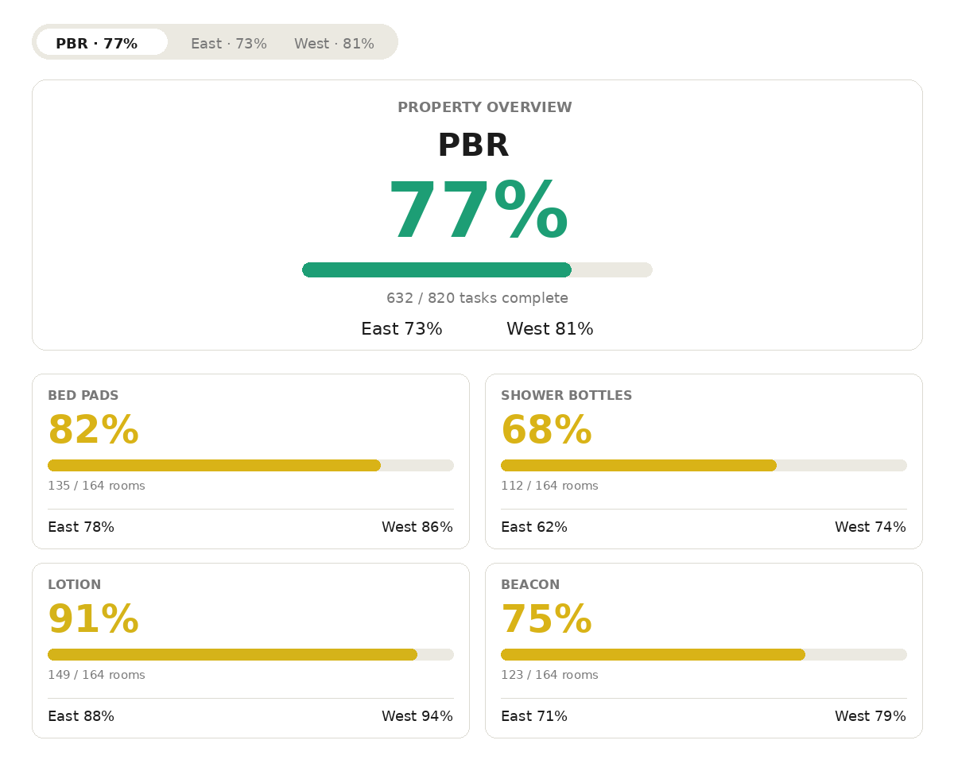
PBR home — centered hero with property percentage and East/West split, and 2-column big cards below.
Tapping East or West in the bar at the top takes you back to the per-tower checklist view, which works exactly like before.

Home icon
A small house-shaped icon now sits in the page header, immediately to the left of the dark/light theme toggle. Tap it from anywhere in the app — a floor view, the activity log, the task editor — to jump back to the PBR home screen in one click.

Per-column floor percentages
On the floor checklist (after you've picked a specific floor of East or West), each task column header now includes a small colored percentage right under the task name. The percentage shows what fraction of this floor's rooms have that task checked off. Below the percentage, in muted gray, is the raw count — for example, 19/20 if nineteen of twenty rooms are done. When a column reaches 100 percent, the fraction underneath disappears.
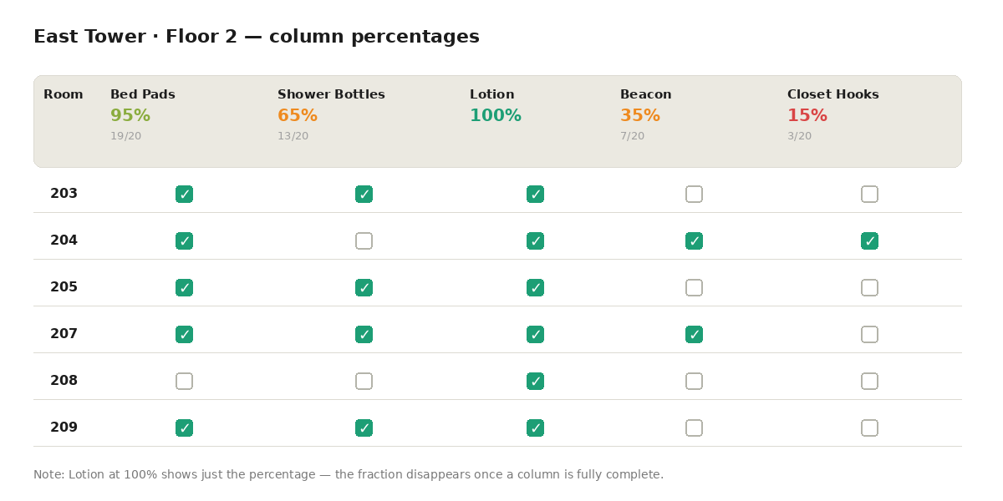
Each task column shows its completion % with the exact count below it.

Smoother colors near 100%
Percentages from 90 to 100 now smoothly slide from yellow into green. The closer you get to 100, the greener it looks: 91 percent is barely shifted from yellow, 95 is noticeably trending green, 99 is almost the full final green, and 100 is identical to the check-mark green. Applies everywhere a percentage shows up.
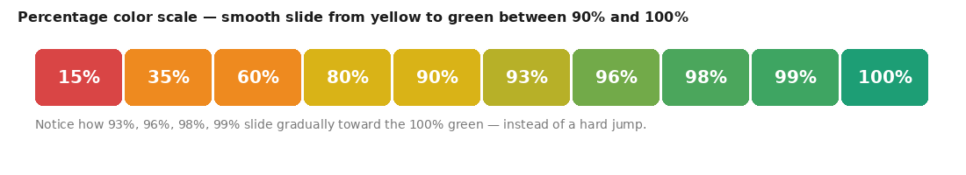
The 90-to-100 range now slides smoothly from yellow into green.

Cycle timer for tasks
Admins can start a tracking cycle on any task — useful for periodic work like refilling shampoo bottles where you want to know when you started this round and when you want it done by.

Starting a cycle (admin only)
On any task card with no active cycle, admins see a small Start cycle pill. Tapping it opens a small date picker with two fields: start date (defaults to today) and target complete-by date (defaults to two weeks out). Once you save, the cycle becomes visible to everyone.

What everyone sees
Once a cycle is active, every task card with that cycle shows a small line such as Started May 10 · Target May 20, with a colored chip on the right showing days remaining. The chip uses the same color scale as percentages, but measures time left: green when most of the cycle remains, orange as the deadline approaches, red when it is overdue. The chip updates automatically as days pass.
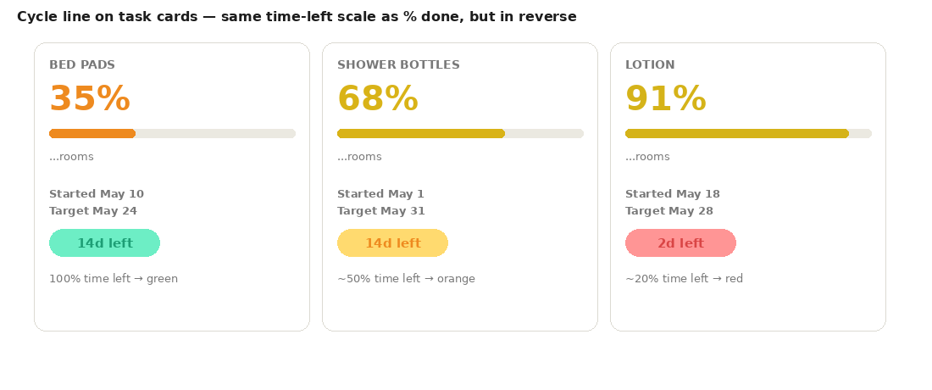
Days-left chip uses the time-left percentage: green when most of the cycle remains, red as the deadline approaches.

Automatic close
When the task hits 100 percent across the whole property, its cycle closes automatically and is logged as completed in N days in the activity log. The card returns to showing the Start cycle pill, ready for the next round.

Appendix

Who to contact
- Property admin: Geverson
- App live URL: https://gevi14.github.io/Room-Task-Tracker/
- Source code: https://github.com/gevi14/Room-Task-Tracker

Glossary
- Cycle — a tracked period for one task with a start date and target complete-by date, set by an admin.
- Tier 1 security — the current sign-in model: name allowlist + shared property PIN.
- PBR — the property name used as a label for the property-wide overview screen.
- Stat card — one of the boxes near the top of the app showing a label, percentage, progress bar, and breakdown.
- Activity log — the admin-only audit history of every check, uncheck, mark, and reset for the last 30 days.

If something looks broken
Hard-refresh the page first: Ctrl+Shift+R on desktop, or close-and-reopen the app on phone. Most weirdness is just a cached old version. If it's still broken after a hard-refresh, tell the admin — usually a known fix or a quick code update.

Room Tracker — a private property tool for hotel housekeeping coordination.

