Room Tracker — Release Notes
v4 · build 2026-05-26-pbr-home-v4 · May 27, 2026

This release adds a property-wide home view, deadline tracking for tasks, per-column floor percentages, and a smoother color scale near the finish line. None of the changes affect how you sign in or how your existing data is stored — the way checkboxes work and the way the staff list is managed are unchanged.

At a glance
- PBR home — new property-wide overview that opens by default, with a centered hero header and East / West breakdown on every task card.
- Home icon — small house in the header takes you back to PBR from anywhere.
- Column percentages — each task column on the floor view now shows what fraction of that floor's rooms are done, with the exact count underneath.
- Smoother colors near 100% — percentages between 90 and 100 now slide gradually from yellow into green instead of jumping.
- Cycle timer — admins can start a tracking cycle on any task with a target completion date. Everyone sees the deadline; the chip colors itself green to red as the date approaches.

PBR home
Opening the app now lands you on a property-wide overview screen labeled PBR. At the top is a centered hero banner showing the total property percentage in large type, with a progress bar and the totals (e.g. 632 / 820 tasks complete) underneath. Just below those is the East / West split so you can see how each tower is performing at a glance.
Below the hero, the five task cards (Bed Pads, Shower Bottles, Lotion, Beacon, Closet Hooks) are laid out in a two-column grid. Each card is noticeably larger than in the per-tower view, and each one carries its own East / West breakdown row under the progress bar. This makes it easy to spot which tower is dragging a particular task down — for instance, if Shower Bottles is sitting at 68 percent and you see East 62, West 74 underneath, you know where to focus.
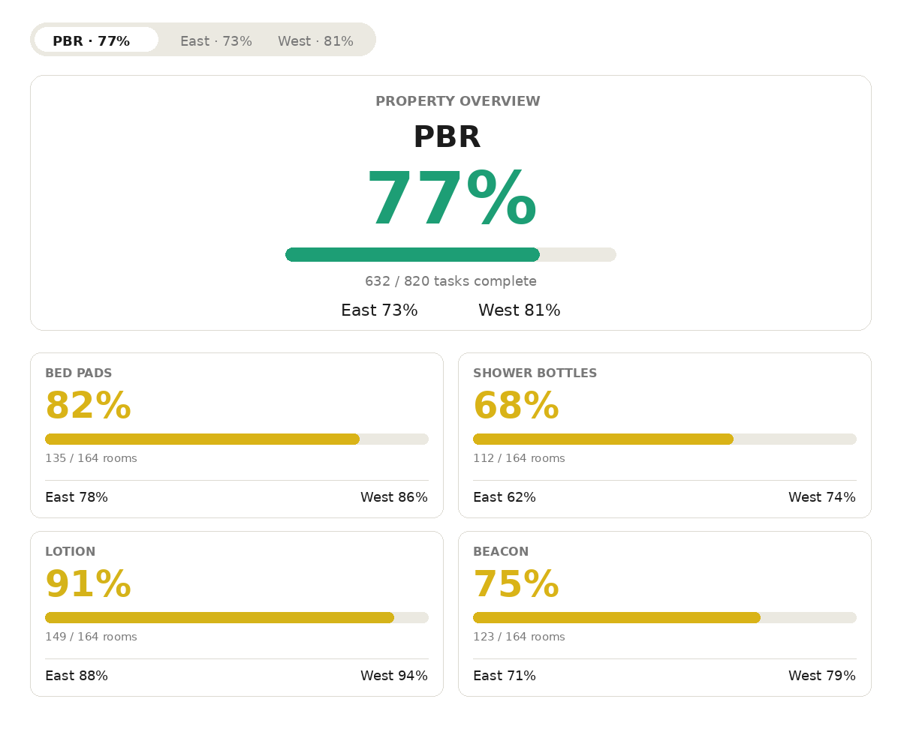
PBR home — centered hero with property percentage + East/West split, and 2-column big cards below.
Tapping the East or West tabs in the bar at the top of the page takes you back to the per-tower checklist view, which works exactly like before.

Why it matters
Most days you don't need the floor-by-floor checklist — you just want to know how the property is doing right now. PBR home gives you that answer in one screen, and the East / West split tells you whether the gap is real or just one tower lagging.

Home icon
A small house-shaped icon now sits in the page header, immediately to the left of the dark/light theme toggle. Tap it from anywhere in the app — a floor view, the activity log, the task editor — to jump back to the PBR home screen in one click.
Returning users keep their last view (East or West) restored on subsequent visits. The home icon is the quickest way to get back to the property overview without using the tower bar.

Per-column floor percentages
On the floor checklist (after you've picked a specific floor of East or West), each task column header now includes a small colored percentage right under the task name. The percentage shows what fraction of this floor's rooms have that task checked off. Below the percentage, in muted gray, is the raw count — for example, 19/20 if nineteen of twenty rooms are done.
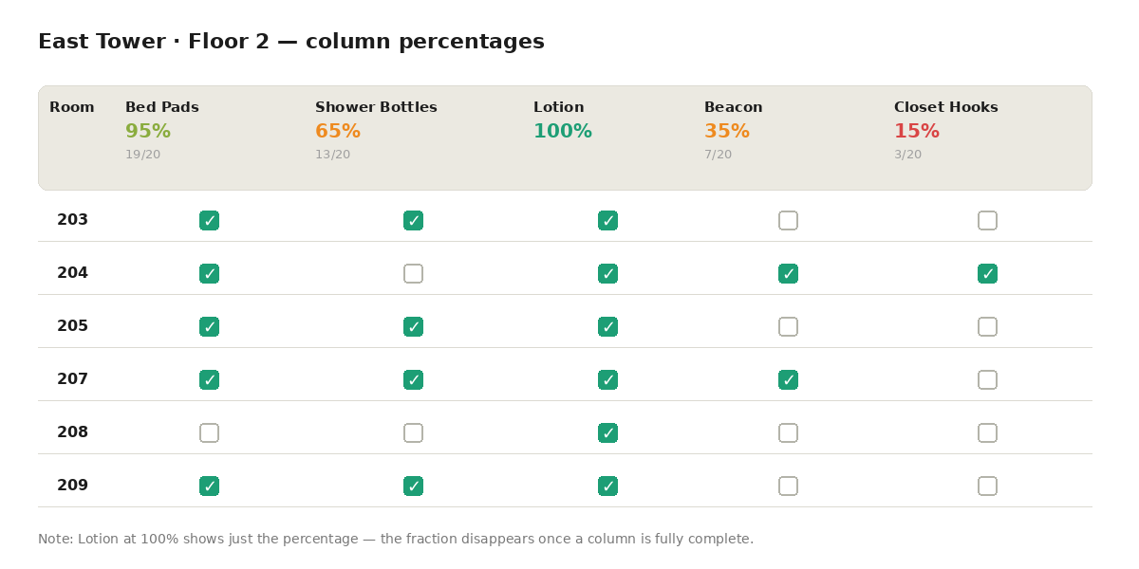
Each task column shows that column's completion % with the exact count below it.
Color rules are the same as the summary cards: red below 33 percent, orange up to 66, yellow up to 90, green at 100. Between 90 and 100 the color slides smoothly from yellow into green (see Color gradient below).
When a column reaches 100 percent, the fraction underneath disappears — at that point the percentage alone tells the full story. The Select all / Clear all pill remains in its existing position.

Smoother colors near 100%
Previously, a task at 95 or 99 percent looked exactly the same yellow as a task at 67 percent. The jump to green happened only at exactly 100. That made it hard to tell at a glance whether a task was almost done or just middling.
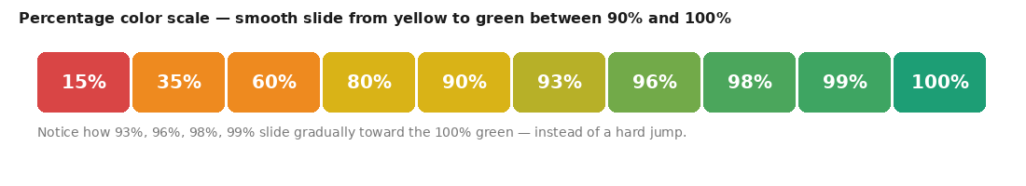
The 90-to-100 range now slides smoothly from yellow into green.
Now, percentages from 90 to 100 smoothly slide from yellow into green. The closer you get to 100, the greener it looks: 91 percent is barely shifted from yellow, 95 is noticeably trending green, 99 is almost the full final green, and 100 is identical to the check-mark green.
The change applies everywhere a percentage is displayed: summary cards, the PBR hero header, floor tabs, and the new per-column percentages on the floor view.

Cycle timer for tasks
Admins can now start a tracking cycle on any task — useful for periodic tasks like refilling shampoo bottles where you want to know when you started this round and when you want it done by.

Starting a cycle (admin only)
On any task card with no active cycle, admins see a small Start cycle pill. Tapping it opens a small date picker with two fields: start date (defaults to today) and target complete-by date (defaults to two weeks out). Once you save, the cycle becomes visible to everyone.

What everyone sees
Once a cycle is active, every task card with an active cycle shows a small line such as Started May 10 · Target May 20, with a colored chip on the right showing days remaining. The chip uses the same color scale as percentages, but measures time left: green when most of the cycle remains, orange as the deadline approaches, red when it is overdue. The chip color updates automatically as days pass — you don't have to do anything.
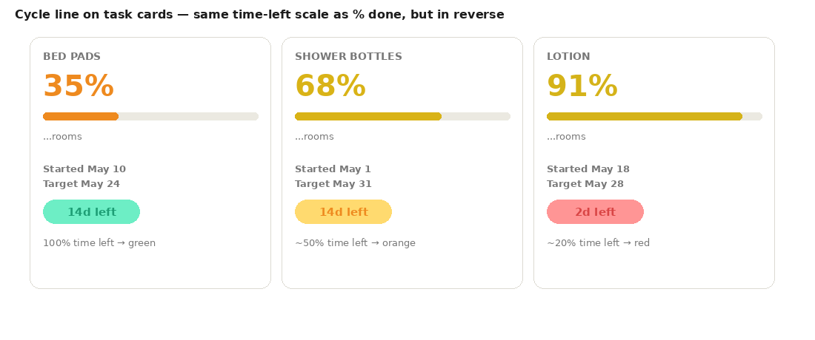
Days-left chip uses the time-left percentage: green when most of the cycle remains, red as the deadline approaches.

Automatic close
When the task hits 100 percent across the whole property, its cycle closes automatically and is logged as completed in N days in the activity log. The card returns to showing the Start cycle pill, ready for the next round.

Editing or ending a cycle (admin only)
Admins can tap the cycle line on a stat card to open the date editor and change the start or target dates, or clear the cycle. The admin Activity panel also has an Active cycles section at the top showing every running cycle with elapsed days, days remaining, the staff member who started it, and Edit / End buttons.

Under the hood
- No changes to sign-in. Name + property PIN works exactly as before. The Microsoft 365 hook from the previous release is still present but dormant — flip it on later by following SECURITY-MICROSOFT.md.
- No changes to Firestore rules in this release. The /config/cycles document is covered by the existing /config/{id} admin-write rule from the previous release.
- Activity log gains three new entry types: cycle-start, cycle-complete, cycle-reset. Same 30-day TTL retention as everything else.
- Build identifier: 2026-05-26-pbr-home-v4
- To verify the live version after upload, open the app, press F12, and paste: document.querySelector('meta[name="rt-build"]').content

How to ship this release
1. Go to https://github.com/gevi14/Room-Task-Tracker/upload/main
2. Drag index.html from C:\Users\gdossantos\Room_Tracker\room-tracker-app\ onto the page.
3. Click Commit changes
4. Wait about 30 seconds, then hard-refresh the live app: Ctrl+Shift+R on desktop, or close and re-open the PWA on phone.
5. Confirm the new PBR home screen appears when you open the app.

What's next
This release closes out the property overview and cycle-tracking work. Open items collected but not yet built: optional Microsoft 365 sign-in for office staff (code is already in place, just needs the Azure registration step). Anything else you want added, reply to the rollout email or send it directly.

Room Tracker is a private property tool for hotel housekeeping coordination.

