Room Task Tracker — What's New
May 12, 2026 • Release update
Below is a summary of the recent updates to the Room Task Tracker app. The tracker is live at https://gevi14.github.io/Room-Task-Tracker/ and is now in use across both towers. Each update is highlighted in red on the screenshots below. The changes break down into three categories: visual, content, and workflow.
1. Visual & UX improvements
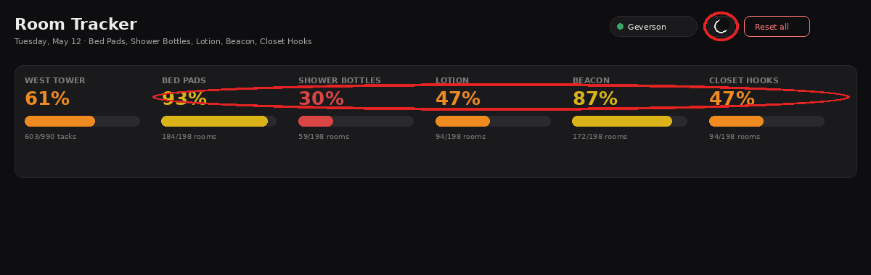
Header bar with the new theme toggle (left red oval) and the new color-coded percentage tiers (right red oval).
Color-coded progress indicators
Each task percentage in the summary row is now color-coded so progress is readable at a glance. The tiers are: red below 33 %, orange 33–65 %, yellow 66–99 %, and green at 100 %. The progress bar beneath each percentage uses the same color and is also taller than before for visibility. The floor tabs (Floor 2, Floor 3, …) carry the same color tiers next to each floor number.
Dark / Light theme toggle
A new sun/moon icon in the header switches the entire app between a dark theme and a light theme. The choice is saved per device, so each housekeeper or supervisor can pick what works best for them.
2. New tasks and rooms
Closet Hooks added as a fifth task
Every room now has five tasks instead of four: Bed Pads, Shower Bottles, Lotion, Beacon, and the new Closet Hooks. The new column appears on every floor of both towers and works exactly like the others.
East Tower Floor 1 added
East Tower now includes Floor 1 with rooms 114, 117, and 118. A new "Floor 1" tab is available in the East Tower view.
3. Workflow improvements
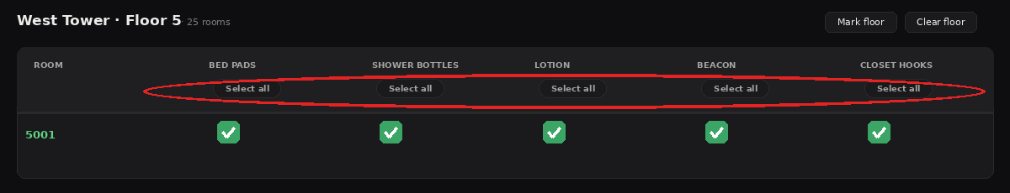
"Select all" pill button under each task column header (red oval). One tap marks every room on the current floor done for that task.
"Select all" button per task column
Each task column header on the floor table now has a small "Select all" button. One tap marks every room on the current floor as done for that task and stamps your name on each. When all rooms on the floor are already done, the button turns green and reads "Clear all" — pressing it then clears the column. The button always reflects the current state of the column.
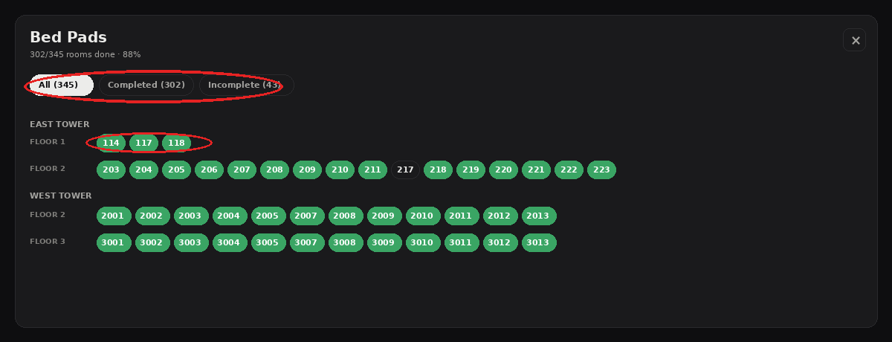
Detail view for one task. Red oval at top: the three filter pills (All / Completed / Incomplete). Red oval below: room chips grouped by tower and floor — each one is itself clickable to toggle that task.
Click a task percentage to see all rooms for that task
Every task percentage card in the summary row (Bed Pads, Shower Bottles, Lotion, Beacon, Closet Hooks) is now clickable. Tapping it opens a detail view that lists every room across both towers and every floor, with each room shown as a pill: green if done, gray if not. This makes it easy to scan, at a single glance, exactly which rooms still need that task — without scrolling through floors one at a time.
Filter the detail view
At the top of the detail view are three filter pills: All, Completed, and Incomplete, each showing a live count. The list refreshes instantly when you switch filters, and tapping any room pill toggles that task for that room — useful for cleaning up the stragglers at the end of a shift.
Try it
Open https://gevi14.github.io/Room-Task-Tracker/ on any phone or computer. On iPhone Safari, tap the Share button and choose "Add to Home Screen" to install it as an app icon. The tracker syncs across every device in real time.
— End of release notes

