D’s VM Setup Doc

Update Your Local Host File
From your machine
$ echo "<cloud VM IP here> D-CLOUD" | sudo tee -a /etc/hosts

Replace “D-CLOUD” with any name you want. This is the host name for your cloud PC so you can connect to it from your machine without having to remember the IP.

Set Up SSH Server - Part 1
From the cloud provider's console:
$ apt update
$ apt install openssh-server ufw -y
$ systemctl start ssh
$ systemctl enable ssh
$ ufw allow ssh
$ ufw enable
$ systemctl start ufw
$ systemctl enable ufw

From your machine, test connecting to your cloud PC via SSH using the password:
$ apt update
$ apt install openssh-client -y
$ ssh root@D-CLOUD #enter your password
$ useradd -m -G sudo -s /bin/bash muict
$ passwd muict #set your non-root password here

From your machine (out of your SSH session above):
$ ssh-keygen
$ ssh-copy-id muict@D-CLOUD

From your active SSH session:
$ nano /etc/ssh/sshd_config
Locate the “PasswordAuthentication” and "PermitRootLogin" lines and set to:
PasswordAuthentication no
PermitRootLogin no
Then, restart the service:

$ systemctl restart ssh
The SSH server should be all set up securely, and you shouldn’t need cloud provider’s console nor the root login anymore, unless there is an emergency.

Set Up RDP-Over-SSH
From an active SSH session:
$ sudo apt update
$ sudo apt install xrdp jwm -y
$ sudo nano /etc/xrdp/xrdp.ini

In the file, locate the line with “port=3389“ and change it to “port=tcp://.:3389”. Then, restart the service:
$ sudo systemctl restart xrdp

From your local machine:
$ sudo apt update
$ sudo apt install remmina -y

Open Remmina and click the “Add a new connection profile” button top-left of the screen.
Enter the name of the connection (I use “Cloud PC”). Then in the “Basic” tab, enter:
- Server: localhost:3389
- Username: muict
- Password: the non-root password you set earlier
In the “SSH Tunnel” tab, press the “Enable SSH Tunnel” button, and enter:
- Custom: D-CLOUD:22
- Authentication type: Public key (automatic)
- Username: muict
- SSH private key file: ~/.ssh/id_rsa
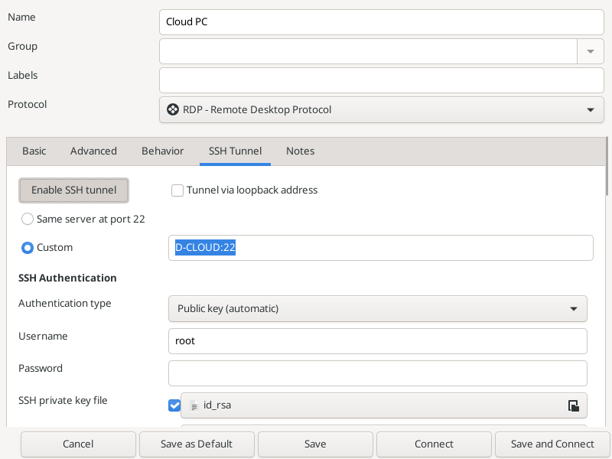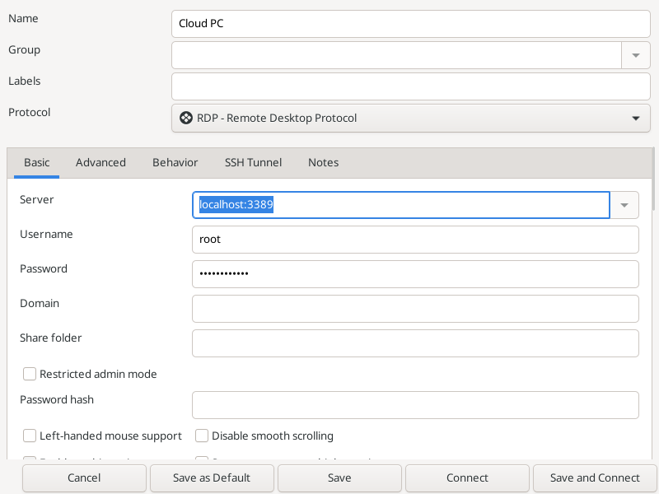
Press “Save and Connect”, and it should connect successfully.

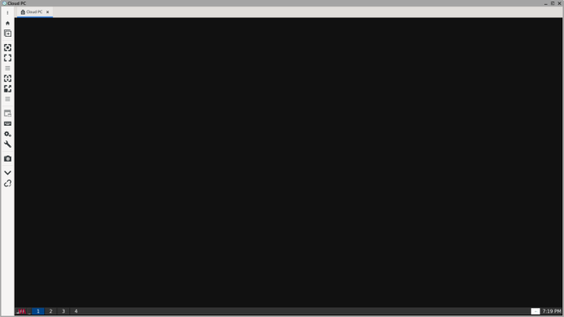
(If you can see the task bar at the bottom of the screen that’s a success.)

Set Up GUI & Software
Then run the following commands:
$ sudo apt update
$ sudo apt install lxterminal lxtask pcmanfm firefox-esr l3afpad \
notification-daemon xarchiver gnome-icon-theme gmrun rsync \
fasttrack-archive-keyring fonts-tlwg-laksaman -y
$ sudo update-alternatives --install /usr/bin/x-terminal-emulator \
x-terminal-emulator /usr/bin/lxterminal 100
$ cd ~
$ wget https://github.com/gewaleelek/basic-jwm-setup/raw/refs/heads/main/.jwmrc
$ mkdir ~/Documents
$ mkdir ~/Downloads
$ mkdir ~/Desktop
$ cp /usr/share/applications/lxterminal.desktop ~/Desktop
$ sudo shutdown -r now # this will restart
After the VM boots up, connect to it via RDP and you should see a better GUI and VirtualBox installed.
Note: to make it so that the desktop shortcuts don't ask you every time you double click on them, open the File Manager -> Edit -> Preferences -> "Don't ask options on launch executable files"

