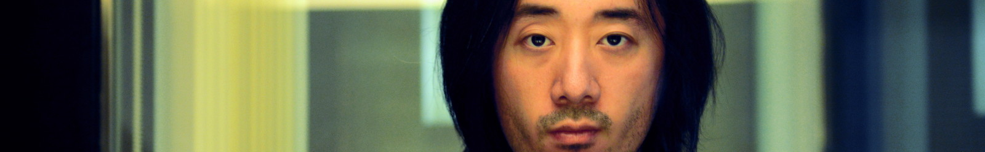

Ge Wang | Creative Consulting Rates

Consulting portfolio: http://www.gewang.com/consulting/
Contact: consulting@gewang.com

Billable Hourly Rates
These are my standard billable hourly rates. The billable hours correspond to demonstrable progress and concrete deliverables; in actuality the number of hours spent is usually higher than billed. Possible deliverables are below, will consult to fit your needs.

Product Design + Software Prototyping: $350 / hour
• product design: design documents, user interaction design, user interface design, storyboards, game design, gamefication, music learning system design, user-to-user social interaction design; specifications can be tailored for engineering team and product management team.
• software prototyping: multimedia software prototype in (well-documented) C/C++/Objective C, on either desktop or mobile device, high-performance graphics + audio; aimed to demonstrate novel interactions, product concepts, and storyboards; can prototype elements of the product design above.

Creative Marketing: $250 / hour
• strategy + action planning: documented, deep brainstorming sessions with team, branding analysis and planning, projections of scenarios of target user bases; aimed towards design and storyboards of video marketing, messaging, and launch plan.
• marketing videos: documented concept and storyboards; can synthesize a set of brand-specific best practices to optimize product showcase through video.
• press + PR coaching: collaboration to develop main messaging points for launch, press release, interviews, and public speaking / product demonstrations.

Video Production + Photography: rates dependent on scope of project
• video production: concept, storyboard, direction, camera work, editing (full pipeline).
• photography: high-end still photography for products.

