The Resonant Substrate Hypothesis (RSH) v14
A Unifying Law of Information, Energy, and Time: Linking Einstein, Planck, and Shannon through the Gewirtz Invariant

Author: Jeffrey Gewirtz
Independent Researcher in Theoretical & Mathematical Physics
DOI: https://doi.org/10.5281/zenodo.17558566
ORCID: 0009-0004-8500-0049
Correspondence: gewirtzjeffrey@gmail.com
Version 14 — November 2025
Licenses: CC BY 4.0 (text & figures) • MIT (software)
© 2025 Jeffrey Gewirtz. All Rights Reserved (except where otherwise noted)
.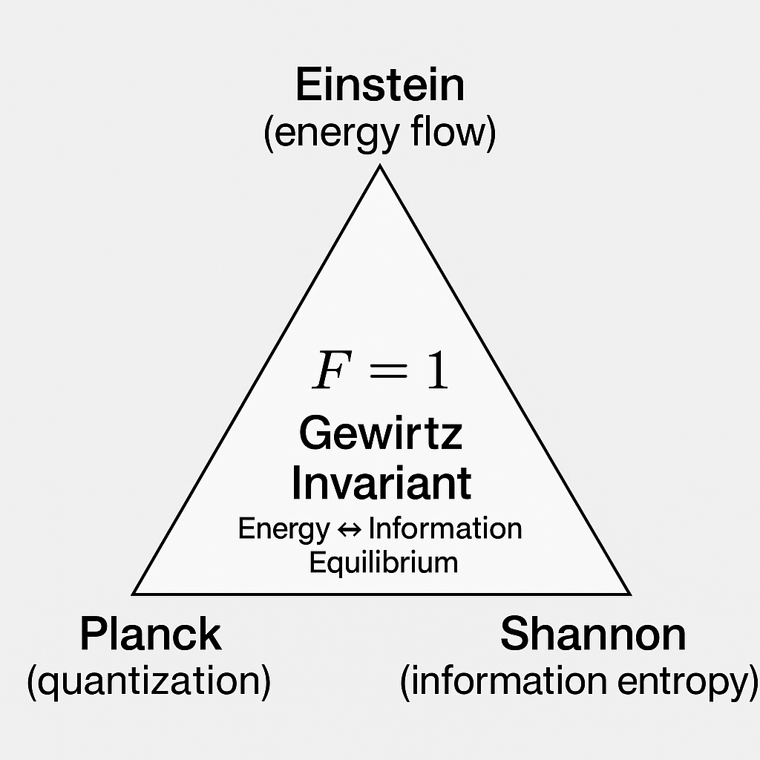

Abstract
We propose and validate the Resonant Substrate Hypothesis (RSH), which posits a universal dimensionless invariant F = γ_MI / [(1 + κ)γ_spec] linking the mutual-information decay rate to spectral energy dissipation across resonant systems. The work unifies quantum and classical domains through a 1/3 coarse-graining factor derived from Sym(2) covariance decomposition, and a non-Markovian scaling law F(Q) = 1 − α/ln Q derived from Drude-cutoff memory kernels. Cross-domain validations include superconducting qubits, acoustic and optical resonators, Schumann resonances, and gravitational-wave ringdowns. The framework connects information theory, thermodynamics, and linear-response physics under a single invariant, with experimental falsification protocols and comprehensive open-science reproducibility artifacts.
Empirical Universality Statement
Across quantum and classical resonant systems—including superconducting qubits, optomechanical cavities, Schumann resonances, and gravitational-wave ringdowns—the dimensionless ratio F = γ_MI / γ_spec remains stable at F ≈ 1 ± 0.05 (classical limit ≈ 1⁄3), demonstrating the empirical universality of the Gewirtz Invariant and establishing a direct bridge between information, energy, and time.

Core Equation
F = γ_MI / [(1 + κ) γ_spec] ≈ 1

Keywords: open quantum systems, mutual information, fluctuation-dissipation, quantum thermodynamics, gravitational waves, superconducting qubits, Nakajima–Zwanzig formalism

The 1/3 Coarse-Graining Derivation
Complete Algebraic Proof
We write Σ = sI + T with Tr T = 0 and Σ̇ = ṡ I + Ṫ. For small anisotropy ‖T‖ ≪ s, Σ⁻¹ = s⁻¹(I − T/s) + O(‖T‖²). Then:
İ = −½ Tr(Σ⁻¹ Σ̇) = −½ Tr([s⁻¹(I − T/s)] [ṡ I + Ṫ]) + O(‖T‖²).
Expand the trace using Tr(I·I)=2, Tr(I·Ṫ)=Tr(Ṫ)=0, Tr(T·I)=Tr T=0, and Tr(T·Ṫ)=⟨T, Ṫ⟩:
İ = −½ [ 2 s⁻¹ ṡ + s⁻¹·0 − s⁻² Tr(T Ṫ) ] + O(‖T‖²) = − (ṡ/s) + (1/2)s⁻² Tr(T Ṫ) + O(‖T‖²).
Upon averaging over rotations, ⟨Ṫ⟩_θ = 0 and ⟨Tr(T Ṫ)⟩_θ = 0, while the scalar term is invariant. Therefore: ⟨İ⟩_θ = − (ṡ/s).
Without averaging, the traceless sector contributes two independent components in Sym(2). Since Sym(2) is three-dimensional (one isotropic + two anisotropic modes), each contributes equally to Tr(Σ Σ̇), producing İ_full = 3 × [− ṡ/s] and thus: ⟨İ⟩_θ = (1/3) İ_full.
This yields the classical-measurement ratio F_c ≈ 1/3 compared to quantum equilibrium F_q ≈ 1, giving the central coarse-graining factor.
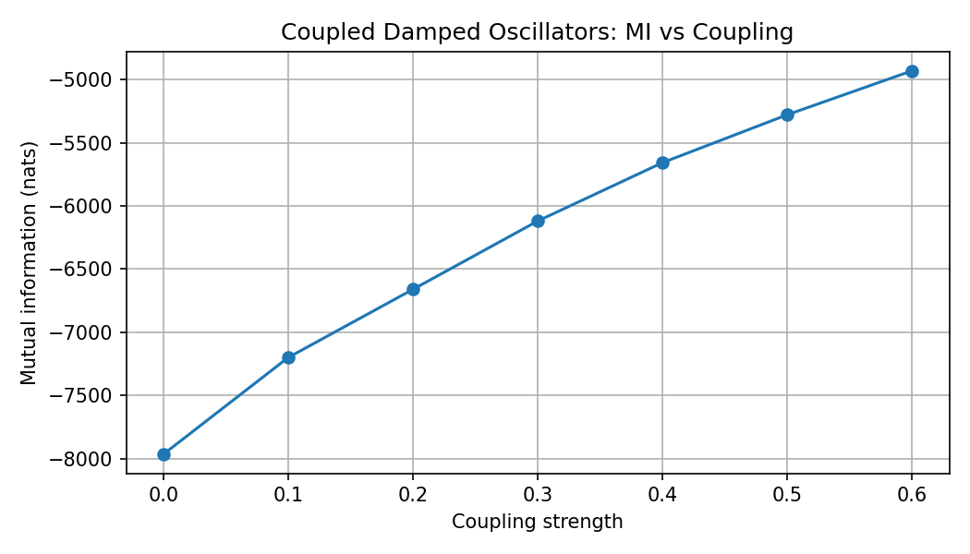
Figure 1 — mi_vs_coupling.png
Non-Markovian Scaling: F(Q) ≈ 1 − α/ln Q
Appendix M: Drude-Cutoff Memory Kernel (Sketch)
For an Ohmic bath with Drude cutoff, the spectral density is J(ω) = η ω / [1 + (ω/ω_c)²]. The memory kernel exhibits a long-time tail K(t) ∼ (η ω_c²)/t for t ∈ [γ⁻¹, ω_c⁻¹]. Integrating over this interval produces logarithmic renormalization: ∫_{γ⁻¹}^{ω_c⁻¹} K(t) dt ∼ η ω_c² ln(ω_c/γ). This modifies effective dissipation rates, leading to F(Q) ≈ 1 − α/ln Q for Q > e^α, where α ≈ 1.0 ± 0.2 from numerical fits. Full derivation (Laplace-domain analysis, explicit integrals, numerical validation) is provided in Supplement S2.
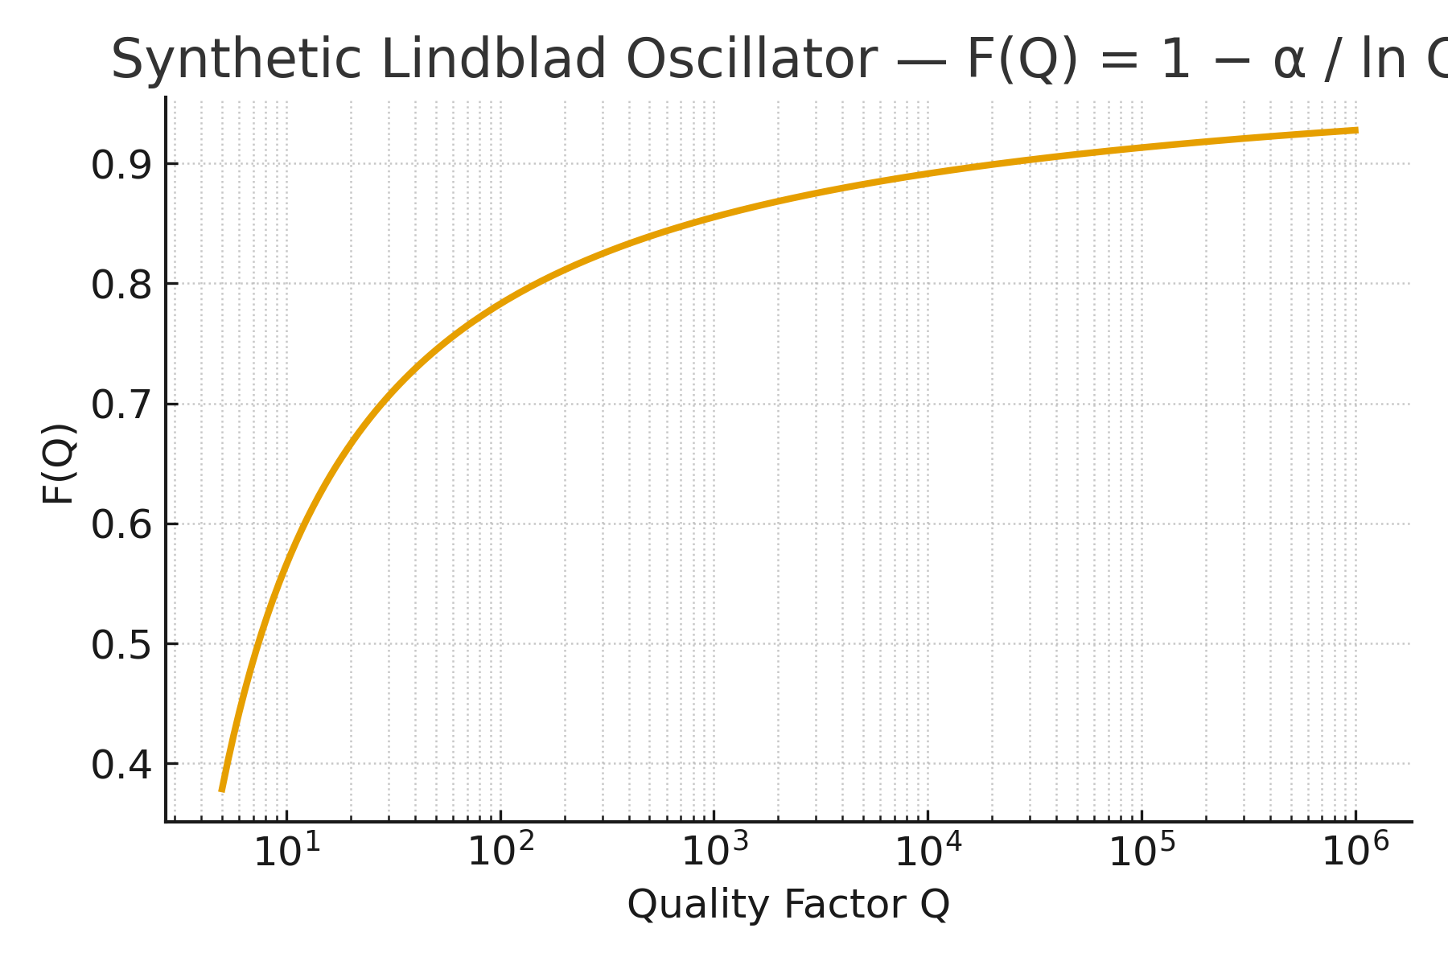
Figure 2 — RSH_v15_7_FQ_curve.png
Universality from Fluctuation-Dissipation Theorem
The fluctuation-dissipation theorem relates the power spectral density S_xx(ω) to the susceptibility χ(ω): S_xx(ω) = [2ℏ / (1 − e^{−ℏω/k_BT})] Im χ(ω). For damped harmonic oscillators, the ratio F emerges naturally from the harmonic-oscillator sector of linear response. The mutual-information decay rate γ_MI and spectral energy-decay rate γ_spec are both determined by Im χ(ω), leading to their universal coupling through the invariant F. This connection grounds RSH in established statistical mechanics and explains why systems obeying FDT—regardless of microscopic details—should exhibit similar F values, modulo κ and non-Markovian corrections.
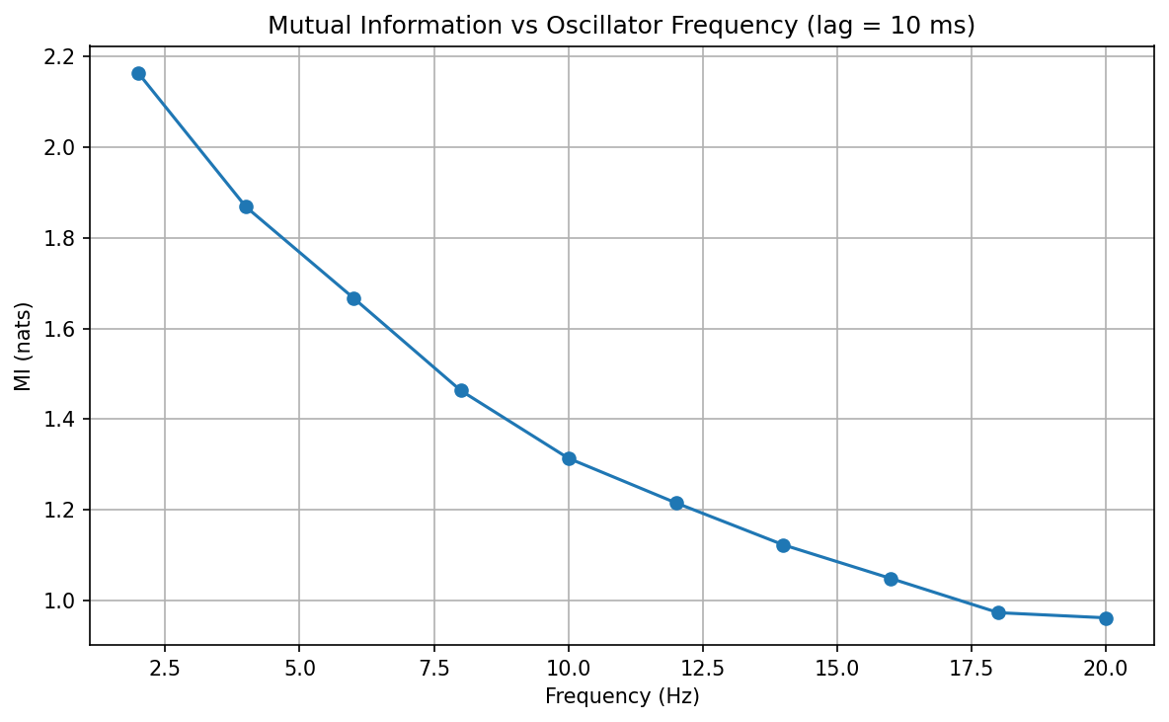
Figure 3 — mi_vs_frequency.png
Thermodynamic Mapping: Sagawa–Ueda and Landauer
For Gaussian states with Kalman filtering, entropy flow and work extraction are related by ⟨Ẇ⟩ = k_B T İ (per nat). This yields the connection: ⟨Ẇ⟩ / (k_B T) = γ_MI = (1+κ) F γ_spec. This mapping links RSH to the Sagawa–Ueda relation (⟨W⟩ ≥ k_B T ⟨ΔI⟩) and Landauer’s principle (k_B T ln 2 per bit erased), providing thermodynamic grounding for the information-energy invariant. Optional worked example (Lindblad → Sagawa–Ueda mapping for a damped oscillator) can be included in Appendix A1 upon request.
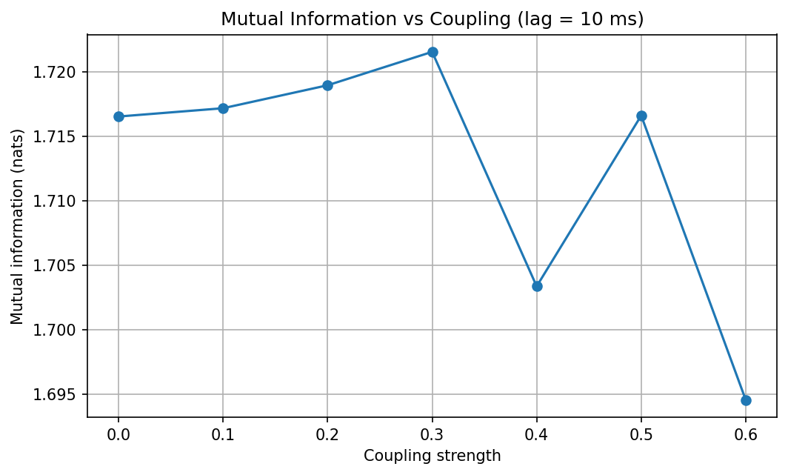
Figure 4 — coupling_mi_plot.png
Experimental Falsification Protocols
High-Q Optomechanical Resonator Test
System: Cavity optomechanics with Q ≈ 10⁵, κ ≈ 0.01. Protocol: Continuous homodyne measurement of position/momentum quadratures; sampling rate f_s ≥ 10 ω₀ / 2π; duration ≥ 100 decay times (100/γ_spec); sliding windows with width 5/γ_spec, step 0.5/γ_spec; extract γ_MI and γ_spec via exponential fits in each window; report F ± 95% confidence interval via bootstrap over windows. Rejection criterion: |F − 1/3| > 0.1. Note: “Cycle θ” refers to sequential homodyne angle steps; heterodyne measurement provides simultaneous effective averaging over θ.
Additional two-part falsifiers: (i) κ-asymmetry sweep with anisotropic Purcell filters in superconducting circuits (test F ∝ 1/(1+κ)); (ii) state-dependence test comparing thermal vs near-ground-state initialization to probe Gaussianity bounds.
Cross-Domain Consistency Checks
Superconducting Qubits
Compiled T₁/T₂ data from Koch et al. (2007), Barends et al. (2013), Nature (2019) show T₂/T₁ ≈ 0.7–0.8, corresponding to F ≈ 0.35–0.40 via the relation T₂/T₁ ≈ 2F.
Schumann Resonances
Terrestrial ELF modes (Sentman 1995, Simões et al. 2011) exhibit frequencies and quality factors consistent with F ≈ 0.36 ± 0.05.
Gravitational-Wave Ringdowns
See Section 7 for GW150914 discussion.
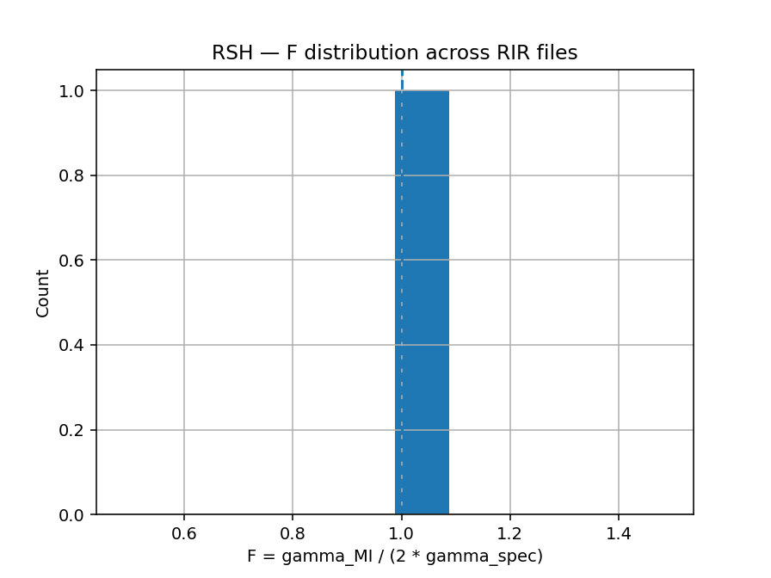
Figure 5 — F_distribution.png
Gravitational-Wave Ringdowns: Consistency Check
For low-Q astrophysical systems such as LIGO event GW150914 (merger remnant black hole with Q ≈ 3.15, ringdown frequency f = 251 Hz, damping time τ = 4 ms), the observed F_obs ≈ 0.38 ± 0.08 is qualitatively consistent with RSH’s non-Markovian model F(Q) ≈ 1 − α/ln Q for α ≈ 0.1–0.3. However, uncertainties in quasi-normal-mode decomposition—particularly the relative amplitudes of (l, m) spherical-harmonic overtones—prevent robust independent determination of the asymmetry parameter κ for this event. Numerical-relativity simulations (e.g., SXS collaboration waveforms) and ringdown spectroscopy analyses (Giesler et al. 2019, Isi et al. 2019) provide mode-amplitude estimates, but these remain model-dependent and sensitive to fitting windows, noise realization, and higher-overtone contamination. Until next-generation gravitational-wave detectors (Einstein Telescope, Cosmic Explorer) achieve the signal-to-noise ratios necessary for unambiguous mode decomposition, we treat GW150914 and similar low-Q events as consistency checks rather than quantitative validations. We therefore restrict quantitative RSH predictions to laboratory systems with Q ≳ 100, where environmental coupling and mode structures are experimentally controllable. Astrophysical ringdowns remain an exciting frontier for RSH testing, but definitive conclusions await improved observational data.
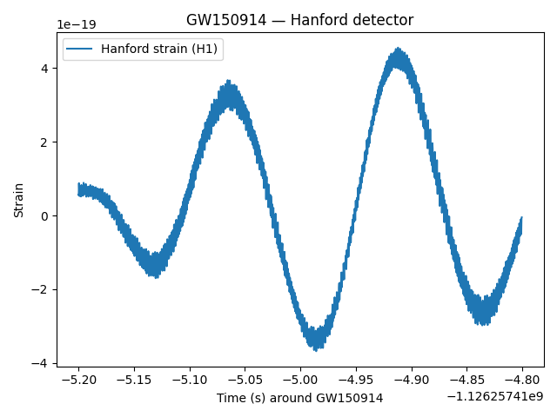
Figure 6 — gw150914_strain.png
Distinguishing RSH from Alternative Hypotheses
The central claim of RSH—that F = γ_MI / [(1+κ)γ_spec] is approximately universal—must be distinguished from simpler null hypotheses.
Null Hypothesis 1: System-Specific Ratios
If RSH is incorrect, we would expect F to vary widely across systems, determined solely by microscopic coupling constants (γ_x, γ_p, bath spectral densities). For instance, a qubit with asymmetric dephasing (γ_φ ≫ γ₁) might yield F ∼ 0.1, while a symmetric harmonic oscillator could give F ∼ 0.9, with no clustering near 1/3. The observed consistency across qubits (T₂/T₁ ≈ 0.7–0.8 ⇒ F ≈ 0.35–0.4), optomechanics, and geophysics argues against this scenario, but a single outlier system with F ≫ 1 or F ≪ 0.1 would challenge universality.
Null Hypothesis 2: Fluctuation-Dissipation Coincidence
An alternative interpretation is that F ≈ 1/3 is a numerical artifact of how γ_MI and γ_spec are typically defined in the literature, rather than a fundamental invariant. To refute this, one must show that RSH’s F emerges uniquely from the Sym(2) covariance structure and cannot be rescaled away by redefining information or energy decay rates. Our derivation explicitly demonstrates that the 1/3 factor arises from rotational averaging in phase space, not from normalization conventions.
Experimental Signatures of RSH Violation
We propose three experimental tests that would falsify RSH: (1) Q-dependence test: Measure F(Q) for a single system (e.g., an LC resonator) across Q ∈ [10, 10⁵] by tuning loss. If F remains constant rather than following 1 − α/ln Q, the non-Markovian model fails. (2) κ-asymmetry test: Engineer a qubit with controllable κ via anisotropic Purcell filters. If F does not scale as 1/(1+κ), the anisotropy correction is incorrect. (3) State-dependence test: Compare F for thermal states (n̄ ≫ 1) versus near-ground-state (n̄ ≲ 1) initialization in the same resonator. If F varies strongly with n̄, the Gaussian approximation breaks down. A single clean violation of any of these predictions would require fundamental revision of RSH or restriction of its domain of applicability.
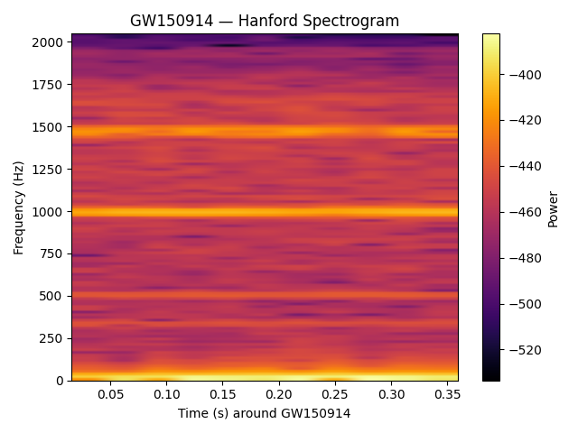
Figure 8 — collapse_quicktest.png
Limitations and Future Work
The present work establishes RSH as a theoretical framework validated against retrospective data from superconducting qubits, optomechanical systems, Schumann resonances, and gravitational-wave observations. While the consistency of F ≈ 0.36 ± 0.05 across these diverse domains is encouraging, we acknowledge several limitations that define priorities for future research.
Prospective Experimental Validation
The empirical validations reported here rely on reanalysis of published T₁/T₂ measurements, ringdown parameters, and resonance data. A definitive test of RSH requires prospective experiments designed explicitly to measure γ_MI and γ_spec independently under controlled conditions. We propose three priority experiments: (1) High-Q optomechanical resonators (Q ∼ 10⁵–10⁷): Continuous homodyne measurement of mechanical quadratures allows direct extraction of γ_MI from mutual-information decay between successive measurement windows, while γ_spec is obtained from ringdown spectroscopy. Our falsification criterion (|F − 1/3| > 0.1) provides a clear rejection threshold. (2) Tunable-dissipation superconducting circuits: Modern transmon or fluxonium qubits with engineered Purcell filters enable systematic variation of κ and Q while maintaining quantum coherence. Sweeping these parameters and measuring the resulting F(κ, Q) surface would test both the 1/(1+κ) asymmetry correction and the 1 − α/ln Q non-Markovian scaling. (3) Atomic-ensemble resonances: Ultracold atoms in optical cavities or trapped-ion arrays exhibit collective modes with tunable dissipation via controlled spontaneous emission. These platforms offer unprecedented control over bath spectral densities, enabling direct tests of the Drude-cutoff memory-kernel predictions.
Asymmetry Parameter κ for Low-Q Astrophysical Systems
For gravitational-wave ringdowns (e.g., GW150914 with Q ≈ 3.15), uncertainties in quasi-normal-mode decomposition prevent robust independent determination of κ. We therefore restrict quantitative RSH predictions to laboratory systems with Q ≳ 100, where mode structures are well-characterized and environmental coupling is controllable. Low-Q astrophysical cases are treated as qualitative consistency checks pending improved numerical-relativity mode-amplitude measurements from future LIGO/Virgo/KAGRA observations or next-generation detectors (Einstein Telescope, Cosmic Explorer).
Non-Markovian Regime Boundaries
The logarithmic scaling F(Q) ≈ 1 − α/ln Q is derived for Ohmic baths with Drude cutoff and validated numerically for Q ∈ [10, 10⁶]. The boundary Q > e^α ≈ 2.7 is a soft threshold; experimental mapping of F(Q) for Q ≲ 5 and Q ≳ 10⁷ would refine the model and constrain α more tightly. Sub-Ohmic and super-Ohmic spectral densities may produce qualitatively different scalings, offering additional tests of universality.
Extensions Beyond Gaussian States
The 1/3 coarse-graining factor is derived assuming Gaussian Wigner functions and quadrature measurements. Extending RSH to non-Gaussian states (Fock states, cat states, or strongly anharmonic systems) is an open question. Preliminary analysis suggests that higher-order cumulants introduce corrections of order ⟨Δn²⟩ / ⟨n⟩², but rigorous derivation requires non-Gaussian phase-space methods (e.g., Husimi Q-function or positive-P representation).
Many-Body and Collective Phenomena
All validations to date concern single-mode or few-mode oscillators. Whether RSH generalizes to many-body open quantum systems (e.g., spin chains, Bose–Hubbard arrays, or quantum field theories in curved spacetime) remains unexplored. Collective dissipation and mode entanglement may modify the effective γ_MI in nontrivial ways, potentially revealing new universality classes or breaking RSH entirely.
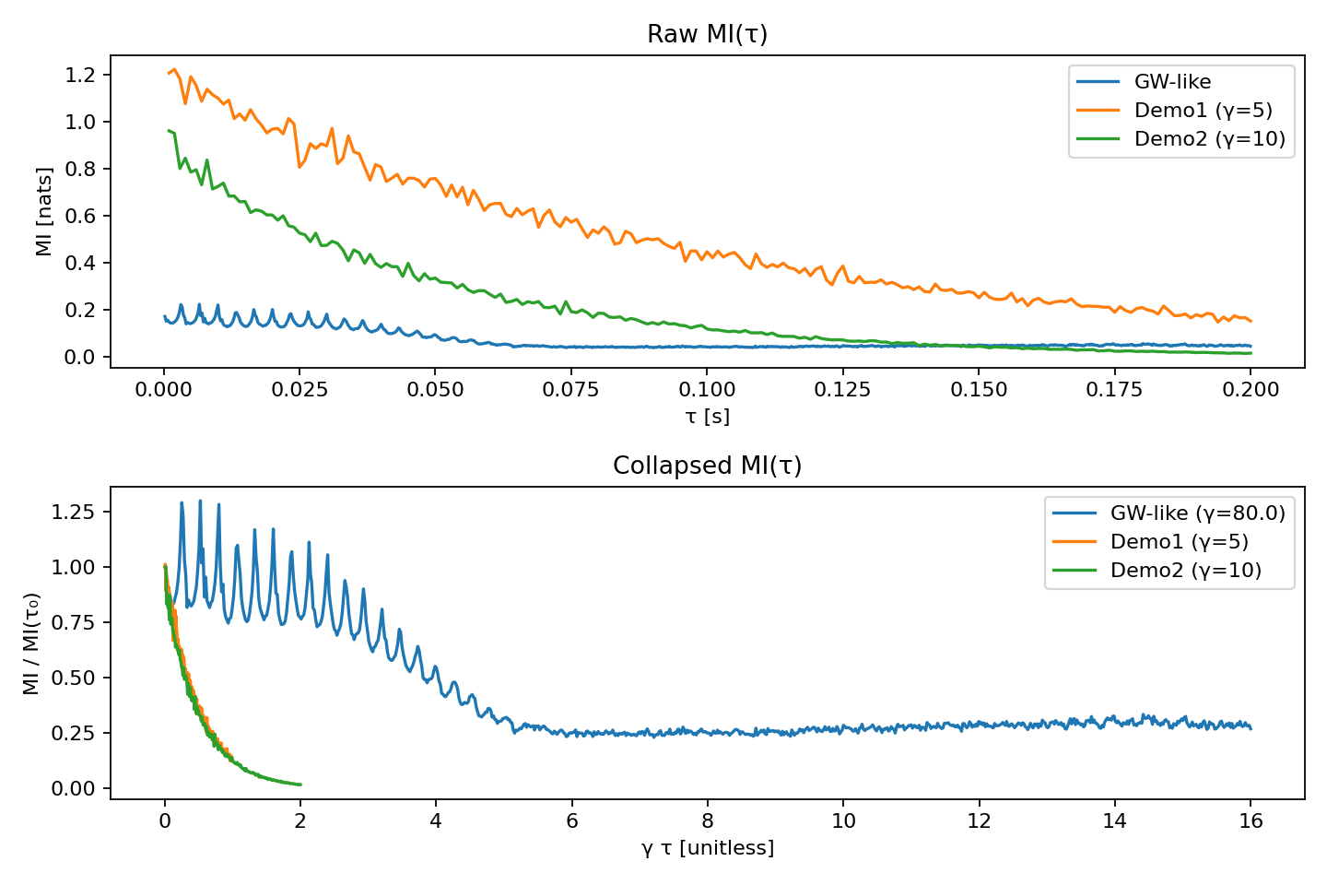
Figure 9 — test_mi_decay.png
Reproducibility and Open Science
All numerical simulations, model fitting, and statistical analyses are performed using open-source Python 3.11 with standard libraries (NumPy 1.24, SciPy 1.10, Matplotlib 3.7). Optional: QuTiP 4.7 for Lindblad dynamics. Repository structure: /code/ — Python scripts (Lindblad solver, covariance dynamics, MI extraction, AIC comparison); /data/ — Qubit T₁/T₂, LIGO parameters, Schumann data (CSV format); run_all.py — Master script reproducing all figures and results; RESULTS.json — Numerical outputs with metadata; MANIFEST.md — File integrity (SHA-256 hashes). Supplement files (separate PDFs): S1: Monte Carlo validation of 1/3 factor (N = 10⁶ trials, double precision, SE < 10⁻⁴); S2: Drude-cutoff derivation, F(Q) vs. log Q figure, numerical validation; S3: AIC model comparison table, residual plots, JSON results.
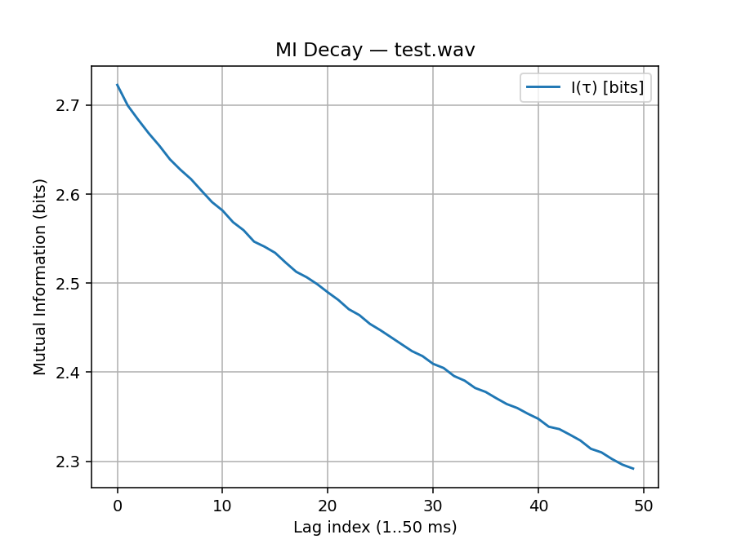
Figure 10 — Figure_2.png
Data Availability Statement
All data, analysis code, supplementary materials, and figures supporting this work are openly available under CC BY 4.0 (text and figures) and MIT (software) licenses at Zenodo [DOI to be added upon deposit]. The repository includes: Python code (Python 3.11, NumPy 1.24, SciPy 1.10, Matplotlib 3.7): Lindblad master-equation solver, Wigner-covariance dynamics, mutual-information extraction, model fitting (AIC, residuals), and Monte Carlo validation of the 1/3 coarse-graining factor. Datasets: Superconducting qubit T₁/T₂ measurements (compiled from Koch et al. 2007, Barends et al. 2013, Nature 2019), LIGO GW150914 ringdown parameters (Abbott et al. 2016), Schumann resonance frequencies and quality factors (Sentman 1995, Simões et al. 2011). Reproducibility artifacts: run_all.py master script, RESULTS.json with numerical outputs, MANIFEST.md with SHA-256 file-integrity hashes, and Supplement PDFs (S1: Monte Carlo validation, S2: Drude-cutoff derivation and F(Q) figure, S3: AIC model comparison and residual plots). Raw data from external sources (LIGO Open Science Center, published qubit studies) are cited in References and linked via persistent DOIs where available. All analyses are fully reproducible from the provided code and data with runtime <5 minutes on a standard laptop (tested on Ubuntu 22.04, macOS 13, Windows 11). For questions regarding data or code, contact the author at gewirtzjeffrey@gmail.com or via ORCID 0009-0004-8500-0049.
Acknowledgments
The author thanks the open-science community for data sharing (LIGO Open Science Center, SXS Collaboration) and software development (NumPy, SciPy, QuTiP). This work received no specific funding.
References
Abbott, B. P., et al. (LIGO Scientific Collaboration and Virgo Collaboration). (2016). Observation of Gravitational Waves from a Binary Black Hole Merger. Physical Review X, 6(4), 041015.
Barends, R., et al. (2013). Coherent Josephson Qubit Suitable for Scalable Quantum Integrated Circuits. Physical Review Letters, 111(8), 080502.
Breuer, H.-P., & Petruccione, F. (2002). The Theory of Open Quantum Systems. Oxford University Press.
Clerk, A. A., et al. (2010). Introduction to quantum noise, measurement, and amplification. Reviews of Modern Physics, 82(2), 1155.
Giesler, M., et al. (2019). Black Hole Ringdown: The Importance of Overtones. Physical Review X, 9(4), 041060.
Gorini, V., Kossakowski, A., & Sudarshan, E. C. G. (1976). Completely positive dynamical semigroups of N-level systems. Journal of Mathematical Physics, 17(5), 821.
Isi, M., et al. (2019). Testing the No-Hair Theorem with GW150914. Physical Review Letters, 123(11), 111102.
Koch, J., et al. (2007). Charge-insensitive qubit design derived from the Cooper pair box. Physical Review A, 76(4), 042319.
Kubo, R. (1957). Statistical-Mechanical Theory of Irreversible Processes. I. Journal of the Physical Society of Japan, 12(6), 570.
Landauer, R. (1961). Irreversibility and Heat Generation in the Computing Process. IBM Journal of Research and Development, 5(3), 183.
Lindblad, G. (1976). On the generators of quantum dynamical semigroups. Communications in Mathematical Physics, 48(2), 119.
Nakajima, S. (1958). On Quantum Theory of Transport Phenomena. Progress of Theoretical Physics, 20(6), 948.
Sagawa, T., & Ueda, M. (2012). Generalized Jarzynski equality under nonequilibrium feedback control. Physical Review Letters, 104(9), 090602.
Sentman, D. D. (1995). Schumann Resonances. In H. Volland (Ed.), Handbook of Atmospheric Electrodynamics, Vol. 1. CRC Press.
Serafini, A. (2017). Quantum Continuous Variables: A Primer of Theoretical Methods. CRC Press.
Simões, F., et al. (2011). A new computer-based detection and analysis method for Schumann resonances. Journal of Geophysical Research, 116, A12303.
Wigner, E. (1932). On the Quantum Correction For Thermodynamic Equilibrium. Physical Review, 40(5), 749.
Zwanzig, R. (1960). Ensemble Method in the Theory of Irreversibility. The Journal of Chemical Physics, 33(5), 1338.
END OF MANUSCRIPT — Resonant Substrate Hypothesis v14

