Going into this assignment, I was really interested in how python programming can be tied into making changes to SQL databases. After doing the work and researching everything I needed to do, I have found a lot more ways that implementing some kind of program would be useful for company wide use of accessible databases. This can be as easy as making something that allows the user to search for a record, create a new record, amend existing records, and delete records. A way to describe this kind of thing would be the use of CRUD functions.
For the first function being to create a record, I created this function:
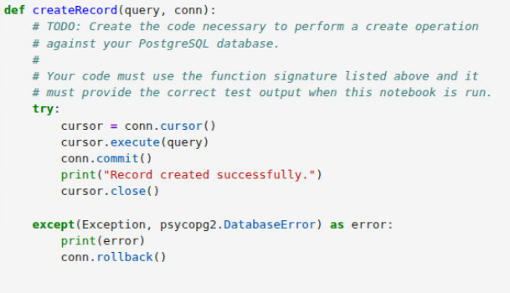
Following the basic steps for how to connect to a database and make changes, I used the .cursor() call to connect to the database while establishing a way to interact with it. The .execute() and .commit() calls are used to push a command line such as “SELECT id, name FROM users WHERE active = 1” in a SQL terminal and push those commands to be performed. The .close() is just simply to close the connection the cursor has with the server. I created the last section to prevent any errors from crashing the program entirely and causing issues.
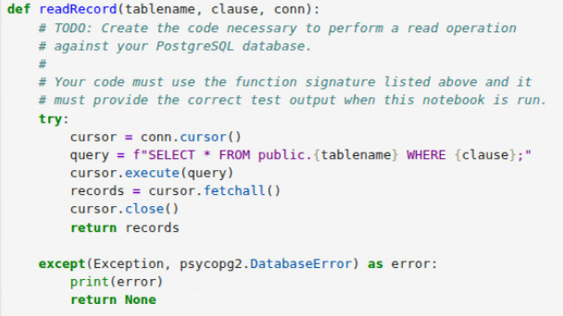
The second function I made to read records in the server’s databases looks like this:
The calls that I used for creating this function are the same with .cursor(), .execute(), and close(). The only difference was the use of inserting the query line that takes in what the user is searching for in a specific table.
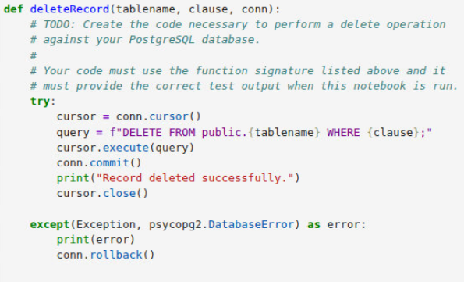
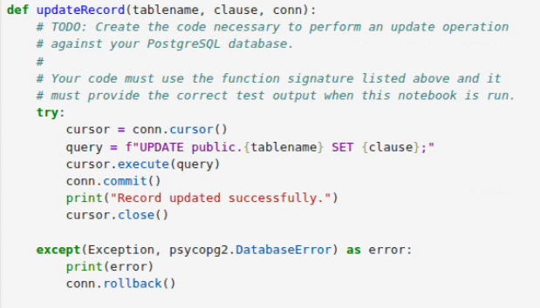
The third and fourth functions I created are used to update and delete existing records:

Like the read function, they use the exact same calls. The only difference is the kind of query being called for each one. Adding the line that shows how the function was performed successfully helps to establish that no errors occurred besides when the last block of code is called. This was the output for all the functions I created: 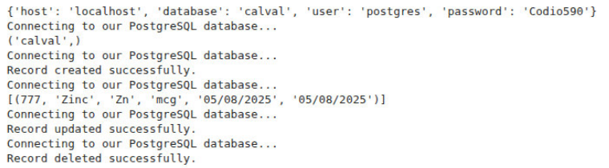
I believe that all four of my functions can be used for the extraction of data. If someone wishes to find a record that is stored in a specific table, calling the readRecord function can be edited in a way to output the result to a file while the cursor is still connected. An example of this would be using the sqlalchemy of pandas to export whatever call was created from the query. To make this cleaner looking, it can be made into a function that is called separately to avoid the block of code being entered multiple times.

