When working on this assignment, it was a bit of a learning curb trying to figure out how to use PostgreSQL and DBeaver because this was my first time using them. It took a while for me to understand how data is downloaded into the program as well as how to create a table to import data too. After everything I was able to learn from completing this assignment, I can say that I have a better understanding of databases.
Looking at the database that I created from the data given for this assignment, it was easy to convert the csv file to a table. This is the table that I was able to create with the csv file after formatting everything:
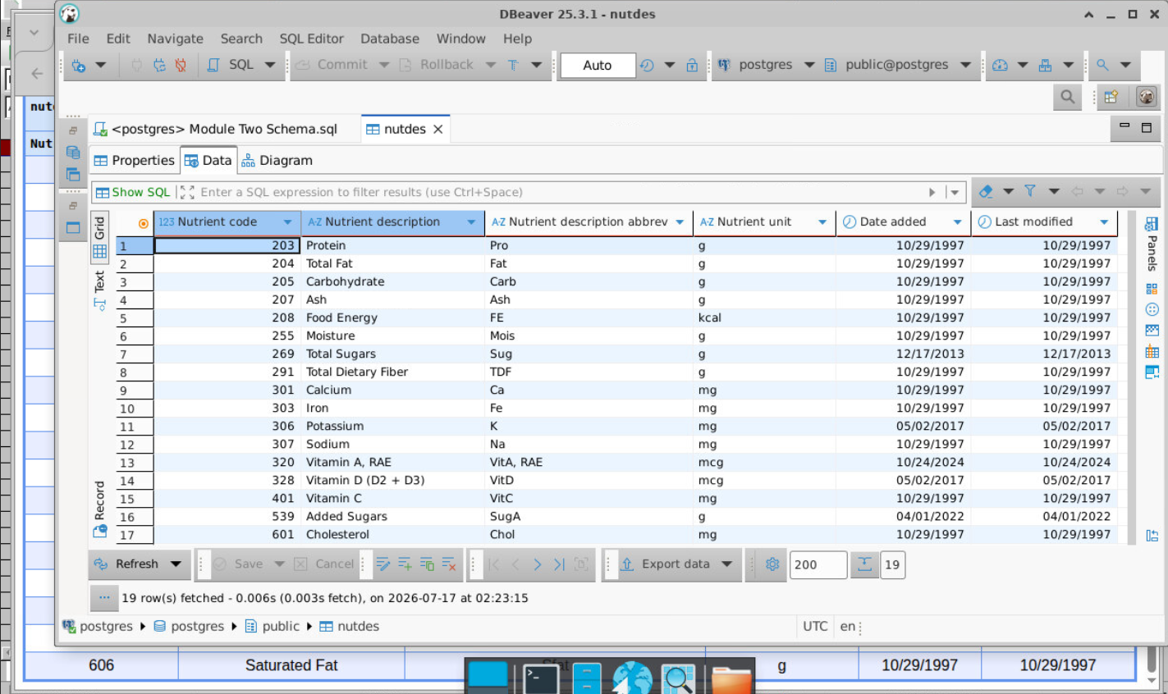
The six columns that are present are the “Nutrient code,” “Nutrient description,” “Nutrient description abbrev,” “Nutrient unit,” “Date added,” and “Last modified.” The nutrient code column provides the identification code for each listed nutrient in a three-character numerical format. Nutrient description describes what the nutrient for that row is. Nutrient description abbrev contains short form versions of each nutrient that can be used for quick summaries. The nutrient unit column gives the measurement unit that is used to calculate each form of nutrient for dietary creation purposes. An example would be if someone making a diet plan wants to recommend how much protein someone should be consuming daily, it would be described as 55 grams of protein. The last two columns, date added and last modified, provide dates that describe when the nutrient in its line was added to the dataset and when was the last time the information for said nutrient was edited.
I believe that all the data types corresponding to each column are appropriate for the data being stored. Nutrient code is stored as a three numerical data type. This makes sense since being able to categorize each nutrient as a number sequence allows people that have knowledge of each code key to be able to recall what it means if given a short meal plan that needs to be created for an individual. The nutrient description column contains string variables that are used as short descriptors for each nutrient. This helps to support the kind of information being stored because it provides what the nutrients suggested are. Nutrient description abbrev being stored as a string also helps to support the kind of information that is being stored because it allows for a short form way to mention the mentioned nutrient, such as protein having the abbreviation “Pro.” The nutrient unit column is also a string because not all of the units being used are singular characters. It makes sense to have it as a string to support units being labeled as both “g” and “kcal”. The last two columns contain the date data type. This helps to support the information being stored because it can be transitioned to different format types as opposed to containing a string that cannot be necessarily manipulated easily.
As for the other aspects of the table such as the constraints, relationships, scalability, accuracy, and efficiency of the table and its data, I was able to notice a couple things. I didn’t find any constraints from what I could say with the table, but I did see how the relationships for each piece of data are connected. For example, I can tell that all the columns have some kind of identification relationship between one another. Total sugar is tied to the code 269 with an abbreviation of Sug that is measured in grams. The only thing that did confuse me is how the dates exactly tied into the table. Of course they provide more record keeping information, but that kind of thing is not the most important for a consumer and most users create diet plans. I do believe that each data type used for the table provides a simple way to scale information, specifically by providing nutrient code a way to organize information effectively. They also help to maintain accuracy via its descriptions and units. Storage efficiency is also maintained by allowing the code to be able to identify each row by three numbers.

