Shiny app for beginners
Activity #1: Start the demo app
- Start the demo app. If you are using RStudio from your own laptop, go to New project New Directory Shiny app. If you are on Posit.cloud, go to New Project New RStudio project File New File Shiny app.
- Name the app Shiny_demo. This will be come a name of a folder.
- Run the app.
Activity #2: Making small changes
- Change the application title to “Shiny demo”. Run the app to see the effect.
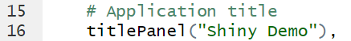
- Change the color from “darkgray” to “green”. Run the app.
- Swap data to mtcars

Activity #3: Adding and using control widgets
- Bring the Shiny Cheat sheet: Help Cheat Sheets Web application with Shiny
- Add a color select to the UI. Add these 5 lines. Run the app. Make sure there is no errors and it looks good.
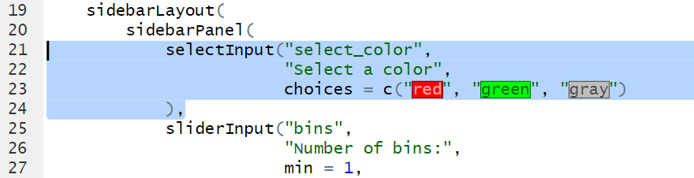
- Change the color of the plot. Change this line and run the app.
Activity #4: Change data columns
- Add a selectInput to select the columns. Run the app to make sure the control widget works.
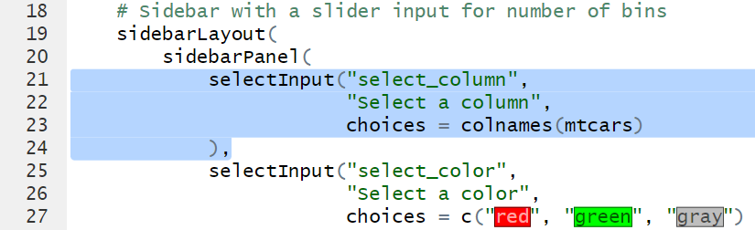
- Use the select column to plot. Run the app.

Activity 5. Add a plot.
- First add the plotoutput in UI. Run the app.
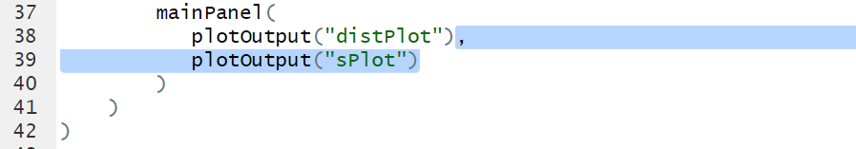

- Generate the plot in a separate R script.
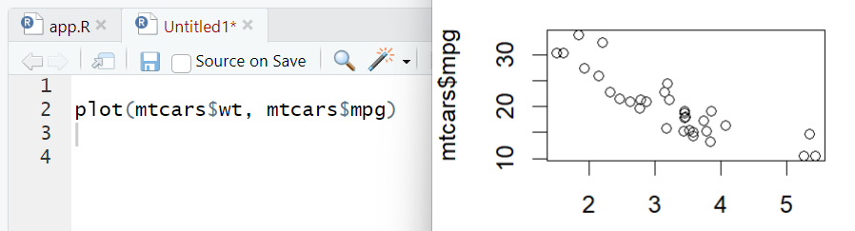
- Copy the code into the Shiny app inside a output function.
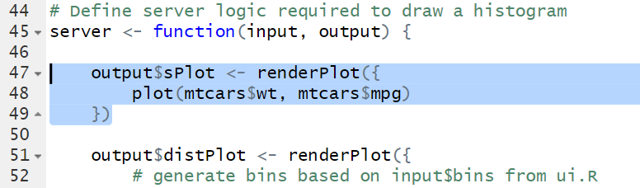
- Change the code to use selected columns.

Activity 6: Publishing the app on Shinyapp.io
- Log into Shinyapps.io
- Click on the top right corner (your name). Then select Tokens.
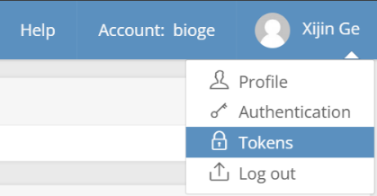
- Click on 
- Click on Show Token and the Show Secret. Copy to clipboard.
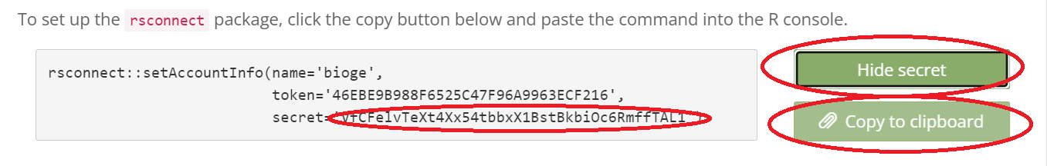
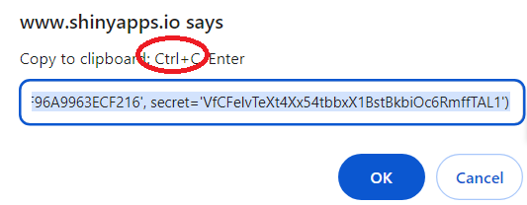
- Go back to RStudio. Run the app. Click the Publish button on the top right.
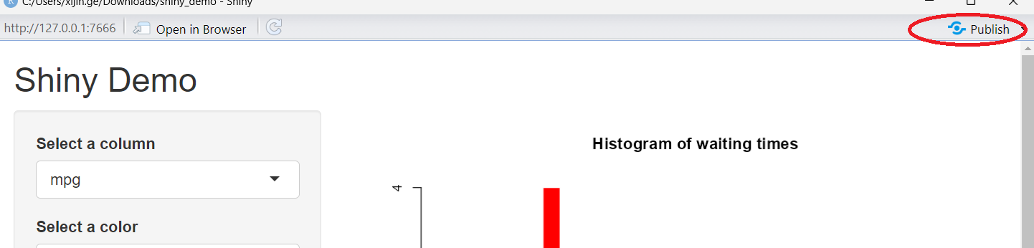
- Connect to Shinyapps.io by pasting the secret.
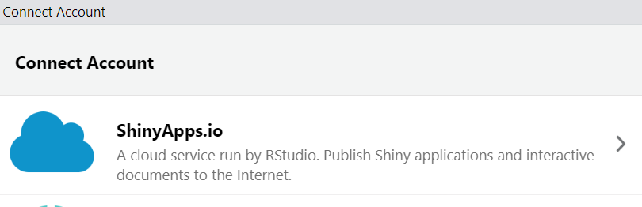
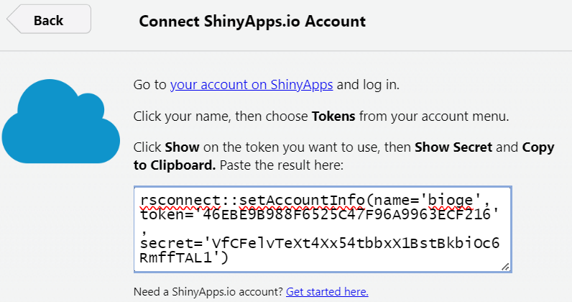

Activity 7. Interacting with ChatGPT through API
- Start a new R script file. Save a ChatGPT.R. https://github.com/irudnyts/openai
install.packages("remotes")
remotes::install_github("irudnyts/openai", ref = "r6")

Sys.setenv(
OPENAI_API_KEY = 'sk-proj-XEFD_g86’
)

library(openai)
client <- OpenAI()
completion <- client$chat$completions$create(
model = "gpt-3.5-turbo",
messages = list(list("role" = "user", "content" = "What's up?"))
)

completion$choices[[1]]$message$content

