50.005 – Programming Assignment 2

Secure File Transfer

Team Members:  
Ashlyn Goh Er Xuan 1002840 Cl02  
Wong Chi Seng 1002853 Cl02

# Instructions to Run

# Problem with Original Protocol

The problem with the original protocol is that it does not prevent a playback attack. Hence, an attacker can maliciously repeat a valid data transmission. In our case, the attacker can store information without authorisation and then retransmit it back to the client to trick the client into transferring the file.

To prevent the playback attack, we introduced a nonce into our protocol. The client generates a nonce and sends it to the server. On the other hand, the server must return the nonce that is encrypted with its private key back to the client.

# Protocol Specifications

## AP Protocol

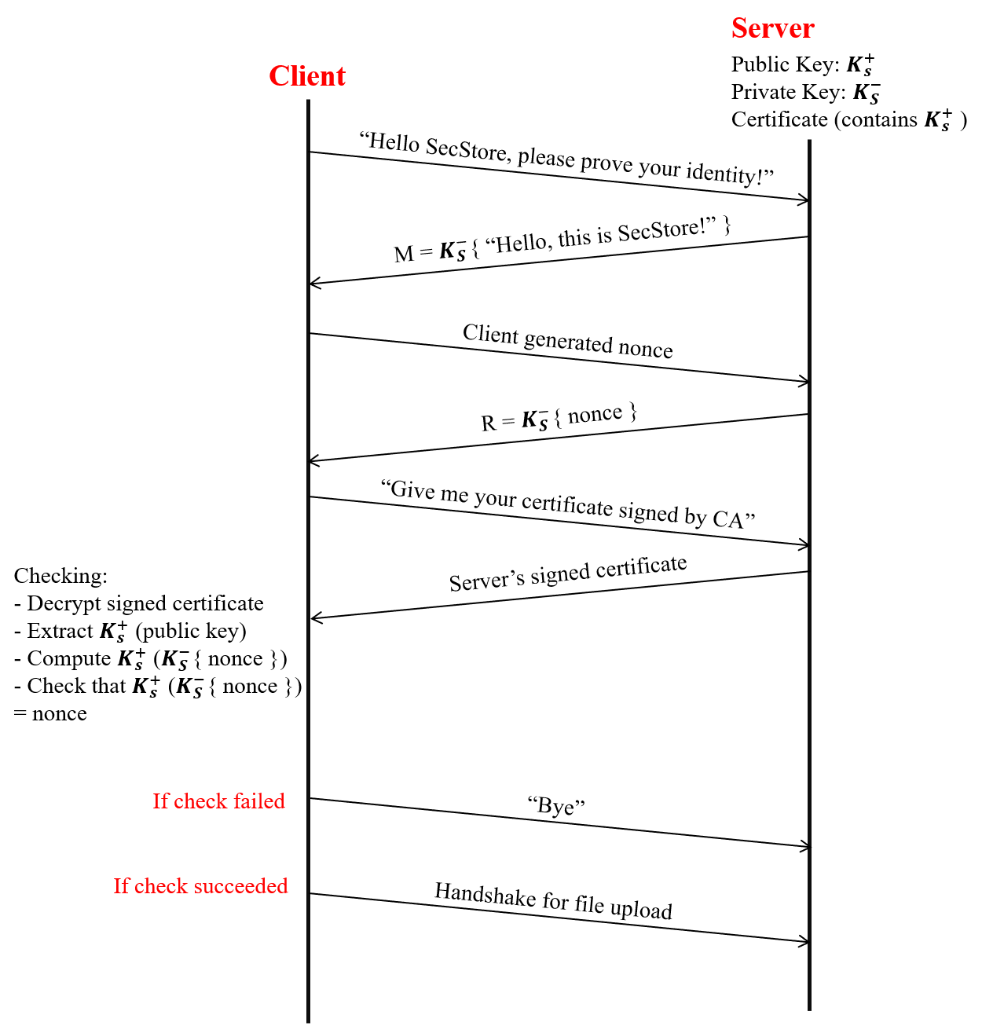

*Figure 1: Authentication Protocol Specification*

## CP-1 Protocol

## CP-2 Protocol

# Results

# Conclusion