PRO-100 touch-M for V1.02b( upgrading)

1. When we press the button «Старт» (window #1) to start the test procedure we see three windows (2), (3) and (4) changing one by one (if no alcohol detected):
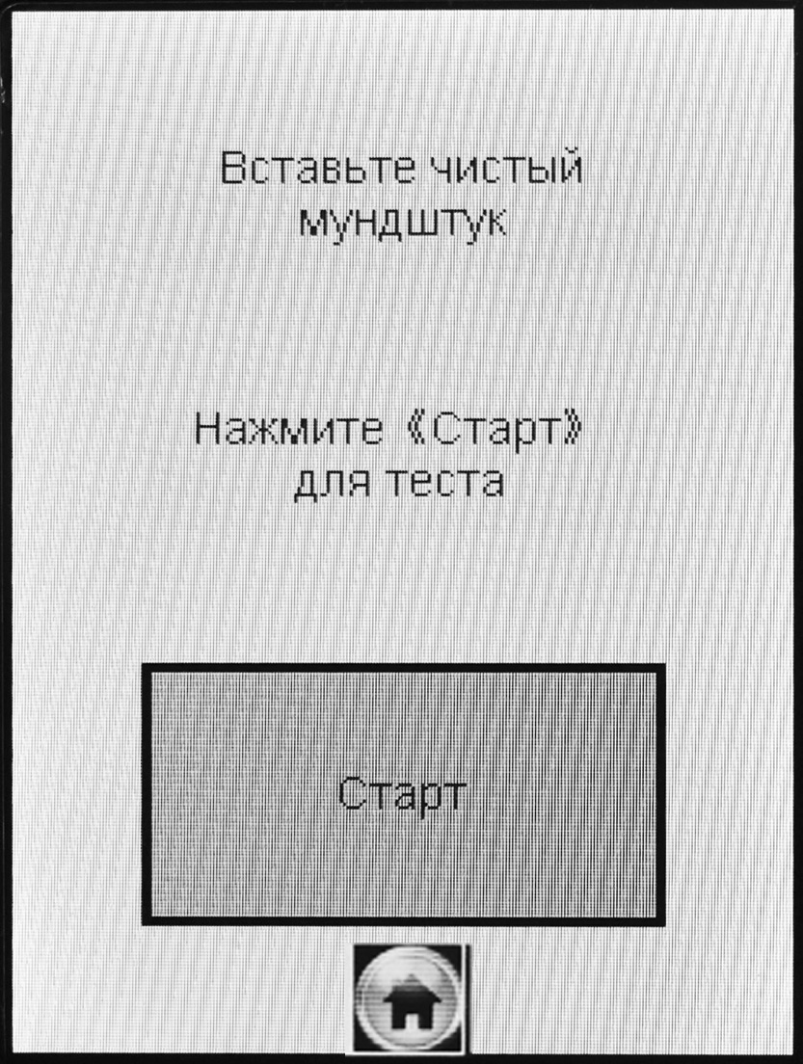
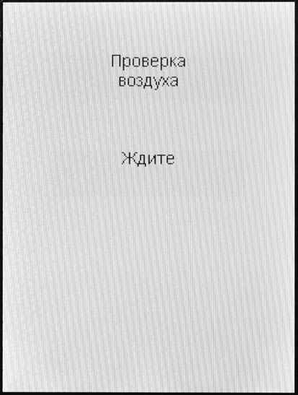
1
2

→ →

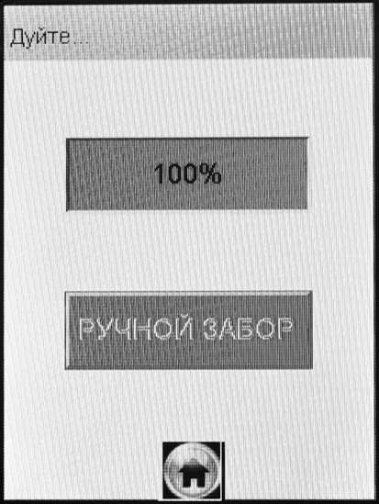
current form
Ждите
Ждите

4
3

→

We would like you to add the message «Алкоголь не обнаружен» on the window #3:

→ →

required form
Ждите
Алrоголь
не обнаружен

Ждите

3

→

2. Please introduce the additional line «Дата поверки: XX/XX/XX» in the printout (as shown below). This date (annual approval checking date) we enter via the “Engineer” menu, «Поверка» button. The entered date must be saved in the memory and printed out with every test report.

BUT on the main screen (on the second line from the button) we must see this date + 12 months and the instrument should be blocked when the current date exceeds this expire date
Example:
Come «Engineer» menu → choose «Поверка» and enter the date: 060811
In the printout, lines 10 and 11 will be indicated «Дата поверки» 06/08/2011
On the main window at the line «Очередная поверка» we will see 06/08/2012
The instrument will be blocked when the current date is 07/08/2012

Printout of PRO-100 touch (current form) Printout of PRO-100 touch (required form)
(line 1) | АЛКОТЕКТОР
(line 2) | PRO-100 touch-M
Номер Прибора: 850215 (line 3) | The same (no changes)
Тест N0.: 00002 (line 4) | The same (no changes)
Дата: 03/08/2010 (line 5) | The same (no changes)
Время: 16:13 (line 6) | The same (no changes)
Воздух: 0.00 мг/л (line 7) | The same (no changes)
Дата Регулировки: (line 8) | The same (no changes)
03/06/2011 (line 9) | The same (no changes)
(line 10) | Дата поверки:
(line 11) | 06/08/2011
Режим: РУЧНОЙ ЗАБОР (line 12) | The same (no changes)
(line 13) | The same (no changes)
Результат:  0.000 мг/л (line 14) | The same (no changes)
Имя Обследуемого: (line 15) | The same (no changes)
_ _ _ _ _ _ _ _ _ _ _ _ _ (line 16) | _ _ _ _ _ _ _ _ _ _ _ _ _
Место Обследования: (line 17) | The same (no changes)
_ _ _ _ _ _ _ _ _ _ _ _ _ (line 18) | _ _ _ _ _ _ _ _ _ _ _ _ _
Гос. Номер Машины: (line 19) | The same (no changes)
_ _ _ _ _ _ _ _ _ _ _ _ _ (line 20) | _ _ _ _ _ _ _ _ _ _ _ _ _
Нагрудный Знак: (line 21) | The same (no changes)
_ _ _ _ _ _ _ _ _ _ _ _ _ (line 22) | _ _ _ _ _ _ _ _ _ _ _ _ _
Инспектор: (line 23) | The same (no changes)
_ _ _ _ _ _ _ _ _ _ _ _ _ (line 24) | _ _ _ _ _ _ _ _ _ _ _ _ _
Отдел ДПС: (line 25) | The same (no changes)
_ _ _ _ _ _ _ _ _ _ _ _ _ (line 26) | _ _ _ _ _ _ _ _ _ _ _ _ _
Темп.: 24 ‘С (line 27) | Темп.: 24 °С
 | _ _ _ _ _ _ _ _ _ _ _ _ _

Подпись Обслед.: The same (no changes)
_ _ _ _ _ _ _ _ _ _ _ _ _ _ _ _ _ _ _ _ _ _ _ _ _ _ _ _ _ _
Подпись: The same (no changes)
_ _ _ _ _ _ _ _ _ _ _ _ _ _ _

3. Add the headlines of the printout: (line1) – АЛКОТЕКТОР, (line2) – PRO-100 touch-M.

4. We think it is not necessary to make the air test (self test) when the instrument is switching on and leave one the air test (self test) before test of subject. We used the alcohol vapor when the instrument made the first air (blank) self test and nothing happened – the instrument came to the ready for subject test.
5. The measured temperature should be available to download to PC with other test results.

6. Problem! If the printer is switched on first and then we switch on the instrument the Bluetooth sign appears on the main screen for very short time and disappears. But the connection is OK and the printing is available. Please try it and correct.

7. Please correct the following names and messages: in menu «Установки»:
current form required form

УСТАНОВКИ
УСТАНОВКИ

Меню Инженер

Установки Дата, Время

УСТАНОВКИ
УСТАНОВКИ
Инженер
Установки Дата, Время
8. In menu «Поверка»
current form required form

Поверка
Поверка

Закрыт

МЕЖРЕГУЛИРОВОЧНЫЙ ПЕР-Д
Закрыт

Поверка

9. To find the serial number and the software version of the instrument we suggest to add one button (ID) in the Muster menu («Мастер») (password # 2: 119119).
current form required form
Мастер
Мастер
Стереть
Темп.
ПАРОЛЬ
Коэфф.
Стереть
Темп.
ID
ПАРОЛЬ
Коэфф.

If we enter to this window «ID» we will see the serial number and the software version, for example:
required form
Информация
Зав. номер
120372

Версия
V: 102110715

10. Translate the menu of «Bluetooth»:
current form required form
Bluetooth
Module: Print

State: Working

Bluetooth
Модуль: Принтер

Соединение: Установлено

Match
Соединить

Bluetooth
Module: Print

State: None

Bluetooth
Модуль: Принтер

Соединение: Отсутствует

Match
Соединить

Bluetooth
Module: Bluetooth

State: Working

Bluetooth
Модуль: Bluetooth

Соединение: Установлено

Match
Соединить

Bluetooth
Module: Bluetooth

State: None

Bluetooth
Модуль: Bluetooth

Соединение: Отсутствует

Match
Соединить

11. Set the mask at 0.007 mg/l for the approval testing, and the mask at 0.02 mg/l for the normal version of software. So we will have two version of software: one for certification and one for customers.

