PRO-100 touch-M for V1.02b

1. Procedure of thermo-compensation. All samples of PRO-100 touch-M we received had the same coefficients of thermo-compensation.
What is a method of adjustment for thermo-compensation you use in PRO-100 touch-M? Other models you adjust each instrument individually. But now it seems you use common average coefficients for all PRO-100 touch-M or it determinates by the software version. Because the thermo compensation did not meet the requirements we tried to adjust every unit individually. And we met the following problems:

1. We tried to enter the thermo coefficients manually by pressing the button (we enter the coefficient taken from fuel cell, when we use the test concentration 0.381 mg/L at the certain temperature.
**
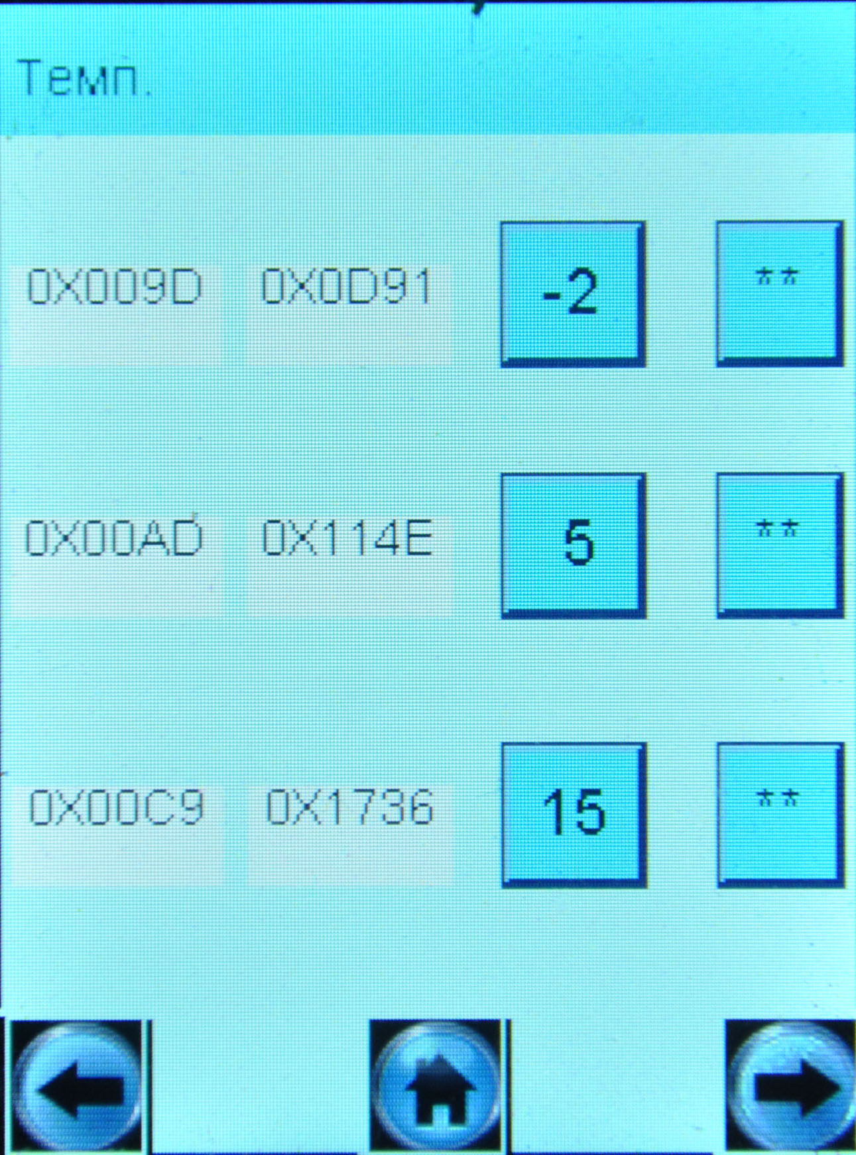
температурный коэффициент сигнала
Coefficient of signal
Thermo coefficient of signal
BUT! This coefficient is put on the place of thermo coefficient of signal (see picture), which is impossible to enter! Although when we check the signal parameters we saw two coefficients – one is a thermo and the second one is from signal of FC:
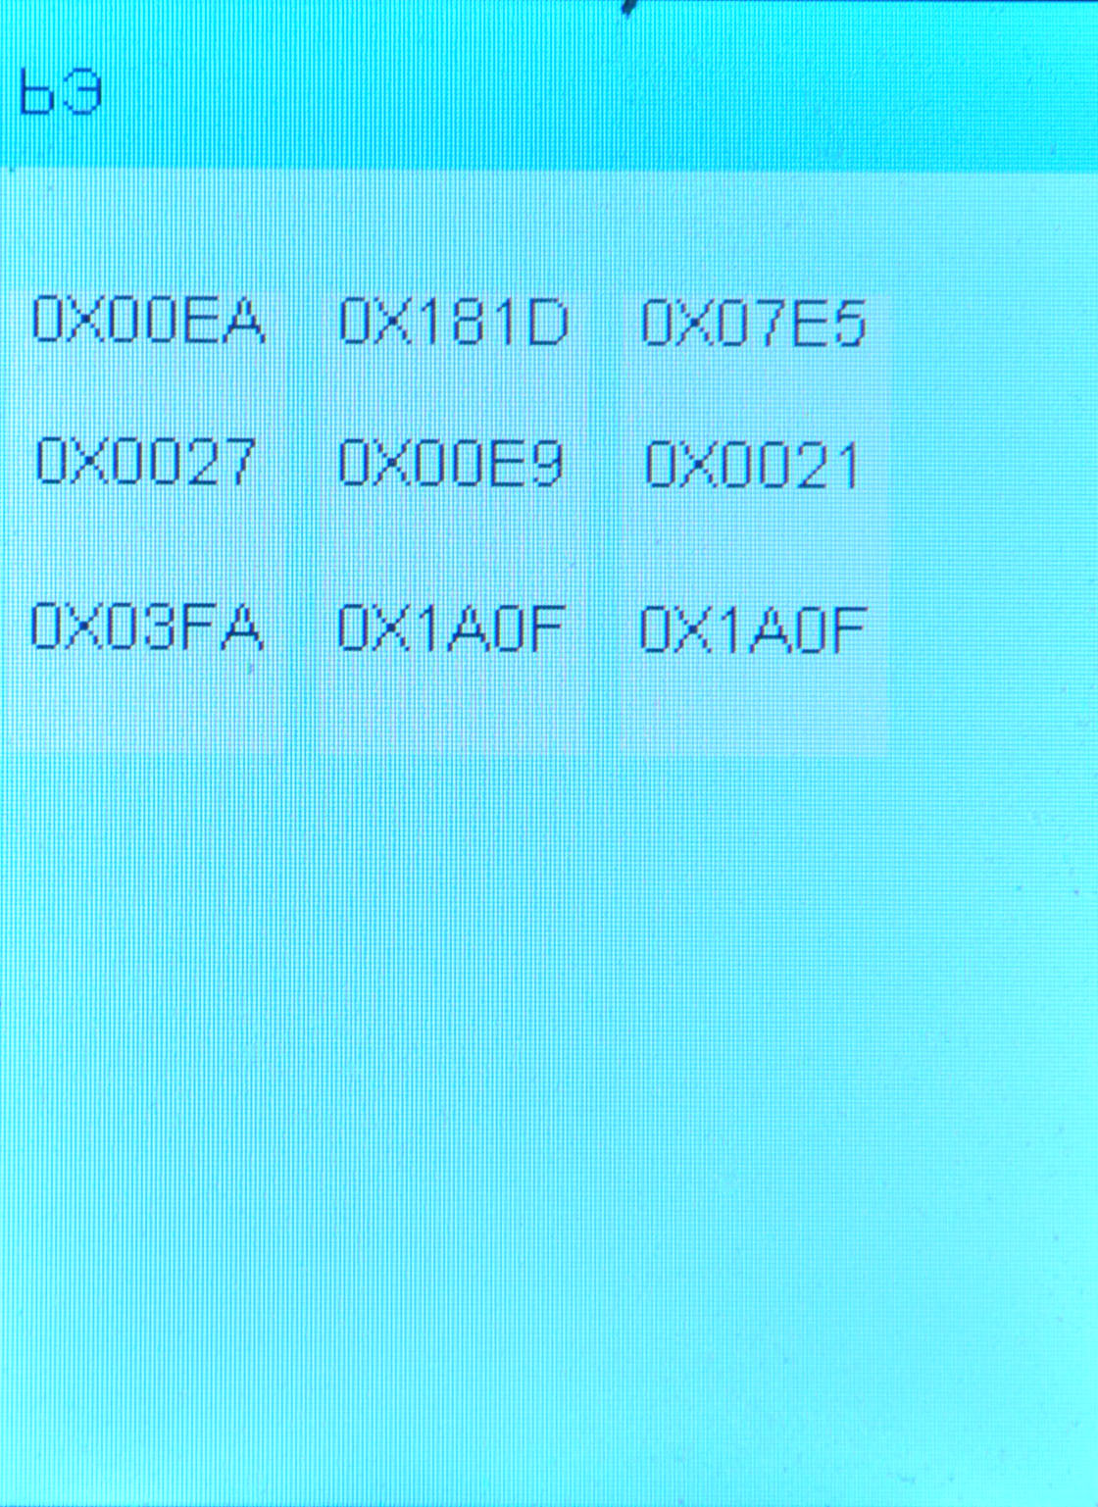
температурный коэффициент сигнала
Coefficient of signal
Thermo coefficient of signal
When we make adjustments at 25 temperature degrees we can enter the first line only, the second line becomes 0000 or 1900.
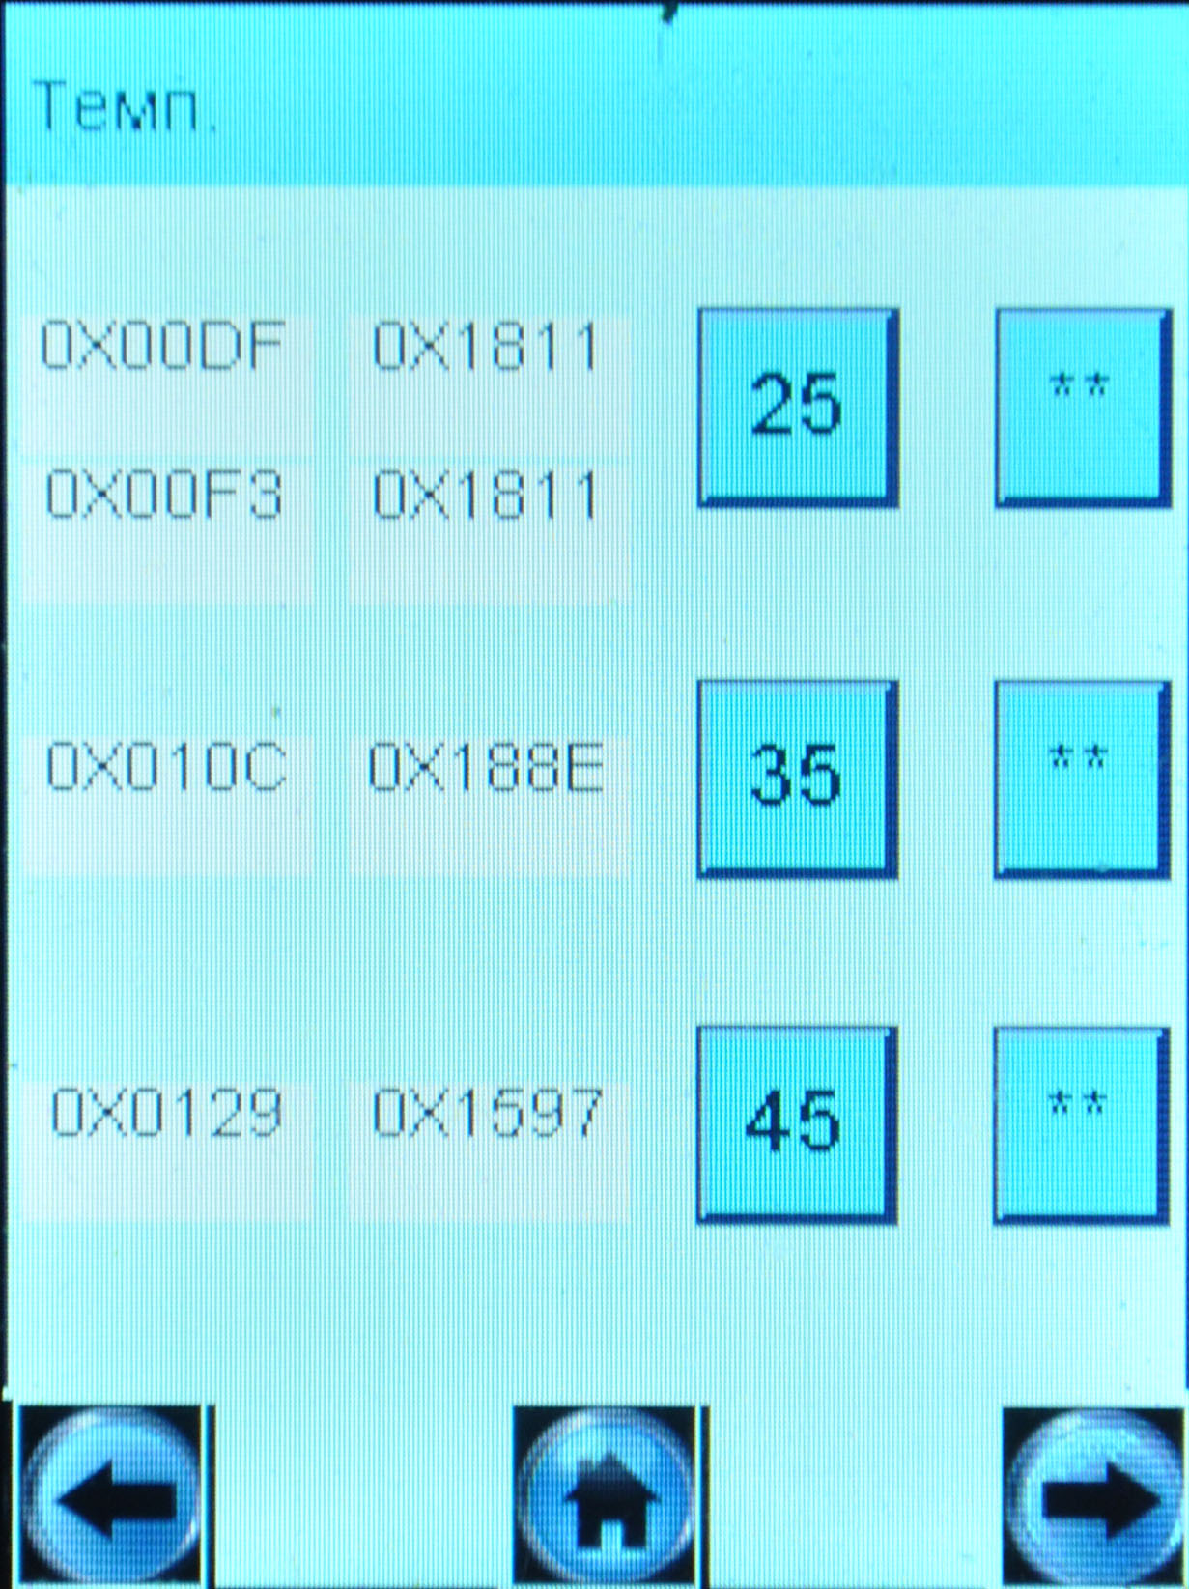
First line
Second line

So, there is something wrong with the manual adjustments.
But we need this mode to correct the factory settings.

2. For the sample with SN 120370 you used the standard concentration 0.350 mg/L (NOT 0.381). It is very strange, because how it is possible that the same software version requires the different standard concentration for the adjustment???? So we could adjust the instrument for the thermo compensation, but only for high temperatures. For the low temperatures we could not do it.

3. All samples have the problems at the low alcohol concentrations. The results were “jumping” at the low concentration range. We made 5 – 7 tests at the temperature +5°C and – 5°C.

4. We need to set the high limit of temperature at 50°C (not 45°C) for PRO-100 touch. But for PRO-100 touch-M it is not necessary (if it is a problem!). Please ask your engineers to do this.

We tested all four samples but only one (SerN 120372) gave the good and stable results. It needed the adjustments at two temperature points +5°C and - 2°C.
For other instruments we could not reach the required results at low temperature range. We used the standard concentration 0.380 mg/L and used the automatic mode by pressing the button).
What causes these problrms. Maybe it is a sensor? And we need to change a FC and make the individual thermo adjustments?

I would like you to solve these problems of software to let us possibility to use the manual thermo compensation: 1. to enter both coefficients of signal and 2. to use only one standard concentration (0.380). If you choose another one please inform us in advance.

2 Printout. We need to have a name of PRO-100 touch-M as a headline of the printout.

