PRO-100 touch-M for V1.02b( upgrading)

- In the screening mode we see two windows appearing one by one:
current form:
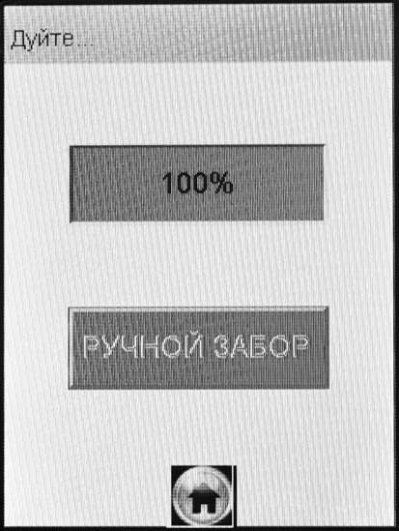
Ждите
Алгоголь
не обнаружен

Ждите

→

Remove the first window (it is not needed). Also this window should not appear if we repeat the screen test.
required form:

2. In the printout every time we see strange letters ending the serial number of instrument (for example: SerN 120372, but in the printout we see: 120372>= or 120372?2). Please correct.

3. In the menu «Запись» (“Record”) please translate Connect/ Disconnect (Подключен/Отключен)
current form required form
Запись Connect…
Тест No 00126
ДАТА 07/02/2011
Время 17:31:30
Режим РУЧНОЙ ЗАБОР
РЕЗУЛЬТАТ 0.000 мг/л
Имя Обслед.
Место Обслед.
Гос. Номер машины
Нагрудный знак
Инспектор
Отдел ДПС
Запись Подключен…
Тест No 00126
ДАТА 07/02/2011
Время 17:31:30
Режим РУЧНОЙ ЗАБОР
РЕЗУЛЬТАТ 0.000 мг/л
Имя Обслед.
Место Обслед.
Гос. Номер машины
Нагрудный знак
Инспектор
Отдел ДПС

Запись Disconnect…
Тест No 00126
ДАТА 07/02/2011
Время 17:31:30
Режим РУЧНОЙ ЗАБОР
РЕЗУЛЬТАТ 0.000 мг/л
Имя Обслед.
Место
Гос. Номер машиныОбслед.

Нагрудный знак
Инспектор
Отдел ДПС
Запись Отключен…
Тест No 00126
ДАТА 07/02/2011
Время 17:31:30
Режим РУЧНОЙ ЗАБОР
РЕЗУЛЬТАТ 0.000 мг/л
Имя Обслед.
Место Обслед.
Гос. Номер машины
Нагрудный знак
Инспектор
Отдел ДПС

ATTENTION! The message: «Disconnect» does not appear even the printer is not connected. We see always the message «Connect».

4. In the menu «Bluetooth» please replace one word to the other one.
current form required form

Bluetooth
Модуль: Отсутствует

Соединение: Отсутствует

Соединить
Bluetooth
Модуль: Bluetooth

Соединение: Отсутствует

Соединить

5. Calibration:

1. The problem was not solved! Everything left the same.

We need: the standard concentration and coefficients should be replaced ONLY if we press the button “Cal.” Or after the manual enter of the coefficients and pressing the button INPUT. If we do not press “Cal.” button or the button INPUT the standard concentration value and coefficients should be without changes.

2. If we enter calibration coefficients manually then the standard concentration should not be changed (must be the same), but the coefficients should be changed on the new coefficients.

It should work like this (for manual calibration):

We enter the standard concentration which we want to use for the calibration: «0.474» and press button
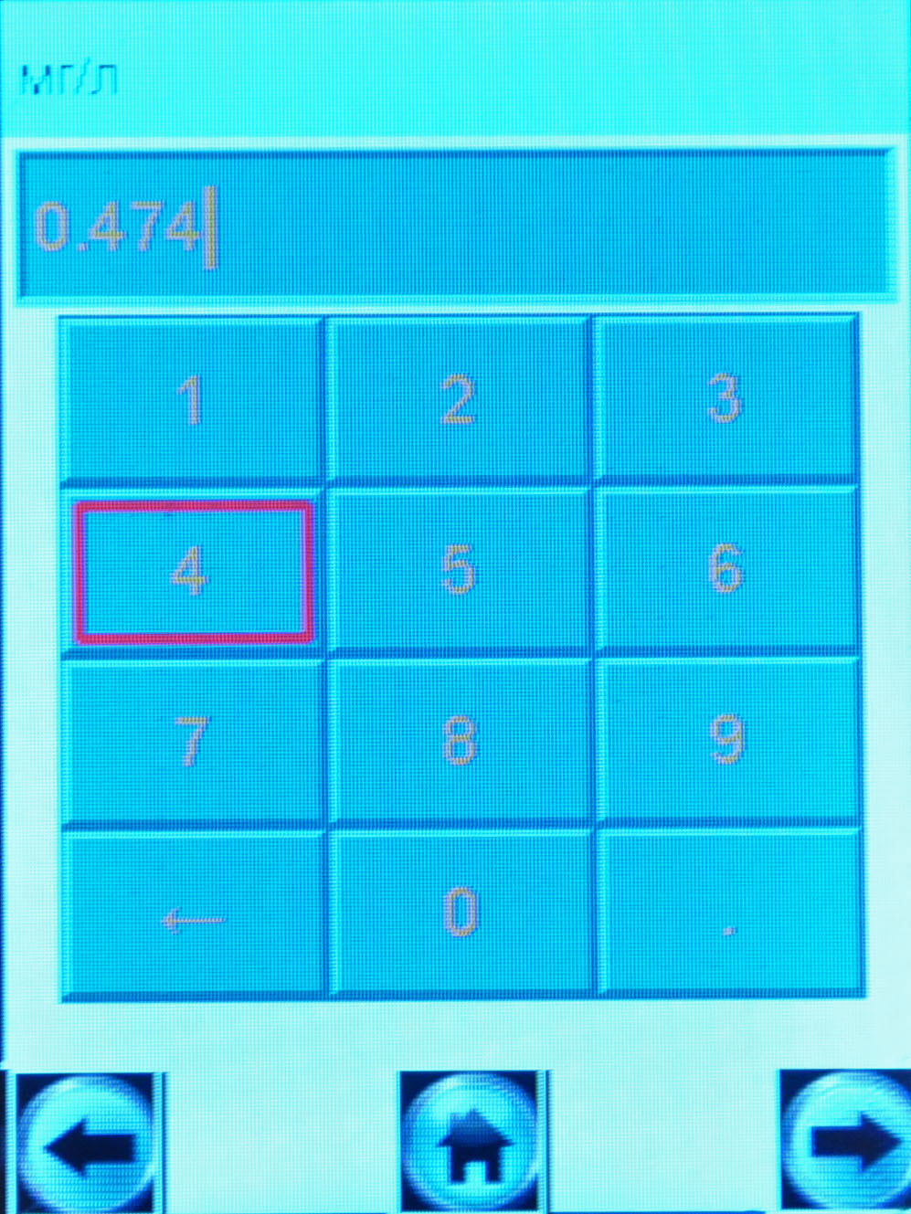
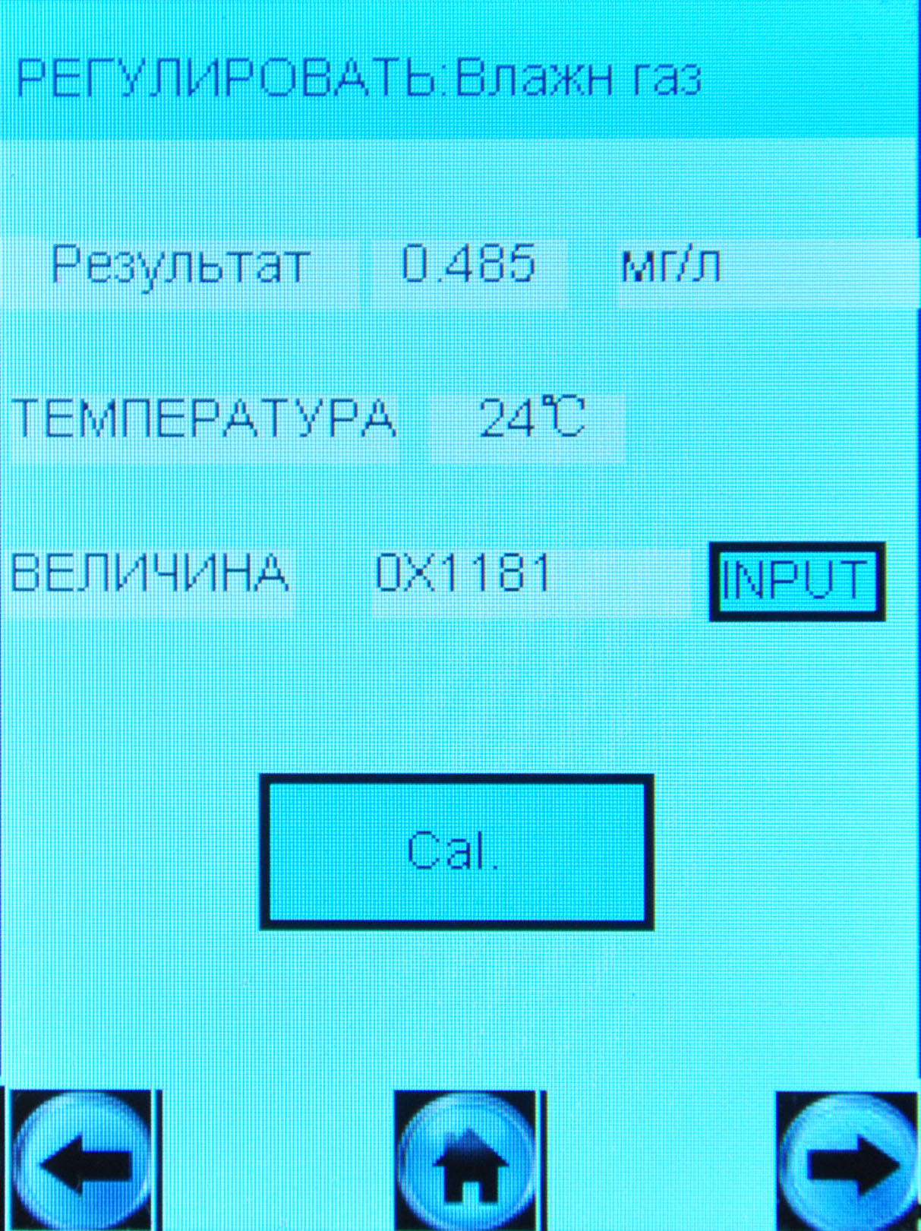
This is the standard concentration we used the last time for calibration

→

Then we press INPUT button and enter the coefficient: «1124», we will see:

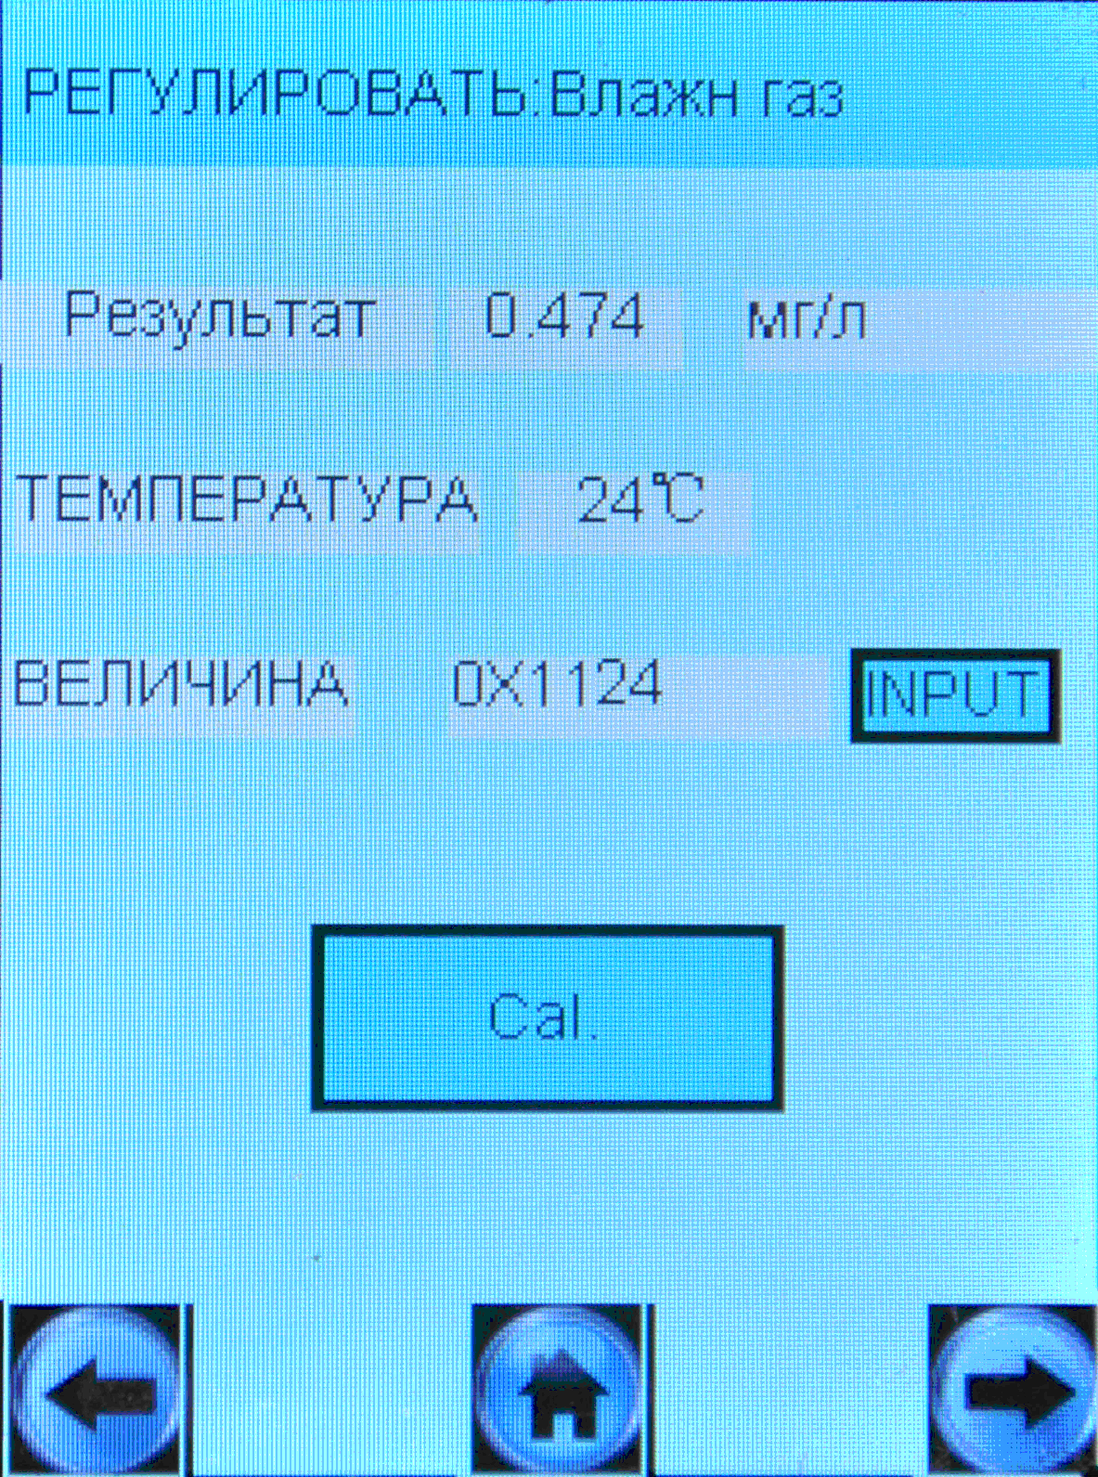
The standard concentration we use for the manual calibration.
The coefficient we entered before.

The same procedure should be for the dry gas calibration.

The automatic calibration (by pressing “Cal.” button) – Everything is OK All things work correctly.

6. The thermo-compensation: it seems there are no changes. Everything is as it was.
Our questions (please give your answers):
- What method do you use for the therm-compensation: individually for each instrument or you use the same coefficients for all instruments?
- What is a value of the standard concentration you use while you make the therm-compensation (0.380 or a different one?)
- What are the lowest and the highest temperature to activate the block feature of the instrument (-5°C and + 50°C degrees? or different)

Problems:
1. We cannot enter the coefficients manually. It does not work. What we do:
А) Keep the instrument at the temperature [- 2°C] and then take a sample with the concentration 0.381 mg/L, get result and check the coefficients:

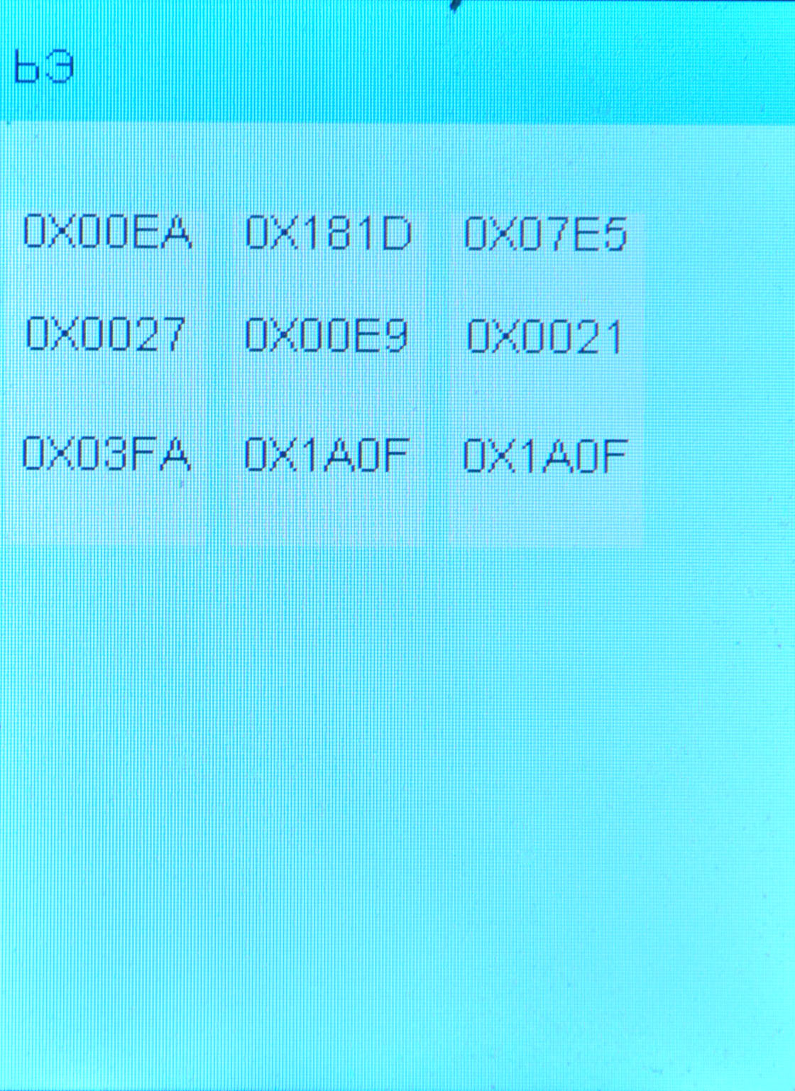
температурный коэффициент сигнала
Coefficient of the signal
Open the menu for the thermo-compensation and try to enter the coefficients (by pressing the button) – we enter the signal coefficient from FC which we had when we used standard concentration 0.381 mg/l.
**
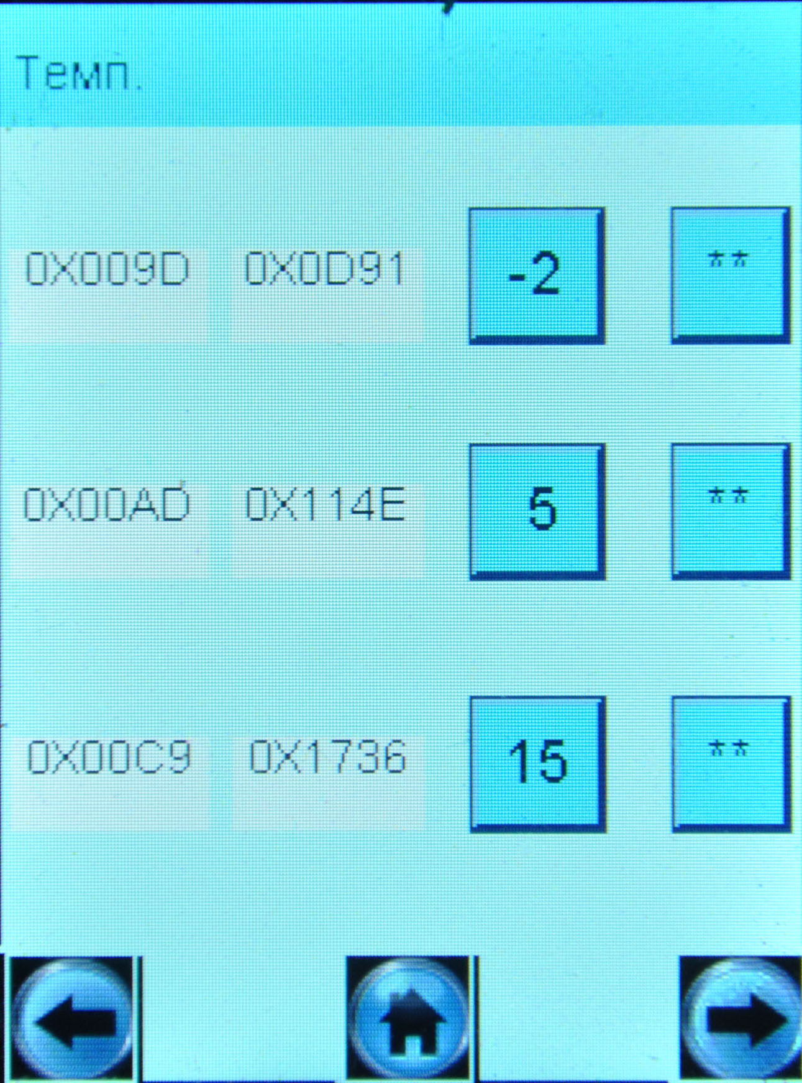
температурный коэффициент сигнала
Coefficient of signal
Therm coefficient of signal

BUT! This coefficient is placed on the position of the therm coefficient of signal, which is not possible to enter, but the coefficient of signal is replaced by zeros. Please check and you will see the problem!

В) When we make the thermo-compensation at the temperature +25°C we can enter coefficients only on the first row the second row filling by zeros or the number 1900.
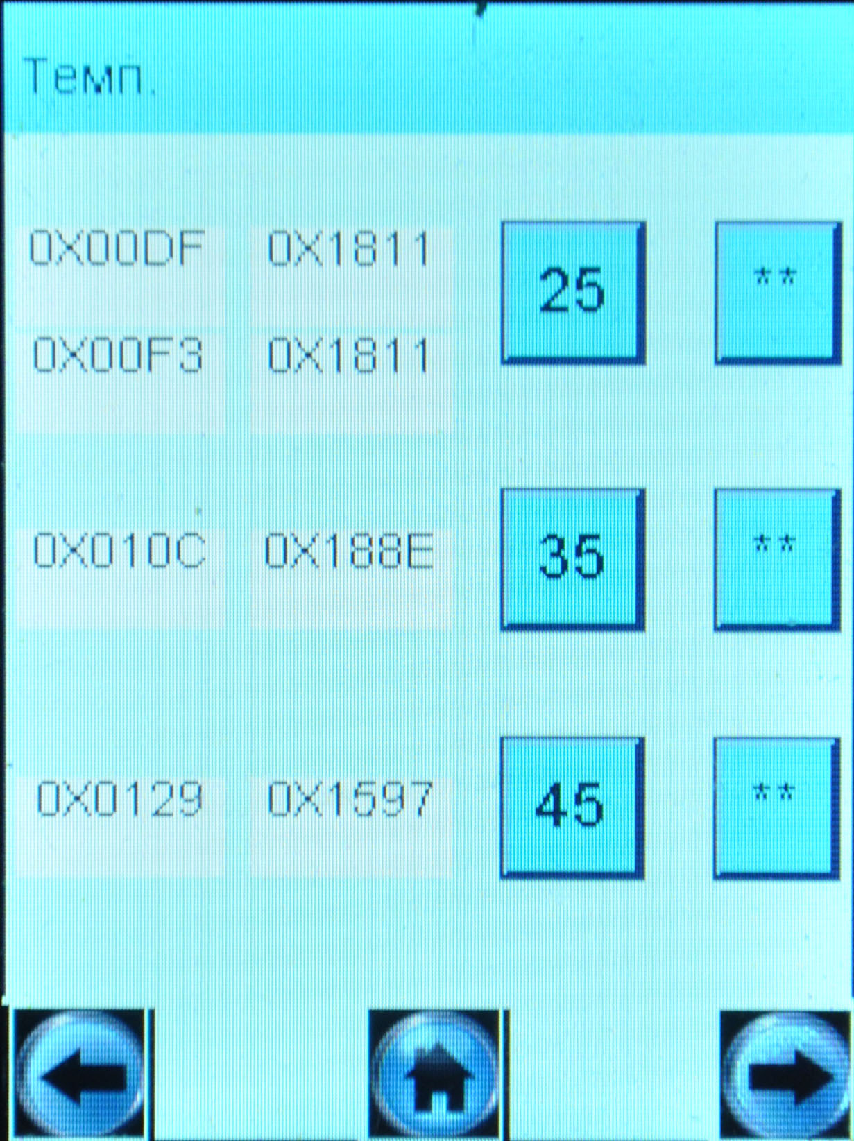
первая строка
вторая строка
Second row
First row

So something is wrong with the software.

We can accept the thermo-compensation via PC (as it is done for PRO-100 combi) if it is easier for your engineer to do.

