PRO-100 touch ( upgrading)
- Records – change the data format 09/09/2010 (now: 09/СЕН/ 2010).
- Menu – Settings – Checking (with dry gas) – window of result: Please change the headline:
current form required form
Проверка регулир. | Проверка сухой газ
РЕЗУЛЬТАТ  0.000 мг/л | РЕЗУЛЬТАТ  0.000 мг/л

- Place the icon “home” in the window “Test without keypad” to return to the Main menu and the same to the window “Time”.
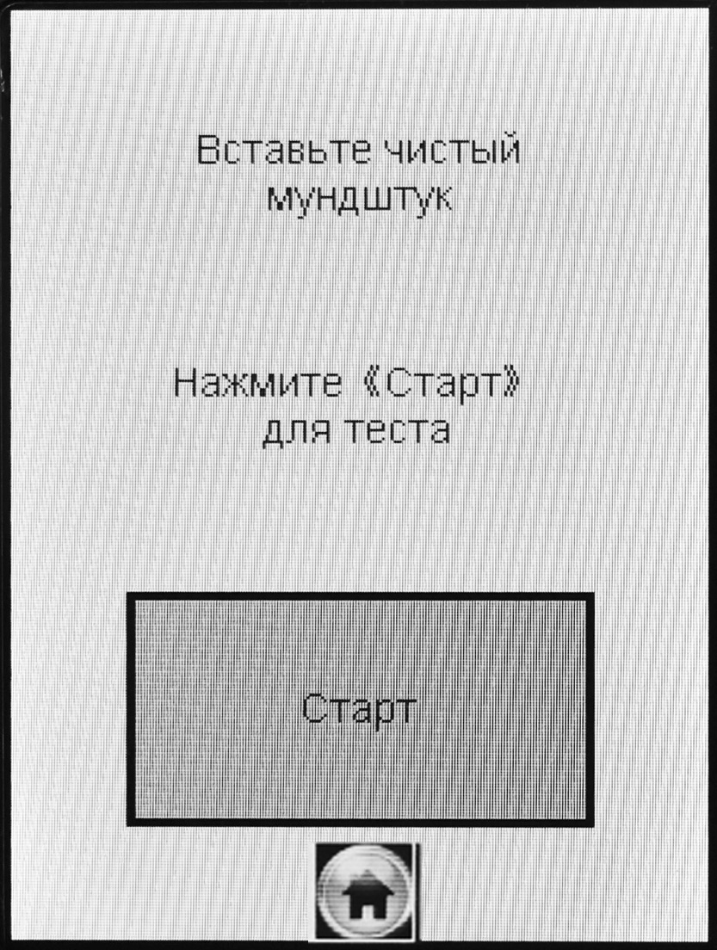
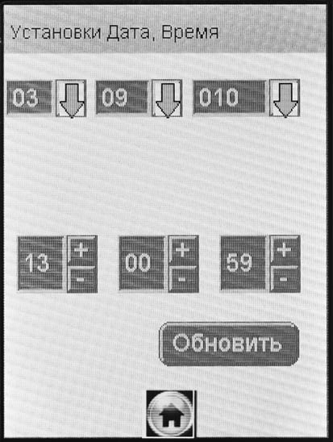

- Please change the letter С:
current required
Темп.: 26'C | Темп.: 26'C

- Please add the headline in the window of test result of the air check (in the case of an alcohol detected):
current form required form
Обнаружен  алкоголь | Проверка воздуха
Обнаружен  алкоголь | Обнаружен  алкоголь

- Please translate the “jump” to the Russian:
current form required form

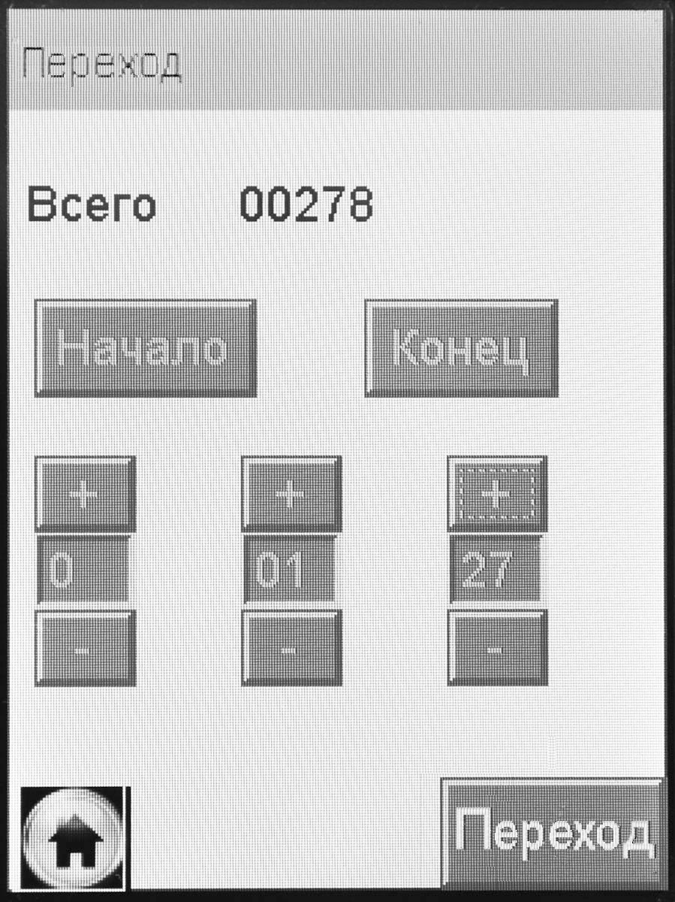
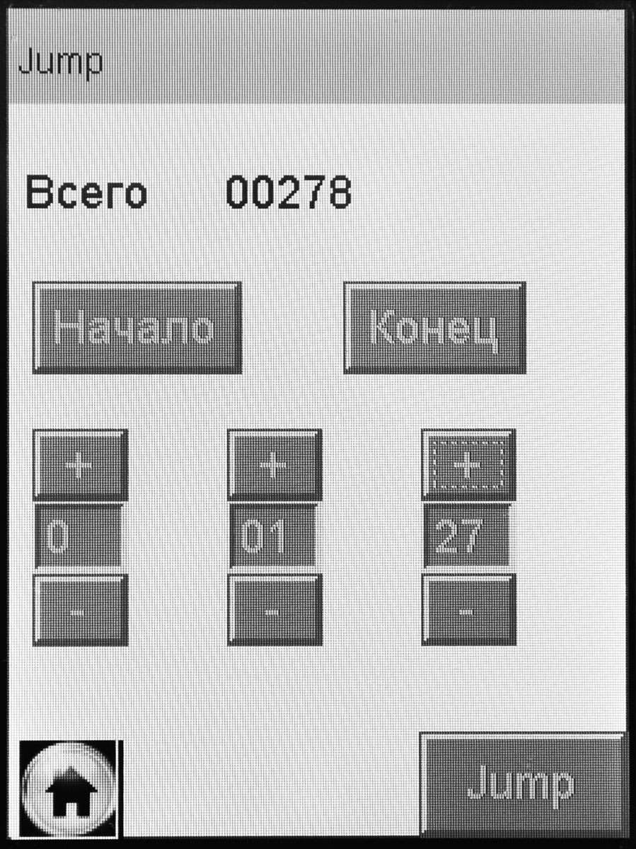

- Please change the letter size: «RU V1.27» -
current view required view
АЛКОТЕКТОР  PRO-100 touch  RU V1.27 | АЛКОТЕКТОР  PRO-100 touch  RU V1.27

- Battery charge indication. Is it possible to make the indication by color : зеленый – желтый – красный
Green – Full
Yellow – Half
Red – nearly empty.

- Problem! When we get the printout with the GPS data the instrument loses the GPS signal and finds it again after switching off and on again.

