PRO-100 touch-M for V1.06b (upgrading)

- Solve the problem of calibration!
Screen «Calibration»:
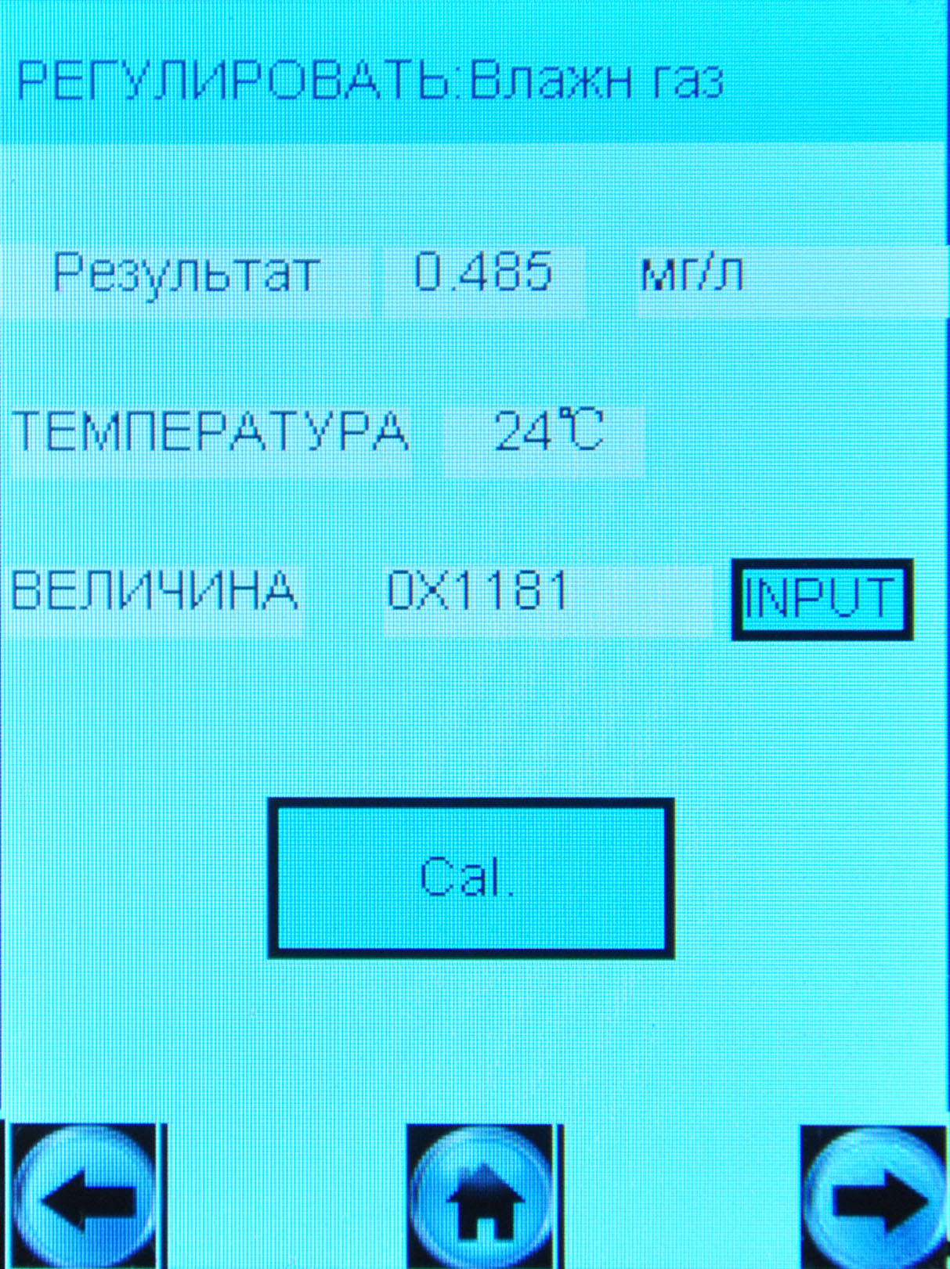
We enter to this screen and don’t press buttons “INPUT” or “Cal.”, then we leave this screen by buttons ,  or . In this case sensitivity will change. It is not correct!
It is required to change the sensitivity setting only after sampling (after pressing button “Рег.”), or after changing the coefficients manually (after pressing button “INPUT”).
Required to solve this problem when adjust sensitivity on wet and dry gas.

2. Number of the device is displayed incorrectly. We want to change serial numbers of two devices: 120370 and 120371.

3. Set block to turn on device if temperature below -5°С and above 50°С.

