PRO-100 touch-M for V1.08b (upgrading)

1. Remove 3rd sign of result when result is above 3.00 mg/l (on display, in printout, in tests memory)
1) On screen “РЕЗУЛЬТАТ”
current form required form
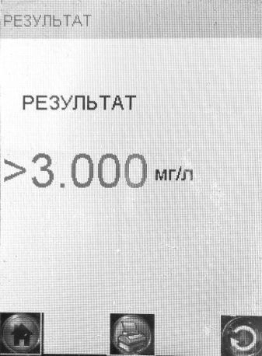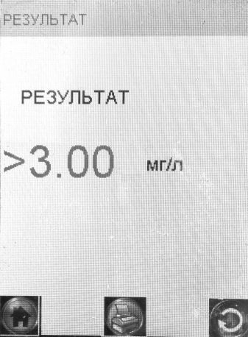
2) On screen “Запись” in tests memory
current form required form
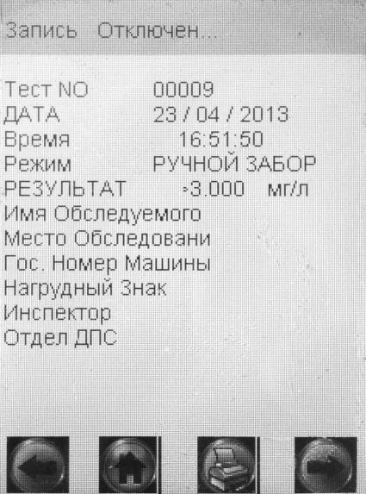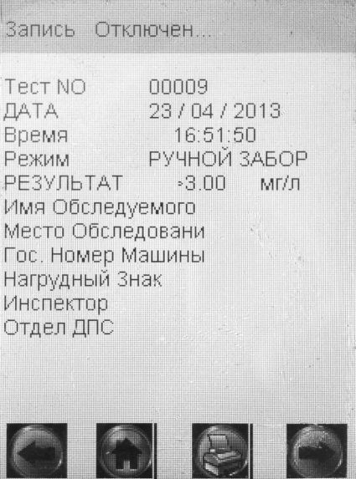
3) In printout
current form required form
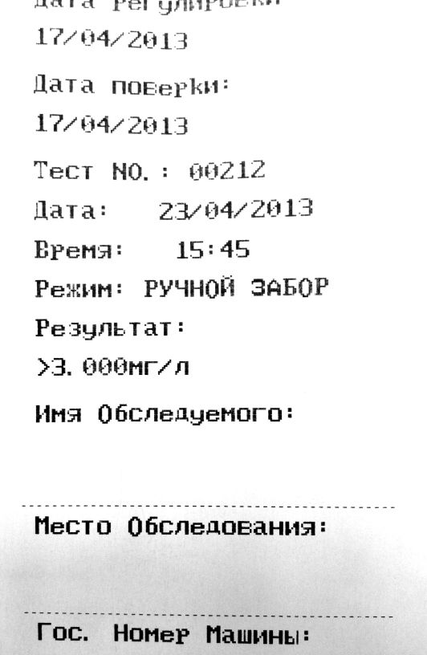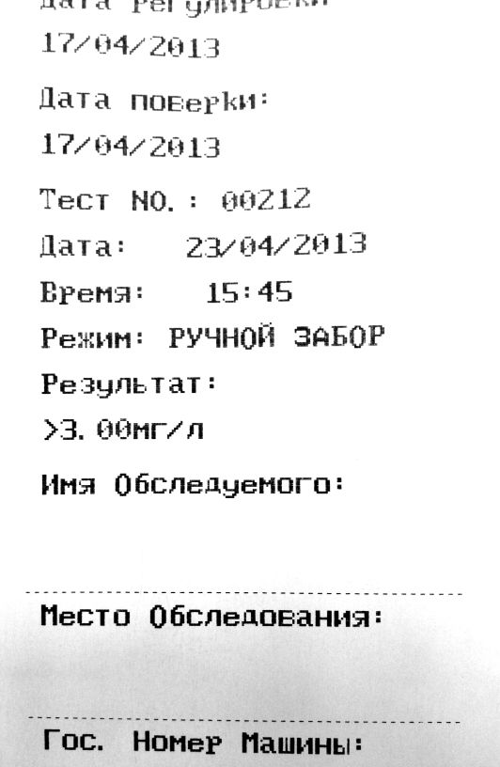

2. Remove 3rd sign of concentration for calibration
Now we can input a concentration with 3 digits after decimal point. It is required only 2 digits after decimal point.
Do these changes on wet and dry gas.
current form required form
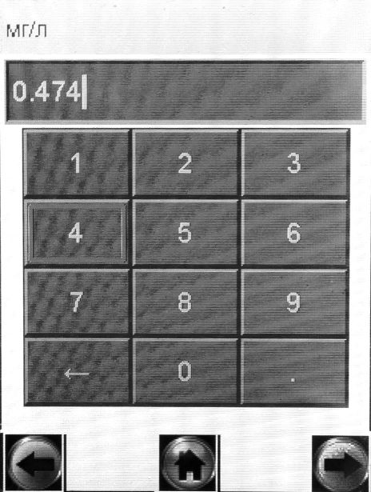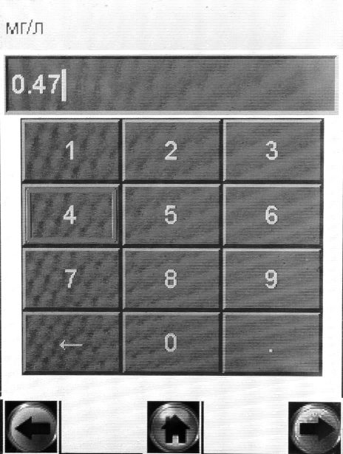

3. When we download data from device to PC we have different results in tests memory and on PC.
For example:
- tests № 225÷228,231,232 are displayed in tests memory like results “0.00 mg/l” but on PC these results displayed like “0.015 mg/l”
- test № 224 is displayed in tests memory like result “0.06 mg/l” but on PC this result displayed like “0.075 mg/l”
The device measures concentration with 3 digits after dot (x.xxx mg/l) and stores it in memory with 3 digits after dot too. But on screen and in printout the result is displayed with 2 digits after dot (x.xx mg/l). It isn’t correct.

The result should be rounded down to two decimal places and stored in memory like value with two digits after the decimal point (like x.xx mg/l).

Picture – downloaded data from the device
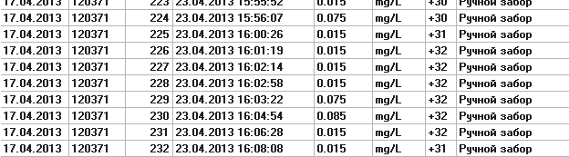

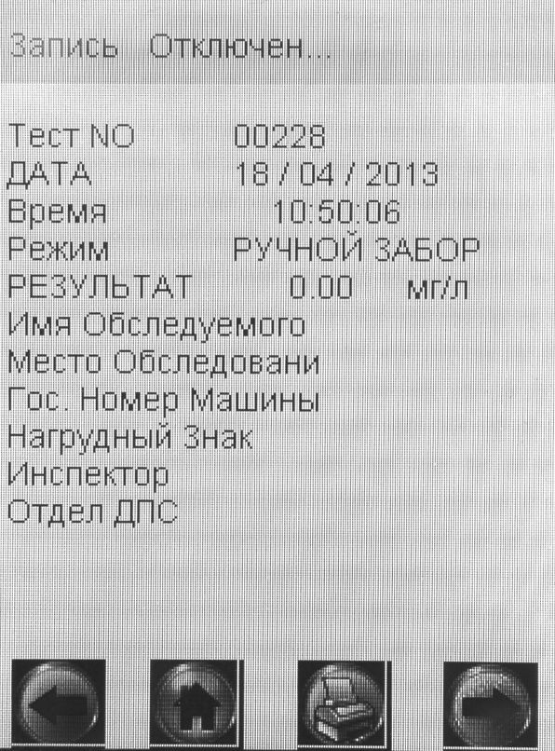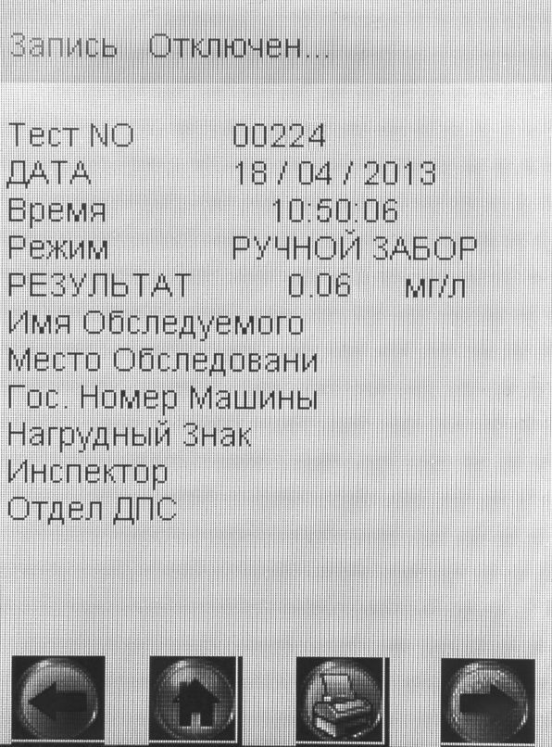

It looks like the device “adds” 0.015 to each result when it is sent to PC. Please check and correct!!!

