“Linux Process Watchdog And Auto-Restart System”

A Project Report Submitted in the partial fulfillment of the requirements for the award of the degree of

BACHELOR OF TECHNOLOGY
In

DEPARTMENT OF COMPUTER SCIENCE AND INFORMATION TECHNOLOGY

By

KAMTAM PRIYANKA 2520090001

JALA GEYA REDDY 2520090123

Under the Esteemed Guidance of

M. Raghupathi Assistant Professor

Department of Computer Science and Engineering




K L (Deemed to be) University DEPARTMENT OF COMPUTER SCIENCE ENGINEERING
&

DEPARTMENT OF COMPUTER SCIENCE AND INFORMATION TECHNOLOGY

Declaration

The Project Report entitled “Linux Process Watchdog And Auto-Restart System” is a record of Bonafide work of JALLA GEYA REDDY - 2520090123 , KAMTAM PRIYANKA – 2520090123 submitted in partial fulfillment for the award of B. Tech in Computer Science and Engineering (or) Computer Science and Information Technology to the K L University. The results embodied in this report have not been copied from any other departments/University/Institute.

KAMTAM PRIYANKA 2520090001
JALLA GEYA REDDY 2520090123

K L (Deemed to be) University

DEPARTMENT OF COMPUTER SCIENCE ENGINEERING

CERTIFICATE

This is certify that the mini project based report entitled “Linux Process Watchdog And Auto-Restart System” is a bonafide work done and submitted KAMTAM PRIYANKA – 2520090001, JALLA GEYA REDDY – 2520090123 in partial fulfillment of the requirements for the award of the degree of BACHELOR OF TECHNOLOGY in Department of Computer Science Engineering, K L (Deemed to be University), during the academic year 2026-2027.

Signature of the Guide

Signature of the Course Coordinator Signature of the HOD

ACKNOWLEDGEMENT

The success in this project would not have been possible but for the timely help and guidance rendered by many people. Our wish to express my sincere thanks to all those who has assisted us in one way or the other for the completion of my project.

Our greatest appreciation to my Course Coordinator Dr. K. Anusha, and my guide M. Raghupathi , Department of Computer Science which cannot be expressed in words for his/her tremendous support, encouragement and guidance for this project.

We express our gratitude to Dr. P Venkateshwara Roa (CSE), Head of the Department for Computer Science Engineering for providing us with adequate facilities, ways and means by which we are able to complete this project-based Lab.

We thank all the members of teaching and non-teaching staff members, and also who have assisted me directly or indirectly for successful completion of this project. Finally, I sincerely thank my parents, friends and classmates for their kind help and cooperation during my work.

JALLA GEYA REDDY 2520090123 KAMTAM PRIYANKA 2520090001

ABSTRACT
Long-running programs can terminate unexpectedly because of faults, resource exhaustion or external signals. An operating system provides the mechanisms to observe such terminations, but an application must use them deliberately to recover. This project presents the Linux Process Watchdog and Auto-Restart System, an educational, web-based application that monitors a separate worker process in a Linux environment and automatically attempts to restart it when it terminates unexpectedly.
The system is implemented in Python 3. A Flask backend (app.py) exposes an HTTP interface to a browser dashboard built with HTML, CSS and JavaScript. A watchdog component (watchdog.py) launches the worker (worker.py) as a separate operating-system process using Python’s subprocess facilities and runs a monitoring thread that periodically checks the worker’s state. When termination is detected, the watchdog records the exit status, applies the configured restart policy and delay, and relaunches the worker where permitted. A lock protects the state shared between the monitoring thread and the web request handlers, and every significant event is written to a persistent log file (logs/watchdog.log). The dashboard shows the worker status, process identifier (PID), uptime, restart count, exit code and recent events where supported, and offers a controlled crash simulation that terminates only the worker managed by the application.
The project demonstrates six Operating Systems course outcomes: the operating system as a service layer, process management, signals and inter-process concepts, memory management, file systems and I/O, and concurrency with synchronization. It runs on Ubuntu under WSL2 and is intended for learning and demonstration; it is not a production-grade process supervisor.
Keywords: Operating Systems, Process Management, Watchdog, Auto-Restart, Signals, Threads, Synchronization, Flask, Python, Linux, WSL2.
INDEX / TABLE OF CONTENTS

Note: In Microsoft Word, right-click the table above and choose “Update Field → Update entire table” after final editing so that page numbers match the final pagination.

CHAPTER 1 — INTRODUCTION

1.1 Background of the Project
Every program that runs on a modern operating system executes as a process: an instance of a program together with its own address space, open files, scheduling state and unique process identifier (PID). The operating system creates processes, schedules them on the CPU, isolates their memory, delivers signals to them and reclaims their resources when they terminate. Because a process may terminate at any time, for example through an unhandled error, an external signal or a resource limit, software that must remain available needs a mechanism to notice termination and recover.
A watchdog is a supervising component that periodically checks whether another program is still alive and takes a recovery action, such as restarting it, when it is not. Watchdog behaviour is a common pattern in system administration and embedded systems. This project implements a small, transparent watchdog in Python so that the underlying operating-system ideas can be observed through a web dashboard.

1.2 Problem Statement
When a worker process terminates unexpectedly, there is no automatic recovery unless another component detects the failure and relaunches it. Learners studying Operating Systems often meet process creation, termination, exit status, signals and synchronization only as isolated theory. The problem addressed by this project is to design and implement a Linux-based system that (i) runs a worker as a separate process, (ii) detects when it terminates, (iii) restarts it according to a configurable policy, (iv) records every event persistently, and (v) presents the live state through a browser dashboard that can be used for demonstration.

1.3 Scope of the Project
The scope of the project covers the following:
- Monitoring a single worker process (worker.py) that is launched and managed by the application.
- Starting and stopping monitoring from a browser dashboard served by Flask on http://127.0.0.1:5000.
- Periodic state checking, termination detection and automatic restart according to a configurable monitoring interval and restart delay.
- Display of status, PID, uptime, restart count, exit code and recent events where supported by the implementation.
- A controlled crash simulation that terminates only the worker managed by this project.
- Persistent event logging to a file and thread-safe access to shared state.
The project does not monitor arbitrary system processes, does not supervise multiple services, and is not intended to replace production supervisors such as systemd or supervisord. It is an educational demonstration.

1.4 Objectives of the Project
- To demonstrate process creation, identification, monitoring and termination using Python on Linux.
- To detect unexpected worker termination and apply an automatic restart policy.
- To show how a monitoring thread and web request handlers can safely share state using a lock.
- To maintain persistent event logs using file input and output.
- To provide an interactive web dashboard that makes process behaviour visible.
- To map the implementation to Operating Systems course outcomes CO-1 to CO-6.

1.5 Importance of the Application
The application turns abstract Operating Systems topics into observable behaviour. A student can start monitoring, see a real PID, trigger a crash, watch the watchdog detect it and see the new PID appear after restart, while the log file records the sequence. This supports understanding of the process life cycle, the meaning of exit status, the role of signals, process isolation, and the need for synchronization when several threads access shared data. The same pattern, a supervisor that detects failure and restarts a service, is also the basis of real-world service managers, which makes the concept relevant beyond the classroom.

1.6 Target Users / Audience
Audience | How they use or benefit from the project
Undergraduate students | Learn process management, signals, threads and file I/O through a working example.
Faculty / evaluators | Observe a live demonstration of OS concepts during project evaluation and viva.
Beginner developers | Study a small Flask application that coordinates a background thread and a child process.

CHAPTER 2 — OS CONCEPTS AND BACKGROUND STUDY

2.1 Operating System Concepts Related to the Project

2.1.1 Operating System as a Service Layer (CO-1)
An operating system acts as a service layer between applications and hardware. Applications request services, such as creating a process, opening a file or using a network socket, through system calls exposed via libraries. In this project, Python’s standard library and Flask call into the Linux kernel on the program’s behalf to create the worker process, read its status, write the log file and accept HTTP connections on a network socket.

2.1.2 Process Management (CO-2)
A process is a program in execution with its own address space and resources, identified by a PID. A process moves through states such as new, ready, running, waiting and terminated. When a process ends it produces an exit status; on Linux a normal exit yields a non-negative code, and Python’s subprocess module reports termination by a signal as a negative return code equal to the negative signal number. A parent process must collect (reap) the status of its terminated child; otherwise the child remains as a zombie entry in the process table. The watchdog performs this role for the worker it launches.
Process versus thread. A process has its own address space and operating-system resources, whereas threads are independent flows of execution that live inside one process and share its address space. In this project the Flask server and the watchdog monitoring thread are threads of the same Python process, while the worker is a separate process with its own address space. Communication between threads is cheap but requires synchronization; communication with the worker process is mediated by the operating system.

2.1.3 Inter-Process Communication and Signals (CO-3)
A signal is an asynchronous notification delivered by the kernel to a process, for example SIGTERM (request to terminate) or SIGKILL (forced termination that cannot be caught). Signals are how a process can be asked to stop or be forcibly ended, and a termination caused by a signal is visible to the parent through the exit status. In this project the worker’s termination, whether normal or caused by a signal such as the one used in the crash simulation, is detected by the watchdog through the process state and exit status, and the dashboard’s restart path relies on process control signalling as indicated in the system architecture diagram (“Restart (Signals)”).
Scope note: the project does not claim to implement pipes, message queues, shared memory or sockets between the watchdog and the worker. The communication between the browser and the Flask server uses HTTP over a network socket, and the watchdog observes the worker through the process-control interface of the operating system.

2.1.4 Memory Management (CO-4)
Each Linux process has its own virtual address space, which the kernel maps to physical memory. This process isolation means a fault in one process does not corrupt another process’s memory. When a process terminates, the kernel reclaims the memory it held. This is why a crashed worker can simply be launched again as a fresh process with a clean address space. Distinction: memory management is *explained and demonstrated by behaviour* in this project (the worker runs in a separate address space and its memory is reclaimed by the kernel on exit); the application does not implement its own allocator or paging mechanism.

2.1.5 File Systems and I/O (CO-5)
Files are accessed through file descriptors obtained from the kernel. The project writes watchdog events to logs/watchdog.log so that the history survives beyond the lifetime of a single process and can be reviewed after the application stops.

2.1.6 Concurrency and Synchronization (CO-6)
Concurrent execution means that more than one flow of control makes progress during the same period. The watchdog thread periodically updates the worker’s status while Flask may simultaneously serve several HTTP requests that read or change the same data. Without protection, such access could produce a race condition. A lock (mutual-exclusion primitive) ensures that only one thread at a time executes the critical section that touches shared state.

2.2 Existing Methods / Tools
Tool / Method | Description | Remark for this project
systemd | Standard Linux service manager that can restart failed services (restart policies). | Production-grade and powerful, but configuration-driven; it hides the underlying mechanics from learners.
supervisord | Python-based process control system that starts and restarts programs. | Full-featured; larger than needed for a teaching demonstration.
Shell loops / cron checks | Scripts that check a process and relaunch it. | Simple but coarse; offers no live dashboard or structured state.
Manual monitoring (top, ps) | Administrator inspects processes by hand. | No automatic recovery.

2.3 Proposed Approach
The proposed approach is a compact watchdog written in Python that separates responsibilities across three components, as shown in the system architecture (Chapter 5): a Flask backend (app.py) that receives dashboard requests, a watchdog component (watchdog.py) that launches and monitors the worker and applies the restart policy, and a worker process (worker.py) that runs as a separate operating-system process. A monitoring thread polls the worker at a configurable interval. When termination is detected, the exit code is recorded and, if the restart policy permits, the worker is relaunched after a configurable delay. All events are appended to a log file, and the dashboard presents the live state to the user.

2.4 Advantages of the Proposed Approach
- Transparency: each OS mechanism (process creation, status polling, signals, locking, file I/O) is visible in a few small Python files.
- Observability: a browser dashboard shows PID, status, restart count and events in real time.
- Safety of demonstration: crash simulation affects only the worker managed by the application.
- Configurability: monitoring interval and restart delay can be changed to study their effect.
- Portability: the application runs on Ubuntu under WSL2 using only Python 3 and Flask.

CHAPTER 3 — SYSTEM REQUIREMENTS

3.1 Hardware Requirements
The application is lightweight. The following figures are suggested minimums for a smooth demonstration on a Windows laptop running WSL2; they are not measured benchmarks.
Component | Suggested requirement
Processor | Dual-core 64-bit processor with virtualization support enabled (required for WSL2)
Memory (RAM) | 4 GB minimum; 8 GB recommended
Storage | At least 2 GB free disk space for the Ubuntu distribution, Python packages and logs
Display / Network | Standard display; local loopback network interface (127.0.0.1) for the dashboard

3.2 Software Requirements
Software | Purpose
Windows with WSL2 enabled | Host environment for the Linux subsystem
Ubuntu (WSL2 distribution) | Linux environment in which the project is developed and executed
Python 3 with venv and pip | Runtime and package management
Flask (from requirements.txt) | Backend web framework and HTTP API
Modern web browser | Access to the dashboard at http://127.0.0.1:5000
Text editor / IDE | Editing the source files

3.3 Operating System Environment — Ubuntu / WSL2
The Windows Subsystem for Linux, version 2 (WSL2), runs a real Linux kernel in a lightweight virtual machine, allowing a Linux distribution such as Ubuntu to run alongside Windows. The project is executed inside the Ubuntu environment so that the worker is a genuine Linux process with a Linux PID, Linux signal semantics and the Linux file system. The project folder on the Windows drive is reachable from Ubuntu under the /mnt/c/ path, which is why the setup commands in Chapter 7 begin with a cd into that location. Because the Flask server listens on the loopback address, the dashboard is opened from the Windows browser at http://127.0.0.1:5000.

3.4 Development Tools and Runtime Requirements
- Python virtual environment (`.venv`) to isolate project dependencies from the system Python installation.
- pip to install the packages listed in requirements.txt.
- Terminal (Ubuntu shell) that must remain open while the Flask server runs.
- Browser developer tools (optional) to observe HTTP requests made by the dashboard JavaScript.

CHAPTER 4 — TECHNOLOGY AND TOOLS USED
This chapter describes each technology used in the project, its purpose and where it appears in the project files. Table 4.1 gives a summary.
Table 4.1: Summary of technologies, purpose and location in the project
Technology | Purpose | Where used
Python 3 | Backend logic, process management, monitoring | app.py, watchdog.py, worker.py
Flask | Web server and HTTP API | app.py
subprocess module | Launch and monitor the separate worker process | watchdog.py
Threads and lock (threading) | Periodic monitoring; protection of shared state | watchdog.py, app.py
File I/O | Persistent event logging | watchdog.py, logs/watchdog.log
HTML | Dashboard structure | templates/index.html
CSS | Dashboard appearance | static/css/style.css
JavaScript | Browser interactions and API requests | static/js/app.js
Ubuntu on WSL2 | Linux execution environment | Whole project

4.1 Python 3
Python 3 is a high-level, interpreted language with a rich standard library. It is used for all backend logic: the web server routes, the process launcher and monitor, the worker program and the file-logging code. Its readable syntax suits an educational project, and the standard-library modules for process control, threading and file handling expose operating-system services with little boilerplate.

4.2 Flask
Flask is a lightweight Python web framework. It maps URL routes to Python functions, renders the dashboard page from templates/index.html and serves static assets from the static/ folder. In this project Flask provides the HTTP interface between the browser and the watchdog logic. The development server accepts several requests, which is why shared state must be protected (Section 4.4). The application is a demonstration and is run with Flask’s development server rather than a production web server.

4.3 Process Management APIs
The project relies on Python’s subprocess facilities to start the worker as a separate operating-system process and to query it. The concepts used are summarised below; the exact calls used are described in Chapter 6.
Concept / facility | Role in the project
Process creation with subprocess | Starts worker.py as a child process with its own PID
PID | Identifies the running worker; displayed on the dashboard when available
Polling process state | Determines whether the worker is still running
Exit code / return code | Recorded when the worker terminates; negative values indicate termination by a signal
Terminate / kill facilities | Used for stopping the worker and for the controlled crash simulation

4.4 Threads and Synchronization
The threading module provides threads and synchronization primitives. The watchdog runs a monitoring thread in the background so that checking the worker does not block the web server. A lock (threading.Lock, as indicated in the project overview) guards the shared state, such as status, PID and restart count, so that the monitoring thread and request-handling threads never modify it at the same instant.

4.5 File Systems and Logging
Event logging uses ordinary file operations. Each significant event (monitoring started, worker started, worker terminated, restart attempted, monitoring stopped) is written with a timestamp to logs/watchdog.log. The file system provides durability: the log remains available after the application or the worker has ended. The log file is created during execution depending on the application’s logging setup.

4.6 HTML, CSS, and JavaScript
Technology | File | Responsibility
HTML | templates/index.html | Structure of the dashboard: status panel, controls, configuration inputs, event list
CSS | static/css/style.css | Layout, colours and visual styling of the dashboard
JavaScript | static/js/app.js | Sends API requests to Flask (AJAX calls) and updates the page with the responses

4.7 Linux / WSL2 Environment
Linux provides the kernel services on which the project depends: process management, signals, the file system and memory management. WSL2 makes these available on a Windows computer. Running on a real Linux kernel ensures that PIDs, signals and exit statuses behave as described in Linux documentation.

CHAPTER 5 — SYSTEM ARCHITECTURE AND DESIGN

5.1 Overall System Architecture
The system follows a layered design. The user interacts with a web dashboard in the browser; the dashboard communicates with a Flask backend using HTTP requests (REST-style API calls); the backend coordinates the watchdog component and the worker process; and both of those rely on services of the Linux kernel. Figure 5.1 shows the architecture of the project.
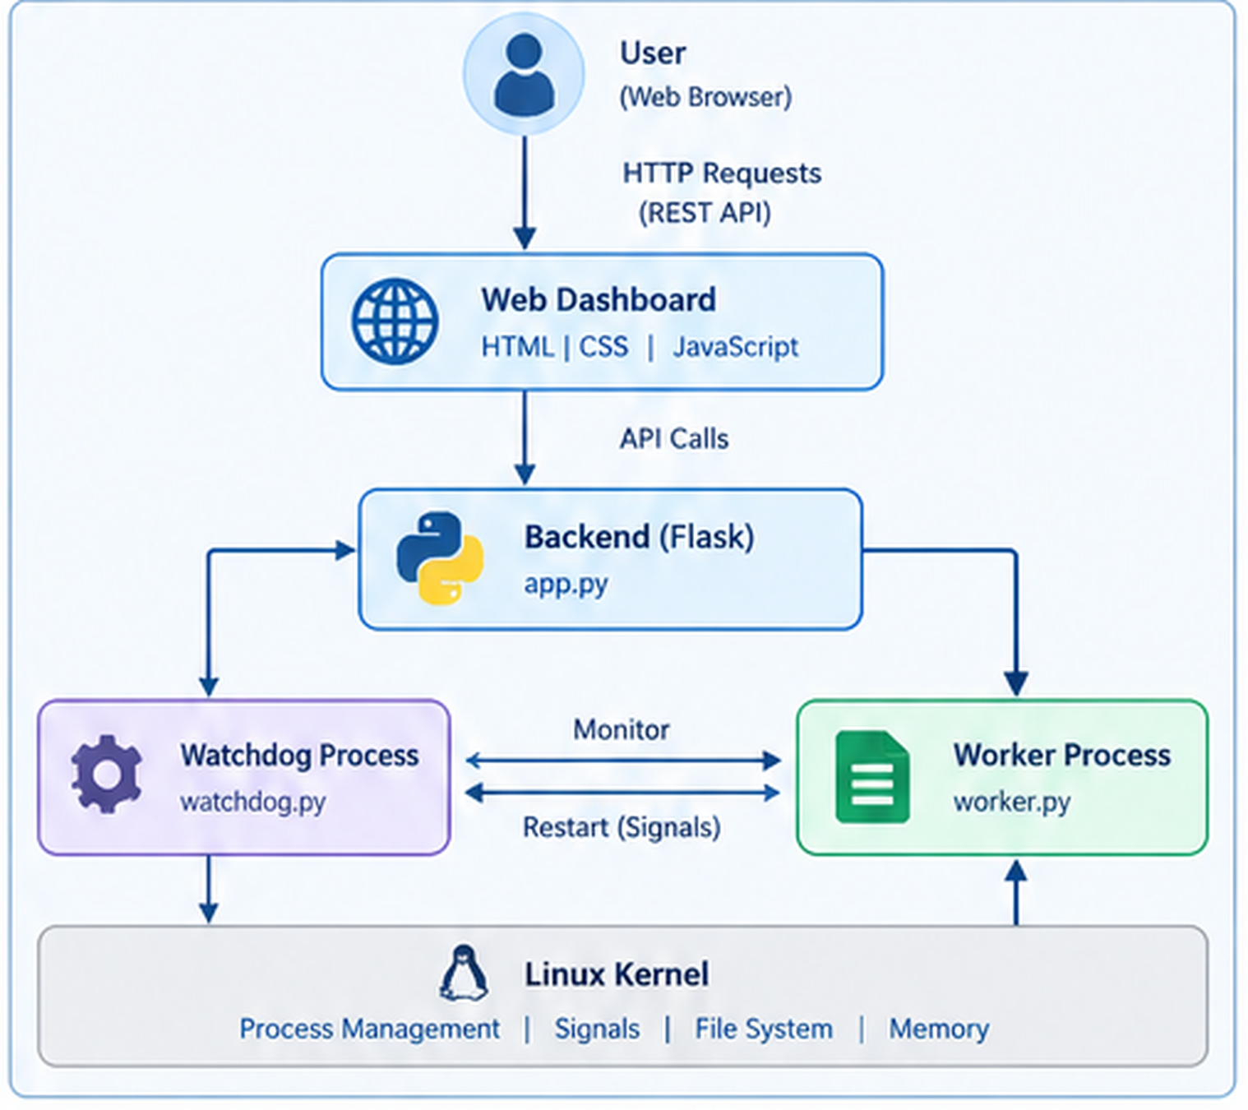
Figure 5.1: System Architecture of the Linux Process Watchdog and Auto-Restart System
The flow shown in Figure 5.1 is explained below, component by component.
Component | Role and interaction
User / Web Browser | The user opens the dashboard and issues commands (start, stop, crash simulation, configuration). The browser communicates through HTTP requests (REST API).
Web Dashboard (HTML, CSS, JavaScript) | Presents status, PID, uptime, restart count, exit code and events. JavaScript turns user actions into API calls to the Flask backend and refreshes the display from the responses.
Flask Backend (app.py) | Receives the API calls, serves the dashboard page and static files, and coordinates the watchdog and the worker. In the diagram it is linked to both the Watchdog Process and the Worker Process.
Watchdog Component (watchdog.py) | Runs the monitoring thread. It monitors the worker at a configured interval, detects termination, and performs the restart (shown in the diagram as “Restart (Signals)”). It also protects shared state with a lock and writes the event log.
Worker Process (worker.py) | The separate process that is being supervised. It runs independently of the Flask server; its termination is what the watchdog detects.
Linux Kernel and OS facilities | Provides process management, signals, file system and memory services used by all components, as labelled in the diagram.
Event Log File (logs/watchdog.log) | Persistent record of events. It is written by the watchdog component through the file-system services of the kernel. The log file is not drawn as a separate block in Figure 5.1; it is part of the file-system service shown in the Linux Kernel layer.

5.2 System Workflow
The overall workflow of one monitoring session is as follows:
- The user opens http://127.0.0.1:5000 and clicks Start on the dashboard.
- The browser sends an HTTP request to the Flask backend.
- The backend launches the worker process through the watchdog, using subprocess, and records its PID.
- The watchdog monitoring thread wakes up periodically (monitoring interval) and checks the worker’s state.
- While the worker is running, the dashboard shows its status, PID and uptime.
- If the worker terminates (naturally, or through the crash simulation), the watchdog records the exit code and logs the event.
- If the restart policy permits (for example, the restart limit has not been reached, where supported), the watchdog waits for the restart delay and launches a new worker; the PID and restart count change.
- All events are appended to the log file and shown among the recent events on the dashboard.
- When the user clicks Stop, monitoring ends and the worker is stopped.

5.3 Flowchart / Data Flow
Figure 5.2 presents the monitoring and restart logic as a flowchart. The restart decision depends on the configured policy, and the exact conditions are those implemented in watchdog.py.
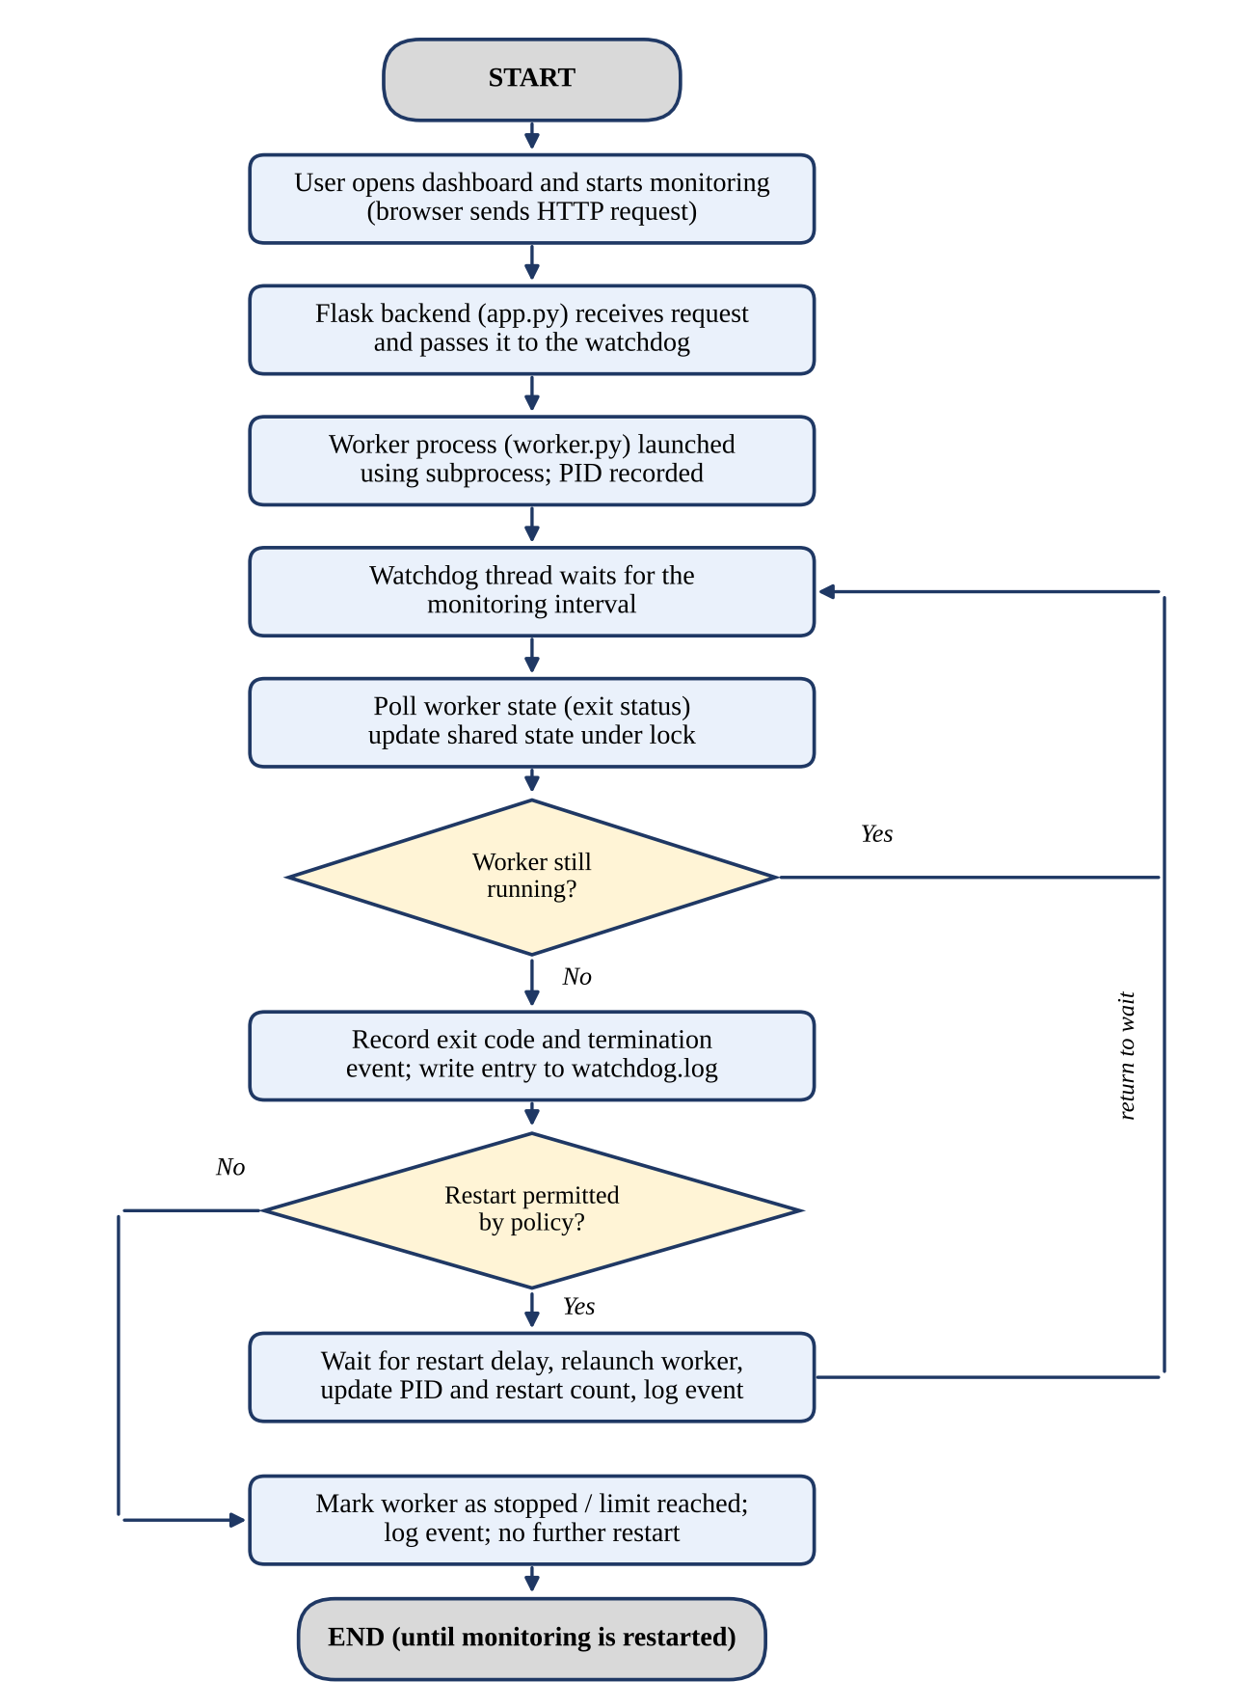
Figure 5.2: Flowchart of Monitoring and Auto-Restart Logic
Data flow summary. The table below lists the main data items and the direction in which they travel.
Data item | From | To | Medium
Start / stop / crash / configuration commands | Browser (JavaScript) | Flask (app.py) | HTTP request
Status, PID, uptime, restart count, exit code, events | Flask / watchdog state | Browser | HTTP response
Launch / terminate requests | Watchdog | Worker via kernel | Process-control interface
Process state and exit status | Kernel | Watchdog | Process status query
Event records | Watchdog | logs/watchdog.log | File write

5.4 Module Description
Module / File | Responsibility
app.py | Flask application; defines the backend routes and coordinates the dashboard, watchdog and worker.
watchdog.py | Worker monitoring, failure detection, restart handling, shared-state synchronization and event logging.
worker.py | The separate worker process that is supervised.
requirements.txt | Lists the Python dependencies to be installed with pip.
README.md | Project instructions and documentation.
templates/index.html | Dashboard interface (structure).
static/css/style.css | Dashboard styling.
static/js/app.js | Frontend logic and API interactions.
logs/watchdog.log | Persistent event log created during execution, depending on the logging setup.
Note: the project overview sheet also lists a configuration file, config.py, for configuration settings. If this file is present in the final submission, it holds the monitoring settings referred to in this report.

5.5 Input and Output Design
Category | Item | Description
Input | Start / stop monitoring | Buttons on the dashboard
Input | Monitoring interval | Configurable value controlling how often the worker is checked
Input | Restart delay | Configurable wait before a restart attempt
Input | Crash simulation | Button that terminates only the managed worker
Output | Status and PID | Current worker state and PID when available
Output | Uptime, restart count, exit code | Displayed where supported by the implementation
Output | Recent events | Latest watchdog events shown on the dashboard
Output | Log file | Persistent logs/watchdog.log

CHAPTER 6 — IMPLEMENTATION
This chapter explains how the project is implemented. The complete source code was not attached while preparing this report. Therefore, the code listings below are illustrative pseudocode that follows Python style to explain the logic; they are not copies of the actual source files, and function or variable names shown are representative only. Replace or align them with the actual code if the faculty requires verbatim listings.

6.1 Module-wise Implementation
Module | Implementation summary
app.py | Creates the Flask application, defines routes that serve the dashboard and handle control and status requests, and calls into the watchdog component. It does not poll the worker itself.
watchdog.py | Holds the shared worker state; starts and stops the worker; runs the monitoring thread; detects termination; applies the restart policy; writes events to the log file; guards shared state with a lock.
worker.py | A small program that runs continuously as a separate process so that there is something to supervise.
static/js/app.js | Sends requests to the backend when the user clicks controls and periodically requests status to refresh the dashboard.

6.2 Algorithm / Pseudocode
Algorithm: Watchdog monitoring loop
INPUT : monitoring_interval, restart_delay, restart policy
STATE : worker (process handle), status, pid, restart_count, exit_code

start_monitoring():
worker <- launch worker.py as a separate process
record pid, set status = RUNNING, log 'worker started'
start monitoring thread

monitoring_thread():
while monitoring is enabled:
sleep(monitoring_interval)
result <- poll(worker) # None means still running
if result is None:
continue
lock: exit_code <- result; status <- TERMINATED
log 'worker terminated, exit code = result'
if restart policy permits:
sleep(restart_delay)
worker <- launch worker.py again
lock: pid <- new pid; restart_count <- restart_count + 1
status <- RUNNING; log 'worker restarted'
else:
status <- STOPPED; log 'no further restart'; stop loop

stop_monitoring():
disable monitoring; stop worker if running; log 'monitoring stopped'

6.3 Core Implementation Logic
The central idea is that the watchdog does not inspect the worker’s internals. It asks the operating system whether the child process is still alive and, if not, what its exit status was. Because the worker is a separate process, a failure inside it does not stop the Flask server or the monitoring thread. After a termination is detected, the decision to restart is a policy decision. It depends on the watchdog configuration, for example the restart delay and, where supported by the implementation, a maximum number of restarts.
The following illustrative snippet shows the launch-and-poll pattern in Python style (illustrative, not verbatim):
# illustrative sketch of the launch / poll pattern
import subprocess, sys

worker = subprocess.Popen([sys.executable, "worker.py"]) # create child process
pid = worker.pid # process identifier

status = worker.poll() # None -> still running, otherwise the exit code
if status is not None:
# a negative value means the worker was ended by a signal
print("worker terminated with code", status)

6.4 Process Management APIs Used
Facility | What it does | Used for
subprocess.Popen | Creates a new process and returns a handle | Launching the worker; reading its PID
poll() on the handle | Checks state without blocking; returns the exit code once the process has ended | Detecting termination; recording the exit code
terminate() / kill() | Sends SIGTERM / SIGKILL to the process | Stopping the worker and the controlled crash simulation
Return code semantics | Non-negative = exit status; negative = ended by that signal | Explaining the exit code shown on the dashboard
The exact methods used in watchdog.py (for example, whether wait() or poll() is called) should be confirmed against the source code. The table above lists the standard Python facilities that provide these operations.

6.5 Process and Thread Implementation
Aspect | Process (worker) | Thread (monitoring / Flask handlers)
Address space | Own, separate address space | Shared with the Flask/watchdog Python process
Creation | Through subprocess | Through threading
Failure impact | A crash affects only the worker | An unhandled error can affect the whole application process
Communication | Mediated by the operating system | Direct access to shared variables (needs a lock)
Role | The supervised workload | Supervision and request handling
The Flask server and the watchdog’s monitoring thread run inside one Python process, whereas the worker is created as a different process. This separation is essential: a watchdog that lived inside the process it supervised would be lost when that process crashed.

6.6 IPC / Signals and Synchronization

6.6.1 Signals and process termination
When the controlled crash simulation is triggered, the managed worker is terminated using process-control facilities that rely on Linux signals. The kernel ends the process, and the next status check by the watchdog observes the termination and the exit status. The simulation is restricted to the worker launched by this application; it does not target other processes on the system.

6.6.2 IPC scope
The report does not claim that pipes, shared memory, message queues or sockets are used between the watchdog and the worker. The IPC-related concepts demonstrated are (i) the parent–child relationship and exit-status reporting, (ii) signal delivery, and (iii) HTTP communication between the browser and the Flask backend over a network socket.

6.6.3 Lock-based synchronization
Shared state (status, PID, restart count, exit code and recent events) is read by the Flask request handlers and written by the monitoring thread. A lock ensures mutual exclusion: only one thread executes the critical section at a time, so the dashboard never reads a half-updated state and two updates never interleave. The pattern is:
# illustrative sketch of lock-protected shared state
import threading

state_lock = threading.Lock()

def update_state(new_status, new_pid):
with state_lock: # acquire; release automatically
state["status"] = new_status
state["pid"] = new_pid

def read_state():
with state_lock:
return dict(state) # return a consistent snapshot

6.7 File I/O and Logging
Each event is written as a timestamped line to logs/watchdog.log. Appending to a file ensures earlier history is preserved. The log supports post-mortem analysis: after a demonstration, the sequence of start, termination, delay and restart can be reconstructed from the file. The logs directory and file are created during execution depending on the logging setup of the application.

6.8 Frontend and Backend Integration
The dashboard page is served by Flask from templates/index.html, with styling from static/css/style.css. The JavaScript in static/js/app.js sends asynchronous requests to the backend (AJAX calls) when the user presses controls, and it requests the current status to update the page without reloading. Flask returns the current state in the HTTP response, and JavaScript renders it. The exact route names and response format are those defined in app.py and are not reproduced here.

6.9 Error Handling and Limitations
The project handles common situations such as invalid configuration input, worker crashes and the possibility of a race between a status check and a state change (handled by the lock). The limitations are stated honestly:
- It supervises a single worker; it is not a general-purpose process supervisor.
- It uses periodic polling, so a termination is detected only at the next check, up to one monitoring interval later.
- State is held in memory; after the application stops, only the log file persists.
- It uses Flask’s development server and has no authentication, so it should be used only on a local machine for demonstration.
- It is an educational demonstration and does not claim enterprise-grade reliability.

CHAPTER 7 — EXECUTION AND DEMONSTRATION

7.1 Environment Setup in Ubuntu / WSL2
- Install WSL2 and an Ubuntu distribution on Windows (see the Microsoft and Ubuntu WSL documentation in the References chapter).
- Open the Ubuntu terminal and confirm that Python 3 is available (python3 --version).
- Ensure that the venv module is available; on Ubuntu this may require installing the python3-venv package.
- Copy or locate the project folder; from Ubuntu, Windows drives are mounted under /mnt/c/.

7.2 Installation and Execution Commands
The expected setup and execution workflow is shown below. Adapt the directory path to the location of the project on your computer.
cd "/mnt/c/Users/DELL/OneDrive/Documents/S OS/linux-process-watchdog/linux-process-watchdog"
python3 -m venv .venv
source .venv/bin/activate
python -m pip install -r requirements.txt
python app.py
The application is then accessed in a web browser at http://127.0.0.1:5000. The terminal in which python app.py was started must remain open while the Flask server is running; closing it stops the server and the dashboard becomes unreachable. To stop the server, press Ctrl+C in that terminal.
Command | Purpose
cd "…/linux-process-watchdog" | Move into the project folder
python3 -m venv .venv | Create an isolated virtual environment
source .venv/bin/activate | Activate the virtual environment
python -m pip install -r requirements.txt | Install the dependencies
python app.py | Start the Flask server (keeps running in the terminal)

7.3 Sample Inputs and Expected Outputs
The values below are sample inputs and expected outputs that describe how the system is intended to behave. They are not recorded measurements. Actual values (PID numbers, timestamps) will differ on every run.
Input / Action | Expected output
Open http://127.0.0.1:5000 | Dashboard loads and shows the worker as not running / stopped before monitoring is started.
Click Start monitoring | Status changes to running; a PID is displayed; uptime begins to increase.
Click crash simulation | The worker is terminated; the watchdog detects the termination at the next check; an exit code is shown.
Wait for the restart delay | A new worker starts with a new PID; restart count increases by one (if the restart policy permits).
Open logs/watchdog.log | Timestamped entries for start, termination and restart events.
Click Stop monitoring | Monitoring stops; status changes to stopped; a stop event is logged.

7.4 Screenshots of Execution
Actual screenshots must be captured from the running application and inserted in the placeholders below. No screenshot has been fabricated.
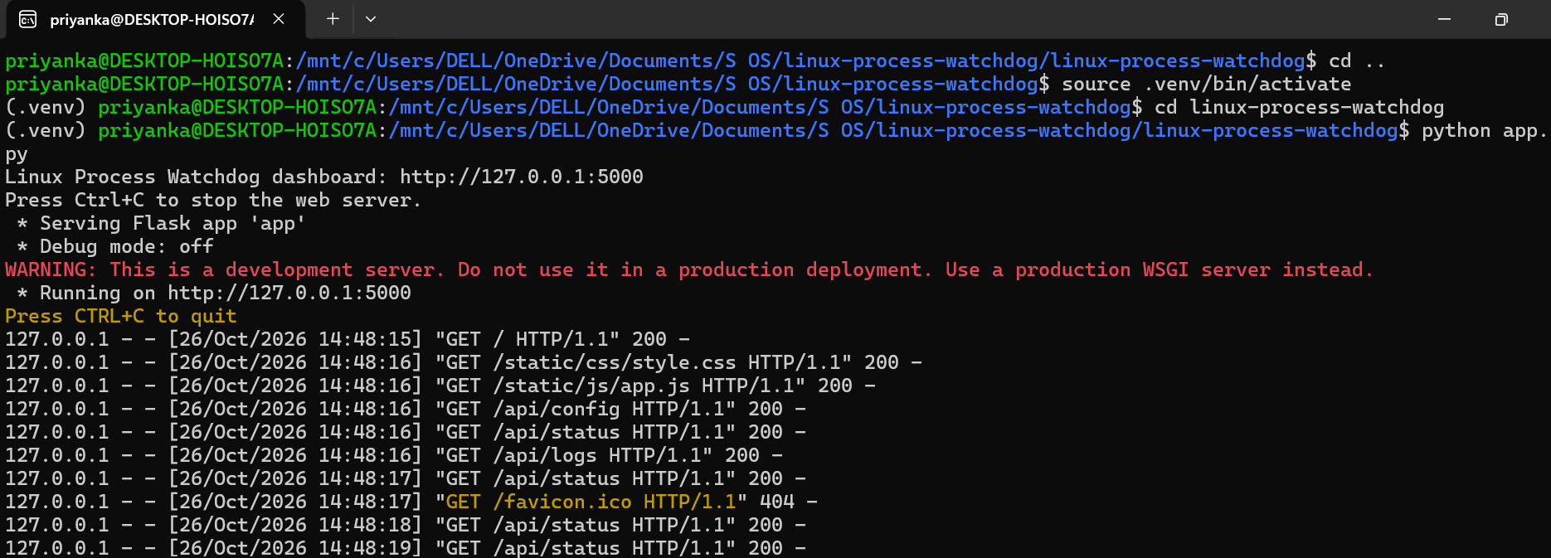
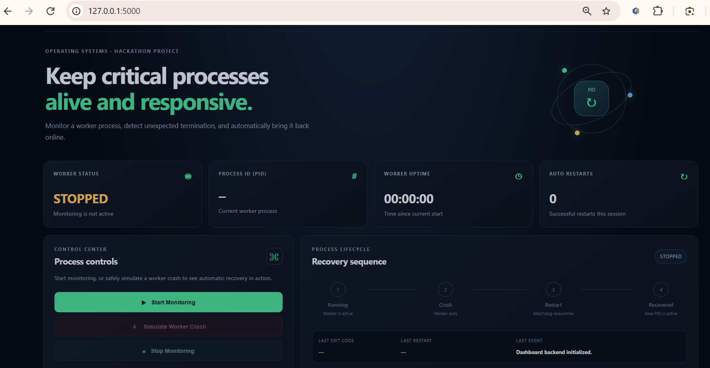
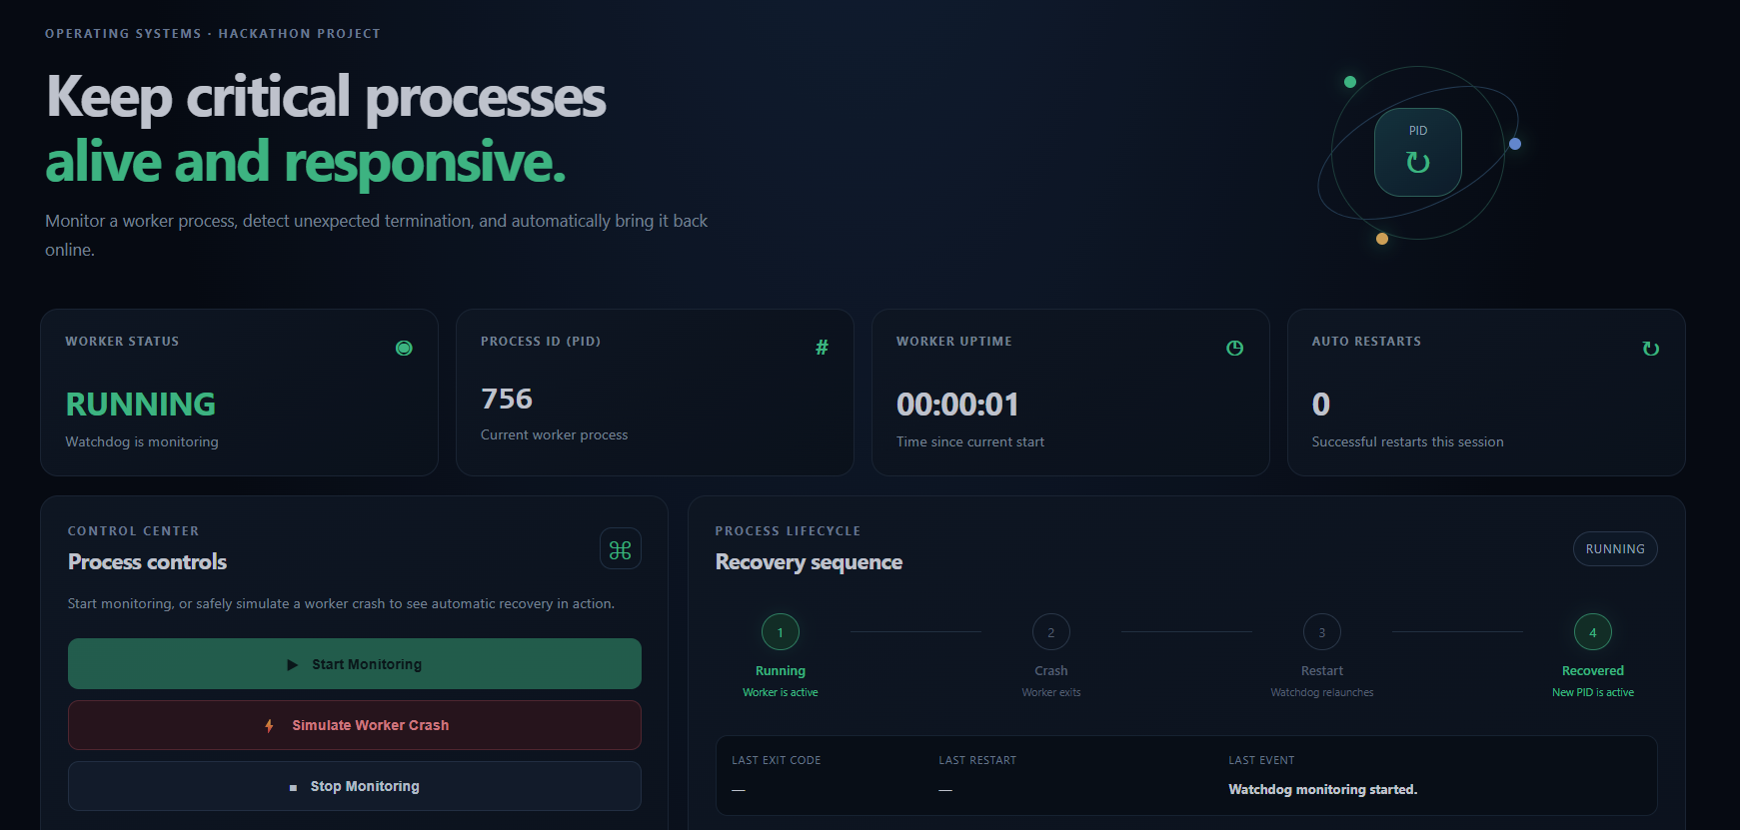
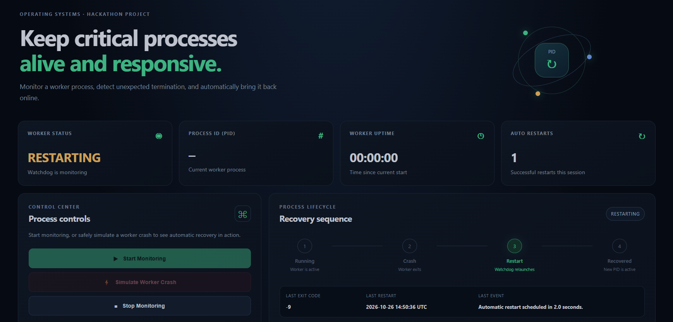
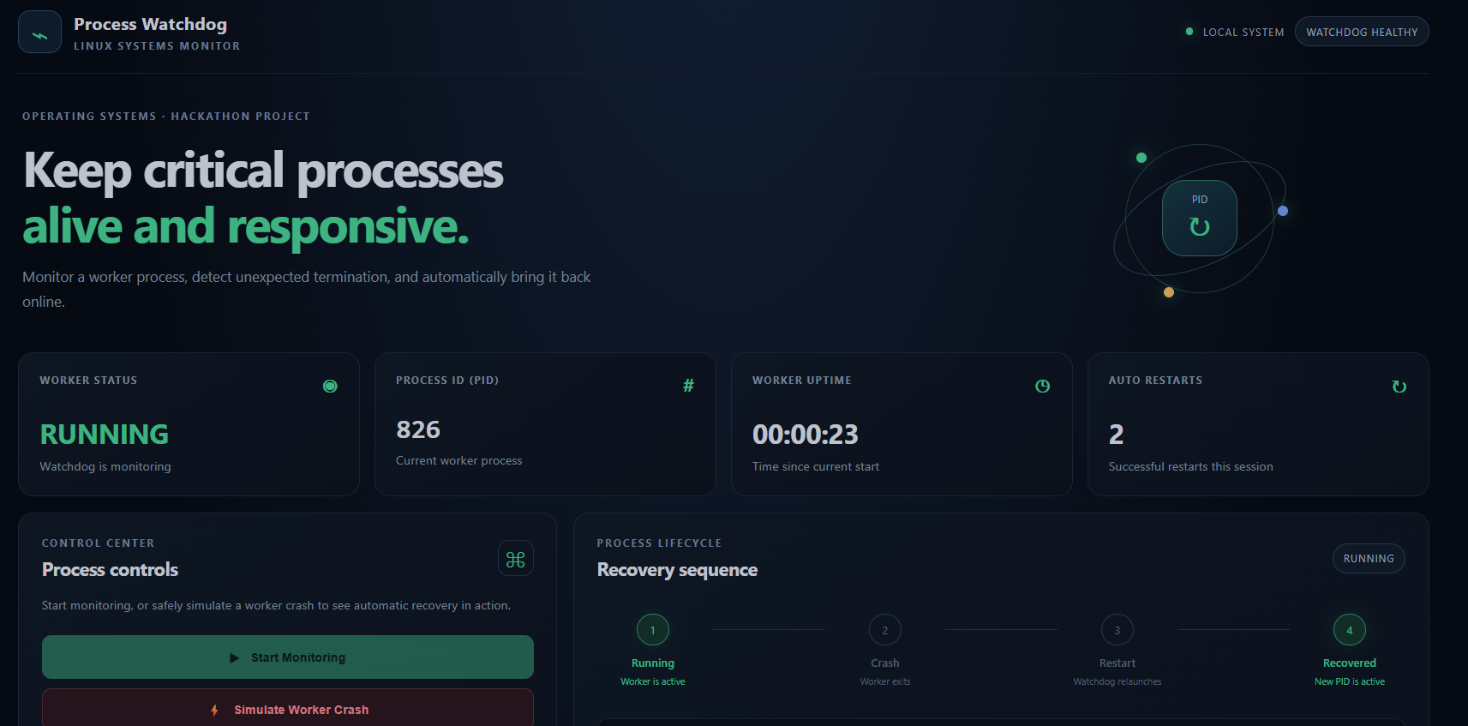
[ INSERT SCREENSHOT HERE ]
Figure 7.1: Terminal showing the Flask server running
Capture the Ubuntu terminal after `python app.py` shows the server running on 127.0.0.1:5000.

[ INSERT SCREENSHOT HERE ]
Figure 7.2: Dashboard before starting monitoring
Capture the initial dashboard at http://127.0.0.1:5000.

[ INSERT SCREENSHOT HERE ]
Figure 7.3: Dashboard with the worker running (PID and status visible)
Capture after clicking Start monitoring.

[ INSERT SCREENSHOT HERE ]
Figure 7.4: Dashboard after the controlled crash and automatic restart
Capture showing the new PID, updated restart count and recent events.

[ INSERT SCREENSHOT HERE ]
Figure 7.5: Contents of logs/watchdog.log
Capture the log file (for example, displayed in the terminal with cat) after the demonstration.

7.5 Demonstration of OS Concepts
Table 7.1 maps each course outcome to the project module and the evidence that can be shown during demonstration. The “Nature” column states whether the concept is directly implemented or explained.
Table 7.1: Course outcome mapping
CO | Course outcome | Project module | Evidence / demonstration | Nature
CO-1 | OS as a service layer | app.py, watchdog.py | Process creation, file writing and HTTP networking are performed through OS services | Implemented (uses OS services); explained in report
CO-2 | Process management | watchdog.py, worker.py | Worker launched as a separate process; PID displayed; termination and exit code detected; automatic restart | Directly implemented
CO-3 | IPC and signals | watchdog.py | Termination and restart behaviour with signals; parent–child exit-status reporting; HTTP between browser and server. No pipes or other IPC claimed | Signal-related behaviour implemented; other IPC explained only
CO-4 | Memory management | worker.py (separate process) | Separate address space; kernel reclaims memory on termination; restarted worker starts clean | Explained and observed by behaviour; no custom memory mechanism implemented
CO-5 | File systems and I/O | watchdog.py, logs/watchdog.log | Timestamped event log persists after the application stops | Directly implemented
CO-6 | Concurrency and synchronization | watchdog.py, app.py | Monitoring thread plus simultaneous web requests; lock protects shared state | Directly implemented

7.6 Test Cases and Results
The test cases below define how the system should be verified. The Expected Result column describes intended behaviour. The Observed Result column is intentionally left blank and must be filled in after the tests are actually executed on the running application.
Test ID | Objective | Procedure | Expected Result | Observed Result
TC-01 | Start monitoring | Open the dashboard; click Start monitoring | Monitoring begins; the worker is launched
TC-02 | Confirm worker running | Observe the status panel after starting | Status shows running
TC-03 | View PID and status | Read the PID and status fields | A PID and status are displayed
TC-04 | Trigger controlled crash | Click the crash simulation control | Only the managed worker is terminated; the Flask server keeps running
TC-05 | Detect termination | Watch status within one monitoring interval | Termination is detected; exit code recorded/displayed where supported
TC-06 | Observe restart attempt | Wait for the restart delay | A new worker is launched with a new PID
TC-07 | Check restart count and status | Read dashboard after restart | Restart count increased; status running
TC-08 | Review event logs | Open the dashboard events and logs/watchdog.log | Start, termination and restart events with timestamps
TC-09 | Stop monitoring | Click Stop monitoring | Monitoring stops; no further restarts; stop event logged

CHAPTER 8 — CONCLUSION

8.1 Summary of the Project
The Linux Process Watchdog and Auto-Restart System is a web-based educational application that supervises a separate worker process on Linux. A Flask backend serves an HTML, CSS and JavaScript dashboard; a watchdog component launches the worker with subprocess, checks it periodically in a monitoring thread, detects termination, and restarts it according to a configurable interval and delay; a lock protects shared state; and events are recorded in a persistent log file.

8.2 Objectives Achieved
Objective | Addressed by
Demonstrate process creation, monitoring and termination | watchdog.py launching and polling worker.py
Detect unexpected termination and restart automatically | Monitoring thread and restart policy
Safely share state across threads | Lock-protected shared state
Persistent event logging | logs/watchdog.log
Interactive dashboard | Flask, HTML, CSS and JavaScript
Map to course outcomes CO-1 to CO-6 | Table 7.1

8.3 Results Achieved
The design provides a working demonstration path: start monitoring, observe a running worker with its PID, trigger a controlled crash, observe detection and restart, and review the log. Verification of the outcome is to be recorded through the test cases in Section 7.6 and the screenshots in Section 7.4, which the student completes after running the application. This report does not state measured results beyond those that the student records.

8.4 Skills and Learning Outcomes
- Understanding of the process life cycle, PIDs, exit status and signal-based termination.
- Practical use of Python’s subprocess and threading facilities.
- Understanding of race conditions and lock-based mutual exclusion.
- Use of file I/O for persistent logging.
- Building a Flask backend with an HTML, CSS and JavaScript frontend.
- Working in a Linux environment using Ubuntu on WSL2.

8.5 Limitations and Future Enhancements
Limitation | Possible future enhancement
Single supervised worker | Support monitoring several workers or user-selected commands
Polling-based detection | Use event-driven notification of child termination to reduce detection delay
In-memory state; log-only persistence | Store history in a database and add log filtering and download
No authentication; development server | Add authentication and deploy behind a production server
Basic restart policy | Add richer policies such as exponential back-off and health checks
Limited resource metrics | Display CPU and memory usage of the worker

CHAPTER 9 — REFERENCES

9.1 Operating Systems Textbooks
[1] A. Silberschatz, P. B. Galvin and G. Gagne, Operating System Concepts, 10th ed. Hoboken, NJ, USA: Wiley, 2018.
[2] A. S. Tanenbaum and H. Bos, Modern Operating Systems, 4th ed. Boston, MA, USA: Pearson, 2015.
[3] M. Kerrisk, The Linux Programming Interface. San Francisco, CA, USA: No Starch Press, 2010.

9.2 Python and Flask Documentation
[4] Python Software Foundation, “Python 3 Documentation.” [Online]. Available: https://docs.python.org/3/
[5] Python Software Foundation, “subprocess — Subprocess management.” [Online]. Available: https://docs.python.org/3/library/subprocess.html
[6] Python Software Foundation, “threading — Thread-based parallelism.” [Online]. Available: https://docs.python.org/3/library/threading.html
[7] Python Software Foundation, “venv — Creation of virtual environments.” [Online]. Available: https://docs.python.org/3/library/venv.html
[8] Pallets, “Flask Documentation.” [Online]. Available: https://flask.palletsprojects.com/

9.3 Linux Process and System-Interface Documentation
[9] The Linux man-pages project, “signal(7) — overview of signals.” [Online]. Available: https://man7.org/linux/man-pages/man7/signal.7.html
[10] The Linux man-pages project, “wait(2) — wait for process to change state.” [Online]. Available: https://man7.org/linux/man-pages/man2/wait.2.html
[11] The Linux man-pages project, “kill(2) — send signal to a process.” [Online]. Available: https://man7.org/linux/man-pages/man2/kill.2.html

9.4 Ubuntu / WSL and Web Documentation
[12] Microsoft, “Windows Subsystem for Linux Documentation.” [Online]. Available: https://learn.microsoft.com/en-us/windows/wsl/
[13] Canonical Ltd., “Ubuntu on WSL documentation.” [Online]. Available: https://documentation.ubuntu.com/wsl/
[14] MDN Web Docs, “Fetch API.” [Online]. Available: https://developer.mozilla.org/en-US/docs/Web/API/Fetch_API

