Supplementary material
Machine-learning-driven discovery of metal-organic framework adsorbents for hexavalent chromium removal from aqueous environments

Mingxing Jiangª, Weiwei Fu^{b}, Ying Wang^{c}, Duanping Xuª, Sitan Wang^{a,*}
ª College of Environmental Science and Engineering, Liaoning Technical University, Fuxin 123000, P. R. China
^{b} School of Information Engineering, Dalian Ocean University, Dalian 116023, P. R. China
^{c} School of Chemical Equipment, Shenyang University of Technology, Liaoyang 111000, P. R. China
* Corresponding author. Tel: +86-418-5110118, E-mail: wangsitan@lntu.edu.cn

Text S1. Hyperparameter tuning
Specifically, the first step involved determining the range of each hyperparameter and selecting several parameter values within the range using reasonable intervals. Subsequently, an exhaustive search method was employed to explore all possible combinations of hyperparameters, and 10 models were trained on different training sets (Fig. S7). Afterwards, each model was applied to predict the validation set and the coefficient of determination was calculated. Finally, the average coefficient of determination was calculated for each combination of hyperparameters, and the combination yielding the highest coefficient of determination represented the optimal hyperparameter combination for the machine learning (ML) model (Fig. S8). This strategy was applied independently to optimize the hyperparameters for each ML model during training. After a series of parameter tuning iterations, each ML algorithm trained its model on the training set using its respective optimal hyperparameter combination [1, 2].

Text S2. Random forest and extreme gradient boosting tree
Ensemble learning completes the learning task by building multiple base learners. Among them, the base learners are built using the decision tree algorithm. The inference rules based on the leaf nodes of the decision tree can achieve classification or regression prediction for new data. Regression trees mainly refer to the CART algorithm, which is a binary tree that uses a recursive binary split strategy to divide the regions [3].
Random forest (RF) is an ensemble learning algorithm based on the bagging idea. The final output of the model is determined by the prediction results of multiple independent decision trees (Fig. S9). Each decision tree model is trained independently from the original data by random sampling, including random sampling of the samples and features. This allows the model to have a small generalization error and significantly reduce the variance in prediction. It generally has high accuracy and generalization ability [4, 5].
Extreme gradient boosting tree (XGBoost) is an improved algorithm based on gradient boosting decision framework and is one of the popular ensemble learning algorithms [6]. Boosting is a forward-stagewise additive modeling technique, characterized by the continuous entry of model members into a joint prediction queue during the iteration process. The parameters and weights of the models that entered the joint prediction queue earlier are unaffected by subsequent models entering the queue, and at each iteration, only the parameters and weights of the current model need to be estimated (Fig. S10). XGBoost optimizes the cost function by performing a second-order Taylor expansion, considering both first- and second-order derivatives. It incorporates a regularization term to manage model complexity, which includes the number of leaf nodes in the tree and the square of the L2 norm of the output score on each leaf node. This regularization term reduces model variance, leading to a simpler learned model and preventing overfitting [7].
Based on the discussion above, it can be concluded that Bagging is effective in reducing variance and alleviating overfitting issues. On the other hand, Boosting is effective in reducing bias and alleviating underfitting problems. Therefore, when the base learners are prone to overfitting, Bagging-based random forests can effectively avoid overfitting issues, while the Boosting may exacerbate them. Conversely, if the base learners' performance is weak, Bagging cannot improve the overall performance of the ensemble model. However, XGBoost, which is based on Boosting, can enhance the overall predictive accuracy of the model.

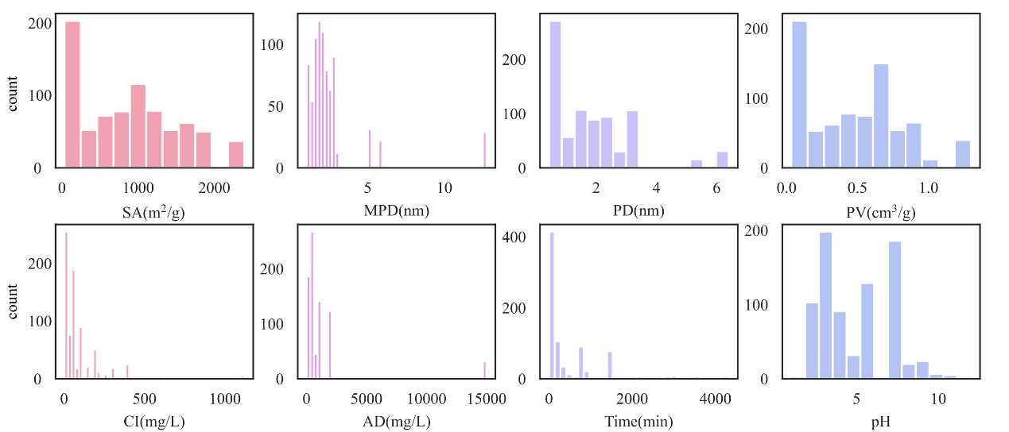
Fig. S1. Statistical distribution maps of quantitative variables
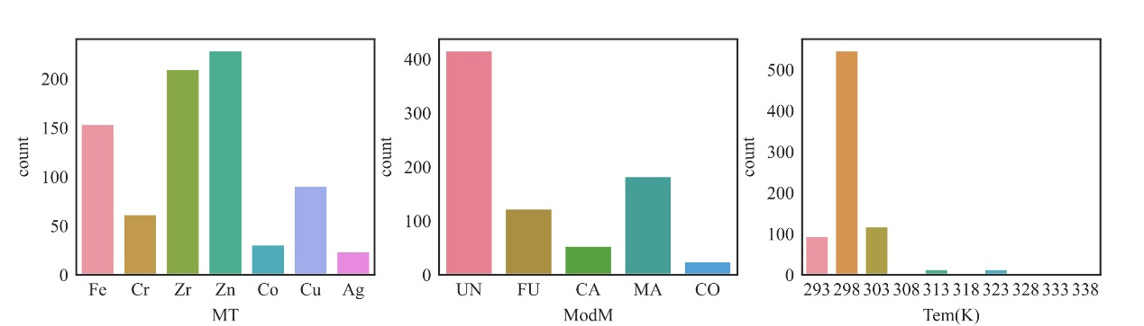
Fig. S2. Statistical distribution maps of qualitative variables and reaction temperature
Note:ModM UN:Unmodified;FU:Functionalized;CA:Carbonized;MA:Magnetic;CO:Composite

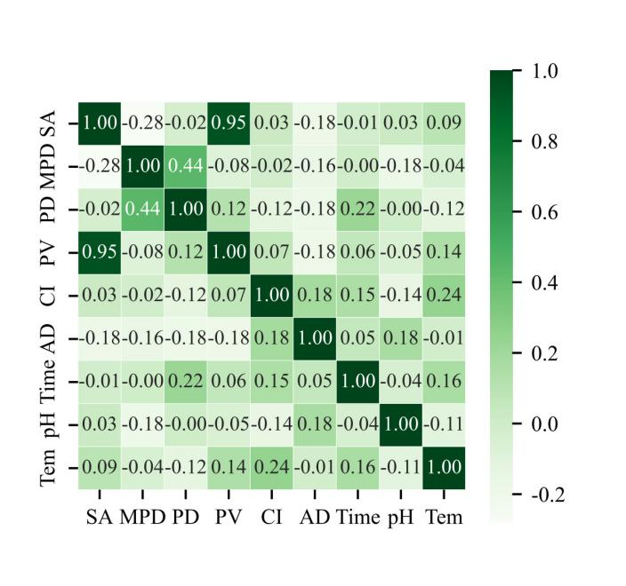
Fig. S3. Thermal map of correlation between quantitative variables
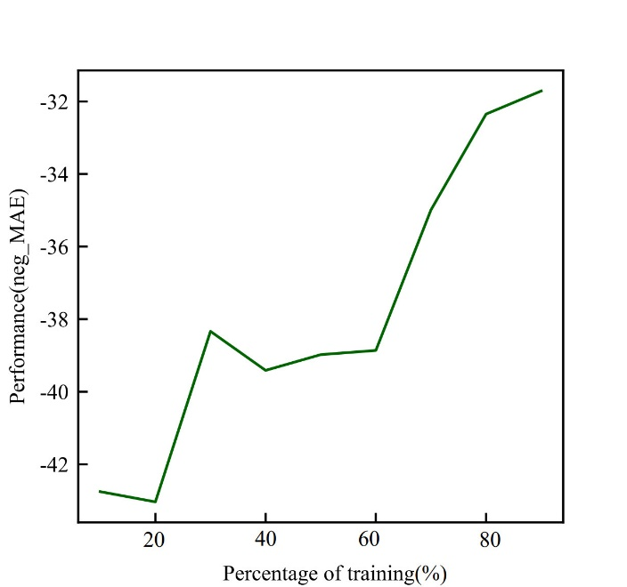
Fig. S4. Learning curve

(a)
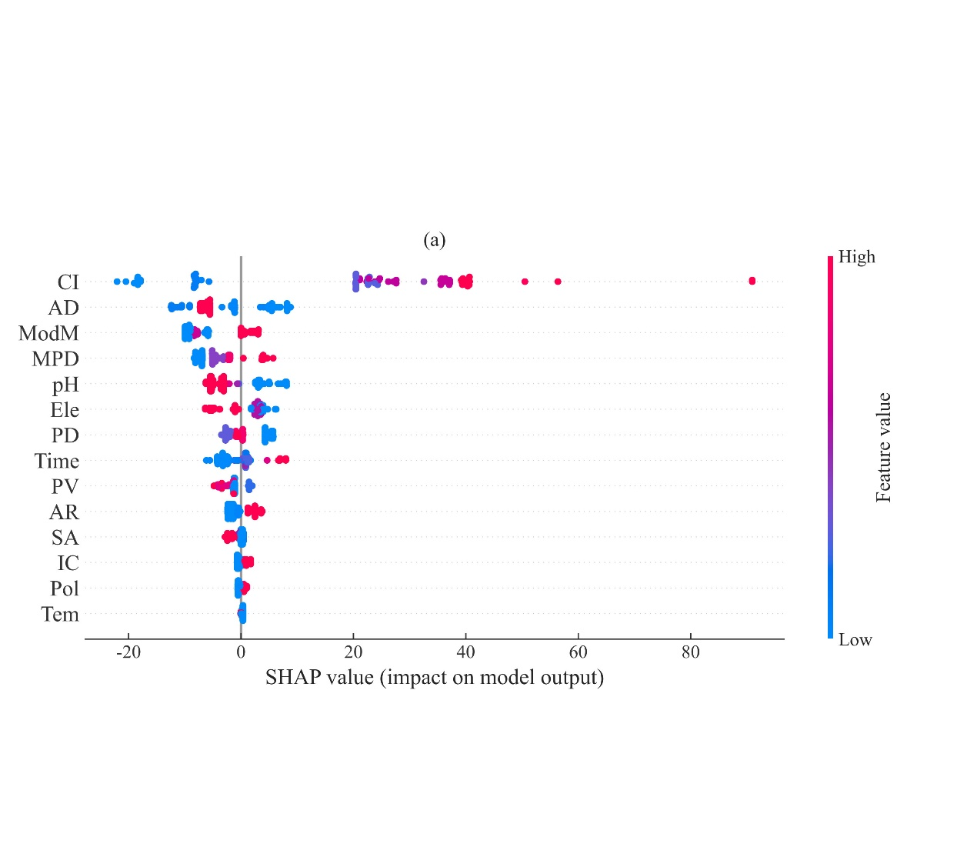
(b)
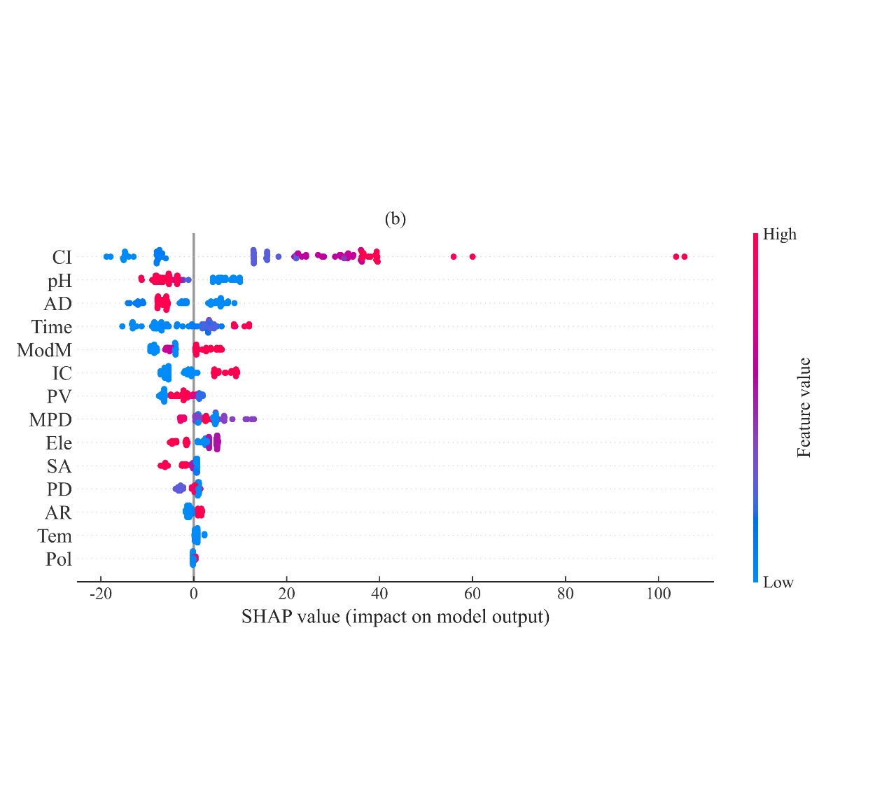
Fig. S5. Here, we employed SHAP to explain the random forest (a) and XGBoost (b) models trained on the Cr (VI) dataset in water adsorption of MOFs. Two bee swarm plots are used to display the importance of features, where each point represents a sample from the test set. The position along the x-axis reflects the impact of the corresponding feature on the model prediction for a specific sample. When multiple points overlap on the same x-axis position, they are stacked to demonstrate the density.
Note: IC: ionic charge; AR: atomic radius; Pol: polarizability; Ele: electronegativity

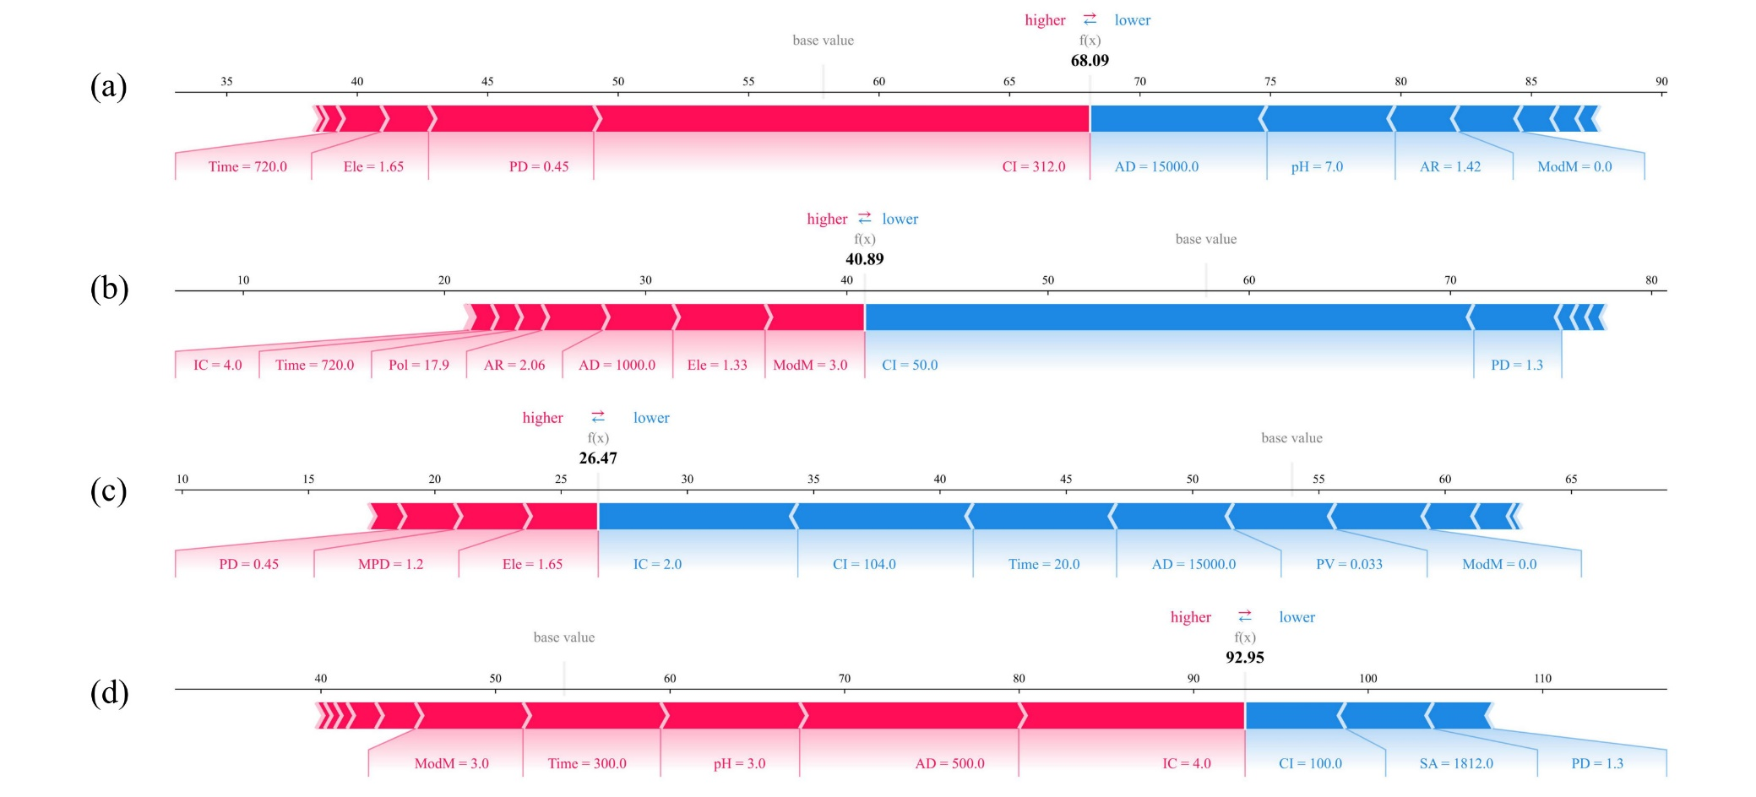
Fig. S6. Here, we provide explanation plots for individual samples to visually illustrate the contribution of different features to the model output. Specifically, we selected four samples from the test set and visualized the model predictions for them using two different models: random forest (a, b) and XGBoost (c, d). The plot focuses on the base_value, which represents the mean of the prediction, while f(x) shows the specific predicted value for that sample. Red features increase output while blue features decrease output.
Note: ModM=0: Unmodified; ModM=3: Modified; IC: ionic charge; AR: atomic radius; Pol: polarizability; Ele: electronegativity

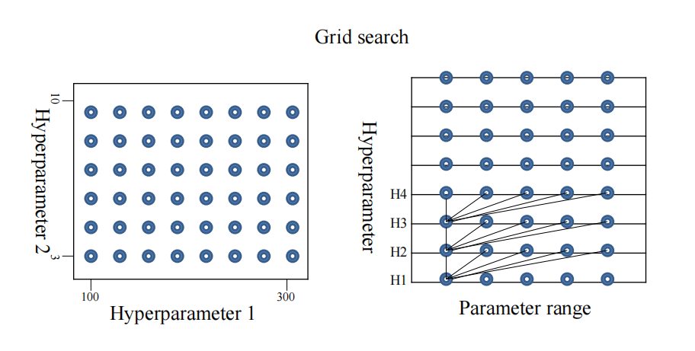
Fig. S7. Grid search

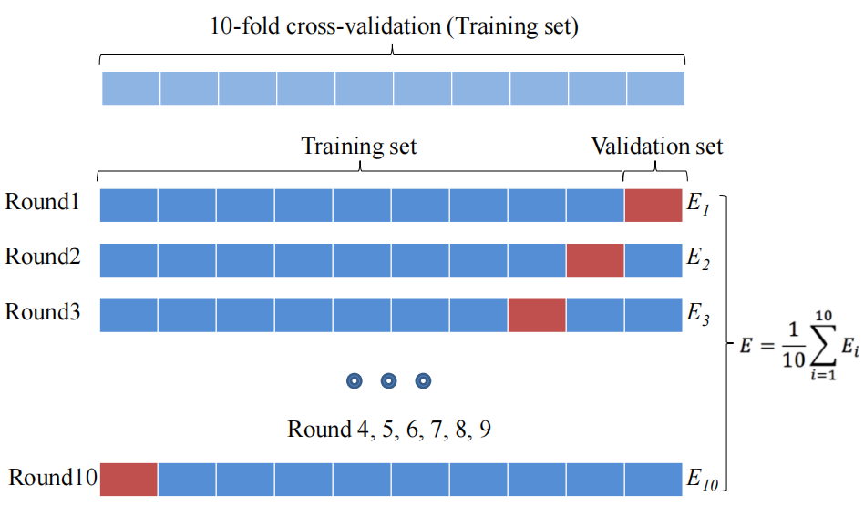
Fig. S8. 10-fold cross-validation

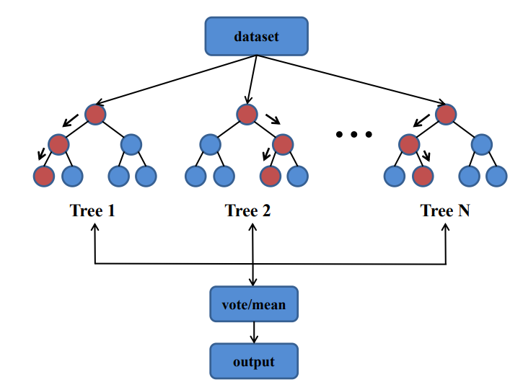 | 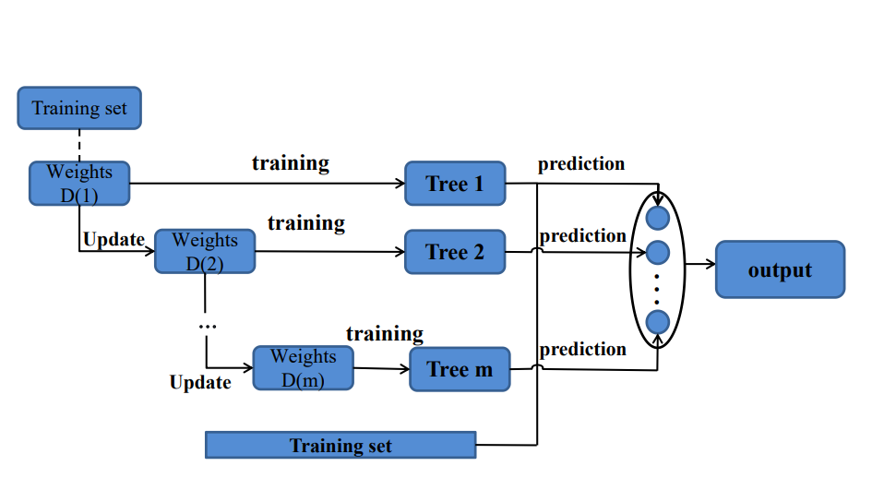
Fig. S9. Random forest | Fig. S10. Gradient boosting

Table S1. Statistical information of quantitative variables

Variablcs | Mean | Std Dev | Low Qu | Median | Upp Qu | Min | Max | Std Er
SA (m²/g) | 881.79 | 635.21 | 241.32 | 800 | 1327 | 32 | 2393 | 22.44
MPD (nm) | 2.61 | 2.21 | 1.64 | 2.12 | 2.45 | 1.03 | 12.75 | 0.08
PD (nm) | 1.85 | 1.44 | 0.52 | 1.51 | 2.54 | 0.43 | 6.4 | 0.05
PV (cm³/g) | 0.48 | 0.33 | 0.12 | 0.45 | 0.69 | 0.03 | 1.3 | 0.01
CI (mg/L) | 108.10 | 170.43 | 20 | 50 | 100 | 2.5 | 1120 | 6.02
AD (mg/L) | 1363.98 | 2854.17 | 400 | 500 | 1000 | 20 | 15000 | 100.85
Time (min) | 475.89 | 751.24 | 60 | 120 | 720 | 0.25 | 4320 | 26.54
pH | 4.94 | 2.14 | 3 | 5 | 7 | 1 | 12 | 0.08
Tem (K) | 299.25 | 5.68 | 298 | 298 | 298 | 293 | 338 | 0.2
Q (mg/g) | 51.51 | 63.45 | 12.5 | 27.97 | 64.97 | 0.08 | 349 | 2.24

*Std Dev: Standard Deviation; Std Er: Standard Error; Upp Qu: Upper Quartile; Low Qu: Lower Quartile.
Table S2. MAE, RMSE, R² and optimized hyperparameters in six machine learning models
Model | MAE(mg/g) | RMSE(mg/g) | R² | Optimized hyperparameters
RF | 17.27 | 23.32 | 0.67 | n_estimators=150, max_depth=8, min_samples_leaf=10
GBDT | 25.58 | 30.12 | 0.46 | n_estimators=120, max_depth=5, min_samples_leaf=3, learning_rate=0.1, loss=“ls”
XGB | 13.66 | 17.68 | 0.81 | n_estimators=250, max_depth=15, min_child_weight=7, gamma=0.1,  subsample=0.8, colsample_bytree=0.9, learning_rate=0.01
LR | 205.2 | 299.6 | -52.67 | fit_intercept=“True”
KNN | 26.22 | 32.8 | 0.36 | n_neighbors=5, weights=“distance”
SVR | 25.16 | 33.11 | 0.34 | kernel=“rbf”, C=10, epsilon=1

Table S3. The information related to the 20 MOFs screened is as follows
Rank | Filename  (Ref code) | All_Metals | DOI_public | Ingredient | Synonyms | Stability（Predicted）
 |  |  |  |  |  | Stability in aqueous solutions and acidic conditions | Stability upon solvent removal & Thermal stability℃
1 | NIKYUC02 | Fe | 10.1002/adfm.200600676 | NIKYUC02:catena-(dodecakis(μ₃-Formato-O,O,O')-hexa-iron(ii) bis(tetrahydrofuran) clathrate) | - | - | 0.22 & 301.6
2 | VEYVEC | Co | 10.1039/C3CE40442K | VEYVEC:catena-[μ₄-Dihydrogenmellitato)-(μ₂-4,4'-bipyridine)-hexaaqua-di-cobalt hydrate] | - | - | 0.57 & 266.5
3 | RUBTAK04 | Zr | 10.1002/anie.201505461 | RUBTAK04:catena-(tris(μ₄-Benzene-1,4-dicarboxylato)-bis(μ₃-hydroxo)-bis(μ₃-oxo)-tri-zirconium) | UiO-66 | Highly stable | >400
4 | SURHEU | Zr | 10.1002/anie.201505461 | SURHEU:catena-(tris(μ₄-Benzene-1,4-dicarboxylato)-bis(μ₃-hydroxo)-bis(μ₃-oxo)-tri-zirconium) | UiO-66 | Highly stable | >400
5 | SURKUN | Zr | 10.1002/anie.201505461 | SURKUN:catena-(tris(μ₄-Benzene-1,4-dicarboxylato)-bis(μ₃-hydroxo)-bis(μ₃-oxo)-tri-zirconium n-propoxide) | UiO-66 | Highly stable | >400
6 | BIBBUL | Zn | 10.1016/j.ica.2013.03.015 | BIBBUL:catena-((μ₂-1,1'-Butane-1,4-diylbis(2-methyl-1H-imidazole))-(μ₂-2,2'-bipyridine-3,3'-dicarboxylato)-zinc dihydrate) | - | - | 0.69 & 352.8
7 | XUFPIZ | Co | 10.1016/j.inoche.2014.10.019 | XUFPIZ:catena-((μ₂-4,4'-Oxydibenzoato)-(μ₂-1,1'-(1,2-phenylenebis(methylene))bis(1H-imidazole))-cobalt monohydrate) | - | - | 0.9 & 406.8
8 | WILGII | Ag | 10.1039/b706731c | WILGII:catena-((μ₄-4,4'-Bipyridazine)-bis(μ₃-4,4'-bipyridazine)-(μ₂-aqua)-tri-silver(i) tris(trifluoromethanesulfonate) monohydrate) | - | - | 0.81 & 331.9
9 | MAXHUP | Ag | 10.1021/ja054913a | MAXHUP:catena-[(μ₈-Chloro)-tetrakis(μ₃-3-amino-1,2,4-triazolato)-hexa-silver(i) hydroxide dihydrate clathrate] | - | - | -
10 | BOHJUF | Zr | 10.1021/ja500330a | BOHJUF:catena-(dodecakis(μ₄-Fumarato)-octakis(μ₃-hydroxo)-octakis(μ₃-oxo)-dodeca-zirconium hydrate) | MOF-801(SC) | Stable | >400
11 | YEDKOI | Cr | 10.1039/b512169h | YEDKOI:catena-[tris(μ₄-Benzene-1,4-dicarboxylato)-(μ₃-oxo)-diaqua-hydroxy-tri-chromium(iii) pyridine solvate hexahydrate] | MIL-88B | Stable | 0.23 & 419.6
12 | SETQEP | Fe | 10.1021/cm301242d | SETQEP:catena-((μ₄-Terephthalato)-(μ₂-hydroxo)-iron o-xylene clathrate) | MIL-53(Fe) | Stable | 0.18 & 324.5
13 | GIRYIR | Zn | 10.1039/C3CC49106D | GIRYIR:catena-[bis(μ₃-4-nitrophthalato)-bis(μ₂-4,4'-ethene-1,2-diyldipyridine)-bis(μ₂-hydroxo)-tri-zinc hydrate] | - | - | 0.1 & 289.1
14 | RUMRUO | Zn | 10.1021/acs.cgd.5b00530 | RUMRUO:catena-[N,N-dimethylammonium tetrakis (μ₃-5-amino-1H-tetrazol-1-yl)-pentakis(μ₂-fluoro)-tetra-zinc] | - | - | 0.85 & 280.3
15 | CUIMDZ01 | Cu | 10.1021/ic010384+ | CUIMDZ01:catena-(bis(μ₂-Imidazolato-N,N')-copper(ii)) | - | - | -
16 | USIRUL | Cu | 10.1021/acs.inorgchem.6b00813 | USIRUL:catena-[bis(μ₂-Cyano)-bis(μ-2,6-bis(pyrazin-2-yl)-4,4'-bipyridine)-di-copper acetonitrile solvate] | - | - | 0.94 & 306.4
17 | AQUDAT | Cu | 10.1039/C6CC04808K | AQUDAT:catena-[(μ-4,4'-(propane-1,3-diyl)dipyridine)-bis(μ-tetrazol-1-yl-5-carboxylato)-di-copper(ii) neon] | - | - | 0.06 & 278.7
18 | c6ce00407e_c6ce00407e5 | Zn | - | - | - | - | -
19 | MINVOU | Cr | 10.1039/b201381a | MINVOU:catena-[tetrakis((μ₄-terephthalato)-(μ₂-hydroxo)-chromium(iii)) tris(terephthalic acid) clathrate] | MIL-53as | Stable | 0.7 & 395.8
20 | OCUNAC | Cr | 10.1126/science.1116275 | OCUNAC:catena-[tris(μ₄-Terephthalato)-(μ₃-oxo)-diaqua-fluoro-tri-chromium pentadecahydrate] | MIL-101 | Stable | >300

Table S4. The 20 MOFs obtained from the screening
Group A | Group B | Group C | Group D
RUBTAK04, SURHEU, SURKUN, BIBBUL, XUFPIZ, BOHJUF, SETQEP | WILGII, USIRUL, MINVOU, OCUNAC | NIKYUC02, VEYVEC, YEDKOI, GIRYIR, RUMRUO, AQUDAT | MAXHUP, CUIMDZ01, c6ce00407e_c6ce00407e5

Table S5. Sources and purities of all chemicals
Materials | Purity | Source
ZrCl₄ (UiO-66) | AR Grade | Shanghai Aladdin Biochemical Technology Co.,Ltd.
ZrOCl₂·8 (H₂O) | AR Grade | Shanghai Aladdin Biochemical Technology Co.,Ltd.
Fumaric acid | AR Grade | Shanghai Aladdin Biochemical Technology Co.,Ltd.
Terephthalates | AR Grade | Chengdu Acorda Chemical Reagent Co.,Ltd.
N,N-dimethylformamide | AR Grade | Shanghai Aladdin Biochemical Technology Co.,Ltd.
Methanol | AR Grade | Tianjin StarMark Science and Technology Development Co.,Ltd.
Formic acid | AR Grade | Chemart (Tianjin) Chemical Technology Co.,Ltd.
Potassium dichromate | AR Grade | Sinopharm Chemical ReagentCo., Ltd
NaOH | AR Grade | Tianjin New Technology Industrial Park Kemao Chemical Reagent Co.,Ltd.
Hydrochloric acid | AR Grade | Tianjin New Technology Industrial Park Kemao Chemical Reagent Co.,Ltd.

References
[1] S. Sundhararajan, A. Pahwa, P. Krishnaswami, A comparative analysis of genetic algorithms and directed grid search for parametric optimization, Engineering with Computers. 14(3) (1998) 197-205, https://doi.org/10.1007/BF01215973.
[2] J. Li, L. Pan, M. Suvarna, Y.W. Tong, X. Wang, Fuel properties of hydrochar and pyrochar: Prediction and exploration with machine learning, Appl. Energy. 269 (2020) 115166, https://doi.org/10.1016/j.apenergy. 2020.115166.
[3] L. Breiman, J. Friedman, R. Olshen, C. Stone, Classification and Regression Trees, (1984).
[4] H. Li, C. Wang, Y. Zeng, D. Li, Y. Yan, X. Zhu, Z. Qiao, Combining Computational Screening and Machine Learning to Predict Metal&ndash;Organic Framework Adsorbents and Membranes for Removing CH₄ or H₂ from Air, Membranes, 2022.
[5] L. Breiman, Random Forests, Machine Learning 45(1) (2001) 5-32, https://doi.org/10.1023/A:1010933404324.
[6] T. Chen, C. Guestrin, Xgboost: A scalable tree boosting system, Proceedings of the 22nd acm sigkdd international conference on knowledge discovery and data mining, 2016, pp. 785-794.
[7] M. Yang, J.J. Zhu, A. McGaughey, S. Zheng, R.D. Priestley, Z.J. Ren, Predicting Extraction Selectivity of Acetic Acid in Pervaporation by Machine Learning Models with Data Leakage Management, Environ. Sci. Technol. (2023), https://doi.org/10.1021/ acs.est.2c06382.

