Jeremy Lian Zhi Wei (U1640621H)

NTU SPMS PAP

PH2101 - Electromagnetism

April 2018

**Animation of charged particle motion in a Penning Trap**

This note is meant to accompany the MATLAB script Jeremy_Lian_Zhi_Wei_02_matlab_script.m. In Part I, the physics behind the motion of a charged particle in an E cross B field is investigated, subsequently drawing parallels to that of a Penning Trap – a storage device for charged particles using homogeneous axial magnetic field and inhomogeneous quadrupole electric field. In Part II, the finite difference method for approximating ordinary differential equations is briefly introduced, and its application in the context of this project is explained. The ‘*Stability*’ section in Part I and ‘*Convergence of results*’ section in Part II lay out certain restrictions on parameter values in the accompanying MATLAB script. Fig 5 is also useful as a visual aid when defining the geometries of the trap in the code.

**Part I: Theory**

Lorentz Force

A particle of mass and charge moving through a magnetic -field and an electric -field experiences a force:

(1)

Magnetic Field

For the case where , the force arising from the magnetic field component would be perpendicular to both and , much like that of a centripetal force. The particle’s trajectory here will thus be circular. For the component of the velocity parallel to the , it would remain constant (definition of the cross-product), and it should be obvious that the particle’s trajectory in the general case is a spiral. This is known as the cyclotron orbit.

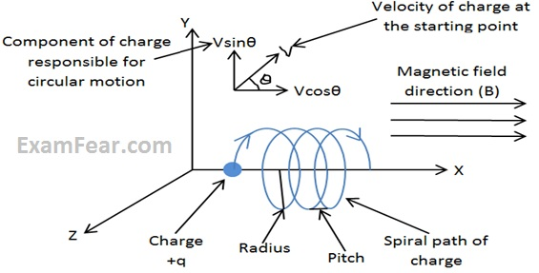

Fig 1: Trajectory of a charged particle in -field [1]

Electric Field

In the presence of an electric field, the resultant force would accelerate the charged particle in the direction of the field. However, in the case of an E cross B field, things get a little more complex. For the component of parallel to , the radial motion is undisturbed, and the particle is accelerated axially along both fields.

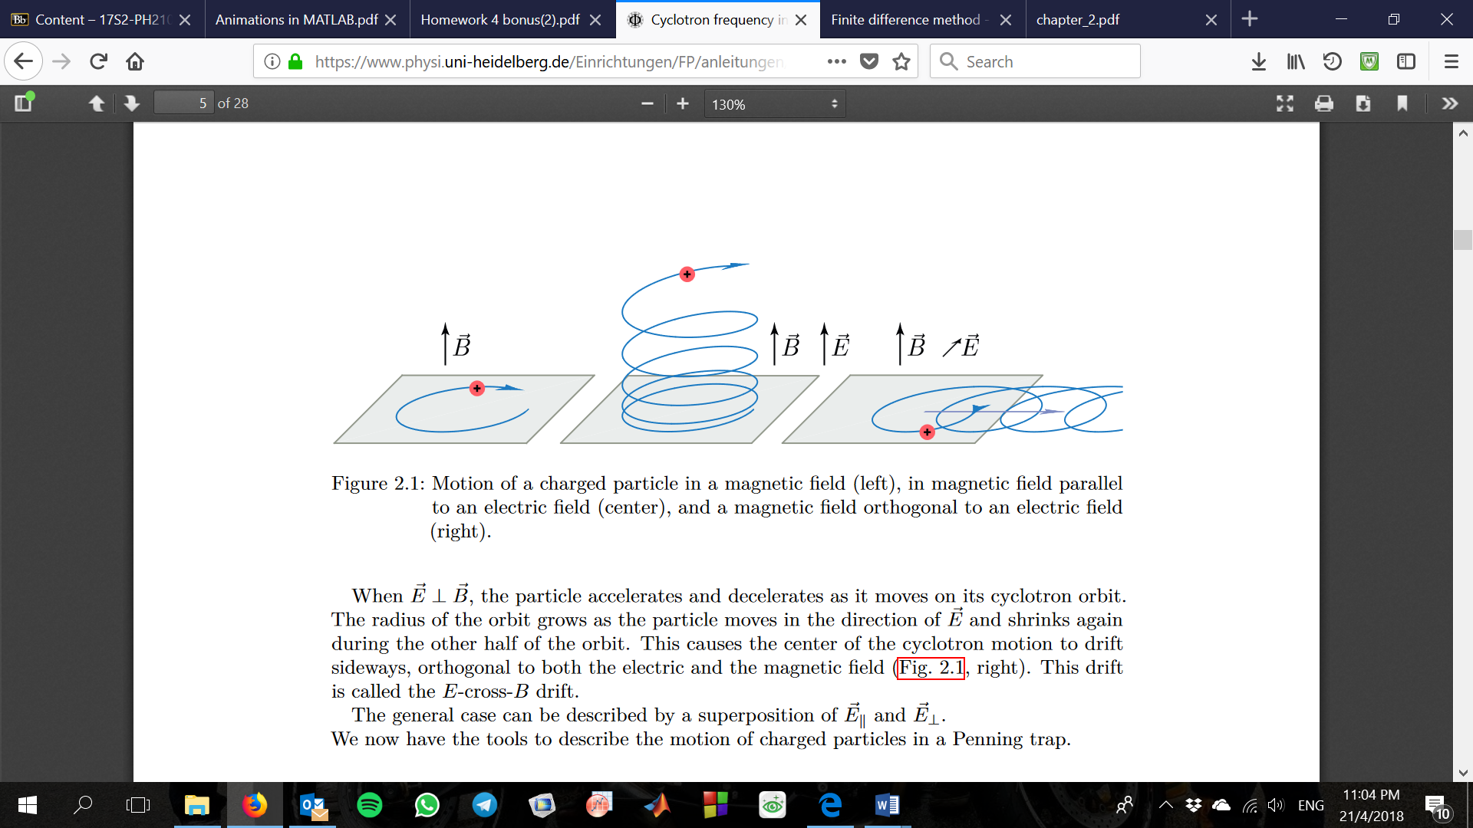

Fig 2: Trajectory of a charged particle () [2]

When , the particle accelerates and decelerates as it moves along its cyclotron orbit. The radius of the orbit grows when the particle moves in the direction of and shrinks in the opposite direction. This results in an E cross B drift of the centre of the cyclotron motion, orthogonal to both the electric and the magnetic field.

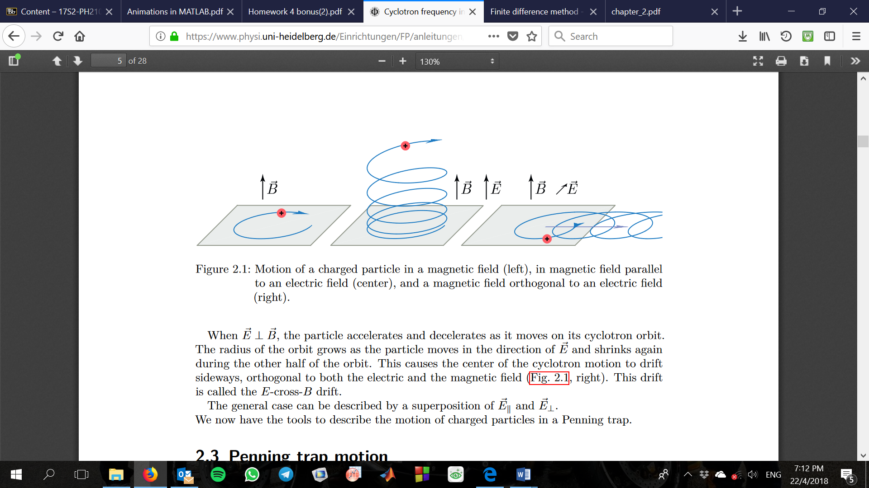

Fig 2: Trajectory of a charged particle () [2]

Penning Trap

The magnetic -field, in direction by convention, can therefore be used to confine a charge radially, while the -field can be set up to confine it axially. A Penning Trap achieves this through a quadrupole potential that gives rise to a unique -field that is proportional to the --- displacement of the particle from the origin in the centre of the trap.

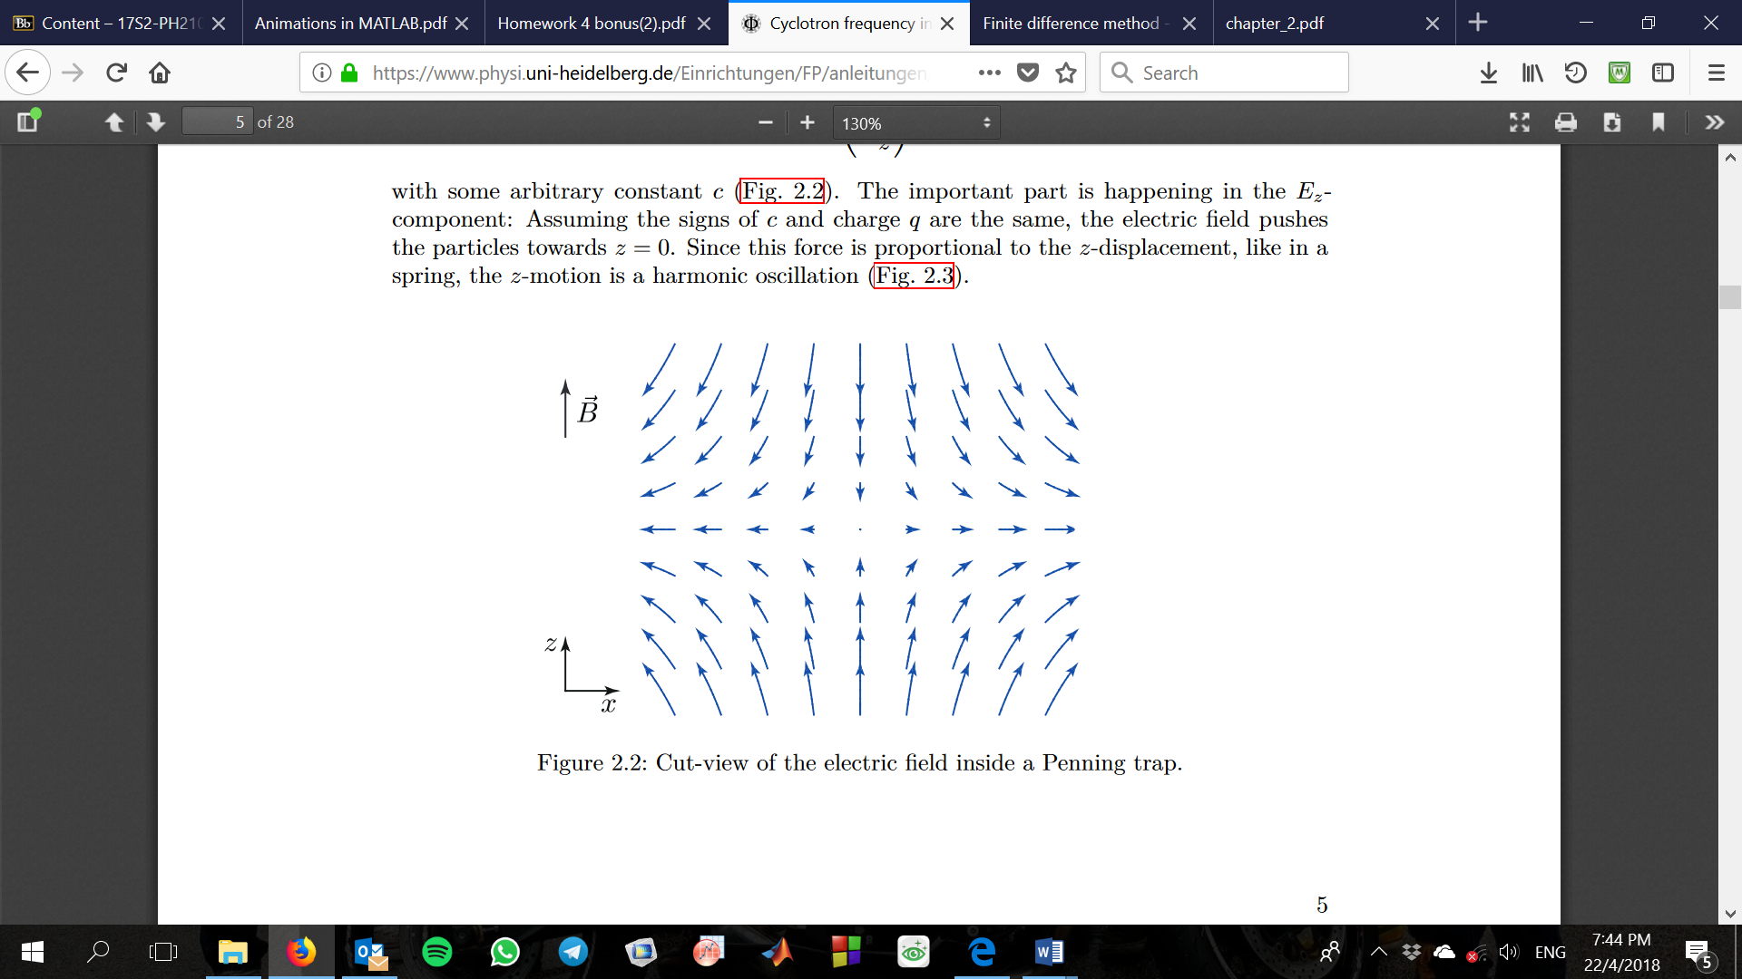

Fig 3: Quadrupole Electric field in a Penning Trap[2]

For a positive (negative) charge, the electric field in the direction contributes to a restoring force that pushes (pulls) it towards the centre of the trap. It is evident from Equation 1 that this force is proportional to its -displacement, and thus the particle undergoes a harmonic oscillation in the -direction much like that of a spring.

However, the particle’s motion does not consist of just its cyclotron orbit and the axial oscillation. The E cross B field in the Penning Trap causes the centre of the cyclotron motion to drift orthogonally to both the electric and magnetic field. Additionally, because the -field near the centre of the trap is radial, this E cross B drift is itself a circular orbit known as a magnetron motion. Thus, the motion of a particle in a Penning Trap is a superposition of its fast cyclotron orbit, its axial oscillation, and a slow magnetron drift around the centre of the trap.

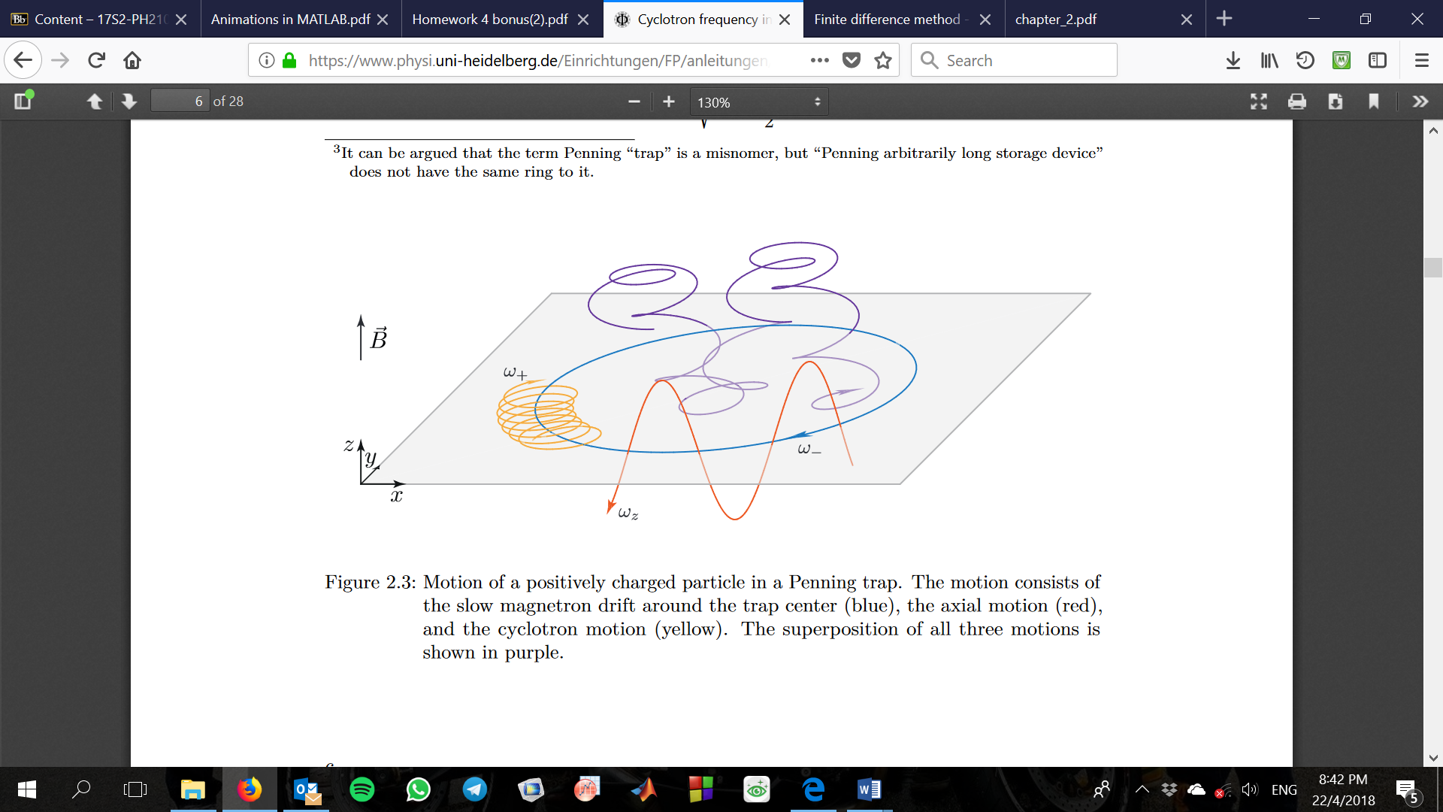

Fig 4: Motion of a positively charged particle in a Penning Trap, shown here in purple (cyclotron motion shown in yellow, axial oscillation in red, and magnetron motion in blue)[2]

Electric Quadrupole Potential / Field

The electric quadrupole potential of the Penning Trap is given to be:[2]

(2)

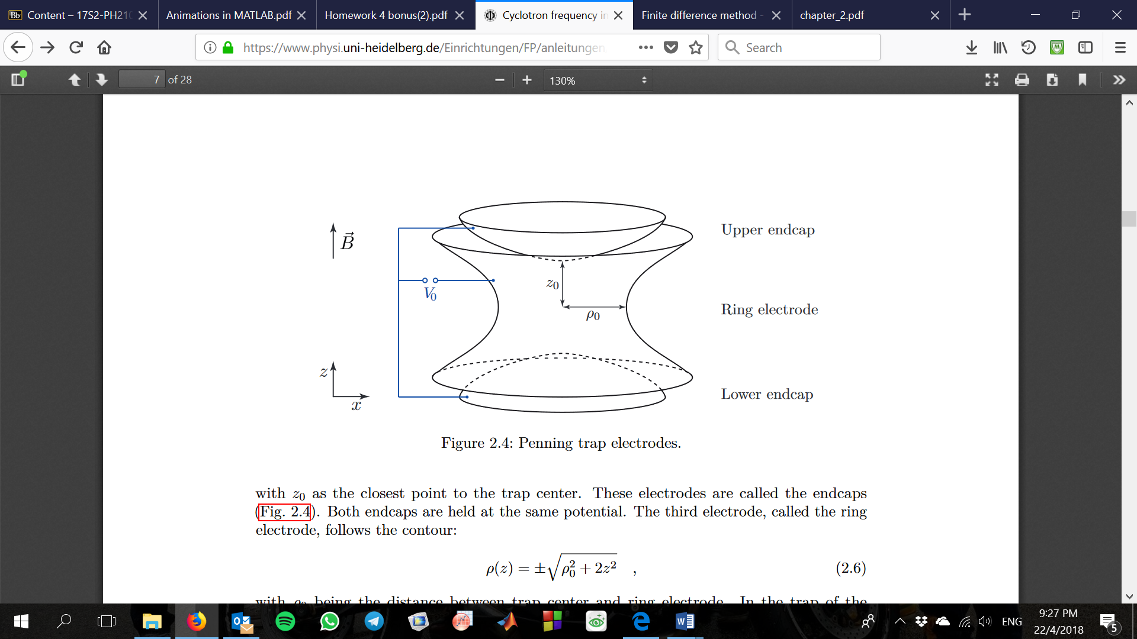

Fig 5: Schematic of a Penning Trap setup[2]

Thus, its -field in Fig 3 can be expressed:

(3)

Stability

From Fig 3, it is obvious that the particle is on a potential hill in the radial plane. Damping processes or collisions can disturb the unstable equilibrium of its magnetron drift that causes it to roll down the potential hill, out of the confines of the trap. Ensuring stability of the particle’s trajectory translates into solving for real-valued frequencies in the particle’s equations of motion, which gives the condition[2]:

(4)

**Part II: Numerical Analysis of Trajectory**

Finite Difference Method

Approximating the derivatives of displacement allows us to solve, numerically, differentiation equations involving acceleration and velocity. For time step > 2, each component of acceleration and velocity can be approximated by[3]:

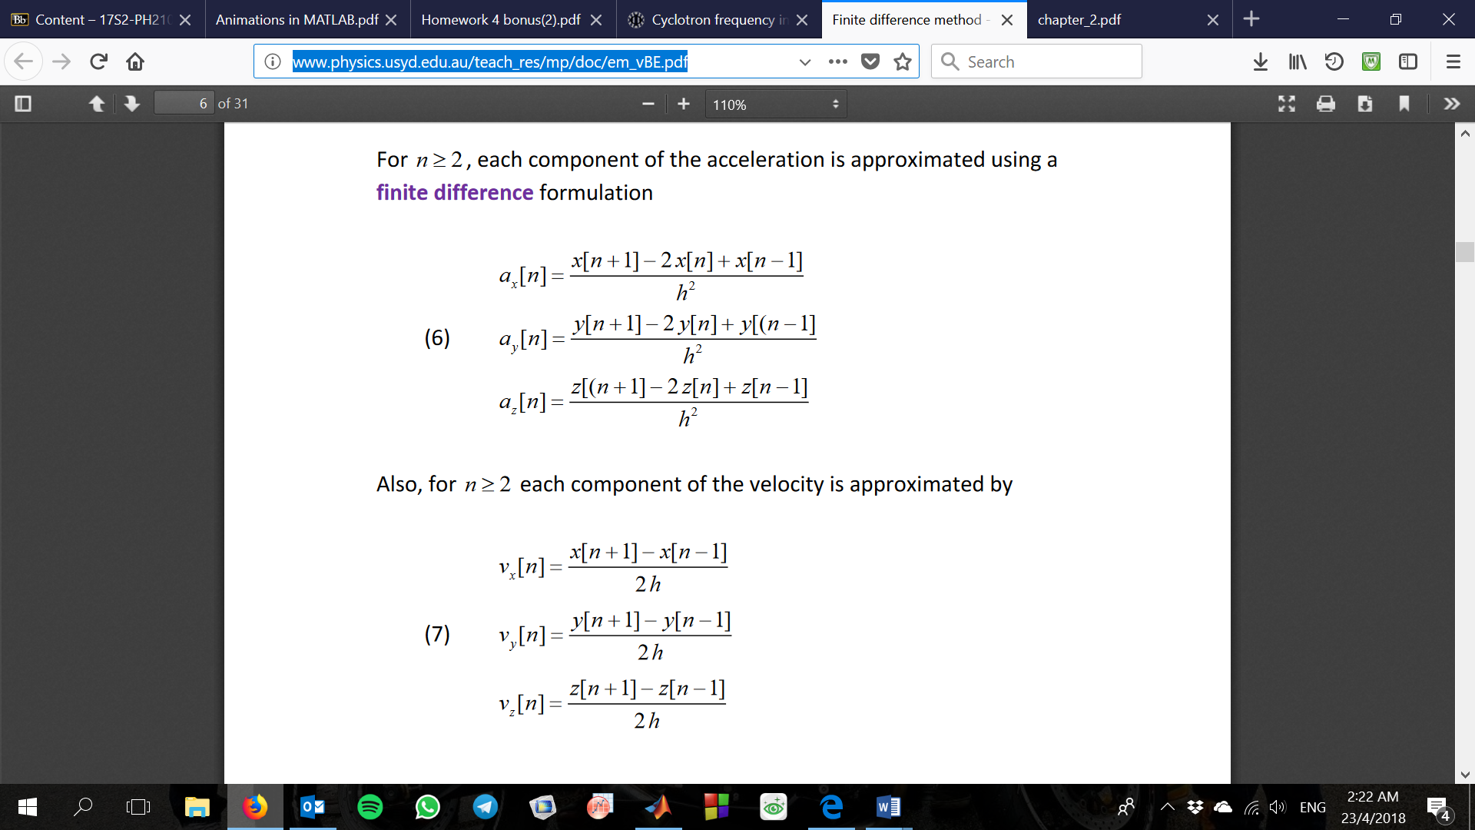 

(6)

(5)

where is the time step size / time increment.

Consider the cross product

Using Newton’s Second Law of Motion together with Equation 1, the components of the particle’s acceleration can be written:

(7)

Combining Equations 5, 6 and 7, the components of the particle’s displacement for time step > 2 can be derived:

where .

To implement the above 3 equations we have derived in the MATLAB script, we need to set the initial conditions at and for the trajectory of the particle:

For ,

where , and are initial position parameters that are changeable as variables in the accompanying MATLAB script.

For ,

where , and are initial velocity parameters that are changeable as variables in the accompanying MATLAB script.

Convergence of results

It is imperative that the time step size be small enough to minimise the approximation errors using finite differences. A guide[3] would be to set a value for such that it satisfy the condition

It is practical to run the script provided with smaller and smaller values of while checking for convergence of results as a way of determining a sensible value for .

Results from MATLAB plot

Fig 6 is a screen capture of the MATLAB trajectory plot, depicting the cyclotron motion moving axially within a larger circular orbit that is the magnetron drift.

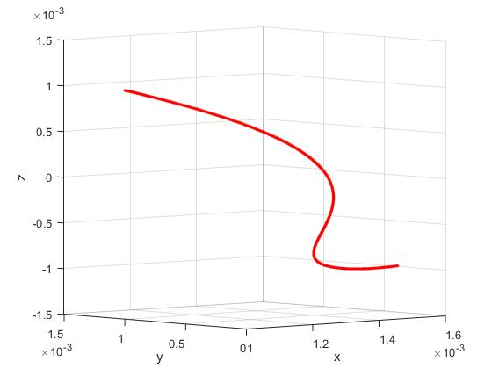

Fig 6: Trajectory plot of particle motion

A larger time step allows the superposition of its cyclotron orbit, axial oscillation, and magnetron drift about the centre of the trap to be more readily observable (Fig 7).

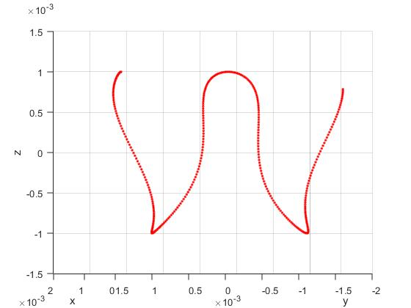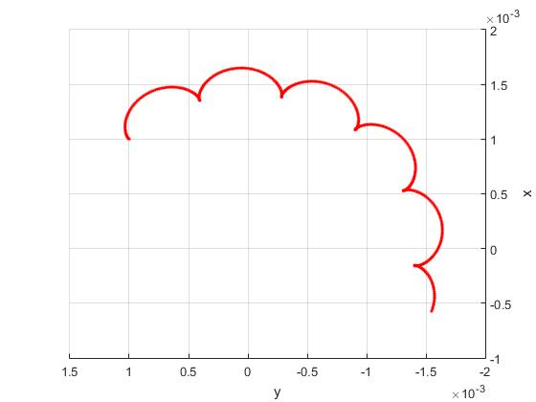

Fig 7: Trajectory plot of particle motion, showing axial oscillations in the axial plane,

with cyclotron and magnetron motion in the radial plane.

**References**

[1] ExamFear. *Motion of a Charge in a Magnetic Field*. Retrieved from: <http://www.examfear.com/notes-dir/00/00/12/00001297.html>

[2] Blaum Group. Universitat Heidelberg. *Cyclotron frequency in a Penning Trap*. Retrieved from: <https://www.physi.uni-heidelberg.de/Einrichtungen/FP/anleitungen/F47.pdf>

[2] Ian Cooper. The University of Sydney. *Moving Charges in Electric and Magnetic Fields*. Retrieved from: <http://www.physics.usyd.edu.au/teach_res/mp/doc/em_vBE.pdf>