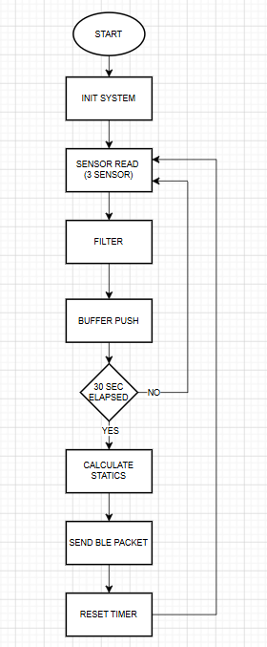
Tools Used:
This project was developed as a software-based simulation without using physical hardware. The embedded system architecture was implemented using the C programming language.
- Programming Language: C
- Development Environment (IDE): Visual Studio Code
- Compiler: GCC (GNU Compiler Collection / MinGW)
- Communication Protocol: I2C (modeled at simulation level)
- BLE: Simulated in software (no physical BLE hardware used)
A modular architecture was adopted, where sensor reading, filtering, buffering, statistical analysis, and BLE communication were implemented as separate modules.

Datasheet Links:
Although no physical sensors were used, the system behavior was designed based on real sensor datasheets.
- Oxygen Sensor (DFRobot SEN0322):
https://wiki.dfrobot.com/Gravity_I2C_Oxygen_Sensor_SKU_SEN0322
- CO2 Sensor (Sensirion SCD41):
https://sensirion.com/products/catalog/SCD41
- Temperature Sensor (TI TMP117):
https://www.ti.com/product/TMP117

BLE Results:
In this project, no physical BLE hardware was used. BLE communication was simulated through console output.
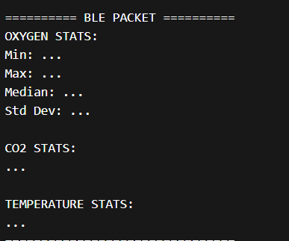
Every 30 seconds, statistical results (minimum, maximum, median, and standard deviation) were calculated from the sensor data and packaged into a single BLE packet. This packet was then displayed as a formatted console output.

References:
The following resources were used during the development of this project:
- Sensor datasheets (DFRobot, Sensirion, Texas Instruments)
- General knowledge of median filtering and statistical analysis
- Standard C programming libraries

Burcu Gezici

