BIGHMS.COM
BigHMS is a hotel management system that comes with hotel door-lock software. This software will enable you to manage every aspect of your hotel starting from installation and configuration of hotel door-locks, generating door-lock card for each hotel doors, check-in and check-out of guest from hotel, writing new door-lock card for customer, manage bar(s), restaurant(s), spa, laundry, swimming pool(s), cab, generate monthly as well as yearly reports, etc.

Table of Content
- How to Install BigHMS
  - Installation of XAMPP
  - Installation of BigHMS Files and Database
  - How to Login on Client PC
  - How to Login on Server PC
  - Installation of BSW & Creating BSW Desktop Shortcut
  - Configure Privilege In MySQL For BSW
- How to Connect remotely to BigHMS Database Server

HOW TO INSTALL BIGHMS

Installation of XAMPP
First download XAMPP for PHP 5.6 https://www.apachefriends.org/download.html and install it on your system (or server)

Installation of BigHMS Files and Database
Unzip and Copy BigHMS Folder into htdocs of XAMPP. If you install xampp to c: drive, the path should be c:\xampp\htdocs. Make sure the folder name is bighms. If you use rename the folder, note it because you will include it in config file later.
Now, to setup database for bighms;
- Open browser, and type http://localhost/phpmyadmin/
- Click databases tab
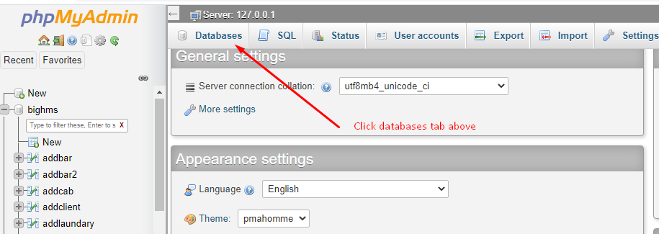
- Type in bighms and click create button 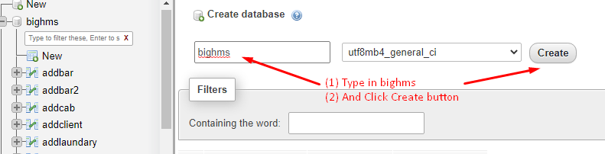
- Then click bighms to open it. 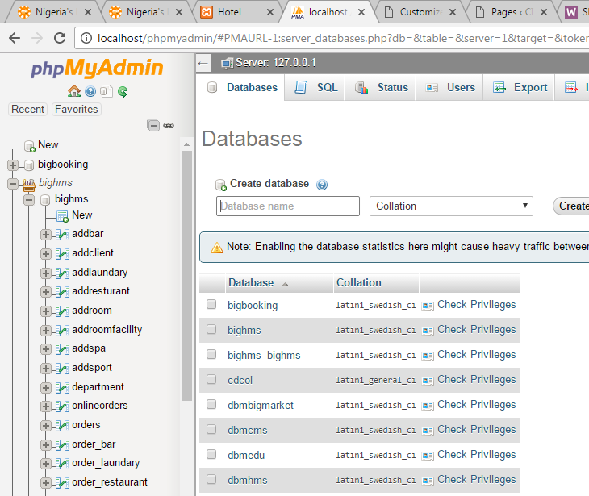
- Click “Import” tab 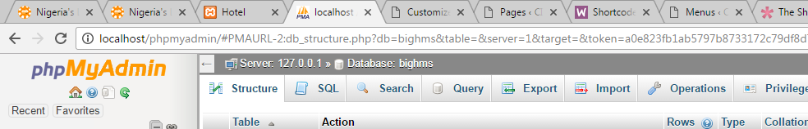
- Click “Choose File” button to location database in the zip file sent to you. The database file is inside the database folder in bighms folder. Note: c:\xampp\bighms\database\ 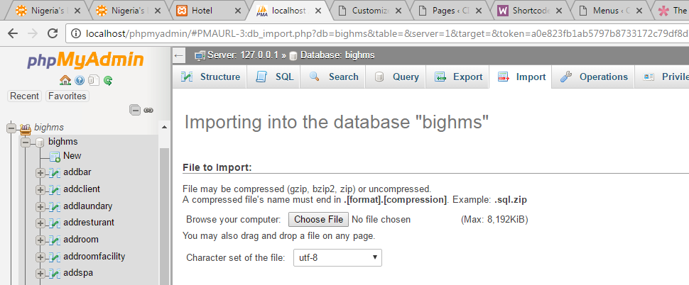
- Then click “GO” button below to import
- Finally, browse http://localhost/bighms to access the application from the same system (say server).

To access the application from another system (say client):
Make sure you assign IP ADDRESS to the server. Example say SERVER IP ADDRESS is 198.163.1.26.
- On Server, open config file in root folder of bighms.
- Change the $domain IP Address to your own IP address. i.e. 198.163.1.26 and save the file
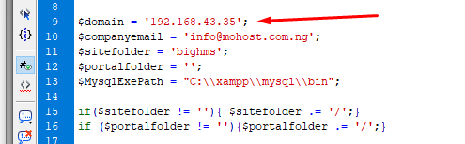
- If you change foot folder of the application from bighms to something else, make sure you include it in $sitefolder variable. After making changes, save the file
- Now, go to your system (client system), open your browser and type http://your-Ip-Address/bighms example: http://198.163.1.26/bighms
How to Login on Client PC
- Type http://your-Ip-Address/bighms example: http://198.163.1.26/bighms
- Enter your username and password. E.g. username: admin, password: 111, you can login as receptionist, manager, bar, etc. collect your login details from your administrator.

How to Login on Server PC
- Type http://localhost/bighms
- Enter your username and password. E.g. username: admin, password: 111, you can login as receptionist, manager, bar, etc. collect your login details from your administrator.

Installation of BSW & Creating BSW Desktop Shortcut
BSW is a desktop application for Bighms to enable you configure door smartcard for customer. With this software you can read, erase, and write to card. See diagram below;

For more information or help call our HOTLINES
T: +234-7060624802, +234-703-909-0014, +234-8119996059
E: tfrancislinks@yahoo.com, support@progmatech.com
W: www.progmatech.com

FINALLY, YOU NEED TO PLACE ICON ON THE SERVER AND CLIENT DESKTOP. FOR SERVER COPY THE FILE “Prenox HMS - Server” INSIDE “DESKTOP ICONS” FOLDER TO DESKTOP (SERVER).
FOR CLIENT SYSTEM(S), YOU NEED TO SEND YOUR IP ADDRESS TO US TO CONFIGURE IT FOR YOU.

