bambooBSC install

author: Bill chen
contact: chen.xin.nien@gmail.com

Quick view:
Linux: https://github.com/billchen198318/bamboobsc#install-on-linux

Windows: https://www.youtube.com/watch?v=pM3q9udreDo

System required
A. JDK8 ( jdk8 is required )
B. MySQL 5.6 or later

1. DataBase setup

a. first install MySQL Server
b. config max_allowed_packet=16M
c. config lower_case_table_names = 1

example for my.ini ( my.cnf )

[mysqld]
max_allowed_packet=16M
lower_case_table_names = 1

d. import bbcore.sql to DataBase
# mysql -u root -p
MYSQL> create database bbcore;
MYSQL> exit;
# mysql bbcore -u root -p < bbcore.sql

In Linux or FreeBSD must be set lower_case_table_names = 1

2. Config settings file
a. modify apache-tomcat-8.0.38\webapps\core-web\WEB-INF\classes\applicationContext\conf\applicationContext-dataSource.properties
b. modify apache-tomcat-8.0.38\webapps\gsbsc-web\WEB-INF\classes\applicationContext\conf\applicationContext-dataSource.properties
c. modify apache-tomcat-8.0.38\webapps\qcharts-web\WEB-INF\classes\applicationContext\conf\applicationContext-dataSource.properties
d. modify apache-tomcat-8.0.38\webapps\gsbsc-mobile-web\WEB-INF\classes\applicationContext\conf\applicationContext-dataSource.properties

dataSource.jdbcUrl= this options modify success database server address
dataSource.user= this options modify mysql account
dataSource.password= this options modify mysql password

3. Start

Windows:
apache-tomcat-8.0.38\bin\catalina.bat run
or
apache-tomcat-8.0.38\bin\startup.bat

Linux / *BSD:
apache-tomcat-8.0.38/bin/startup.sh

4. Open the Web ( If the server IP-Address is 127.0.0.1 and PORT is 8080 )
input url
http://127.0.0.1:8080/core-web/pages/way.jsp

if way.jsp cannot redirect to login page. change 127.0.0.1:8080/core-web/index.action
http://127.0.0.1:8080/core-web/index.action

*** please use FireFox or Google chrome browser ***

5. Login account
administrator user hr manger ( same power user, but can delete account )
account: admin account: tiffany
password: admin99 password: tiffany

default user(power user) sales ( only view , can input measure-data and enter 360 project score )
account: tester account: steven
password: tester password: steven

Login page
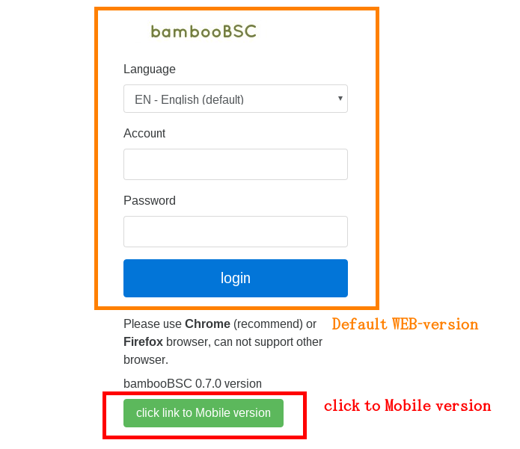

6. modify Application site settings ( If you do not operate this step may page will like figure 6-3, error for page request )
1. click Application site item for menu
2. Query ( figure 6-1 )
3. click modify icons ( figure 6-1 )

In edit mode, modify Host to correct server hostname with server-port , or IP address with server-port
and click Save. ( figure 6-2 )

After modification, please refresh( click F5 ) the WEB to take effect

Need to change the settings, including
A. CORE
B. BSC
C. QCHARTS

*** If the results page ( figure 6-3 ), Step 6 Host ( figure 6-2 ) are usually not set correctly. ***

( figure 6-1 ) : management Application site page

( figure 6-2 ) : modify Application site page

( figure 6-3 ) : request page fail !

7. User lost account password
command script file in WEB-INF\classes\

command:
lost_password 1 account-id

Linux:
lost_password.sh

Windows:
lost_password.bat

example generate new password for account tester: lost_password 1 tester

8. Server ( apache-tomcat server & bambooBSC webapps ) run with DHCP net environment
when reboot server the IP-address will reset on my server environment, but not want every config bambooBSC config

reference :
https://github.com/billchen198318/bamboobsc/issues/24

Config settings file
a. modify apache-tomcat-8.0.38\webapps\core-web\WEB-INF\classes\applicationContext\conf\applicationContext-appSettings.properties
b. modify apache-tomcat-8.0.38\webapps\gsbsc-web\WEB-INF\classes\applicationContext\conf\applicationContext-appSettings.properties
c. modify apache-tomcat-8.0.38\webapps\qcharts-web\WEB-INF\classes\applicationContext\conf\applicationContext-appSettings.properties

config base.applicationSiteHostUpdateMode value to 2

base.applicationSiteHostUpdateMode=2

9. Special locale ( CHINA ) cannot access google or twitter web site config.

Config settigs file

a. modify apache-tomcat-8.0.38\webapps\core-web\WEB-INF\classes\applicationContext\conf\applicationContext-appSettings.properties
b. modify apache-tomcat-8.0.38\webapps\gsbsc-web\WEB-INF\classes\applicationContext\conf\applicationContext-appSettings.properties
c. modify apache-tomcat-8.0.38\webapps\qcharts-web\WEB-INF\classes\applicationContext\conf\applicationContext-appSettings.properties

config twitter.enable value to N and change googleMap.url to http://maps.google.cn

googleMap.url=http://maps.google.cn

twitter.enable=N

