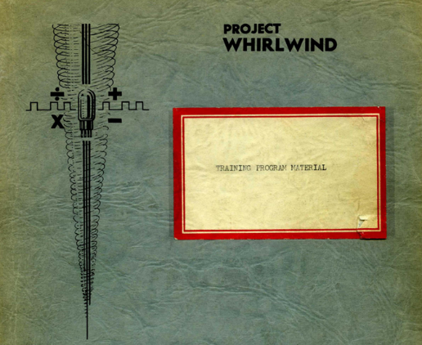

**Whirlwind   
Look-and-Feel**

**Guy C. Fedorkow**

Gungsuh font

Version 2.0

Guy C. Fedorkow, Oct 17, 2023

Updated Apr 13, 2024 with Rainer & Jürgen; restarted Feb 2025

 Caution! Construction Site!

If you see errors or can offer corrections or content, please contact guy dot fedorkow at gmail dot com.

1. Introduction 3

# Introduction

This note outlines possible approaches to building models to convey the look and feel of the Whirlwind computer, as seen by programmers and operators.

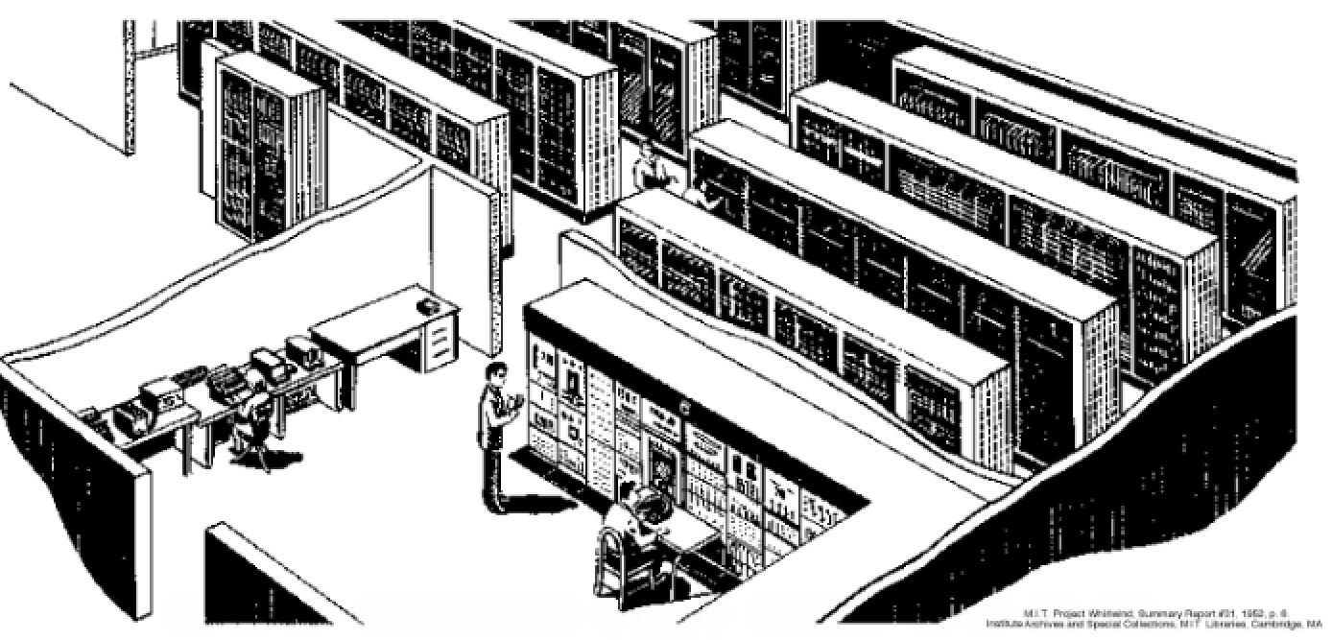

``

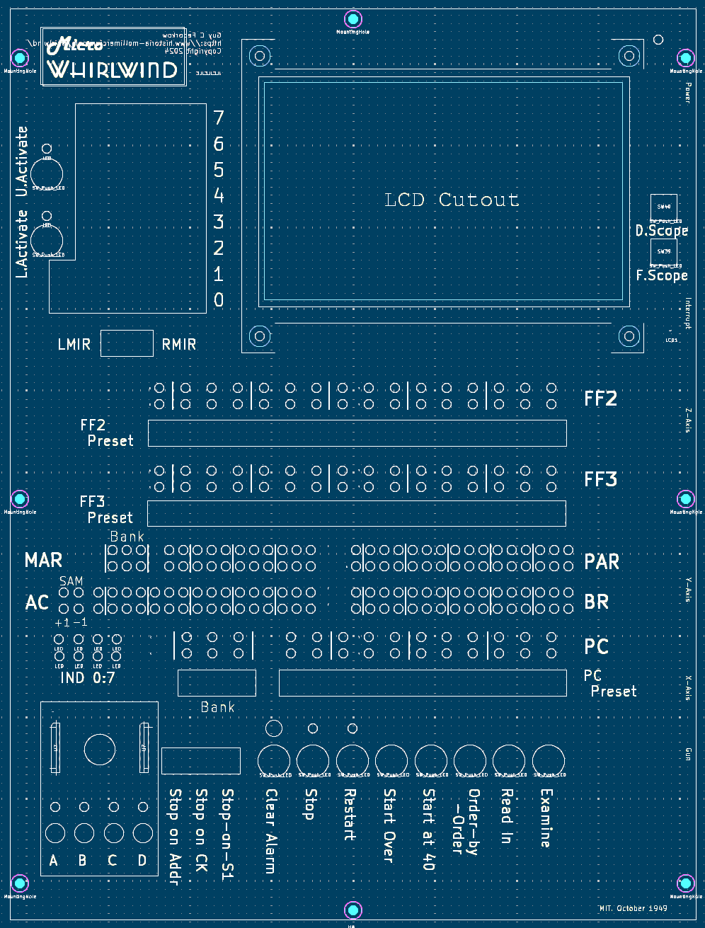

U2-R7

U5-R5B15

U5-R5B0

U5-R3Bxx

U5-R3Bxx

U2-R2B15

U5-R0Bxx

U5-R1Bxx

U2-R1B07

U2-R2B07

U2-R3B07

U2-R4B07

U2-R5B07

U2-RxBxx

U2-RxBxx

U1-R3B15

U1-R2B15

U1-R7B15

U1-R6B15

U1-R1B0

U1-R0B0

U1-R5B0

U1-R4B0

U1-R8B13, 14, 15

Ux-R1Bxx

U1-R8

U2-R1B0

U5-R4B15

U5-R4B0

U2-R2B08

U2-R4B15

U2-R4B08

U2-R3B15

U2-R3B08

U2-R5B15

U2-R5B08

U2-R0B13

U2-R0B08

U2-R1B15

U2-R1B08

U1-R8

B8

B0

B7

B3