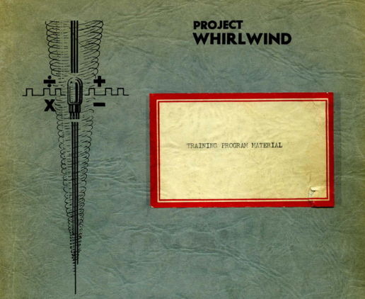
Whirlwind
Look-and-Feel
Guy C. Fedorkow

Gungsuh font
Version 1.0
Guy C. Fedorkow, Oct 17, 2023
Updated Apr 13, 2024 with Rainer & Jürgen

 Caution! Construction Site!
If you see errors or can offer corrections or content, please contact guy dot fedorkow at gmail dot com.

1. Introduction 3

Introduction
This note outlines possible approaches to building models to convey the look and feel of the Whirlwind computer, as seen by programmers and operators.



