Running the Laning-Zierler Compiler-Interpreter on a Simulated Whirlwind Computer

Larry Stabile
May 31, 2025

It is ironic that the Whirlwind, one of the first computers designed for real-time computation, spawned one of the first high-level computer languages -- via a decidedly non-real-time interaction.

The Laning-Zierler compiler-interpreter, initially developed in 1953, took a major step in advancing high-level languages toward modern forms, allowing expression evaluation, assignment, labeling, and conditional or unconditional branching, a forerunner to Fortran.

A user interacted with the system via the Flexowriter, a keyboard/printer/reader/punch. Punch here is to paper tape, and the interaction is to type on the keyboard to punch the tape, possibly load the tape onto a separate reader, read the tape into memory, and execute the program, which prints the results to the Flexowriter printer.

The Flexowriter had its own paper tape reader, but the Ferranti photoelectric reader was much faster and justified requiring the user to move the tape. Printing also required some waiting, as printing a single character could take 125 milliseconds. Contrast this with other Whirlwind peripherals: X-Y driven oscilloscopes, light pen input, radar input, and myriad (truly physical) switches and knobs. Flexowriter languages were not the real-time part.

The syntax of the LZ language is strikingly familiar. Figure 1 shows an LZ program and its corresponding output, on a virtual Flexowriter. This is produced from the original LZ code, running on Guy Fedorkow’s Whirlwind instruction simulator [3]. Figure 2 shows the initial portion of the hand-written listing from which the running code was gleaned. The remainder of this paper shows how we got from the listing to the output.

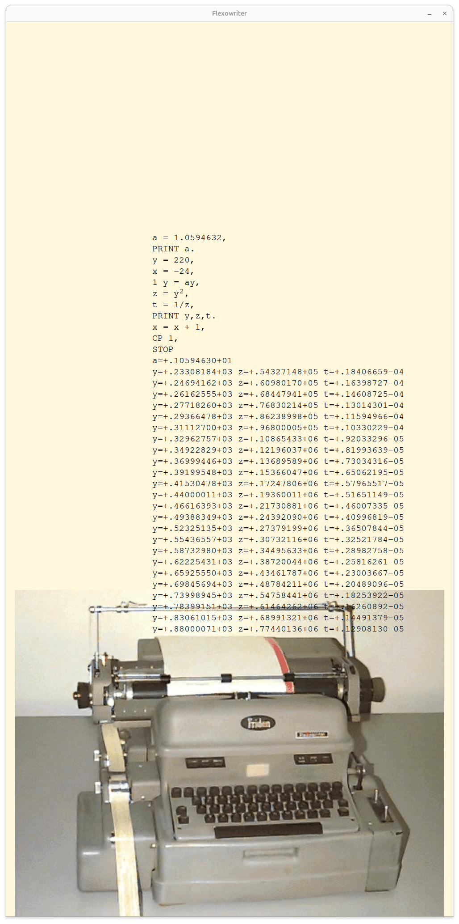Figure 1: Simple LZ program which prints musical note frequencies, their squares, and inverse squares, on a virtual Flexowriter. When set to original Flexowriter speeds, printing all the text above takes almost three minutes.

This effort began with the hand-written listing, two pages of which are shown in figures 2 and 4. There is a total of 20 sheets (see [4]).

An additional boost to this effort was the availability of notes on the program by Donald Knuth, from 1976. [5] The listing as it turns out is also from Knuth’s archive, as it is his notes on the listing in light pencil. The first page of Knuth’s notes are shown in figure 3.

The initial effort was to transcribe the hand-written listing to text. This was done using syntactic conventions to capture the comments in the source, and also notes of the transcriber (see figure 8). We thus had a form which could be run through a simple parsing tool, which translated the transcript format to Whirlwind assembler.

Perusing the initial listing shows there are two external modules required by the LZ code, the floating-point arithmetic library, and the floating point printer. The floating arithmetic lib is available in the file Subroutines.pdf [6], a collection of modules in typewritten text (see figure 5). This module was ported and tested separately from the main LZ code, and is crucial to its operation, as is described below. It’s more than your average float lib!

The printer could not be found, but a printer of double-precision fractional numbers was in the library, and made a good starting point for a float printer. As a result we have a reasonable simulation of the original LZ system, all in Whirlwind code.

The code having been gathered up was then assembled and debugged. There were several phases to this, and progress was incremental until it all came together. In the paper we’ll go over some of the methods used to get it all to work, the issues encountered, and coding methods on Whirlwind. However first we’ll look into the Whirlwind architecture to establish the basis and context for the effort.

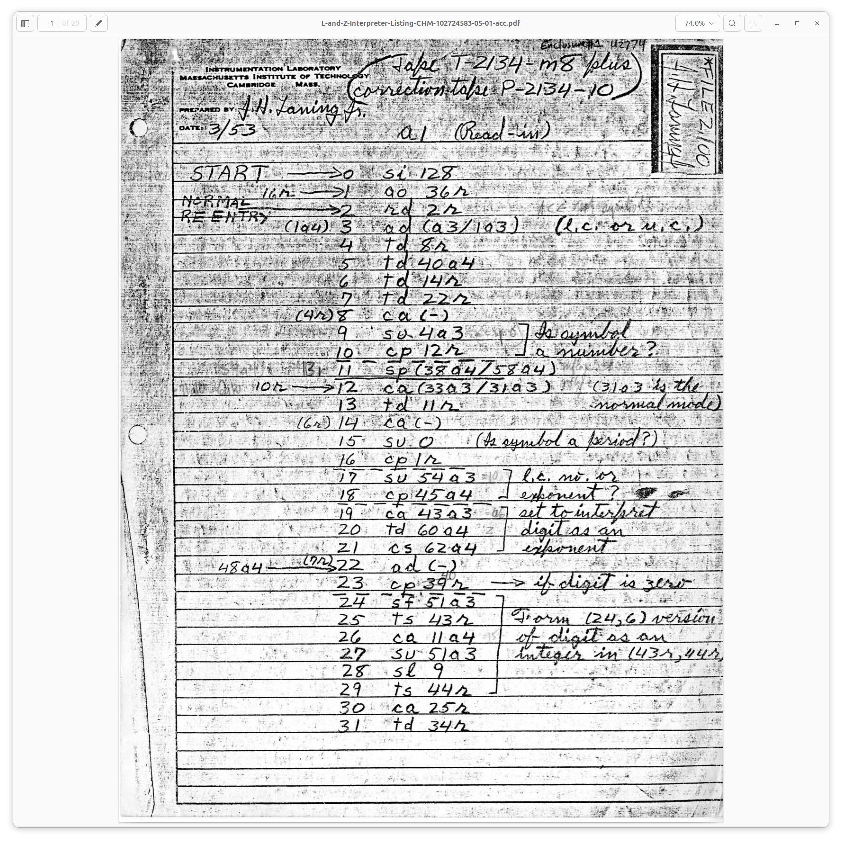Figure 2: First page of the Laning and Zierler Compiler-Interpreter

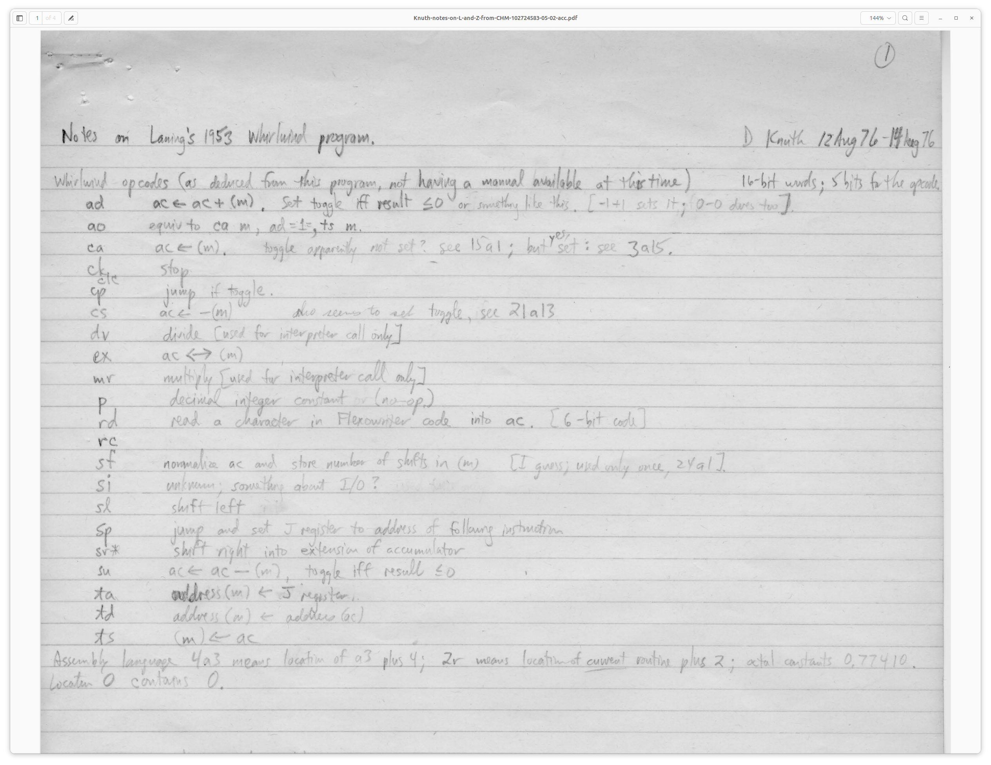Figure 3: Page one of Donald Knuth's 1976 analysis of the LZ program.

Whirlwind in brief
Whirlwind was a 16-bit machine. Instructions had a 5 (sometimes 6) bit opcode, in the high end of the word, and 11 bits of address (or integer value) in the low end. Generally therefore 2K words of memory was available, though there were as time went on at least three 2K banks available (instructions were provided to switch among banks).

There was effectively a single accumulator, the AC. Some operations used an extension register BR. There was also an address register, AR, affected by changes in control flow.

Whirlwind was a one’s-complement machine – a real headache; in particular, both zero and negative-zero need to be accounted for. The advantage is mostly to hardware: to negate, just flip the bits. Saves several vacuum tubes!

As if one’s-complement weren’t enough, numbers were all considered as fixed-point fractions. So there is a sign bit, then 15 bits of .101010… or whatever value. But the words are considered integers too, in particular when writing the address fields of other instructions. Thus we have the instruction dv (divide), which alarms if the (fractional) numerator is greater than the (fractional) denominator, since the result would be one or more, and at the same time we have the instruction ao, which adds (integer) one (fraction 2⁻¹⁵) to the contents of a given memory location.

But fractional was in fact a natural choice, given the application space of this machine, in real-time work, radar, and so forth. And to get better resolution, they wrote multi-precision fractional and floating point libs. Floating numbers in storage used two words, in (24,6) format: 24 bits plus sign for mantissa, and 6 bit plus sign for exponent. The floating accumulator (the MRA, Multiple Register Accumulator) used three words, a (30,15) format.

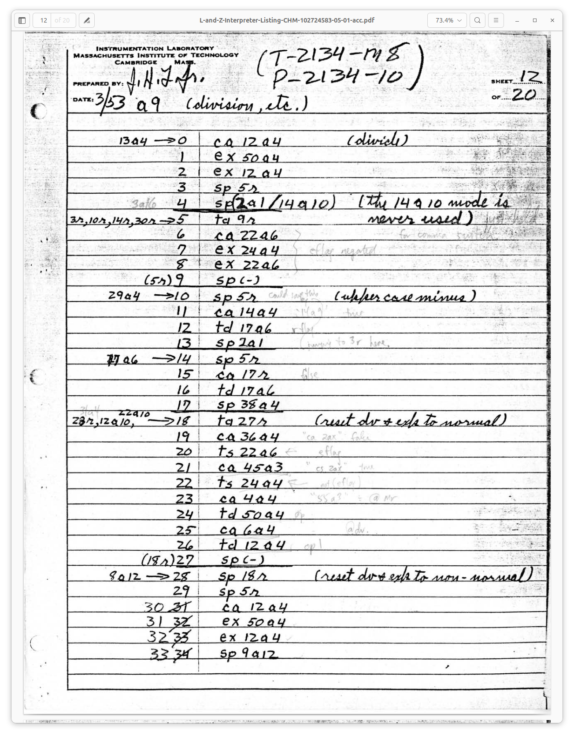Figure 4: Another page from the coding sheet. The light-colored marks are Knuth's notes.

The Great Unwashed
Whirlwind embraced tightly the principles of the von Neumann architecture, which combined program and data into a single memory. Thus the presence of instructions which wrote other instructions was not only permitted, but was a fundamental part of the machine architecture. In later days this became known as “impure code,” and spawned a lot of debate about instruction sets, and some mostly good-natured derision when programmers did not want to stick to the no-self-modifying-code dictum. There was a period, in the late seventies and early eighties, when the transition from on-the-fly self-modification to read-only code was made, as caching and pipelining made their way into the mainstream of computer design. So self-modifying code was sinful!

But not so sinful for Whirlwind coders, as it was the only way to write compact code. To execute a set of operations on a block of numbers, for instance, one wrote the code as for the first number, then did ao (add one) on each instruction that needed to advance to the next item in memory. So ao is used mainly for incrementing the address in an instruction. Note there is no so (subtract one).

Another common Whirlwind method is to select an instruction to execute based on some condition, like deciding to do a divide rather than multiply. Each such instruction is stored as data, with a zero address. When an address is known, the appropriate instruction is loaded, and that address added in and stored for execution. The execution point is typically the next instruction.

To use this type of system well it’s advantageous to view a sequence of instructions on some given data as a specific machine, which is then modified on each pass.

Instructions
The instruction set has similar basic attributes to later and latter-day instruction set architectures. A major notable difference between then and now is the Whirlwind instructions which directly support self-modification. The td instruction (transfer digits), for example, writes the AC into the address portion of an instruction word, thus altering the data that instruction will use when executed. Instructions take a single parameter, which in most cases is an address. In shifts and some I/O instructions the operand is an integer.

Instructions like ca, clear-and-add, are used to load the AC. There is also cs, clear-and-subtract, and cm, clear-and-add-magnitude; these are used primarily as loaders. ad adds the contents to the AC, and su subtracts the contents. dv divides, and mr and mh multiply.

ts stores the AC into memory. The sp instruction jumps to the given location, depositing the address of the instruction following (the return address) into the AR (address register). ta stores the AR into memory, effecting a save of the return instruction.

A common pattern for subroutine enter and return is:

enter_subr: ta subr_rtn
...subr instructions…
subr_rtn: sp 0

ta stores the return address (AR) into the sp return instruction’s address field.

si selects an I/O device. rc writes to a device. rd reads from a device.

There are a few varieties of shifts, slr: shift left and round; srr: same only right. slh: shift left and hold (don’t round); srh goes right. These are arithmetic shifts and don’t shift the sign bit. clc (cycle left) shifts all bits.

Shifting can get complicated since it can extend to or from the B Register (BR). The BR is always considered positive, and negative numbers are complemented in the AC before and after a shift.

The Floating-point Library
The floating point library (float lib) operates as an interpreter; the language it interprets looks just like Whirlwind machine language. The essential difference is that the float lib uses a three-word accumulator for floating numbers, the MRA (Multiple Register Accumulator).
But the float lib also interprets some other general-purpose instructions, and emulates a comprehensive machine in interpreted form. Overall, the instructions interpreted are:
- ca n Clear the MRA and add contents at address n
- cs n Clear and subtract
- cm n Clear and add magnitude
- ad n Add
- su n Subtract
- mr n Multiply
- dv n Divide
- ts n Transfer to Storage
- ex n Exchange
- sp m Jump to subprogram
- cp m Jump to subprogram if MRA is negative
- ta m Transfer sp return address to storage

These instructions are indistinguishable from standard Whirlwind instructions; thus we have an interpretive virtual machine, which uses floating point numbers as its sole data type.
The interpreter is entered by calling the address with label “ax”, via “sp ax”. The instructions to be interpreted follow the call. Within the interpreted instruction stream, another occurrence of “sp ax” returns control to the calling Whirlwind code, at the location following the last “sp ax”.
By this method, code can jump in and out of the floating lib as desired to effect floating calculations. Due to the labels involved, I call this “going in and out of spax,” or when code is interpreted it’s “under spax.” And instead of the float lib, I’ll sometimes call it “the spax system.”
The spax system keeps no state between its invocations, except for the MRA. Thus one is free to jump in and out. There is no stacking and thus no recursion.
Floating arithmetic is implemented straightforwardly, except for divide (dv). Divide uses a second-order Taylor series approximation to 1/(a + kb), where a and b represent the high and low word of the denominator:

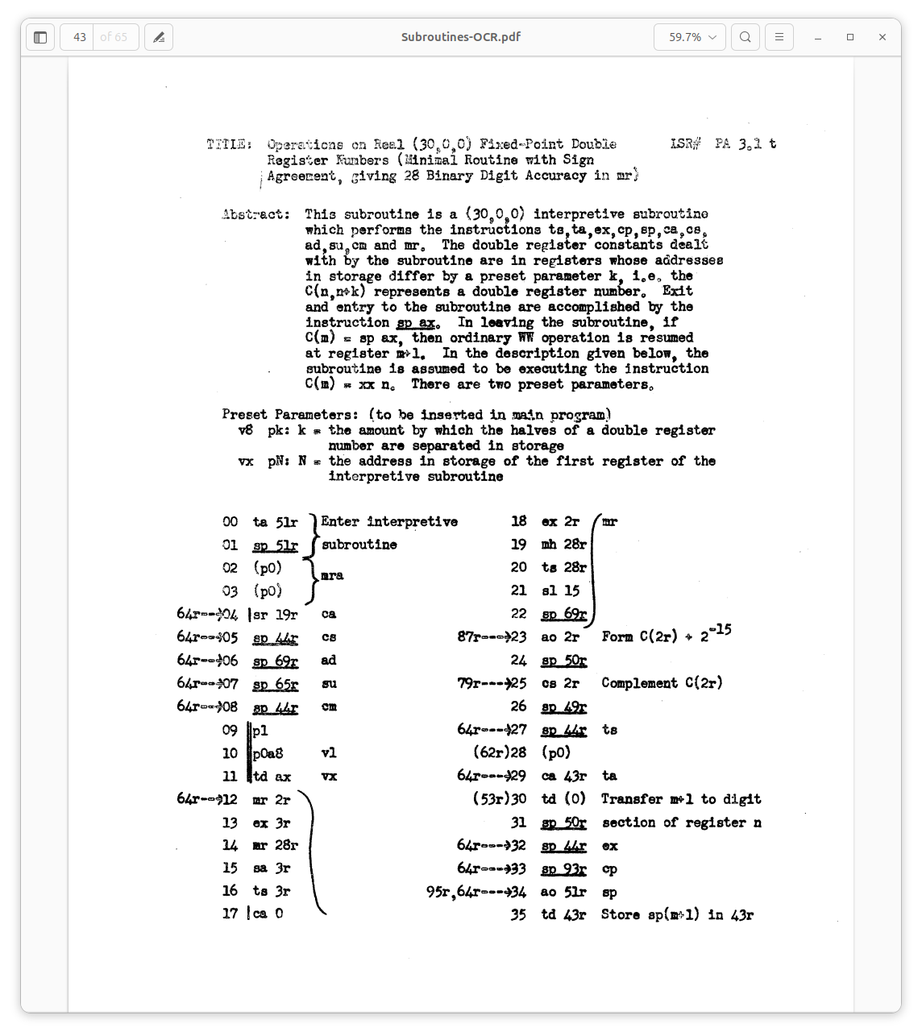Figure 5: Initial page of the (24,6) floating point library.

The LZ System

A note about versions
The version ported in this work is dated March 1953. Yet the documentation for the system, dated January 1954, describes features that are not in the ‘53 version. Indeed Knuth signals the absence of certain apparently-planned features in his notes:
We have found in total that the following features were not yet implemented in the ‘53 version:
- Subscript and indexing syntax for variables.
- Drum-based buffer for indexed variables (for processing large vectors).
- SR and CR instructions, to call one-line subroutines within the language.
- A library of math functions, such as square root, sine, cosine, etc. The syntax of these is F¹ = square root; F² = sine; F³ = cosine, and so on.
- A “D” operator for differential equations (Runge-Kutta algorithm).
- Special processing of the Flexowriter “stop” character.

The LZ Language
Figure 1 shows a sample LZ program. This prints musical note frequencies, by successively multiplying by 2^{1/12}. It also demonstrates exponents, division, and printing by calculating note², and 1/note².
A number written next to a line is a label. CP jumps to its given label if the MRA is negative, so we get a conditional loop.
Expressions accept single-letter lower-case numeric variables (in later versions, with a “subscript” option). Addition is indicated by +, subtraction by -, and division by /. Multiplication is denoted by juxtaposition (e.g., xy means x times y), but also by “dot” – not period, but colon, where they filed off the lower dot of the colon on one or two of the Flexowriters [1?].

Exponentiation (by an integer) works by successive multiplication or division. It is indicated by true superscript characters, typed as upper-case numerals and upper-case -. This feature did not make it into ASCII and modern programming. Of course we can denote and print superscripts and much more today, but it’s not available via the same typewriter interaction as it was on the Flexowriter.

Parentheses may be used for grouping, up to four levels. Operator precedence is the same as in the C language; Laning was concerned whether this was implemented correctly, as indicated in his letter to Knuth in 1976 [2]:
The notion of operator precedence as a formal concept did not occur to me in 1953; I lived in fear that someone would write a perfectly reasonable algebraic expression that my system would not analyze correctly.
The language is described in detail in [1].

Processing LZ
The LZ system runs in two overall phases:
- Compile the input source text into instructions to be interpreted. The instructions to run the musical-note example are shown in figure 6.
- Execute the resulting instructions through the interpretation system. The interpretation system in this case is spax plus some special interpreters, such as for exponentiation or printing.

Figure 6: Debugger print of compiled musical-note LZ code.
dbg 1101> p comp_code,50,i
0o40(comp_code):
0o40 = SP 0o41
0o41 = SP 0o1662(equals)
0o42 = MR 0o776(val_1)
0o43 = AD 0o1733(temp)
0o44 = TS 0o1111(var_a)
0o45 = SP 0o1736(print)
0o46 = MR 0o1111(var_a)
0o47 = SP 0o50
0o50 = SP 0o1662(equals)
0o51 = MR 0o774(val_2)
0o52 = AD 0o1733(temp)
0o53 = TS 0o1155(var_y)
0o54 = SP 0o55
0o55 = SP 0o1662(equals)
0o56 = SP 0o1674(minus)
0o57 = MR 0o772(val_3)
0o60 = AD 0o1733(temp)
0o61 = TS 0o1175(var_x)
0o62 = SP 0o63
0o63 = SP 0o1662(equals)
0o64 = MR 0o1111(var_a)
0o65 = MR 0o1155(var_y)
0o66 = AD 0o1733(temp)
0o67 = TS 0o1155(var_y)
0o70 = SP 0o71
0o71 = SP 0o1662(equals)
0o72 = SP 0o1701(exponent)
0o73 = SI 0o1155(var_y)
0o74 = SI 0o2
0o75 = AD 0o1733(temp)
0o76 = TS 0o1145(var_z)
0o77 = SP 0o100
0o100 = SP 0o1662(equals)
0o101 = MR 0o770(val_4)
0o102 = DV 0o1145(var_z)
0o103 = AD 0o1733(temp)
0o104 = TS 0o1143(var_t)
0o105 = SP 0o1736(print)
0o106 = MR 0o1155(var_y)
0o107 = MR 0o1145(var_z)
0o110 = MR 0o1143(var_t)
0o111 = SP 0o112
0o112 = SP 0o1662(equals)
0o113 = MR 0o1175(var_x)
0o114 = SP 0o1667(plus)
0o115 = MR 0o766(val_5)
0o116 = AD 0o1733(temp)
0o117 = TS 0o1175(var_x)
0o120 = CP 0o2003
0o121 = SI 0o0

Phase 1: Parsing and Compiling
The first phase, parsing and compiling, is done character-by-character, as each is read from the Flexowriter paper tape. Characters index into a switch table, which then jumps to a handler for a particular character. State changes are effected by altering the instruction stream, by saving data in certain fixed locations, and by allocating space in three buffers:
- The compiled code, denoted in the ported system by the label comp_code, but hard-coded in the original to address 32, and growing upward.
- Space for literal read values, like 3.14159. These are allocated at the end of the compiled code block, and grow down. In the original they were assigned address 197 (growing down).
- A parentheses stack, allowing for four-deep nesting.

Program, write thyself
The common technique of writing into the instruction stream is displayed right from the start in this phase. Consider the detection of the shift-up or shift-down characters:

a4: ca a3
1a4: td 3a1
sp 2a1 ; E (not used)
...
2a1: rd 2a1
3a1: ad a3 ; (l.c. or u.c.) [(a3/1a3)]
td 8a1
...
8a1: ca 0
...
a3: .word a3
1a3: .word a4
a3 is the base of the lower case switch table, and a4 the upper case switch table. The executable code at a4 sets 3a1 to point to the lower case table, its initial state.
The code at 2a1 reads a character via rd, then adds the switch table base address. This address is then stored in 8a1, which via ca will load the AC with the contents of the table entry.
When the shift-up character is read, it is dispatched and winds up at this code:
42a4: ca 53a3
sp 1a4
...
1a4: td 3a1
sp 2a1
53a3: .word 1a3

Note the highlighted lines, the instruction at 3a1 is written by the td at 1a4. The shift-down character will execute 1a4 and set it back to lower case.
Controlling state in this manner is common in Whirlwind code. Another example is seen in reading digits. When a digit is read, a cp detects this and branches to a digit-handling section of code. That section rewrites the address of the instruction of the non-digit handler, i.e., the code executed if the character is not a digit. This new target processes the number resulting from the digit sequence, and rewrites instructions again to return to a normal state.

Program, reuse thyself
Whirlwind programmers took advantage wherever they could of ways to optimize space. A couple of interesting examples are described here.

Who needs that switch table?
While reading characters, the switch table which drives each read obviously must remain intact. But when all the source is read and compiled, the table is no longer needed. When endowed with such a small memory, you look for every word.
Any lower-case letter may be a variable. A variable requires two words, for storing a (24,6) floating number. So the system uses those character entries for the actual values. But each character requires a word in the table, and a float value requires two words. What if there are two variables – two lower-case letters – consecutively stored in the table? Well, as it turns out, there aren’t! Each lower case letter has a non-letter character between it and the next letter; it’s a quirk of the Flexowriter character code. Whirlwind programmers were very astute at finding and exploiting these happenstance alignments.

Constants are wherever you find them
In another example, the value -32767 is needed in some arithmetic code in the system. This is also the value of the instruction ca 0. By hardware convention, on Whirlwind location zero always contains zero. And there are places in the code where loading a zero is desired. So a ca 0 which will never be written is ripe for the plucking as -32767. Taking advantage of the numeric values of instructions is another common technique used in Whirlwind programming.

Compiling expressions
As characters are read, and information about the expression to be calculated is accumulated, and parsing state altered, certain characters will terminate whatever is currently being built and call for one or more words to be added to the compiled code.
A certain call is made, sp 9a8, to add a word, in the AC, to the compiled-code heap. As a line is compiled, not only are words added, but previous words modified, resolving addresses as required. There are code block patterns for each type of line (assignment, print, etc.). For instance the assignment of a variable to a single number:
a = 1.0594632,
results in this code:
0o40 = SP 0o41
0o41 = SP 0o1662(equals)
0o42 = MR 0o776(val_1)
0o43 = AD 0o1733(temp)
0o44 = TS 0o1111(var_a)

The comma terminator triggers the compilation of the last two instructions.
More on code blocks in the next section on execution.

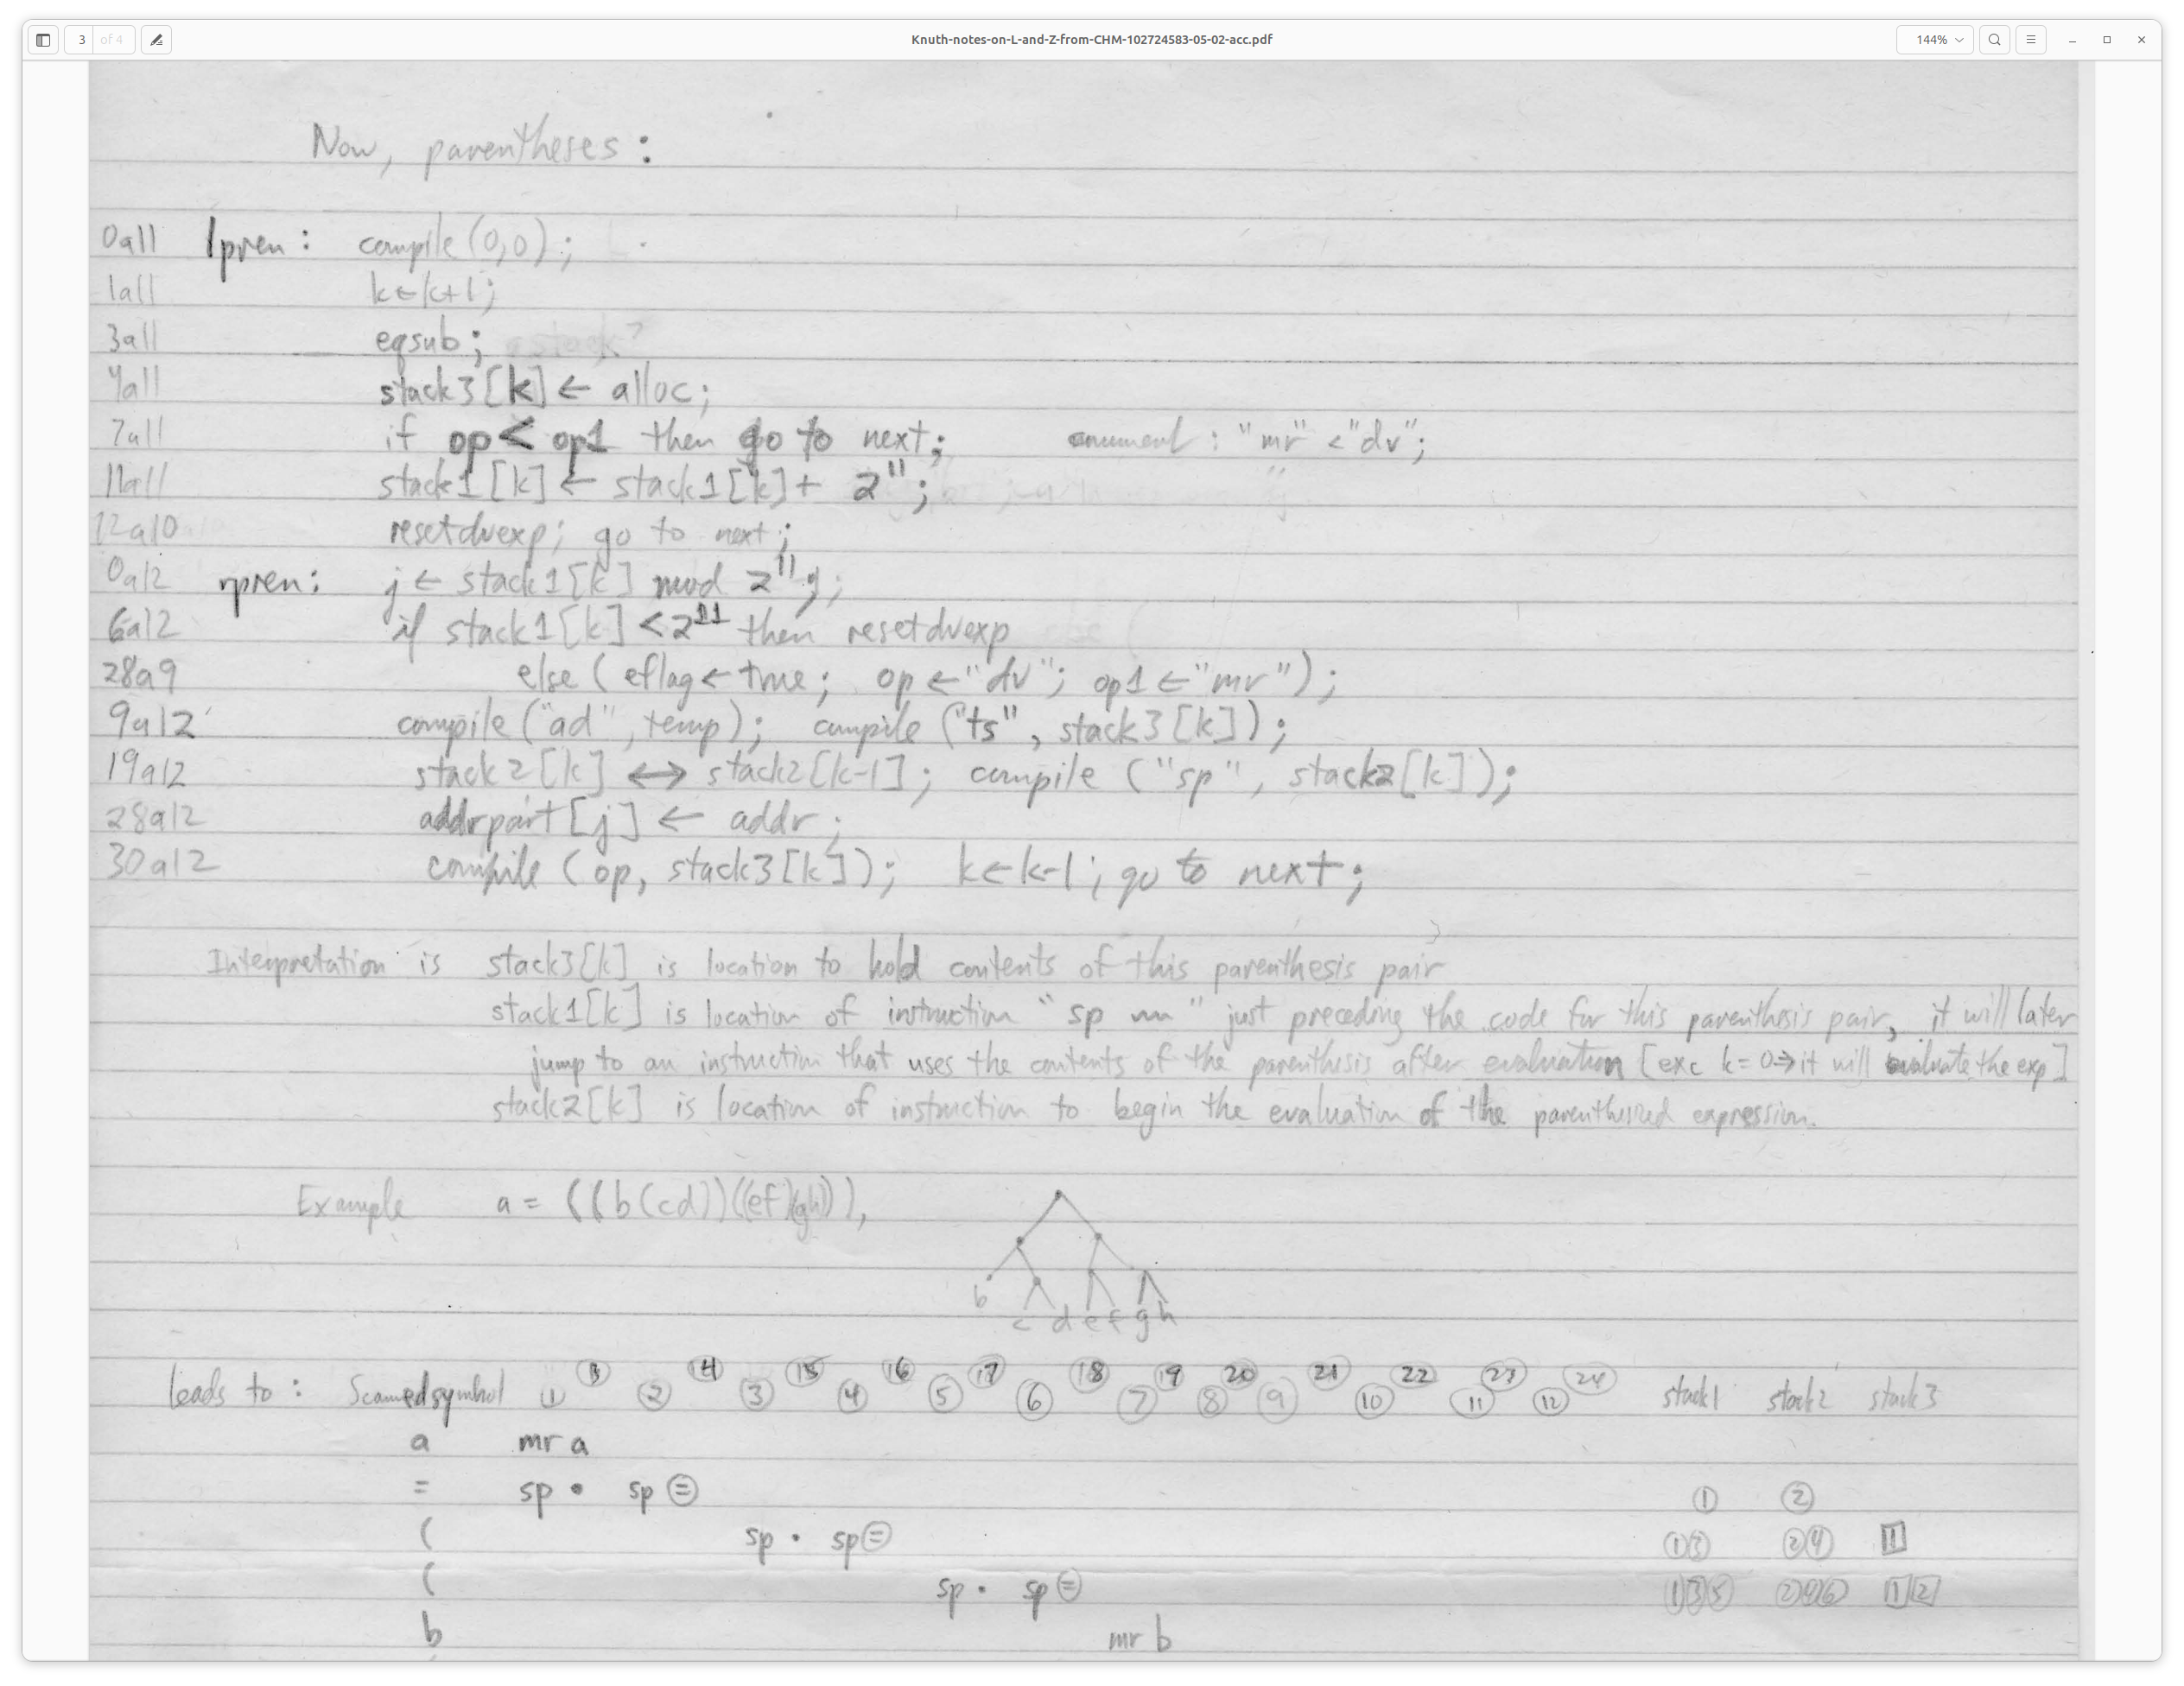Figure 7: Knuth's description of parenthesis processing.

Phase 2: Interpreting the compiled code
Compilation proceeds until the STOP statement is reached. Referring to the previous example, the initial assignment statement, note that as yet no clear reason has been found for the jump at 0o40 to 0o41. It’s perhaps a nop reserved for future work like the SR instruction.
Also recall this is interpretive code here, so its execution is under spax.
At 0o41, equals is called, and so is interpretive. Equals simply loads 1.0 into the MRA. The next instruction, MR 0o776, multiples val_1 (1.0594632) by the MRA and leaves the result in the MRA. Then temp, which is zero here, is added, and finally TS 0o1111 stores the result, in the fixed and former switch table entry for the letter “a”.
As mentioned, this code block is not emitted purely sequentially, with partial information filling-in until ultimate resolution. The need for temp space could be another reason for the extra sp.
Another code block type of note is that for print. The LZ line:
PRINT y,z,t.
results in:
0o105 = SP 0o1736(print)
0o106 = MR 0o1155(var_y)
0o107 = MR 0o1145(var_z)
0o110 = MR 0o1143(var_t)
and the next instruction is:
0o111 = SP 0o112

In this case the print routine comes out of spax and does not interpret each MR as a multiply, but just gets its operand, the address of the variable to be printed. It then prints that variable and via ao moves on to the next MR.
To detect the end of the list, the code simply does a cp on the MR instruction. cp checks for negative (a set sign bit). MR has the sign bit set in its opcode, and it appears no negative opcode can follow the MR. Thus it’s able to check reliably that the end of the print list has been reached. The opcode for SP (0o123), has the sign bit clear.
Note that this assessment is based not only on code inspection, but on comments in the coding sheet which are incomplete, i.e., did not get scanned, or were otherwise illegible. However assuming this assessment is correct it’s another good illustration of the extreme lengths Whirlwind programmers went to optimize their code.
The code continues to be interpreted until the zero instruction is reached. Here we run into a problem, because the LZ code does not seem to add an “end program” or similar marker to the end of the compiled code, and without that the program crashes. This may be due to the ‘53 code being an early version. In any event, for today’s purposes, since the calculation is done by that point, code was added to detect the zero and halt the machine.

Comments on the development of the port

Chain-of-custody
Care was taken to to assure that changes from the original hand-written text were tracked and marked, to show clearly where changes were needed or there were errors in transcription. Using Github’s history mechanism we can track the original transcript though edits and transformations, if such a level of detail is ever desired. However comments are formatted into separate fields in such a way as to retain most of the original listing’s comments, separate from comments from the porting effort. In this way changes from the original are noted without too much clutter.

Reading the hand listing
Several of the problems encountered in the effort were errors in transcribing the original hand listing. Sometimes just reading the handwriting was a challenge, but in addition the notation wasn’t always obvious, for instance the difference among, sp 0, sp (0), or, sp (-) (operationally, none), or the use of double vertical lines in the code (this seems to indicates being under spax). Some lines were just left blank. Choosing some value and tracking down issues for each such case took some time. Knuth’s notes were a significant help here.
Given all this, the code required only minor changes, with exception of the address space issues, floating point accuracy, and float printing (see below).

Assembly language generation
Simple parsing tools allowed the translation of the raw transcript to our more modern-looking Whirlwind assembler (Fedorkow, [3]); see figures 8 and 9. The tools looked for specific quirks in the transcript, such as parenthesized parameters. Labels were generated only for those addresses referenced by the code, thus avoiding lots of label clutter or the use of hard addresses. Labels were generated following the original format, <offset><section-name>, e.g., 39a3. Once the automatic translation was finished, some hand-editing then followed for label names, corrections, and so forth. As mentioned above these edits were notated in comments.
In several cases mnemonic labels were added to aid readability, and these help for instance in the Whirlwind debugger, which was developed as part of the simulator.
Figure 8: Section a1 from the initial transcript of the LZ language processor. This format captured all the text on the coding sheet, with the exception of the light-pencil notes by Knuth.

section a1
START --> 0 si 128
16r --> 1 ao 36r
NORMAL RE ENTRY --> 2 rd 2r
(1a4) 3 ad a3 (l.c. or u.c.) ; [LAS was ad (a3/193)]
4 td 8r
5 td 40a4
6 td 14r
7 td 22r
(4r) 8 ca (-)
9 su 4a3 -| Is symbol
10 cp 12r -| a number?
11 sp 38a4 ; [LAS was sp (38a4/58a4)]
10r --> 12 ca 33a3 31a3 is the normal mode ; [LAS was ca (33a3/31a3)]
13 td 11r
(6r) 14 ca (-)
15 su 0 (Is symbol a period?)
16 cp 1r
17 su 54a3 -| l.c. no.[?] or
18 cp 45a4 -| exponent?
19 ca 43a3 -| set to interpret
20 td 60a4 | digit as an
21 cs 62a4 -| exponent
48a4 (7r) --> 22 ad (-)
23 cp 39r --> if digit is zero
24 sf 51a3 -|
25 ts 43r | Form [?] (24,6) version
26 ca 11a4 | of digit as an
27 su 51a3 | integer in (43r, 44r
28 sl 9 |
29 ts 44r -|
30 ca 25r
31 td 34r

Figure 9: Section a1 after translating to our modern Whirlwind assembler language.

a1:
si 0o1004
1a1: ao 36a1
2a1: rd 2a1
3a1: ad a3 ; (l.c. or u.c.)
td 8a1
td 40a4
td 14a1
td 22a1
8a1: ca 0
su 4a3 ; -| Is symbol
10a1: cp 12a1 ; -| a number?
11a1: sp 38a4 ;
12a1: ca 31a3 ; 31a3 is the normal mode
td 11a1
14a1: ca 0
su 0 ; (Is symbol a period?)
cp 1a1
su 54a3 ; -| l.c. no. or exponent?
cp 45a4 ; -|
ca 43a3 ; -| set to interpret
td 60a4 ; | digit as an
cs 62a4 ; -| exponent
22a1: ad 0
23a1: cp 40a1 ; --> if digit is zero
sf 51a3 ; -|
25a1: ts 43a1 ; | Form (24,6) version
ca 11a4 ; | of digit as an
su 51a3 ; | integer in (43r, 44r
slr 9 ; |
ts 44a1 ; -|
ca 25a1
td 34a1

Address space issues
The hand listing, Knuth’s notes, and other documentation indicate that allocation of addresses was still being done up-front by the programmer, as is shown on the coding sheet.
Some parameterization was available, via certain two-letter combinations which may be assigned by some automated means; this is the origin of the “ax” label for entry into the float lib. Nevertheless the hand listing says sp 852 in various spots, and the entry point 852 shows up in other documents as well. Other hard-coded addresses (all decimal) are 32 (compiled code), 197 (value buffer), and 222 (float printer).
However when trying to see how the code would fit together, it just wouldn’t. Normally the origin address is 0o40 (32), so right away the standard code origin needs to change if the compiled code buffer remains at 32. Where should it go? The other fixed addresses didn’t help matters. So one change made to move forward was that all the hard-coded addresses were replaced with symbolic labels, and spaces for the buffers and code in question allocated in fixed-size, non-overlapping blocks, and then assembled using standard contemporary techniques. Importantly, staying under the 2K limit was retained.

Floating point printing
The hand listing says sp 222 to do the float printing, but alas there is no such subroutine there. The existing documentation of such routines is in a file called Subroutines.pdf [6]. For instance it contains the floating point (spax) lib. It also contains a number of printers, such as for single- and double-precision fractions, but no floats.
The double-precision fraction printer uses an unknown output device and the qp instruction. This instruction was obsoleted however by 1953. And it drove some device whose character code is unknown. So this routine was ported and converted to use the Flexowriter. The printing format is the fractional part of the numbers shown in the virtual Flexowriter (figure 1) and the Laning letter (figure 11).
To utilize the fractional printer for floats, some additional effort was required. First, by a naive algorithm running under spax, a floating number x is reduced to a fraction such that 0.1 <= x < 1.0, saving the resulting base 10 exponent. This results in a floating binary exponent e such that -4 <= e <= 0. Shifting the fraction (mantissa) right by |e| results in a denormalized two-word fraction whose printed representation in decimal will be appropriate to a power of 10 base. The exponent is then printed separately.
Adding the code to do this arithmetic exposed some accuracy issues, as described below.

The Flexowriter Window
The virtual Flexowriter originated as a simple demo, but then it was realized that it was a good way to get something close to the behavior of the actual machine, especially the superscript numerals and color ribbon shift. An ASCII format was developed to represent LZ code (with the modern ^<n> denoting superscript), which is then translated to Flexowriter codes for consumption by a Whirlwind program.
Similarly, Flexowriter codes are accepted directly by the virtual Flexowriter from Whirlwind, and printed to approximate the appearance of the original.

Figure 10: Source LZ code for the musical notes program.

a = 1.0594632,
PRINT a.
y = 220,
x = -24,
1 y = ay,
z = y^2,
t = 1/z,
PRINT y,z,t.
x = x + 1,
CP 1,
STOP

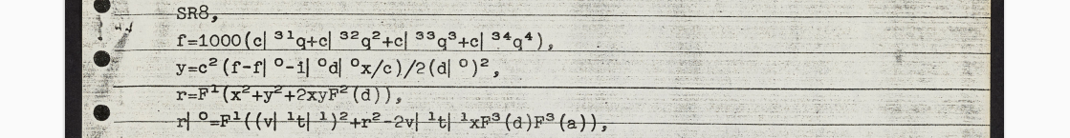
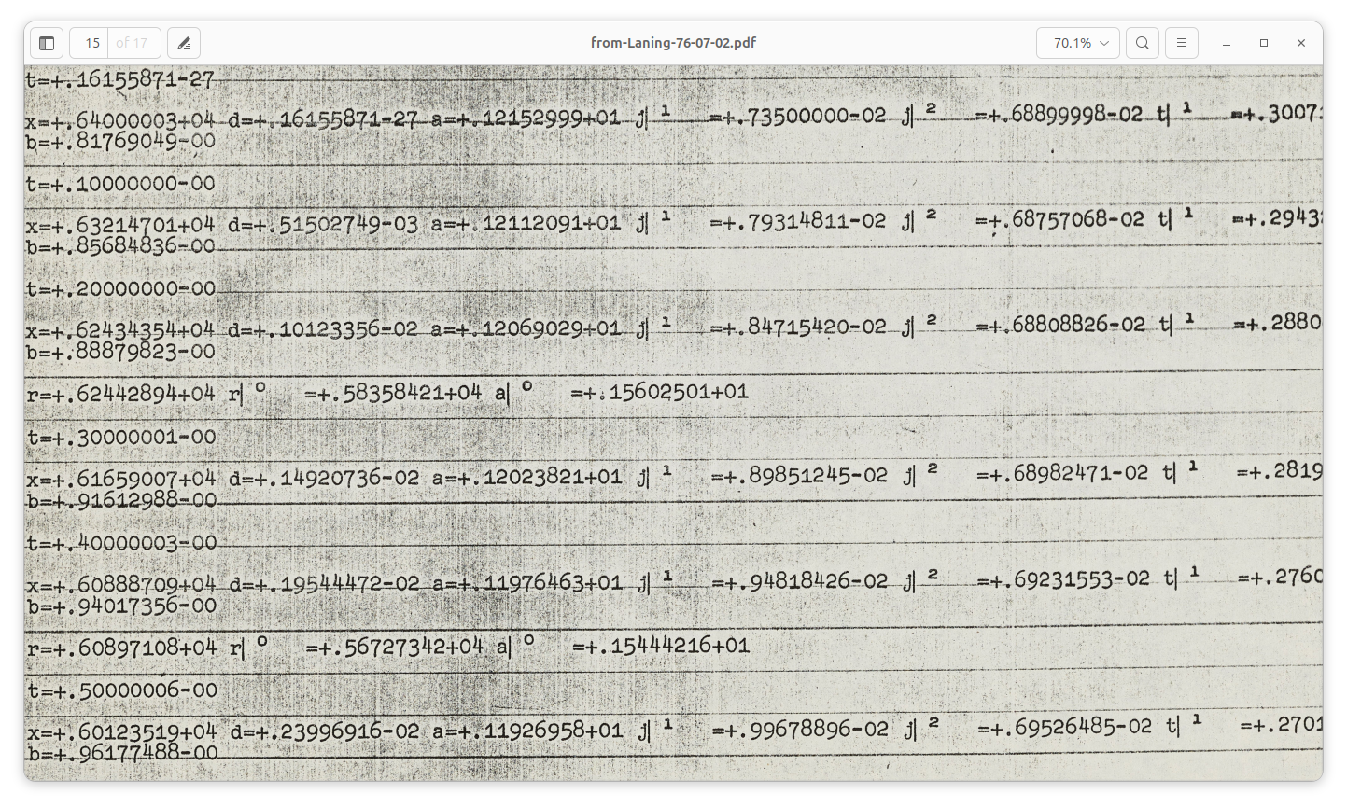Figure 11: Flexowriter printout of a partial LZ program and LZ run, from Laning's letter to Knuth. [2]

Floating point accuracy
This has been one of the more challenging areas of this project, and there may be lurking issues. One fundamental problem is that, in the original code, shifting of packed words was not being done correctly. Signed and unsigned numbers were being packed into the same word, then bit-manipulated via complementing pre- and post-shift. This showed up as errors in numbers with negative exponents. Code was added to correct this, but it’s an odd thing to have slipped by the library writers, so it is speculated that either the errors were likely corrected in later versions, or there is some machine behavior not being simulated properly.
Another accuracy and stability area still not completely resolved is floating point divide, and it is noted that none of the other multi-precision libraries support it. It’s also where ca 0 is used as −32767.

Conclusion
In developing LZ, Laning and Zierler effectively added layers of machine, each of which shares basic structure with the others. Starting with Whirlwind instructions, the floating point library implemented a machine very close to Whirlwind, with a different basic data type. In turn that was used to run code compiled from a language – which we’ve called LZ here – which is also structured much like Whirlwind.
The space constraints, and the urge – or need – to optimize every bit, mean that this development was very challenging. While the “impure” programming style is confusing to us now, it was seen in those days as the only way to make full use of memory, and was an architectural style that lasted some years.
LZ was a forerunner to Fortran, which is generally credited as the breakthrough high-level language. It was of course more widely used, as a flagship product of an already-large computer company, so it evolved rapidly, and quickly was supported on various computers and their peripherals. LZ, while interesting, was in some sense already somewhat isolated in that it was an academic project, with exotic I/O systems such as the Flexowriter. So it was hard to use outside that realm. Whether LZ influenced the design of Fortran seems to remain in debate; for instance see Backus’s comments that he thought his team was influenced by it, but then later said no never mind he wasn’t sure. [7]
An interesting note is that Fortran supported a capital-letters-only style from its inception and for many years thereafter, because IBM in those days stuck with the most fundamental character code and did not support lower case, much less superscripts. As time went on lower case was supported, and case-sensitive languages like C were developed, but superscripting, especially so easily typed as a shift, never made it into programming as such.
So the use of the Flexowriter was a significant influence on the LZ language, and that specific interactive style would never be seen again.

Acknowledgements
Thanks to Guy Fedorkow, for providing a base for this work, to Professor Donald Knuth for providing code analysis and historical archives, and to Dag Spicer for introducing us to the Professor.

References
- Laning, Jr., J. Halcombe; Zierler, Neal, A Program For Translation of Mathematical Equations for Whirlwind I, Instrumentation Laboratory, Massachusetts Institute of Technology. Engineering Memorandum E-364, January 1954, https://archive.computerhistory.org/resources/text/Fortran/102653982.05.01.acc.pdf.
- Laning, J.H, Letter to Donald Knuth, July, 2 1976, https://cs.stanford.edu/~knuth/from-Laning-76-07-02.pdf.
- Fedorkow, G., Whirlwind Simulator Documentation, https://github.com/gfedorkow/Whirlwind-Instruction-Simulator/blob/master/Documentation/Whirlwind-Development-Environment.pdf
- Laning et al, Program Listing (Hand-written coding sheet) [Knuth archives?]
- Knuth, D, Notes of Laning’s 1953 Whirlwind Program, August 12, 1976. [Knuth archives?]
- Subroutines.pdf
- See https://en.wikipedia.org/wiki/Laning_and_Zierler_system, which excerpts Backus, John Warner. The History of FORTRAN I, II and III. Proceedings First ACM SIGPLAN conference on History of programming languages. San Jose, California, USA. Archived from the original on 2005-08-27. (16 pages)

Whirlwind documentation uses the word “register” to refer to memory locations as well as components like accumulators.
The DEC PDP-8 is the last machine I recall clearly having to write using this impure-code style; this was in the mid-seventies. However later in the seventies I recall the Prime 100, 200, and 300 still required some degree of self-modifying code. See https://www.sysovl.info/pages/blobs/prime/programmercompanion/early_prime_instr_summary.pdf
In the Whirlwind documentation the terms digit or binary digit are used instead of bit.
The syntax for this is that used for superscripts, along with vertical bar (“|”). So x|² means x₂. See figure 11, an excerpt from a Flexowriter printout as shown in a letter to Knuth from Laning. [2] Unlike modern fonts, the vertical bar on the Flexowriter is at the far left of the character cell, thus making the superscript look detached. The reason is unknown for the large space between the superscripted number and the “=” sign.
Unlike modern systems, shifting in the Flexowriter is via special characters that establish the mode. Character codes for upper and lower case (e.g., “a” and “A”) are the same, and are only case-interpreted by the shift mode in effect.

