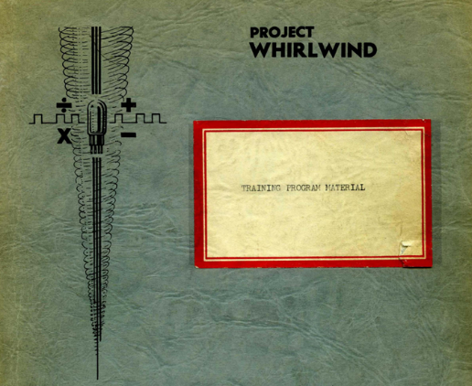
Whirlwind I/II
Program Notes

Gungsuh font
Version 1.0
Guy C. Fedorkow, Apr 2018

 Caution! Construction Site!
If you see errors or can offer corrections or content, please contact guy dot fedorkow at gmail dot com.

1. Introduction 3
1.1 Architecture 3
2. ToDo List 4
2.1 DCL Series 4
2.2 Paper Tapes 4
2.3 Other 5
2.4 Mag Tapes 5
2.5 Fun and Games in a Whirlwind 5
3. Recovered Programs 6
3.1 Bounce 6
3.2 Assemblers 10
3.2.1 FB2703sa 10
3.2.2 FB2037 10
3.2.3 Basic Converter T3600 10
3.2.4 Photo-Electric Converter – M-1232 10
3.3 Read-In Program 11
3.4 RLC 11
3.5 Quick Brown Fox 11
3.6 Blackjack 12
3.7 Jingle Bells 12
3.8 Number Display 12
3.9 Nim 13
3.9.1 NIM Source Format - 102766757_fc131-247-12 13
3.9.2 NIM Binary Format 15
3.10 Mad Game 16
3.11 Calendar 17
3.12 Wwchkr 19
3.13 Light Gun Checkout 19
3.14 Polynomial 20
3.15 FB126-52-271_1-28-56 21
3.16 Payroll Demonstration Routine 21
3.17 Vibrating String Demo 21
3.18 Route and Display / Track-While-Scan / D Israel 22
3.18.1 Parameters 23
3.18.2 Algorithms 24
3.19 Tracking Program 24
3.20 Laning and Zierler Algebraic Interpreter 24
3.20.1 Status, Nov 8, 2024 25
3.20.2 Status Dec 23, 2024 26
4. Magnetic Tapes 27
4.1 Tape 68 27
4.1.1 68_001_fbl00-0-50 – CRT Test 27
4.1.2 68_003_fbl00-0-71 – Toggle Switch Register Test 27
4.2 Tape 87 27

Introduction

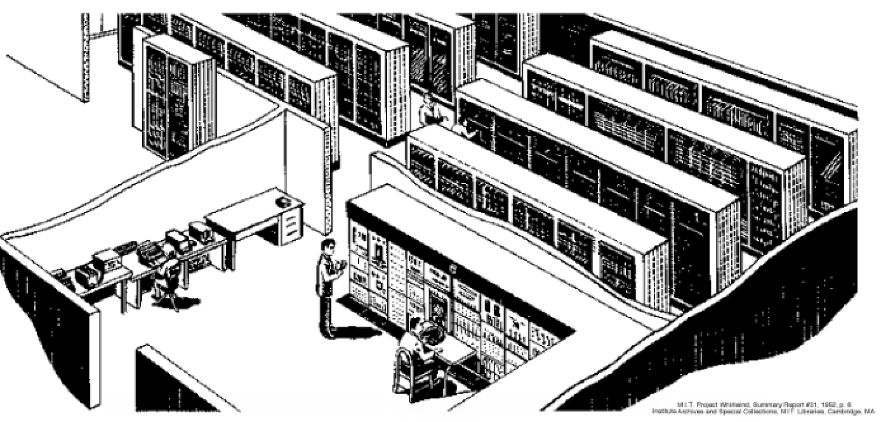

Architecture

Program Counter
PR (Instruction Register)
A Register
B Register
Accumulator
IOR Register
Memory
Single-bit shift path
16-bit load path
Figure 1: WW Programmer's View

ToDo List

DCL Series
DCL-031 gives the list of S&EC project numbers. (We ‘could’ scan the table, look up tape names to annotate the list of programs with possible projects.)
DCL-057 describes a Calendar demo program
DCL-105 lists Tic-Tac-Toe on tape fb-131-6. But I can’t find a copy
DCL-047_Payroll_Demonstration_Routine_Jan55.pdf -- Demonstration program for Payroll, written by B Riskin, Jan 13, 1955. We may have the tape, fb-131-208-8, hash e725ad-7fbefa
DCL-058_Programs_for_Solving_Secular_Equations.pdf -- Secular Equations? Who knew? They’re used for In molecular orbital calculations https://en.wikipedia.org/wiki/Characteristic_polynomial#Secular_equation.
The description by F. J. Corbato is very mathematical. Mentions Tape fb 10172-20-B

Paper Tapes
The following tapes have a photo of either the box with a couple instructions, or a note that was inserted into the box.
2018_12/102782308_2658-m14_ad_and_bd_ck9-1-54_.7ch | 179a66-096cf4 | Binary

2018_12/102782309_1251m1106576_tracking_pgm.7ch | 5f7944-8820ce | Binary | fb1251m1106576 | fbl25lmll06576

2018_09/102781919_fc_convert_tabs.7ch | 5960a2-54be03 | CS-Source
2018_06/102766842_ff_read_in_program.7ch | 1dadf9-757e02 | Binary
2018_06/102766848_fb_t-3432m302_cm_ck.7ch | ac1b1c-762a25 | Binary
2018_06/102766859_fb2251m0_kybd_input_check.7ch | 351e89-b99f54 | Binary | fb2259 | FB2259M0

Other
http://www.bitsavers.org/pdf/mit/whirlwind/history/Doug_Ross_from_History_of_Personal_Workstations_19860109.pdf
- Personal history of Doug Ross, some of which covers Whirlwind.
  - See https://en.wikipedia.org/wiki/Douglas_T._Ross
Pg 70 references Ross’s Scope Input Program, which he cites as Tape fc-126-50-505, as a WW program that would track a moving object on the oscilloscope screen. We do have an fc-126-50-1010 by DT Ross. No idea what it does, or if it’s related.

Mag Tapes

Len's mag tape recovery
https://github.com/LenShustek/readtape

Fun and Games in a Whirlwind

Games
Blackjack | Authentic tape, but no document
Nim | Dated and documented
Mad Game | Authentic tape | No clue what this was for…
Bounce with manual control | Modified tape | We’d have to add the knob adjustment
TicTacToe | Modern WW code

Demos
Calendar Demo | Dated and documented
Vibrating String | Dated and documented
Big Numbers | Authentic tape, but no document
R-196 Bounce | Transcribed code
Jingle Bells | Authentic tape, but no document | This code appeared in Murrow’s “See It Now” clip.
Vector Clock | Modern WW code

Links
https://videogamehistorian.wordpress.com/2014/01/22/the-priesthood-at-play-computer-games-in-the-1950s/
https://en.wikipedia.org/wiki/OXO_(video_game)

Recovered Programs

Bounce

From Reel_08/M_2308_19530713.pdf
131. Special Problems (Staff training, demonstrations, etc): Combelic, 5.5 hours;
Frankovich, 2.5 hours; Kopley, 6 hours; Siegel, 24 hours; Vanderburgh, 2 hours;
WWI 64 minutes
All four demonstration tapes have been tested with the new scope decoders,
and are working properly. They are: Bouncing Ball Tape #2690; Polynomial Tape #2691;
Number Display, Tape #2692; RLC Display, Tape #2693.
Vanderburgh

That lead to two tapes
102663328_fb131-0-2690_new_decoders_3of4.7ch
102663328_fb131-0-2693_rlc_1of4.7ch

"new decoders" is a version of the bounce program with a hole in the baseplate, and well-regulated bounce characteristics.

-------- Forwarded Message --------
Subject: | The Bounce Report, Issue #4,582
Date: | Sun, 9 Aug 2020 15:32:03 -0400
From: | Guy Fedorkow <fedorkow@mit.edu>
To: | Deborah Douglas <ddouglas@mit.edu>
CC: | David Nunez <dnunez@mit.edu>, David C. Brock <dbrock@computerhistory.org>, Al Kossow <kossow@computerhistory.org>
Greetings Colleagues,
I've made a bit more progress with The Bounce Tape, intuitively named "102663328_fb131-0-2690_new_decoders_3of4", after what I assume someone scribbled on the paper tape leader.
This one does draw a hole in the floor, and unlike the example from the training manual, it actually bounces properly.
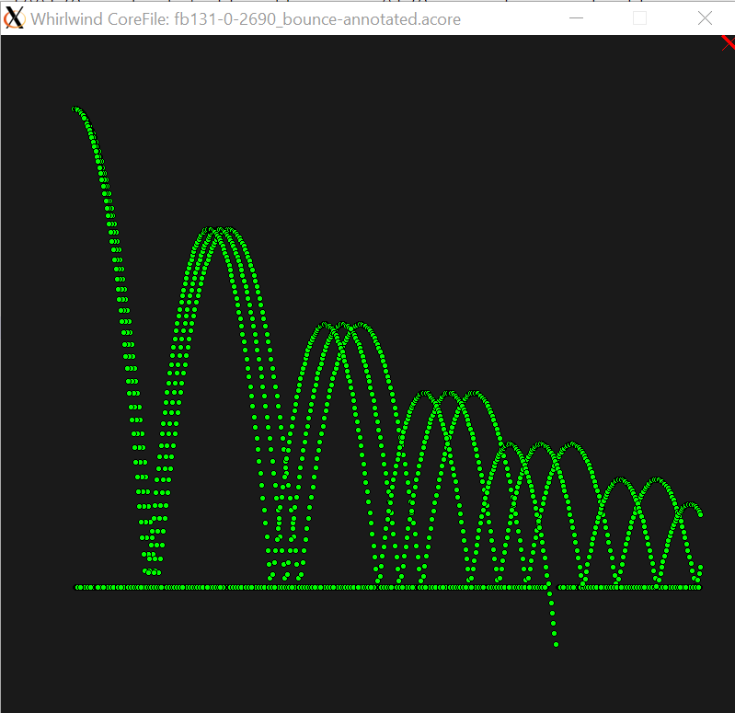
I can see no sign yet that this version had any "user input" to make it a game, but there's enough to guess what the user input would have done.
But this version "runs on automatic". The first pass, the ball misses the hole by a large margin, but with each succeeding pass, they slow the horizontal velocity a teeny bit. So the bounces come closer together, and after a few passes, the ball falls through the floor.
I don't think anything unusual happens, it just tosses the ball out again, each time a bit slower. There is code that might terminate the program, but I don't see the conditions that would cause that yet.
We've all seen what I think was Jack Gilmore's comment that the 'game' was played by 'turning a knob'. Presumably the alleged knob would directly adjust the initial horizontal velocity for each pass; the skill in the game would be to guess how much to turn the knob to get the ball through the hole without too many tries, where it takes a couple seconds for each bounce to play out.
One catch with this theory is that I have not seen a digital "knob" input, i.e., something you can turn that the programmer can access. But there are lots of ways to do this, and they must have tried some of them during aircraft simulation days, when pilots would have wanted to operate 'analog' controls.
This brings us to an existential question about software artifacts :-)
- we have the example from the manual, but we can't use it *exactly*, because it doesn't work. We could fix the bugs. The virtue of this code is that a dedicated nerd could see the structure of the code, and roughly how it works, from looking at the 30 instructions plus the Python translation. But even that requires a Dedicated Nerd, not a casual one. The obvious flaw is that the exemplar was broken from Day One, so we'd be showing something similar to the artifact, but not the thing itself.
- We can run the tape image as-is. It will draw successive scans on the display, sometimes falling through the hole, usually not. It can't slow the horizontal velocity forever, so I don't know yet whether it resets and keeps going, or terminates, but either way seems fine; we'd just make it start again if it terminates. (after referring to Turing, Dr. Alan, "The Halting Problem")
- We could tweak the artifact to add the knob. Maybe we can find more clues to make this less of a guess. The advantage is that it would make it interactive, in a way that's pretty intuitive, and not (IMHO) too nerdy.
I've done this work using a new tool, which draws what you might think of as a flow chart, reverse-engineered from the code. By watching the simulation, it figures out which instructions go where, who calls what, and how often. It then makes that into a picture so you can see how the code flows. Each bubble represents an atomic strip of code, i.e. the bubble might represent many instructions, but you know if it starts executing the first instruction of the bubble, it's sure to finish the last, although from there, it could go any number of places (e.g. if-then-else and all). I can annotate the program with labels as I figure out what each strip does, and gradually the flow chart starts to make sense.
This tool needs much more work, but it's already proven quite valuable for figuring out how this bounce tape works. (Sheesh, it's only 160 instructions, how hard can that be??)
I've attached a sample flow graph.
I've also enclosed the "source code" written in my Whirlwind assembler language, more or less as the authors would have written it. Except I've added labels and comments to keep track. They probably drew flow charts and tossed them in the trash, but we've seen very few clues on that yet. So all the English words are mine, but the instructions in memory are exactly from the artifact.
As Debbie said once, decoding this is sort of like the New York Times Sunday crossword puzzle. You start with a hundred confusing clues, and get nowhere until reading clues the third time through you find the one that's "obvious", fill that in, yielding the first letter for the next clue, and so on (yeah, right, until you have four clues left and *not one* of them makes any sense!)
Debbie, let me know if you want to talk over what you'd like to do with this thing...
/guy
; Bounce paper tape
; Annotated by guy
; Jul 22, 2020
.WW_File 102663328_fb131-0-2690_new_decoders_3of4.7ch/102663328_fb131-0-2690_new_decoders_3of4_gs001_.tcore
.WW_TapeID (None)
.org 0
r0000: .word 0
r0001: .word 1
i0002: .word 0
.org 32
i0032: .word 0
.ORG 00040
@0040:100172 i0040: ca r0172 ; #114630 @@ JumpedToBy: a0163 a0215
@0041:040212 ts xpos ; transfer to storage
; This series of blocks draws the x-axis
; It appears that the program draws a dot every second pixel on the screen, i.e., they convert the pixel x address to
; an iteration count by SRR 1, i.e., divide by two. So some constants are in screen pixels, some in interator counts.
@0042:100212 x_axis_point: ca xpos ; xpos is current x position @@ JumpedToBy: a0061
@0043:110174 ad ball_x_velocity ; add; ball_x_velocity is initialized to 0o200 -- two pixels after dropping least-significant six bits
@0044:040223 i0044: ts dot_xpos ; store the sum to dot_xpos @@ JumpedToBy: a0055
@0045:040212 ts xpos ; store the same sum to xpos
@0046:160001 r0046: srr 00001 ; shift right; on the first time through, this results in one pixel unit in AC @@ ReadBy: i0157
@0047:074050 w0047: sp before_the_hole ; this jump switches between before_the_hole and past_the_hole @@ WrittenBy: a0053 a0162
; This path is taken drawing the x-axis prior to the hole in the floor, but not after
@0050:114203 before_the_hole: su left_hole_edge ; this is the location of left edge of the hole in the floor, at 017400 @@ JumpedToBy: w0047 r0207
@0051:070056 cp i0056 ; branch if negative, i.e., x-axis up to the hole in the floor
[…etc…]

Assemblers

FB2703sa
102766905_2037_basic_conversion_start_at_2037.7ch
102766905_2037_basic_conversion_start_at_2037_gs001.tcore
102766905_2037_basic_conversion_start_at_2037_gs002_nwwin.tcore
102766905_2037_basic_conversion_start_at_2037_gs003.tcore
converter_merged.tcore
converter_merged.ww

[Jan 10, 2024] I got this one to merge, and start, but it promptly fails with unknown I/O addresses

[Sep 9, 2026]
Here’s the trace; none of it makes sense
Info: SI: PhotoElectricTapeReader A initialized in Char mode
pc:0o2037: SI 0o0200 AC=0o000000, BR=0o0, Core@0o0200= None ; select I/O: Mechanical Paper Tape Reader
Info: RD: PhotoElectricTapeReader A read character 0o25 (ascii '1')
pc:0o2040: RD 0o0002 AC=0o000025, BR=0o0, Core@0o0002=0o000000 ; RD: PhotoElectricTapeReader: 0o25 ('1')
pc:0o2041: CA 0o0015 AC=0o130024(-0o47753), BR=0o0, Core@0o0015=0o130024(-0o47753) ;
Reading Uninitialized Memory at location 0o407, bank 0
Info: RD: PhotoElectricTapeReader A read character 0o10 (ascii ' ')
pc:0o2042: RD 0o0407 AC=0o000010, BR=0o0, Core@0o0407= None ; RD: PhotoElectricTapeReader: 0o10 (' ')
SI: unknown IO address 0o45: si 0o45 (octal 45 / decimal 37) is not in 2M-0277 Table 5 -- no matching I/O device/mode found.
pc:0o2043: SI 0o0045 AC=0o000010, BR=0o0, Core@0o0045= None ; select I/O: unknown i/o device
Alarm 'Unknown I/O Device' (4) at PC=0o2043 (0d1059)
Total cycles = 4, last PC=0o2044, wall_clock_time=0 sec, avg time per cycle = 0.0 usec, ww_time = 112.0 usec

FB2037
102766896_fb2037_basic_conversion.7ch
102766896_fb2037_basic_conversion_gs001_.petrA
102766896_fb2037_basic_conversion_gs002_.tcore
102766896_fb2037_basic_conversion_gs003_NWWIN.tcore
102766896_fb2037_basic_conversion_gs004_.tcore

[Aug 28, 2026]

hi Juan, Larry,
I took a quick try at getting what I think is one the assemblers, "Basic Converter" to operate. Definitely just a start... it does run, but appears to fail in several different dimensions.
The least expected is that it fails if the second character on the input tape (that is, the program to be assembled) is not '|'... no idea why, but that's easy to work around.
The second failure is when it hits a CF bank switch instruction, apparently to address 13 of bank 3. No surprise, there's nothing in the bank.
We've never successfully traced through a CF instruction, and it seems that as a side effect, this makes my trace utility go a bit crazy. I'll stare at that some more, but in the meantime, I overwrote the CF with a halt.
The third failure seems to be that it does this CF call in the middle of reading what ought to be the tape name specifier. I assume this means that I don't have the right input format yet.
The extracted flow chart is quite complex; it runs some 200+ instructions before halting, so it's doing _something_, but I don't know what...
Along the way, I modified the trace mechanism to decode I/O operations as they happen; it's easy to see that RC and RD and write and read, but it's not so easy to tell from a bare execution trace what they do...
I'm in California this week, but maybe push on this a bit more next week.
All this stuff is checked into guy-dev. GitHub/Code-Samples/Basic-Conversion has the images, my proto-cs source file, and a Makefile.
/guy

Basic Converter T3600
102782043_3600m0_basic_conversion_5-13-54_copy.7ch
102782043_3600m0_basic_conversion_5-13-54_copy_gs001.tcore
102782043_3600m0_basic_conversion_5-13-54_copy_gs002_NWWIN.tcore
102782043_3600m0_basic_conversion_5-13-54_copy_gs003.tcore

Status: As of Jan 4, 2024, this executable traps on unknown I/O devices. [That, we can fix!]
$ wwsim *gs001* --NoAl
Info: Automatically return 0 and 1 from locations 0 and 1
Info: core file 102782043_3600m0_basic_conversion_5-13-54_copy_gs001.tcore
Info: Whirlwind tape file name: 102782043_3600m0_basic_conversion_5-13-54_copy.7ch/102782043_3600m0_basic_conversion_5-13-54_copy_gs001.tcore
Info: corefile JumpTo address = 02037o
Info: starting corefile blocknum 00o
Switch CheckAlarmSpecial=0
start at 0o2037
SI: unknown IO address 0o200
Alarm 'Unknown I/O Device' (4) at PC=0o2037 (0d1055)

Photo-Electric Converter – M-1232
I don’t think we have a tape for this, but we did transcribe the source given in this document, along with a (very) brief description.
The doc is dated Jun 22, 1951, and uses what looks like a variant of the 1951 instruction set.

Status: Jan 4, 2024 – I can’t assemble it – my 1951 instruction set includes most of the unusual instructions, but there are a few more that I haven’t seen before.

Read-In Program
Hash: 1dadf9-757e02
Status: started July 31, 2019
Artifact 102768842
This short tape appears to be a paper-tape read-in program.
It’s built to load at location 0o3735
Al Kossow included a photo of a scrap of cardboard with the tape number T3264-3 and the contents of the FF registers – which seem to be parameters, not variables.

RLC
102663328_fb131-0-2693_rlc_1of4.7ch
Not sure what it's for, but it displays a sine curve and a step function

Quick Brown Fox
------- Forwarded Message --------
Subject: | CHARM
Date: | Sun, 15 Dec 2019 19:15:52 +0000
From: | Al Kossow <kossow@computerhistory.org>
To: | Len Shustek <len@shustek.com>, Guy Fedorkow <fedorkow@mit.edu>
This would explain what the teletype was for
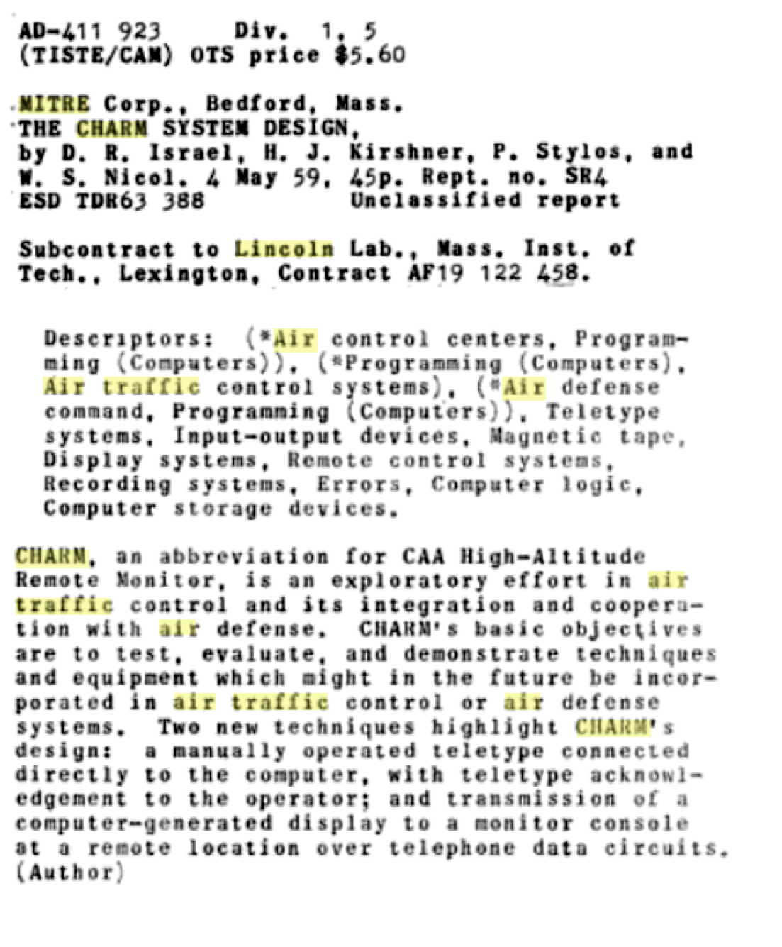

Blackjack
Status: it works, with some quirks and bugs
(See blog)
Note for followup – the code uses the Character Generator in the graphics unit… when was that added? That might help date the program…

Jingle Bells
Status: it works, well enough to convert the output to an MP3
(see blog)

Number Display
Tape 102766750_fb131-0-2692_number_display.7ch
This code displays a number coded in binary, octal, decimal and (sort-of) hex, incrementing every couple of seconds.
The code seems to be described in the Summary Report #23, Second Quarter 1950, Section 6.2 pg 25.

The hex display uses 0-9, but not A-F. [Write down the letter sequence and compare it to the QWERTY keyboard!]
Note from LGP-30 wiki page https://en.wikipedia.org/wiki/LGP-30
Unlike other computers of its day, internal data was represented in hexadecimal instead of octal, but being a very inexpensive machine it used the physical typewriter keys that correspond to positions 10 to 15 in the type basket for the six non-decimal characters (as opposed to the now normal A – F) to represent those values, resulting in 0 – 9 f g j k q w, which was remembered using the phrase "Fiber Glass Javelins Kill Quite Well".

Nim
There are three tapes in the paper-tape collection alleged to be Nim
- 102766757_fb131-247-12_12-4
- 102766757_fb131-247-12
- 102766757_fc131-247-12 - CSii Source format

The instructions are given in a two-page doc:
Static-Document-Files/Bitsavers-Docs/whirlwind/DCL-series/DCL-113-Generalized-Nim-Playing-Routine-Dec55.pdf

To: Scientific and Engineering Computations Group
From: A. Zabludowsky
Date: December 5, 1955
Subject: GENERALIZED NIM PLAYING ROUTINE
The program uses LMIR, RMIR, FF2 and FF3 for input, and CRT and printer(flexo?) for output.

NIM Source Format - 102766757_fc131-247-12

[Jan 12, 2024] This FC file was converted to .ww format with a few bugs along the way.
The file contains a few instances of the ambiguous number “0.5”, i.e., not +/-0.nnn decimal or 0.50000 octal.
There’s a jump to a missing label “p1”. [which seems to have fixed itself along the way??]
The resulting image runs, and produces a display with large seven segment numbers, running continuously changing the display. Not good.

[Jan 24, 2024]
I corrected the assembler to start loading the assembled code at 0o40 instead of 0, and along with a couple of minor bugs, that got the opening screen of Nim to work.
To play the game, I’ll need interactive Manual Intervention Registers, plus FF Registers 2 & 3.
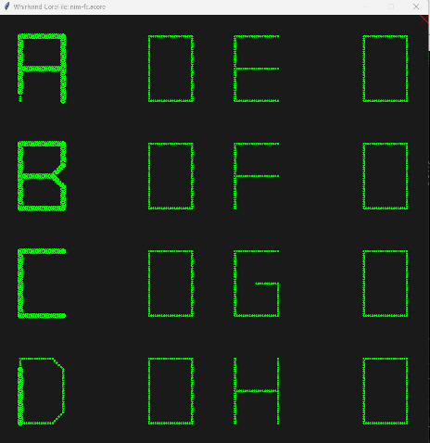

[Feb 15, 2024]
Ok, so I now have a rudimentary Buttons and Lights panel.

The game kinda works.
Setup instructions are a bit complicated. With each step, numbers are set in LMIR, RMIR, FF2 and FF3, then the program is instructed to read them with a press of the Upper (left) Activation Register.
It appears that numbers are all input as Octal Decimal, i.e One is 0o00, Nine is 0o11, Ten is 0o0100.
- Configure the rule for withdrawing tokens. You can take no more than N tokens from M groups in each move.
  - Set N Tokens to remove in FF2. Must be less than or equal to 99
  - Set M groups to remove in FF3. Must be less than or equal to 7
The program has no defaults, but a “conventional” setting would be FF2=7, FF3=1, i.e. remove as many as seven items from one pile.
If you ask to remove from more than one pile, it might be necessary to remove something, perhaps zero, from the designated number of piles.
- From there, the eight bins must be “filled”. They all start with zero tokens, but all eight must be specified (even to keep them at zero, i.e., unused).
  - Enter the number of tokens for the first bin in the RMIR. Press Left Activate. The screen should show the number of tokens in that bin on the next refresh.
  - Enter the number of tokens for the next bin in the RMIR. Press Left Activate
  - Repeat until all eight have been “filled”. It’s “confusing” to set zero in a bin, because the display starts with zero and doesn’t change the contents visibly, so you have to carefully count up through the eight bins.
A more reliable strategy is to set ‘unused’ bins to One, so you can tell when you’re done.
- Once the bins have been filled, the next action is a user move
  - Set the number of the group from which you want to remove tokens in the LMIR. Set the number of tokens to remove in the RMIR. Press Left Activate.
At this point, You’d Think that the machine would make a move, and take some tokens. Haven’t seen that yet. It usually crashes with a Jump to Zero (but I don’t know yet from where it jumps…)

The game will produce a few messages on the Flexowriter, printed on the simulator console (along with all the other messages – useful only with the “-q” cmd line flag. So far, all I’ve seen is “Illegal Move”

To make this game usable as a demo, I could:
- Script the setup with a project_exec attached to the check to the Activate Register [Done]
- Move the Flexo Output to a scroll area of the Panel object.

Mar 22, 2024
It appears that the FC version is “the first half” of the game, that does all the setup, but doesn’t play.
For that, go to the FB Version.

NIM Binary Format
Mar 22, 2024
I think the two binary tapes are the same thing.
One of the .ch files extracts to one .tcore file
The second, “10*12-4” extracts into two tcore files, one of which is identical to the first .tcore, but also has a second patch file which merge with a handful of overwrites, i.e. sure look like they belong together.
The binary .tcore files present on both fb tapes corresponds approximately to the compiled version of the FC tape. Presumably the FC tape had a companion tape to bring in the second half of the program, but I don’t know where that is.

The FB “10*12-4” version does run, and appears to play the game, sort of. It usually executes the user input to remove objects from groups, and sometimes responds by removing some itself.
I did automate the setup; upon start, it sets the FF regs and the Intervention Registers to place a number of tokens in some of the buckets, and from there switches to normal User-Play, triggered by LMIR/RMIR and Activate.

Nim Binary Recovery History Notes
For some reason, I had the Drum Offset param set to 0o40, causing everything to load off-by-0o40. Clearly not a good start. Here are now-obsolete notes.
Both files start at 0o705, run a handful of instructions and promptly trap doing an I/O Read without a preceding SI, i.e., reading from an unspecified device, followed by a Halt (i.e., a zero word). Trying 705 as Decimal, i.e., 0o1301, is worse, starting immediately at a Halt (zero) opcode. Not sure how it’s supposed to start, but that can’t be legit.
start at 0o705
pc:0o0705: TS 0o0332 AC=0o000000, BR=0o0, Core@0o0332=0o000000 ; Transfer to Storage
pc:0o0706: TS 0o0333 AC=0o000000, BR=0o0, Core@0o0333=0o000000 ; Transfer to Storage
pc:0o0707: TS 0o0334 AC=0o000000, BR=0o0, Core@0o0334=0o000000 ; Transfer to Storage
pc:0o0710: TS 0o0335 AC=0o000000, BR=0o0, Core@0o0335=0o000000 ; Transfer to Storage
pc:0o0711: TS 0o0336 AC=0o000000, BR=0o0, Core@0o0336=0o000000 ; Transfer to Storage
branch forwards from pc=0o0712 to 0o1240
pc:0o0712: SP 0o1240 AC=0o000000, Core@0o1240=0o157777(-0o20000) ; Subprogram
pc:0o1240: SL 0o3777 AC=0o000000, BR=0o0, Core@0o3777= None ; Shift Left Hold/Roundoff
Warning: RD to unknown I/O device None
pc:0o1241: RD 0o0631 AC=0o000000, BR=0o0, Core@0o0631=0o114000(-0o63777) ; Read
Alarm 'Unknown I/O Device' (4) at PC=0o1241 (0d673)
Halt Instruction! (Code=0) at pc=01242
pc:0o1242: SI 0o0000 AC=0o000000, BR=0o0, Core@0o0000=0o000000 ; Select Input
Alarm 'Program Halt' (5) at PC=0o1242 (0d674)
Ran 8 cycles; Used mem=45MB

Nim in the WW Documents

Search File Names for nim :
Search MITRE File Contents for nim :
Static-Document-Files/MITRE-scanned-docs/Reel_08/TXT/M_2209_19530601.sptxt: The problem of mechanizing the playing of the game of Nim using WWI was deemed

Static-Document-Files/MITRE-scanned-docs/Reel_20/TXT/Summary_Report_No._30,_Second_Quarter_1952.sptxt:

The Application of a Large-Scale digital Computer to the Game of Nim The problem of mechanizing the playing of the game of Nim using WWI was deemed interesting and has been programmed for the case of six piles containing six units each. With the present program, the human player has the first move – the machine wins only if the human player makes a mistake. A check register alarm signifies the end of the game. It was hoped that a scope display of r e s u l t s would be ready, but due to unexpected delays, this was not completed.

Static-Document-Files/MITRE-scanned-docs/Reel_21/TXT/Summary_Report_No._44,_September_-_December_1955.sptxt: Generalized NIM Playing Routine
131. STAFF TRAINING, DEMONSTRATIONS, ETC.
Generalized NIM Playing Routine
Generalized NIM is a game in which a number of groups are available, in this routine eight marked A to H. Each group is composed of a number of pieces (Ni). The game consists of each player (computer vs. human) in turn removing not more than n pieces from any one group and this from not more than m groups. The winner is the one who removes the last piece.
The game is displayed on the scope showing decimally the number of pieces in each group at the time of display.
n and Ni (the initial number of pieces in each group) can be varied from 0 to 99 and m can be varied in the range 1 - 8 at the beginning of each game. Direct typewriter types the human win, machine win or wrong move message.
.
This routine is explained more fully In Digital Computer Laboratory Memorandum DCL-113
A. Zabludowsky
Digital Computer Laboratory

Static-Document-Files/MITRE-scanned-docs/Reel_22/TXT/Summary_Report_No._34,_Second_Quarter_1953.sptxt:from "The Solution of Simultaneous Linear Equations with the Aid of the 602 Calculate- The problem of mechanizing the playing of the game of Nim using WWI was

Search Bitsavers File Contents for nim :
Static-Document-Files/Bitsavers-Docs/whirlwind/DCL-series/TXT/DCL-015-3_List_of_Programs_Mar57.sptxt: NIM D. Sternlight:t, 10ao1eo53 '

Mad Game
Status: Jul 10, 2019 – it works, darned if I know what it’s for.

-------- Forwarded Message --------
Subject: | Mad Game emulation
Date: | Wed, 10 Jul 2019 16:37:43 -0400
From: | Guy Fedorkow <fedorkow@mit.edu>
To: | Deborah Douglas <ddouglas@mit.edu>, David C. Brock <dbrock@computerhistory.org>, David Nunez <dnunez@mit.edu>, Al Kossow <kossow@computerhistory.org>, Dag Spicer <spicer@computerhistory.org>
CC: | Ariel Weinberg <asweinbe@mit.edu>
Greetings Colleagues,
It is my great pleasure to announce the recovery of yet another scrap of Whirlwind software that does *something*, but darned if I know what it's for...
I took up work on the Whirlwind tape that had "Mad Game" written on its leader. As far as I can tell, the program executes perfectly, but as is often the case, it's not at all obvious why they went to the trouble.
The program required a rewrite of the graphics driver in my emulator, but that was due anyway. I'd taken advantage of a shortcut to get Blackjack to work; the new driver is closer to a real emulation of the phosphor display. Odd as it may seem, emulation of the way images on a phosphor screen just fade away isn't easy in modern graphics systems.
The Mad Game program puts up 7+5+3+1=16 dots and short vectors in a triangle pattern, with one more dot in the center labeled "RESET". Clicking any of the 16 dots simply makes it turn off. There's a column of hot-spots down the right side; clicking one of those makes the whole row disappear. Reset puts them all back.
It's possible that the dots (which you can hit with a LightGun) and the short vectors (which will not trigger the light gun) would be displayed on different screens. That's something I hadn't expected in the emulator, and the manual doesn't completely make sense (yet) in describing the rules for multiple displays.
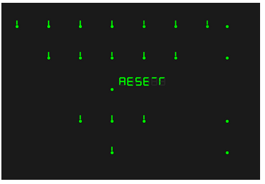
The program logic doesn't seem complicated, and that makes it puzzling. All it seems to do is turn off the dots and associated vectors when hit with the light gun. There really doesn't seem to be a block of code in there just waiting to print "You Win!!!" :-)
If indeed it was played on two (or three) screens, I suppose it might have been a component in some larger game or exercise, i.e., the guy with the light gun follows some rule to decide which spot to turn off, and the person watching the short vectors would have to do something in response.
I'm a bit surprised at the way the program was written -- it uses a lot of code for what appears to be a very simple function. I guess the Optimize-into-Obscurity disease that infected many Whirlwind programmers wasn't universal.
If anyone recognizes this as a game-board layout for some kind of game, please speak up and let me know!
Thanks
/guy

Calendar
The Calendar demo program is described in DCL-57, Mar 2 1955

[Apr 20, 2020]: The tape has a program segment followed by what must be a data segment read from PETRA (or is that PETRB??)

The tape seems to have four segments:
- an initial executable loads a data segment into the drum
- The next section of the tape seems to contain date parameters; many of them in flexo code, but with some kind of structure
- The last two are executables.

The code runs in a tight loop reading the data segment, overwriting everything, eventually including itself.
No obvious exit from the loop…

[Apr 23, 2020]
Al sent two copies of the program,
- 102663436_fb131-98-1_calendar_2-7-55_cantread.7ch and
- 102663458_fb131-98-1_2-18-55_copy.7ch

The first executable of "Copy" seems to be full of single-bit errors, and it reports bad checksums on blocks. But it does seem to contain all four objects.
The code for the first executable runs in a tight loop reading the data segment, overwriting everything, eventually including itself. It seems clear there's a bit error in the exit test from the loop.
Another bit error difference between the tapes seems to switch the input device between PETRA and PETRB. The Copy version, which won't run, reads from PETRA (probably incorrectly).
The two executables at the end of Copy seem to have (mostly) good checksums.

Can't-Read seems to have good checksums, but there must be something else wrong with it… the tape appears to end abruptly part way through the section of calendar data, at voffset = 782(d) on the tape. Data at the same location of the Copy tape goes on to at least voffset = 1180
The data segments don't line up byte-for-byte… the short string segment at location voffset=782 is off by two bytes.
The drum loader on the Can't-Read tape (the first executable) does run to termination, after reading 939 bytes from PETRB

Neither tape will "run" as-is. Current experiments are to take the loader from Can't-Read and combine that with the data segment from Copy.

The first byte of the PETRA tape corresponds to Copy voffset=182(d), which puts the last byte at 182+939= 1121(d)

Debug 7ch: voffset=01119(d) hex_from_tape=40 (Valid=1) octal_result=0, flexo-to-ascii '\0'
Debug 7ch: voffset=01120(d) hex_from_tape=65 (Valid=1) octal_result=51, flexo-to-ascii '\n'
Debug 7ch: voffset=01121(d) hex_from_tape=0 (Valid=0) octal_result=0, flexo-to-ascii '\0'
[lots of nulls]
Debug 7ch: voffset=01121(d) hex_from_tape=0 (Valid=0) octal_result=0, flexo-to-ascii '\0'
Debug 7ch: voffset=01121(d) hex_from_tape=7f (Valid=1) octal_result=77, flexo-to-ascii '\077'
Debug 7ch: voffset=01122(d) hex_from_tape=7f (Valid=1) octal_result=77, flexo-to-ascii '\077'
Debug 7ch: voffset=01123(d) hex_from_tape=7f (Valid=1) octal_result=77, flexo-to-ascii '\077'
Debug 7ch: voffset=01124(d) hex_from_tape=7f (Valid=1) octal_result=77, flexo-to-ascii '\077'
Debug 7ch: voffset=01125(d) hex_from_tape=7f (Valid=1) octal_result=77, flexo-to-ascii '\077'
Debug 7ch: voffset=01126(d) hex_from_tape=7f (Valid=1) octal_result=77, flexo-to-ascii '\077'
Debug 7ch: voffset=01127(d) hex_from_tape=0 (Valid=0) octal_result=0, flexo-to-ascii '\0'
[a few more nulls]
Debug 7ch: voffset=01127(d) hex_from_tape=0 (Valid=0) octal_result=0, flexo-to-ascii '\0'
[the following looks like the start of a 556 block]
Debug 7ch: voffset=01127(d) hex_from_tape=5f (Valid=1) octal_result=76, flexo-to-ascii '0'
Debug 7ch: voffset=01128(d) hex_from_tape=5f (Valid=1) octal_result=76, flexo-to-ascii '0'
Debug 7ch: voffset=01129(d) hex_from_tape=41 (Valid=1) octal_result=40, flexo-to-ascii 't'
Debug 7ch: voffset=01130(d) hex_from_tape=40 (Valid=1) octal_result=0, flexo-to-ascii '\0'
Debug 7ch: voffset=01131(d) hex_from_tape=40 (Valid=1) octal_result=0, flexo-to-ascii '\0'
Debug 7ch: voffset=01132(d) hex_from_tape=41 (Valid=1) octal_result=40, flexo-to-ascii 't'
Debug 7ch: voffset=01133(d) hex_from_tape=41 (Valid=1) octal_result=40, flexo-to-ascii 't'

Wwchkr
[Jan 29, 2022]
There’s a tape of alleged diagnostics, 102782346_1227p50_ww_checker.7ch…
It contains several files.
The first of which exercises the CF instruction.
I’ve added numerous comments to a source file, but it’s odd as (modern) diagnostics go… it certainly is meant to exercise the bank selection logic, but it doesn’t actually verify anything… it just steps through each bank and writes a couple of words, then puts the original values back.
The program also seems to end by jumping off a cliff, i.e., doing a bank switch where the next instruction is undefined.
This code is the one instance I’ve found (as of Jan 2022) that prints a clear message for the operator on the Flexowriter (instructions to set some switches and restart).

[and I haven’t tried to figure out the rest…]

Light Gun Checkout
Status: partly running,
July 17, 2019
Yet another “what the heck does this do??”
This program manipulates the Buffer Disk. It reads 0o377 bytes from a track, switches A & B fields, then reads another 0377. It tests the status of three toggle switches in the Intervention Registers, and ends up writing blocks back to the drum.
The program doesn’t appear to touch the Light Gun or the CRT display.
I’m wondering if it sets up some data-set on the drum for a subsequent exercise
It would be hard to be sure of what it does, since the program assumes there’s something already on the drum.
As of Jul 7, it runs in a loop until it overflows an address increment instruction, changing the op-code, causing a trap because it’s the wrong instruction. There must be some loop termination test that I can’t see…

Polynomial
Shows “F400” in dot-matrix points on the display, then traps on an arithmetic alarm (ok, that was before I fixed multiply/divide…)

Here's a more-recent (May 21, 2020) display from the program
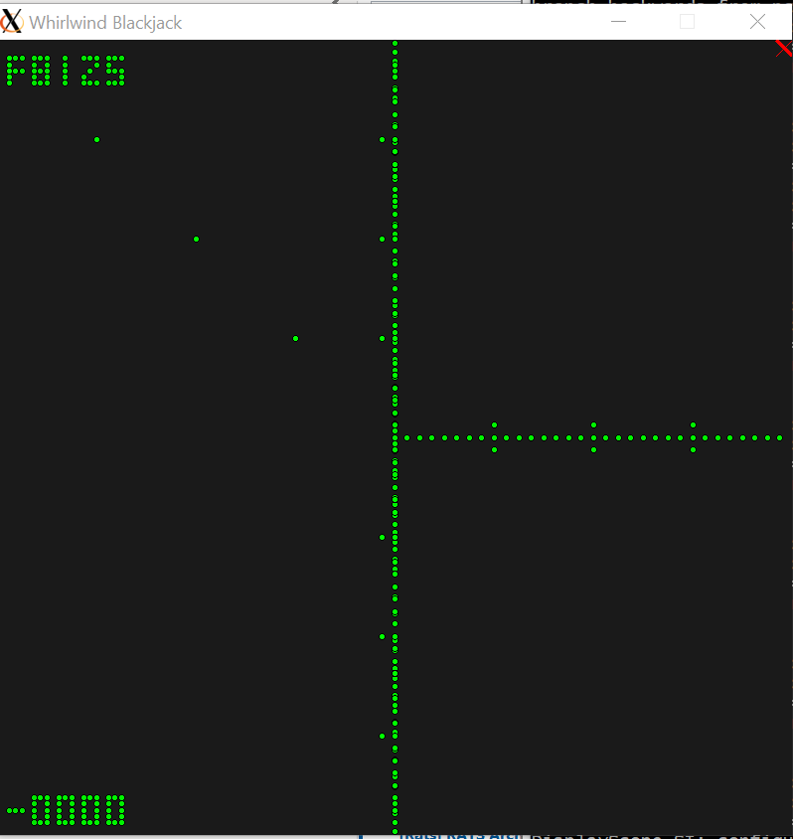

Martin noticed that a similar display turned up in Making Electrons Count

A composite pdf
http://www.bitsavers.org/pdf/mit/whirlwind/Whirlwind_Tape_1951.pdf
mostly covers the Tape-to-Flexo spooler, but mentions this code

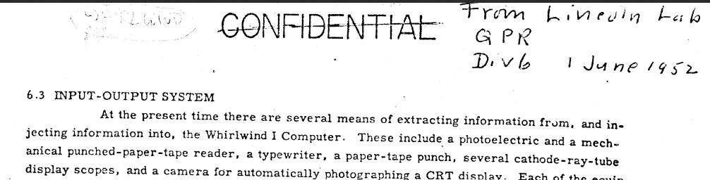

From page 6-130 of whatever doc this is, it says:
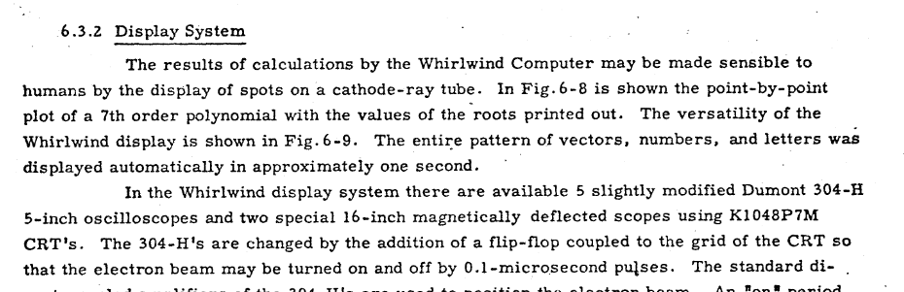

FB126-52-271_1-28-56
I dunno. It looks like a patch tape

Payroll Demonstration Routine
Program written by B. Riskin, Jan 13, 1955
[we probably have the tape and the doc; See DCL-047, and tapes that look like fb-131-209-8]

Vibrating String Demo

Vibrating-String-fc-131-204, Vibrating-String-fc-131-97

Described in DCL-090_Whirlwind_Display_Program_Jun55.pdf
From: Dean N. Arden and G. W. Patterson
Date: 17 June 1955

These two versions of the program are both in WW Native assembly language, and were both compiled and working by Jan 2021
The 204 version is more sophisticated, and includes a number of initial configurations plus a knob to control how tightly the right end of the string is anchored.

Route and Display / Track-While-Scan / D Israel
David Israel
Status: barely started, Jul 19, 2019, update Feb18, 2021
Described in Bitsavers M-1343, complete with code and a block diagram. (We could use an alternate copy of this doc; some pages are very hard to read)
We hand-transcribed the code in the back of the document, given in a unique five-column format.

Quite a bit about testing radar track and intercept in M-1528 biweekly June 6, 1952
Including a promise of an updated copy of M-1343.
“Some material prepared for the Lincoln Quarterly Report has
been revised and will be issued in M-note form for use in the training of new staff members. This material will replace sections of M-1343.”
Jan 27, 2021 – I got far enough in converting the transcribed code to get a .acore file, although with some hacks
- It uses the 1950 version of the instruction set. That’s ok, except the graphics are completely different.
- There are some constants that are in non-canonical format.
- Israel’s work was all coded in decimal; makes it hard to debug in octal; maybe I need a sim mode to print traces in decimal.
- They use an unusual configuration of FF Registers, the light pen interface is different.

Feb 18, 2021
Whew, slow progress on this code.
I think the purpose of the program is to :
- Read radar data
- Ignore some degree of clutter
- Maybe display several aircraft, but Track two aircraft
- Allow the operator to designate one as Target, the other as Intercept
- Compute a heading to direct the Intercept to intersect with the Target
- Display the Heading in a FF register.

Status
- I’ve modified the Sim to do decimal numbers to line up with the document M-1343 more easily.
- The flow-graph extractor actually agrees with Israel’s flow chart in M-1343
- I have a new module to simulate the radar station and aircraft tracks. Not sure the parameters all line up, but it does generate two plausible aircraft tracks. The new module has to include emulation of the 1951 version of the Light Pen, interfaced via a FF register.
- The program will interact with the “radar” station and display the tracks.
- The Light Gun will tag one of the tracks, but I’m not sure if it’s indicating Target or Intercept.
- The program does display the tracks, but as of today, Tracking doesn’t seem to work
  - i.e., it knows where the aircraft are, but it’s not estimating velocity or predicting new positions for the tracked aircraft (i.e., the projected vx, vy, x & y stay zero)
[fixed around Mar 1 by finding a typo in the constant that tells the program when the previously-seen aircraft is expected to run up again in the radar returns]

Status, Mar 29, 2021
Yow, is this ever hard.
But finally the output of the arc-tan approximator correlates to a pythonic paper and pencil style solution of the geometry
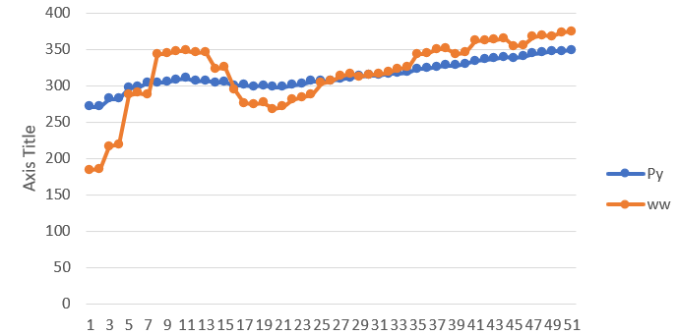
But the BCD converter still doesn’t work! Arghh!

Status, Apr 2, 2021

Copy comments from trace log back to source
Make a video

Parameters
B-52 bombers can cruise at 650 MPH
Radar Interface
- Radar sends one word every 20 msec, 50 per sec. I think it does this continuously.
- A word can be either an azimuth or range reading, determined by the second-from-most-significant bit.
- The radar rotates four times a minute, 15 seconds per rotation.
- A rotation sends 15 * 50 = 750 per complete scan
- There are only 256 discrete values of azimuth
- -> so each azimuth is sent (750/2) / 256 = 1.46 times
- The number of readings sent per scan has to be approximately right, although not necessarily exactly right, as the program counts 650 samples to determine when it’s ‘almost’ completed a revolution, and should start looking for a target again.

Coding from M-1343 pdf pg 13
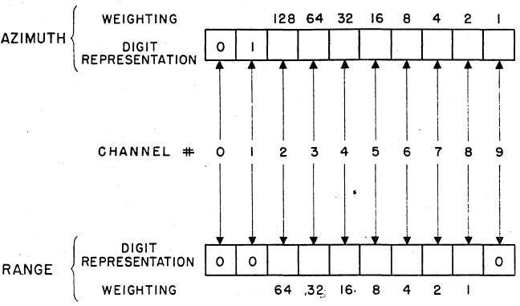

0

0

0

0

0

0

0

0

0

0

0

0

Algorithms

Tracking Program
2018_12/102782309_1251m1106576_tracking_pgm.7ch
2018_12/102782309_1251m1106576_tracking_pgm.jpg
[Jan 27, 2021] I don’t know what it does, but there are a few lines of hand-written instructions from the box in a JPG file.
The tape decodes into a number of binaries, as expected.
The first tape sets extended memory fields (to the default values) and jumps into the TSR loader
I haven’t done enough with that to know what it ‘should’ do there, but it runs a bit and then traps with an arithmetic overflow

Laning and Zierler Algebraic Interpreter
Sources
- https://en.wikipedia.org/wiki/Laning_and_Zierler_system
- https://www.computerhistory.org/collections/catalog/102724583 - Laning’s hand-written listing plus Knuth’s hand-written analysis of L&Z

- Digital_Computers_Advanced_Coding_Techniques_Summer_1954.pdf – see pg 13-1 (pdf pg 64) Extensive notes from the MIT Summer Session of 1954 on Automatic Programming, including notes from a lengthy discussion among the assembled experts, including Backus and Hopper)
- E-364_A_Program_For_Translation_of_Mathematical_Equations_For_Whirlwind_I_Jan54.pdf – The description written by Laning and Zierler themselves
- R-233_The_MIT_Systems_of_Automatic_Coding_May54.pdf – see pg 20 – This is the written version of a talk given to Navy sponsors in 1954 on the general topic of Automatic Programming.
- Jones_A_Survey_of_Automatic_Coding_Techniques_for_Digital_Computers_May54.pdf – see pg 28 – This is a 1953/54 survey done as an MIT Masters thesis under Charles Adams to figure out what projects were out there in the US computing community at large for Automatic Programming.

See also (from Paul McJones)
[1] John Backus. 1978. The history of Fortran I, II, and III. History of programming languages. Association for Computing Machinery, New York, NY, USA, 25–74. https://doi.org/10.1145/800025.1198345

[2] J. W. Backus. Programming in the 1950's - some personal impressions. In A History of Computing in the Twentieth Century, N. Metropolis et al, Eds., Academic Press, New York, 1980, pages 125-135. Preprint. PDF

Guy’s fave quote:
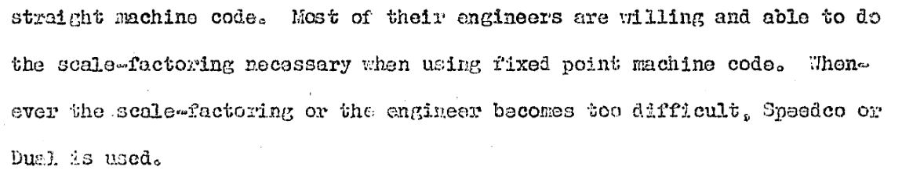

Status, Nov 8, 2024
Greetings Colleagues,
I checked in a series of updates for getting the Laning and Zierler algebraic interpreter running. The code now starts to execute, but clearly still has a problem.
Below is the trace. You can see the jump to octal 200, where things go downhill. The source code says that 0o200 contains "p 58a4". 'p' is not an op code; I'd taken it as simply meaning a constant, i.e., that 0o200 should contain the address of the 58th instruction in block a4. That happens to be a valid SI instruction, but can't possibly be the right thing.
One possibility is that 'p 58a4' means something else. Another possibility is that some other instruction was supposed to put an op-code on top of a valid operand at 0o200, but there's a typo or something preventing that.
There are a lot of similar instruction lines, so we will need to solve this to make much progress.
Here's my sample program:
x = 1
y = 2
z = xy
PRINT xyz.
I don't know if it's valid L-and-Z syntax, but I don't think it should fail before reading the second character!
I also added a simple Makefile to the repo to run the Flexo-conversion, assembler and sim with the right arguments. Just type 'make'.
Finally, this is confusing to debug, given three addressing modes -- decimal, octal and Comprehensive-System relative labels. So I've used the ability to recycle the ASM Listing file back into source. Thus, the .ww file contains all the address assignments from the previous assembler run, making it easier to read code and update the same file when debugging. The makefile does not 'automatically' copy a new listing file back on top of the source file; you may want to do that manually if you make a large enough change.
I think the next step here will be to go through the first strip of instructions one at a time and make sure each one does something sensible.
And I haven't checked, but maybe Knuth's notes decode the "p <number>" syntax.
Thanks
/guy

Status Dec 23, 2024
-------- Forwarded Message --------
Subject: | Laning & Zierler
Date: | Mon, 23 Dec 2024 17:18:33 -0500
From: | Guy Fedorkow <fedorkow@mit.edu>
To: | Larry Stabile <l.stabile@comcast.net>
CC: | Rainer Glaschick <rainer@glaschick-pb.de>, Sancho Villa, Roberto <rsancho@minsait.com>
hi Larry,
I've taken up the L and Z code again for a bit...
I think the (next) missing piece is the 'standard' Whirlwind floating point library, described in
http://www.bitsavers.org/pdf/mit/whirlwind/Subroutines.pdf
Laning says they use (24,6) floats, so I'm just looking at that library.
I'm sure it's on a tape somewhere, but I don't know yet how to find it, so I've been transcribing the code. I have enough done that it certainly seems to be the right thing...
Interesting that L&Z assembler notation also aligns with the notation used in that doc.
I also now see that lines in L&Z marked with "||" notation are instructions that are to be executed by the interpreter, not as native instructions. Very clever, quite confusing. And "sr*15" appears to be the initial notation for "shift right and hold", i.e.., don't zero out B and don' do a round-off calculation.
The library uses double-precision numbers, but they don't store the two halves in adjacent locations; the second half apparently is stored in a block at a fixed offset, which is somehow communicated to the library. If I can get it to run as far as an interpreted instruction, I assume I'll find out where the offset comes from!
In the mean time, I seem to have turned up an inconsistency in the implementation of the "shift and hold" instructions with negative numbers. The Book says the AC reg is complemented if negative before and after shifting, but does not say that the B register is. Surely it's both halves...
Longer term, it might be good to ponder on how to find examples of "known code" in the tape repository -- I'm thinking of something like a convolution operation between a probe pattern and an unknown tape... But that's for later.
/guy

Everett Tape
See blog at C:\Users\guyfe\Documents\guy\History-of-Computing\Whirlwind\guy\Blog-Articles\MITM-Everett-Tape
Files are at ~/WW/GitHub/Recovered-Tapes/Source-Images/Paper-Tapes/MIT-Museum-Tapes/Everett-tape

The tape was read in Dec 2021, but I’m afraid I’ve lost the context (as of Aug 2026) for how much decoding could be done.

Magnetic Tapes

Tape 68

68_001_fbl00-0-50 – CRT Test
This code draws a box and diagonal lines on the CRT

68_003_fbl00-0-71 – Toggle Switch Register Test
Jan 13, 2020
This code validates the settings of the Toggle Switch Registers

Tape 87
Jan 23, 2020
Looks like it might contain the television study, among other things.
I don’t understand the format of the tape, but many blocks look like code, and among the blocks are strings with what look like TV station call letters.

\0##:W\0\0\0 : WCWLDZFK
QWW\0##\0# : R0WQCZKT
QZQ<stop>Q#XI : KZ0L<black>KTK
A\0####D<null> : KTKTKTKT
DE_\0##)# : KVCTKVCV
N#5#R88<null> : CVCVCVCT
#V###(#C : KTKVVCVC
2#0##<null>#l : KKTKKtkr

