
Whirlwind I/II
Another Modern Theory of Operation

Gungsuh font
Version 1.0
Guy C. Fedorkow, Aug 19, 2022

 Caution! Construction Site!
If you see errors or can offer corrections or content, please contact fedorkow@mit.edu.

1. Introduction 3
2. Architecture 5
2.1 Bit Numbering 6
2.2 Registers 6
2.3 Ones-Complement Arithmetic 7
3. Instruction Set 7
3.1 Summary 7
3.2 Sources 11
3.3 Memory Transfer 11
3.3.1 TS – Transfer Storage – write AC to memory 11
3.3.2 TD – transfer digits 12
3.3.3 TA – transfer address 12
3.3.4 EX – Exchange AC and Memory 12
3.4 Arithmetic and Logic 12
3.4.1 SD – Sum Digits – XOR 12
3.4.2 MD – Multiply with No Roundoff (Logical AND) 13
3.4.3 AD – Add Memory to AC 13
3.4.4 SU - Subtract 13
3.4.5 CM – Clear and Add Magnitude 14
3.4.6 CS – Clear and Subtract 14
3.4.7 SA – Special Add 15
3.4.8 AO – Add One 15
3.4.9 DM – Difference of Magnitudes 15
3.4.10 AB – add BR - ?? 16
3.4.11 CA – Clear and Add 16
3.4.12 MR – Multiply and Roundoff 16
3.4.13 MH – Multiply and Hold 17
3.4.14 DV - Divide 17
3.5 Shift 18
3.5.1 SLR – Shift Left and Roundoff 18
3.5.2 SLH - Shift Left and Hold 18
3.5.3 SRR – Shift Right and Roundoff 18
3.5.4 SRH - Shift Right and Hold 19
3.5.5 CLC – Cycle Left and Clear 20
3.5.6 CLH – Cycle Left and Hold 21
3.5.7 SF – Scale Factor 21
3.6 Control Flow 22
3.6.1 CP – Conditional Program – Branch if Negative 22
3.6.2 SP – Subprogram – Unconditional Branch 22
3.6.3 Reset/Illegal 22
3.6.4 CF - Change Fields – Memory Map 22
3.6.5 CK – Check Alarm 24
3.7 I/O 24
3.7.1 SI - Select In/Out – Device Control 25
3.7.2 RD – read from IOR to AC 25
3.7.3 RC – Record – Transfer AC to an I/O unit 25
3.7.4 BI – block transfer In 26
3.7.5 BO – block transfer out 26
4. I/O Gear 26
4.1 CRT Display 26
4.2 Flexowriter 28
5. Coding and Formats 29
5.1 Tape format 36
5.1.1 556 Loader Tape Format 36
5.1.2 Photoelectric Conversion Program 36
5.1.3 Other Tape Formats 37
5.2 Boot Loader Error! Bookmark not defined.
5.3 Toggle Switch Storage for Utility Control Program 42
5.3.1 A Later Utility Control Program Manual 43
6. Packaging 43
6.1 Floor Plan 45
6.2 ALU, FFR and ES Memory Racks 46
6.2.1 Toggle Switch Registers 48
6.2.2 Core Memory Units 49
6.3 Cost 55
6.3.1 Storage Tubes 57
6.4 Power 57
6.5 Where’s Whirlwind? 59
6.5.1 “Where’s Whirlwind” Email Summary, Jan 2, 2018 59
6.6 Whirlwind Components 61
7. Modern Software Tool Chain 62
8. Source Documents 64

Introduction

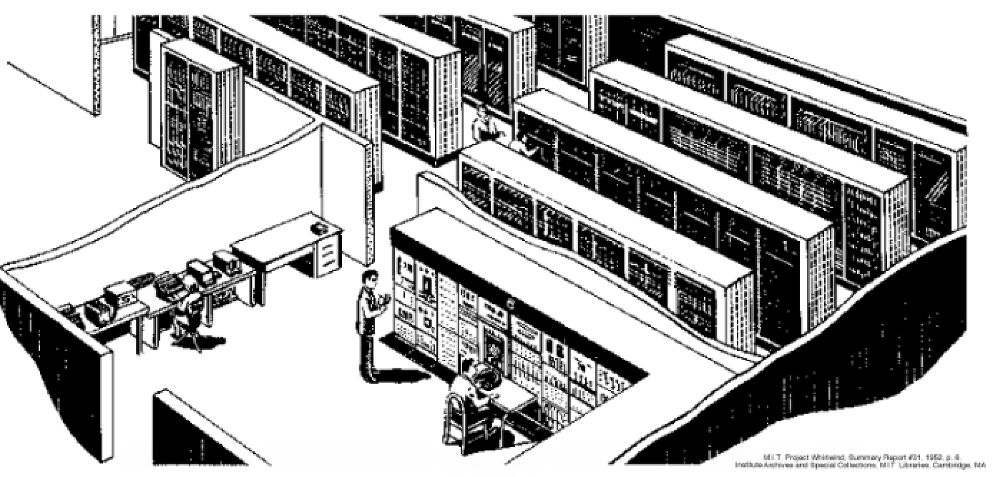

Contemporaneous Machines

https://en.wikipedia.org/wiki/UNIVAC_1103

IBM 701

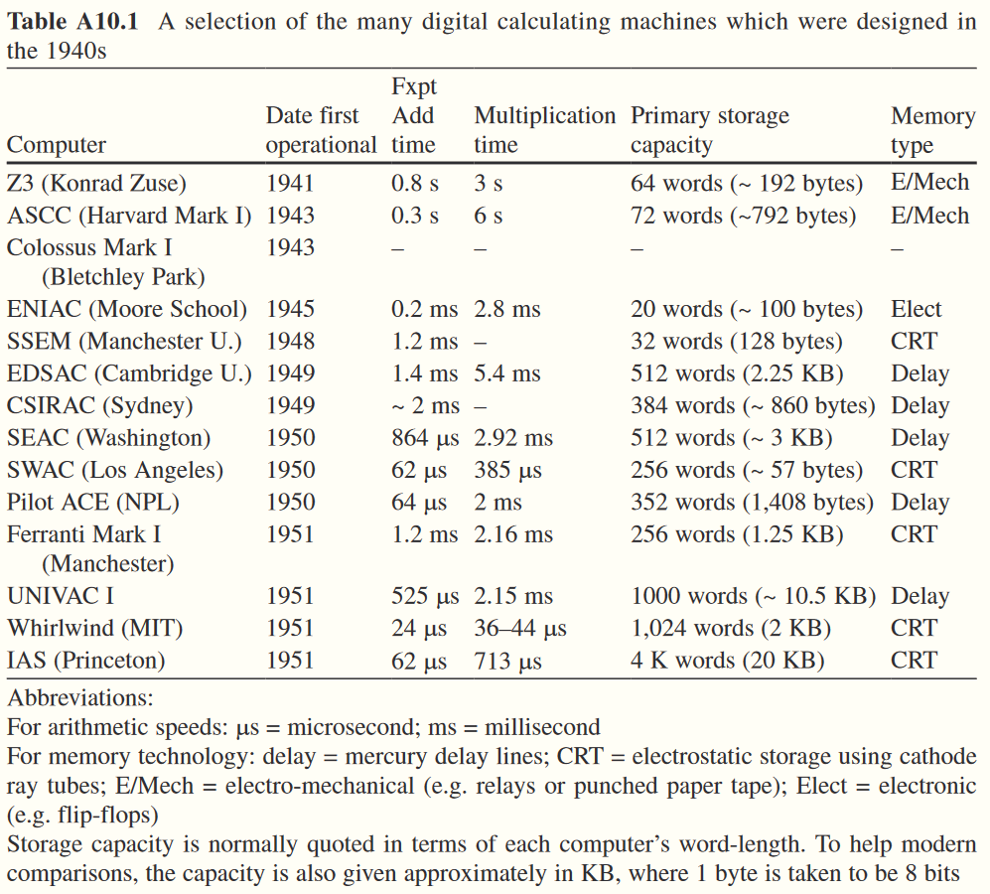
https://link.springer.com/content/pdf/bbm%3A978-1-84882-933-6%2F1.pdf
From Moving targets: Elliott-Automation and the dawn of the computer age in Britain, 1947 – 67. Published by Springer, 2011

Architecture

Program Counter
PR (Instruction Register)
A Register
B Register
Accumulator
IOR Register
Memory
Single-bit shift path
16-bit load path
Figure 1: WW Programmer's View
Flexowriter
Tape Reader
Drum
Mag Tape
(etc)
SAM

Bit Numbering
It’s Big-Endian
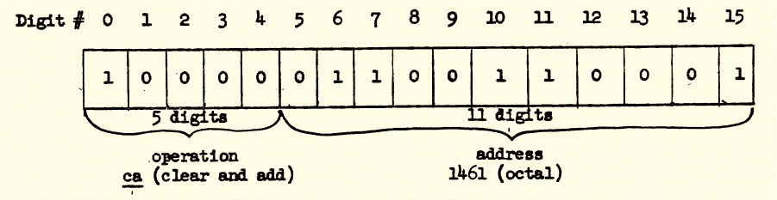

Registers
[Caution! Whirlwind refers to main memory as Registers too]
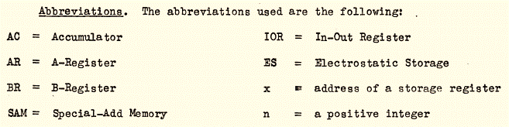

Ones-Complement Arithmetic
[I’ll never figure out those shift instructions without grokking the impact of the ones-complement notation]

Instruction Set

Summary

 |  | 1958 - Doc 2M-0277 |  | 1949 - R-193 A SHORT GUIDE  Vol II, pg 3 |  | Summary Report No. 22, First Quarter 1950
Oct-al | Deci-mal | Code | Description | Code | Description
0 | 0 | SI | Select Input | RI | read initially
1 | 1 | unused | unused | RS | remote unit stop
2 | 2 | BI | Block Transfer In | RF | run forward
3 | 3 | RD | Read | RB | run backward
4 | 4 | BO | Block Transfer Out | RD | read
5 | 5 | RC | Record | RC | record
6 | 6 | SD | Sum Digits |  |  | QH
7 | 7 | CF | Change Fields |  |  | QD
10 | 8 | TS | Transfer to Storage | TS | transfer to storage
11 | 9 | TD | Transfer Digits | TD | transfer digits
12 | 10 | TA | Transfer Address | TA | transfer address
13 | 11 | CK | Check |  |  | CK - Check
14 | 12 | AB | Add B Reg
15 | 13 | EX | Exchange |  |  | QE - Exchange
16 | 14 | CP | Conditional program | CP | conditional program
17 | 15 | SP | Subprogram | SP | subprogram
20 | 16 | CA | Clear and add | CA | clear and add
21 | 17 | CS | Clear and subtract | CS | clear and subtract
22 | 18 | AD | Add to AC | AD | add
23 | 19 | SU | Subtract | SU | subtract
24 | 20 | CM | Clear and add Magnitude | CM | clear and add magnitude
25 | 21 | SA | Special Add | SA | special add
26 | 22 | AO | Add One | AO | add one
27 | 23 | DM | Difference of Magnitudes
30 | 24 | MR | Multiply & Round | MR | multiply and round off
31 | 25 | MH | Multiply & Hold | MH | multiply and hold
32 | 26 | DV | Divide | DV | divide
33 | 27 | SL | Shift Left Hold/Roundoff | SL | shift left
34 | 28 | SR | Shift Right Hold/Roundoff | SR | shift right
35 | 29 | SF | Scale Factor | SF | scale factor
36 | 30 | CL | Cycle Left
37 | 31 | MD | Multiply Digits no Roundoff (AND)
[note that there were at least two major versions of the WW instruction set. A note in the box of material from Judy Clapp seems to outline the differences…]

Based on Memorandum M-1624-1 Whirlwind_Training_Program_Material.pdf pg pdf 14

1950 Instruction Set
Order | Operation  Name | Code Decimal | Code Octal | Function
ri - | read initially | 0 | 0 | Take words from external unit until internal storage is full.
rs -- | remote unit stop | 1 | 1 | Stop external unit.
rf k | run forward | 2 | 2 | Prepare to use external unit k in forward direction.
rb k | run backward | 3 | 3 | Prepare to use external unit k in backward direction.
rd x | read | 4 | 4 | Transfer to register x a word supplied by external unit.
re x | record | 5 | 5 | Arrange for transfer of contents of register x to external unit.
ts x | transfer to storage | 8 | 10 | Transfer contents of AC to register x.
td x | transfer digits | 9 | 11 | Transfer last 11 digits from AC to last 11 digit positions of register x.
ta x | transfer address | 10 | 12 | Transfer last 11 digits from AR to last 11 digit positions of register x.
cp(-)x | conditional program | 14 | 16 | If number in AC is negative, proceed as in sp; if number is positive disregard the cp(-) order, but clear the AR.
sp x | subprogram | 15 | 17 | Take next order from register x. If the sp orde.- was at address y, store y • 1 in last 11 digit positions of AR.
cax | clear and add | 16 | 20 | Clear AC and BR, then put contents of register x into AC. If necessary, add In carry from previous sa addition.
cs x | clear and subtract | 17 |  | Clear AC and BR, tnen put OMBJIMMBJ of contents of reg!««»r » into AC. If necessary, add in carry from previous sa addition.
adx | add | 18 |  | Add contents of register x to contents of AC, storing result in AC.
su x | subtract | 19 |  | Subtract contents of register x from contents of AC, storing result in AC.
cm x | clear and add magnitude | 20 |  | Clear AC and BR. then put positive magnitude of contents of register x into AC. If necessary add in carry from previous sa addition.
sa x | special add | 21 |  | Add contents of register x to contents of AC, storing result in AC and retaining any overflow for next ca, cs, or cm order. Only orders 1 through 15 may be used between the sa order and ca, cs, or cm orders for which the sa Is a preparation.
ao x | add one | 22 |  | Add the number 1x 2"' to the contents of register x. Store result In AC and In register x.
mr x | multiply and round off | 24 |  | Multiply contents of register x by contents of AC: round off result to 15 numerical digits and store in AC. Clear BR.
mh x | multiply and hold | 25 |  | Multiply contents of register x by contents of AC and retain the full product in AC and the first 15 digit positions of BR, the last digit position of BP being cleared.
dv x | divide | 26 |  | Divide contents of AC by contents of register x, leaving 16 numerical digits of the quotient In BR and iO in AC according to stgn of the quotient. (The order s' N following the dv order will round off the quotient to 15 numerical digits and store it in AC.)
sl n | shift left | 27 |  | Multiply the number represented by the contents of AC and BR by 2**n. Round off the result to 15 numerical digits and store it In AC. Disregard overflow caused by the multiplication, but not that caused by round-off. Clear BR.
sr n | shift right | 28 |  | Multiply the number represented by the contents of AC and BR by 2**-n. Round off the result to 15 numerical digits and store it In AC. Clear BR.
sf x | scale factor | 29 |  | Multiply the number represented by the contents of AC and BR by 2 sufficiently often to make the positive magnitude of the product equal to or greater than 1/2. Leave the final product In AC and BR. Store the number of multiplications as last 11 digits of register x, the first 5 digits being undisturbed.
Based on R-193 A SHORT GUIDE TO CODING (using the Whirlwind I code of October 1949) C.W. Adams https://dome.mit.edu/bitstream/handle/1721.3/39817/MC665_r11_R-193-v-2.pdf?sequence=1

Summary Report No. 22, First Quarter 1950.pdf gives “new” opcodes added beyond what’s in R-193
ck x check 11 01011
Stop the computer and ring an alarm if the contents of register x is not identical with the contents of AC; otherwise proceed to next order.

Temporary orders now in use, but not to be used in final coded programs:
qh x h-axis-set 6 00110
Transfer contents of AC to register x; set the horizontal position of the display scope beam to correspond to the numerical value of the contents of AC.

qd x display 7 00111
Transfer contents of AC to register x; set the vertical position of the display scope beam to correspond to the numerical value of the contents of AC; intensify the beam to display a spot on the face of the display scope.
(note M-1083 Interim Display Equipment and Temporary Operation qf: F - Scope Display)

qe x exchange 13 01101
Exchange the contents of AC with the contents of register x (original contents of AC to register x, original
contents of register x to AC).

NOTES:
Check order. This order cannot be used for anything but an identity check. It is intended primarily for use in special test problems and in spot-checking to assure reliability, especially in handling film units.

Display orders. The qh operation sets horizontal deflection and leaves it set until the next qh. A new vertical deflection must be provided each time a spot is displayed by qd. The qd operation can be used without a qh operation by allowing the horizontal deflection to be provided by a linear time-base sweep generator in the display scope, in which case computed values can be synchronized with the sweep by allowing each new sweep to cause the computer to start over at the beginning. In any one program either the qh or the time-base (not both) is used, the proper one being chosen by manually setting a switch. The temporary display orders will be replaced later by using operation rf to select the device and rc to put the number into it.
Op Code qf was added in mid-1950, and is (allegedly) described in M-1083 Interim Display Equipment and Temporary Operation of qf: F-scope Display (which I don’t have).

Summary Report No. 26, Second Quarter 1951.pdf - The order codes were modified again in Summary Report #26 Second Quarter 1951. Page 29 gives a chart.
One important change is the introduction of a variation in the Shift instruction, including “sl *n” and “sr *n”, which is said to avoid roundoff and clearing of Register B.
This format is commonly used in Laning and Zierler, and the WW Subroutine Library.
The description below doesn’t say what it does with negative numbers;

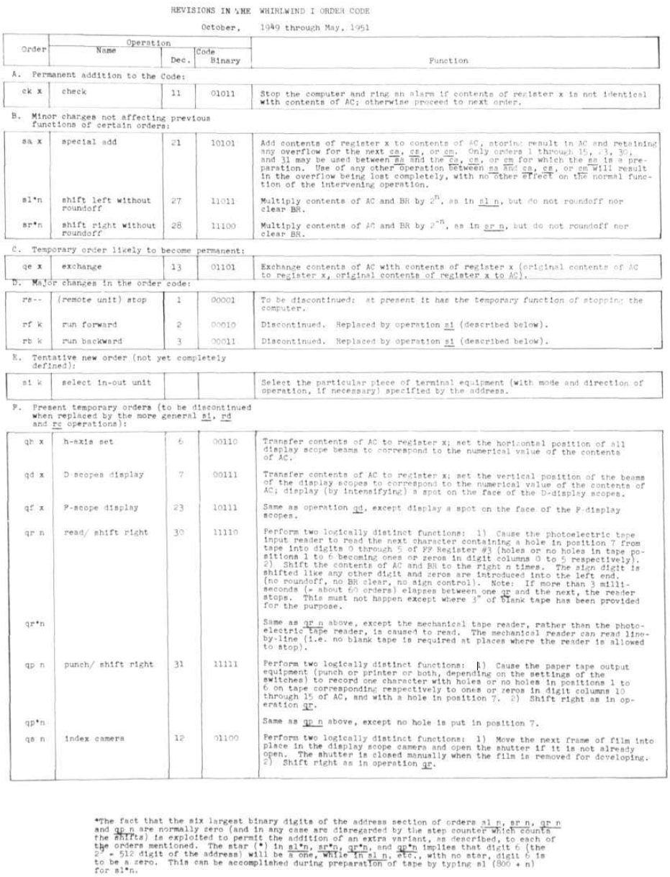

Sources
One Reference doc for the instruction set is: 2M-0277, dated Oct 1958
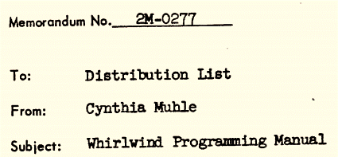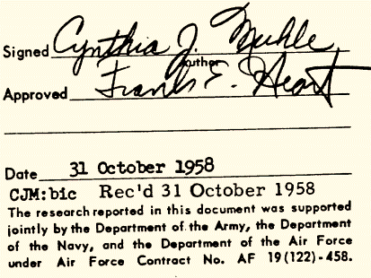

A second source is Memorandum M-1624-1 Whirlwind_Training_Program_Material.pdf
September 2, 1952; Revised November 28, 1952
M-1624 has been OCR’d

Memory Transfer

TS – Transfer Storage – write AC to memory
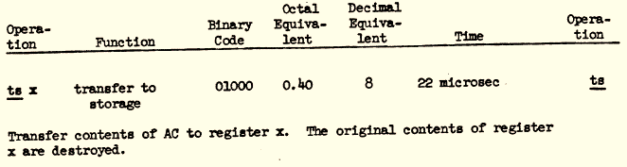
*x = AC

TD – transfer digits
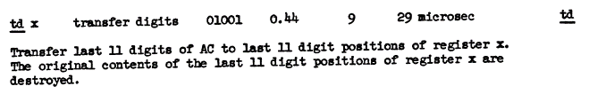
*x = *x & 0xf800 | AC & 0x07FF

TA – transfer address
# ta X transfer address 01010 29 microsec
# Transfer last 11 digits of AR to last 11 digit positions of register x.
# The original contents of the last 11 digit positions of register x are
# destroyed. The ta operation is normally executed after an sp or cp
# instruction in connection with sub-programing; less frequently after ao,
# sf or other operations.
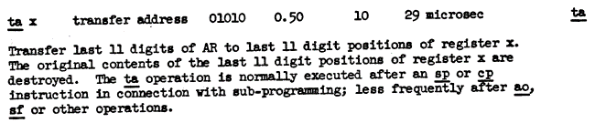

EX – Exchange AC and Memory
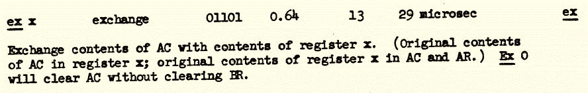

Arithmetic and Logic

SD – Sum Digits – XOR

sd X sum digits 00110 22 micrsec
The sum of the original contents of digit i of AC and original contents
of digit i of register x becomes stored in digit i of AC. The final
value of digit i of AC is O if the values of digit i of AC and of register
x are alike; the final value of digit i of AC is 1 if the values of
digit i of AC and of register x are different.
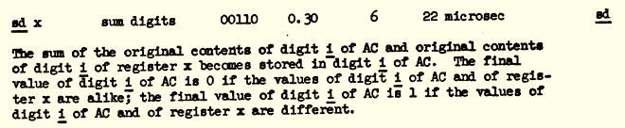
AC = AC ^ *x // xor operation

MD – Multiply with No Roundoff (Logical AND)
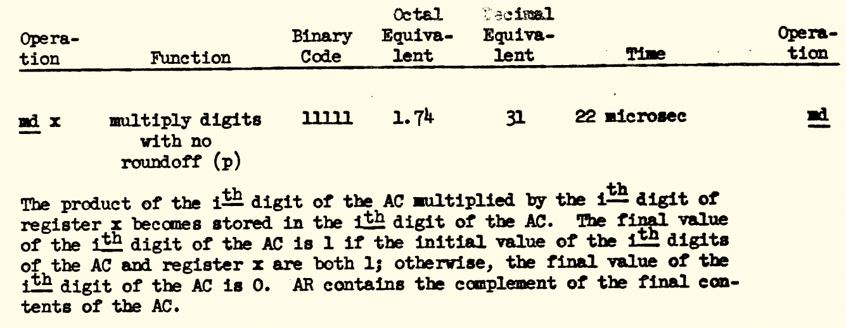
AC = AC & *x

AD – Add Memory to AC
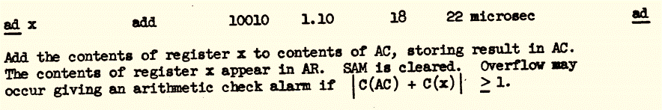

SU - Subtract
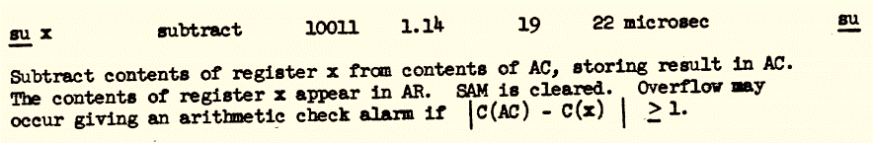

CM – Clear and Add Magnitude
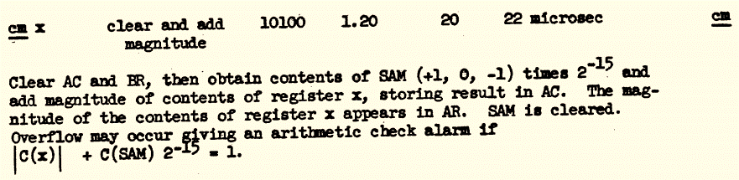

CS – Clear and Subtract
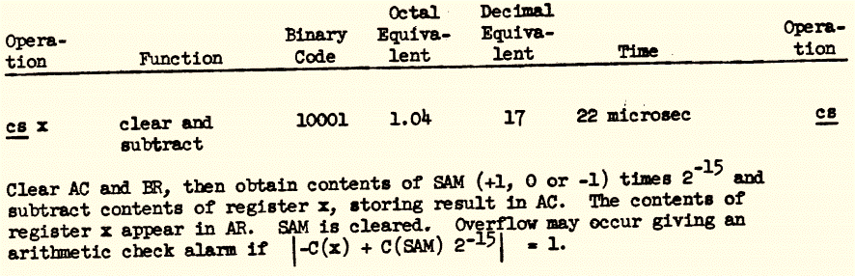

SA – Special Add
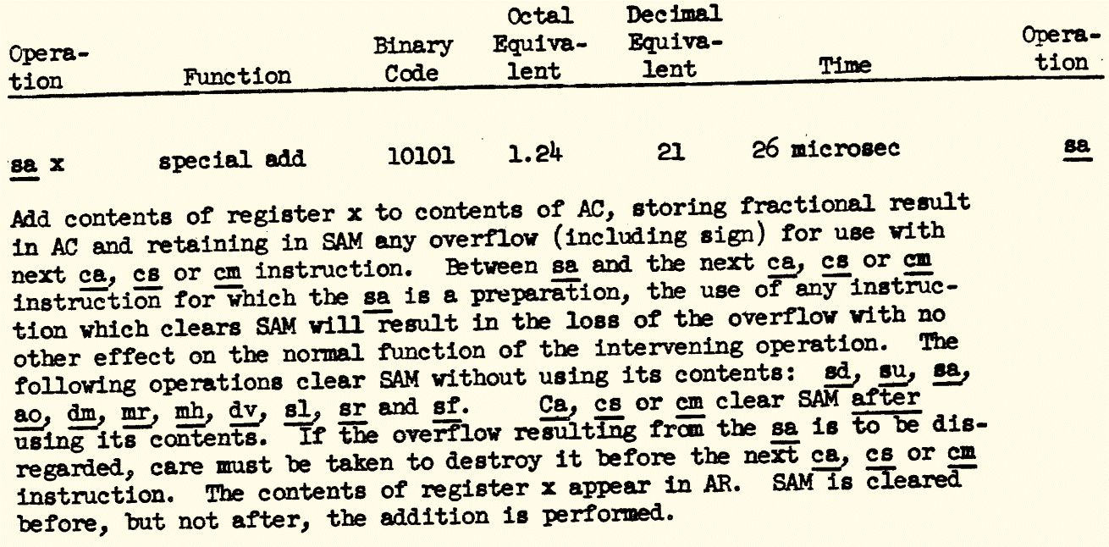
Details on Arithmetic Overflow are given in R-127 (MC665_r17_sr-2-v-5.pdf, pdf pg ~34)
Summary report no. 2, volume 5, Whirlwind I computer block diagrams, volume 1 of 2 volumes
https://dome.mit.edu/handle/1721.3/40672

AO – Add One
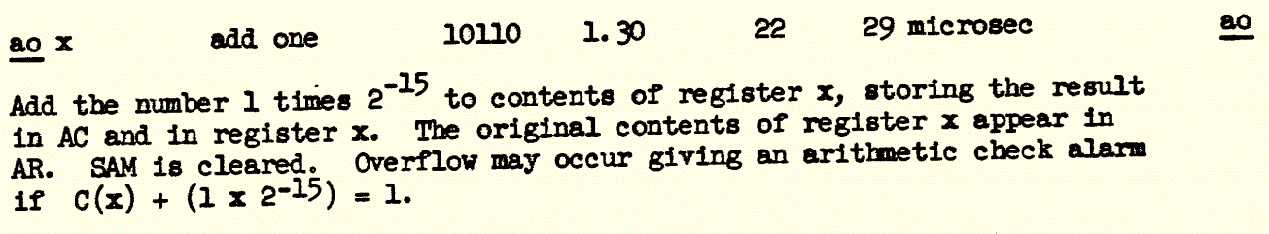

DM – Difference of Magnitudes
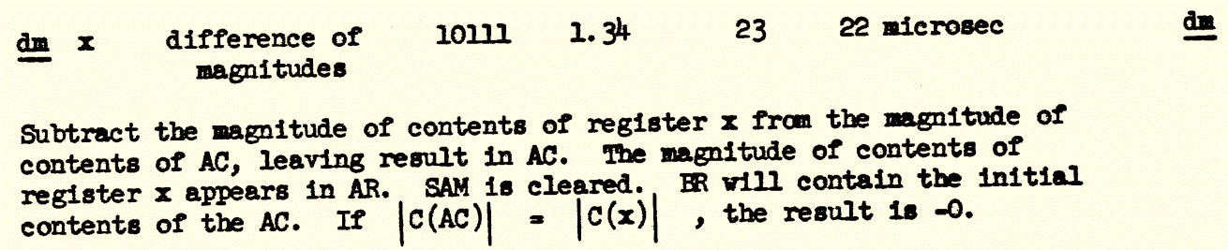

AB – add BR - ??
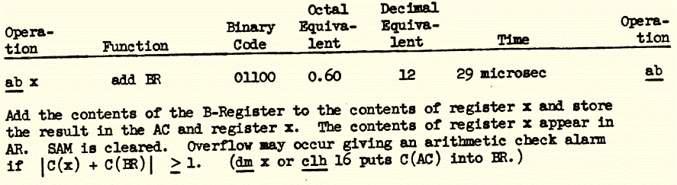

CA – Clear and Add
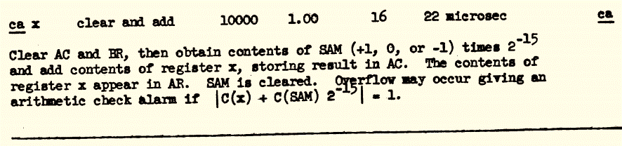

MR – Multiply and Roundoff
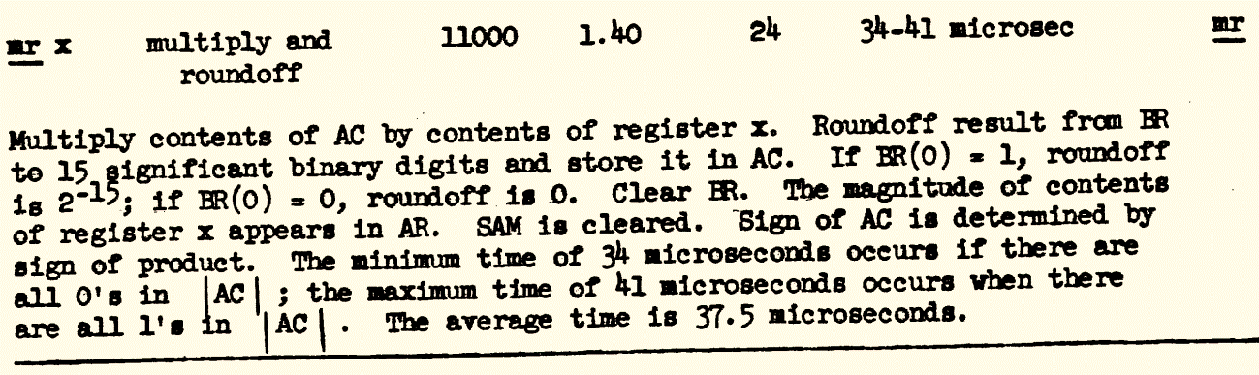

MH – Multiply and Hold
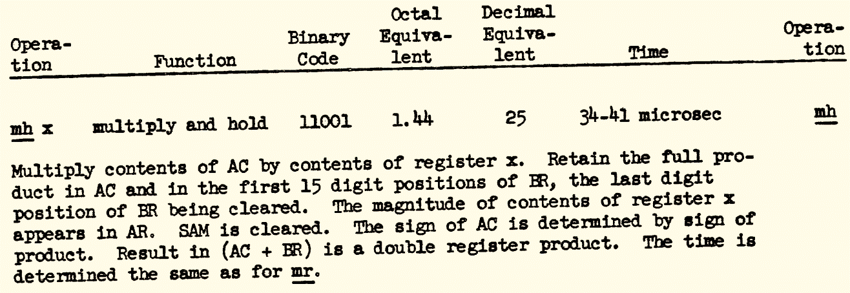

DV - Divide
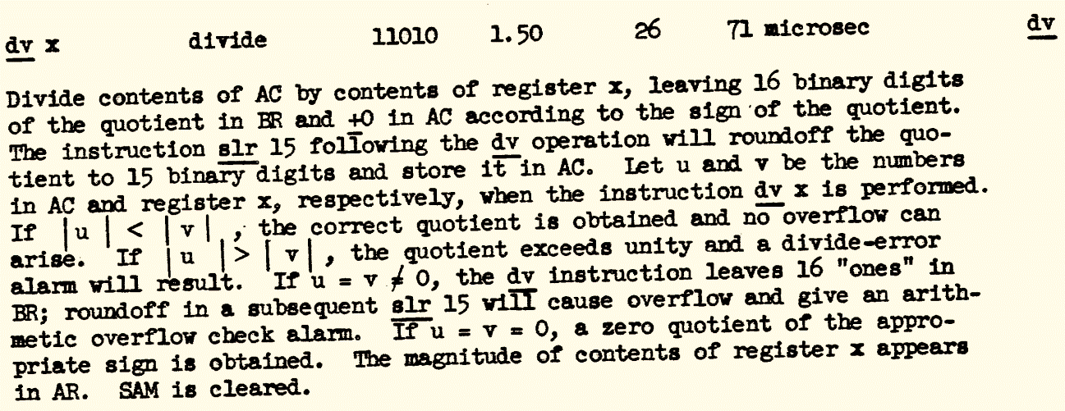

Shift

SLR – Shift Left and Roundoff
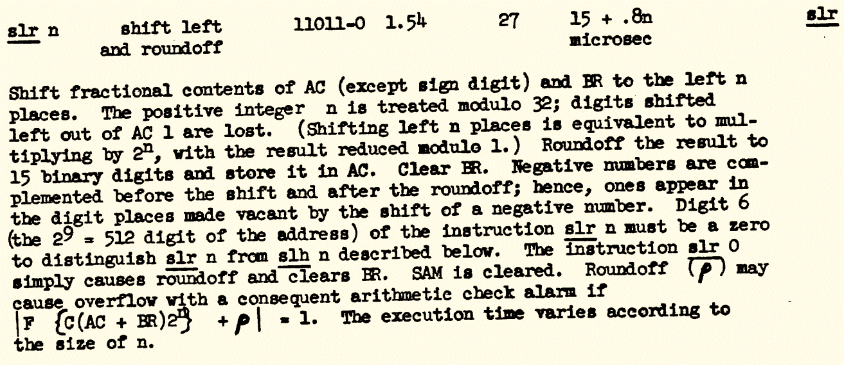

SLH - Shift Left and Hold
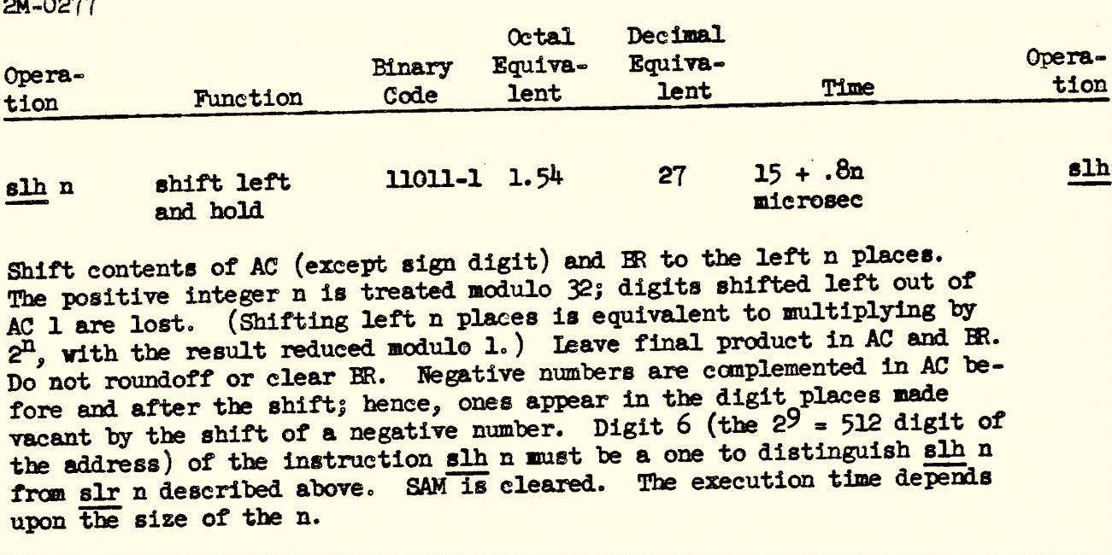

SRR – Shift Right and Roundoff
# srr n shift right and roundoff #28 #34o 41 microsec
# Shift contents of AC and BR (except sign digit) to the right n
# places. The integer n is treated modulo 32; digits shifted right out
# of BR 15 are lost. (Shifting right n places is equivalent to multiplying
# by 2**-n .) Roundoff the result to 15 binary digits and, store it in AC. Clear
# BR. Negative numbers are complemented before and after the shift, hence
# ones appear in the digit places made vacant by the shift of a negative number.
# Digit 6 (the 2**9=512 digit of the address) of the instruction srr n must be
# a zero to distinguish srr n from srh n described below. The instruction
# srr a simply causes roundoff and clears BR. SAM is cleared. Roundoff
# (in a srr 0) may cause overflow, with a consequent arithemetic check alarm.

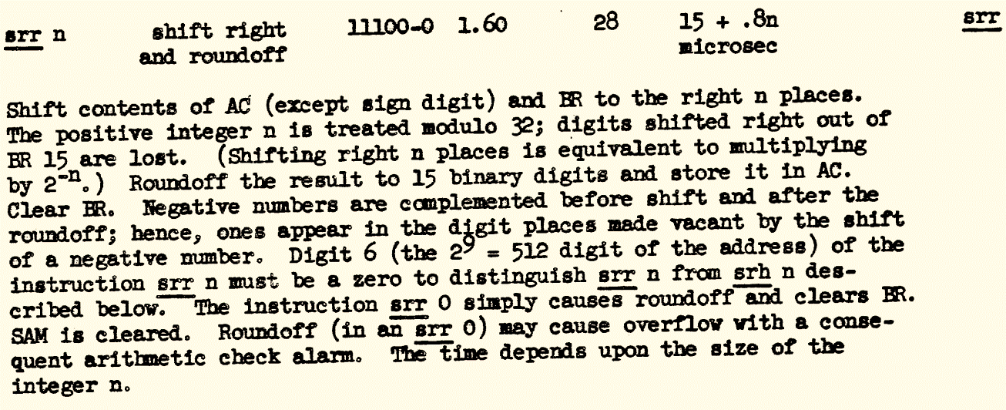

SRH - Shift Right and Hold

# srh n shift right and hold #28 #34o 41 microsec
# Shift contents of AC and BR (except sign digit) to the right n
# places. The integer n is treated modulo 32; digits shifted right out of
# BR 15 are lost. (Shifting right n places is equivalent to multiplying by
# 2**-n) Do not roundoff the result nor clear BR. Negative numbers are
# complemented before and after the shift, hence ones appear in the digit places
# made vacant by the shift of a negative number. Digit 6 (the 2**9=512 digit
# of the address) of the instruction srh n must be a one to distinguish srh n
# from srr n described above. SAM is cleared.

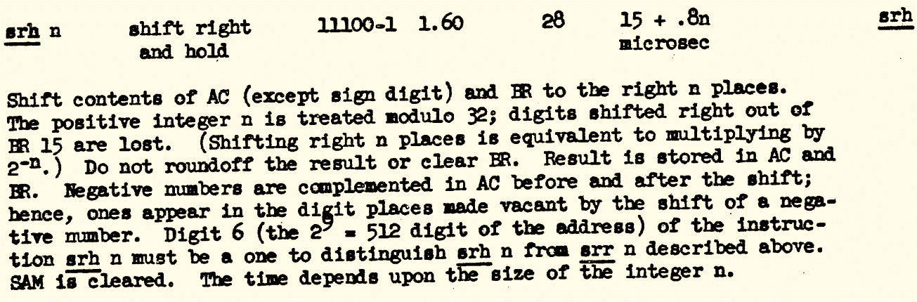

CLC – Cycle Left and Clear
clc n cycle left and clear (BR) llll0-0 1.70 15 + .8n usec

Shift the full contents of A {including sign digit) and BR to the left n
places. The psitive integer n is treated modulo 32; digits shifted left
out of AC O are carried around into BR 15 so that no digits are lost. No
roundoff. Clear BR. With the c1c operation there is no complementing of
AC either before or after the shift; the actual numerical digits in AC and
BR are cycled to the left. The digit finally shifted into the sign digit
position determines whether the result is to be considered a positive or
negtive quantity. Digit 6 (the 2**9 = 512 digit of the address) of the
instruction clc n must be a zero to distinguish clh n from clc n described
below. The instruction clc 0 simply clears BR without affecting AC. The
excution time depends on the size of the integer n.
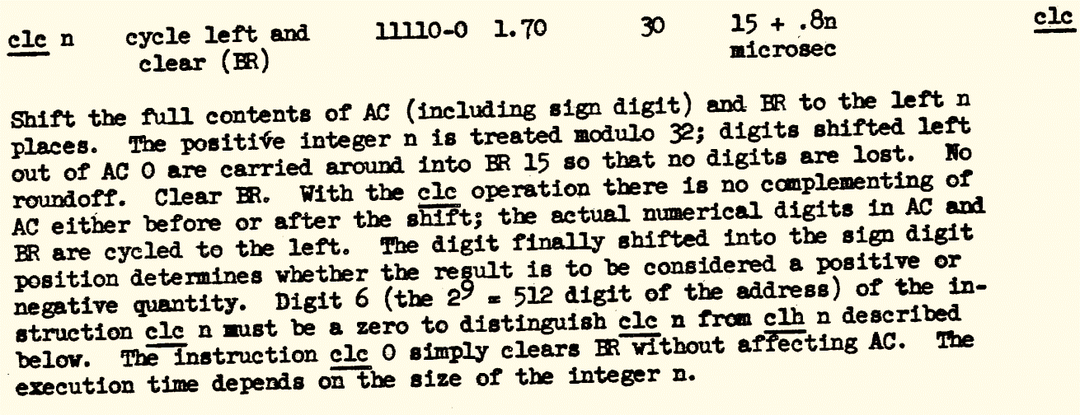

CLH – Cycle Left and Hold
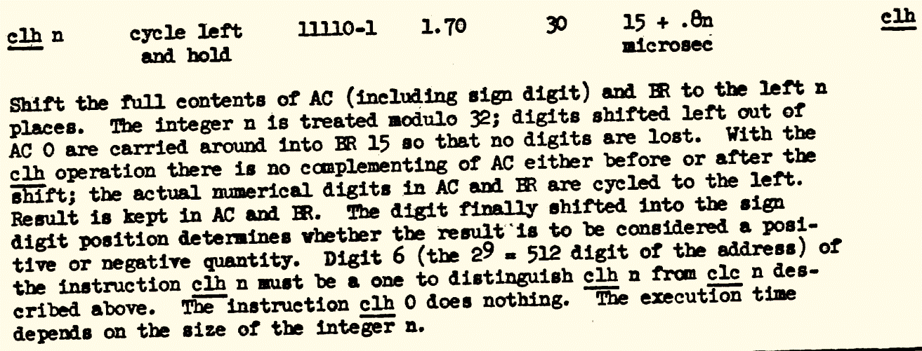

SF – Scale Factor
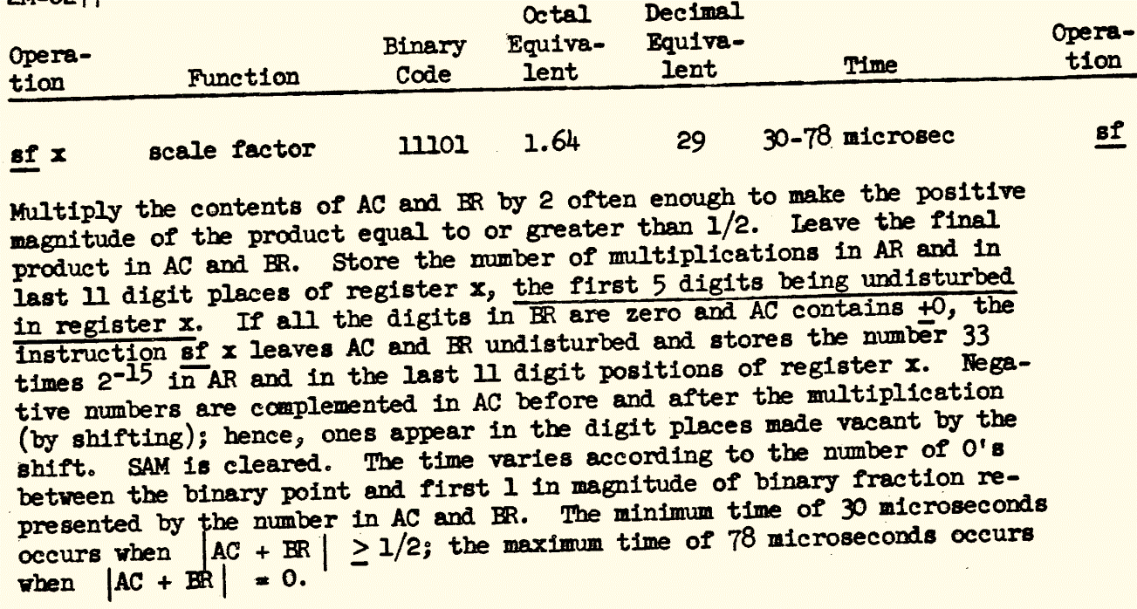

Control Flow

CP – Conditional Program – Branch if Negative
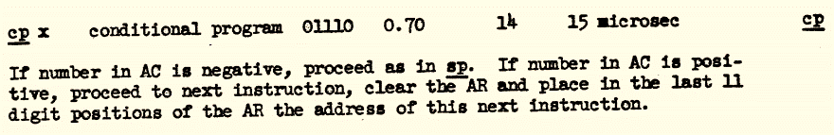

SP – Subprogram – Unconditional Branch
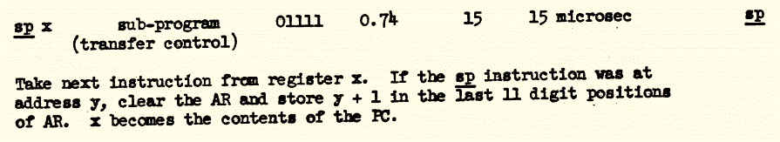

Reset/Illegal
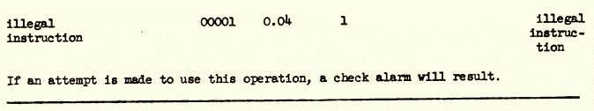
[This instruction did some kind of Reset in the 1953 version]

CF - Change Fields – Memory Map

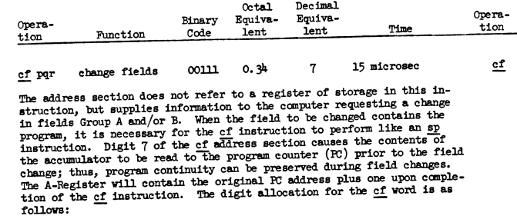
This op code is used for bank switching on the version of the machine with 6K words of core
# cf pqr change fields O0l11 0d7 15 microsec
# The adress section does not refer to a register of storge in this
# instruction, but supplies information to the computer requesting a change
# in fields Group A and/or B. When the field to be changed contains the
# program, it is necessary for the cf instruction to perform like an sp
# instruction. Digit 7 of the cf address section causes the contents of
# the accumulator to be read to the program counter (PC) prior to the field
# change; thus, program continuity can be preserved during field changes.
# The A-Register will contain the original PC adress plus one upon
# completion of the cf instruction. The digit allocation for the cf word is
# as follows:
#
# digits O - 4: O0ll1 cf order.
# digit 5: spare
# digit 6: examine feature - causes contents of core
# memory Group A control and Group B control
# registers to be read into the Accumulator.
# digit 7: sp enable - reads content of AC to PC to
# establish starting point of program in the
# new field.
# digit 8: change Group A field enable. (If, when the
# examine feature of digit 6 is requested,
# there is a "1" in digit 8, the content of
# Group A control will be changed before read-out
# to the A-Register takes place.)
# digit 9: change Group B field enable. (If, when the
# examine feature of digit 6 is requested,
# there is a "1" in digit 9, the content of
# Group B control will be changed before read-out
# to the A-Register takes place.)

# digits 10 - 12: contain field designation for Group A
# (registers l - 1777).
# digits 13 - 15: contain field designation for Group B
# (registers 2000 - 3777).

Group B
Group A
15
14
13
12
11
10
9
8
7
6
5
4
3
2
1
0
1
1
1
0
0
Group B Enable
Group A Enable
SP Enable (i.e., jump)
Examine A and B
Figure 2: CF Bit Definitions

[go look up the following at the Smithsonian:
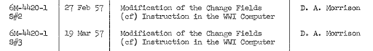
See Smithsonian Archive Collection AC006 record
http://bitsavers.org/pdf/mit/mitre/MITRE_Archive/AC006_WHIRLWIND_I_Computer_Collection_at_Smithsonian.pdf

See notes on these Smithsonian documents in Appendix 12.1.

CK – Check Alarm
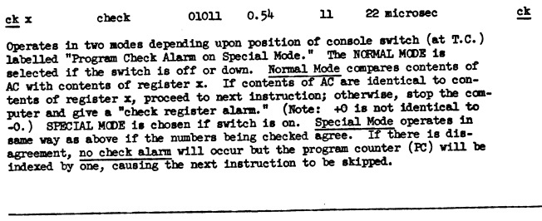

I/O

SI - Select In/Out – Device Control
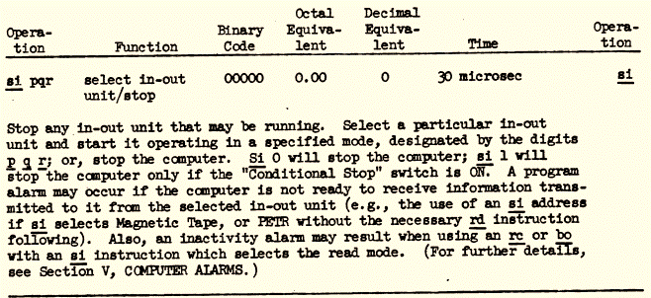

RD – read from IOR to AC
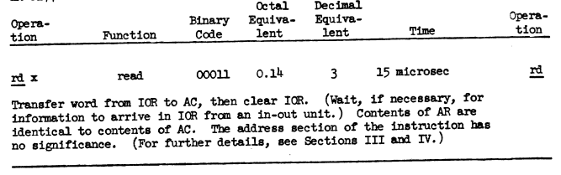

RC – Record – Transfer AC to an I/O unit
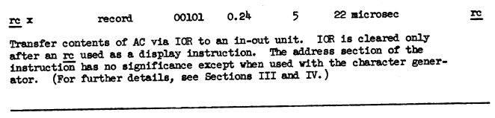

BI – block transfer In
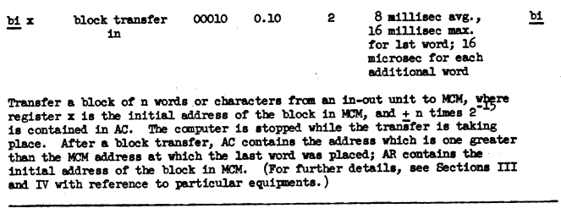

BO – block transfer out
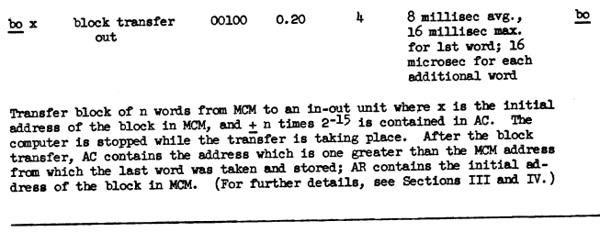

I/O Gear

Revised I/O System
After starting out with machine instructions dedicated for each of a handful of I/O devices on Whirlwind, the team took a step back and redesigned the I/O system to allow for the much wider range of devices they found confronting them.
A Design document outlining their plan, prior to implementation, is given in
M-1235_Operation_of_In-Out_Control_Aug51.pdf

CRT Display

There were two versions of the Oscilloscope Display controller.
The first version, in 1950, used three special instruction orders, as described below.
This was replaced by the New IO System [date?], which provided a much richer set of I/O operations.

First-Generation CRT Controller

https://dome.mit.edu/bitstream/handle/1721.3/38977/MC665_r04_M-1108.pdf?sequence=1
Document M-1108, dated Oct 4, 1950, gives a detailed description of the operation of the original CRT interface, including:

Special display is controlled by three WW orders: QH, QD,
and QP. With these three orders, the computer is able to display pat-
terns of points on three output oscilloscopes, two of which are remotely
located for better viewing and the third of which is mounted in test
control as a monitor scope.
Order cyi sets the horizontal deflection of all three scopes
to a voltage which is proportional to the numerical value of digits zero
through seven of the accumulator. The conversion from an eight-digit
number to a proportional voltage is done by the horizontal decoder.
This voltage is held by the horizontal decoder, and thus maintained
on the horizontal deflection plates of the three scopes, until the next
QH order comes along. On time pulse seven of each qp.order the hori-
zontal decoder is cleared, and on time pulse one the new eight-digit/
number: is read in..
Both 0,3 and
OJF
set the vertical deflection of the three scopes
to a voltage which is proportional to the numerical value of digits
zero through seven of the accumulator. The conversion from an eight-
digit number to a proportional voltage is done by the vertical decoder. This
voltage is held by-the vertical decoder for about eighty microseconds and then
dropped*

Second-Generation CRT Controller
See 2M-0277 Section 3.8 pg 59, pdf-pg 61

The horizontal and vertical components
of the vector are determined by a pair of numbers stored in register v. Digits 0
to 5 of this register give the horizontal deflection of the vector from its origin,
with maxima of ± 31 units, where a unit is equivalent to 2⁻⁸ spacing when displaying
points; digits 8 to 13 provide a similar range for the vertical component of the
vector. Digits 0 and 8 respectively are the Sign digits of the two components.
The largest horizontal or vertical vector is thus about 1/16th the distance across
the usable portion of the scope face.
[which means that the picture below, and the simulator, are wrong as of Dec 2023. Oops.]
0
1
2
3
4
5
6
7
8
9
10
11
12
13
14
15
0
1
2
3
4
5
6
7
8
9
10
11
12
13
14
15
0
1
2
3
4
5
6
7
8
9
10
11
12
13
14
15
0
1
2
3
4
5
6
7
8
9
10
11
12
13
14
15
X or Y absolute CRT address
X short-vector offset
Y short-vector offset
short-vector command word
Figure 3: Composing the CRT Vector Addressing Delta Word

0
1
2
3
4
5
6
7
8
9
10
11
12
13
14
15
0
1
2
3
4
5
6
7
8
9
10
11
12
13
14
15
0
1
2
3
4
5
6
7
8
9
10
11
12
13
14
15
0
1
2
3
4
5
6
7
8
9
10
11
12
13
14
15
X or Y absolute CRT address
X short-vector offset
Y short-vector offset
short-vector command word
Figure 3: Decomposing the CRT Vector Deltas to Screen Coords

Light Gun

Apr 18, 2026: Here’s a Theory of what might be inside the light gun… Waiting for a negative from MITRE archive to confirm
Photo Tube
Trigger
CRT Faceplate

Flexowriter

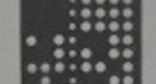
0.860”
0.100”
Holes (including sprocket holes) are on 0.1” centers in both directions
Data punches are ~0.075” dia
Sprocket punches are ~0.050” dia

Drum Storage
M-2539-2, Section XII pg 3
There are two drums, the Auxiliary Drum (used for program storage) and Buffer Drum (used for staging real time sensor data)
The two drums are identical in capacity:
- 16.7 msec revolution time
- 12 “groups”, i.e., tracks
- 2048 words per track

Magnetic Tape

Date: Sat, 18 Jul 2020 10:38:15 -0700
To: Guy Fedorkow <fedorkow@mit.edu>
From: Len Shustek <len@shustek.com>
Subject: Re: WW tape density
Guy,
Here are numbers about the tapes we've seen:
100 characters/inch
2 data bits/character, so 8 tape characters/word
0.08 inches/word
12.5 words/inch
0.8 to 1.5 inches between blocks,
or between tape marks and blocks if the tape mark is not adjacent to the block
Here are numbers for when Whirlwind read or wrote the tape:
30 inches/second
3000 characters/second
333 usec/character
Here are numbers for when we read the tapes:
50 inches/second
5000 characters/second
200 usec/character
There's a terminology confusion between "bit" on the tape and "bit" in a word that I've tried to avoid by using "character" for what is recorded on the tape.
Let me know if any of that is confusing or inconsistent, or if you need more.
Len

Whirlwind Hardware

Schematics
Document M-264, Jan 1950, gives a long list of engineering block, schematic and circuit drawing numbers for WW components.

Digit Plane Driver
From MITRE F-3634.tif
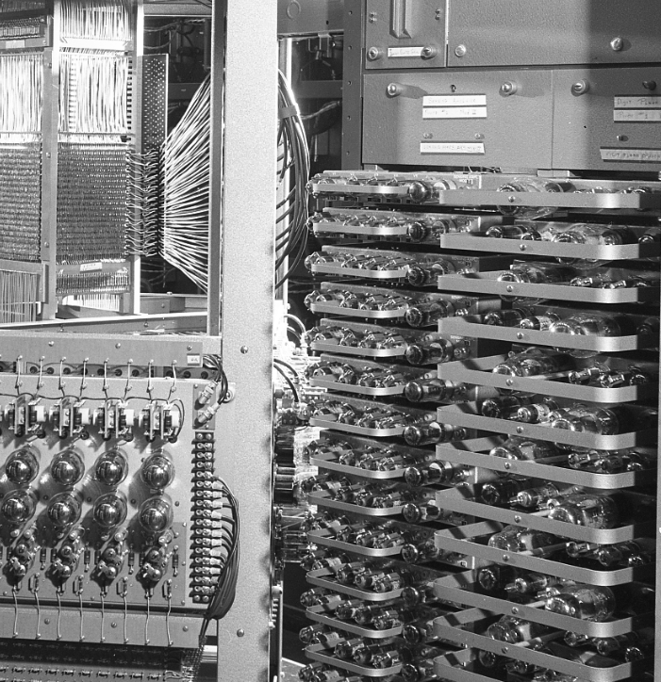

What’s a Digit Plane Driver?
While memory systems for computers may have many complicated aspects, the basic goal is simple enough. The CPU produces a memory address. In Whirlwind, an 11-bit binary number initially allowed up to 2048 16-bit words to be addressed. That address identifies which address the programmer wants to read or write. In case of a write, the CPU also produces a sixteen-bit word that the programmer wants written to that address. In the case of a read, a similar 11-bit address is generated, and the memory system is expected to return a 16-bit value read from that address.
That leads to two independent mechanisms in the memory system:
- An address decoder takes the 11-bit address, and ultimately decodes it to one of the available 2048 addresses.
- Circuitry is then needed to read or write each of the 16 bits at that address.

CPU
Core Planes
Address Decode
Digit Plane
Digit Plane
Digit Plane
16-bit read/write data
10-bit address
32 ‘X’ wires
32 ‘Y’ wires
16 sense/ inhibit wires
Latches & Bus Drivers
Figure 4: 1024-Word Core Memory
Latches & Timing

Figure 1-1 in R-234 gives a stylized view of a three-dimensional core plane.
In the initial WW core system, memories were organized as two banks of planes, each plane containing 32x32 = 1024 cores. Seventeen planes were used in each bank, one per bit in the addressed word, plus one more for parity.

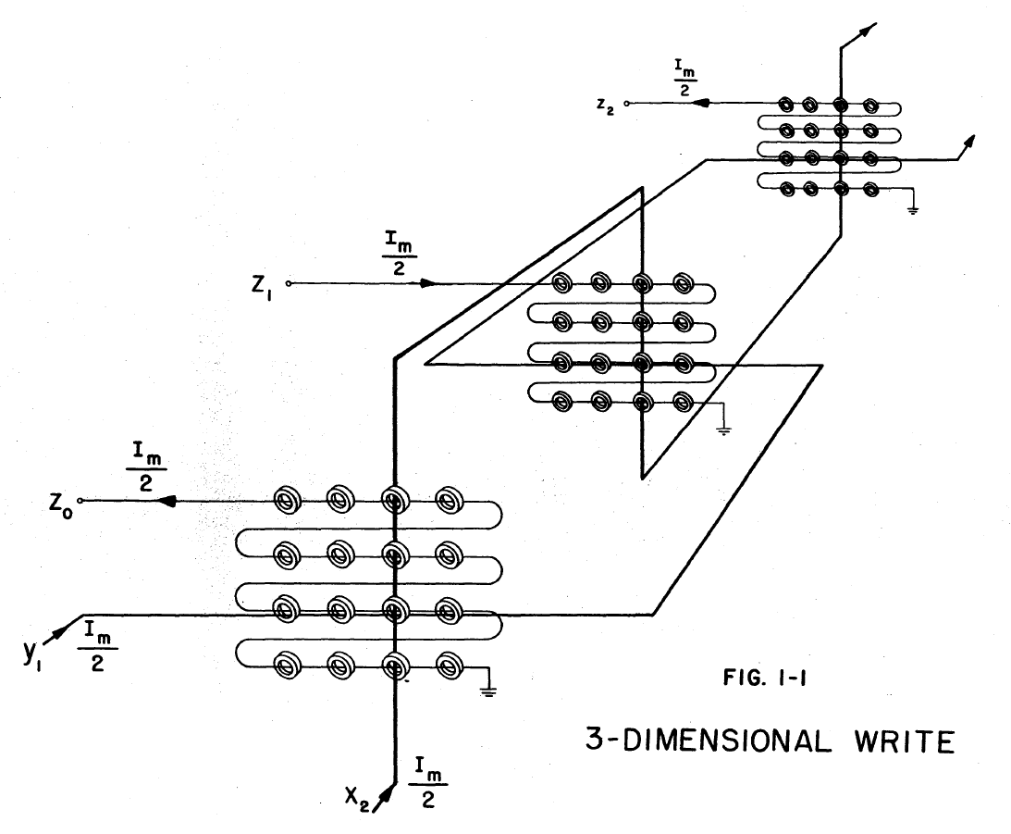
From Address Decoders
From Address Decoders
Connection to and from one digit plane driver per bit in a 16-bit word

In operation, the address decoder logic would drive the X and Y planes to select the word. A sense/inhibit winding passed through all the cores in a specific plane yields signals for each bit in the selected word.
That Sense/Inhibit winding serves two purposes:
- The intuitive purpose is during a Read cycle. If the selected core in each plane contains a ‘one’, then a read cycle generates a small pulse in the Sense winding. If the core contains zero, no pulse is generated.
- Write operations are a bit less obvious. The coincidence of drive currents at an x,y location will cause a one to be written to all bits at that address. However, if the Inhibit line carries the appropriate negative current, writes of ones to selected bits in the word can be ‘inhibited’, leaving them at zero while writing ones to other bits.
Each core memory unit requires a set of Digit Plane Drivers to carry out this dual function, of sensing the small pulse during a read and of generating inhibit current during a write.

Digit Plane drivers went through several design iterations as core memory matured.
The document R-234, thesis report from 1954, gives the schematic for an early version of the WW core-plane digit driver.

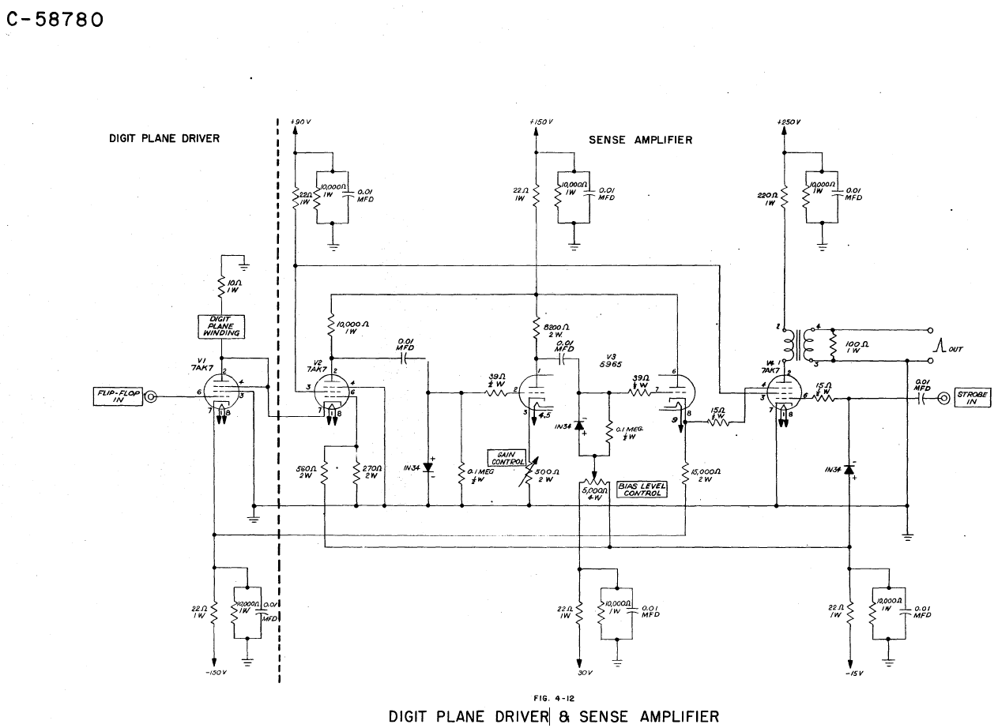

The design iteration that was used in Whirlwind and survives in the MIT and CHM collections is a “Mod-II” version. [haven’t found the schematic yet].

The Whirlwind team also designed digit plane drivers for the XD-1 SAGE prototype. Memorandum M-2842 gives the schematic for that unit on pdf page 4 (WW drawing B-59149).
From a cursory comparison of the schematic and the Mod-II photos, this schematic seems much closer to what must be in the Mod-II unit.
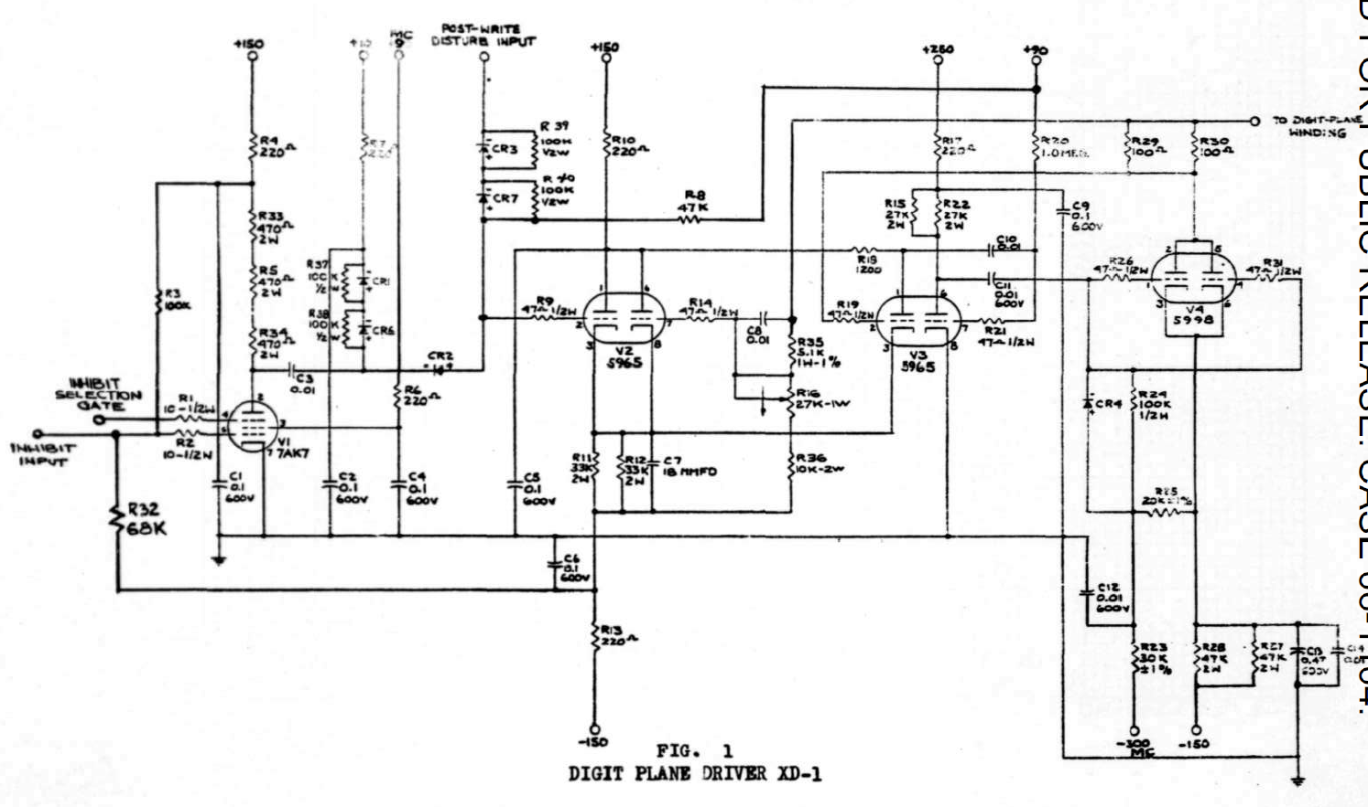
In each case, the basic outline is the same – there’s a large vacuum tube (V4 above) that drives the core plane with the relatively high current needed to prevent the core from switching in the case of writing a zero. Then there’s a sensitive amplifier (V2 and V3) to sense the small pulse generated during a read cycle.

Note to Debbie, Sep 6, 2021
hi Debbie,
I think you've got the general idea alright. But there's a lot more stuff than a digit plane driver...
We haven't looked very much into the hardware architecture of MTC or WW. But I think what we normally see in the photos of the MTC is actually just the Memory stack and controller. That's the core plane (the obvious part) but also racks of drivers, amplifiers, decoders, and timing generators. I think the actual 'computer' part of MTC was a row of racks behind the famous MTC photos, where a rats' nest of cables interconnected Burroughs logic modules.
So as you said, in the Bank C module, each core plane has 4,096 cores which make up one bit of a word. So a stack of 16 of them make up a word. To read or write a word, you activate the one core at the given x-y location in each plane, and read or write all 16 bits at the same time. This is the 'parallel' part of the parallel computer.
But that 'activation' is no piece of cake. The computer gives us a 12-bit address. That has to be broken down into X and Y (that's easy) and then decode each group of 6 bits into 64 individual wires. Those wires have to drive quite a bit of current -- maybe half an amp in a microsecond. So somewhere in there are racks of decoders and drivers.
Out the other side of the core planes come the sixteen binary digits.
The digit plane driver has two functions:
If the computer wants to read the word, it activates the core, producing sixteen teeny millivolt pulses (or not) for ones and zeros. The Digit Plane Driver amplifies those teeny pulses into something the normal logic in the rest of the memory controller can latch, gate, drive onto busses, etc.
If the computer wants to write a word, again it activates the core, but the Digit Plane Drive must drive the desired one or zero into each bit ("digit") of the core stack. Again, that probably takes half an amp (hence the one big tube in each one of the driver modules).
All of this has to happen on the right microsecond, so the memory controller would also have some kind of timing generator.
I suppose the simplest way to look at it is that the Digit Plane Driver functions as the bridge between the analog millivolt-amd-amp core stack and the ones-and-zeroes standardized digital part of the rest of the memory controller. But I don't think that's very enlightening as to what the rest of all that stuff contributes to the picture.
In the abstract, electrostatic memory is just the same... drive a X and Y to select a spot on a tube, one tube per bit, the electrostatic equivalent of a digit plane driver senses the millivolt read signal for each of the 16 bits in the word, or drives <something> to write a bit to the face of each tube. But the analog part of these two memory systems is completely different; hence the giant new racks of controller for one small core plane stack, vs much more than 16 racks full of stuff for electrostatic tubes.
…
/guy

--------------------------------------
Biweekly M-1818, Jan 30, 1953
Digit-Plane Driver (P. Bagley)
The digit-plane driver developed by Laspina is being repackaged in
a plug-in unit. The plug-in unit has been increased in size to make parts more readily accessible, and parts have been placed to keep crystals and electrolytic condensers away from resistors dissipating more than a watt. Sketches have been made, and a laboratory model will be constructed and tested.

Biweekly M-1878, Feb 27, 1953
Digit Plane Driver P.I.V. (MTC) circuit: C-53685 Assy&Pl: D-53570 A1 Panel: D-53728

Biweekly M-2311, Jul 17, 1953
MTC section…
Digit Plane Driver Plug-in
(J. D. Crane) (UNCLASSIFIED)
Plans for a panel to facilitate checking of Digit Plane Driver Plug-in units are complete.

Biweekly M-2311, Aug 18, 1953
MTC Memory Mod. II Digit Plane Driver
(D. Shansky) (UNCLASSIFIED)
Operating margins of the circuit have been investigated and have been found to be adequate. The circuit has been packaged and a prototype constructed. The prototype will be tested in the next period.

Coding and Formats

Tape format

556 Loader Tape Format
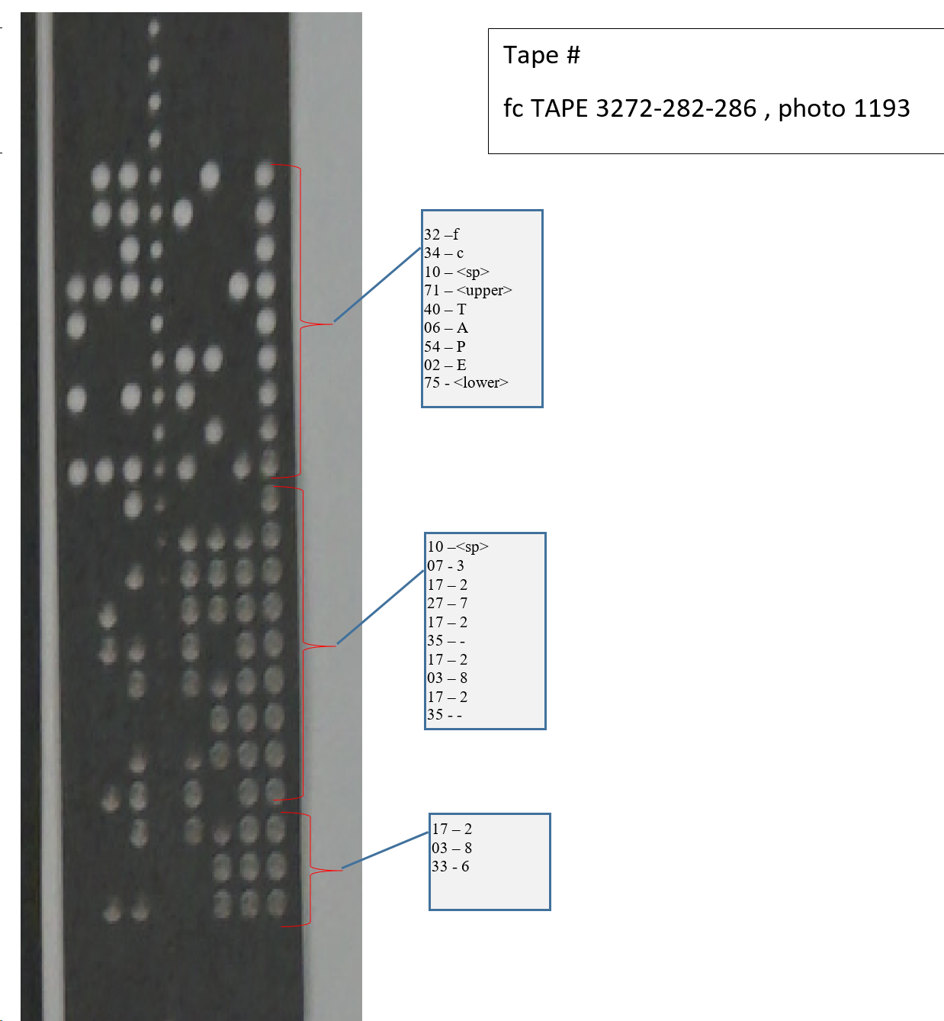

Photoelectric Conversion Program

Doc M-1232 describes the Photoelectric Conversion Program, which seems to be the first run at an assembler; the program takes WW programs in text format and converts them to 5-5-6.

The doc gives four formats for text-coded files:
- Decimal addresses, “checked” or “unchecked”
- Octal addresses, “checked” or “unchecked”
In both cases, “checked” tapes seem to have the character followed by its ones-complement in the next position on tape.
The doc also gives a worked example [which might be illustrative to reverse-engineer] [caution! This doc may illustrate “5-5-6”, not “556”! What comes out doesn’t look quite the same… But the doc does include (pdf pg 9) the Toggle-Switch Register program to read 5-5-6]
The doc might actually give the hand-written source code for the converter.

Other Tape Formats

Memorandum M-1551 also describes “sexadecimal” mode for paper tape, i.e., sixteen bits encoded as four characters on tape.
[or is it M-1451?] see M-1451_Initial_Operation_of_WWI_Terminal_Equipment_with_the_new_In-Out_System_Jul52.pdf
[I don’t know where it’s used…]

Bootstrapping from Scratch
“Bootstrapping sucks” – Nabil, Lincoln Labs, 2017

Starting a computer always involves a process called Bootstrapping, starting with the smallest possible program that may be somehow manually loaded, and progressing, sometimes through several increasingly-complex phases, to the desired application program.
Whirlwind was no different.
Whirlwind was equipped with thirty-two Toggle-Switch Registers, essentially programmable (by flipping switches) read-only memory, plus five Flip-Flop Registers, each essentially one 16-bit word of general-purpose memory. Using these resources, an operator could set up a small program to operate the paper tape reader, and read in a much larger executable program.
The programs stored on tape had to be encoded in a format that the 32-word loader program could interpret, check and store in Core (or Electrostatic) memory.
Although I don’t think there was One and Only One Loader Program, the doc Whirlwind_Training_Program_Material.pdf, (pdf pg 36) contains an example (shown below).

Whirlwind binary tapes were coded in “556 Format”, in which three consecutive words on tape formed one 16-bit word (with no redundancy or error-check). Groups of three were combined into blocks, each of which loaded a sequence of words into memory, or carried out some other function. The loader format included a simple checksum to catch mal-formed blocks.
Figure X shows a short sample. In this case, the example starts with a word count, identifies the first address to be loaded, and then gives a sequence of words to be stored at successive memory locations. The example ends with instructions for checking the checksum.
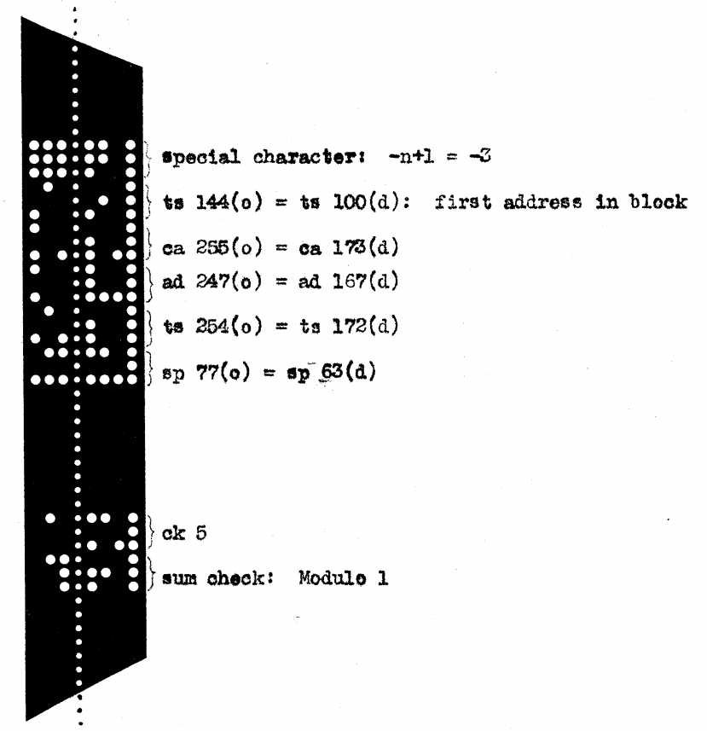

The boot loader takes full advantage of a number of (unsavory) WW characteristics.
- For a memory-load block, the word count given in the first word is negative. This has two effects:
  - A loader block can’t be more than 32K words. That wasn’t going to happen anyways for a machine with only 2K address space.
  - The count can be incremented with a single AO (Add One) instruction (there isn’t a Subtract One)
  - The count is tested for exhaustion with a CP (Conditional Program) instruction, which simply tests the sign bit. Note that a zero resulting from AO will be a negative zero, i.e., the resulting branch falls through for (accumulator >= 1), or branches for (accumulator <= 0).
  - The following word must be positive, or else it’s also interpreted as a count, overwriting the previous one.
- The word following the word count in a memory load block is not actually just the start address, it’s the actual instruction word which would store the first word of the block to the intended location of core memory. For example, it would be a ‘TS 040’ instruction to start loading at octal 040.
- A sequence of words follows, each to be loaded to subsequent addresses
  - After each word is loaded, the word count is incremented
  - The checksum is accumulated
  - The TS Transfer to Storage instruction itself is incremented so it points to the next address
- When the word count expires, the program reads the next word as an instruction and stores it in a temporary register. In the example above, that would be the Checksum instruction, CK 5.
- The final word in the block is the expected checksum; that’s read into the accumulator, then the stored CK 5 instruction is executed to do the check

This same mechanism can be used for stuff other than loading words of memory. For example, a two-word block
SP 40 #branch to Location 40
SP 1 #branch to location 1
… will conditionally start the program executing at location 040:
- The first word is positive, so there’s no word count
- The first word is the branch to the start of the program, to be saved for later use in location 2 (read the code)
- The second word is the operation code, which says “branch to location 1”
  - Location one always contains One, which is a conditional stop (depending on some control key on the console).
    - Either it traps, so the operator can figure out what to do
    - Or it executes the next instruction (which was the branch we just put in location 2) starting the program.
This mechanism gets a bit more complicated (!) when bank-switch is invoked via the Change Fields instruction to load Core locations above the first 2048 words.

Clear WordCount
Read first word from tape into ACC
Negative ?
Store ACC in WordCount
Store ACC in NextOp (it’s the instruction to execute after the next word)
Initialize Accumulated Checksum in AccXsum with ACC
Store previous AccXsum checksum in FinalXsum
Read Next Word from tape into ACC
Store in SPY (register 2)
Execute the instruction in NextOp
Add the word in ACC to AccXsum using SA instruction
Increment NextOp instruction
Increment WordCount
WordCount Negative ?

# The WW Exemplar from Whirlwind_Training_Program_Material.pdf, pdf pg 36
Addresses specified in Decimal notation
INPUT PROGRAM, OCTOBER 1952
Ad | Op Code | WW Coder’s Comment | Guy’s Comments
0 | +0x2-15
1 | +lx2-l5 | Conditional stop
2 | Flip Flop Reg #2 | (sp y)
3 | Flip Flop Reg #3 | (word counter)
4 | Flip Flop Reg #4 | (accumulated sum-mod-one)
5 | Flip Flop Reg #5 | (final sum-mod-one)
6 | Flip Flop Reg #6 | (ts x or ck 5 or sp 1 or sp 21)
7 | sa 4 | add new word to sum-mod-one | SA is “Add with no alarm on overflow”
8 | ts 4 | store new sum
9 | ao 6 | increase ts x instruction by one
10 | ao 3 | increase word counter by one
11 | cp 18 | if word counter is negative, read in next word
12 | ts 3 | reset word counter
13 | rd 13 | read initial word from tape
14 | cp 12 | if word is negative, reset counter | That is, assume a negative number means a Word Count, and keep overwriting it if there are subsequent negative Word Counts
15 | ts 6 | if word is positive, place it in 6 | Word 6 is the operation to be carried out on this block
16 | ex 4 | reset sum-mod-one in case this is WORD block | This must reset the checksum by writing the instruction just placed into #6 into #4, while fetching the old checksum into AC
17 | ts 5 | store the previously accumulated sum-mod-one 10 5 in case this is CK block
18 | rd 18 | read word from tape
19 | ts 2 | place it in 2 in case this is SP block
20 | sp 6 | perform next the instruction in 6
 | 556 Input:
21 | si 139 | select photoelectric reader word input
22 | cao | prepare to reset word counter | This is almost certainly “CA 0”, i.e., clear Accumulator and add the contents of location 0 (which is zero)
23 | sp 12
 | Magnetic Input:
24 | si 66 | select magnetic tape reader forward
25 | rd 25 | read first word of block
26 | cp 12 | if negative, reset counter and proceed to read in
27 | sp 24 | if positive, select input again to skip to next block
28 | immaterial | these words are not now needed and are
29 | immaterial | assigned no
30 | immaterial | value at present
31 | CLOCK
Contents assigned to registers 24 through 30 will be changed when the auxiliary drum is installed.

Bootstrapping Utility Control Program from Drum
When there was a valid image on the drum, bootstrapping required less in the TSR, and relied on the Utility Control Program to do work.
Starting the UCP did two things:
- Copy all 2048 words of core memory to Group (track) 0 of the Aux Drum
- Copy track 11 of the Aux Drum, containing the UCP, into core memory
- Start the UCP at location 0o40
Track 11 is hardware write protected (i.e., they disconnected the write head!)

Here’s what it says in DCL-022 pg 36:
The Test Storage Input Program
Decimal  Addresses | Octal  Instructions
o | +0
1 | +1
2 | Flip Flop 2
3 | Flip Flop 3
22 | mh36
25 | ta2
26 | ca32 Record MCM on group 0 of the auxiliary drum
27 | si 707
28 | bo 32
29 | ad 26 Read group 11 of the auxiliary drum (the utility control program) into MCM
30 | si 703
31 | bi 36

- The test storage input program has entry points at registers 25 and 26 (decimal).
- The entry point at 26 is obtained by pressing the read-in button.
- The entry point at 25 is used by the STOP instruction.

A Later Utility Control Program Manual
From Wolf Engineering, LW-9, pg 5, edited by guy
(I think this is the same as the one above, with liberal decimal/octal confusion added for good measure)
3. Toggle Switches
The toggle switches in Test Storage should be set as listed below. The locations are given first in decimal, then in octal.
Octal Entry
7: 0.50002 ta 2
8 : 0.34320 cf 320
9 : 0.77777 sp 3777
19 : 0.14062
20 : 0.40024
21 : 0.33741
22 : 1.00023 ca 23 ; UCP without cores to DG #0
23 : 1.14024 su 24 ; Drum Group (DG) #7 Block-In
24 : 0.74036 sp 36
25 : 0.50003 ta 3 ; UCP, Program use
26 : 1.00032 ca 32 ; UCP, RI
27 : 0.00707 si 707
28 : 0.20032 bo 32
29 : 1.14025 su 25 ; DG #9 Block-In
30 : 0.00703 si 703
31 : 0.10036 bi 36

The Operating System
Ok, just kidding

Utility Control Program
As long as Aux Drum track 11 was in order, the UCP serves as the program loader, reading binaries from PETR, or running the CS converter (or a few other things, I think).
M-2539-2, Section XV pg 9 gives the definition of the extended 556 loader commands, including Block Length, Address, Checksum, Ditto, etc.
The UCP read-in function appears to copy paper tape images to drum tracks 0-10 on AD, 2-7 of BD.

UCP actions are controlled by an octal word on SELECTOR PANEL and INSERTION PANEL (whatever they are…) M-2539-2 simply says that there are a whole lot of codes, but you don’t need most of them (i.e., no cross-reference). (maybe see DCL-22).

M-2539-2, Section XV pg 8 outlines the mechanism by which the UCP finds and loads programs that won’t fit on the AD Track 0, by searching the drum and then magnetic tape (!).

UCP also logs each program run somehow (presumably on a printer of some sort), giving the programmer and the computer time consumed.

Use of the UCP is described in DCL-22

Director Tapes
Director Tapes are used by the UCP (I think) to run a series of jobs.
M-2539-2, Section XV describes a complete language of commands that tell the machine what to do next (assuming nothing goes wrong) including reading sequences of tapes into memory and then running them.

Magic Addresses

There appear to be a series of reserved addresses at the high end of core memory for Comprehensive System use

Address | Name |  | Who Says
0o002 | Stop | By default, contains a jump to CS-II Stop | DCL-025, pg 2
0o3763 | Programmed Arithmetic trap | Contains a CK instruction which halts in case of a Programmed Arithmetic error | DCL-22, pg 15, paragraph 2.5.4
0o3742 | CS-II STOP | This seems to be the return address to complete a CS-II program and return to the Director | DCL-025, pg 2
0o3732 | Start CS-II interpreter? |  | Hint from Everett tape gs002
0o3706 |  |  | Hint from Everett tape gs001
0o3775 | Stop Read-In and Change Fields? |  | Listed in 6M-4420-1

Packaging
By the time Whirlwind was fully operational in 1954, the machine comprised “12,500 vacuum tubes and 23,800 crystal diodes”. The computer room floor plan, while electrostatic storage was in place, was packaged in about 98 racks (see Figure 5).

Floor Plan
The following doc gives the actual floor plan and layout for the computer room and control room, plus a number of other details on how the parts hook together.
http://bitsavers.org/pdf/mit/whirlwind/Whirlwind_DrawingList_1952.pdf

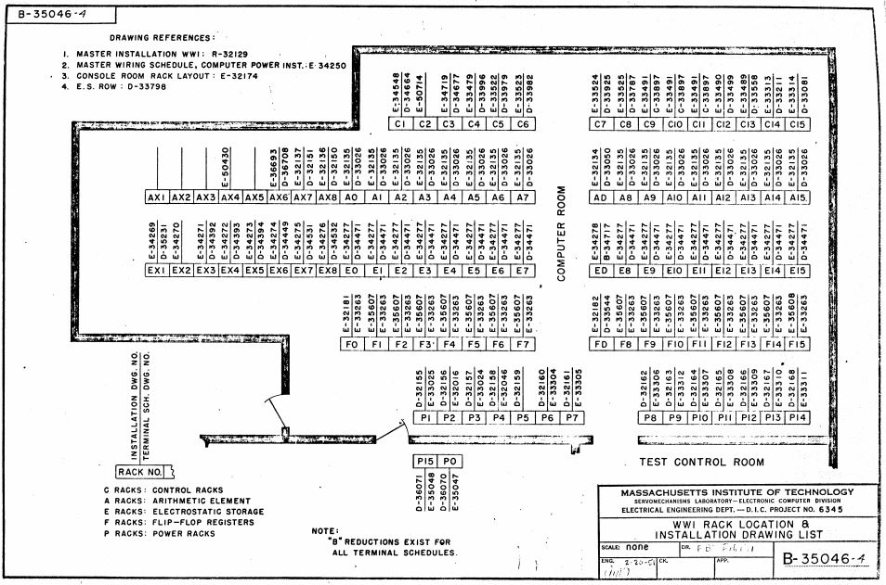
Control Logic, Operation Matrix, Toggle Switch Registers
Accumulator, SAM, A & B Registers, Program Counter
Electrostatic Storage Tubes and Control
Flip-Flop Registers and Comparison Register
Power Control & Voltage Variation Panels
~70 feet
~30 feet
Figure 5: Barta Computer Room Floor Plan

Alternate Floor Plan
R-193-Vol1 (MITRE Reel 11) pg 14
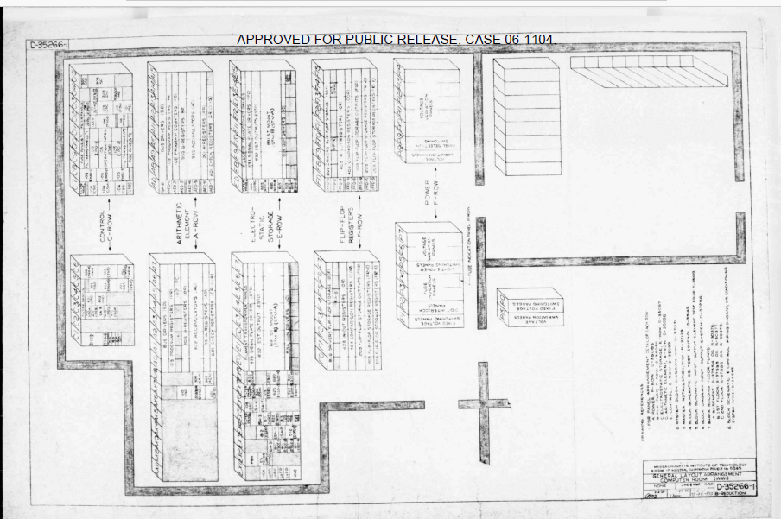

Barta in 1996
http://www.mit.edu/~mbarker/n42/schemec.html

N42 Base Building Elements Blueprints Scheme C
Draft 12/17/96
These Blueprints represent the draft design for the N42 building as of 12/17/96.
[…]
- N42 Floor 1 Blueprint (75K)
- N42 Floor 2 Blueprint (71K)
- N42 Basement Blueprint (72K)
N42 Discuss Meeting via the World Wide Web

ALU, FFR and ES Memory Racks

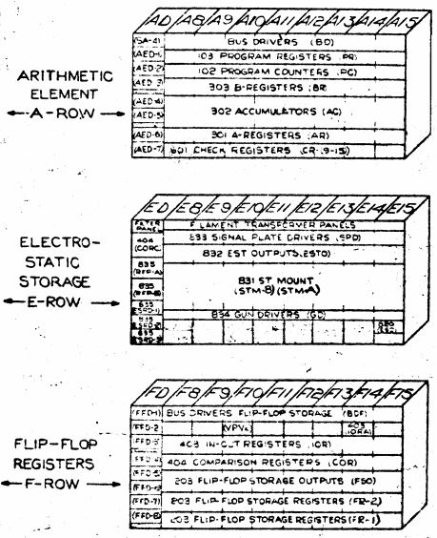

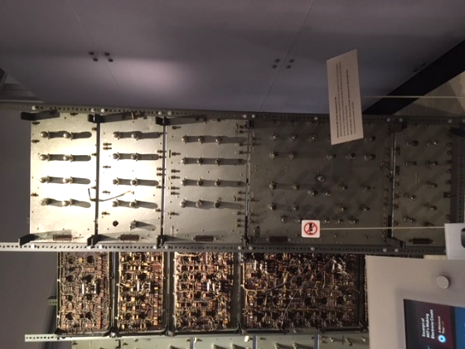
103 Program Register
301 A Register
102 Program Counter
303 B Register
403 In Out Register
302 Accumulator
601 Check Register
404 Comparison Register
Designator numbers align with R-127 PDF Page 20

Toggle Switch Registers
Toggle Switch Registers are encapsulated in Block Diagram unit 202.
The Drawing List appears to show Block 202 in Rack C6, Drawing B-35089-6 (at the back of the computer room)
Toggle Switch Registers themselves may be shown in Drawing E-33523, Cable Chart D-33982

From the General Numbers doc:

One set of Toggle Switch Register settings (from late in the machine’s life) can be found in the Wolf Research doc:
LW-9_The_New_Whirlwind_Utility_Control_Program_Jan59.pdf
on BitSavers.

[note the use of plugin modules in the Operation Control Matrix racks; see photo pg 134 of Redmond]

Core Memory Units
-------- Forwarded Message --------
Subject: | core and whirlwind
Date: | Thu, 18 Apr 2019 13:38:25 -0400
From: | Guy Fedorkow <fedorkow@mit.edu>
To: | Deborah Douglas <ddouglas@mit.edu>, David C. Brock <dbrock@computerhistory.org>
CC: | Guy Fedorkow <guy.fedorkow@gmail.com>
hi Debbie, David,
Reading Wolf's notes on Whirlwind bringup offered a hint I hadn't come
across previously.
http://www.bitsavers.org/pdf/mit/whirlwind/wolf_research/Wolf_Research_Whirlwind_I_Checkout_Progress_Report_Jul63.pdf
By the time Wolf was installing the machine, apparently it had three
memory banks (A, B, and C), not the two we all know about.
That actually solves another puzzle, how the heck did they end up with
6K words of memory...
Core planes are usually square, i.e. X-by-X, not rectangular
(X-by-Y). That means that the capacity of a core plane usually has a
simple power-of-two integer as a square root. 1024 words works, 2048
words does not, and certainly 3K doesn't.
Further, the note says that Bank C provides 4K words of storage (which
did work) as opposed to Banks A and B, which gave them parity error
grief. From this, I'm guessing that A and B were the first two at 1024
words each, and Bank C was added later, once they'd found that they
could make 4K word planes reliably.
This also provides a simple explanation for how Ken Olsen ended up
with three core units...
If this is something "everyone" knows, I'll just update my notes and
move on, but if not, maybe we should visit the three known instances and
count cores...
Wolf's checkout notes also provide an inadvertent inventory of what
was connected to the machine at the end of its tenure at MIT.
Apparently there was a card-reader by then (those insidious IBM guys...)
/guy

Which Memory Plane When?
Biweekly M-1953 indicates that “Bank B” was considered the ‘first’ bank, while A was the second. This refers to Electrostatic tubes, but the designation probably didn’t change.
The second bank of electrostatic storage (Bank A) is now in operation
but is not as yet quite as reliable as Bank B. Programmers can arrange with
Roberts or Corderman to use Bank A if they so desire. Bank A is not, however,
to be considered as permanently available at high reliability, and errors encountered
in Bank A operation are not to be charged against WWI reliability.
Full reliability of Bank A is expected by the promised date of May 15.

The following docs in the Smithsonian archive might help answer questions about core planes [none of which seem to be in Al’s collection or the MITRE collection]
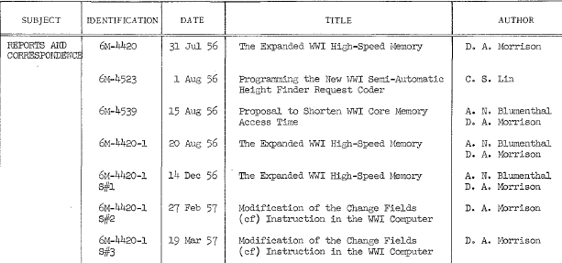

Rough sketch of 4K Memory Plane Driver schematic, from MIT Warehouse, drawn May 24, 2019 by Guy:
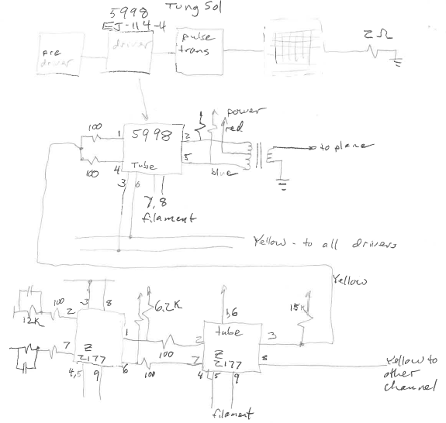

More on Core Memory Architecture
Sep 10, 2021
hi Debbie,
Yes, I'm sure those are digit plane drivers. I've enclosed a snip from your photo, followed by a photo of the digit plane driver at Tyler, followed by a photo of Bank A at CHM, followed by an intact set of memory controller racks at CHM.
Don't you wish you could just go look at whatever the heck it is in the photo, and get someone to explain what it was?
I'm afraid my story is shifting a bit here... I'm sure we'd seen schematics that indicated that the Digit Plane Driver module had both the half-amp write driver and the millivolt read sense amp in one module. I'll admit to being a bit surprised at that, since the two technologies aren't easily compatible. But hey, radar people handle much worse, so who knows.
Looking more closely at the CHM photo, I see the two columns are different. The left hand column is the digit plane driver module like the ones MITM has. You can tell because of the distinctive alternation of right side up and upside down modules. The second column actually says "Sensing Amp, Mod II", as you can see in the photo from CHM.
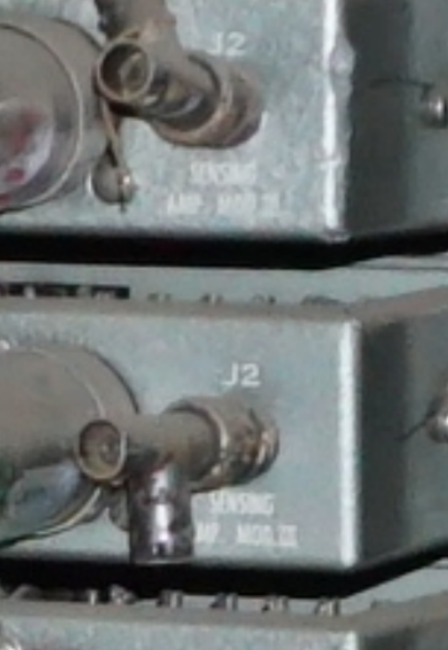
That would indicate that the functions were not in fact combined. The Digit Plane Driver may have been responsible for Digit Plane Driving (go figure), i.e., generating the pulse for writing ones and zeros to the selected column of cores. The Sensing Amps would have been in charge of reading the bit, i.e., amplifying the millivolt pulse.
The photos also show the sense amps and the drivers connected to each plane by separate cables, but all the planes we've seen use a single read/write wire woven diagonally through the plane.
At this point, you may be ready to Throw Up Your Hands and say "why can't I get a straight answer? What the heck is this thing? What's wrong with these so-called Computer People??!!".
Part of this surely is just that it's hard to put all the pieces together, but we may also be seeing revisionism in action; they surely got smarter over the decade, and the newer more efficient memory designs may have eclipsed what they were doing at the start.
I haven't started to read your exhibit material yet. But for this one Digit Plane Driver device, a simpler (engineering) story may be that the digit plane driver converts between the standard digital pulses that flow through the rest of the machine into the unique analog signals that work with the magnetic cores.
I'm not sure if there's a concept that's too hard to get across there... Digital computers are in fact analog devices with a veneer of digital abstraction ironed on over the top. Occasionally the underlying analog nature, where you can't be too sure if it's a One or a Zero, peeks through, and Bad Stuff inevitably happens.
Memory systems are usually where this analog nature is closest to the surface; if they don't get the exact voltages and currents tuned just right, the margin between one and zero vanishes and sadness spreads through the computer room.
So the digit plane driver and sense amps are on the front line in that conversion between relatively-reliable digital abstraction in the rest of the computer and the analog-ish memory system.
I'll work on the material over the weekend.
Looking forward to the day when we can do this with a white-board at hand!
Thx,
/guy
The MITRE photo from the MTC
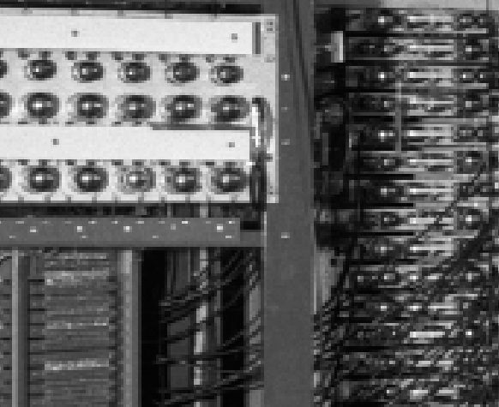
MITM Digit Plane Driver
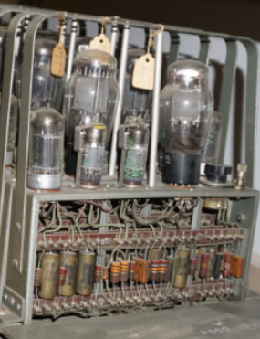
Distinctive Bank A shower stall
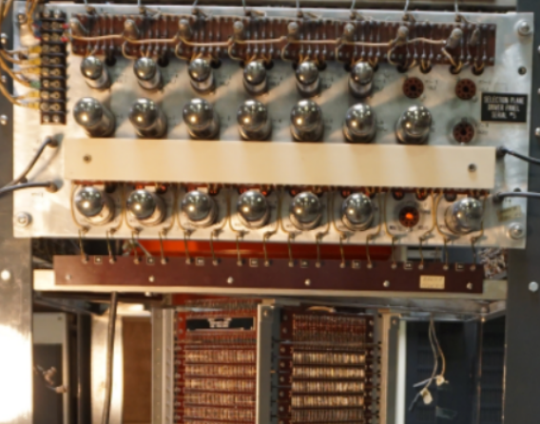
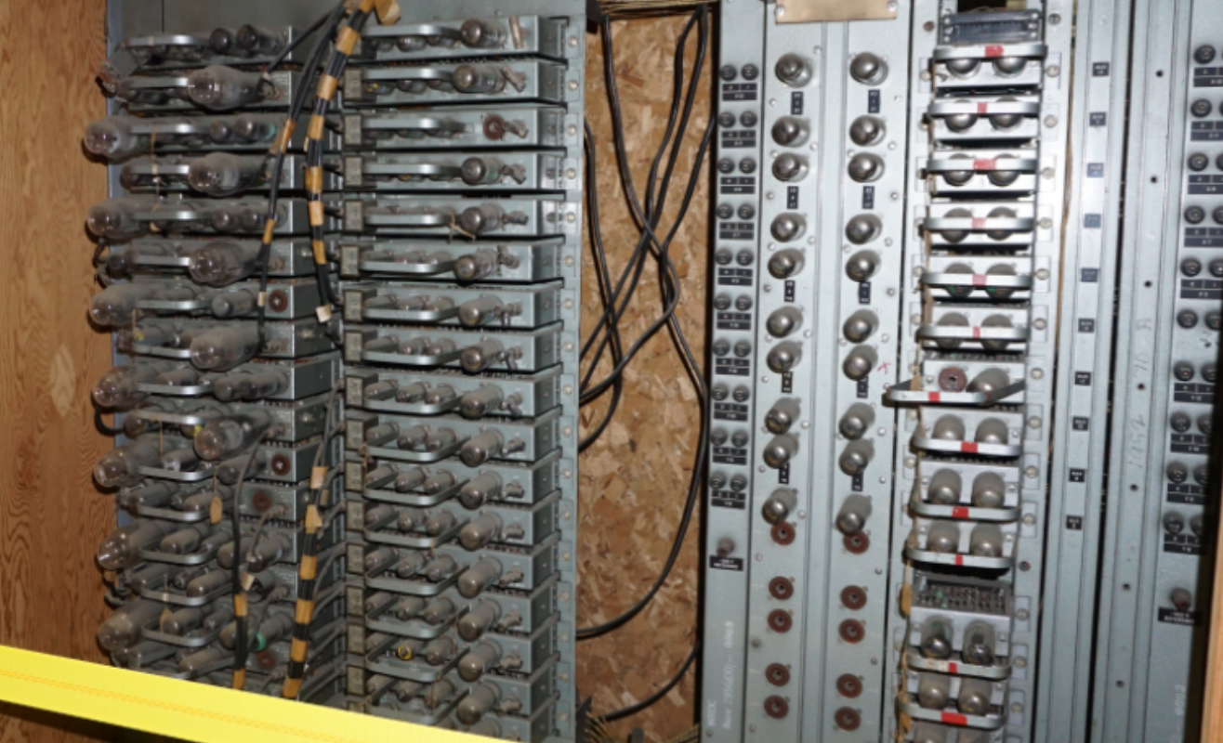

PIUMP / Modular Development
The Plug In Unit Mounting Panel (PIUMP) turns up first in Memorandum M-1953 - BIWEEKLY REPORT, April 10. 1953 as an off-handed remark that something built with a new PIUMP was installed.
The new PIUMP's for the new display system have been
completed and have been mounted in the computer room ( WWI ).

Buttons and Lights

Toggle Switch Registers
M-2539-2, Section XI pg 24 says that the programmer can rely on locations zero and one to contain zero and one.

Start-Stop
M-2539-2, Section XI pg 25
Buttons mentioned are:
- START – Starts the machine at an address toggled in to PC RESET switches
- START AT 40 – Starts the machine at location 40 (I assume regardless of what’s in the switch register)
- STOP – Just stop the machine where ever it happens to be
- RESTART – start the machine up from whatever happens to be in the PC.

M-2539-2, Section XV pg 7 also mentions:
- EXAMINE SELECTOR PANEL BUTTON
- SELECTOR PANEL (which contains one word, coded as octal, not binary)
- INSERTION PANEL (for supplying parameters to the UCP)
(I can only assume these are physical buttons, but why you need a button to examine a switch is not yet clear)

- STOP on SI 1 Switch configures what to do with the 01 version of halt

Cost
Cost numbers from Memo L-11, Feb 1949, pg 4

*Note there’s no budget line item for ‘programming’(!)

Retrospective cost Analysis from Kenneth Flamm, from Redmond & Smith
Numbers from Creating the Computer: Government, Industry and High Technology by Kenneth Flamm, pg 54-60. And Flamm references Redmond & Smith as his source.
Neither mention costs after 1951, although development of core memory went on for some time after that date.

Storage Tubes

Memorandum L-18, February 15, 1950 gives the cost breakdown for making storage tubes:
At your suggestion I have prepared the following cost estimate for constructing standard storage tubes. The cost per tube in January is approximately $1,500 each. These costs include direct manpower and materials as well as a proper allocation of building operation, administrative, and supervisory costs covering such direct contract charges as material procurement and standards group, purchasing, stock clerks, guards, telephone operators, and so forth.
The storage tube group constructs approximately three tubes per week, of which one is a research tube and two are the so-called standard tubes. Of the two standard tubes, about 75% or one and one-half tubes per week are satisfactory

Power
[guy’s back-of-the-envelope guess]
(Tube power numbers from 6AD7 data sheet.)

The following Power Estimate is from memo L-11, Feb 15, 1949, at a point where the machine was estimated to need 4,500 vacuum tubes.
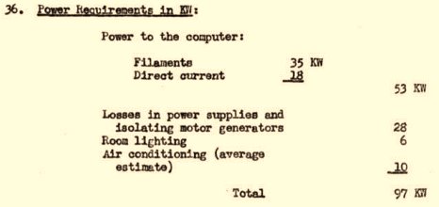
In proportion, Report L11 allocates more power per tube to filaments than my data sheet reading.

Power Notes
From Stewart Coffin, WW power supply designer:
On 1/2/2019 9:41 PM, stcmsd@aol.com wrote:
The drawings do not mean much to me, but I can still picture in my mind what the power supply room in the basement looked like. Near the foot of the stairs were the rotating dc generators. I believe one supplied filament power, which was brought up slowly to lengthen the life of the vacuum tubes. Another was used to supply a variable voltage for marginal checking. Farther down on the left, opposite the storage tube lab, were the thyratron d-c power supplies in two rows facing each other. The +150 and +250 were probably the largest at 50 amps each. The +600 was pretty large too. Another was +90 I believe. Sorry, can't remember the rest. Stewart

Electricity Consumption
Can we find the Power Utility Bills from MIT Annual Reports
They list Barta Building “Maintenance”
Power for MIT is listed as purchased from Cambridge Electric Light Company

What fraction of University power went into WW?

Where’s Whirlwind?

Some racks are on display at CHM
More racks are the CHM archive
Some racks are in the MIT Museum archive

There are three core memory units
- One at the Smithsonian (we think)
- One in the MIT Museum Collection – probably the mythical Third Core Unit, possibly built for Ken Olsen at Lincoln with the Memory Test Computer.
- and there’s one at CHM (catalog 102667558)

“Where’s Whirlwind” Email Summary, Jan 2, 2018
I've been stuck on this question of "Where's Whirlwind?" for a bit, so I took a run through catalogs for MIT Museum, CHM and the Smithsonian, just as a first pass of figuring out what's there and how to explain it.
I suppose the answer is "a lot" or "a little" depending on your point of view.
MIT and the Smithsonian both have a number of unique and significant artifacts from this machine, but pound-for-pound, not a significant fraction. Ok, those core memory units are heavy, but so is the rest of the stuff.
But CHM has hundreds of circuit boards and panels, although most of what's there came from the arithmetic unit and the so-called Flip-Flop Registers, i.e., the five words of memory implemented as discrete vacuum tubes.
Those two subsystems should account for 34 racks. Of those, the combined collections contain enough gear to fill about half those racks, i.e, there's a bit more than half of the core functional units of the machine still around.
The floor plan I'm working from is from Oct 1951, so it predates core memory. There are hundreds of smaller vacuum tube modules and racks, which I expect are core memory controllers. But I don't know yet how many parts are from the Memory Test Computer vs WW, or even what the WW core-memory floor plan looked like. I'm sure we can fit the puzzle pieces together eventually, but not without searching through many more engineering drawings to find the revisions in ~1954.
There's also quite a few of the control room buttons and lights. The markings on those items really don't seem to line up with the 1951 floor plan, so it's hard to tell how much of it exists. But it looks like maybe a quarter, including the wall of blinking indicator lights that shows up in the photos of Jay Forrester et. al, posing with The Computer.
These are the 17 Arithmetic racks. Stuff marked Red is at CHM, Blue is Smithsonian, Green is MIT. White of course is "Don't know where it went". For all the identical units, I'm just arbitrarily filling racks left-to-right -- a more careful examination might reveal tags that show which panel went into which rack.
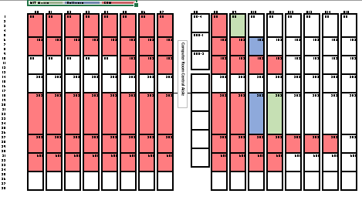
Similar picture for the Flip Flop Storage racks
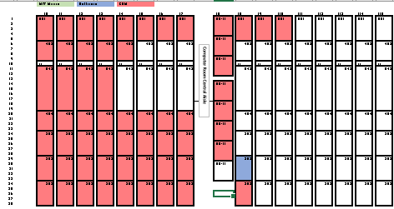
This picture shows the entire machine as of 1951... the 34 racks above are highlighted in yellow boxes below
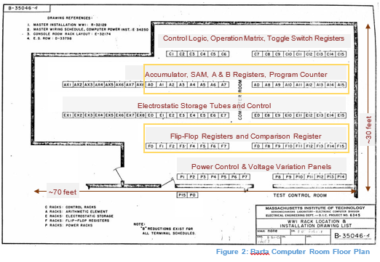
If we want to do anything with this, I think there are a couple steps
- the museum catalogs (don't shoot me please) all have lots of small inconsistencies, i.e., markedly different dimensions for multiple copies of what's supposed to the same unit. I especially like the few items that have a description reading "a curator said this is from Whirlwind".
- not being able to fill in the Memory row seems like a big gap
- the catalogs have things which undoubtedly came with the Whirlwind acquisitions, but are probably not part of Whirlwind as such (e.g., those analog multipliers, or tube-testing racks). A more-careful look at the actual objects might reveal which ones do fit into the machine somewhere, and just aren't described well, vs which ones were bystanders when the Collection Vacuum Cleaner blew through.
- some kind of graphical format that jams this all into one drawing, maybe overlaid on the real floor plan, might make it easier to grasp at a glance.
David, for now I'm inclined to park this, pending discovery of a later floor plan. But let me know if you think we should do something with it sooner rather than later.
/guy

Whirlwind Components
From the MIT off-site storage

IN-1042 - Bus Driver, Arithmetic Rack, Serial #11
Rack-mounted Electronic Panel from Whirlwind arithmetic unit
Phenolic circuit board with components on rear side
26" wide, 11.5" tall, 8.5" deep.
Five vacuum tubes: 2 x 6Y6G, 3x 7AD7
16 BNC connectors
16 pulse transformers
One copy of this Bus Driver panel was located at the top of each of the 16 arithmetic unit racks, A0-A15, as shown in Whirlwind I Master Drawing List and General Rack Layout, PDF Page 10.

IN-1043 – 302 Accumulator, Digits 1-14, Serial #11
Rack-mounted Electronic Panel from Whirlwind arithmetic unit
Phenolic circuit board with components on rear side
26" wide, 27.5" tall, 8.5" deep.
28 Vacuum Tubes: 15x 7AK7, 11x 7AD7, 2x 6SN7
30 BNC connectors
22 Pulse Transformers
Partial Sum and Carry indicator lamps on the rear side of the panel.
One copy of this 302 Accumulator panel was located in the middle of each of the 16 arithmetic unit racks, A0-A15, as shown in Whirlwind I Master Drawing List and General Rack Layout, PDF Page 10.
This unit implements one bit (‘digit’) of the Whirlwind Accumulator; sixteen copies of this panel would make up the full Accumulator register. The place of the Accumulator in the arithmetic unit is shown in Report R-127 WW Block Diagrams Vol II, Figure 29 (https://dome.mit.edu/handle/1721.3/40674).

2000.006.34 – 16-7J Electronic Multiplier
Rack Mounted Electronic Chassis
Manufactured by Electronic Associates, Inc
19” rack-mount width, 8” high, 15” deep
Vacuum tubes and circuitry wired on insulating stand-offs.
The Multiplier unit contains four similar modules, each of which includes
- 10 miniature vacuum tubes (12AX7 and 12AT7)
- One “chopper” unit in an octal tube base
- Many capacitors, resistors and other small components.
The chassis also contains 12 additional miniature vacuum tubes, and a large encapsulated device with fifty pins (6” diameter, 3” tall) with no visible manufacturer’s identification.
The front panel includes eight overload indicators, eight balance controls, eleven toggle switches.
The front panel is marked as “TC2”
The rear panel holds two multi-pin connectors.
[and there’s little direct evidence this unit was ever part of Whirlwind; it just came with all the rest of the WW stuff. Guy’s Theory: it is, or is part of, and analog multiplier.]

Whirlwind Programming Environment
[note: “conversion” is the WW word for “assembly”, i.e., there isn’t an assembler or compiler there are various conversion programs]

Basic Conversion

Comprehensive System Language
This section is based on document M-2539.
Revision | Date
M-2539 | December 1953
M-2539-1 | April 1954
M-2539-2 | December 1955

CS provides an interpretive language environment that’s still assembly instructions, but with two-word floating point numbers as the default.
- Instruction architecture is similar to WW, i.e., an accumulator, one-address instructions, etc
- Numbers are stored in two-word pairs in memory
- “floating addresses” are supported, i.e., one can specify labels for instructions and data, which will be resolved at “conversion” time.
  - Labels must be one letter followed by up to three digits
- Fixed addresses and floating addresses can be used in the same program as desired.
  - E.g. “115 | ” indicates a fixed address
  - “a24 , “ indicates a floating label
  - The conversion program detects duplicate or undefined labels.
- There are interpreted instructions for “cycles”, i.e., loops with various kinds of incrementing indices, without the programmer having to track each counter.
  - Cycles may be nested
- There’s a “post mortem” system. A programmer can provide a tape in addition to the source code called an “fp” tape that gives instructions for what to dump to print after termination.
- There’s a mechanism for managing “temporary” registers. Not sure if this is just a label trick, or if it has some enforcement; see page VII-13 of M-2539-2, Volume One.
- There’s something that looks like they’re trying to improve subroutine linkage over the base hardware instruction set. But it’s still a TA instruction at the start of the subroutine to save the return address.
- There’s a complicated mechanism to print formatted numbers.

M-2539-2 also contains a concise summary of the WW base instruction set, with a one-page summery in five-point type following page XI-24.

[continue reading –
- Section XIII describes how CS are emulated
- Section XIV describes how to use the conversion program
- Section XV describes the Utility Control Program
Section XV of Comprehensive System Manual Part II, Advanced Coding Techniques also contains a description of the Read-In format used by the UCP program stored on drum.
See a scan of this doc at http://www.bitsavers.org/pdf/mit/whirlwind/M-series/M-2359-2_Comprehensive_System_Manual_Dec55.pdf , Section XV, page 9 (M-2359 didn’t seem to make it into the MITRE collection)

The CS-II interpreted op codes are given in document DCL-83.

Modern Software Tool Chain

Tape Decoder
Dis-assembler
Simulator
WW 556 binary tape image
Core file with no labels
Assembler Source listing
.ww file
With optional zero, one memory defined
Assembler
Memory Core Image with symbols
.core file
Assembler Source Listing
.lst file
Note that the Assembler output listing format is compatible with its own input, i.e., you can add comments and labels to the listing and reassemble it
Tape Decoder and Assembler core files are both compatible with the simulator; (but you’d expect the assembler output to have more symbols)
Manually-generated .sym file

File Formats

Binary Tape Files: .7ch

Core Images: .tcore, .acore
“core” format files describe memory images, and may also contain some metadata such as a Start Address.
Each line starts with a memory address, followed by up to eight 16-bit Octal numbers
- Memory image lines start with “@C<addr>
- Directives start with %<directive>

$ cat cal.tcore
%JumpTo 040
@C040: 0000210 0014000 0043000 0134000 0070046 0130042 0074040 0130042
@C050: 0014000 0134000 0070054 0074106 0100042 0114074 0044110 0100112
@C060: 0174114 0110110 0170004 0070100 0100112 0000706 0100112 0024000
@C070: 0000706 0110110 0040112 0130112 0100110 0023000 0100074 0044042

;[000] 0177762 0000100
@C100: 0074040 0100112 0170024 0110000 0170012 0040112 0074064 0000000
@C110: 0074040 0000000 0024000 0020000 0003776 0054004 0064554

Symbol Files: .sym

Octal Tape Files: .otf

Assembler Files: .ww, .lst

Building the Simulator
Source Code is on github at https://github.com/gfedorkow/Whirlwind-Instruction-Simulator
The simulator requires at least Python 3.7
Add the path to the Common directory to the environment variable PYTHONPATH
Install some python packages
- pip install psutil
- pip install screeninfo
- pip install numpy

Source Documents
[moved to separate document, Apr 9, 2018]

Appendices

The CF Instruction
The CF instruction was added in July 1956 to allow expansion to 6K words of memory, with the addition of a 4K Memory Test Computer core memory bank. There were several changes made to the instruction (including at least one for which we have not found a description. )
Doc Num | Issue Date | Contents
6M-4420 | 31 July 1956 | Initial announcement; Note this is the description of what might be done; not the description of what was done.  In particular, the layout of CF bits were scrambled/rearranged by the next version of the doc. (That matters a lot if you try to read the proposed use with ReadIn programs!)  ReadBack is hypothesized, but not promised.
6M-4420-1-s1 | 14 Dec 1956 | This version defines the bits used by CF; A, B, A-En, B-en, SP and ReadBack.  The doc notes that ReadBack and SP aren’t compatible, won’t work, but might not generate an alarm.  “Field Duplication”, using the same bank twice, does generate an alarm  Trying to set a bank to #6 or #7 (which don’t exist) should generate an alarm.  When doing ReadBack in combination with changing the bank settings, the readback will be the new setting (not the old one)
6M-4420-1-s2 | 27 Feb 1957 | This version announces that the accumulator will be cleared after the CF instruction if the SP bit is used. That is, it moves the AC into PC, then clears AC, the completes the branch.  The use case is a branch to 0o35, where the drum block read starts. In octal:  26| 1.141036  …  35| ad 26  36| si 703  37| bi 36
6M-4420-1-s3 | 19 Mar 1957 | Version S3 presents a revised timing diagram for implementation of the S2 change, clearing the AC.
2M-0277 | 31 Oct 1958 | Complete WW Programming Manual, including CF (and every other instruction)

Including the use of a Phantastron oscillator (cool!) https://www.radartutorial.eu/17.bauteile/bt52.en.html
Drafting department drawing A-58815
Whirlwind used a single parity bit per word to check for errors. So while the memory unit externally acted like a 16-bit device, internally it added one more check bit.
I wonder who invented the boot loader? Can’t be ENIAC; in that machine, the entire application was manually loaded…
J Frankovich, personal communication, said programmers competed to see who could write the smallest and coolest loader (2017)
I saw a note somewhere warning the reader not to confuse “556” with “the older 5-5-6” format. Ugh.
Tapes I’ve found do put just the address in this second word, implying that some boot loaders assumed the following instruction would be Transfer to Storage (TS).
Example one of a zillion cases of self-modifying code
“CK 5” says “read location 5 (the temporary memory location at address 5) and compare it to the contents of the accumulator (into which we just put the expected checksum). Trap if not equal.
Redmond and Smith pg 224
https://dome.mit.edu/bitstream/handle/1721.3/45950/MC665_r28_L-18.pdf?sequence=1

