**IMPES Scheme Theoretical Development**

Under the assumptions IMPES (implicit pressure – explicit saturation) makes for two-phase flow, the fluids are immiscible and there is no mass transfer between the phases. For the case of a sand, the wetting phase is the water and the non-wetting phase is the oil, and this would be vice-versa if the reservoir was some form of calcium carbonate. For the most part though, water is the wetting fluid relative to oil and gas, while oil is the wetting fluid relative to gas (Aziz, 1989). Due to the curvature and surface tension of the interface between the two phases, the pressure in the wetting fluid is less than that in the non-wetting fluid. The pressure difference is given by the capillary pressure

pc=po−pw

Where

pw

 and

po

 are the respective pressures of the wetting and non-wetting phases. Empirically, the capillary pressure is a function of saturation Sw.

IMPES solves the two-phase differential equations, and the basic idea behind it is to separate the computation of the pressure from that of the saturation. IMPES is simple to set up and efficient to implement, and it requires less computer memory compared to the SS method(Douglas, Peaceman, Rachford, 1959). Nonetheless, the classical IMPES method requires very small time steps for the saturation for the algorithm to be stable, which is expensive and prohibitive, particularly for small grid block problems such as coning problems.

The transmissibility at each grid block boundary must be calculated carefully in each direction.

Tw1.±12,j,k=(A1𝛾11h1)i±12,j,k=(A1krwk11uw1h1)i±12,j,k

where

A1k11h1

 contains the rock and grid properties and the fluid property

uw1

, and the rock/fluid property

krw

. For the rock, grid, and fluid properties, the harmonic and arithmetic averages are incorporated respectively. As for the rock/fluid property, upstream weighting is used as the averaging method between respective blocks to calculate the transmissibility terms in at each face of the grid block. Based on whether which respective grid block is upstream in relation to the direction of the flow, determines the

krw

chosen to use to calculate the transmissibility on that face of the grid block. In effect, the grid block that is upstream is the one chosen to provide the

krw

value. This can be formulated in a computer by creating if statements depending on the pressure array. Basically, if an adjacent block pressure is higher than that means it is upstream in relation to the flow and therefore that relative permeability is chose for the transmissibility calculation.

–T1,i+12,j,k (pni+1,j,k−pni,j,k

)

+Tn1,i−12,j,k(pni,j,k−pni−1,j,k)

–T2,i,j+12,k (pni,j+1,k−pni,j,k

)

+Tn2,i,j−12,k(pni,j,k−pni,j−1,k)

–T3,i,j,k+12 (pni,j,k+1−pni,j,k

)

+Tn3,i,j,k−12(pni,j,k−pni,j,k−1)

=–Tw1,i+12,j,k (pnc,i+1,j,k−pnc, i,j,k

)

+Tn1,i−12,j,k(pnc,i,j,k−pnc,i−1,j,k)

–Tw2,i,j+12,k (pnc,i,j+1,k−pnc,i,j,k

)

+Tnw2,i,j−12,k(pnc,i,j,k−pnc,i,j−1,k)

–Tw3,i,j,k+12 (pnc,i,j,k+1−pnc,i,j,k

)

+Tnw3,i,j,k−12(pnc,i,j,k−pnc,i,j,k−1)

–(T𝛾)1,i+12,j,k (z,i+1,j,k−z i,j,k

)

+ (T𝛾)n1,i−12,j,k(zi,j,k−zi−1,j,k)

–(T𝛾)2,i,j+12,k (z,i,j+1,k−z i,j,k

)

+ (T𝛾)n2, i,j−12,k(zi,j,k−zi,j−1,k)

–(T𝛾)3,i,j,k+12 (z,i,j,k+1−z i,j,k

)

+ (T𝛾)n2, i,j,k−12(zi,j,k−zi,j,k−1)

+Qni,j,k

where

Sn

is given and

Ti,j−12,k=(A1𝜆k11h11)i−12,j,k

T𝛾1,i,−12,j,k=(A1𝜆k11h11)i−12,j,k

In IMPES, the previous equation is explicitly solved for S; i.e., for each timestep n = 0,1,2,…,

 Sn+1

 satisfies

*[Math Processing Error]*

= *[Math Processing Error]*) *[Math Processing Error]*

*[Math Processing Error]*) *[Math Processing Error]*

*[Math Processing Error]*) *[Math Processing Error]*

*[Math Processing Error]*) *[Math Processing Error]*

*[Math Processing Error]*) *[Math Processing Error]*

*[Math Processing Error]*) *[Math Processing Error]*

+Qnw,i,j,k

where *[Math Processing Error]*

The IMPES method uses equation 2

Sn

 to evaluate

pn

; next, we utilize

Sn

,

pn

, and equation 2 to compute

Sn+1

 (Chen, 2007).

In my IMPES code, I implemented the single point upstream weighting, which is a first order approximation. In general, the relative permeabilities can be approximated using either single or two-point upstream weightings, while the former approximates the slopes of the capillary pressures.

For the pressure computation in the classical IMPES method, the saturation is assumed to be known, and the pressure array is solved for implicitly. In effect, the calculations of the pressures and saturations are separated respectively and the former is calculated implicitly while the latter is calculated explicitly.

The implicit formulation expresses inter-block flow terms using new time values for all the variables in all the grid blocks. Therefore, the linear solver required for resulting matrix equation is matrix-matrix or matrix-vector multiplications, requiring work (number of scalar multiplications) of order n^3 or n^2, respectively. In terms of stability, the IMPES method treats capillary pressure explicitly and has therefore a stability limit depending on the magnitude of the sole of the capillary pressure. The SS method treats all primary variables implicitly on the other hand, and in this respect it is unconditionally stable. The second limitation when it comes to these methods stems from the explicit treatment of transmissibility, which are where the strongest nonlinearities are involved. Because this treatment is identical for both the IMPES and SS formulations, so is the stability limit (Chen, 2007).

The IMPES formulation, on the other hand, takes all the variables in the inter-block flow terms explicitly, except for the pressure, which is done implicitly. Doing this ensures that all entries but those in the last column of the matrix are zero which allows for the elimination of all non-pressure variables and reduction of a vector to a scalar equation in pressure only. In effect, the multiplications required in the solution of the IMPES pressure formulation are just scalar multiplications, requiring a small fraction of the work of the matrix-matrix and matrix-vector multiplications in the implicit formulation. Therefore the CPU time per grid block for moderate or large n is much less for the IMPES formulation than for the implicit formulation (Chen, 2007).

**Simultaneous Solution Scheme Theoretical Development**

The simultaneous solution method is an alternative method to IMPES, and it writes the saturation derivatives in terms of pressure derivatives and the solution of the resulting equations for pressure. The SS method was first proposed by Douglas et a. (1959), and later extended and further analyzed by several investigators (Coats et a., 1967; Coats, 1968; Sheffield, 1969). When dealing with the differential equation for two-phase flow, these equations are parabolic and many methods will not work applied to systems of coupled nonlinear equations of this type. In effect, the explicit method and the ADI method, a method that uses a different level of implicitness in different blocks, are both unstable for these types of problems. The SS method is based on the backward difference approximation, which has been shown to be stable for problems of this type (Douglas, 1960). Instead of just one equation for water and for oil respectively in different T matrices for the case of IMPES, there are two equations for each grid block, one for water and one for oil, for the case of the SS method, and this means that the matrix is twice as big as for the case of the same system using IMPES. This form is useful because many matrix algorithms can be readily extended to this type of “block-structure matrices” by formal substitution of matrix operations for arithmetic operations. The finite difference equations for all grid points can now be written in a matrix form as

*[Math Processing Error]*

where T is the transmissibility matrix, D is the accumulation matrix, G is the vector of gravity terms, and Q is the source vector.

The SS method requires non-zero capillary pressure since the equations of pw and po are coupled through Sw’. The matrix D becomes dominant and the system of equations becomes singular, as the capillary pressure slope decreases. Thus, if one wishes to simulate the case of zero capillary pressure, a small “dummy” Pc curve (linear) must be used. Fortunately though, the value of the capillary pressure derivative is not meaningful enough to affect the answers.

Another remark on the SS method is that after the time step is completed, Sw must be updated, and this step involves the treatment of the nonlinearities due to capillary pressure. A final remark of the SS method is that it becomes expensive for multidimensional problems since the number of unknown’s is N x number of phases. Thus, it is typically not implemented for 2D or 3D simulations. Nonetheless, its real value is in conjunction with implicit treatment of transmissibility and its relative stability (i.e. it is unconditionally stable based on Fourier Analysis) compared to other finite difference methods. Stability problems become severe especially in the simulation of multidimensional flow around a single well, where high flow velocities are attained due to convergence of the flow towards the sink. This stability problem is dud to the explicit treatment of transmissibility, and most of the methods of handling this problem are closely related to newton’s method of solving nonlinear equations. Of the two basic solution methods (SS and IMPES, only the SS method is suitable for implicit treatment of the T matrix, which is why the SS can be easily extended to multiphase flow. In 1D, instability of explicit saturation equations occurs when the saturation front advances one grid point per time step. In multidimensional (especially single-well) problems, instability of explicit equations occurs for much smaller time steps, but using linearization techniques such as Newton’s method improves this situation immensely (Aziz, 1989).

Sine one iteration needs approximately the same amount of work as the solution of one time step, a fast rate of convergence is crucial for the practical feasibility of using a fully implicit method, or semi-implicit method. Therefore, a good initial guess is very important. For most cases, the essential conditions are that the functions of the residual have continuous second derivatives and the Jacobi matrix have an inverse, and under these conditions, we always have a good starting value for the iteration, which is the result of the previous time step. With stability analysis, it can be shown that the stability increases with increasing “implicitness” of the method; however this is gained at the expense of larger truncation errors. Therefore, for the solution of practical multidimensional problems, the linearized method is recommended since the fully implicit equations have large truncation errors and the stability gain may not be utilized because time steps are limited by other considerations as well (Aziz, 1989).

**Comparison of IMPES vs. SS vs. Buckley Leverette in 1D**

Based on the finite difference formulations of IMPES and SS respectively, I created two different codes using my general master code that can be implemented for 1D, 2D, and 3D IMPES, and then a separate code for my SS code (was not able to get the SS to more than 1 dimension unfortunately). Nonetheless, from a 1d perspective, we can see the differences in outcome between both of the respective codes and the analytical Buckley Leverette Solution.

As can be seen in Figure 1 and Figure 2, comparing the water saturation at block 2 reaching a water saturation value of 0.65, we see that both codes and the analytical Buckley Leverette model yield similar results. As shown in Figure 3 from the Buckley Leverette Analysis, breakthrough does in fact occur at around a water saturation of 0.65.



Figure 1

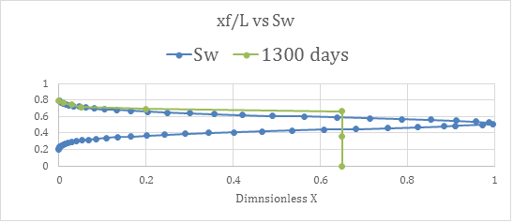

Figure 2

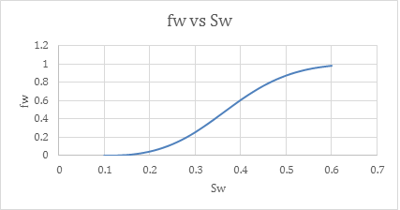

Figure 3

The input parameters for the both of the SS and IMPES codes respectively are shown in Figure 4:

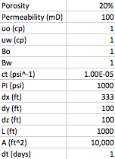

Figure 4

The input data for the Buckley Leverette is based on the exact dimensions and rock-fluid properties (i.e. the Brooks Corey relationship in Figure 6), and it can be seen in Figure 5.

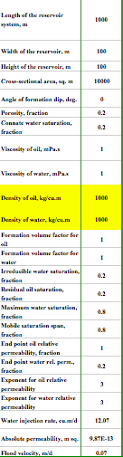

Figure 5

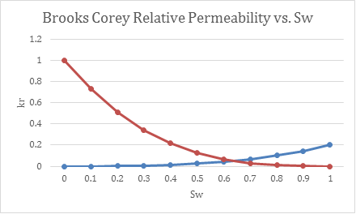

Figure 6

In conclusion, the simultaneous solution gives the most conservative results followed by the Buckley Leverette and then IMPES; nonetheless, they all give similar results which is expected given the same initial conditions.

**2D Analysis of Flow Patterns in Water Displacement Scenarios**

**Buckley Leverette Theory**

Secondary recovery, or waterflooding, is one of the most effective recovery methods to increase the oil production rates through pressure maintenance and sweeping of the oil thus increasing the oil recovery. The Buckley Leverett theory is a model for waterflooding of a one-dimensional, incompressible and multiphase petroleum reservoir. It is a simplified model, and it neglects the effects of gravity and capillary pressure (Ahmed, 2001).

The theory behind the Buckley Leverette model is common in fluid mechanics: Darcy’s Law and the differential form of mass balances. The fractional flow equation is a model used to determine the water fraction of the total fluid flow at a particular location and time, and it is also referred to as water cut (Ahmed 2001). The fractional flow equation is the basis of the Buckley Leverett theory, and its assumptions are that the displacement is linear, oil and water are immiscible and the system is water wet and incompressible. Another assumption, known as the diffuse flow condition, is that the oil and water saturations at any point in the linear displacement path are uniformly distributed relative to the thickness, which allows for the displacement to be considered one-dimensional. Assuming that the reservoir is horizontal and there is not gravity effect, the fractional flow equation is simplified to

fw=𝜆w𝜆t=11+1M(Sw)

where

 𝜆w

 is the mobility of the water and

𝜆t

 is the total mobility(Ahmed, 2001).

Using dimensionless and normalized variables makes solving the Buckley-Leverett equation simpler and more conveniently. Defining the dimensionless position xD is merely a function of the to0tal length of the reservoir and gives an idea where the water front is positioned relative to the entire reservoir span. In conclusion, Buckley Leverette is an analytical solution to the water-displacement process and can be used to benchmark 2-phase reservoir flow code.

**Flow Patterns**

The ultimate recovery based on the displacement process of secondary recovery depends on many factors, including reservoir and fluid characteristics that are beyond the petroleum engineer’s control. Other factors such as the number and type of wells, well rates, and well locations, however, can be controlled. Reservoir flow models are useful for performing a specific analysis of these factors based on the specific reservoir and fluid properties. The determination of a development plan can be optimized based on the most efficient well pattern that would yield the most effective displacement, and thus lead to the highest ultimate recovery before water breakthrough at the production wells.

Displacement efficiency accounts for the efficiency of recovering the mobile hydrocarbon. Specifically, the ratio of mobile oil to the original oil in place at reservoir conditions is the dimensionless value that the displacement efficiency for oil represents.

ED=VpSoi−VpSorVpSoi=(Soi− Sor)Soi

where

Vp

is the initial pore volume,

Soi

 is the initial oil saturation, and

 Sor

 is the residual oil saturation. Displacement efficiency can approach 100% if residual oil saturation can be driven to zero (Fanchi, 2005).

The definition of displacement efficiency can be modified to include the effects of swelling. Instead of using the reservoir volume in the definition of displacement efficiency, swelling uses the surface volume. The volume conversion is achieved by dividing reservoir volume by the formation volume factor (FVF). For example, the displacement efficiency of a water-flood is

*[Math Processing Error]*

where

Boi

 is the oil FVF at the beginning of the water-flood and

Boa

 is the oil FVF at the waterflood pressure. Note that the oil formation volume factor is maximum at the bubble point pressure; therefore if the water-flood is conducted at or just above the bubble point pressure, the value of Boa will be maximized and the residual oil term will be minimized. In effect, the resulting displacement efficiency for a water-flood is then maximized (Fanchi, 2005).

In addition to displacement efficiency, volumetric factors such as areal and vertical sweep efficiencies are used to determine the overall recovery efficiency and are defined by

EA=Swept AreaTotal Area

and

EV=Swept ThicknessTotal Thickness

Reservoir models give us insight in the parameters that affect both the swept area and swept thickness. The product of the area and vertical sweep efficiency is the volumetric sweep efficiency

EVol

:

EVol= EA+EV

The overall recovery efficiency must account for both the volumetric and displacement effects. IT is thus defined as the product of the volumetric sweep efficiency and the displacement efficiency:

RE=ED x EVol= ED  x EA x EV

Note that the efficiency factors can be relatively large, and yet the recovery efficiency will be relatively small due to the multiplicative effect of the terms (Fanchi, 2005).

**Analysis of 2D water-flooding scenarios**

The initial conditions for all of the 2D water-flooding scenarios are all based on the same grid properties and initial conditions as shown in Figure 8. To be able to increase the amount of grids from a 3 x 3 reservoir with a specific volume, I implemented a spreadsheet that equalized a 9 x 9, 10 x 10, 9 x 10, and 9 x 11, and a 20 x 20 in terms of their block dimensions yielding the same total reservoir volume as can be shown in Figure 7 below. Additionally, for each scenario, even if the total number of wells increased, the net amount injected and produced from the reservoir was 4000 bbd so the energy input – energy output is always the same, thus allowing the well patterns themselves to be compared.

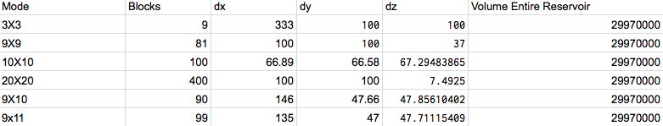

Figure 7

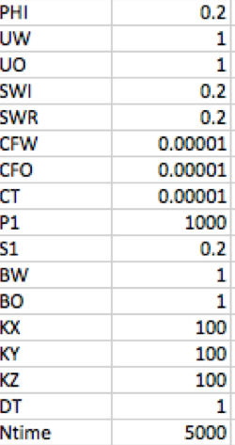

Figure 8

**5-spot vs. Inverted 5-spot**

Using a 10 x 10, two-dimensional grid, a comparison of a 5-spot and Inverted 5-spot pattern was implemented. As can be seen in Figure 9, the breakthrough time for each model occurs at the exact same time at 569 days which is also reasonably comparable with the other models, in addition to proving that both well configurations match up perfectly. For both cases, the amount injected (4000 bbd) was the same for the amount produced (4000 bbd) at each time step, thus mass conservation was implemented and the pressure field basically reaches a steady state by looking at the output files. The water front reaches the producers at either the boundaries or the center at the same time no matter the configuration.

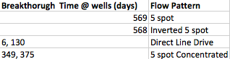

Figure 9

**Direct Line Drive**

The Direct Line Drive well configuration was implemented using grid dimensions of dx = 66.8 ft , dy = 66.8 ft , dz = 67.29, and the same initial conditions as the 5-spot and inverted 5-spot. The main difference is the sheer amount of wells the direct-line drive implemented: twenty injectors and twenty producers compared to the 5 spot patterns that used 5 wells each respectively. The breakthrough time for the Direct Line Drive occurs at a mere 6 days for some producers and around 130 days for the rest of the producers. This is assuming the net flow input-output for the reservoir is the same as the 5 spot pattern. Thus, each well flowrate for the direct line drive is at only 200 bbd instead of 1000 bbd. Thus, this is a comparison of the flow pattern in and of itself. Reducing the breakthrough time from 569 days to 72 days is a reasonable since there are so many more wells compared to the regular 5-spot and Inverted 5-spot patterns.

**5 spot Concentrated vs. 5 Spot and 5-Spot Inverted**

The 5-spot concentrated is merely the same pattern as the 5 spot but in a more concentrated form. Thus, instead of totaling just 5 wells, the 5-spot Concentrated consists of 10 producers and 4 Injectors in a more dense pattern. Increasing the sheer amount of wells has a significant effect on the breakthrough time as can be seen in Figure 9 where the breakthrough time respective producer is at either t = 375 days or t = 349 days, which are both around the same range as the 569 days as was the case for the regular 5 spot and Inverted 5-spot.

**9 spot vs. Inverted 9 spot (9x11)**

To implement a 9 spot well pattern, I created a 9 x 11 grid instead of a 9 x 9 or 10 x 10. The setup based on injectors (red) and producers (blue) can be seen in Figure8. Nonetheless, the initial conditions are all the same as the previous versions. Thus, the reservoir is slightly smaller (i.e. one fewer grid block of dx = 135 ft, dy =  47 ft, and dz = 47.7 ft) on the boundary. For the 9-spot scenario, there are 18 Injectors and 6 producers and the 6 producers reach a breakthrough time based on mirroring pattern at around 200 days. The break-through time for well 23 is the same time for well 73, and from looking at Figure 10, it can be seen that this is a “mirroring” pattern. So block 25 is equal to block 75 and block 31 is equal to block 76 etc. For the case of the Inverted 9-spot the situation is reversed and there are 19 producers and 6 injectors, and the breakthrough time does not seem to follow the same mirroring pattern or any other pattern. This difference is not expected since for both scenarios the total amount injected and produced from the reservoir is exactly the same, and unfortunately I did not have time to investigate this further.



Figure 10

/var/folders/dy/fjn_tyjs03992xj69z71jyh40000gn/T/com.microsoft.Word/WebArchiveCopyPasteTempFiles/GA+4uU6KZAAAAAElFTkSuQmCC

Figure 11

**Verification of SPE CSP #10 vs. Master Code IMPES 1D, 2D, 3D**

To verify the master IMPES code (1D,2D,3D), the exact reservoir and simulation in SPE CSP #10 was implemented to see any discrepancies in the results. The grid was 2 dimensional with one injector at a constant flowrate of 246 ft^3/d at one end and a producer at a constant bottom hole pressure of 95 psi at the other end. Instead of water being injected, gas is injected, so a different set of relative permeability data was implemented as shown in Figure 12.

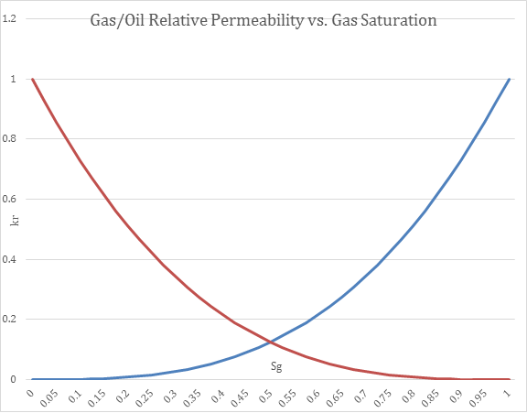

Figure 12

As can be shown in Figure 13, the input data of the reservoir in terms of the input file were exactly the same.

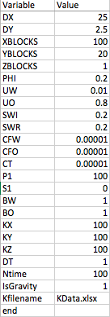

Figure 13

I never found a saturation or pressure map to compare but I did compare the production rate of my well from the Figure 14 which is from the CSP paper below.

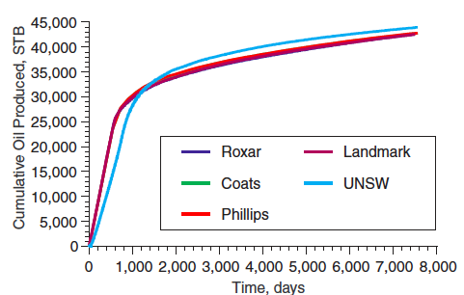

Figure 14

Comparing my results in the J-output file (adding up each row for each time step = 22.7 bbd), and summing all the flow rates for each producing block of the well I get a rate of 22.7 bbd for the entire well for the first 2000 days. From Figure 14, deducing from the slope and noting that the cumulative production for the first 2000 days, is 30,000 STB, then we know that the well was producing at a constant rate of 30 bbd. The discrepancy between my model and the paper is around 33% and I believe it has something to do with the respective density difference between the gas and the oil in comparison to my assumption that they are the same density as I did for the case of the water-flooding scenarios. I noticed that if I reduced the oil viscosity from 1 cp to 0.8 cp, I could get my oil flow rate to increase to 28 bbd which is pretty close to the paper, but of course wrong. I was unsure how to implement the density difference, but I am pretty sure it would change the Bmatrix and have something to do with the following equation:

Soco+Sgcg=1

Given the densities, I was unsure how to implement this since theis equation is in terms of compressibility.

**Black Oil**

For two-phase flow, it is assumed that there is no mass transfer between the phases. The black oil model relaxes this assumption due to the additional phase of gas making it three-phase flow. The black oil model assumes that the hydrocarbon components are divided into a gas and oil component in a stock taken at standard conditions, yet still assumes that there is no mass transfer between the water and the other two phases (oil and gas). Because of the mass interchange between the oil and gas phases, mass is no longer conserved within each phase, but rather the total mass of each component must be conserved.

For the water component,

𝜕(∅𝜌wSw)𝜕t= −∇ (𝜌wuw)+qw

For the oil component,

𝜕(∅𝜌OoSO)𝜕t= −∇ (𝜌OouO)+qO

For the gas component,

𝜕∅(𝜌GoSO+ 𝜌gSg )𝜕t= −∇ (𝜌GouO+𝜌gSg )+qG

where

𝜌Oo

 and

𝜌Go

 indicate the partial densities of the oil and gas components in the oil phase respectively.

The fact that the three phases jointly fill the void space provides the following constraint:

Sw+Sg+So=1

Instead of working with mass conservation equations above, the black oil model works in terms of “standard volumes”. In effect, the mass fractions of the oil and gas components in the oil phase can be determined by the gas solubility ratio,

RSO

 ( also called the dissolved gas/oil ratio), which is the volume of gas (measured at standard conditions) dissolved at a given pressure and reservoir temperature in a unit volume of stock tank oil:

RSO=WG 𝜌OsWO 𝜌Gs=VG VOS

where

WG

and

WO

are the weight of the oil and gas components, respectively.

The oil formation volume factor

BO

 is the ratio of the volume of the oil phase to the volume of the oil component measure at standard conditions:

BO(p,T)=VO(p,T)VOS

where

VO=WO + WG 𝜌o

Consequently,

BO=(WO+WG)𝜌OsWO𝜌O

The mass fraction of the oil and gas components **in the oil phase** are respectively,

COo=WOWO+WG=𝜌OsBO𝜌O

CGo=WGWO+WG=RSO𝜌GSBO𝜌O

which together yield

COo+CGo=1

, and therefore

𝜌O=RSO𝜌GS+𝜌OsBO

The gas formation volume factor

Bg

 is the ratio of the volume of the gas phase measured at reservoir conditions to the volume of the gas component measured at standard conditions:

Bg(p,T)=Vg(p,T)VGs

Let

Wg=WG

 be the weight of the free gas. Because

Vg=WG𝜌g

 and

VGs=WG𝜌Gs

, we see that

𝜌g =𝜌GsBg

The definition of transmissibility is

T∞=kr∞u∞B∞k

where

∞=w, o, g

Substitution the previous three equations and dividing the resulting equations by

𝜌Ws

 ,

𝜌Os,

𝜌Gs,

 respectively we obtain:

𝜕𝜕t(∅Sw)Bw= −∇ (𝜌wuw)+qw= ∇ (Tw[∇pw−𝛾w∇z])+qwsBw

𝜕𝜕t(∅So)Bo= −∇ (𝜌OuO)+qO= ∇ (To[∇po−𝛾o∇z])+qOsBO

*[Math Processing Error]*

These are the conservation equations on “standard volumes”. The previous equations combined with the unity equation of saturation and the phase/capillary pressure results in six equations for six unknowns. If the bottom hole pressure is not given, the source/sink term defining this pressure introduces one more unknown. Nonetheless, with appropriate boundary and initial conditions, this is a close differential system for these unknowns (Chen, 2007).

**Rock and Fluid Properties**

The capillary pressures

pcw

 and

pcg

 are assumed to be functions of the saturations only:

*[Math Processing Error]*

*[Math Processing Error]*

There are models for oil relative permeability such as Stone’s model I and II that are functions of

krc

,

krow

krog

,

Sw

, and

Sg

(Chen, 2007).

**Black Oil Fluid Properties**

The black oil model is constituted by three phases and three components: water, oil, and gas. The entire water component is always only in the water phase with density

𝜌w .

Likewise, the oil component exists solely in the oil phase with density

𝜌Oo

, and the gas component is divided into two parts: one part in the gas phase, which is called free gas with density

𝜌g

, and the other part in the oil phase, which is termed the solution gas with density

𝜌Go

. Thus the oil phase density

𝜌O

 is given by:

𝜌O=𝜌Oo + 𝜌Go

The oil component density

𝜌Oo

is evaluated from

𝜌Oo =𝜌Os Bo

wher the oil formation volume factor

Bo is

Bo=Bob(pb)(1−co(p−pb))

where

Bob

 is the bubble point pressure

pb

 and

co

, the oil compressibility. The solution gas density

𝜌Go

 is computed by

𝜌Go=𝜌Gs Bg

where

𝜌Gs =YG𝜌Air

,

Bg=ZTp  ps  Ts

where

YG

 is the raw gas density (which is unity for air),

𝜌Air

, the air density, Z the gas deviation factor, T the temperature, and

  ps

 and

  Ts

, the formation pressure and temperature at standard conditions.

The oil viscosity

uo

 is given by

  uo=  uob( pb)(1+cu(p− pb)

where

  uob

 is the oil viscosity at

 pb

 and

cu is the oil viscosity compressibility.

 The gas viscosity

  ug

 is a function of p(Chen, 2007):

  ug=  ug(p)

**Phase States**

If the reservoir pressure is above the bubble point pressure of the oil phase, the flow is two-phase and it is considered under saturated, meaning that all gas is dissolved in to the oil phase, and there is no gas phase present (no free gas; i.e.

Sg=0

). The densities and viscosity in the oil phase depend on both p and

 pb

:

𝜌Oo (p, pb)=𝜌OS BOb( pb)(1+co(p− pb))

𝜌Go (p, pb)=RSO ( pb)𝜌GsBOb( pb)(1+co(p− pb)),  𝜌g (p)=𝜌GS Bg( p)

  uo(p, pb)=  uob( pb)(1+cu(p− pb),   ug=  ug(p)

If the reservoir pressure is below the bubble point pressure, then the flow is three-phase and is considered saturated because the free gas comes out of solution (i.e.

Sg≠0

 and

 pb=p

). The densities and viscosity depend on the pressure p:

𝜌Oo (p)=𝜌Os Bob(p)

𝜌Go (p, pb)=RSO ( pb)𝜌GsBOb( pb)

 𝜌g (p)=𝜌GS Bg( p)

  uo(p)=  uob

  ug=  ug(p)

In the under-saturated state, p =

 po

,

 pb

,

and Sw

are the primary uknowns. For the saturated state, p =

 po

,

 So

,

 and Sw

 are the primary unknowns. Consequently, the initial conditions for e ach grid block consist of a pressure,

 Sw,

 and

 So

(Chen, 2007).

**Treatment of Initial Conditions**

Differences in phase gravities and capillary pressure over geologic time cause fluids to segregate until the reservoir system reaches gravity/capillary equilibrium. There exists up to five different fluid zones from the top to the bottom of a reservoir: gas cap, gas/oil transition, oil-water transition, and water zone and for each zone, different initial data can be specified. Each zone stated above is considered to be a continuous phase except for the case of the oil zone, where the gas component is not continuous even though the oil phase is continuous. For a continuous phase, the initial pressure is directly calculated from a hydrostatic relation based on the fluid density, while for a discontinuous phase, the initial pressure is determined from the capillary pressure function evaluated at the endpoint saturation. For a continuous phase, the initial saturation is calculated from either the capillary pressure function or the saturation relation, whereas for a discontinuous phase, the initial saturation is given at the endpoint saturation (Chen, 2007).

**Gas Cap Zone**

Initially, only the gas phase is continuous in the gas cap zone, and therefore the vertical distribution of the gas pressure can be computed from the hydrostatic relation

dpgdz=𝛾g

In addition,

Sw=Siw

So=0

where

Swi

 is the irreducible water saturation. From these variables, other variables can be deduced:

Sg=1−Sw−So

 po= pg− pcgo(Sgmax)

 pw= po− pcow(Swi)

where

Sgmax

 is the maximum gas saturation in the original gas cap (Chen, 2007).

**Gas/oil transition zone**

As stated previously, both the gas and oil phases are continuous in the gas/oil transition zone, so the vertical pressure distribution of these phases can be directly obtained from the hydrostatic relations

dpgdz=𝛾g

dpodz=𝛾o

And an additional condition is

Sw=Siw

From these conditions, we can deduce these variables:

Sg=pcgo−1(pg−po)

 pw= po− pcow(Siw)

So=1−Sg−Sw

where we assume that

pcgo

has an inverse

 pcgo−1

 (Chen, 2007).

**Oil zone**

The oil phase is also only continuous in the oil zone; therefore:

dpodz=𝛾o

Additional, we have

Sw=Siw

Sg=0

It follows that

 pg= po− pcgo(0)

 So=1− Sg− Sw

 pw= po− pcow(Siw)

where the capillary pressure

 pcow

 is assumed to be invertible (Chen, 2007).

**Water Zone**

In the water zone, only the water phase is continuous:

dpwdz=𝛾w

In addition, we know that

Sg=So=0

From this, we have

 po= pw− pcgo(Swmax)

 pg= po− pcgo(0)

Sw=1

where

Swmax

is the maximum water saturation in the original water zone. Given the depths of the water/oil contact and the oil/gas contact, the initial pressure and saturation at all grid blocks can be uniquely determined if a reference pressure and a reference depth are given. For a undersaturated reservoir, the reference depth and pressure are arbitrary and can be specified in any of the five fluid zones. For a saturated reservoir however, the reference depth must be the depth of the oil/gas contact, and the reference pressure must be the initial bubble point (saturation) pressure. If capillary pressures are ignored (

  pcow and pcgo

), the initial phase saturations (often the endpoint saturations) must be imposed, but the pressure can be obtained from the reference pressure. If this assumption is made, no transition zone is generally assumed to exist in the reservoir (Chen, 2007).

**Conclusion**

In the end, the two phase program that I developed can be implemented in 1D, 2D, and 3D for however many blocks desired with the capability of implementing a permeability map and also differing block volumes. I did this and coded the simultaneous solution scheme in 1D, 2D, and 3D. Looking back, I am surprised how simple my algorithm is for my program given that when I presented my results, I was hard coding the transmissilbity and was limited to a 5 x 5 setup. Hard coding my program resulted in about 5000 lines, but implementing functions into my code and understanding how to build the matrices using my algorithm reduced the entire code to less than 1000 lines and that is in addition to having the capability to do 3D.  The code is stable and behaves symmetrically in my 2D water-flooding patterns for the 5-spot, Inverted 5-spot, Direct Line Drive, and concentrated 5-spot where they give reasonable results in comparison to one another. For the 9-spot patterns, the breakthrough time is not perfectly symmetrical but I think this may be due to well interference effects from having wells too near each other. To test this, I would merely increase the block numbers from a 10 x 10 to something like 20 x 20 and make the reference reservoir larger. My simulator is validated with SPE CSP #10, given that the same input parameters result in the same output as the paper.

**References**

Chen, Z. (2007). *Reservoir simulation: mathematical techniques in oil recovery* (Vol. 77). Siam.

Aziz, K., & Settari, A. (1979). *Petroleum reservoir simulation*. Chapman & Hall.

Fanchi, J. R. (2005). *Principles of applied reservoir simulation*. Elsevier.

Peaceman, D. W. (2000). *Fundamentals of numerical reservoir simulation* (Vol. 6). Elsevier

Ahmed, Tarek. Reservoir Engineering Handbook Second Edition. 2001.

Christie, M. A., & Blunt, M. J. (2001, January). Tenth SPE comparative solution project: A comparison of upscaling techniques. In *SPE Reservoir Simulation Symposium*. Society of Petroleum Engineers.

Bottom of Form