Phys 212 Lab: How Capacitors Work
Name: ____________________________ Date: ______________
Name: ____________________________ Lab Sect.: __________
Name: ____________________________ Lab Instructor: ______________________

Goals:
- To examine how a capacitor stores energy.
- To examine how capacitors behave when used in tandem (in series).
- To model how capacitors might actually be made based on what principles of electrostatics have been discussed thus far.
Lab Objectives:
- Make experimental measurements using standard equipment, including multi-meters and oscilloscopes.
- Record and process experimental data.
- Identify patterns in the data and devise an explanation for an observed pattern.
Labs are graded based on the rubric below:
Participation |  | 75 pts
  75 pts  Full Participation  Name is on sign in sheet and lab submission | 25 pts  Inadequate Participation  Team member is disrespectful and not participating with group. Team member did disproportionately small amount of work | 0 pts  No attendance or work on lab
Physics Effort  Small deductions can be made for minor errors like sign, unit or vector notation |  | 50 pts
  50 pts  Very good  Reasoning is Correct. All answers acceptable. Units are included and Explanations are good | 40 pts  Good  One physics mistake | 30 pts  Adequate  More than one physics mistake, or substantial part of work missing that was reasonably expected to be complete | 15 pts  Inadequate  Large portion of recitation is wrong, or incomprehensible | 0 pts  no submission  Name not on any paper
Communication |  | 25 pts
  25 pts  Very Good  Complete sentences, units labeled, graphs have labeled axes. Clear answers | 20 pts  good  Complete sentences, errors with units or graphs | 10 pts  Inadequate  Brief phrases, incomplete sentences, minimum work to communicate | 0 pts  No Marks
*Lab Space Clean Up* Please ensure that your area is clean and your TA signs-off on the sign-in sheet before leaving. Failure to do so will result in a 10 point penalty.

Equipment:

- PASCO 550 Universal Interface
- Voltage Probes
- Phys212 LabKit Module
- 2 Amp Power Supply
- (7) banana-plug connecting wires
- Software: PASCO Capstone

Introduction:
A capacitor consists of two isolated conductors with a charge +Q on one conductor (typically referred to as a “plate” and an equal but opposite charge −Q stored on the other conductor. This charge stored by a capacitor is proportional to the potential difference between the two conductors:
, (Eq. 1)
where C is known as the capacitance. The capacitance of a given set of conductors depends only upon their geometry (the shape of the conductors and the distance between them) and on the “stuff” placed between them, this “stuff” is called a dielectric.

If a capacitor has a capacitance C₀ when the space between the conducting plates is occupied by vacuum, or air, adding an insulating material into that space increases the capacitance by a multiplier called the dielectric constant κ , which depends on the type of insulating material:
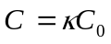, (Eq. 2)
where C is the capacitance when a material with dielectric constant κ has been inserted between the plates.

A capacitor also stores electric potential energy. A capacitor with a capacitance C that has a potential difference V between its plates stores an electric potential energy equal to
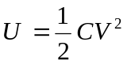. (Eq. 3)
By solving Equation 1 for the voltage V, we can also see that
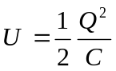. (Eq. 4)
This energy is stored in the electric field between the plates of the capacitor.

In this laboratory we will study how capacitors behave when combined in series and in parallel. When capacitors are in series, they are connected one immediately after the other, with exactly one conducting connection leading from one plate of one capacitor to one plate of the other. When arranged in series, capacitors will always carry the same charge. Capacitors in series have an “equivalent capacitance” given by
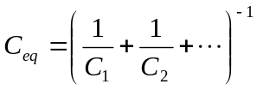, (Eq. 5)
where C_{i} is the capacitance of the i^{th} capacitor connected in series.

We can also connect any number of capacitors in parallel. In this case, all capacitors will share a common conducting connection across one of each of their plates, and another common conducting connection across their other plates. When arranged in parallel, the capacitors will all have the same potential difference across them and equivalent capacitance is given by
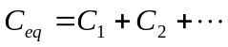, (Eq. 6)
the sum of the capacitances of the individual capacitors.

Directions:
In this experiment we will use a Power Supply to provide a fixed potential difference (Voltage) in the same way a battery does. This potential difference pulls electrons around the circuit creating a current.

Lab Activity 1: How capacitors store energy
In this first activity, we will examine how capacitors are used to store energy by studying the charging and discharging process at a qualitative level.

- Make sure that the PASCO interface is powered on (the power button should be glowing blue light)
- Plug your voltage probe into Channel A. Make sure the arrow on the probe is aligned right below the “A” on the 550 Interface. The arrow or the word TOP must be aligned or you will blow the PASCO interface.
- Open PASCO (start -> All Programs -> PASCO scientific -> PASCO Capstone), and click on Hardware Setup in the upper left corner. You should see a picture of the PASCO interface box. Click on the part of the picture that corresponds to the channel A that your voltage probe is plugged into.
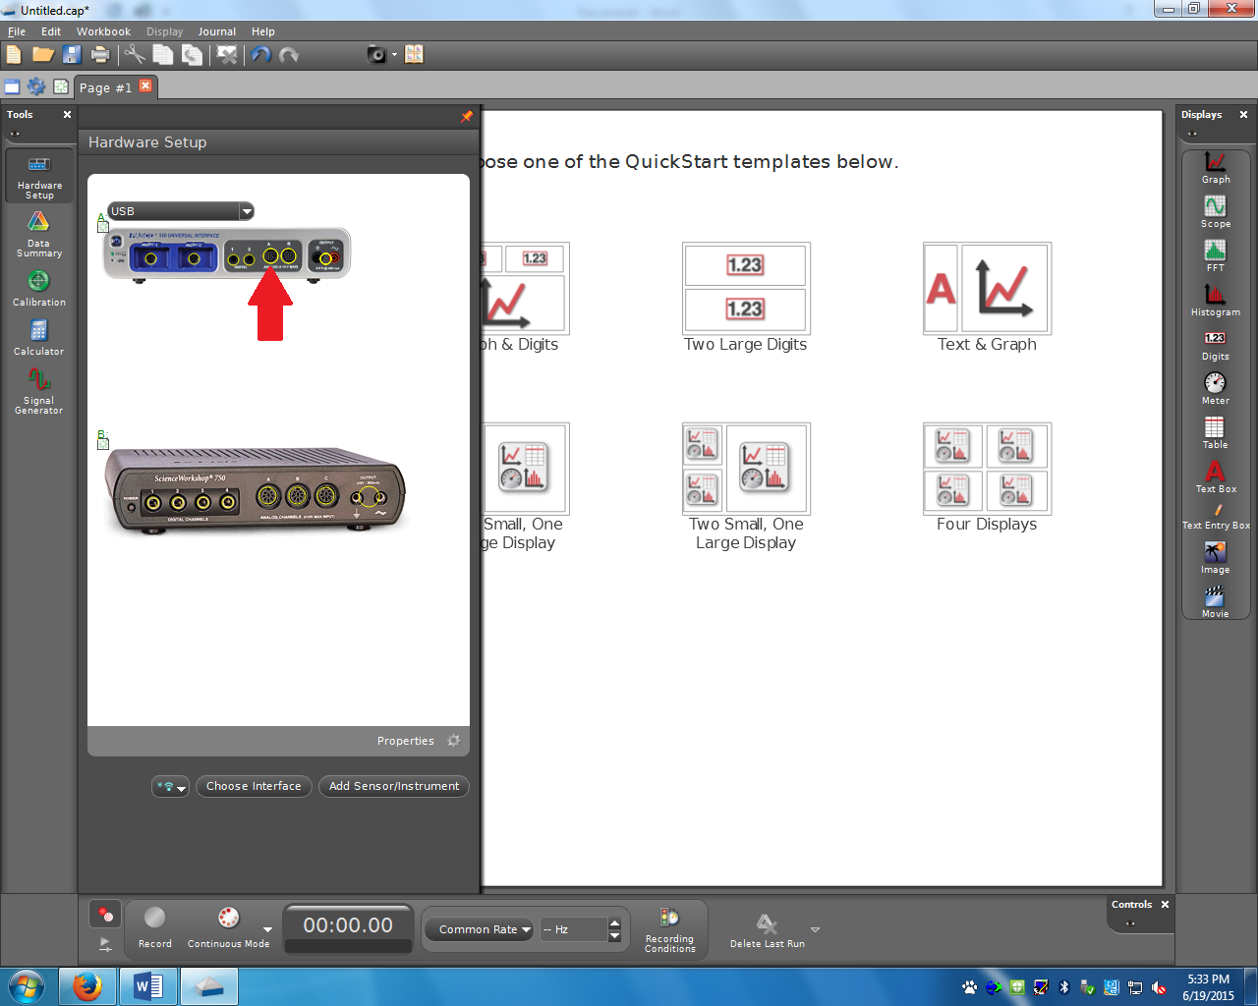

A drop down menu should appear. Scroll down to “Voltage Sensor”, and click it. Now click the “x” on the box to the right of “Tools” in the upper left corner to close the Hardware Setup box.

- Click “Table and graph” from the menu of QuickStart templates.
- Drag “Digits” icon in the rightmost column to page or double-click it to create a digit display. If there is no “Digits” icon, click “Show or hide tools” to show tools, and select “Digits”. There will be a “Digits” icon in the coulumn. Drag “Digits” icon in the rightmost column to page or double-click it to create a digit display.
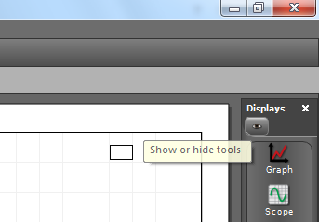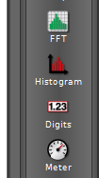

- Table:
- Click the “Select Measurement” button on the top of the first column of the table. Select “Time(s)”.
- Click the “Select Measurement” button on the top of the second column of the table. Select “Voltage(V)”. PASCO is now configured to operate as a digital voltmeter.
- Enter your table title in the upper left corner of the table.

- Graph:
- Click the “Select Measurement” button along x-axis of the graph. Select “Time(s)”.
- Click the “Select Measurement” button along y-axis of the graph. Select “Voltage(V)”.
- Enter your graph title in the lower left corner of the graph.

An example of one possible arrangement of these displays is shown in Figure 1.

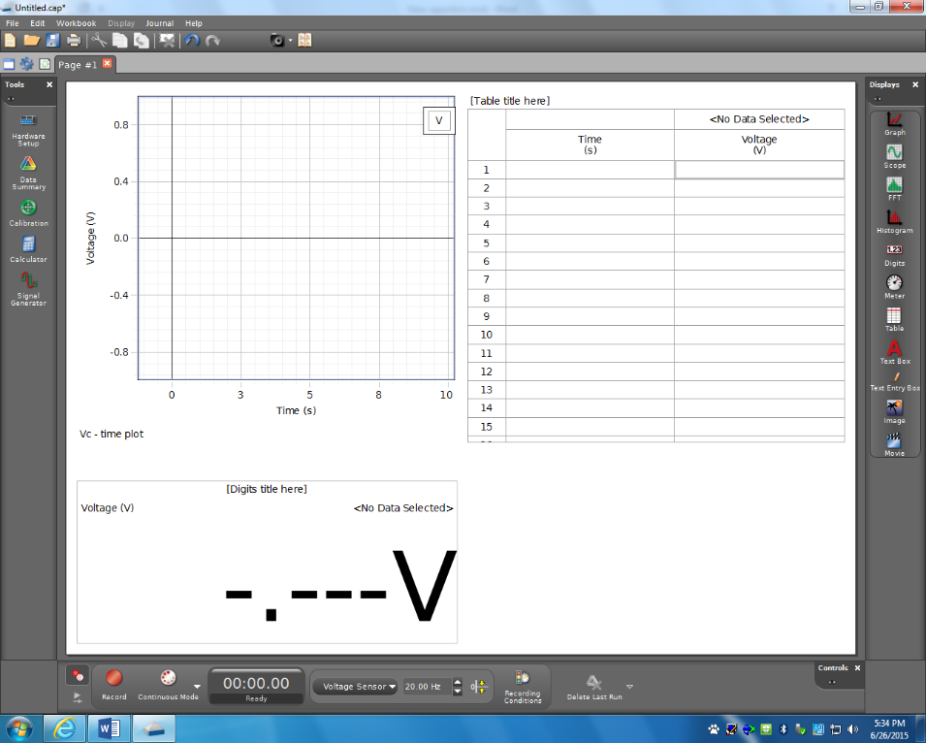
Figure 1 PASCO display with Graph, Table and Digits display enabled for a Voltage sensor plugged into Analog Channel A.

- Connect the ends of a banana-plug wire to the two terminals of the 1-F capacitor for a few seconds (this will ensure that your capacitor is initially uncharged.)
- Set up the circuit shown in Figure 2 below. The power supply should be set to 3V and be turned on only after you finish connecting the wires. Make sure switch is at B. Do NOT close the circuit yet. Note that the switch has two possible closed positions, labeled A and C.

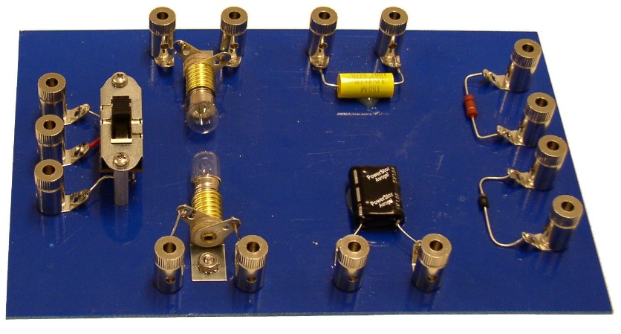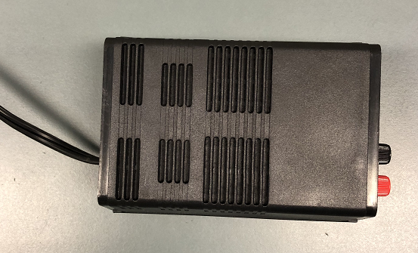
A
B
C
+
−
Voltage Probes from Science Workshop Interface. Check
Set to 3V

Figure 2. Single-capacitor circuit with double-throw switch.

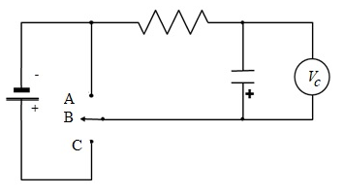
Figure 3. Circuit diagram corresponding to actual circuit wired in Figure 2.
- Compare the actual circuit you connected with the circuit diagram depicted in Figure 3. Ask one of your TAs to check your circuit. Later in the course, you will be required to connect circuits when provided just the diagram, and so it’s worthwhile to take some time now to see how the idealized diagram corresponds to the actual wiring.
- Connect the red voltage probe from the PASCO 550 Universal Interface box to the positive terminal of the 1-F capacitor, and the black probe to the negative terminal of the capacitor. PASCO Capstone should now be configured to measure the potential difference across the capacitor, V_{C}. (check that the connector screws on the blue board are tight)
- Click on the Record button in PASCO Capstone to begin recording data, watch the light bulb, and close the circuit by moving the switch to position C. You will see the voltage data being displayed “on the fly” in the digits window, being recorded in the table, and displayed on the graph.
  - When the capacitor seems to have charged completely, flip and hold the switch to position A. This position of the switch is spring-loaded, and it will be necessary for you to continue to apply light pressure for the switch to remain closed in this position.
  - When the capacitor seems to have discharged completely, stop recording data by clicking the Stop button in PASCO Capstone.
  - Note that you now have (a) a graph that displays V_{C} versus t and (b) a table which shows the potential difference readings (in volts) at different times (in seconds).
- You might wish to do this a few times in order to get a reasonable set of data. Note that you can delete any set of data in “Data summary” in the leftmost column.

Q1. Explain, with detail and in a sentence, what happened to the lightbulb when you flipped the switch?

Q2. What happened to the measured potential difference across the capacitor during the experiment? Sketch (or include screenshot) the potential difference across the capacitor vs. time, assuming that you started the experiment at t = 0. In the sketch , label when the switch was thrown from position C to position A. Also indicate the numerical value of the voltage when the capacitor is completely charged.

Q3. Calculate how much energy was stored in the capacitor when it was fully charged.

Q4. Using the idea of energy conservation, explain the entire process of charging and discharging that you observed. Remember that energy can take on different forms for example: chemical energy, light, heat, electrical energy (i.e., electric field). Your explanation should include a few sentences to describe the process.

Lab Activity 2: Capacitors in series
- First, discharge both the 1-F and the 1-μF capacitors completely. You can do this by connecting a wire to both terminals of each capacitor in turn. Remember from activity 1 that the 1-F capacitor may take a while to discharge completely.
- Connect the circuit shown in Figure 4 below. Make sure the power supply is turned off while changing circuit.
- Again, compare the actual circuit with its corresponding circuit diagram in Figure 5.
- With the switch in the open position, measure the initial potential difference across each capacitor to make sure the capacitors do not have any charge.
- Connect the voltage probe sensors to smaller (1-μF) capacitor. The +(red) probe should connect to the left side, the –(black) probe should connect to the right side as in the picture below.
- Then, throw the switch to position C, while watching the bulb and measuring the potential difference across the smaller (1-μF) capacitor.
- Measure the final potential difference across each capacitor after the switch has been left in position C for a while. (First connect the PASCO probes across one capacitor to read its potential difference, and then move the probes and repeat for the second capacitor.)

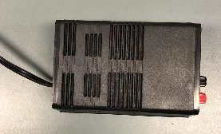
A
B
C
+
−
Voltage Probes from Science Workshop Interface

Figure 4 Two capacitors wired in series with a light bulb.

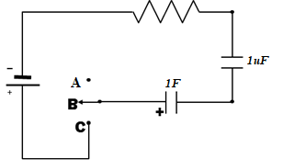
Figure 5 Circuit diagram for circuit depicted in Figure 4.

Q5. What is the total capacitance of the two capacitors in series?

Q6. What happened to the bulb right after you flipped the switch? Could you see anything happen? Do you think the 2 capacitors in series charged more rapidly or more slowly than when you had only a 1-F capacitor in the circuit? (You do not have to explain anything here — just report your empirical observations using complete sentences.)

Q7. What is the final potential difference that you measured across each capacitor after they are fully charged ?

Q8. Use your understanding of capacitors in series to explain your observation in Q7 with complete sentences.

Q9. Describe in a few sentesnces why it makes sense that capacitors in series all have the same charge. It may be helpful to sketch a picture of several capacitors and their plates (with charge) while in series.

Lab Activity 3: How are capacitors designed?
The aim of this activity is to get you to think about how capacitors are made. A dielectric is placed between the conducting plates of the capacitor so as to increase its capacitance. Dielectric materials are insulators, so an applied electric field does not actually make charges move from one point in a dielectric to another. However, the molecules in a dielectric act like dipoles that are free to rotate and line up in an applied electric field. The result is that the "effective" electric field inside the dielectric medium is reduced by a factor called the dielectric constant κ. The dielectric constants for some common materials are listed below. Refer to this table when answering questions in this lab activity.

Material | Dielectric Constant
Air | ~1
Polystyrene | 2.6
Paper | 3.5
Pyrex | 4.7
Silicon (a semiconductor) | 12
Water (near room temperature) | ~80
Titanium-based ceramic | ~130
Strontium titanate | ~310
Table 1 Dielectric constants of various insulating materials

Another important consideration is the breakdown value of a dielectric: if the magnitude of the electric field across the plates of a capacitor becomes too large, the molecules inside the dielectric essentially get "torn apart" and charges can then move from one place to another. In other words, the dielectric no longer behaves as an insulator! Dielectric breakdown is why the casing of a capacitor has a maximum-rated voltage listed on it.

Your goal in this activity is to try to make a model of the 1-μF capacitor.

Q10. First, model the 1-μF capacitor as a parallel plate capacitor, as depicted below. You have to make some intelligent estimates of the distance d and the plate area A from the external appearance of the capacitor (looking at the 1-μF capacitor on the circuit board approximately how long do you think it is and what is its diameter?). (Use a ruler, or use a ruler on your phone) How large a dielectric constant is needed to produce the measured capacitance? Is this realistic (compare it to the values in Table 1)? Because you are estimating its good to keep track of your uncertainty on those estimates. Record them below (but we won’t use them in the calculation of κ)
d
area of plates A

What is the equation we used to model this parallel plate capacitor?:

Estimated value of A: ___________________________

Estimated value of d: ___________________________

Based on values of C, A & d, what is the value for the dielectric constant :

Is this reasonable or not? Justify your answer.

Q11. So, you've probably figured out by now that the parallel plate model does not work! Model the capacitor as a cylindrical capacitor instead. This should consist of a solid inner cylinder of radius R₁, a cylindrical outer shell with radius R₂, both of length L. How large a dielectric constant is needed to produce the measured capacitance? Is this realistic?

Write the expression used for calculating capacitance of cylindrical capacitor:

Estimated radius of inner cylinder: _________________________

Estimated radius of outer cylinder: _________________________

Estimated length of cylinder : _________________________

Based on the values of C, L, R₁ and R₂, write dielectric constant

Is this reasonable or not? Justify your answer.

Q12. Neither the simple parallel plate nor the cylindrical capacitor schemes seem to work. So, how are these capacitors constructed? Design an alternative scheme that can produce the measured capacitance in the given compact package/geometry. Think creatively but remember that your scheme should be amenable to large-scale manufacturing and hence cannot be extremely intricate! (Hint: look at the expression for the capacitance of a parallel plate capacitor. What geometrical factor should you maximize to increase capacitance? What geometrical factor should you minimize to increase capacitance? How would you make a package that is compact but meets these requirements?)

