PID Lateral Control

1. Calculating steering dynamics

Steering System is modelled as a second order linear system (PT2), described by the following transfer function:

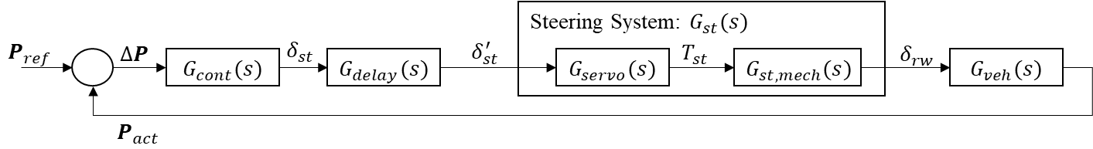

Here and are the reference and actual vehicle poses, provided by the planning and the localization. The error is controlled by the vehicle lateral controller described by the transfer function . Then, the steering angle is sent to the low level steering angle controller. Between, there is a delay block which models the transfer delay due to communication. Then, the low level control calculates the intervention torque . Please be noted, that includes the feedback of the steering angle. This is usually some linear controller, which is hidden from the vehicle controller layer. Then, steering torque is applied on the steering column (or rack, depending on the vehicle type). The steering column to road-wheel connection point system is modelled by transfer function. In this sense: . Even though, this system is usually higher ordered than 2, e.g., 4 (if both servo and mechanical transfer functions are second ordered), usually: , which means two time constant is more dominant than the rest. Thus, is simplified to a second order transfer function neglecting . is the transfer function of the vehicle reacting on the road wheel angle and outputting its new pose accordingly. is usually LPV, or NLPV system. Then, loop closes on the vehicle control level.

Our aim is, to identify the parameters of , namely gain, time constant and damping. The gain is considered to be , as the input is always normalized between 0 and 1. The gain of the real system is simply handled as a constant factor outside of the steering system. Therefore, only two parameters shall be calculated. For this, measurements with step excitation have been recorded. That has been done with multiple speeds and amplitudes.

Results are shown in the below figure. It is seen, that – even though parameters have variance – the mean values can be calculated for each speed. Damping slightly increases with speed, while the time constant is closely constant up until 13 m/s then starts a slow increase too. This is per the expectations, as at higher speeds the servo controller is usually damps the system more to prevent strong interventions.



Proposals based on results:

* calculate mean parameters, or
* fit a linear function on points and use value accordingly, or
* use look-up table with means for the various speed values, use linear interpolation between speed values and keep parameters constant outside unobserved range.

1. Inverse dynamics of the steering

Continuous – Discrete: Backward Euler

Then, the discrete transfer function is:

So, knowing what steering angle shall be on the output, the input is modified with the inverse of the transfer function:

For simplicity: , then:

Equation is non-causal, therefore it is slightly modified for practical usage:

Where is the target steering angle provided by the vehicle control, are measured and stored values of the actual steering angle in the previous two cycles.

Parameters:

* time constant of , defined by identification,
* : damping of , defined by identification,
* : discrete time step of the controller.

1. Error dependent gains