|  |  |  |
| --- | --- | --- |
| **Prepared by: Gary Flauder** | *gflauder@hotmail.com* |  |
| **Date: 23 August 2024** |  |  |

|  |  |  |  |
| --- | --- | --- | --- |
| Project Overview | | | |
| Project Name | **Service Invoice System** | | |
| Target Start Date | TBD | **Target Implementation Date** | TBD |
| Requestor Name | David Decary-Hetu | **Business Project Sponsor** | University of Montreal |
| IT Contact | TBD | **IT Project Sponsor** |  |

## PROJECT SCOPE

This document is intended to establish a common understanding and is a conceptual general scope of work on new concepts and process handling with the business.

**Common Definitions –**

“Public View” - Describes what a user sees when they are NOT logged into the site

“Private View” – Describes what a user sees when they are either logged into the site.

“Risk” – A multiplication factor of uncertainty assigned to an estimated “task”. i.e. 30% means the task could vary by 30%.

Descision pointS – These Markers define a required decision or where additional clarification is needed.

## Our General Understanding

As an ongoing process of improvement and functionality, [Criminologie](https://criminologie.ca/) would like to update their software and provide a more modern appearance as well as address several bugs that exist in the system.

Pyrite is a one-off framework that was written to house articling software.

The software was last updated in 2018, and as such, some of the packages of the core Pyrite framework no longer exist (software did not install) and will not function without first updating or replacing them and will need to remain functional at an outdated version of PHP 5 prior to any work beginning. It also appears that the software does not support Windows OS development platform. The code is not system agnostic and will need to be addressed via a Docker setup.  
  
It also makes sense to upgrade the CSS to Bootstrap 5 from 3, JQuery and Javascript all to their modern current versions to start as these only affect front end only and require little intervention.   
  
Milestone 3 and beyond will see the remaining PHP upgraded and bring the entire software up to a current version of PHP 8.2 and ensure any dependencies are also upgraded. For example, mcrypt is no longer supported after PHP 7.1and will need to be replaced and recoded where it is used in the software.

The main goal to start is to update the look and feel of the website for the new one.

Descision point – Because the original GIT repositories are read only, I suggest a project owner create their own repositories where the finished code can be pushed to. I will maintain private forked repositories as well, but this will allow the owner to accept pull requests as work progresses to update the main projects.

# New Features / Changes

## Milestone -1 Project Setup and Review

This effort is for:

Review existing code, learn how the existing frameworks PyritePHP, PyriteEmail and PyriteView operate and are assembled. Determine what no longer works and update the core frameworks as required to get the package operational and installed at a development level. New forks will be generated and new repositories setup to accommodate this. The system will be installed to a development server I provide called “Staging”. Tasks will be assigned to milestones and estimates.  
  
Separate layout (style) changes from functional (code) changes. Identifying and new requirements, which are then categorized into phases—addressing the most critical (Phase 1) first.

Once the project is organized into tasks and phases, all tasks will move into an Asana project to track and manage. All project participants will have access to the board to work together.

## Milestone-2 –Rework Screen Layouts

This effort is for:

Update the sites public facing and backend facing layouts. Bootstrap, JQuery and Javascript will all be updated to their latest stable versions. Any issues in design, or design decisions will get posted to the Asana project board for review/decision.  
  
Rework the existing layouts.html page into 4 distinct PHP/TWIG/HTML pages. Header, Side-Navigation, Footer, Body and Errors (errors and status updates/messages) to match the PowerPoint design layouts. By separating each section into their own component, we gain much more control ofhow each section appears without upsetting another sections. Also ensure the pages maintain exactly the same look and feel.  
  
Content then on each of the following pages will change:

1) Home page;

2) Instructions to authors;

3) About us;

4) Contact us;

5) Login page; (not provided)

6) Status page for when people create an account, try to log in, etc;

7) Dashboard - logged in home page;

8) Article submission page;

9) Article status page;

10) Reports page

11) User and control page.

Descision point – Because my language is English, I will assume any French language provided is accurate. I can rework any French from Google Translate into proper English if no translation is provided.

Descision point – Establish a clear footer design for public and private views.

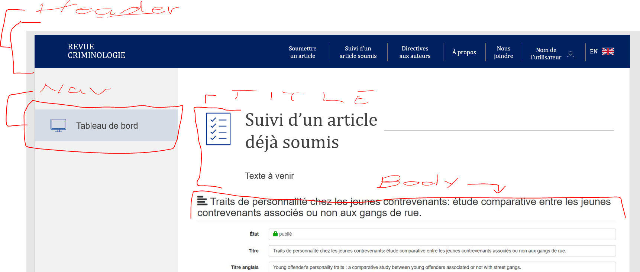

Sample breakdown of components

## Milestone 3 – Update remaining system requirements

The effort is for updating PHP to 8.2, adjusting for any PHP extensions no longer supported from 5.6 to 8.2. Update SQLITE to latest version.

Suggest any improvements and/or cost savings and or stability improvements.  
  
Perhaps move to new server and maintain old site as backup for a few weeks.

## Milestone 4 – Bug Fixes

This effort is for repairing existing issues that have been identified:

1. People who submit articles associate their submission with a journal volume. Sometimes they make a mistake, and we need to change the volume. There is a bug in how that is processed.

Descision point – What exactly is the bug we need to fix? How exactly should this work? Are we adding new functionality or just fixing something?Audit Log? Etc.

1. When a person is a reviewer for a paper, he loses all of their access to the rest of the dashboard. The reduced privileges should be limited to the paper where they are the reviewer (or the author). *(Potentially fixes in Milestone 1)*
2. There is a bug when I add a reviewer, whereas only the email of the person is recorded, and not the other information.

## Milestone 5 – Potential New Feature

Consider moving from Sendgrid to Postmark for emails.

Descision point – Is there a driving reason to do this?

## Milestone 6 – New Feature / Translations -further scope required

Find the best solution to manage the French/English text on web pages, and the content of automated emails. We are using text templates and PO Edit right now.   
  
This is really a much larger feature and would need to be scoped out in detail. However, a suggestion, if one isn’t already in use is to build a command line tool to quickly identify keys that might be missing between the 2 PO files and add those to the files.   
  
A local translation editor can be built into the system to allow editing PO files directly, and we can add some templating for emails perhaps, buy we really need to define exactly what it is we would want the system to do.

## Proposed Development Milestones:

Because the software is neither supported nor recognized as a common framework and falls into the category of custom software. Unlike a common framework like Laravel, there is a large learning curve up front before work can start and that is reflected in onboarding time.

The software also lacks any unit tests which allow developers to maintain quality control and ensure any new code they introduce doesn’t break existing code, or at the least, ensure the code works as expected.

Descision point – Highly recommend considering a few extra weeks to build in Unit testing.

Consequently, estimates can vary and are provided as rough ball park only!

|  |  |  |
| --- | --- | --- |
| Module / Function | Descriptions | Estimated Development Time /days  Low / Hi |
| Milestone 1 | Feature 1 - Project Onboarding, Setup and Review | 20 / 36 |
| Milestone 2 | Feature 2 - Rework Screen Layouts | 16 /32 |
| Milestone 3 | Update remaining system requirements | 8 / 16 |
| Milestone 4 | Bug Fixes. | 8 / 24 |
| Milestone 5 | Sendgrid to Postmark | 1/3 |
| Milestone 6 | New Editor for translations, templates | TBD |
|  | Unforeseen complications integrating with existing code / changing existing code. | 10 |
|  |  |  |
|  | **Total Hours** | **53 / 111** |
|  | **@45.00/hr USD** | **$2385/ $4995** |

|  |
| --- |
| **Key Success Factors and Assumptions** |
| Success Factors  **Ownership**. Visible and ongoing management ownership of the project is crucial. Active participants in the Project teams are critical to ensure effective decisions take place.  **Scope and Requirements.** The boundaries and objectives of this implementation must be clearly defined and communicated to mitigate the risk of the requirements being incomplete or detached.  **Quality Assurance & Availability**. Organizational support for the project determines how the project team manages conflicting priorities. Specifically, having the appropriate individuals available for User Acceptance Testing and Acceptance. |