|  |  |  |
| --- | --- | --- |
| **Prepared by: Gary Flauder** | *gflauder@hotmail.com* |  |
| **Date: 23 August 2024** |  |  |

|  |  |  |  |
| --- | --- | --- | --- |
| Project Overview | | | |
| Project Name | **Service Invoice System** | | |
| Target Start Date | TBD | **Target Implementation Date** | TBD |
| Requestor Name | David Decary-Hetu | **Business Project Sponsor** | University of Montreal |
| IT Contact | TBD | **IT Project Sponsor** |  |

## Purpose

This project aims to update and modernize the Service Invoice System by addressing existing bugs, upgrading outdated software components, and enhancing the user interface to improve functionality and appearance.

## PROJECT SCOPE

This document is intended to establish a common understanding and is a conceptual general scope of work on new concepts and process handling with the business.

**Common Definitions –**

“Public View” - Describes what a user sees when they are NOT logged into the site

“Private View” – Describes what a user sees when they are either logged into the site.

“Pyrite” – The original name of the framework developed for Articling.

“Docker” – Virtualized server/development environment that can run on any device and makes the software platform agnostic.

Decision Points – These Markers define a required decision or where additional clarification is needed.

## Our General Understanding

Criminologie seeks to update its software to address bugs and modernize its appearance. The current software, based on the outdated Pyrite framework, requires updates to function with PHP 8+ and will need to be adapted for a modern development environment.

Key Updates Required:

* Framework Updates: Transition from outdated Pyrite framework components.
* Frontend Updates: Upgrade CSS to Bootstrap 5, and update JQuery and JavaScript.
* PHP/SQLITE Upgrade: Update PHP to version 8.2, replace deprecated extensions (e.g., mcrypt), update SQLLITE, ensure compatibility throughout.

Decision Point – *Create new repositories for ongoing development due to the read-only status of the original GIT repositories.*

# New Features / Changes

## Milestone -1 Project Setup and Review

* Review existing code and frameworks (PyritePHP, PyriteEmail, PyriteView).
* Set up new repositories and development environment.
* Separate layout changes from functional code changes.
* Organize tasks into phases and manage through Asana.

## Milestone-2 –Rework Screen Layouts

* Update public and backend layouts with the latest versions of Bootstrap, JQuery, and JavaScript.
* Rework layout into distinct PHP/TWIG/HTML pages (Header, Side-Navigation, Footer, Body, Errors) following new design PPT.
* Maintain consistent look and feel across all pages.

Decision Point– *Confirm accuracy of provided French translations and establish a clear footer design as well as any new screen layouts.*

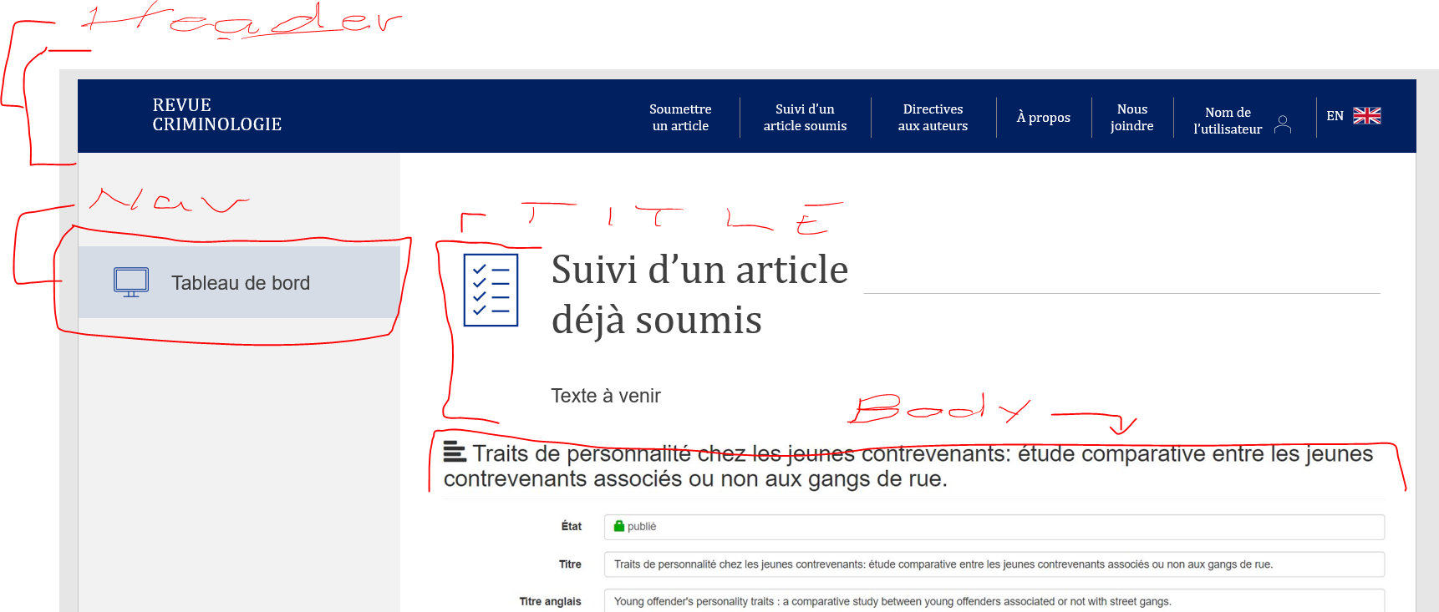

Sample breakdown of components

## Milestone 3 – Update remaining system requirements

* Update PHP to 8.2 and adjust for deprecated extensions.
* Update SQLite and suggest improvements.
* Adjust for any Composer (3rd party Library) updates.

## Milestone 4 – Bug Fixes

Fix identified bugs related to article submissions, user access, and reviewer information.

1. People who submit articles associate their submission with a journal volume. Sometimes they make a mistake, and we need to change the volume. There is a bug in how that is processed.

Decision Point– What exactly is the bug we need to fix? How exactly should this work? Are we adding new functionality or just fixing something? Audit Log? Etc.

1. When a person is a reviewer for a paper, he loses all of their access to the rest of the dashboard. The reduced privileges should be limited to the paper where they are the reviewer (or the author). *(Potentially fixes in Milestone 1)*
2. There is a bug when I add a reviewer, whereas only the email of the person is recorded, and not the other information.

## Milestone 5 – Potential New Feature

Consider moving from Sendgrid to Postmark for emails.

Decision Point– Is there a driving reason to do this?

## Milestone 6 – New Feature / Translations -further scope required

* Explore solutions for managing French/English text and automated emails.
* Consider building a command-line tool for identifying missing PO keys and a local translation editor.

## Proposed Development Milestones and Methods:

* The custom nature of the software presents a significant learning curve.
* Lack of unit tests necessitates extra time for quality control.

Consequently, estimates can vary and are provided with a low and high.

Decision Point– *Consider additional time for unit testing to build in testing*

|  |  |  |
| --- | --- | --- |
| Module / Function | Descriptions | Estimated Hours  Low / Hi |
| Milestone 1 | Feature 1 - Project Onboarding, Setup and Review | 20 / 40 |
| Milestone 2 | Feature 2 - Rework Screen Layouts | 16 /32 |
| Milestone 3 | Update remaining system requirements | 8 / 16 |
| Milestone 4 | Bug Fixes. | 8 / 24 |
| Milestone 5 | Sendgrid to Postmark | 1/3 |
| Milestone 6 | New Editor for translations, templates | TBD |
|  | Unforeseen complications integrating with existing code / changing existing code. | 10 |
|  |  |  |
|  | **Total Hours** | **53 / 115** |
|  | **@45.00/hr USD** | **$2385/ $5175** |

|  |
| --- |
| **Key Success Factors and Assumptions** |
| Success Factors  **Ownership**. Visible and ongoing management ownership of the project is crucial. Active participants in the Project teams are critical to ensure effective decisions take place.  **Scope and Requirements.** The boundaries and objectives of this implementation must be clearly defined and communicated to mitigate the risk of the requirements being incomplete or detached.  **Quality Assurance & Availability**. Organizational support for the project determines how the project team manages conflicting priorities. Specifically, having the appropriate individuals available for User Acceptance Testing and Acceptance. |