Requirement Specification
“Bless You” – CBR Based Sneeze Detector
DVA406 - vt’15: Group 1

Project members:
Simon Palmér
Niclas Säll
Göran Forsström

Introduction
In the course DVA406 Intelligent System a mini-project is included as part of the examination.
The project should let you define your problem, find a solution and solve it.
The project chosen is:
“Bless You” – a CBR-based Sneeze Detector.

Background
The current trend to analyze big data is a way to get early indications of events in the society. One such event is the outbreak of an influenza.

Problem High Level Description
A microphone, placed in e.g. a public library, keeps listening to the sound in the library, when it detects that someone sneezes a counter is incremented. A supervisory system is able to read the sneeze count at cyclic intervals. The read counter values can be used to detect if a flu is in progress.

High Level Description
The experimental “Bless You” system prototype features:
- Sound input in the form of .wav-files.
- A library of sound files of known sneezes used for CBR.
- Detection of sneezes according to a feature detection: such as FFT, Crest Factor, and Wave-lets.
- Response is just a detection sneeze being TRUE or FALSE and an incremented count.

.

Block Diagram, CBR System
In the figure below:
“New Problem” = a new sneeze sound file.
“Case Library” = sneeze features

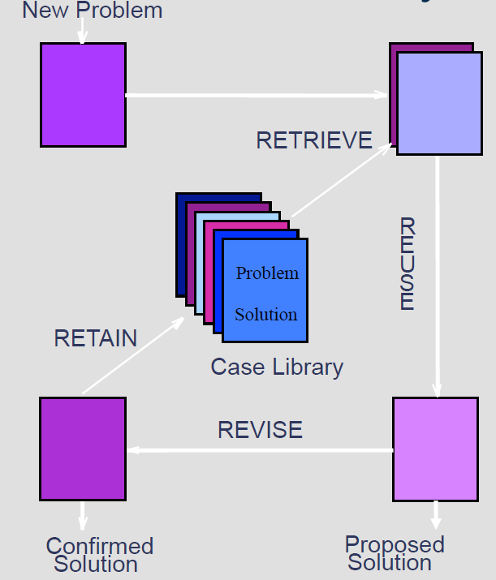

Block Diagram, Feature Detector
The audio files in the library are analyzed for usable features.
Sneeze Feature Extractor:
- This program reads the sound files and extracts a relevant feature using e.g. FFT, Crest Factor, Wave Lets or any other means.

Sneezes in audio files

Sneeze Feature Case Library:
A database with extracted features of the reference sneezes.

Block Diagram, CBR evaluation
An audio file is evaluated by CBR.

Sneeze Feature Case Library:
A database with extracted features of the reference sneezes.

“Bless You”:
- This program reads the selected sound file and extracts a relevant feature using e.g. FFT, Crest Factor, Wave Lets or any other means.
- The feature set is compared to the Case Library and a match is search for.
- The Case Library is updated if required.
- The count is incremented at match.

Sneeze audio file

Report on match

Use Case Descriptions

Use Case Name: | Browse for Sound File to be examined
Actors: | User
Initiator: | User
Goal: | Evaluate if a sound file contains a sneeze or not
Main Scenario: | 1. Select file.  2. When file selected it is analyzed.  3. The system replies TRUE or FALSE and increments count at TRUE.  4. If confirmed and proposed solutions are equal the sneeze features are added to the library if library size is below recommended size.  5. If confirmed and proposed solutions are different:  If proper sneeze not detected: add current feature set to library as positive case.  If false sneeze detected as sneeze: add current feature set to library as negative case.

References

Ref. | Doc.Id | Document Title
ProjPlan | TBA | Project Plan

History
Date | Version | Status | Notes | Author
2015-02-12 | 1 | w | Document introduced. | GF

