A Survey of Image Segmentation Techniques

Wei-Guang Teng
Department of Engineering Science
National Cheng Kung University
Tainan, Taiwan
wgteng@mail.ncku.edu.tw

Abstract
The abstract should summarize the contents of the paper and should contain at least 70 and at most 150 words. Do not cite references in the abstract.
Keywords: About four key words or phrases in alphabetical order, separated by semicolons (;).
1. Introduction
All manuscripts must be in English. The template is used to format your paper and style the text. All margins, column widths, line spaces, and text fonts are prescribed; please do not alter them.
The text should be justified to occupy the full line width, so that the right margin is not ragged, with words hyphenated as appropriate. Italic type may be used to emphasize words in running text. Bold type and underlining should be avoided.
Before you begin to format your paper, first write and save the content as a separate text file. Keep your text and graphic files separate until after the text has been formatted and styled.
2. Overview of xxx
Several relevant techniques for image segmentation are generally explored in Section 2.1. In addition, the approach of self-organizing map is introduced in Section 2.2 as a theoretic basis in this work.
2.1. Image Segmentation Techniques
For image segmentation, relevant approaches generally focus on identifying discontinuities and similarities in an image. Well-known approaches include edge detection, region-based methods, and histogram thresholding [6]. These conventional approaches have been proved to be advantageous in utilizing either global or local information [7]. Specifically, both the edge detection and the histogram thresholding techniques utilize the global information of color distribution for segmenting images into regions of similar colors. These techniques work great with grayscale images which are with only a single color component. However, when directly extending these two techniques for handling color images, the segmentation results may be poor. On the other hand, as region-based techniques merely use local information for growing regions into larger ones, the corresponding segmentation results may also be restricted.
In recent years, data clustering techniques are introduced for several digital imaging applications. To be more specific, hierarchical clustering methods and neural networks [8][9][10] are applied for image segmentation since these techniques can group image pixels together according to their similarities of color components and spatial coordinates. Nevertheless, a major problem of applying these techniques for image segmentation is that a proper number of clusters (or segments) usually should be determined in advance. Otherwise, unsatisfactory results can be obtained due to the problem of over-segmentation or under-segmentation, i.e., splitting up into too many or too few regions. Thus, the feasibility of utilizing clustering techniques directly tends to be low in practice.
2.2. Discovering ROIs from Medical Images
The self-organizing map (SOM) is commonly used for dimensionality reduction [12]. Specifically, in a typical SOM, the n-dimensional input vectors can be mapped to a few neurons of one or two dimensions. For our purpose of segmenting color images, a typical option is to use all color components of each pixel as an input vector. Consequently, the corresponding two-layer (i.e., input vectors and output neurons) structure of the SOM can be shown as in Fig. 1. Without the loss of generality, the RGB color model is used in Fig. 1. Nevertheless, other color models including CMY, HSL, YIQ, CIE XYZ and CIE L*u*v* can also be utilized in a similar way. Throughout the iterative learning process, the output neurons usually converge on the dominant colors of the original image. In other words, the goal of color reduction can thus be achieved by discarding insignificant colors.
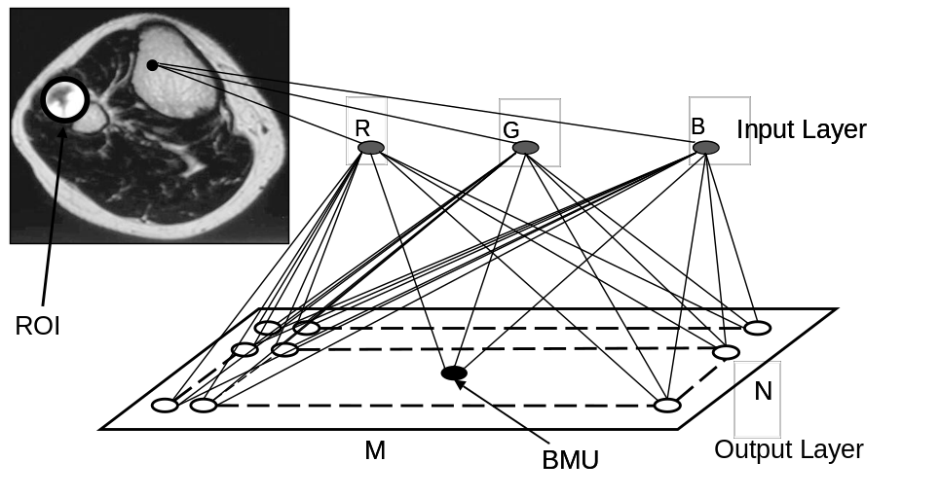
Figure 1. Two-layer structure of the self-organizing map for image segmentation
The weight vectors associated with the neurons in the output layer are denoted by 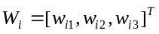 whose initial values are randomly determined, where 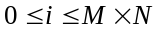 (i.e., the size of the output layer). Note that the SOM works iteratively to form an unsupervised learning process. In each iteration, the most similar neuron or the best matching unit (BMU) can be found for an input vector. In addition, a training process begins by involving neighboring units of the BMU according to a function which is described by an exponential decay on time t as follows.
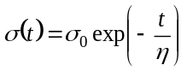 (1)
where η is a time constant and 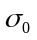 is the initial value of the neighboring length.
To further investigate the performance of our approach, corresponding executing time is measured and reported in Table 1. Note that our approach is more efficient than algorithm active contour in most cases. Consequently, our approach is both effective and efficient in handling several types of medical images.
Table 1. Table captions should always be positioned above the tables.
Image ID | Image size  (pixel × pixel) | Active contour | Our approach
Image ID | Image size  (pixel × pixel) | Execution time (sec.) | Execution time (sec.)
(a) | 267 × 317 | 23.5 | 19.7
(b) | 600 × 800 | 341.3 | 93.6
(c) | 235 × 331 | 13.1 | 18.8
(d) | 256 × 256 | 16.7 | 16.3
(e) | 443 × 462 | 271 | 43.8
(f) | 591 × 500 | 213.5 | 61.3

3. Concluding Remarks and Potential Extensions
Although a conclusion may review the main points of the paper, do not replicate the abstract as the conclusion. A conclusion might elaborate on the importance of the work or suggest applications and extensions.
References
- M. Borsotti, P. Campadelli, and R. Schettini, “Quantitative Evaluation of Color Image Segmentation Results,” Pattern Recognition Letter, 19:741-747, 1998.
- T. F. Chan and L. A. Vese, “Active Contours without Edges,” IEEE Transactions on Image Processing, 10(2):266-277, February 2001.
- G. Dong and M. Xie, “Color Clustering and Learning for Image Segmentation Based on Neural Networks,” Neural Networks, IEEE Transactions on Neural Networks, 16(4): 925- 936, July 2005.
- M. L. Giger, “Computer-aided Diagnosis in Medical Imaging – A New Era in Image Interpretation,” Business Briefing: Next-Generation Healthcare, Medical Imaging Ultrasound, 2000.
- R. C. Gonzalez, R. E. Woods, “Digital Image Processing,” 2nd Edition, Prentice Hall, 2002.
- Z. İşcan, M. N. Kurnaz, Z. Dokur, and T. Ölmez,” Ultrasound Image Segmentation by Using Wavelet Transform and Self-Organizing Neural Network,” Neural Information Processing, 10(8-9):183-191, August 2006.
- J. Jan, “Medical Image Processing Reconstruction and Restoration Concepts and Methods,” Taylor & Francis, CRC, November 2005.
- Y. Jiang, K.-J. Chen, and Z.-H. Zhou, “SOM-based Image Segmentation,” Proceedings of the 9th International Conference on Rough Sets, Fuzzy Sets, Data Mining and Granular Computing, LNAI 2639, pages 640-643, 2003.
- T. Kohonen, “Self-Organization and Associative Memory,” 3rd Edition, Springer-Verlag Inc., 1989.
- L. Lucchese and S. K. Mitra, “Color Image Segmentation: A State-Of-Art Survey,” Proceedings of Indian National Science Academy, Vol. 67-A, pages 207–221, March 2001.
- F. Ma, S. Xia, “A Multiscale Approach to Automatic Medical Image Segmentation Using Self-Organizing Map,” Journal of Computer Science and Technology, 13(5):402-409, September 1998.
- V. Meas-Yedid, E. Glory, E. Morelon, Ch. Pinset, G. Stamon, and J-Ch. Olivo-Marin, “Automatic Color Space Selection for Biological Image Segmentation,” Proceedings of the 17th International Conference on Pattern Recognition, 3(23-26): 514 – 517, August 2004.
- Medical, Science and Nature Images: Photography and Digital Imagery by Scott Camazine, http://www.scottcamazine.com/.
- S. H. Ong, N. C. Yeo, K. H. Lee, Y. V. Venkatesh, and D. M. Cao, “Segmentation of Color Images Using a Two-Stage Self-Organizing Network,” Image Vision Computing, 20(4):279–289, 2002.
- D. L. Pham, C. Xu, and J.L Prince, “A Survey of Current Methods in Medical Image Segmentation,” Annual Review of Biomedical Engineering, January 1998.

