Jsp lab3 assignment report

Guoqingyan 20154825

Zhouxinhao 20155016

Designed decision:

The lab3 mainly combines the jsp and servlet and the database. The main user interface is the same as the lab1 and lab2 basically, but because of some new need, we do some improvements.

The report mainly introduces our assignment from two aspects, one is different classes and the other is the different interfaces like the lab1 and the lab2.

Our first step is creating the database. Firstly, we make the ER diagram and then we will transfer the ER diagram to the different relations. And later we will create the table and insert different values. From all things, the thumb attribute will insert the relative path of the photos of the media. The resource attribute will insert the relative path of the according video and audio.

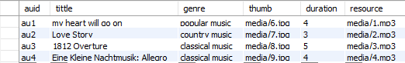



Then we will explain the bottom relation classes. The main thoughts of our creation is to imitate the managebean in JSF, we will make the steps of getting and setting the attributes of the objects in the background process. We will create the Media class which is a parent class, and it includes all the sharing attributes of all the media, like the title, genre and thumb. And the class Movie, Audio, TVshow, album and episode will inherit the attributes from the parent class Media. They inherit all the sharing attributes but at the same time, they have their own attributes. Each class has its according getters and setters to set and get according attributes. And also in the TVshow, it has the episode’s arraylist and in the album, it has the picture’s arraylist.

Then, when it comes to the Tool class, we need to create the static methods to call the method name to be convenient for the later processing. Because the types of the bottom relation classes of the attributes have both the int and the float and also the file type, but the type that we get from the submitting information from the form from the jsp file is only string, so we want to transfer the format. As a result, we use the too classes, so we think it is an innovation maybe.

Later, we create the management class. We will create four static attributes and the four ones are the list of movie, the list of tvshow, the list of audio and the list of album. In the class, we can realize the function of the addition. The management class can realize the union of the information and can help to call.

The above is all about the whole structure and classes of our lab3. And next, we will introduce our lab3 through all the main pages.

Firstly, the register page will create the BDConn object in the JSP, if so, we can load the database, read the content of the userinfo form in the database. The information of the form will be submitted to the servlet end and the background will verify the information to realize the login function.

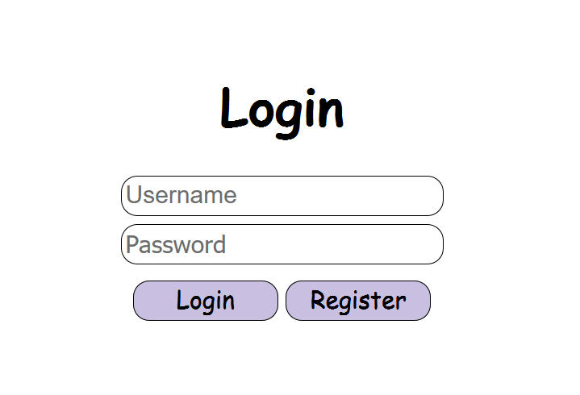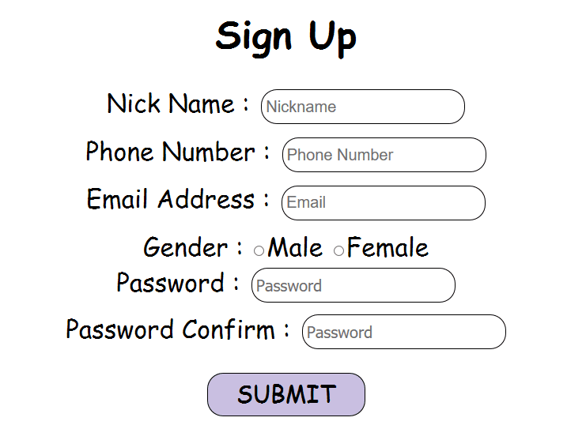

Secondly, we will talk about the four .jsp which are movie.jsp, audio.jsp, tvshow.jsp and the album.jsp. From the four, movie.jsp and audio.jsp can load and read the content of the database directly and show the information on the screen. The album.jsp and audio.jsp can realize the thing that when you click on ‘title’ and then it will jump to the according detailed information. Also, we have foreign key in the table of episode and picture in the database, so that the according tyshow and picture can match the own information. And the tvshow and album can click on to look at the detailed information and can realize the function of watching online and download.

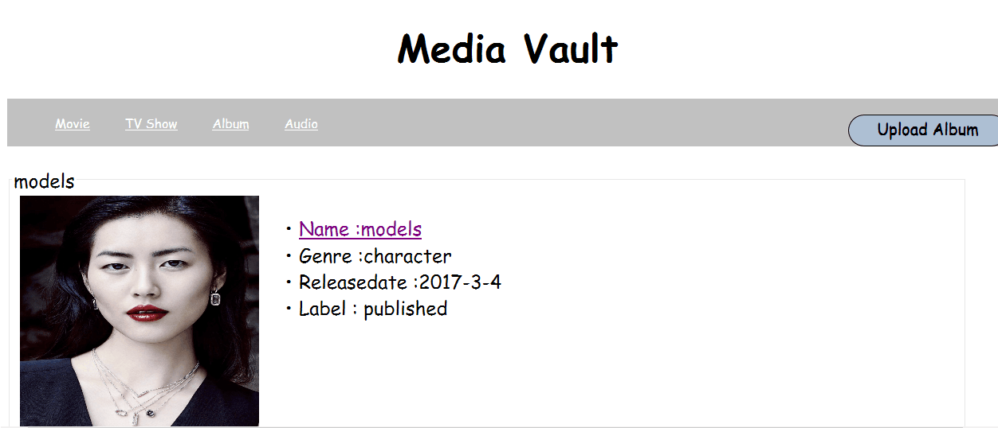

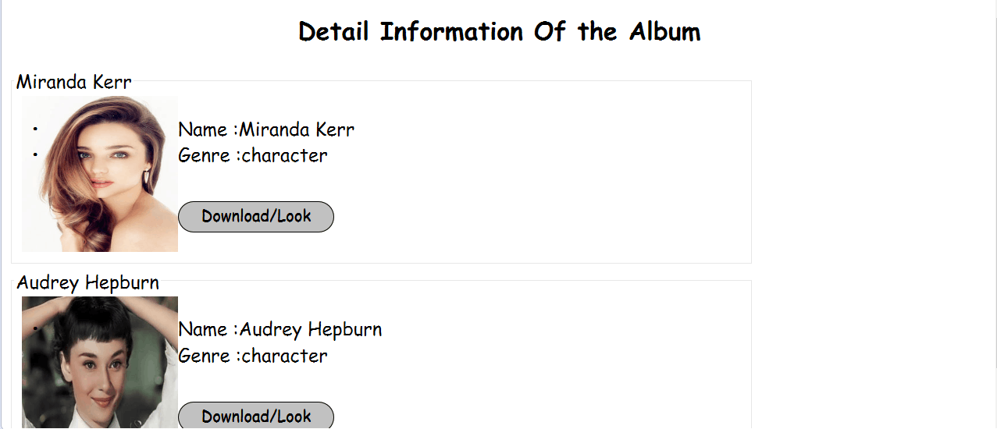

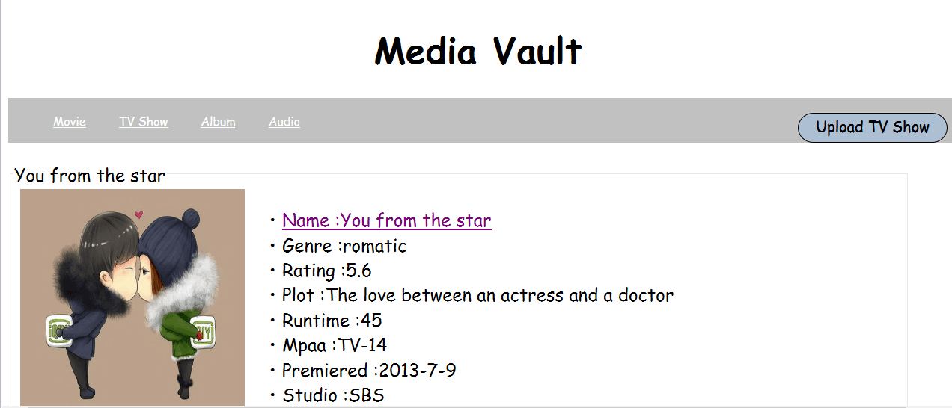

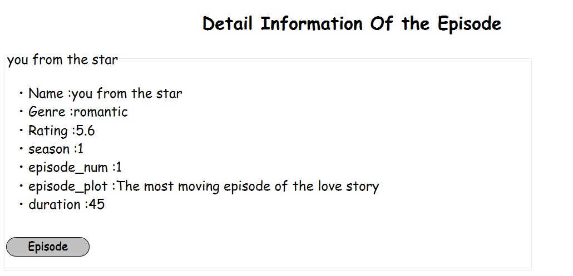

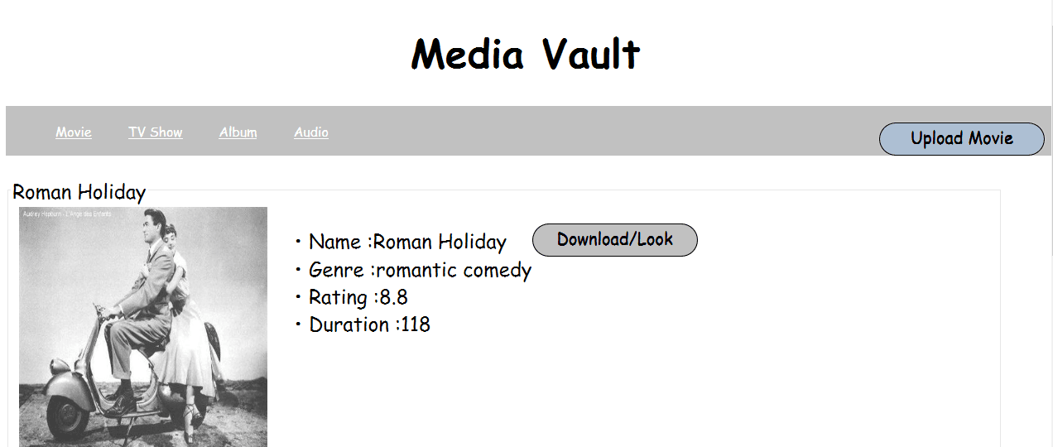

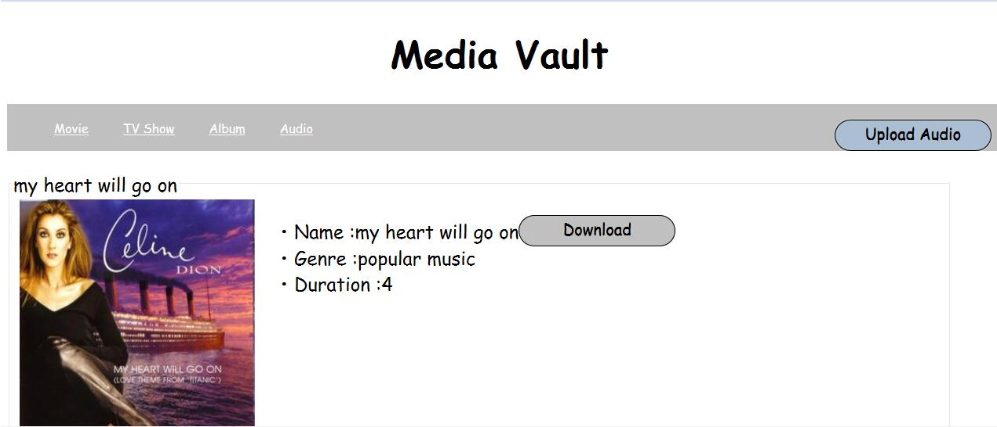

Thirdly, we will introduce the upload function. We can realize the upload function and download function by the jar package outside. We will realize the function by uploading the files according to the different file types. In the jsp page in the front end, the users can fill in the according information and select the local files. In the servlet end at the background, we can load the database and insert the relative information in it. We can process the information submitted by the jsp according to whether the information I txt information or not. Last but not least, when it come to the upload of the files, we not only need to upload it to the server but also need to write the relative path after the upload to the database.

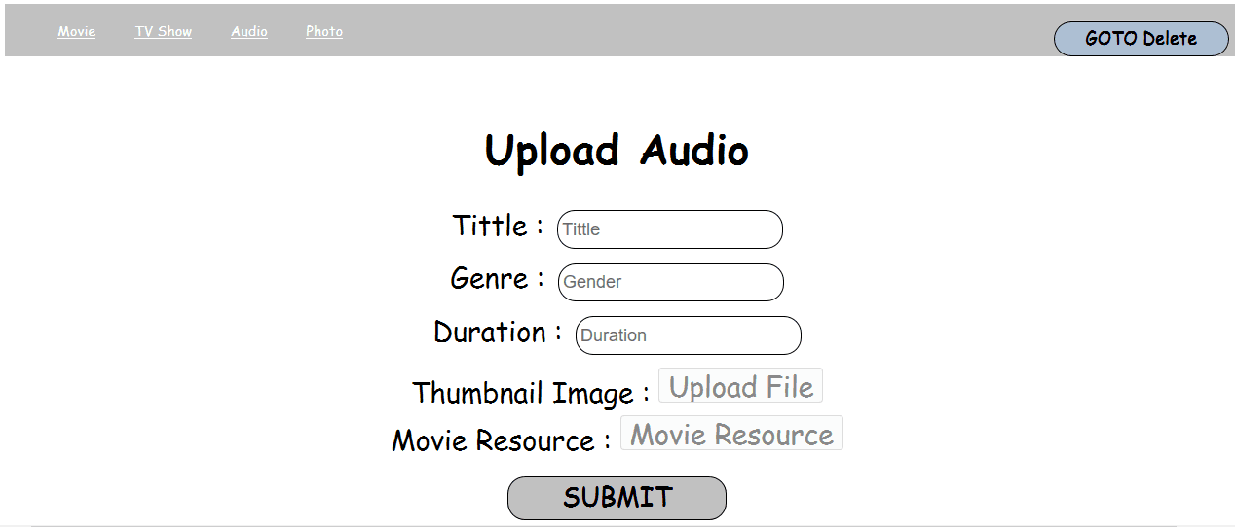

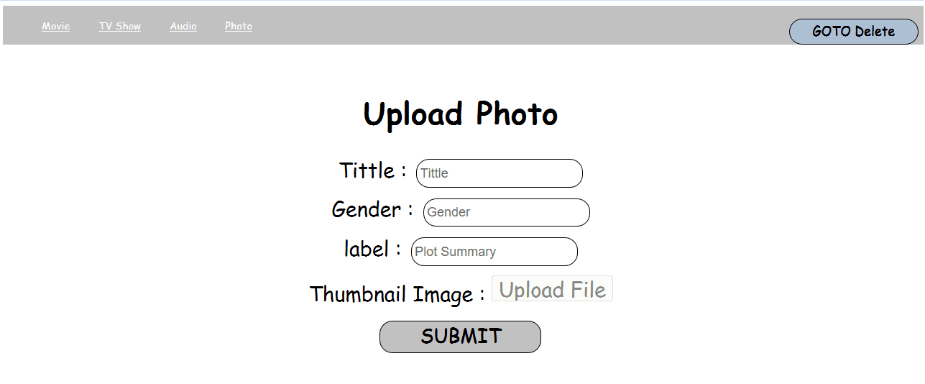

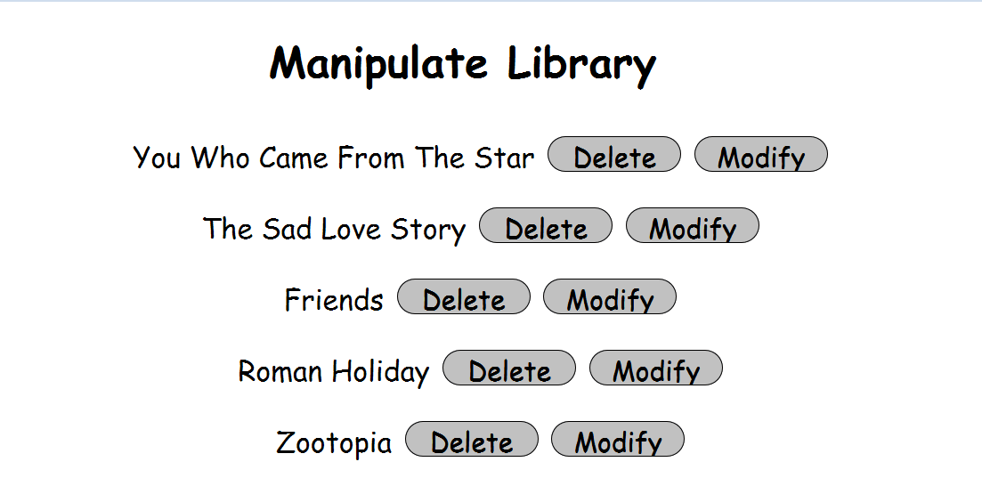

The problems we met:

1.The named way of upload id needs to get the size of list and then plus one, so we need to read the database firstly and then transfer the information of the database into the according objects, and then save to the according container and then upload the files but we cannot upload the files directly.