Module 8: Portfolio Milestone
Greg Fritz
Professor Herbert Pensado
CSC450-1
February 8, 2026

Screenshot:
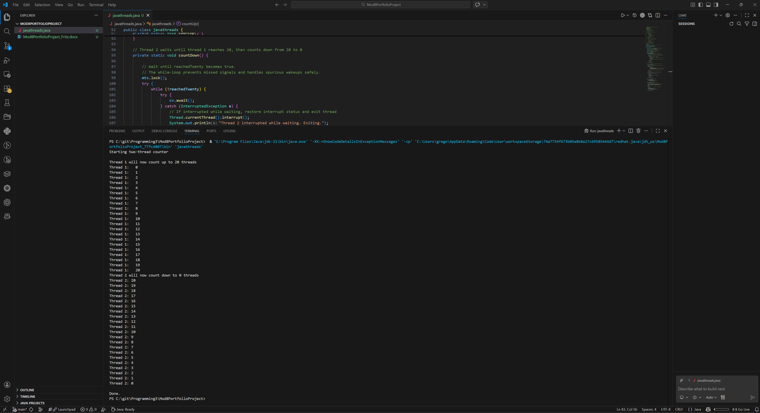

Implementation Java vs. C++ Reflection
This Java application demonstrates fundamental concurrency concepts by using two coordinated threads. The first thread counts upward from 0 to 20, and once it reaches 20, it signals a second thread to begin counting downward from 20 to 0. While concurrency is often associated with improved performance, this project highlights that concurrency also introduces overhead and complexity that can outweigh performance benefits in certain scenarios. Thread creation itself has a non-trivial cost. When a thread is started, the JVM must allocate internal data structures and coordinate with the underlying operating system to schedule execution. In small programs such as this one, the cost of creating threads can be proportionally large compared to the amount of work the threads actually perform. Additionally, context switching occurs when the CPU switches execution from one thread to another, which requires saving and restoring thread state. These context switches can reduce overall efficiency when threads frequently block and wake. Synchronization further impacts performance. This program uses a lock and condition variable (or equivalently, a monitor with wait/notify) to ensure safe coordination between threads. While synchronization is necessary to prevent race conditions, it introduces blocking behavior. When thread 2 waits for thread 1 to reach 20, it enters a waiting state and later must be woken by a signal. This blocking and wake-up process adds latency and scheduling overhead. In highly concurrent systems with many threads, excessive locking can lead to contention, reduced parallelism, and even thread starvation.
Another significant performance consideration is console I/O. Printing output to the console is relatively slow and is internally synchronized. Even though two threads are used, output operations are effectively serialized. This means that the primary bottleneck in this program is not computation but I/O latency. As a result, concurrency does not improve execution speed; instead, it serves an instructional purpose by demonstrating correct coordination and synchronization. This illustrates an important real-world lesson that concurrency should be applied selectively and only when it provides a measurable advantage, such as overlapping I/O waits or leveraging multiple CPU cores for computationally intensive tasks.
Vulnerabilities Exhibited with Use of Strings
Although this counter application does not accept user input, strings are discussed because they are one of the most common sources of security vulnerabilities in real-world applications. Strings frequently store user input, configuration values, file paths, credentials, and network data. Improper handling of strings can lead to injection attacks, data leaks, and authentication bypasses.
In Java, String objects are immutable. This immutability is beneficial in concurrent programming because strings can be shared safely between threads without synchronization concerns related to modification. However, immutability can also introduce security risks when strings contain sensitive data such as passwords or cryptographic keys. Because a String cannot be modified after creation, its contents may remain in memory until garbage collected, potentially exposing sensitive information through memory dumps or debugging tools.
Another vulnerability related to strings is improper validation and normalization. Attackers can exploit inconsistencies in string handling such as Unicode normalization differences, unexpected whitespace, or encoding mismatches to bypass validation logic. In multi-threaded applications, these risks can be amplified if different threads perform validation and processing inconsistently. Secure coding practices emphasize validating input at trust boundaries, using parameterized APIs instead of string concatenation for commands or queries, and avoiding the logging of sensitive string data. While this program only outputs fixed strings, the discussion reinforces best practices that are essential in realistic concurrent systems. Developers must treat strings as potentially dangerous carriers of untrusted data and design defensive validation and sanitization strategies accordingly.
Security of the Data Types Exhibited
The program uses primitive numeric types (int) and a Boolean flag to coordinate execution between threads. On the surface, these data types appear simple and low risk, but concurrency introduces subtle security and correctness challenges. The primary concern is memory visibility and ensuring that changes made by one thread are visible to another thread at the correct time. In Java, the Java Memory Model defines how threads interact through memory. Without proper synchronization, one thread may observe stale values due to CPU caching or instruction reordering. For example, thread 2 could potentially read an outdated value of the reachedTwenty flag and either start too early or wait indefinitely. This program avoids such issues by using synchronization mechanisms that establish a happens-before relationship. When thread 1 updates the shared flag and signals the condition, Java guarantees that thread 2 will see the updated value once it resumes execution.
In C++, similar data types are used, but the security implications are more severe if synchronization is incorrect. A data race in C++ results in undefined behavior, meaning the program may behave unpredictably depending on compiler optimizations and runtime conditions. Undefined behavior can lead not only to crashes but also to exploitable states in more complex applications. Proper use of mutexes and condition variables is therefore essential to maintain correctness and security. This comparison highlights that the security of data types in concurrent programs is heavily dependent on how they are accessed and synchronized. Even primitive types can become a source of defects if shared access is not carefully controlled.
Both the Java and C++ implementations of this application follow the same logical design. One thread counts upward, signals completion, and another thread counts downward. From a performance standpoint, the observable differences in this specific program are minimal because console output dominates execution time. However, broader differences between Java and C++ become more apparent when considering larger and more complex systems. C++ typically offers superior raw performance and predictability because it compiles directly to native machine code and allows fine-grained control over memory allocation and object lifetimes. There is no garbage collector, so developers can avoid pauses associated with memory reclamation. This makes C++ attractive for real-time systems, high-frequency trading, and performance-critical applications. Java, on the other hand, runs on a managed runtime with garbage collection and just-in-time (JIT) compilation. While garbage collection introduces overhead, modern JVMs are highly optimized and can achieve performance comparable to native code in many scenarios. The JIT compiler can optimize frequently executed paths dynamically, sometimes outperforming statically compiled code. In this assignment, garbage collection overhead is negligible because the program allocates very little memory.
Thread management in both languages generally maps to operating system threads. Java provides higher-level concurrency utilities such as executors and thread pools that simplify scalable designs, while C++ relies on libraries and frameworks to provide similar abstractions. From a developer productivity standpoint, Java’s standard concurrency libraries reduce boilerplate and lower the risk of implementation errors. From a security perspective, Java is generally considered less vulnerable to certain classes of high-impact attacks due to its managed runtime environment. Java enforces memory safety through bounds checking, managed references, and garbage collection. These features significantly reduce the risk of buffer overflows, dangling pointers, and use-after-free vulnerabilities, which are common sources of exploits in native code. Whereas C++ places more responsibility on the developer. While it is possible to write highly secure C++ code, doing so requires strict adherence to secure coding standards, careful memory management, and often additional tooling such as static analyzers and sanitizers. Concurrency errors and memory corruption bugs in C++ can be subtle and difficult to detect, especially in large codebases. For this specific counter program, both implementations are safe because they do not process untrusted input and use proper synchronization. However, in general-purpose applications, Java’s managed environment provides stronger default protections against memory-related security threats. As a result, the Java implementation may be considered less vulnerable overall, particularly in environments where security and reliability are higher priorities than maximum raw performance.

Git Hub links:
https://github.com/gfritzcsu/Programming3/tree/main/Mod8PortfolioProject
https://github.com/gfritzcsu/Programming3/commits/main/Mod8PortfolioProject

