Module 2: Critical Thinking
Greg Fritz
Professor Herbert Pensado
CSC450-1
December 21, 2025

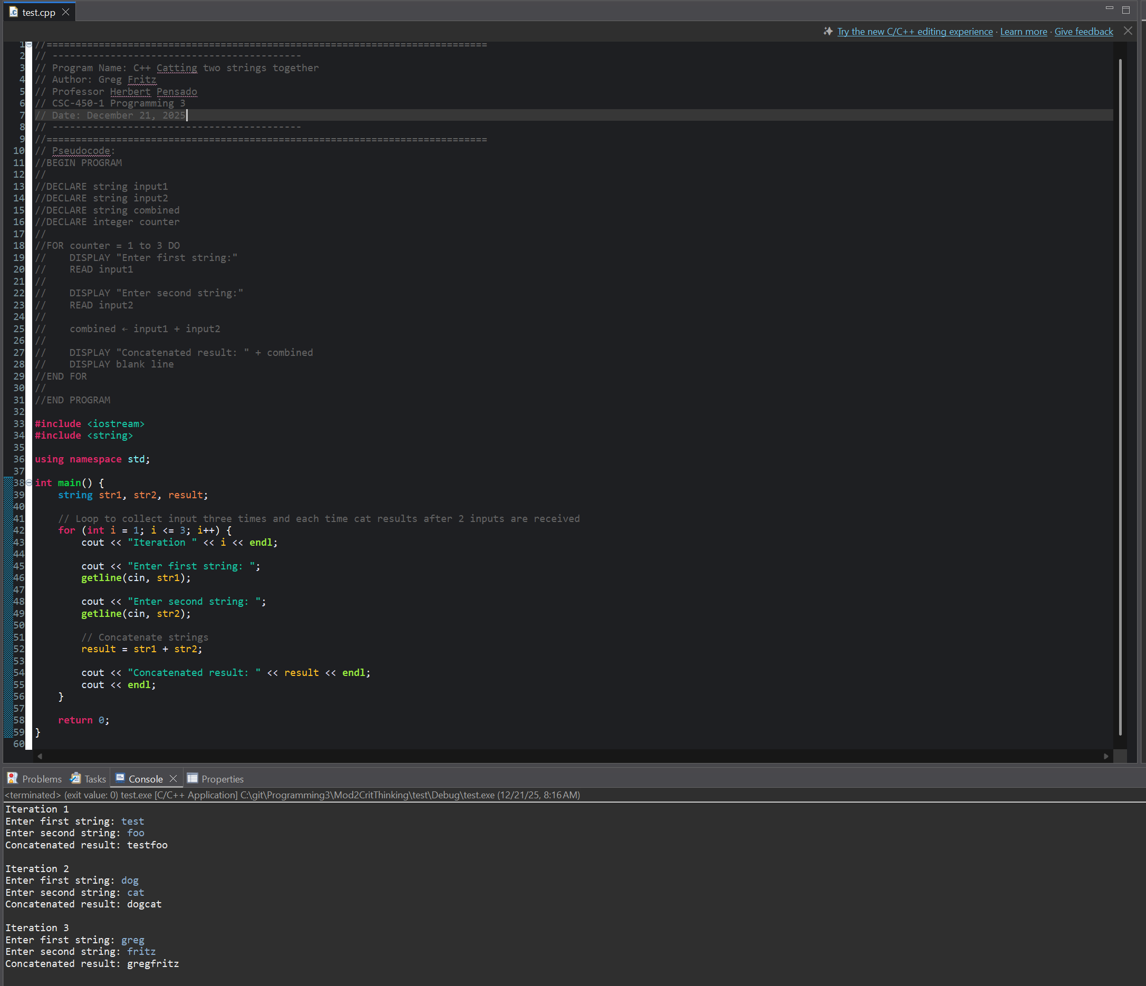
Git Hub links:
https://github.com/gfritzcsu/Programming3/tree/main/Mod2CritThinking
https://github.com/gfritzcsu/Programming3/commits/main/Mod2CritThinking

