Module 1: Critical Thinking
Greg Fritz
Professor Herbert Pensado
CSC450-1
December 14, 2025

Simple C++ Output
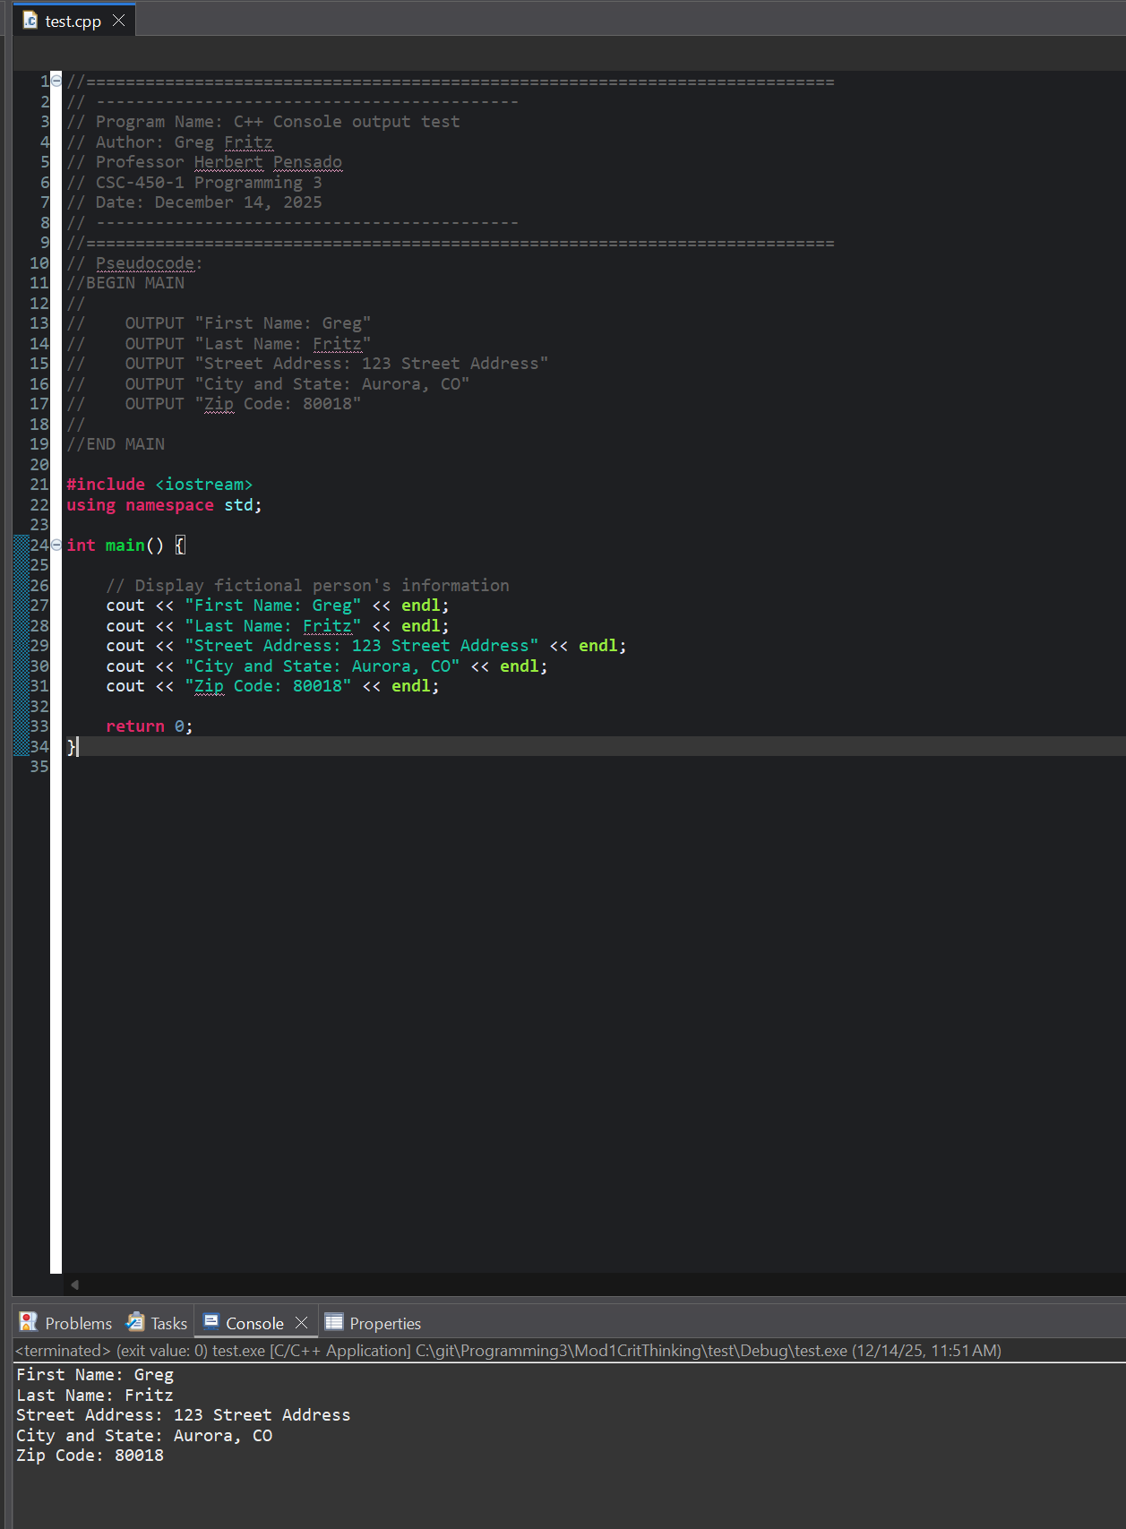
Mod1-1 corrections
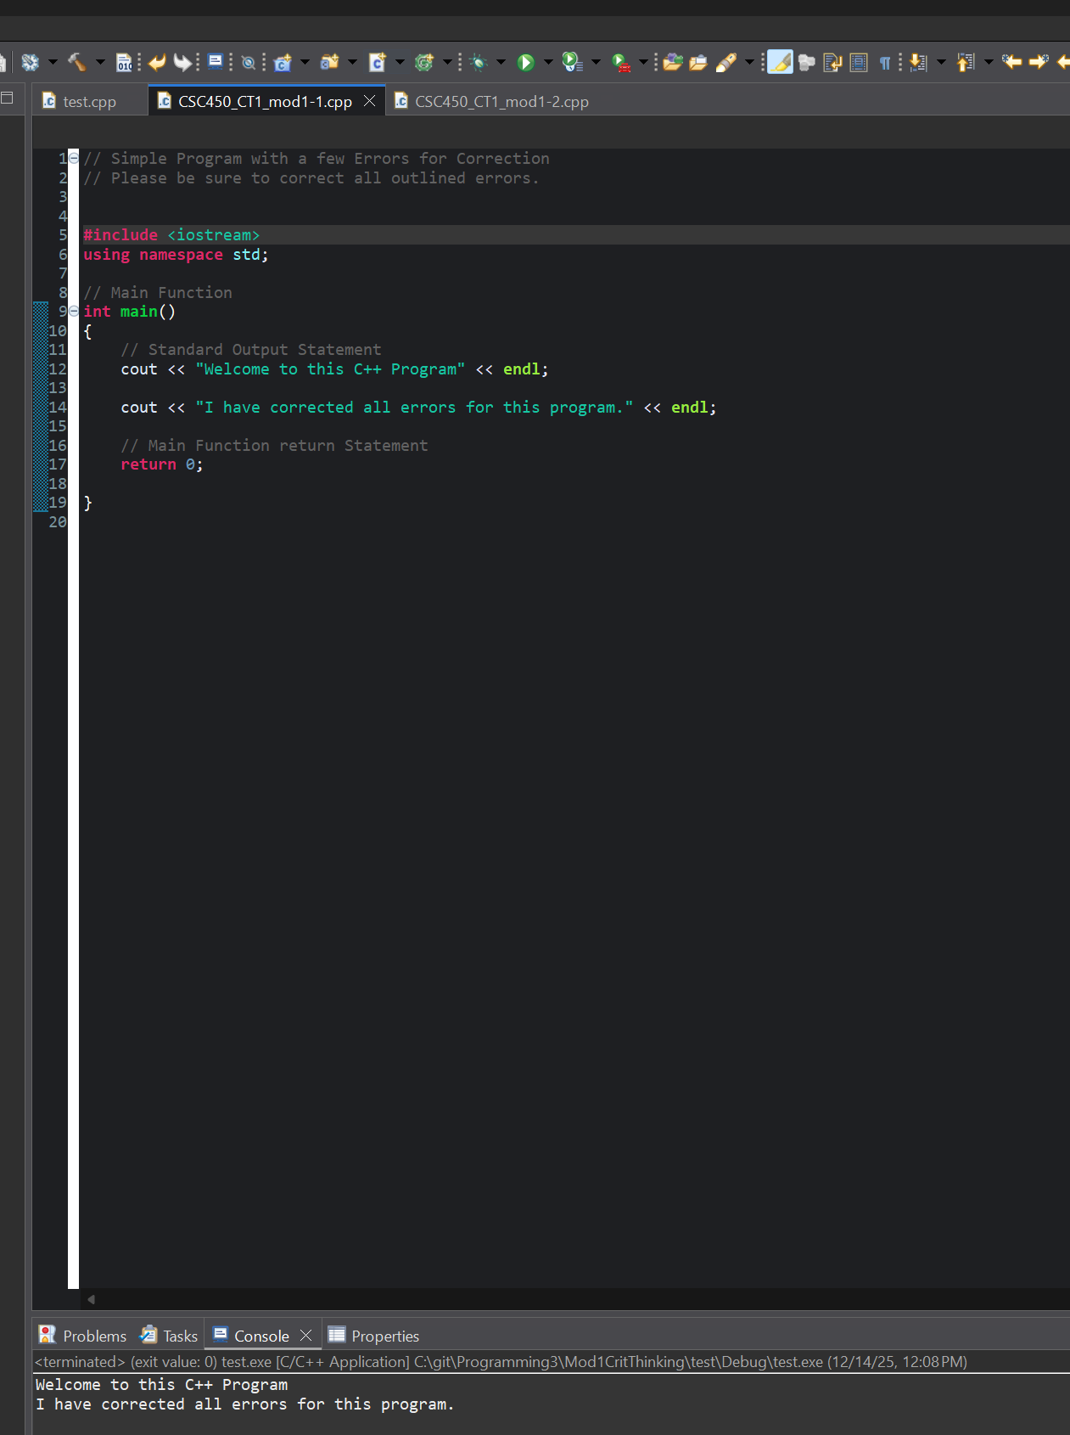
Mod1-2 corrections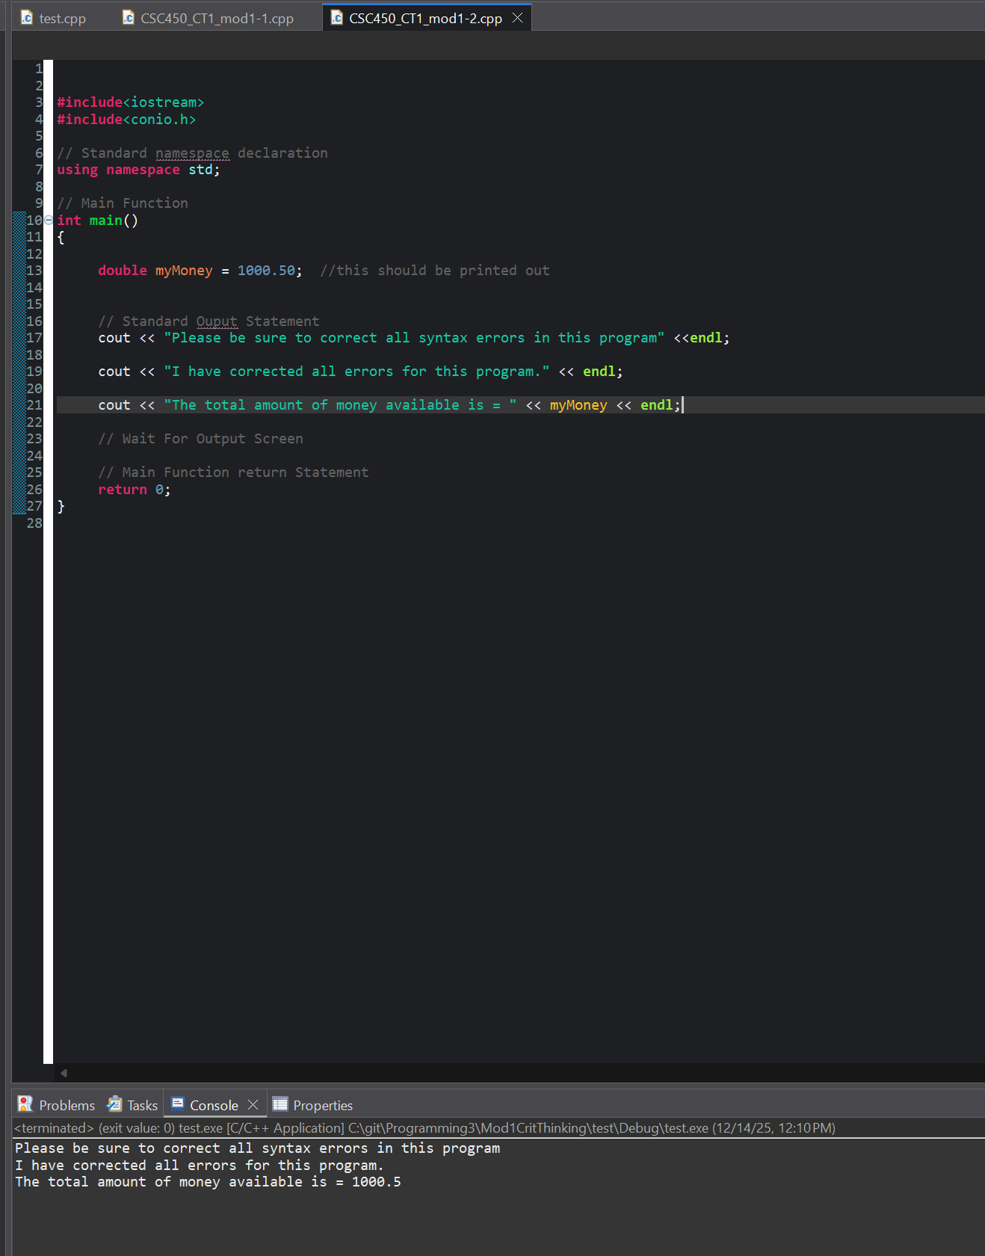
Git Hub links:
https://github.com/gfritzcsu/Programming3/tree/main/Mod1CritThinking
https://github.com/gfritzcsu/Programming3/commits/main/Mod1CritThinking

