Module 7: Portfolio Milestone
Greg Fritz
Professor Herbert Pensado
CSC450-1
February 1, 2026

Screenshot:
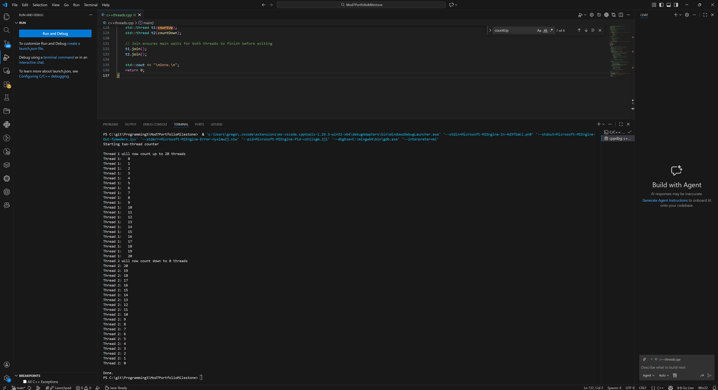
Reflection:
Even though concurrency can improve responsiveness and throughput, it can also reduce performance when the work done by each thread is small. Creating threads has overhead as they need memory for stacks, have scheduling costs, and can allow for frequent context switching can slow execution. In this application, the biggest limiter is the console output writing to std::cout since it is far slower than incrementing an integer, so the program is primarily I/O-bound, not CPU-bound in this case. Synchronization also affects performance by using a std::mutex helps protect the shared state and prevents interleaved output, it can create lock contention if many threads compete for the same lock. Using a std::condition_variable helps performance compared to busy waiting because thread 2 sleeps efficiently until thread 1 signals that it has reached 20, which avoids wasting CPU cycles in a polling loop.
Since strings are a common source of vulnerabilities in C++ programs, especially when user input is involved. The most dangerous issues occur with C-style strings (char[]) and unsafe functions like strcpy, sprintf, or gets, as these can cause problems that can lead to buffer overflows, memory corruption, and crashes or exploitation. Another common risk is format-string vulnerability for example, passing user-controlled input directly as a format specifier to printf. While this counter program uses std::cout and does not accept user input, in a realistic version where a user provides values or labels, the program should use std::string and safe formatting, validate and sanitize any input, and avoid converting to raw C strings unless necessary. Additionally, even std::string can be misused as out-of-range indexing, unbounded concatenation, or unsafe conversions can happen easily, so bounds-aware access and input validation are still important in many situations.
This program uses int and bool for shared state for both the counter and reachedTwenty. The main security or correctness concern here is thread safety. Plain int and bool are not automatically safe to read/write across multiple threads. Without synchronization, the program could experience race conditions causing incorrect values, unpredictable behavior, or missed updates. This is why the design protects these variables with a mutex and uses a condition-variable to predicate and ensure thread 2 cannot proceed until thread 1 has set the flag. In broader applications, developers should also consider overflow especially when counters could exceed INT_MAX or when signed or unsigned conversion bugs might be applicable, and use more precise types such as fixed-width integers (std::int32_t, std::uint32_t) when ranges matter. If the shared variables were accessed frequently and independently, std::atomic<int> / std::atomic<bool> could be an alternative, but atomics must still be used carefully to preserve program ordering and correctness especially when coordinating start and after logic like this assignment requires.

Git Hub links:
https://github.com/gfritzcsu/Programming3/tree/main/Mod7PortfolioMilestone
https://github.com/gfritzcsu/Programming3/commits/main/Mod7PortfolioMilestone

